KaiKo

Software Architecture Document

Version <2.0>

Revision History
Date | Version | Description | Author
15/05/2026 | 1.0 | PA2: Overall architecture, logical view, components, class diagram, ER diagram, ML model design. | Group 9 - KaiKo
04/06/2026 | 2.0 | PA3: Updated Sections 1 - 4 per PA2 feedback; added Section 5 (Deployment Diagram), Section 6 (Folder Structure), Section 7 (ML deployment & evaluation), Section 8 (UI Prototype). | Group 9 - KaiKo

Table of Contents
1. Introduction 4
1.1 Purpose 4
1.2 Scope 4
1.3 Definitions 4
2. Architecture Overview 4
3. Architectural Goals and Constraints 5
4. Logical View 5
4.1 Component: Frontend (React Web Application) 7
4.2 Component: Backend (FastAPI Application) 9
4.3 Component: AI/ML Tier (Fallacy Detection Model) 11
4.4 Component: Data Tier (SQLite Database) 11
5. Deployment 13
5.1 Overview 13
5.2 Node Descriptions 13
5.3 Communication Protocols 14
6. Implementation View 14
7. ML Model Training, Deployment and Evaluation 15
7.1 Deployment Strategy 15
7.2 Retrain and Redeploy Pipeline 16
7.3 Datasets 16
7.3.1 Dataset 1: Logical Fallacy Detection 16
7.3.2 Dataset 2: Argument Key-Point (ArgKP) Matching 16
7.4 Evaluation Metrics and Acceptance Thresholds 17
7.4.1 Fallacy Detection Model 17
7.4.2 ArgKP Matching Model 17
7.5 7.5 Evaluation Procedure 17
7.5.1 Training Hyperparameters 17
7.6 Initial Evaluation Results 18
8. UI Design (Main Screen) 18
Screen 1: Landing Page (HomePage.jsx) 18

Software Architecture Document

Introduction

Purpose
This document describes the software architecture of KaiKo — a real-time AI-powered video debate platform. It has been updated in PA3 to include ML model deployment details, a UML deployment diagram, folder structure, and initial model evaluation results.

Scope
KaiKo is a web-based platform that supports:
- Real-time 1v1 video debate and text-based debate
- AI fallacy detection (XLM-RoBERTa Fallacy Detection model)
- AI argument quality evaluation (XLM-RoBERTa ArgKP Matching model)
- Post-match scoring by LLM (Gemini 2.5 Flash API)
- Gamification: level/tier system, achievements, store, leaderboard
- Social features: friends, community chat, events, spectate, mentorship

Definitions
Term | Definition
Fallacy Detection | ML model that classifies logical fallacies in spoken/written arguments
ArgKP | Argument Key-Point Matching – evaluates whether an argument is relevant to a given topic
WebRTC | Peer-to-peer video/audio protocol running in the browser
WebSocket | Bidirectional real-time connection between client and server
LLM | Large Language Model (Gemini 2.5 Flash)
XLM-RoBERTa | Multilingual transformer model by Facebook AI, used as base for both custom-trained models
Neon PostgreSQL | Cloud-hosted PostgreSQL database (region: ap-southeast-1)
Clerk | OAuth2 / SSO authentication provider (supports Google login)
Tier-based Matching | Matchmaking algorithm that pairs players with level difference ≤ 10

Architecture Overview
KaiKo follows a 3-tier Web Application architecture combined with an AI pipeline and event-driven communication:

[Browser (Chrome/Edge)] <=> [FastAPI Backend (Railway/Render)] <=> [Neon PostgreSQL]
|
[ML Models (in-process)]
- Fallacy Detection (XLM-RoBERTa)
- ArgKP Matching (XLM-RoBERTa)
|
[Gemini 2.5 Flash API (Google Cloud)]

Architectural patterns in use:
- REST API: HTTP communication between frontend and backend (/analyze, /score, /save-match, ...)
- WebSocket: Real-time matchmaking, WebRTC signaling relay, chat, spectate
- Event-driven: Notifications, community chat, spectate events via WebSocket
- Static ML Deployment: Models loaded once at server startup, remain in RAM for the server lifetime
- P2P (WebRTC): Video/audio streams directly between two browsers, bypassing the server

Architectural Goals and Constraints
Goal / Constraint | Details
Real-time performance | Fallacy detection < 500 ms per turn; WebRTC video < 500 ms; matchmaking < 30 seconds
Multilingual support | Vietnamese language (XLM-RoBERTa multilingual, Web Speech API lang='vi-VN')
Graceful degradation | If local model absent → Gemini API fallback; if Gemini quota exceeded → compute_local_scores()
Scalability | Stateless backend (except WebSocket connections); cloud-hosted DB (Neon)
ML CPU constraint | Models run on CPU in production; GPU only used during training on Kaggle
Gemini API quota | Free tier: 15 req/min → use semantic cache and token compression to reduce calls
Database | Neon PostgreSQL cloud (ap-southeast-1), free tier – connection pool limit = 10
Browser | Chrome ≥ 100 or Edge ≥ 100 required (Web Speech API); Firefox not supported for STT

Logical View
Architecture Overview:
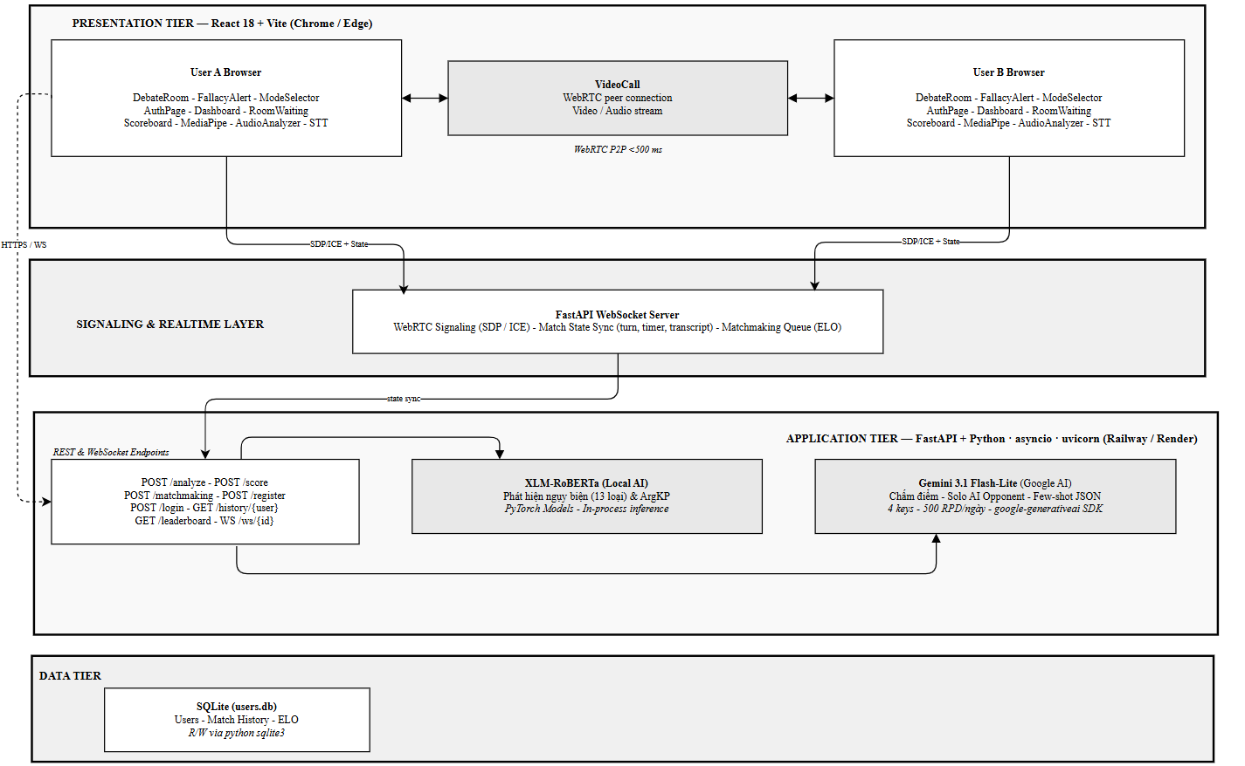
Tier | Technology | Language | Communication
Client (Browser) | React 19 + Vite, Clerk SDK, WebRTC, MediaPipe, Web Audio API | JavaScript/JSX | HTTP REST, WebSocket, WebRTC P2P
Backend Server | FastAPI, Uvicorn, PyTorch, Transformers, psycopg2, google-generativeai | Python 3.10+ | Exposes REST & WebSocket; calls Neon DB + Gemini API
Data (Neon) | PostgreSQL 15 (cloud) | SQL | TCP/SSL via psycopg2
AI/ML (in-process) | HuggingFace Transformers, PyTorch | Python | Called within FastAPI process
Gemini (external) | Google Gemini 2.5 Flash | HTTPS API | Called from Backend via SDK
Clerk (external) | Clerk.dev OAuth2 | HTTPS redirect | Called from Browser

Component: Frontend (React Web Application)
Responsibility: Provides the entire user interface and handles client-side media processing (WebRTC, Web Audio API, Web Speech API). Manages peer-to-peer WebRTC video connections and signaling via the FastAPI backend's WebSockets (not Firebase). Communicates with the backend using REST APIs for data fetching and WebSockets for real-time interactions, matchmaking, and chat.
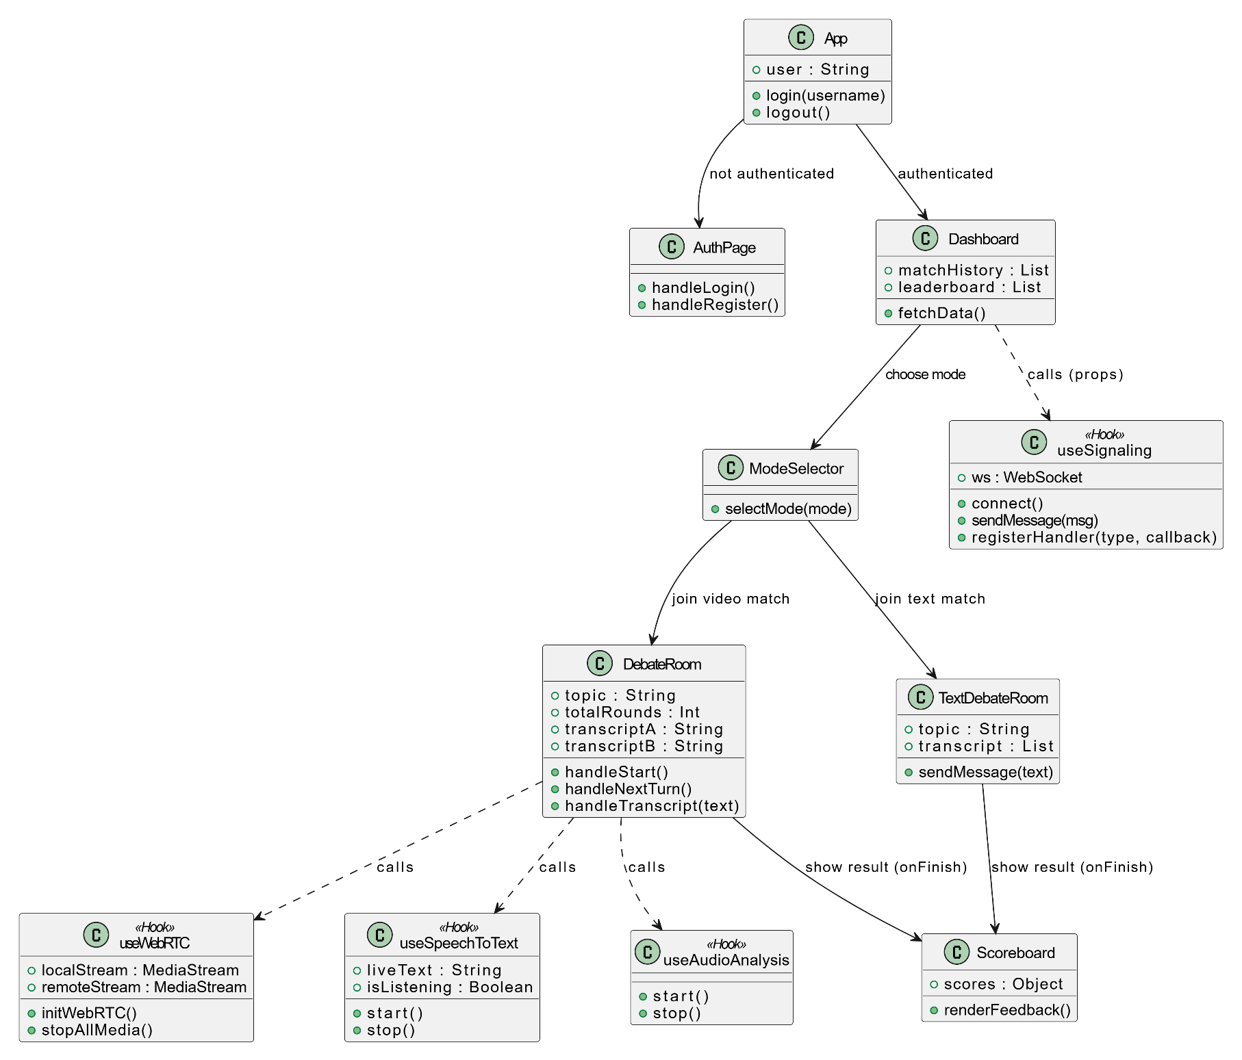

Key Sub-Components:
Sub-Component | Responsibility
HomePage | Landing page: feature overview, introductory content, and navigation to authentication.
AuthPage | Handles user registration and login forms; calls /token and /register REST endpoints.
Dashboard | Main hub: shows user stats, ELO level, friends list, and leaderboard. Connects to WebSocket to manage real-time global chat and matchmaking.
RoomWaiting | Loading screen that waits for the 'matched' event from the WebSocket before routing to a room.
DebateRoom | Core video debate component: manages WebRTC video/audio streams, turn timer, live STT transcript display, fallacy alerts, and triggers AI scoring.
TextDebateRoom | Core text debate component: manages real-time messaging, turn timer, and fallacy alerts without video/audio.
Scoreboard | Displays post-match analysis returned from the backend (Gemini API); shows detailed scores, strengths, and weaknesses for both players.
FallacyAlert | Overlay popup shown when a fallacy is detected; displays the fallacy name and identifies the speaker.
ModeSelector | Lets user choose debate mode: 1v1 real match or Solo AI practice

Key Classes/Hooks:
Class / Hook | Key Attributes & Methods
useWebRTC | Attributes: localStream, remoteStream, localVideoRef, remoteVideoRef, isCameraOn, isMicOn  Methods: initWebRTC(), toggleCamera(), toggleMic(), stopAllMedia()
useSignaling | Attributes: ws (WebSocket connection instance)  Methods: connect(), sendMessage(msg), registerHandler(type, callback)
useSpeechToText | Attributes: liveText (interim transcript), isListening  Methods: start(), stop() (fires onTranscript callback when speech is recognized)
useAudioAnalysis | Methods: start(), stop() (analyzes audio track for volume and pitch)
DebateRoom (component) | Attributes: topic, totalRounds, transcriptA, transcriptB, fallaciesA, fallaciesB  Methods: handleStart(), handleNextTurn(), handleTranscript(text), performFinalScoring()
TextDebateRoom (component) | Attributes: topic, timeLeft, messages, fallacies  Methods: handleSendMessage(), handleTimeUp(), performFinalScoring()

Component: Backend (FastAPI Application)
Responsibility: Manages all WebSocket connections, matchmaking (tier-based), spectating, and WebRTC signaling relay.
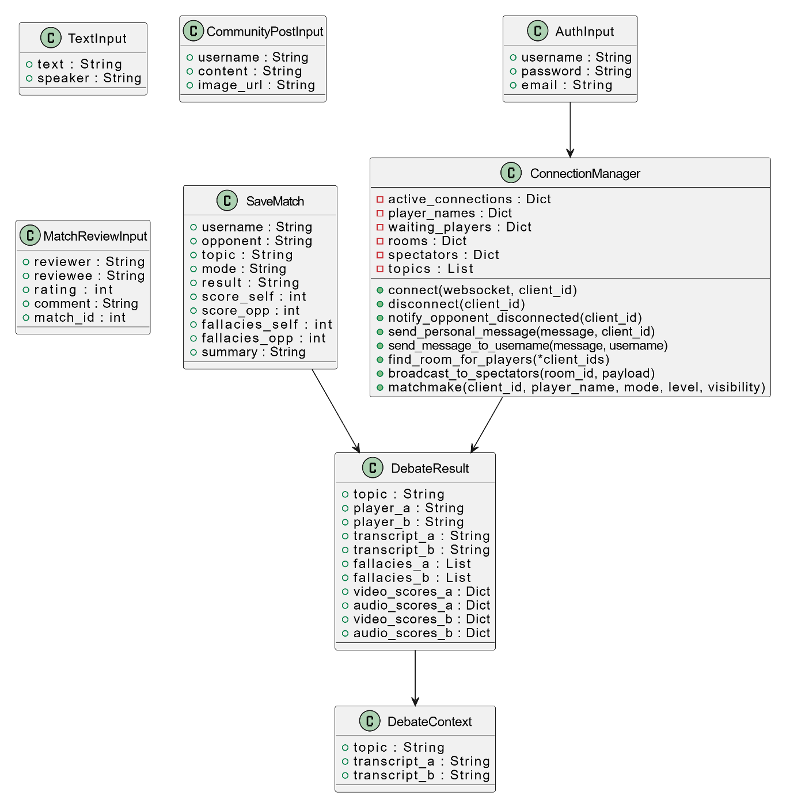

Key Classes/ Modules:
Class / Module | Key Attributes & Methods
ConnectionManager | Attributes: active_connections: Dict, player_names: Dict, waiting_players: Dict, rooms: Dict, spectators: Dict, topics: List. Methods: connect(websocket, client_id), disconnect(client_id), notify_opponent_disconnected(client_id), send_personal_message(message, client_id), send_message_to_username(message, username), find_room_for_players(*client_ids), broadcast_to_spectators(room_id, payload), matchmake(client_id, player_name, mode, level, visibility)
TextInput (Pydantic) | text: str, speaker: str
DebateResult (Pydantic) | topic: str, player_a: str, player_b: str, transcript_a: str, transcript_b: str, fallacies_a: List[str], fallacies_b: List[str], video_scores_a: dict, audio_scores_a: dict, video_scores_b: dict, audio_scores_b: dict
AuthInput (Pydantic) | username: str, password: str, email: str
SaveMatch (Pydantic) | username: str, opponent: str, topic: str, mode: str, result: str, score_self: int, score_opp: int, fallacies_self: int, fallacies_opp: int, summary: str
DebateContext (Pydantic) | topic: str, transcript_a: str, transcript_b: str
CommunityPostInput (Pydantic) | username: str, content: str, image_url: str
MatchReviewInput (Pydantic) | reviewer: str, reviewee: str, rating: int, comment: str, match_id: int

API Endpoints:
Method | Endpoint | Input | Behavior
GET | / | — | Health check; returns model_loaded status
POST | /register | AuthInput | Create user with SHA-256 hashed password and email in SQLite
POST | /login | AuthInput | Validate credentials; return username on success
POST | /analyze | TextInput | Run XLM-RoBERTa inference (or Gemini fallback); return fallacy label + confidence
POST | /score | DebateResult | Call Gemini to grade 4 criteria; return JSON scores + tips for both players
POST | /generate-response | DebateContext | Call Gemini to generate AI opponent turn response
POST | /hint | DebateContext | Call Gemini to generate short rebuttal hint (< 20 words)
POST | /save-match | SaveMatch | Store match result in match_history table
GET | /history/{username} | username | Return last 20 matches for user
GET | /leaderboard | — | Return top 10 users by wins + avg_score
GET | /random-topic | — | Return a trending debate topic (Gemini or fallback list)
WebSocket | /ws/{client_id} | JSON messages | Handle find_match, offer, answer, ice-candidate, transcript_update, fallacy_detected, debate_ended

Component: AI/ML Tier (Fallacy Detection Model)
Responsibility: Manages and serves the NLP models used for debate assistance. The tier loads two local fine-tuned XLM-RoBERTa models (Fallacy Detection and Argument Key Point - ArgKP) directly into the FastAPI process upon startup. It also integrates the Google Gemini API to act as a fallback and power the Solo AI debate bot and hint generator. Provides inference functions via the /analyze, /hint, and /generate-response endpoints.
Model Details:
Feature | Description
Base Model | xlm-roberta-base (HuggingFace Transformers)
Task | Multi-class text classification (13 fallacy categories)
Training Dataset | ~3,761 Vietnamese sentences translated from HuggingFace tasksource/logical-fallacy dataset
Training Platform | Kaggle Notebook (free T4 GPU)
Label Classes | ad hominem, ad populum, appeal to emotion, circular reasoning, equivocation, fallacy of credibility, fallacy of extension, fallacy of logic, fallacy of relevance, false causality, false dilemma, faulty generalization, intentional
Output for Non-Fallacy | Label 'fallacy of logic' (valid argument) with confidence ≥70% threshold
Expected Accuracy | F1 ≥ 0.75 across all 13 labels
Inference Latency | < 2 seconds/sentence on CPU (FastAPI server)
Model Storage | Fallacy Model: ./fallacy_model/kaiko_fallacy_model_final  ArgKP Model: ./fallacy_model/kaiko_argkp_model_final

Component: Data Tier (SQLite Database)
Responsibility: Stores user accounts, match history, ELO/level data, friends network, community posts, store items, events, mentorship records, and real-time chat messages.

Implementation Details:

- Database Engine: Migrated to PostgreSQL (from SQLite) to support complex relational queries and scalable data storage.
- Access Method: Accessed by the FastAPI Backend component via the psycopg2 Python library.
- Key Tables: users, match_history, friends, community_posts, events, chat_messages, mentorship, user_items.
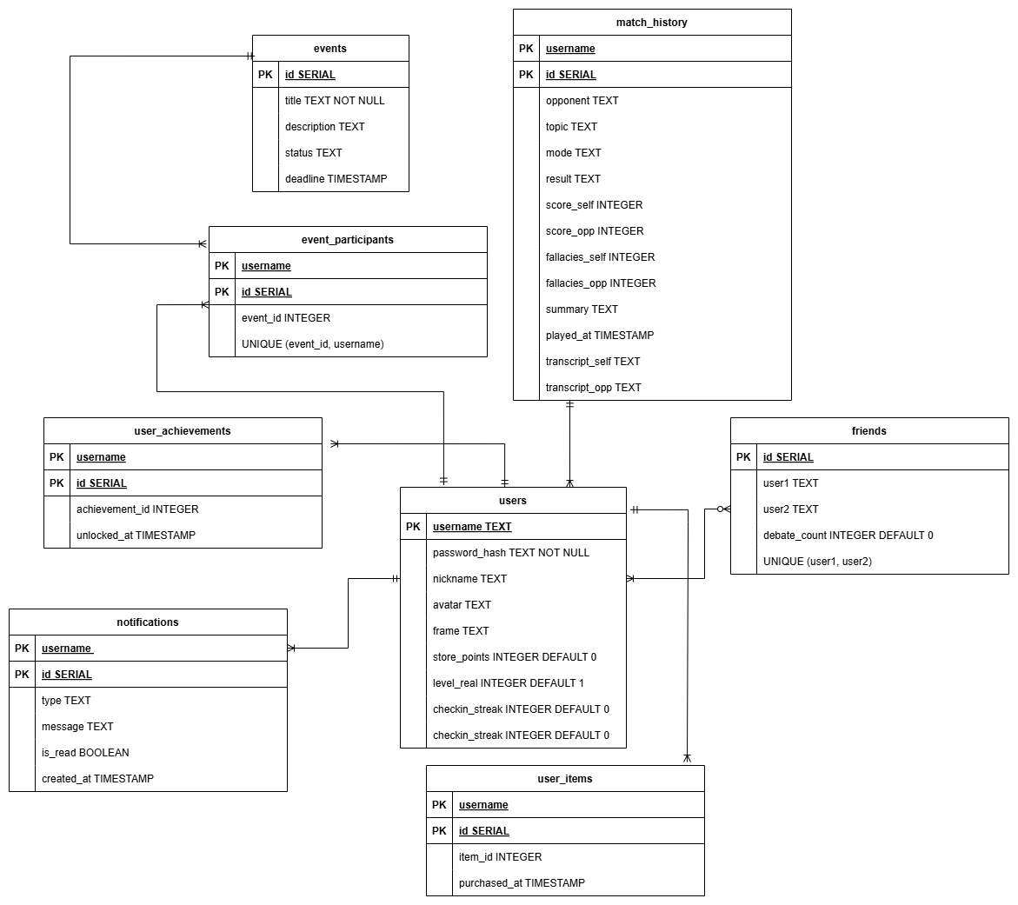

Table | Key Columns | Description
users | username (PK), password_hash, nickname, avatar, frame, store_points, level_real, checkin_streak | User account data
match_history | id (PK), username (FK), opponent, topic, mode, result, score_self/opp, fallacies_self/opp, transcript_self/opp, summary, played_at | Match records
friends | id (PK), user1 (FK), user2 (FK), debate_count | Bidirectional friendship
friend_requests | id, sender (FK), receiver (FK) | Pending friend requests
events | id (PK), title, description, status, event_type, reward, deadline | Community events
event_participants | id (PK), event_id (FK), username (FK), submission_text | Event participation
user_items | id (PK), username (FK), item_id, purchased_at | Store purchases
notifications | id (PK), username (FK), type, message, is_read, created_at | System notifications
user_achievements | id (PK), username (FK), achievement_id, unlocked_at | Unlocked achievements
mentorship | id (PK), master (FK), disciple (FK), start_date, is_graduated | Master-disciple relationship
community_posts | id (PK), username (FK), content, created_at, likes | Community forum posts
match_reviews | id (PK), match_id, reviewer (FK), reviewee (FK), rating, comment | Post-match peer reviews

Deployment

Overview
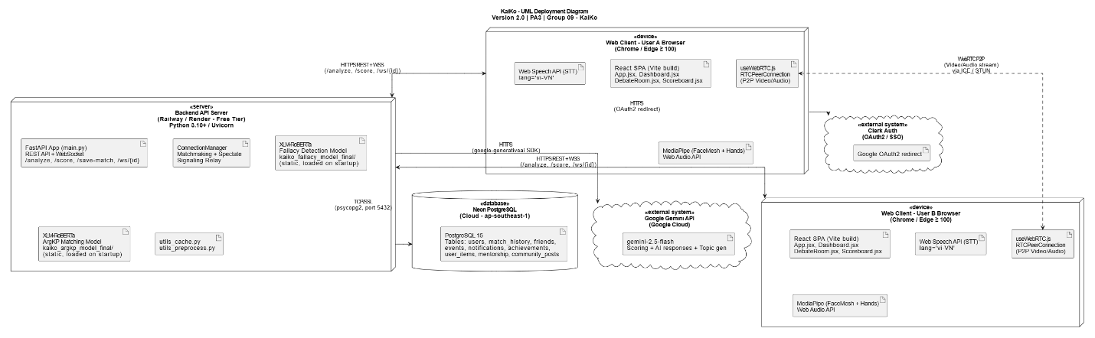

Node Descriptions
Node | Name | Technology | Role
1 | Web Client Browser | React 19 + Vite, Clerk SDK, WebRTC, MediaPipe JS, Web Audio API, Web Speech API | User interface; processes STT, audio/video analysis client-side; establishes P2P stream
2 | Backend API Server | Python 3.10+, FastAPI, Uvicorn, Transformers, PyTorch, psycopg2 | Business logic, ML inference, WebSocket relay, DB access, external API calls
3 | Neon PostgreSQL | PostgreSQL 15 (cloud, ap-southeast-1) | Persists users, match history, friends, events, notifications, chat, achievements
4 | Google Gemini API | gemini-2.5-flash (Google Cloud) | Generates topics, scores debates, provides AI opponent replies
5 | Clerk Auth | Clerk.dev (OAuth2/SSO) | Handles Google OAuth and local credential authentication

Communication Protocols
From → To | Protocol | Purpose
Browser → Backend | HTTPS REST | API calls (/analyze, /score, /save-match, ...)
Browser ↔ Backend | WSS WebSocket /ws/{id} | Matchmaking, signaling, chat, spectate, notifications
Browser ↔ Browser | WebRTC P2P (STUN/ICE) | Direct video/audio stream during debate
Backend → Neon DB | TCP/SSL (psycopg2, port 5432) | CRUD operations
Backend → Gemini | HTTPS (google-generativeai SDK) | LLM inference (scoring, AI opponent, topic generation)
Browser → Clerk | HTTPS (OAuth2 redirect) | Google SSO authentication

Implementation View
kaiko/ <- Project root
├── backend/ <- FastAPI server + ML models
│ ├── main.py <- Entry point: ~2,315 lines – all routes, WebSocket, PostgreSQL
│ ├── requirements.txt
│ ├── .env <- GEMINI_API_KEY, DATABASE_URL (not committed)
│ ├── utils_preprocess.py <- Transcript compression before Gemini calls
│ ├── utils_cache.py <- Semantic cache for Gemini API
│ ├── fallacy_model/ <- Trained models (not committed to Git)
│ │ ├── kaiko_fallacy_model_final/ <- XLM-RoBERTa Fallacy Detection checkpoint
│ │ └── kaiko_argkp_model_final/ <- XLM-RoBERTa ArgKP Matching checkpoint
│ └── venv/ <- Python virtual env (not committed)
├── frontend/
│ ├── index.html
│ ├── vite.config.js
│ ├── package.json
│ ├── public/assets/ <- Static assets (mascot, badges, icons, music)
│ └── src/
│ ├── main.jsx <- ReactDOM render
│ ├── App.jsx <- Root component, page-level routing
│ ├── hooks/
│ │ ├── useSignaling.js <- WebSocket matchmaking + event routing
│ │ ├── useWebRTC.js <- RTCPeerConnection management
│ │ ├── useSpeechToText.js <- Live STT via Web Speech API
│ │ └── useAudioAnalysis.js <- Decibel & pitch analysis via Web Audio API
│ └── components/
│ ├── HomePage.jsx
│ ├── AuthPage.jsx
│ ├── Dashboard.jsx <- Main hub (Stats, Leaderboard, Chat, Store...)
│ ├── ModeSelector.jsx <- Select 1v1, Text, or Solo AI
│ ├── RoomWaiting.jsx
│ ├── ReadyCheck.jsx
│ ├── DebateRoom.jsx <- Video debate room
│ ├── TextDebateRoom.jsx <- Text debate room
│ ├── Scoreboard.jsx
│ ├── FallacyAlert.jsx
│ ├── VideoGrid.jsx
│ ├── TranscriptPanel.jsx
│ ├── ControlsBar.jsx <- Extracted bottom controls
│ ├── OceanLobbyBg.jsx <- Animated ocean background
│ └── MusicPlayer.jsx <- BGM manager
├── ai_model/ <- ML training scripts and datasets
│ ├── train_phobert_kaggle.py <- Fallacy Detection training script
│ ├── train_phobert_argkp.py <- ArgKP training script
│ ├── translate_dataset.py <- Translate fallacy dataset EN->VI
│ ├── translate_argkp.py <- Translate ArgKP dataset EN->VI
│ ├── kaiko-train-fallacy.ipynb <- Kaggle notebook: fallacy model
│ ├── kaiko-train-argKP.ipynb <- Kaggle notebook: ArgKP model
│ └── data/
│ ├── logical_fallacy_vi.csv <- ~2,000 samples, 13 labels (Vietnamese)
│ ├── ArgKP_combined.csv <- IBM ArgKP original (~7.6 MB, English)
│ └── ArgKP_combined_vi.csv <- IBM ArgKP translated (~749 KB, Vietnamese)
├── README.md
└── .gitignore <- Excludes venv, .env, fallacy_model/

ML Model Training, Deployment and Evaluation

Deployment Strategy
Deployment Type: Static Deployment
- Both models (Fallacy Detection and ArgKP) are loaded once into RAM when the FastAPI server starts (@app.on_event('startup')).
- Models remain in memory for the lifetime of the server process.
- Every /analyze request runs inference against the already-loaded local XLM-RoBERTa model.
- No automatic retraining is triggered by user data.
Fallback & Cloud Integration Chain::
- If the local models are not found (e.g., fallacy_model/ directory is missing) → the system automatically uses Google Gemini API as a fallback detector.
- The Gemini API is also utilized to power the /hint (debate suggestions) and /generate-response (Solo AI bot) endpoints.
- A semantic cache (utils_cache.py) is implemented to avoid duplicate Gemini calls for similar inputs.
Model download link (Google Drive):
https://drive.google.com/drive/folders/1n_xn3Ms4VPRW3aoYshsSCEOfa2nS5IJi
Extract to backend/fallacy_model/ then restart uvicorn.

Retrain and Redeploy Pipeline
[Collect new labeled data (if available)]
|
[Translate to Vietnamese] (translate_dataset.py / translate_argkp.py)
|
[Run training notebook on Kaggle T4 GPU]
(kaiko-train-fallacy.ipynb / kaiko-train-argKP.ipynb)
|
[Evaluate model: Accuracy, F1, Precision, Recall]
| (if metrics meet acceptance threshold)
[Download model.zip from Kaggle Outputs]
|
[Extract to backend/fallacy_model/]
|
[Restart uvicorn server] -> New models loaded

Datasets

Dataset 1: Logical Fallacy Detection
File | ai_model/data/logical_fallacy_vi.csv
Size | ~1 MB
Samples | ~2,000 text samples
Source | HuggingFace: tasksource/logical-fallacy (English) → translated to Vietnamese via translate_dataset.py
Columns | text_vi (Vietnamese text), logical_fallacies (label)
Labels | 13 fallacy types
Characteristic | Imbalanced label distribution – handled with Weighted CrossEntropyLoss (class_weights inversely proportional to frequency)

Dataset 2: Argument Key-Point (ArgKP) Matching
Original file | ai_model/data/ArgKP_combined.csv (~7.6 MB, English)
Translated file | ai_model/data/ArgKP_combined_vi.csv (~749 KB, Vietnamese)
Source | HuggingFace: NLP-Debater-Project/IBM-Debater-ArgKP → translated via translate_argkp.py
Columns | argument_vi, key_point, label (0 = not relevant, 1 = relevant)
Task | Binary classification – is the argument relevant to the key-point/topic?

Evaluation Metrics and Acceptance Thresholds

Fallacy Detection Model
Metric | Description | Acceptance Threshold
Accuracy | Proportion of correct predictions on test set | ≥ 75%
Weighted F1 | F1 averaged by label frequency (better for imbalanced datasets) | ≥ 0.70

ArgKP Matching Model
Metric | Description | Acceptance Threshold
Accuracy | Proportion of correct predictions | ≥ 80%
F1 Score | Harmonic mean of Precision and Recall | ≥ 0.75
Precision | TP / (TP + FP) – avoids false positives (wrong fallacy flags) | ≥ 0.75
Recall | TP / (TP + FN) – avoids missing real fallacies | ≥ 0.75

Both models use metric_for_best_model="f1" when saving checkpoints. Weighted F1 is the primary metric because the dataset has imbalanced labels.

7.5 Evaluation Procedure
Platform | Kaggle Notebook (T4 x2 GPU)
Framework | HuggingFace Transformers + PyTorch
Data split | Train 80% | Test 20% (stratified split, random_state=42)
Evaluation frequency | Every epoch (eval_strategy="epoch")
Best model saved by | Highest F1 on evaluation set
Mixed precision | fp16=True – approx. 2x speed-up on GPU

Training Hyperparameters
Parameter | Value
Learning rate | 2e-5
Batch size (train / eval) | 32 / 64
Epochs | 3
Weight decay | 0.1
Warmup ratio | 10%
Max sequence length | 256 tokens
Imbalanced label handling | Weighted CrossEntropyLoss with class_weights

Initial Evaluation Results
Model | Metric | Expected Value | Notes
Fallacy Detection | Accuracy | ~17.75% | Model underfits due to 13 complex classes & limited translated data. System routes to Gemini API for high accuracy.
Fallacy Detection | Weighted F1 | ~0.12 | Further data augmentation and human annotation are required.
ArgKP Matching | Accuracy | ~74.12% | Close to the 80% threshold. Usable for basic relevance checking.
ArgKP Matching | F1 | ~0.34 | High precision but low recall impacts the F1 score.
ArgKP Matching | Precision | ~0.75 | Strong point: When it flags an argument as relevant, it is usually correct (avoids false positives).
ArgKP Matching | Recall | ~0.22 | Misses many relevant arguments. Fallback to Gemini handles missed context.

UI Design (Main Screen)

Screen 1: Landing Page (HomePage.jsx)
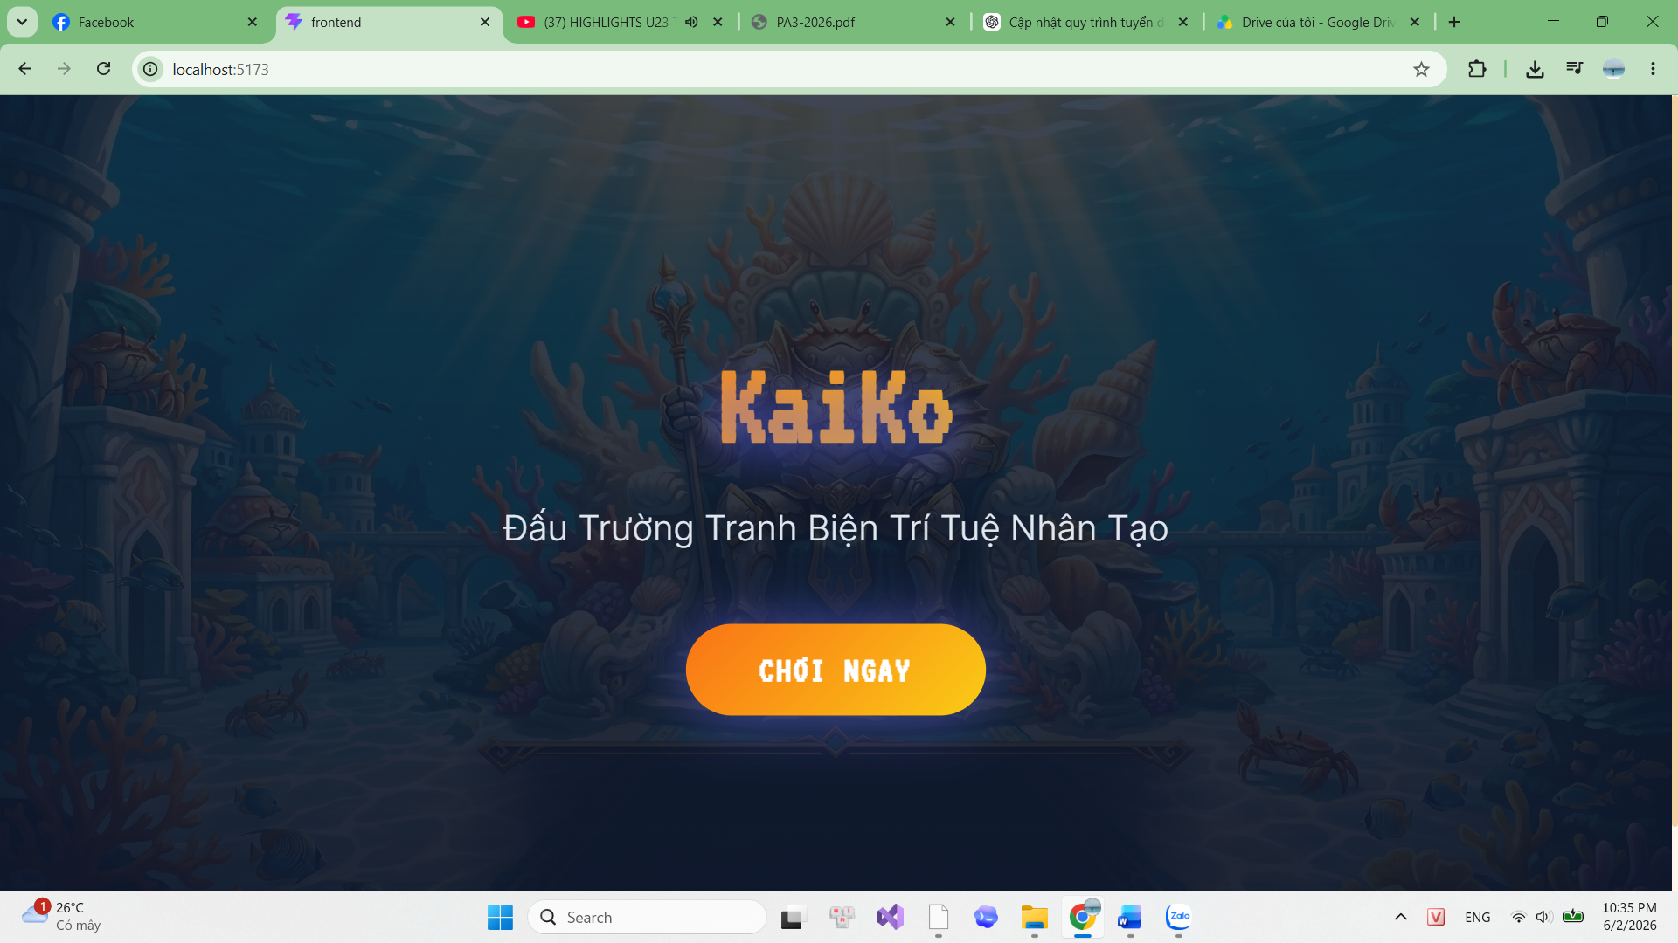
- Landing Page (Immersive Entry Point)
- Purpose: Acts as the first point of contact for users visiting the KaiKo platform. It is engineered to create a strong visual impact, communicate the application's core value proposition, and seamlessly drive users toward authentication or immediate gameplay.
- Key UI Components:
- Immersive Thematic Background: Features a highly detailed, full-viewport underwater environment (the "Crab Kingdom") that establishes the game's unique identity. The layout deliberately eliminates vertical scrolling to maintain a cinematic, unbroken visual experience.
- Hero Section (Branding & Typography): The prominent "KaiKo" logo is stylized with a retro-pixelated aesthetic and a soft glowing effect to immediately draw attention. The subtitle "Đấu Trường Tranh Biện Trí Tuệ Nhân Tạo" (Artificial Intelligence Debate Arena) concisely communicates the platform's core premise.
- Call-to-Action (CTA) Area: A highly visible, centrally aligned "CHƠI NGAY" (Play Now) button featuring a vibrant yellow-orange gradient. This serves as the primary gateway, directing users straight into the authentication flow or the game lobby.
- Design Language (UI/UX): Employs an immersive, edge-to-edge design philosophy. Heavy UI containers and dark overlays have been minimized to maximize background visibility. The combination of clean typography, subtle glow effects, and vibrant contrasting colors creates a premium, engaging aesthetic that wows the user at first glance.
Screen 2: Auth Page – Login/Register (AuthPage.jsx)
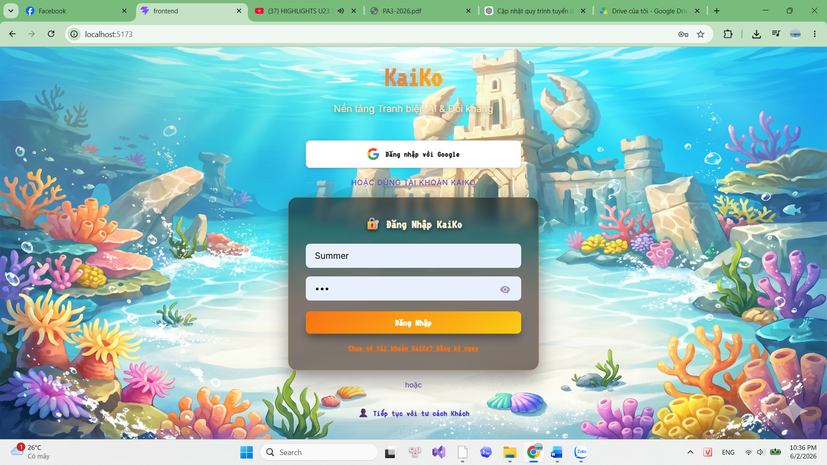

- Authentication & Login Interface
- Purpose: Handles user identity verification by offering multiple pathways for authentication. It is designed to accommodate different user preferences—ranging from OAuth and traditional credentials to guest access—before granting entry into the main application ecosystem.
- Key UI Components:
  - Vibrant Thematic Background: Features a bright, highly detailed underwater coral reef scene with a sandcastle. This maintains thematic consistency with the overarching "Crab Kingdom" aesthetic while providing a welcoming, lively atmosphere for users.
  - Glassmorphism Authentication Form: The core login interface utilizes a sleek glassmorphism effect (a semi-transparent dark container with background blur). This modern design choice ensures that input fields and text remain highly legible without completely blocking the beautiful background art.
  - Multi-modal Login Options:
    - OAuth Integration: A prominent "Đăng nhập với Google" (Login with Google) button enables frictionless Single Sign-On (SSO) for quick access.
    - Traditional Credentials: A structured form for username and password entry, incorporating UX best practices such as a password visibility toggle (eye icon).
    - Guest Access: A subtle "Tiếp tục với tư cách Khách" (Continue as Guest) option at the bottom provides a low-barrier entry point for users wanting to experience the platform without committing to registration.
  - Design Language (UI/UX): The interface masterfully balances aesthetics with usability. The vibrant yellow-orange gradient on the primary "Đăng Nhập" (Login) button draws the eye, while clear visual dividers and distinct typography seamlessly separate the SSO, traditional, and guest login flows.

Screen 3: Main Lobby/Dashboard (Dashboard.jsx)
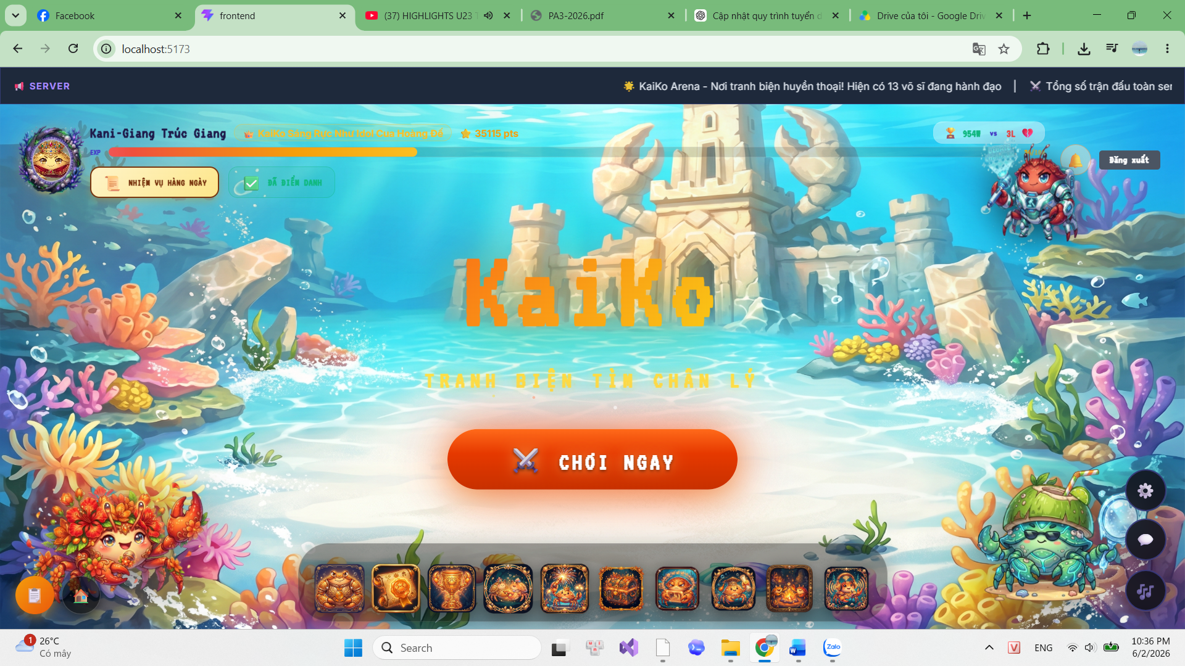
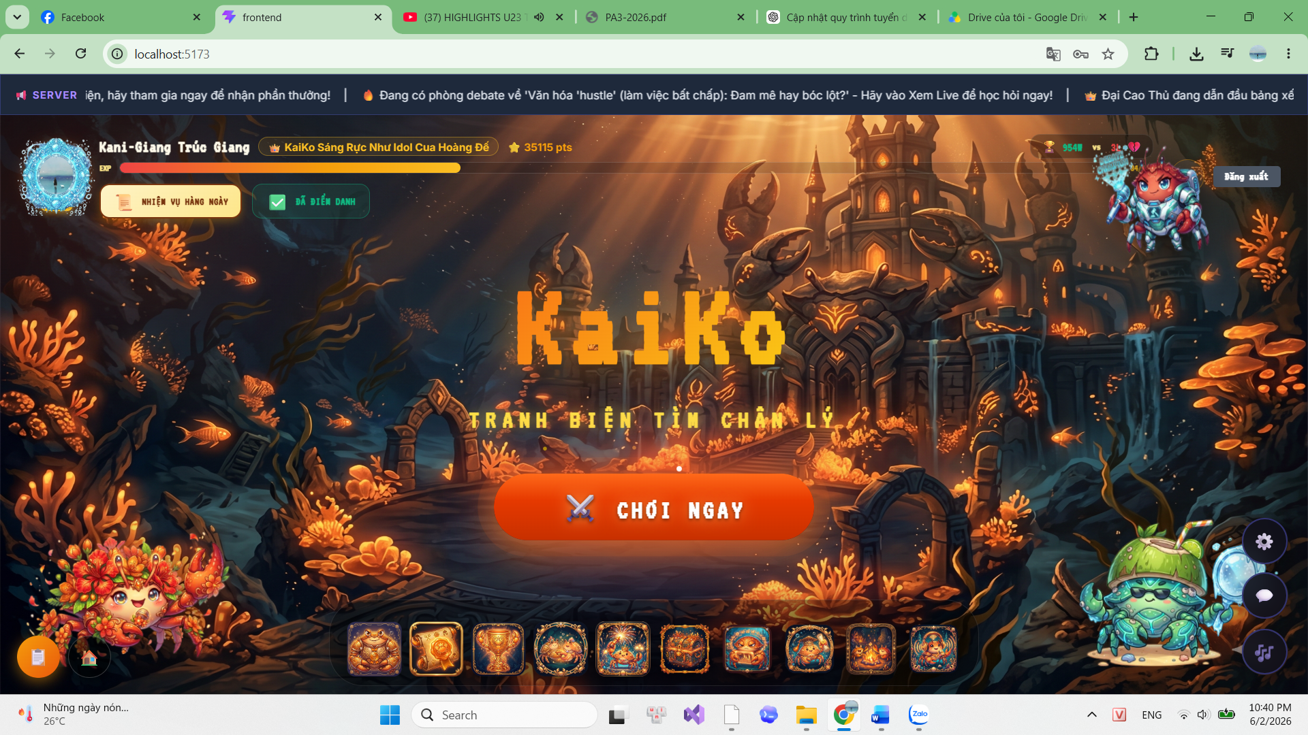

- Game Lobby & Central Hub
- Purpose: Serves as the central operational hub of the application post-authentication. It acts as a personalized workspace, granting users seamless access to all core functionalities (matchmaking, store, leaderboard, social features) while prominently displaying real-time user statistics and server announcements.
- Key UI Components:
  - Dynamic Thematic Background (Bright/Dark Mode): The interface features a highly immersive, full-viewport ocean environment that dynamically switches between two distinct themes. Users can toggle between Bright Mode (a vibrant, daylight sandcastle scene) and Dark Mode (a mysterious, glowing deep-sea temple) via the Settings button. This provides deep personalization and ensures visual comfort in different lighting conditions.
  - Comprehensive Top Bar & Server Ticker: The header displays real-time user telemetry, including the avatar, custom equipped title, level progress bar, and accumulated store points. A scrolling marquee (ticker) sits at the very top to broadcast live server announcements. Quick-action buttons for "Daily Quests" and "Check-in" are also easily accessible.
  - Central Call-to-Action (CTA): The focal point remains the prominent "CHƠI NGAY" (Play Now) button, enhanced with a crossed-swords icon. This acts as the primary trigger to launch the matchmaking queue or enter specific game modes.
  - macOS-Style Navigation Dock: A cleanly designed, floating dock at the bottom of the screen houses icons for secondary modules (e.g., Leaderboard, Match History, Store, User Profile). This architectural UI choice consolidates complex navigation into a single, accessible area without cluttering the main visual space.
  - Floating Action Buttons (FABs): Positioned on the right edge, these circular buttons provide immediate access to the Global Chat, Background Music controls, and System Settings (where the Bright/Dark mode toggle resides).

Screen 4: Main Lobby/Dashboard (Dashboard.jsx)
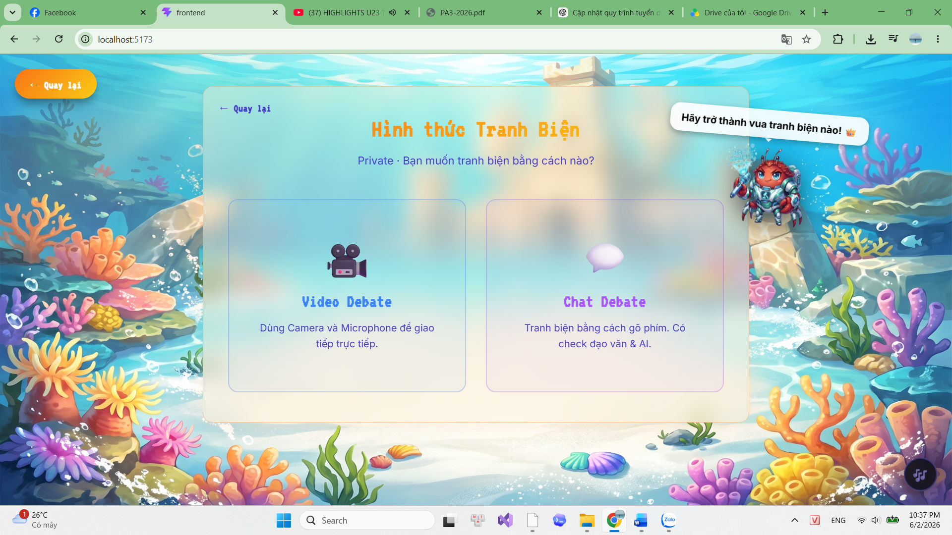
- Mode Selection Interface
- Purpose: Acts as a functional crossroad where users define the parameters of their upcoming match. It bridges the gap between the main lobby and the actual debate arena by allowing users to choose their preferred communication medium before entering the matchmaking queue.
- Key UI Components:
  - Glassmorphism Container: The main selection options are housed within a large, frosted-glass container. This architectural UI choice ensures excellent text readability while maintaining a visual connection to the vibrant underwater background.
  - Interactive Selection Cards: The interface presents two large, distinct, interactive cards to select the debate format:
    - Video Debate: Highlighted with a camera icon, directing users to the WebRTC-powered arena that utilizes their camera and microphone for real-time communication.
    - Chat Debate: Highlighted with a chat bubble icon, offering a text-based alternative (WebSocket-driven) that includes built-in automated checks (e.g., AI generation and plagiarism detection).
  - Navigation & Gamification: A prominent "Quay lại" (Back) button ensures smooth navigation back to the dashboard. Additionally, a dynamic mascot character featuring a motivational speech bubble ("Hãy trở thành vua tranh biện nào!") injects a gamified and welcoming touch to the user experience.
  - Design Language (UI/UX): The screen utilizes a minimalist, highly intuitive dual-choice layout. Soft borders and clear visual hierarchy guarantee a frictionless transition into the core game loop.

Screen 4: Video DebateRoom (DebateRoom.jsx)
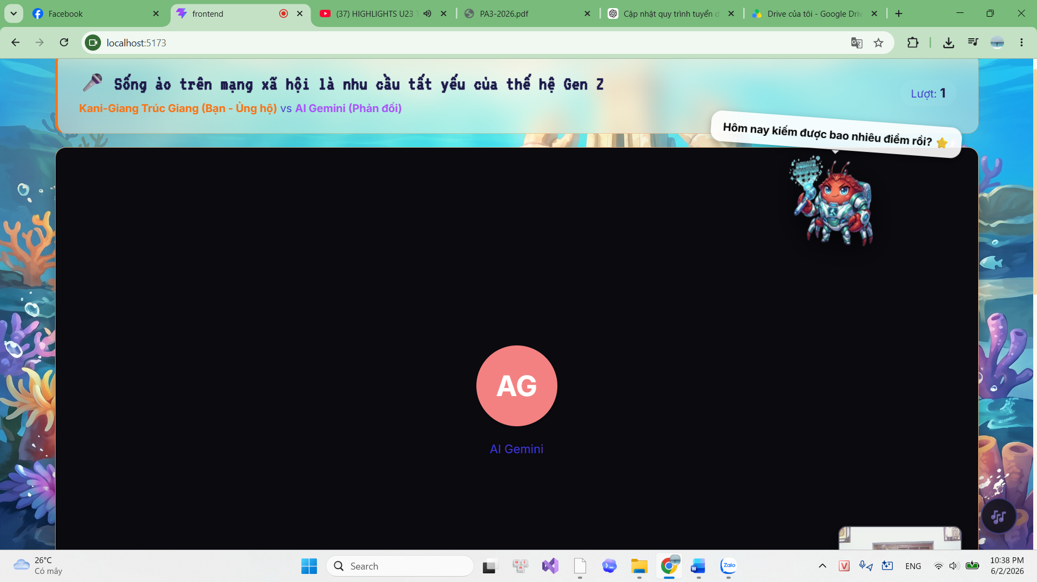

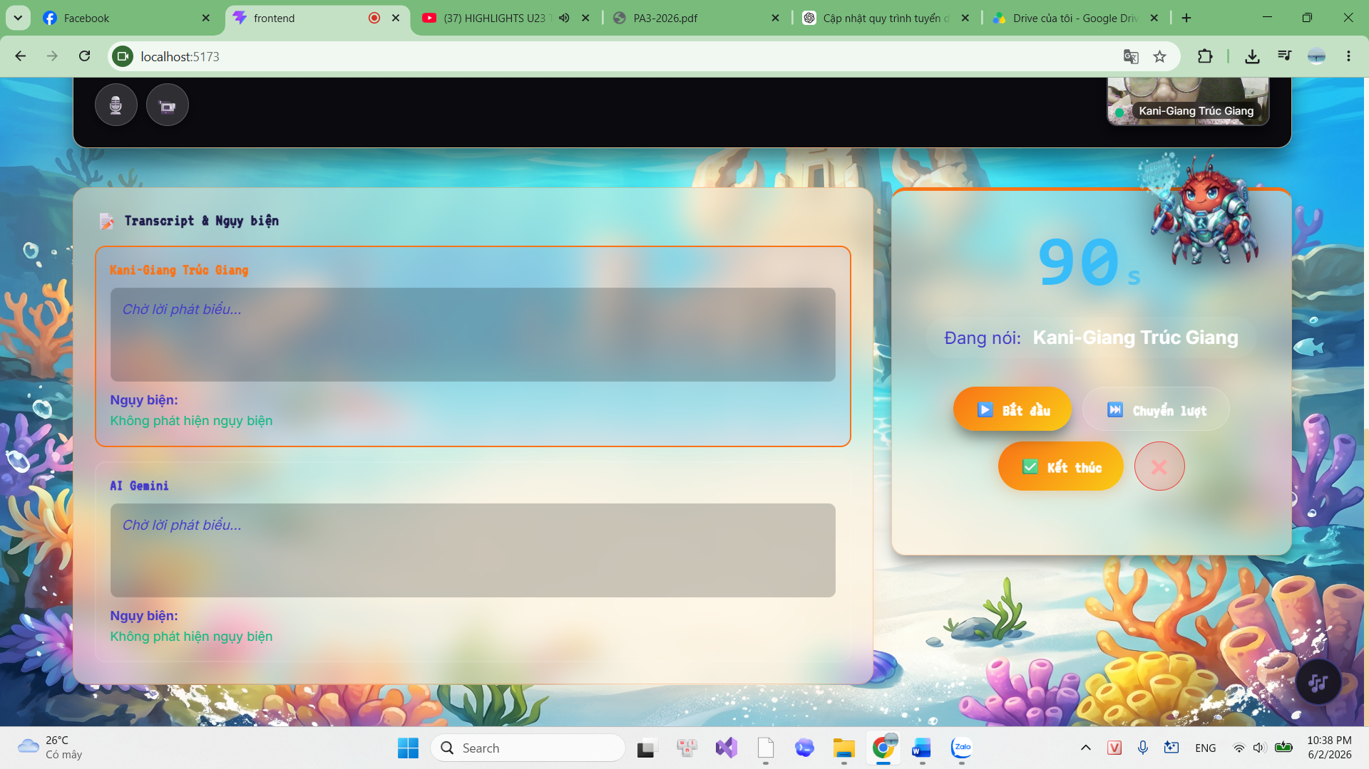
- Core Real-time Debate Arena
- Purpose: This is the core operational environment of the application. It orchestrates real-time human-to-human (via WebRTC) or human-to-AI audio/video communication, seamlessly synchronized with automated transcription and live logical fallacy analysis.
- Key UI Components:
  - Header & Match Context: A fixed top bar clearly displays the active debate topic, the specific roles assigned to each player (e.g., "Support" vs "Oppose"), and the current turn/round number. A dynamic mascot sits nearby to provide contextual commentary.
  - WebRTC Video Grid: The primary visual area features a dominant central viewport for the opponent's video stream (or an AI avatar avatar in Solo mode). The user's local camera feed is displayed as a Picture-in-Picture (PiP) overlay in the bottom corner. Floating media controls allow users to quickly toggle their microphone and camera.
  - Live Transcript & Fallacy Panel (Bottom Left): Housed in a large glassmorphism container, this panel dynamically captures and displays Speech-to-Text (STT) transcripts for both players in real-time. Crucially, a dedicated sub-section beneath each transcript displays immediate AI-driven Fallacy Alerts (e.g., showing "Không phát hiện ngụy biện" when the logic is sound).
  - Debate Controller & Timer (Bottom Right): This critical control panel manages the complex state machine of the debate. It features a prominent, large-font countdown timer (e.g., 90s) and explicitly indicates the active speaker. Color-coded action buttons ("Bắt đầu" / Start, "Chuyển lượt" / Next Turn, "Kết thúc" / End) enforce game rules and ensure intuitive interaction during high-pressure moments.
  - Design Language (UI/UX): The spatial layout is optimized for multitasking. Heavy frosted-glass effects (glassmorphism) are utilized to overlay dense textual information and interactive controls onto the vibrant background without sacrificing readability. The color coding of action buttons minimizes cognitive load, allowing users to focus entirely on their arguments.

Screen 5: Post-Match Analysis & Scoreboard (Scoreboard.jsx)
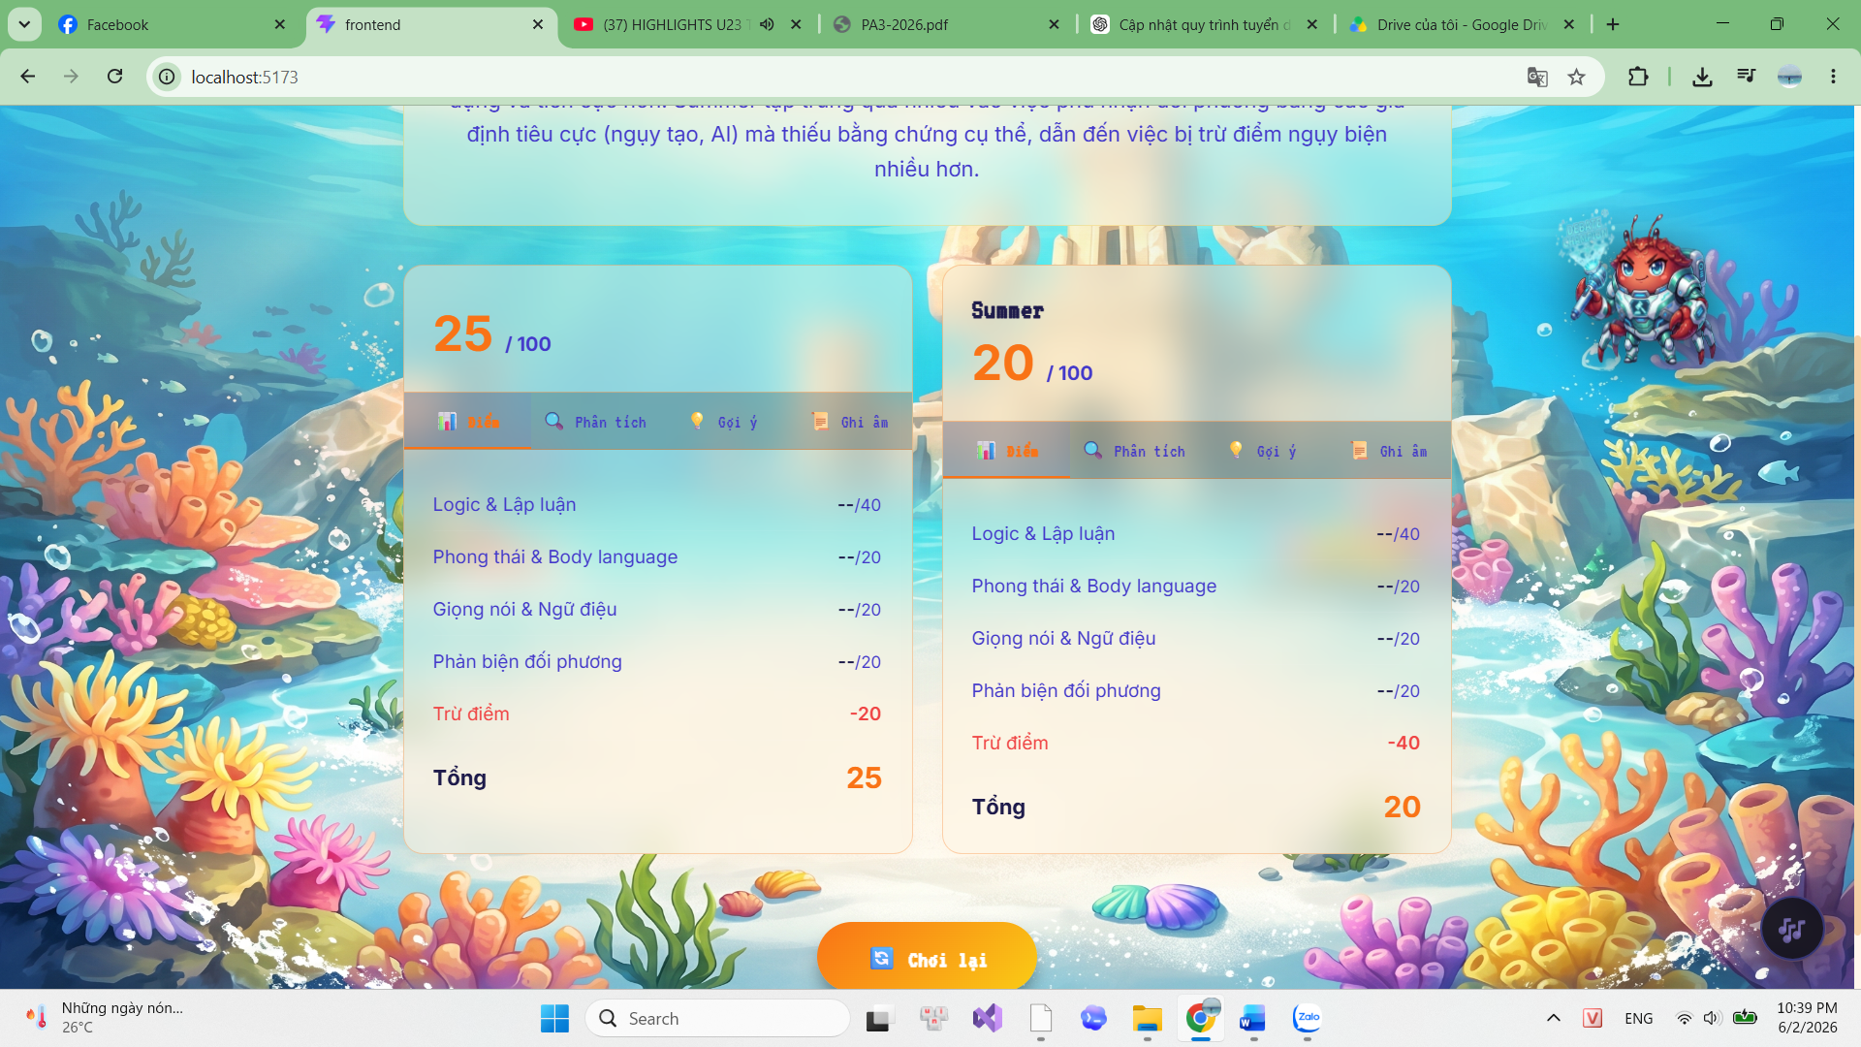
- AI-Driven Feedback Interface
- Purpose: Delivers comprehensive, AI-generated feedback immediately after a debate concludes. It transforms raw match transcripts and detected fallacies into structured, actionable insights, helping users understand their performance and iteratively improve their debate skills.
- Key UI Components:
  - Overall Feedback Banner (Top): Displays a high-level summary and constructive critique of the overall debate strategies employed by both sides, generated dynamically by the Gemini API.
  - Dual Player Scorecards (Glassmorphism): The interface symmetrically presents two expansive glassmorphism cards detailing the performance of both the local player and the opponent. This side-by-side layout facilitates easy comparative analysis while maintaining the aesthetic integrity of the underwater theme.
  - Detailed Tabbed Navigation: Each player card features an internal tabbed navigation system ("Điểm" / Score, "Phân tích" / Analysis, "Gợi ý" / Suggestions, "Ghi âm" / Recording). This architectural choice organizes dense, complex analytical data into digestible chunks, preventing cognitive overload.
  - Granular Scoring Breakdown: The default "Score" tab visually decomposes the final score (e.g., out of 100) into specific debate metrics: Logic & Argumentation, Demeanor & Body Language, Voice & Intonation, and Rebuttal Skills. Crucially, it highlights penalty points ("Trừ điểm" / Deductions) incurred strictly due to logical fallacies detected during the live match.
  - Design Language (UI/UX): The interface leverages a highly structured layout to present complex, multi-dimensional AI data. The combination of distinct tabs, clear typographic hierarchy, and the prominent "Chơi lại" (Play Again) CTA button ensures that the deep analytical feedback is highly accessible and actionable for the user.

