

|  |
| --- |
| **FPT UNIVERSITY** |
| **Capstone Project Document** |
| Capstone Project Management |
|  |
| |  |  |  | | --- | --- | --- | | **<Group Name>** | | | | **Group Members** | Tran Dai Giang | SE03127 | | Pham Tien Long | SE03552 | | Nguyen Minh Hieu | SE03810 | | Do Ngoc Thinh | SE04178 | | **Supervisor** | Tran Dinh Tri | | | **Capstone Project code** |  | | |
|  |

**TABLE OF CONTENTS**

**CHAPTER 1 : PROJECT INTRODUCTION** 4

1.1 **Project Information** 5

1.2 **Purpose** 5

1.3 **Acronyms and Definitions** 5

1.4 **Project Member** 7

1.5 **Background** 7

1.6 **Literature review** 8

1.7 **Proposal** 8

1.7.1 The Idea 8

1.7.2 Objectives 9

1.7.3 Brief description about Website 9

1.8 **Benefit from project** 10

1.8.1 For our group 10

**1.8.2** **For community** 10

1.9 **Critical assumption and constraints** 10

1.10 **Potential risks** 11

**CHAPTER 2: PROJECT MANAGEMENT PLAN** 13

2.1 **Problem Definition** 13

2.1.1 Name of this capstone project 13

2.1.2 Problem abstract 14

2.1.3 Project overview 14

2.2 **Project organization** 15

2.2.1 Software Process Model 15

2.2.2 Role and responsibilities 16

2.2.3 Tools and Techniques 16

2.3 Project management plan 17

2.3.1 Task sheet 17

2.3.2 Convention rules 17

**CHAPTER 3: SYSTEM REQUIREMENTS SPECIFICATIONS (SRS)** 19

3.1 **System Requirement Specification (Specific Requirements)** 19

3.1.1 External Interface Requirements 19

3.1.2 System Features 19

3.1.3 Use-case Specification 31

3.1.4 Other Requirements 108

3.1.5 Software System Attributes or Non-functional Requirements 112

3.2 **Other material (if any)** 113

**CHAPTER 4: SOFTWARE DESIGN DESCRIPTION (SDD)** 113

4.1 **Design Overview** 113

4.2 **System Architectural Design** 114

4.2.1 MVC Definition 114

4.2.2 Components 115

4.2.3 Advantages and Disadvantages 115

4.3 **Detail Design** 117

4.3.1 CRC Cards (Class-Responsibility-Collaborators) 117

4.3.2 Class Diagram 117

4.3.3 Sequence Diagram 117

4.3.4 Entity Relationship Diagram 117

4.3.5 Database Design 118

4.4 **Other material (if any)** 118

**CHAPTER 5: SOFTWARE TESTING DESCRIPTION (STD)** 119

5.1 **Introduction** 119

5.1.1 Overview 119

5.1.2 Test Approach 119

5.2 **Test Plan** 120

5.2.1 Stage of testing 120

5.2.2 Features not to be tested 122

5.2.3 Testing Tools and Environment 122

5.3 **Test Cases** 122

5.4 **Checklists** 122

5.4.1 Checklist of Validation 122

5.4.2 Submission Checklist 122

5.5 **Other material (if any) (including appendix A)** 122

**CHAPTER 6: SOFTWARE USER’S MANUAL** 122

6.1 **Installation Guide** 122

6.2 **User’s Guide** 122

6.3 **Other [Optional]** 122

|  |
| --- |
| - Hanoi, 01/2018 - |

# **CHAPTER 1 : PROJECT INTRODUCTION**

## **Project Information**

Project name: Software Project Management of FPT University’s Capstone Project

Project code: SPMFU

Project type: Website application

Timeline: January 2018 – April 2018

## **Purpose**

Our project team will build a web-based application for managing a software project as FPT University’s Capstone Project. In this document, we will describe the overview of some existing systems, the initial idea for our project, a brief description about our expected system and some potential risks, critical assumptions, constrains. Moreover, this document also shows opportunities that it offers to users.

## **Acronyms and Definitions**

|  |  |
| --- | --- |
| **Acronym & Abbreviation** | **Definition** |
| SPMFU | Software Project Management of FPT University’s Capstone Project |
| FU | FPT University. |
| Member | Everyone who has account and accessed into Capstone Project Management Services. |
| Supervisor | Everyone who has account and accession Capstone Project Management Services with role is a supervisor. |
| Administrator | A person who has the highest permission level and is responsible for managing the website. |
| Q&A | Question and Answer. |

## **Project Member**

|  |  |  |  |
| --- | --- | --- | --- |
| **Full name** | **Phone** | **E-mail** | **Role in Group** |
| Tran Dinh Tri | 0913.091.952 | TriTD@fe.fpt.vn | Supervisor |
| Tran Dai Giang | 0949.540.4.91 | GiangTDSE03127@fpt.edu.vn | Team Leader |
| Pham Tien Long | 01697.894.995 | LongPTSE03552@fpt.edu.vn | Member |
| Do Ngoc Thinh | 0905.252.588 | ThinhDNSE04178@fpt.edu.vn | Member |
| Nguyen Minh Hieu | 0985.485.767 | HieuNMSE03810@fpt.edu.vn | Member |

## **Background**

As we can see, FPT university doesn't have an independent system to manage the working progress of Capstone Project for each group. FAP and CMS are 2 seperated systems and they cause the inconsistency in management. FAP system was to manage the information of each Capstone Project group and the schedule for meeting, while CMS was to store and to submit the documents. With the fact, we have developed a website to address this issue so that users can search for information, manage the schedule and store the documents in a system. The system will solve the problems that cause the inconsistency in management nowadays.

## **Literature review**

In the area of developing an online Capstone Project management, there is no website in Vietnam that does that. However, in the world there are many support website in the field of working management. For example: <https://www.trello.com>. Trello is a web-based project management application that has a variety of work and personal uses including real estate management, software project management, school bulletin boards, lesson planning, and law office case management. Our idea is to bring the working management model and customize it to fit with Capstone Project management system. Users, which are students can post tasks, bugs, documents, check the schedule of work. Supervisors can also check the work schedule of themselves to make it easier for booking offline meetings and track the work progress.

➢ Advantages:

● Users easy to use

● The consistency of management.

● Users don't have to use many site for work.

➢ Disadvantages:

● The storage of server data

● Only focus on Capstone project management

## **Proposal**

### The Idea

Based on the needs of a system that can manage capstone projects and carrying out those for students and supervisors.

### Objectives

This project is the Capstone project in FPT University studying program. Our project will build a web-based application to managing FPT University’s Capstone Project for Software Engineering students.

Firstly, all team member have to take responsibility for this project. We must complete all tasks and requirements from teacher and school. We will learn how to develop a project, how to manage a project, how to communicate better between members, how to control timeline, how to analyze and control risks, how to perform teamwork effectively after this project is finished. Moreover, we can have experience in Web design, web application, software testing, data warehouse architecture. This project is necessary for us to improve skills, knowledge which we learnt in FPTU. This is also an opportunity for us to prove our abilities with recruiters.

Secondly, we want to help FPTU to have a suitable system to manage capstone projects every semeters.

### Brief description about Website

This website uses C# and MySQL.

There will be 5 main roles:

* **Administrator**: Who have the highest power, responsibility for controlling and operating system.
* **Academic staff**: who have resonsibility for controlling students and supervisors all the time doing capstone project.
* **Team supervisor**: who take responsilbility for controlling, tracking processes and works of their own students.
* **Team leader**: who take responsibility for planning and making their capstone project done.
* **Team member**: who take responsibility for making their capstone project done.

## **Benefit from project**

### For our group

After developing and implementing this project, our group will get some benefits:

➢ Have more experiences of software project management how to manage plan, time, member and risk.

➢ Have more knowledge and skill about Ruby on Rails .

➢ Have more experiences in how to communicate with team members and teamwork have more effective.

### **For community**

Just need to have a device that connects to the internet and any web browser and personal information user can:

➢ Easy for users to control and manage the work

➢ Easy to book the schedule for meeting

➢ Users, which include students and supervisor will work on only 1 site that contains all things about the Capstone Project.

## **Critical assumption and constraints**

* Critical assumption:

Human resources: Assume that all members in team have a good healthy to do their tasks.

* CONSTRAINTS:
* Time and deadline: We must complete tasks on time. We work on 14 weeks, each member works 5 hours/day and 5 days/week. We do not have more time for us to complete developing and deliver application to teachers. Besides, we must submit report documents to teacher before deadline, so teacher can have a final review.
* Quality: The products must run well when users perform main functions in Google Chrome 63 and Firefox 57 or higher and website load with performance less than 3 seconds.
* Process: We have to follow the software processing was learned in FPT University
* Human resources: There are 4 members in our team, each member must study atleast 1 subject at school.

## **Potential risks**

After researching, we find out some problems that we may encounter:

|  |  |  |  |  |
| --- | --- | --- | --- | --- |
| **No** | **Description** | **Avoidance plan** | **Contingency plan** | **Impact** |
| **R1** | Illness or absence of team members | Member has to notice to the team about absence period and the plan of how to keep up with the work process. | Ensure that the absence of a member will not affect others and always have plans to deal with this problem | High |
| **R2** | Conflicts between team members | Clear the role and responsibility. | Manager must find cause the conflict and solve them. Team building every week and have meeting if member have conflicts. | Medium |
| **R3** | Business problem | Any ideas are welcome but members have to discuss with others and always focus on the reality and possibility. | Make sure the business logic of any ideas is carefully analyzed. | High |
| **R4** | Equipments of member are broken or lost | Member must be careful with their equipment | Use another equipment until fix or buy new equipment. | Medium |
| **R5** | Change management overload | A large number of change requests dramatically raises the complexity of the project and distracts key resources. | If there is a “must be changed” requirement, all team members must join the meeting to decide whether it should be implemented or not. | High |
| **R6** | Project team misunderstand requirements | When the project team a gap misinterprets requirements develops between expectations, requirements and work packages. | Make sure any miscommunication has to be resolved. | Medium |
| **R7** | New technology | Choosing technology based on member’s qualification. All team members must nurture by self-study. | When someone chooses a new technology, he/she has to explain to all team members about the decision. | High |

# 

# **CHAPTER 2: PROJECT MANAGEMENT PLAN**



## **Problem Definition**

### Name of this capstone project

FU Capstone Project Management will help academic staffs, students of FPT university and supervisors manage team member of team, as long as track down the works, , devide tasks, submit reports of their capstone project that they are doing.

### Problem abstract

As we can see, FPT university doesn't have an independent system to manage the working progress of Capstone Project for each group. FAP and CMS are 2 seperated systems and they cause the inconsistency in management. FAP system was to manage the information of each Capstone Project group and the schedule for meeting, while CMS was to store and to submit the documents. With the fact, we have developed a website to address this issue so that users can search for information, manage the schedule and store the documents in a system. The system will solve the problems that cause the inconsistency in management nowadays.

### Project overview

#### Development environment

##### **Hardware requirement**

* Personal computers for developing with the recommended configuration: 4GB of Ram DDR3L, 100GB of hard disk SSD, Processor: 2.4GHz Intel Core i5
* A sever computers for testing with the Recommended configuration: 4GB of Ram DDR3L, 128 GB of hard disk SSD, Processor: 2.4GHz Intel Core i5

##### **Software requirement**

* + - * + Operating system: Windows 10
        + Web server: Apache 2.4.27
        + IDE: phpStorm 2017.3.4
        + DBMS: MySQL10.1.26-MariaDB
        + Version control: Github
        + Plan control: Microsoft Project Plan 2016
        + Design Graphic: Adobe Photoshop 6
        + Contact tool: Skype, Facebook
        + Architecture design: Draw.io v8.3.5

## **Project organization**

### Software Process Model

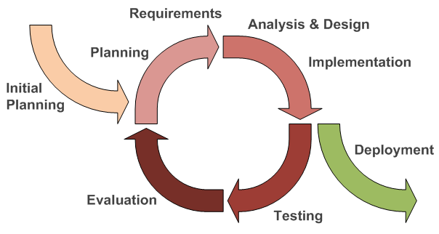

**Figure 1: Iterative and Incremental Software Process Model**

The Iterative and Incremental Software Process Model is a method of software development that is modeled around a gradual increase in feature additions and a cyclical release and upgrade pattern. In incremental development, different parts of the system are developed at various times or rates are integrated based on their completion. In iterative development, Classy team can revisit parts of the system in order to revise and improve them. Tester’s feedback is consulted to modify the targets for successive deliverables.

### Role and responsibilities

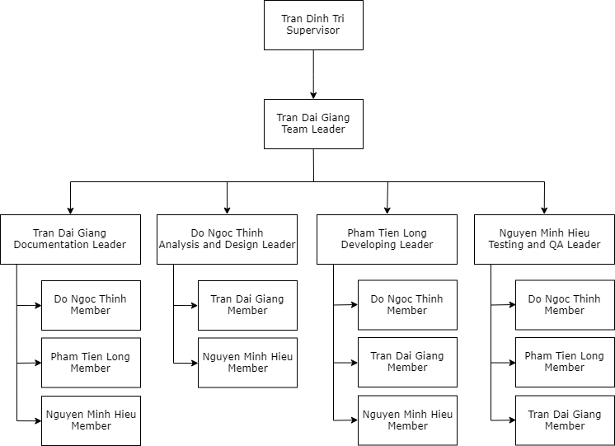

***Figure 2 : Roles and Responsibilities***

### Tools and Techniques

|  |  |
| --- | --- |
| **Programming languages** | **PHP 7.2** |
| **Framework** | **Laravel** |
| **Software architecture** |  |
| **Version control** | **GitHub** |
| **IDEs/Editors** | **Visual Studio 2017** |
| **UML tools** | **Draw.io** |
| **Web server** | **Apache 2.4.27** |
| **DBMS** | **MySQL 7.2** |
| **Project management tool** | **Microsoft Project 2016** |
| **Process model** | **Iterative and Incremental** |
| **Development process** | **Iterative and Incremental** |

## Project management plan

### Task sheet

### Convention rules

#### Naming convention

Naming convention makes programs more understandable by making them easier to read. They can also give information about the function identification.

|  |  |  |
| --- | --- | --- |
| Indentifier Type | Rules for naming | Examples |
| Class | Class’s name should be nouns, in mixed case with the first letter of each Internal word capitalized. Try to keep your class name simple and descriptive. Use whole word avoid acronyms and abbreviations (unless the abbreviation is much more widely used than the long form, such as URL or HTML) |  |
| Interface | Interface’s name should be capitalized like class name |  |
| Methods | Methods should be verbs, in mixed case with the first letter lowercase. With the first letter of each internal word capitalized. | Run();  Get Background(); |
| Variables | Except for variables, all instance, class, and class constants are in mixed case with a lowercase first letter. Internal words start with capital letter.  Variables’s name should be short yet meaningful. |  |
| Constants | The names of variables declared class constants and of ANSI constants should all uppercase with words separated by underscores(“_”). | int MAX_WIDTH = 5;  int MIN_WIDTH = 2; |

# **CHAPTER 3: SYSTEM REQUIREMENTS SPECIFICATIONS (SRS)**



## **System Requirement Specification (Specific Requirements)**

*<Summarize the system requirements in a compact form>*

### External Interface Requirements

#### User Interfaces

#### Hardware Interfaces

#### Software Interfaces

#### Communications Protocol

### System Features

#### Functional Requirement Specification

* **Administrator :**
  + Login
  + Logout
  + Change password
  + Manage Account:
    - Create account (for academic staffs/supervisors)
    - Edit account (for academic staffs/supervisors)
    - Delete account
    - Search account
    - Lock account
    - Unlock account
* **Academic Staff:**
* Login
* Logout
* Import
* View profile
* Edit profile
* Change password
* Reset password
* Notification
* Checking result of capstone project defense
* Work scheduling:
  + Assign room for meeting
  + Edit meeting
* Manage request:
  + View request
  + Approve request
    - From supervisor
  + Reject request
    - From team-leader
* **Supervisor:**
* Login
* Logout
* Change password
* Reset password
* Notification
* Book meeting room
* View profile
* Edit profile
* Manage task:
  + Create task
  + View task
  + Edit task
  + Delete task
  + Assign task to member
  + Remove member from task
  + Task’s deadline
    - Set
    - Edit
  + Task’s priority
    - Set
    - Edit
  + View progress (of total project)
  + Manage comment:
    - Add comment
    - Edit comment
    - Delete comment
* Manage request:
  + View request
  + Approve team-leader’s request
  + Reject team-leader’s request
* **Supervisor head(inherit all function from Supervisor):** 
  + Approve create team
* **Group user - Students :**
  + **Member :**
* Login
* Logout
* Change password
* Reset password
* View profile
* Edit profile
* Notification
* View task
* View task’s progress
* Manage work/report
  + Submit work/report
  + Edit work/report
* Log bug to list
* Add code/test bug as task
* Manage comment:
  + Add comment
  + Edit comment
  + Delete comment
* **Team-leader (inherit all function from Member) :**
  + Manage task:
    - Create task
    - View task
    - Edit task
    - Delete task
    - Assign task to member
    - Edit member’s task
    - Delete member’s task
    - Add code/test bugs as task
    - Task’s deadline
      * Set
      * Edit
    - Task’s priority
      * Set
      * Edit
    - View progress (of total project)
    - Rating
    - Manage comment:
      * Add comment
      * Edit comment
      * Delete comment
    - Request to supervisor :
      * Change project’s name

#### Use-case Table

|  |  |  |  |  |  |
| --- | --- | --- | --- | --- | --- |
| **UC No.** | **Group functions** | **Actor** | **Function name** | | **Note** |
| **UC01** | Login | Administrator, Academic Staff, Supervisor, Student | Login | |  |
| **UC02** | Logout | Administrator, Academic Staff, Supervisor, Student | Logout | |  |
| **UC03** | Change password | Administrator, Academic Staff, Supervisor, Student | Change password | |  |
| **UC04** | Reset password | Academic Staff, Supervisor, Student | Reset password | |  |
| **UC05** | View profile | Academic Staff, Supervisor, Student | View profile | |  |
| **UC06** | Edit profile | Academic Staff, Supervisor, Student | Edit profile | |  |
| **UC07** | Notification | Academic Staff, Supervisor, Student | Notification | | (Bỏ trống chưa quyết làm) |
| **UC08** | Manage account | Administrator | Create account | | For academic staffs/supervisors |
| **UC09** | Administrator | Edit account | | For academic staffs/supervisors |
| **UC10** | Administrator | Delete account | |  |
| **UC11** | Administrator | Search account | |  |
| **UC12** | Administrator | Lock account | |  |
| **UC13** | Administrator | Unlock account | |  |
| **UC14** | Checking result | Academic staff | Checking result | | Check capstone project's status of student |
| **UC15** | Manage team | Head supervisor | Approve create team | |  |
| **UC16** | Head supervisor | Edit team’s supervisors | | (Hỏi thầy) |
| **UC17** | Work scheduling | Academic staff | Assign room for meeting | |  |
| **UC18** | Academic staff | Edit meeting | |  |
| **UC19** | Book meeting room | Supervisor | Book meeting room | |  |
| **UC20** | Import | Academic staff | Import | | Import data of students who are qualified to do Capstone Project. |
| **UC21** | Manage request | Academic staff, Supervisor | View requests | |  |
| **UC22** | Academic staff | Approve request from supervisor | |  |
| **UC23** | Academic staff, Supervisor | Reject request from team leader | |  |
| **UC24** | Manage task (CRC cho vào team) | Supervisor, Team-leader | Create task | |  |
| **UC25** | Supervisor, Student | View task | |  |
| **UC26** | Supervisor, Team-leader | Edit task | |  |
| **UC27** | Supervisor, Team-leader | Delete task | |  |
| **UC28** | Supervisor, Team-leader | Assign task to member | |  |
| **UC29** | Supervisor, Team-leader | Remove member from task | |  |
| **UC30** | Supervisor, Team-leader | Task's deadline | Set |  |
| **UC31** | Supervisor, Team-leader | Edit |  |
| **UC32** | Supervisor, Team-leader | Task's priority | Set |  |
| **UC33** | Supervisor, Team-leader | Edit |  |
| **UC34** | Supervisor, Student | View total progress | |  |
| **UC35** | Supervisor, Student | Manage comment | Add |  |
| **UC36** | Supervisor, Student | Edit |  |
| **UC37** | Supervisor, Student | Delete |  |
| **UC38** |  | Supervisor, Student | View task's progress | |  |
| **UC39** | Manage work/report | Student | Submit | |  |
| **UC40** | Student | Edit | |  |
| **UC41** | Log bug to list | Student | Log bug to list | |  |
| **UC42** | Add code/test bugs as task | Student | Add code/test bugs as task | |  |
| **UC43** | Change project's name | Team-leader | Change project's name | |  |

#### Use-case Diagram

#### Business rules

|  |  |
| --- | --- |
| **No** | **Description** |
| **B1** | The full name must be not empty |
| **B2** | The email address must not be empty |
| **B3** | The email must have @fpt.edu.vn. |
| **B4** | The phone number must be not empty |
| **B5** | The DOB must be not empty |
| **B6** | The password must not be empty |
| **B7** | The password length must be in the range at least 8 characters |
| **B8** | The confirm password must be matched with the new password |
| **B9** | The password must have at least one special character |
| **B10** | The username must match with member code |
| **B11** | The username must be not empty |
| **B12** |  |
| **B13** |  |
| **B14** |  |
| **B15** |  |
| **B16** |  |
| **B17** |  |
| **B18** |  |
| **B19** |  |
| **B20** |  |
| **B21** |  |
| **B22** |  |

### Use-case Specification

#### UC01 - Login

|  |  |  |  |  |  |  |
| --- | --- | --- | --- | --- | --- | --- |
| **Use case ID:** | | | UC01 | **Use case name:** | Login | |
| **Created by:** | | | ThinhDN | **Date Created:** | 21/04/2018 | |
| **Primary Actor** | | | All actors | **Secondary Actor** |  | |
| **Description:** | | | Actors want to login to SPMFU system. | | | |
| **Preconditions:** | | | * User are in home page * Click on “Login” | | | |
| **Trigger:** | | | * Input username & password * Click on button “Login” | | | |
| **Post conditions:** | | | Log on to the system successfully | | | |
| **Normal Flow** | | | | | | | |
| **Step** | **Actor** | | **Action** | | | |
| 1 | All actors | | Click on “Login” in the upper right corner of the homepage | | | |
| 2 | System | | Display login page includes:   * “Username” text-field * “Password” text-field * “Remember me” check box. * “Forgot password” link * “Login” button. | | | |
| 3 | All actor | | Enter data in fields. | | | |
| 4 | System | | Validate inputted email | | | |
| 5 | All actor | | Click “Login” button. | | | |
| 6 | System | | Check login information according to the account table | | | |
| 7 | System | | Redirects to the user's home page base on their role | | | |
| **Alternative Flows: N/A** | | | | | | | |
| **Exceptions:** | | | | | | | |
| **EC1** | | At step 4, if user do not use email of fpt | | | | | |
| **Step** | | **Actor** | **Action** | | |
| 4.1 | | System | Display message error “Please use email form *@fpt.edu.vn” | | |
| 4.2 | | System | Focus on username text-field | | |
| **EC2** | | At step 5, if email or password field is empty | | | | | |
| **Step** | | **Actor** | **Action** | | |
| 5.1 | | System | Display message error “Username/ Password can not be empty!” | | |
| 5.2 | | System | Focus on empty text-field | | |
| **EC3** | | At step 6, if input email was not correct | | | | |
| **Step** | | **Actor** | **Action** | | |
| 6.1 | | System | Display message error “This email is not correct, please try again!” | | |
| 6.2 | | System | Focus on username text-field | | |
| **EC4** | | At step 6, if input email was correct but password was wrong | | | |
| **Step** | | **Actor** | **Action** | | |
| 6.3 | | System | Display message error “Your password is not correct, please try again!” | | |
| 6.4 | | System | Focus on password text-field | | |
| **Priority** | | | High | | | |
| **Frequency of Use:** | | | High | | | |
| **Business Rules:** | | |  | | | |
| **Other Information:** | | | N/A | | | |

#### UC02 - Logout

|  |  |  |  |  |
| --- | --- | --- | --- | --- |
| **Use case ID:** | | UC02 | **Use case name:** | Logout |
| **Created by:** | | ThinhDN | **Date Created:** | 21/04/2018 |
| **Primary Actor** | | All actors | **Secondary Actor** |  |
| **Description:** | | Actors want to logout SPMFU system. | | |
| **Preconditions:** | | * The user has logged into the SPMFU system * Click on user icon on the right corner of navigation bar | | |
| **Trigger:** | | Click “Logout” | | |
| **Post conditions:** | | Log out of SPMFU system successfully. | | |
| **Normal Flow** | | | | |
| **Step** | **Actor** | **Action** | | |
| 1 | All actors | Click on user icon on the right corner of navigation bar | | |
| 2 | System | Display a dropdown list include :   * View my profile * Log out | | |
| 3 | System | Logout account | | |
| 4 | System | Redirect to home page. | | |
| **Alternative Flows: N/A** | | | | |
| **Exceptions: N/A** | | | | |
| **Priority** | | High | | |
| **Frequency of Use:** | | High | | |
| **Business Rules:** | | N/A | | |
| **Other Information:** | | N/A | | |

#### UC03 - Change password

|  |  |  |  |  |  |  |
| --- | --- | --- | --- | --- | --- | --- |
| **Use case ID:** | | | UC03 | **Use case name:** | Change password | |
| **Created by:** | | | ThinhDN | **Date Created:** | 21/04/2018 | |
| **Primary Actor** | | | All actors | **Secondary Actor** |  | |
| **Description:** | | | Actors want to change password for security. | | | |
| **Preconditions:** | | | * Login successfully * Click on icon user * Click on “Profile” * Click on “Change password” | | | |
| **Trigger:** | | | * Input new password and re-input new password * Click on “Change” button | | | |
| **Post conditions:** | | | User changes password successfully | | | |
| **Normal Flow** | | | | | | |
| **Step** | **Actor** | | **Action** | | | |
| 1 | All actors | | Click icon “User” on the right corner | | | |
| 2 | All actors | | Click on ”Profile” | | | |
| 3 | All actors | | On profile page, click on “Change password” | | | |
| 4 | System | | Display change password page includes:  “ Old Password” text-field.  “New Password” text-field.  “Confirm new password” text-field.  “Change” button.  “Cancel” button. | | | |
| 5 | All actors | | Fill all the blanks correctly | | | |
| 6 | All actors | | Click “Change” button. | | | |
| 7 | System | | Validate the entered information | | | |
| 8 | System | | Save new password into database. | | | |
| 9 | System | | Display “Change password successfully” message on pop-up. | | | |
| 10 | System | | Redirect to user profile screen | | | |
| **Alternative Flows:** | | | | | | |
| **AT1** | At step 4 in the main flows, if actors click other hyperlinks or buttons. | | | | | |
| **Step** | **Actor** | | **Action** | | | |
| 6.1 | SPMFU | | Redirects actors to chosen hyperlink or button. | | | |
| **Exceptions:** | | | | | | |
| **EC1** | | At step 4, required fields are not entered. | | | | |
| **Step** | | **Actor** | **Action** | | |
| 6.1 | | SPMFU | Display Change Password page with message error. | | |
| 6.2 | | SPMFU | Mark error fields. | | |
| **EC2** | | At step 4, fields are entered with wrong type of data. | | | | |
| **Step** | | **Actor** | **Action** | | |
| 6.1 | | SPMFU | Display Change Password page with message error. | | |
| 6.2 | | SPMFU | Mark error fields. | | |
| **EC3** | | At step 4, old password is not correct. | | | | |
| **Step** | | **Actor** | **Action** | | |
| 6.1 | | SPMFU | Display Register page with message error. | | |
| 6.2 | | SPMFU | Mark error fields. | | |
| **EC4** | | At step 4, new password and confirm password are not match. | | | | |
| **Step** | | **Actor** | **Action** | | |
| 6.1 | | SPMFU | Display Change Password page with message error. | | |
| 6.2 | | SPMFU | Mark error fields. | | |
| **Priority** | | | Medium | | | |
| **Frequency of Use:** | | | Medium | | | |
| **Business Rules:** | | |  | | | |
| **Other Information:** | | | N/A | | | |

#### UC04 - Reset password

|  |  |  |  |  |  |
| --- | --- | --- | --- | --- | --- |
| **Use case ID:** | | | UC04 | **Use case name:** | Reset password |
| **Created by:** | | | ThinhDN | **Date Created:** | 21/04/2018 |
| **Primary Actor** | | | All actors | **Secondary Actor** |  |
| **Description:** | | | Reset password for actors in case they forget their password to login to SPMFU system. | | |
| **Preconditions:** | | | User can not remember password to login to SPMFU System | | |
| **Trigger:** | | | Click on “Forgot password?” | | |
| **Post conditions:** | | | * System updates new password to Account table * System sends new password to user via email | | |
| **Normal Flow** | | | | | |
| **Step** | **Actor** | | **Action** | | |
| 1 | All actors | | Click “Forgot password” below the “Sign in” button. | | |
| 2 | System | | Display “Forget password” page with:  “Email” text field.  “Confirm” button. | | |
| 3 | All actors | | Enter the email to continue. | | |
| 4 | All actors | | Click “Confirm” button | | |
| 4 | System | | Update password of the users to database. | | |
| 6 | System | | Send a confirmation mail to FPT email. | | |
| 7 | System | | Display message “Reset password successfully” redirect to Login page | | |
| **Alternative Flows:** | | | | | |
| **AT1** | | At step 4 in the main flows, if actors click other hyperlinks or buttons. | | | |
| **Step** | | **Actor** | **Action** | | |
| 4.1 | | System | Redirects actors to chosen hyperlink or button. | | |
| **Exceptions:** | | | | | |
| **EC1** | | At step 4, email text-fields is empty | | | |
| **Step** | | **Actor** | **Action** | | |
| 4.1 | | System | Display error message “You must enter your FPT Email “ | | |
| 4.2 | | System | Focus on email text-field | | |
| **EC2** | | At step 4, if input email is not FPT email. | | | |
| **Step** | | **Actor** | **Action** | | |
| 7.1 | | System | Display error message “You must enter your FPT Email “ | | |
| 7.2 | | System | Focus on email text-field | | |
| **Priority** | | | Medium | | |
| **Frequency of Use:** | | | Medium | | |
| **Business Rules:** | | |  | | |
| **Other Information:** | | | N/A | | |

#### UC05 – View profile

|  |  |  |  |  |
| --- | --- | --- | --- | --- |
| **Use case ID:** | | UC05 | **Use case name:** | Edit profile |
| **Created by:** | | ThinhDN | **Date Created:** | 21/04/2018 |
| **Primary Actor** | | All actors | **Secondary Actor** |  |
| **Description:** | | Users want to view their profile. | | |
| **Preconditions:** | | * Users has logged into system. * Click on user icon | | |
| **Trigger:** | | Click on “View my profile” after click on user icon | | |
| **Post conditions:** | | Display the “Profile” page. | | |
| **Normal Flow** | | | | |
| **Step** | **Actor** | **Action** | | |
| 1 | All actors | Click on user icon | | |
| 2 | System | Display a dropdown list include :   * View my profile * Log out | | |
| 3 | All actors | Click on “Profile” button on the menu of “My Account”. | | |
| 4 | System | Display “Profile” Page includes: | | |
| **Alternative Flows: N/A** | | | | |
| **Exceptions: N/A** | | | | |
| **Priority** | | Medium | | |
| **Frequency of Use:** | | Medium | | |
| **Business Rules:** | |  | | |
| **Other Information:** | | N/A | | |

#### UC06 – Edit profile

|  |  |  |  |  |  |
| --- | --- | --- | --- | --- | --- |
| **Use case ID:** | | | UC06 | **Use case name:** | Edit profile |
| **Created by:** | | | ThinhDN | **Date Created:** | 21/04/2018 |
| **Primary Actor** | | | All actors | **Secondary Actor** |  |
| **Description:** | | | User want to edit their profile. | | |
| **Preconditions:** | | | * Users already logged into system * Go to “View my profile” page | | |
| **Trigger:** | | | Click on “Edit Information” | | |
| **Post conditions:** | | | * Save new information to database * Reload and show updated information on “View my profile” page. | | |
| **Normal Flow** | | | | | |
| **Step** | **Actor** | | **Action** | | |
| 1 | All actors | | Click on “Edit Information” button. | | |
| 2 | System | | Display “Edit Profile” Page includes:   * “Full name” text-fields. * “Date of Birth” text-fields. * “Gender” group radio button. * “ID card” text-fields. * “Address” text-fields. * “Phone number” text-fields. * “Email” input text fields but can’t be edit. * “Save” button. * “Cancel” button. | | |
| 3 | All actors | | Change data in fields. | | |
| 4 | All actors | | Click “Save” button. | | |
| 5 | System | | Save changed in database. | | |
| 6 | System | | Reload and display updated information on “View my profile” page. | | |
| **Alternative Flows:** | | | | | |
| **AT1** | At step 4, actors click “Cancel”. | | | | |
| **Step** | **Actor** | | **Action** | | |
| 4.1 | All actors | | Click “Cancel” | | |
| 4.2 | System | | Display “View my profile” Page. | | |
| **AT2** | At step 4 in the main flows, if actors click other hyperlinks or buttons. | | | | |
| **Step** | **Actor** | | **Action** | | |
| 6.1 | System | | Redirects actors to chosen hyperlink or button. | | |
| **Exceptions:** | | | | | |
| **EC1** | | At step 4, fields are entered with wrong type of data. | | | |
| **Step** | | **Actor** | **Action** | | |
| 4.3 | | System | Display Register page with message error. | | |
| 4.4 | | System | Focus on error fields. | | |
| **EC1** | | At step 4, if any field is empty | | | |
| **Step** | | **Actor** | **Action** | | |
| 4.5 | | System |  | | |
| **Priority** | | | Medium | | |
| **Frequency of Use:** | | | Medium | | |
| **Business Rules:** | | |  | | |
| **Other Information:** | | | N/A | | |

#### UC07 – Notification

|  |  |  |  |  |
| --- | --- | --- | --- | --- |
| **Use case ID:** | | UC07 | **Use case name:** | Notification |
| **Created by:** | | HieuNM | **Date Created:** | 25/02/2018 |
| **Primary Actor** | | Academic Staff, Supervisor, Student | **Secondary Actor** |  |
| **Description:** | | This function allows user to be noticed whenever the team has new action. | | |
| **Preconditions:** | | 1. Actor have to log in successfully to the system. 2. “Notification” icon menu appear on head of the page. | | |
| **Trigger:** | | “Notification” menu item is clicked. | | |
| **Post conditions:** | |  | | |
| **Normal Flow** | | | | |
| **Step** | **Actor** | **Action** | | |
| 1 | Academic Staff, Supervisor, Student | Log in to their account. | | |
| 2 | SPMFU | Display all the notifications of actor. | | |
| 3 | Academic Staff, Supervisor, Student | Click on each notification for more details. | | |
| 4 | SPMFU | Display the selected section. | | |
| **Alternative Flows: N/A** | | | | |
| **Exceptions: N/A** | | | | |
| **Priority** | | Medium | | |
| **Frequency of Use:** | | High | | |
| **Business Rules:** | |  | | |
| **Other Information:** | | N/A | | |

#### UC08 – Manage account – Create account

|  |  |  |  |  |  |  |  |
| --- | --- | --- | --- | --- | --- | --- | --- |
| **Use case ID:** | | | UC08 | | | **Use case name:** | Create account |
| **Created by:** | | | HieuNM | | | **Date Created:** | 25/02/2018 |
| **Primary Actor** | | | Administrator | | | **Secondary Actor** |  |
| **Description:** | | | Administrator create new account for academic staffs/supervisors. | | | | |
| **Preconditions:** | | | “Create account” navigator appear on left side. | | | | |
| **Trigger:** | | | “Create account” is clicked. | | | | |
| **Post conditions:** | | | Add new user information to database. | | | | |
| **Normal Flow** | | | | | | | |
| **Step** | **Actor** | | **Action** | | | | |
| 1 | Admin | | Click “Create account” in side bar. | | | | |
| 2 | SPMFU | | Display Add User page includes:  “Firstname” input text fields.  “Lastname” input text fields  “Address” input text fields.  “Date of birth” date picker.  “Gender” radio button.  “Username” input text fields.  “Password” input text fields.  “Confirm password” input text fields.  “Email” input text fields.  “Account type” radio button  “Telephone” input text fields.  “Cancel” button.  “Create” button. | | | | |
| 3 | Admin | | Enters data in fields. | | | | |
| 4 | Admin | | Click “Add” button. | | | | |
| 5 | SPMFU | | Add new user to database. | | | | |
| 6 | SMPFU | | Display homepage for each type of account. | | | | |
| **Alternative Flows:** | | | | | | | |
| **AT1** | | At step 4 in the main flows, if actors click “Cancel” button. | | | | | |
| **Step** | | **Actor** | | | **Action** | | |
| 4.1 | | SPMFU | | | Redirects to administrator homepage. | | |
| **AT2** | | At step 4 in the main flows, if actors click other hyperlinks or buttons. | | | | | |
| **Step** | | **Actor** | | | **Action** | | |
| 4.1 | | SPMFU | | | Redirects to chosen hyperlink or button. | | |
| **Exceptions:** | | | | | | | |
| **EC1** | | At step 4, required fields are not entered. | | | | | |
| **Step** | | **Actor** | | **Action** | | | |
| 4.1 | | SPMFU | | Display Create User page with message error. | | | |
| 4.2 | | SPMFU | | Red mark error fields. | | | |
| **EC2** | | At step 4, fields are entered with wrong type of data. | | | | | |
| **Step** | | **Actor** | | **Action** | | | |
| 4.1 | | SPMFU | | Display Create User page with message error. | | | |
| 4.2 | | SPMFU | | Red mark error fields. | | | |
| **Priority** | | | High | | | | |
| **Frequency of Use:** | | | High | | | | |
| **Business Rules:** | | |  | | | | |
| **Other Information:** | | | N/A | | | | |

#### UC09 – Manage account – Edit account

|  |  |  |  |  |  |  |  |
| --- | --- | --- | --- | --- | --- | --- | --- |
| **Use case ID:** | | | UC009 | | | **Use case name:** | Edit account |
| **Created by:** | | | HieuNM | | | **Date Created:** | 25/02/2018 |
| **Primary Actor** | | | Administrator | | | **Secondary Actor** |  |
| **Description:** | | | Edit academic staff & supervisor information. | | | | |
| **Preconditions:** | | | 1. “Manage user” navigator appear on header of website. 2. “Edit” button appear on the right of each user in the user list page. | | | | |
| **Trigger:** | | | “Edit User” navigator is clicked. | | | | |
| **Post conditions:** | | | Edit user information to database. | | | | |
| **Normal Flow** | | | | | | | |
| **Step** | **Actor** | | **Action** | | | | |
| 1 | Administrator | | Click “Manage user” in side bar. | | | | |
| 2 | SPMFU | | Display “List Users” page includes supervisors and academic staffs. | | | | |
| 3 | Administrator | | Click on “Edit” button on the right of each user. | | | | |
| 4 | SPMFU | | Display Edit User page includes:  “First name” input text field.  “Last name” input text field.  “Address” input text field.  “Date of birth” date picker.  “Gender” radio button.  “Username” input text field.  “Password” input text field.  “Confirm password” input text fields.  “Email” input text fields.  “Account type” radio button.  “Telephone” input text fields.  “Cancel” button.  “Save” button. | | | | |
| 5 | Administrator | | Enter data in field. | | | | |
| 6 | Administrator | | Click save button. | | | | |
| 7 | SPMFU | | Add new information of user to database. | | | | |
| **Alternative Flows:** | | | | | | | |
| **AT1** | | At step 6 in the main flows, if actors click other hyperlinks or buttons. | | | | | |
| **Step** | | **Actor** | | | **Action** | | |
| 7.1 | | SPMFU | | | Redirects user to chosen hyperlink or button. | | |
| **Exceptions:** | | | | | | | |
| **EC1** | | At step 6, required fields are not entered. | | | | | |
| **Step** | | **Actor** | | **Action** | | | |
| 6.1 | | SPMFU | | Display Edit User page with message error | | | |
| 6.2 | | SPMFU | | Red mark error fields | | | |
| **EC2** | | At step 6, fields are entered with wrong type of data | | | | | |
| **Step** | | **Actor** | | **Action** | | | |
| 6.1 | | SPMFU | | Display Add User page with message error | | | |
| 6.2 | | SPMFU | | Red mark error fields | | | |
| **Priority** | | | High | | | | |
| **Frequency of Use:** | | | High | | | | |
| **Business Rules:** | | |  | | | | |
| **Other Information:** | | | N/A | | | | |

#### UC10 – Manage account –Delete account

|  |  |  |  |  |  |  |
| --- | --- | --- | --- | --- | --- | --- |
| **Use case ID:** | | | UC010 | | **Use case name:** | Delete account |
| **Created by:** | | | HieuNM | | **Date Created:** | 25/02/2018 |
| **Primary Actor** | | | Administrator | | **Secondary Actor** |  |
| **Description:** | | | Administrator want to delete user account. | | | |
| **Preconditions:** | | | 1. “Manage user” navigator appear on header of website. 2. “Delete” button appear on the right of each user in the user list page. | | | |
| **Trigger:** | | | “Delete button” appear on user detail page is clicked. | | | |
| **Post conditions:** | | | User is deleted. | | | |
| **Normal Flow** | | | | | | |
| **Step** | **Actor** | | **Action** | | | |
| 1 | Administrator | | Click “Manage user” in side bar. | | | |
| 2 | SPMFU | | Display “List Users” page. | | | |
| 3 | Administrator | | Click “Delete” button on the right of each user in the user list. | | | |
| 4 | SPMFU | | Display a pop up message with the content “Are you sure you want to delete this user?” and two button:   * “Yes” * “No” | | | |
| 5 | Administrator | | Click “Yes”. | | | |
| 6 | SPMFU | | Delete user in database. | | | |
| 7 | SPMFU | | Display “List Users” page with updated list of users. | | | |
| **Alternative Flows:** | | | | | | |
| **AT1** | | At step 5 in the min flows, if administrator click other hyperlinks or buttons. | | | | |
| **Step** | | **Actor** | | **Action** | | |
| 7.1 | | SPMFU | | Redirects user to chosen hyperlink or button. | | |
| **AT2** | | At step 5 in the min flows, if administrator click “No”. | | | | |
| **Step** | | **Actor** | | **Action** | | |
| 7.1 | | SPMFU | | Cancel the action. | | |
| **Exceptions: N/A** | | | | | | |
| **Priority** | | | High | | | |
| **Frequency of Use:** | | | Medium | | | |
| **Business Rules:** | | |  | | | |
| **Other Information:** | | | N/A | | | |

#### UC11 – Manage account – Search account

|  |  |  |  |  |
| --- | --- | --- | --- | --- |
| **Use case ID:** | | UC11 | **Use case name:** | Search account |
| **Created by:** | | HieuNM | **Date Created:** | 25/02/2018 |
| **Primary Actor** | | Administrator | **Secondary Actor** |  |
| **Description:** | | Administrator want to find a user in user list. Admin send request to system and then get result. | | |
| **Preconditions:** | | 1. “Manage User” navigator appear on sidebar of website. 2. “Search” input field appear above the list user page. | | |
| **Trigger:** | | “Manage User” navigator is clicked. | | |
| **Post conditions:** | | Display user list by require of admin on list user page. | | |
| **Normal Flow** | | | | |
| **Step** | **Actor** | **Action** | | |
| 1 | Administrator | Click “Manage User” navigator. | | |
| 2 | SPMFU | Display “List Users” page with a search menu on top of the page that includes:   * “User Name” input text. * “Member code” input text. * “Email” input text. * “Date of birth” input text. * “Phone number” input text. * “Gender” drop box. * “Search” button. | | |
| 3 | Administrator | Enter data in all or more than one fields. | | |
| 4 | Admin | Click “Search” button on manage user page. | | |
| 5 | SPMFU | Display user list by require of search on list user page. | | |
| **Alternative Flows:** | | | | |
| **AT1** | At step 4 in the main flows, if actors click other hyperlinks or buttons. | | | |
| **Step** | **Actor** | **Action** | | |
| 5.1 | SPMFU | Redirects admin to chosen hyperlink or button. | | |
| **Exceptions:** | | | | |
| **EC1** | At step 4 in the main flows, if all input fields are blank. | | | |
| **Step** | **Actor** | **Action** | | |
| 5.1 | SPMFU | Display List User page with message error. | | |
| 5.2 | SPMFU | Red mark all blank fields. | | |
| **EC2** | At step 4 in the main flows, if actors input wrong type of data. | | | |
| **Step** | **Actor** | **Action** | | |
| 5.1 | SPMFU | Display List User page with message error. | | |
| 5.2 | SPMFU | Red mark error fields. | | |
| **Priority** | | Medium | | |
| **Frequency of Use:** | | Medium | | |
| **Business Rules:** | |  | | |
| **Other Information:** | | N/A | | |

#### UC12 – Manage account – Lock account

|  |  |  |  |  |
| --- | --- | --- | --- | --- |
| **Use case ID:** | | UC012 | **Use case name:** | Lock account |
| **Created by:** | | HieuNM | **Date Created:** | 25/02/2018 |
| **Primary Actor** | | Administrator | **Secondary Actor** |  |
| **Description:** | | Administrator want to lock user account. | | |
| **Preconditions:** | | 1. “Manage user” navigator appear on header of website. 2. “Lock” button of user appear on the right of each user in the user list. | | |
| **Trigger:** | | “Lock” button is clicked. | | |
| **Post conditions:** | | User status becomes de-active. | | |
| **Normal Flow** | | | | |
| **Step** | **Actor** | **Action** | | |
| 1 | Administrator | Click “Manage User” navigator. | | |
| 2 | SPMFU | Display the “List Users” page. | | |
| 3 | Administrator | Click “Lock” button on the right of each user in the user list. | | |
| 4 | SPMFU | Change the status of the user in the database. | | |
| 5 | SPMFU | Display the “List Users” page with updated information in database. | | |
| **Alternative Flows: N/A** | | | | |
| **Exceptions: N/A** | | | | |
| **Priority** | | High | | |
| **Frequency of Use:** | | Medium | | |
| **Business Rules:** | |  | | |
| **Other Information:** | | N/A | | |

#### UC13 – Manage account – Unlock account

|  |  |  |  |  |
| --- | --- | --- | --- | --- |
| **Use case ID:** | | UC13 | **Use case name:** | Unlock account |
| **Created by:** | | HieuNM | **Date Created:** | 25/02/2018 |
| **Primary Actor** | | Administrator | **Secondary Actor** |  |
| **Description:** | | Administrator want to unlock user account. | | |
| **Preconditions:** | | 1. “Manage user” navigator appear on header of website. 2. “Unlock” button of user appear on the right of each user in the user list. | | |
| **Trigger:** | | “Unlock” button is clicked. | | |
| **Post conditions:** | | User status becomes active. | | |
| **Normal Flow** | | | | |
| **Step** | **Actor** | **Action** | | |
| 1 | Administrator | Click “Manage User” navigator. | | |
| 2 | SPMFU | Display the “List Users” page. | | |
| 3 | Administrator | Click “Lock” button on the right of each user in the user list. | | |
| 4 | SPMFU | Change the status of the user in the database. | | |
| 5 | SPMFU | Display the “List Users” page with updated information in database. | | |
| **Alternative Flows: N/A** | | | | |
| **Exceptions: N/A** | | | | |
| **Priority** | | High | | |
| **Frequency of Use:** | | Medium | | |
| **Business Rules:** | |  | | |
| **Other Information:** | | N/A | | |

#### UC14 – Checking result

|  |  |  |  |  |
| --- | --- | --- | --- | --- |
| **Use case ID:** | | UC14 | **Use case name:** | Checking result |
| **Created by:** | | HieuNM | **Date Created:** | 25/02/2018 |
| **Primary Actor** | | Academic staff | **Secondary Actor** |  |
| **Description:** | | Academic staff wants to check the defense result of Capstone Project team. | | |
| **Preconditions:** | | “Capstone Project team” label appear on the left menu of web page. | | |
| **Trigger:** | | “Capstone Project team” label is clicked. | | |
| **Post conditions:** | | Display lists of “Capstone Project team” which are classify by:   * Semester. * Status (Success/fail/not yet). | | |
| **Normal Flow** | | | | |
| **Step** | **Actor** | **Action** | | |
| 1 | Academic staff | Click the “Capstone Project team” label. | | |
| 2 | SPMFU | Display the “Capstone Project team list” webpage with list of Capstone Project team. Each Capstone Project team in the list include :   * “Capstone Project name” label. * “Status” text field. * “Grade” text field. | | |
| **Alternative Flows: N/A** | | | | |
| **Exceptions: N/A** | | | | |
| **Priority** | | Medium | | |
| **Frequency of Use:** | | High | | |
| **Business Rules:** | |  | | |
| **Other Information:** | | N/A | | |

#### UC15 – Manage team – Approve create team

|  |  |  |  |  |
| --- | --- | --- | --- | --- |
| **Use case ID:** | | UC15 | **Use case name:** | Approve create team |
| **Created by:** | | HieuNM | **Date Created:** | 25/02/2018 |
| **Primary Actor** | | Head supervisor | **Secondary Actor** |  |
| **Description:** | | Head supervisor approve create team request of students. | | |
| **Preconditions:** | | 1. “Create team request” label appear on the header of Head supervisor homepage. 2. Display list of team when “Create team request” label is clicked. 3. “Approve” button appear on each request on List request detail. | | |
| **Trigger:** | | “Approve” button is clicked. | | |
| **Post conditions:** | | Team is created | | |
| **Normal Flow** | | | | |
| **Step** | **Actor** | **Action** | | |
| 1 | Academic staff | Click “Create team request” label. | | |
| 2 | SPMFU | Display a list of create team request. | | |
| 3 | Academic staff | Click “Approve” button. | | |
| 4 | SPMFU | Update information of students on the database. | | |
| 5 | SPMFU | Display the successfully message. | | |
| **Alternative Flows:** | | | | |
| **AT1** | At step 3, actors click “Refuse” button. | | | |
| **Step** | **Actor** | **Action** | | |
| 5.1 | SPMFU | Return to “List request” page. | | |
| **AT2** | At step 4 in the main flows, if actor click other hyperlinks or buttons. | | | |
| **Step** | **Actor** | **Action** | | |
| 5.1 | SPMFU | Redirects actor to chosen hyperlink or button. | | |
| **Exceptions: N/A** | | | | |
| **Priority** | | High | | |
| **Frequency of Use:** | | High | | |
| **Business Rules:** | |  | | |
| **Other Information:** | | N/A | | |

#### UC16 – Manage team – Edit team’s supervisor

|  |  |  |  |  |  |  |
| --- | --- | --- | --- | --- | --- | --- |
| **Use case ID:** | | | UC16 | | **Use case name:** | Edit team’s supervisor |
| **Created by:** | | | HieuNM | | **Date Created:** | 25/02/2018 |
| **Primary Actor** | | | Academic staff | | **Secondary Actor** |  |
| **Description:** | | | Academic staff want to edit team’s supervisor. | | | |
| **Preconditions:** | | | 1. “Manage Team” menu appear on the left of web page. 2. Display the “Team list” page when “Team list” button in the “Manage Team” menu is clicked. 3. Click a team. 4. Display “Team information” web page. | | | |
| **Trigger:** | | | “Edit team’s supervisor” button is clicked. | | | |
| **Post conditions:** | | | Edit information of a team in SPMFU system. | | | |
| **Normal Flow** | | | | | | |
| **Step** | **Actor** | | **Action** | | | |
| 1 | Academic staff | | Click “Edit team’s supervisor” button link. | | | |
| 2 | SPMFU | | Display “Edit team’s supervisor” board menu includes:   * “Members” input text field. * “Save” button. * “Cancel” button. | | | |
| 3 | Academic staff | | Enter data in fields. | | | |
| 4 | Academic staff | | Click save. | | | |
| 5 | SPMFU | | Update data of a team in database. | | | |
| 6 | SPMFU | | Display the detail information of “Team information” page. | | | |
| **Alternative Flows:** | | | | | | |
| **AT1** | At step 4 in the main flow, actor click “Cancel” button | | | | | |
| **Step** | **Actor** | | **Action** | | | |
| 6.1 | SPMFU | | Return to homepage. | | | |
| **AT2** | At step 4 in the main flows, if actor click other hyperlinks or buttons. | | | | | |
| **Step** | **Actor** | | **Action** | | | |
| 6.1 | SPMFU | | Redirects actor to chosen hyperlink or button. | | | |
| **Exceptions:** | | | | | | |
| **EC1** | | At step 6 in the main flow, required fields are not entered. | | | | |
| **Step** | | **Actor** | | **Action** | | |
| 6.1 | | SPMFU | | Display with message error. | | |
| 6.2 | | SPMFU | | Mark error fields. | | |
| **EC2** | | At step 4, fields are entered with invalid supervisor’s usernames. | | | | |
| **Step** | | **Actor** | | **Action** | | |
| 6.1 | | SPMFU | | Display with message error. | | |
| 6.2 | | SPMFU | | Mark error fields | | |
| **Priority** | | | Medium | | | |
| **Frequency of Use:** | | | Medium | | | |
| **Business Rules:** | | |  | | | |
| **Other Information:** | | | N/A | | | |

#### UC17 – Work scheduling – Assign room for meeting

|  |  |  |  |  |  |  |
| --- | --- | --- | --- | --- | --- | --- |
| **Use case ID:** | | | UC19 | | **Use case name:** | Assign room for meeting |
| **Created by:** | | | HieuNM | | **Date Created:** | 25/02/2018 |
| **Primary Actor** | | | Academic staff | | **Secondary Actor** |  |
| **Description:** | | | Academic staff assign room for offline meeting of Capstone Project team. | | | |
| **Preconditions:** | | | 1. “Work scheduling” menu appear on a menu on the left. 2. “Assign room for meeting” button appear below the team menu. | | | |
| **Trigger:** | | | “Assign room for meeting” button is clicked. | | | |
| **Post conditions:** | | | Add an offline meeting in SPMFU system. | | | |
| **Normal Flow** | | | | | | |
| **Step** | **Actor** | | **Action** | | | |
| 1 | Academic staff | | Click “Assign room for meeting” button | | | |
| 2 | SPMFU | | Display “Assign room for meeting menu” includes:   * “Room” drop box. * “Capstone project team” input text. * “Save” button. * “Cancel” button. | | | |
| 3 | Academic staff | | Enter data. | | | |
| 4 | Academic staff | | Click “Save” button. | | | |
| 5 | SPMFU | | Save data in database. | | | |
| 6 | SPMFU | | Display new meeting on “Meeting Schedule” page. | | | |
| **Alternative Flows:** | | | | | | |
| **AT1** | At step 4 in the main flow, Academic staff click “cancel” button | | | | | |
| **Step** | **Actor** | | **Action** | | | |
| 6.1 | SPMFU | | Return to homepage. | | | |
| **AT2** | At step 4 in the main flows, if actor click other hyperlinks or buttons | | | | | |
| **Step** | **Actor** | | **Action** | | | |
| 6.1 | SPMFU | | Redirects actor to chosen hyperlink or button | | | |
| **Exceptions:** | | | | | | |
| **EC1** | | At step 4, required fields are not entered | | | | |
| **Step** | | **Actor** | | **Action** | | |
| 4.1 | | SPMFU | | Display page with message error | | |
| 4.2 | | SPMFU | | Mark error fields | | |
| **EC2** | | At step 4, fields are entered with wrong type of data | | | | |
| **Step** | | **Actor** | | **Action** | | |
| 4.1 | | SPMFU | | Display page with message error | | |
| 4.2 | | SPMFU | | Mark error fields | | |
| **Priority** | | | High | | | |
| **Frequency of Use:** | | | High | | | |
| **Business Rules:** | | |  | | | |
| **Other Information:** | | | N/A | | | |

#### UC18 – Work scheduling – Edit meeting

|  |  |  |  |  |  |  |
| --- | --- | --- | --- | --- | --- | --- |
| **Use case ID:** | | | UC18 | | **Use case name:** | Edit meeting |
| **Created by:** | | | HieuNM | | **Date Created:** | 25/02/2018 |
| **Primary Actor** | | | Academic staff | | **Secondary Actor** |  |
| **Description:** | | | Academic staff edit an offline meeting for Capstone Project team. | | | |
| **Preconditions:** | | | 1. “Work scheduling” menu appear on a menu on the left. 2. Click “Meeting Schedule” button appear below the team menu to view the “Meeting Schedule” page. 3. Click “Edit” button on meeting schedule. | | | |
| **Trigger:** | | | “Edit” button is clicked. | | | |
| **Post conditions:** | | | Edit an offline meeting in SPMFU system. | | | |
| **Normal Flow** | | | | | | |
| **Step** | **Actor** | | **Action** | | | |
| 1 | Academic staff | | Click “Edit meeting” button | | | |
| 2 | SPMFU | | Display “Edit meeting menu” includes:   * “Room” drop box. * “Time” drop box. * “Date” date picker. * “Capstone project team” input text. * “Save” button. * “Cancel” button. | | | |
| 3 | Academic staff | | Enter data. | | | |
| 4 | Academic staff | | Click “Save” button. | | | |
| 5 | SPMFU | | Save data in database. | | | |
| 6 | SPMFU | | Display new meeting on Meeting Schedule*(cái phần lưới tôi k nhớ tên eng là gì). | | | |
| **Alternative Flows:** | | | | | | |
| **AT1** | At step 4 in the main flow,actor click “cancel” button | | | | | |
| **Step** | **Actor** | | **Action** | | | |
| 6.1 | SPMFU | | Redirect actor to homepage. | | | |
| **AT2** | At step 4 in the main flows, if actor click other hyperlinks or buttons | | | | | |
| **Step** | **Actor** | | **Action** | | | |
| 6.1 | SPMFU | | Redirects actor to chosen hyperlink or button | | | |
| **Exceptions:** | | | | | | |
| **EC1** | | At step 4, required fields are not entered | | | | |
| **Step** | | **Actor** | | **Action** | | |
| 4.1 | | SPMFU | | Display page with message error | | |
| 4.2 | | SPMFU | | Mark error fields | | |
| **EC2** | | At step 4, fields are entered with wrong type of data | | | | |
| **Step** | | **Actor** | | **Action** | | |
| 4.1 | | SPMFU | | Display page with message error | | |
| 4.2 | | SPMFU | | Mark error fields | | |
| **Priority** | | | High | | | |
| **Frequency of Use:** | | | High | | | |
| **Business Rules:** | | |  | | | |
| **Other Information:** | | | N/A | | | |

#### UC19 – Book meeting room

|  |  |  |  |  |  |  |
| --- | --- | --- | --- | --- | --- | --- |
| **Use case ID:** | | | UC19 | | **Use case name:** | Book meeting room |
| **Created by:** | | | HieuNM | | **Date Created:** | 25/02/2018 |
| **Primary Actor** | | | Supervisor | | **Secondary Actor** |  |
| **Description:** | | | Supervisor book an offline meeting room. | | | |
| **Preconditions:** | | | “Book meeting room” label appear on Capstone Project menu on the left. | | | |
| **Trigger:** | | | “Book meeting room” label is clicked. | | | |
| **Post conditions:** | | | Book an offline meeting in SPMFU system. | | | |
| **Normal Flow** | | | | | | |
| **Step** | **Actor** | | **Action** | | | |
| 1 | Academic staff | | Click “Book meeting room” label. | | | |
| 2 | SPMFU | | Display “Book meeting room” includes:   * “Room” drop box. * “Time” drop box. * “Date” date picker. * “Capstone project team” input text. * “Save” button. * “Cancel” button. | | | |
| 3 | Academic staff | | Enter data. | | | |
| 4 | Academic staff | | Click “Save” button. | | | |
| 5 | SPMFU | | Save data in database. | | | |
| 6 | SPMFU | | Display new meeting on Meeting Schedule*(cái phần lưới tôi k nhớ tên eng là gì). | | | |
| **Alternative Flows:** | | | | | | |
| **AT1** | At step 4 in the main flow, if actor click “cancel” button | | | | | |
| **Step** | **Actor** | | **Action** | | | |
| 6.1 | SPMFU | | Redirect actor to homepage. | | | |
| **AT2** | At step 4 in the main flows, if actor click other hyperlinks or buttons | | | | | |
| **Step** | **Actor** | | **Action** | | | |
| 6.1 | SPMFU | | Redirects actor to chosen hyperlink or button | | | |
| **Exceptions:** | | | | | | |
| **EC1** | | At step 4, required fields are not entered | | | | |
| **Step** | | **Actor** | | **Action** | | |
| 4.1 | | SPMFU | | Display page with message error | | |
| 4.2 | | SPMFU | | Mark error fields | | |
| **EC2** | | At step 4, fields are entered with wrong type of data | | | | |
| **Step** | | **Actor** | | **Action** | | |
| 4.1 | | SPMFU | | Display page with message error | | |
| 4.2 | | SPMFU | | Mark error fields | | |
| **Priority** | | | High | | | |
| **Frequency of Use:** | | | High | | | |
| **Business Rules:** | | |  | | | |
| **Other Information:** | | | N/A | | | |

#### UC20 – Import

|  |  |  |  |  |
| --- | --- | --- | --- | --- |
| **Use case ID:** | | UC20 | **Use case name:** | Import |
| **Created by:** | | HieuNM | **Date Created:** | 25/02/2018 |
| **Primary Actor** | | Academic Staff. | **Secondary Actor** |  |
| **Description:** | | This function allow academic staff to import data of students who are qualified to do Capstone Project. | | |
| **Preconditions:** | | 1. Academic staff have to log in successfully to the system. 2. “Import” button appear on head of the page. | | |
| **Trigger:** | | Click the “Import” button. | | |
| **Post conditions:** | | Browse excel file that contain list of students and import it to database. | | |
| **Normal Flow** | | | | |
| **Step** | **Actor** | **Action** | | |
| 1 | Academic Staff | Click the “Import” button. | | |
| 2 | SPMFU | Browse excel file. | | |
| **Alternative Flows: N/A** | | | | |
| **Exceptions: N/A** | | | | |
| **Priority** | | Medium | | |
| **Frequency of Use:** | | High | | |
| **Business Rules:** | |  | | |
| **Other Information:** | | N/A | | |

#### UC21 – Manage request – View request

|  |  |  |  |  |
| --- | --- | --- | --- | --- |
| **Use case ID:** | | UC21 | **Use case name:** | View request |
| **Created by:** | | HieuNM | **Date Created:** | 25/02/2018 |
| **Primary Actor** | | Academic staff, Supervisor | **Secondary Actor** |  |
| **Description:** | | This function allow actors to view the list of request. | | |
| **Preconditions:** | | “Request” label appear on head of the page. | | |
| **Trigger:** | | “Request” label is clicked. | | |
| **Post conditions:** | | Display list of request. | | |
| **Normal Flow** | | | | |
| **Step** | **Actor** | **Action** | | |
| 1 | Academic staff, Supervisor | Click the “Request” label. | | |
| 2 | SPMFU | Display list of request and their status (Approved or rejected) | | |
| **Alternative Flows: N/A** | | | | |
| **Exceptions: N/A** | | | | |
| **Priority** | | High | | |
| **Frequency of Use:** | | High | | |
| **Business Rules:** | |  | | |
| **Other Information:** | | N/A | | |

#### UC22 – Manage request – Approve request from supervisor

|  |  |  |  |  |
| --- | --- | --- | --- | --- |
| **Use case ID:** | | UC22 | **Use case name:** | Approve request from supervisor |
| **Created by:** | | HieuNM | **Date Created:** | 25/02/2018 |
| **Primary Actor** | | Academic Staff. | **Secondary Actor** |  |
| **Description:** | | This function allows academic staff to approve request from supervisor. | | |
| **Preconditions:** | | “Approve” button appear on the right of each request in the “List request” web page. | | |
| **Trigger:** | | “Approve” button is clicked. | | |
| **Post conditions:** | | Show the request and their status in “List request” web page. | | |
| **Normal Flow** | | | | |
| **Step** | **Actor** | **Action** | | |
| 1 | Academic Staff | Click the “Approve” button. | | |
| 2 | SPMFU | Update database follow by request. | | |
| 3 | SPMFU | Display all requests to the “Request” web page with “Approved” on the right. | | |
| **Alternative Flows: N/A** | | | | |
| **Exceptions: N/A** | | | | |
| **Priority** | | Medium | | |
| **Frequency of Use:** | | High | | |
| **Business Rules:** | |  | | |
| **Other Information:** | | N/A | | |

#### UC23 – Manage request – Reject request from team-leaders

|  |  |  |  |  |
| --- | --- | --- | --- | --- |
| **Use case ID:** | | UC23 | **Use case name:** | Reject request from team-leader |
| **Created by:** | | HieuNM | **Date Created:** | 25/02/2018 |
| **Primary Actor** | | Academic Staff. | **Secondary Actor** |  |
| **Description:** | | This function allows academic staff to reject request from team-leader. | | |
| **Preconditions:** | | “Reject” button appear on the right of each request in the “List request” web page. | | |
| **Trigger:** | | “Reject” button is clicked. | | |
| **Post conditions:** | | Show the request and their status in “List request” web page. | | |
| **Normal Flow** | | | | |
| **Step** | **Actor** | **Action** | | |
| 1 | Academic Staff | Click the “Reject” button. | | |
| 2 | SPMFU | Update database follow by request. | | |
| 3 | SPMFU | Display all requests to the “Request” web page with “Rejected” on the right. | | |
| **Alternative Flows: N/A** | | | | |
| **Exceptions: N/A** | | | | |
| **Priority** | | Medium | | |
| **Frequency of Use:** | | High | | |
| **Business Rules:** | |  | | |
| **Other Information:** | | N/A | | |

#### UC24 – Manage task – Create task

|  |  |  |  |  |  |  |
| --- | --- | --- | --- | --- | --- | --- |
| **Use case ID:** | | | UC24 | | **Use case name:** | Create task |
| **Created by:** | | | HieuNM | | **Date Created:** | 25/02/2018 |
| **Primary Actor** | | | Supervisor, Team-leader | | **Secondary Actor** |  |
| **Description:** | | | Actors want to create a new task. | | | |
| **Preconditions:** | | | “Create task” navigator appear on header of website. | | | |
| **Trigger:** | | | “Create task” navigator is clicked | | | |
| **Post conditions:** | | | Create a new task in team. | | | |
| **Normal Flow** | | | | | | |
| **Step** | **Actor** | | **Action** | | | |
| 1 | Supervisor, Subteam-leader, Team-leader | | Click “Create task” button | | | |
| 2 | SPMFU | | Display task information includes:   * “Tittle” input text. * “Type” combo box(doc/code/bug). * “Deadline” input text. * “Report No” combo box. * “Description” input text area. * “Priority” drop box. * “Assign to” text field. * “Save” button. * “Cancel” button. | | | |
| 3 | Supervisor, Subteam-leader, Team-leader | | Enter data in fields. | | | |
| 4 | Supervisor, Subteam-leader, Team-leader | | Click “Save” button. | | | |
| 5 | SPMFU | | Save data in database. | | | |
| 6 | SPMFU | | Display updated task list at “My Team” page. | | | |
| **Alternative Flows:** | | | | | | |
| **AT1** | At step 4 in the main flows, if Actors click “Cancel” button. | | | | | |
| **Step** | **Actor** | | **Action** | | | |
| 6.1 | SPMFU | | Redirects Member “My Team” page. | | | |
| **AT2** | At step 4 in the main flows, if Actors click other hyperlinks or buttons | | | | | |
| **Step** | **Actor** | | **Action** | | | |
| 6.1 | SPMFU | | Redirects Member to chosen hyperlink or button | | | |
| **Exceptions:** | | | | | | |
| **EC1** | | At step 4, required fields are not entered | | | | |
| **Step** | | **Actor** | | **Action** | | |
| 4.1 | | SPMFU | | Display Register page with message error | | |
| 4.2 | | SPMFU | | Mark error fields | | |
| **EC2** | | At step 4, fields are entered with wrong type of data | | | | |
| **Step** | | **Actor** | | **Action** | | |
| 4.1 | | SPMFU | | Display page with message error | | |
| 4.2 | | SPMFU | | Mark error fields | | |
| **Priority** | | | High | | | |
| **Frequency of Use:** | | | High | | | |
| **Business Rules:** | | |  | | | |
| **Other Information:** | | | N/A | | | |

#### UC25 – Manage task – View task

|  |  |  |  |  |
| --- | --- | --- | --- | --- |
| **Use case ID:** | | UC25 | **Use case name:** | View task |
| **Created by:** | | HieuNM | **Date Created:** | 25/02/2018 |
| **Primary Actor** | | Supervisor, Team-leader | **Secondary Actor** |  |
| **Description:** | | Actors want to view task. | | |
| **Preconditions:** | | “View task” label appear on the right of each task in “My Team” page. | | |
| **Trigger:** | | “View task” is clicked | | |
| **Post conditions:** | | View task detail information. | | |
| **Normal Flow** | | | | |
| **Step** | **Actor** | **Action** | | |
| 1 | Supervisor, Subteam-leader, Team-leader | Click “View task” label. | | |
| 2 | SPMFU | Redirect to “Task detail” page. | | |
| **Alternative Flows: N/A** | | | | |
| **Exceptions:N/A** | | | | |
| **Priority** | | High | | |
| **Frequency of Use:** | | High | | |
| **Business Rules:** | |  | | |
| **Other Information:** | | N/A | | |

#### UC26 – Manage task – Edit task

|  |  |  |  |  |  |  |
| --- | --- | --- | --- | --- | --- | --- |
| **Use case ID:** | | | UC27 | | **Use case name:** | Edit task |
| **Created by:** | | | HieuNM | | **Date Created:** | 25/02/2018 |
| **Primary Actor** | | | Supervisor, Team-leader | | **Secondary Actor** |  |
| **Description:** | | | Actors want to edit task. | | | |
| **Preconditions:** | | | “Edit task” button appear on “Task detail” page. | | | |
| **Trigger:** | | | “Edit task” button is clicked. | | | |
| **Post conditions:** | | | Edit a task in team. | | | |
| **Normal Flow** | | | | | | |
| **Step** | **Actor** | | **Action** | | | |
| 1 | Supervisor, Subteam-leader, Team-leader | | Click “Edit task” button | | | |
| 2 | SPMFU | | Display task information includes:   * “Tittle” input text. * “Type” combo box(doc/code/bug). * “Deadline” input text. * “Report No” combo box. * “Description” input text area. * “Priority” drop box. * “Assign to” text field. * “Save” button. * “Cancel” button. | | | |
| 3 | Supervisor, Subteam-leader, Team-leader | | Enter data in fields. | | | |
| 4 | Supervisor, Subteam-leader, Team-leader | | Click “Save” button. | | | |
| 5 | SPMFU | | Save data in database. | | | |
| 6 | SPMFU | | Display updated task list at “My Team” page. | | | |
| **Alternative Flows:** | | | | | | |
| **AT1** | At step 4 in the main flows, if Actors click other hyperlinks or buttons | | | | | |
| **Step** | **Actor** | | **Action** | | | |
| 6.1 | SPMFU | | Redirects Actors to chosen hyperlink or button | | | |
| **Exceptions:** | | | | | | |
| **EC1** | | At step 4, required fields are not entered | | | | |
| **Step** | | **Actor** | | **Action** | | |
| 4.1 | | SPMFU | | Display page with message error | | |
| 4.2 | | SPMFU | | Mark error fields | | |
| **EC2** | | At step 6, fields are entered with wrong type of data | | | | |
| **Step** | | **Actor** | | **Action** | | |
| 4.1 | | SPMFU | | Display page with message error | | |
| 4.2 | | SPMFU | | Mark error fields | | |
| **Priority** | | | High | | | |
| **Frequency of Use:** | | | High | | | |
| **Business Rules:** | | |  | | | |
| **Other Information:** | | | N/A | | | |

#### UC27 – Manage task – Delete task

|  |  |  |  |  |
| --- | --- | --- | --- | --- |
| **Use case ID:** | | UC27 | **Use case name:** | Delete task |
| **Created by:** | | HieuNM | **Date Created:** | 25/02/2018 |
| **Primary Actor** | | Supervisor, Team-leader | **Secondary Actor** |  |
| **Description:** | | Actors want to delete task. | | |
| **Preconditions:** | | “Delete task” button appear on the right of each task in “Task Detail” page. | | |
| **Trigger:** | | “Delete task” is clicked. | | |
| **Post conditions:** | | Delete task from task list. | | |
| **Normal Flow** | | | | |
| **Step** | **Actor** | **Action** | | |
| 1 | Supervisor, Subteam-leader, Team-leader | Click “Delete” button. | | |
| 2 | SPMFU | Display a pop up to confirm request. | | |
| 3 | Supervisor, Subteam-leader, Team-leader | Click “Confirm” button. | | |
| 4 | SPMFU | Delete task. | | |
| **Alternative Flows:** | | | | |
| **AT1** | At step 3 in the main flows, if Actors click other hyperlinks or buttons | | | |
| **Step** | **Actor** | **Action** | | |
| 4.1 | SPMFU | Redirects Member to chosen hyperlink or button | | |
| **AT2** | At step 3 in the main flows, if Actors click “Cancel” button. | | | |
| **Step** | **Actor** | **Action** | | |
| 4.1 | SPMFU | Redirects Actors to chosen hyperlink or button | | |
| **Exceptions: N/A** | | | | |
| **Priority** | | High | | |
| **Frequency of Use:** | | High | | |
| **Business Rules:** | |  | | |
| **Other Information:** | | N/A | | |

#### UC28 – Manage task – Assign task to members

|  |  |  |  |  |  |  |
| --- | --- | --- | --- | --- | --- | --- |
| **Use case ID:** | | | UC28 | | **Use case name:** | Assign task to members |
| **Created by:** | | | HieuNM | | **Date Created:** | 25/02/2018 |
| **Primary Actor** | | | Supervisor, Team-leader | | **Secondary Actor** |  |
| **Description:** | | | Actors want to assign task other members. | | | |
| **Preconditions:** | | | 1. Assign task to members when create task. 2. Assign task to members when edit task. | | | |
| **Trigger:** | | | Fill the “Assign to” input text field. | | | |
| **Post conditions:** | | | Assign task to members in team. | | | |
| **Normal Flow** | | | | | | |
| **Step** | **Actor** | | **Action** | | | |
| 1 | SPMFU | | Display task information includes:   * “Tittle” input text. * “Type” combo box(doc/code/bug). * “From Date” input text. * “To Date” input text. * “Report No” combo box. * “Description” input text area. * “Priority” drop box. * “Assign to” text field. * “Save” button.   “Cancel” button. | | | |
| 2 | Supervisor, Subteam-leader, Team-leader | | Fill the member’s name in “Assign to” input text field. | | | |
| 3 | Supervisor, Subteam-leader, Team-leader | | Click “Save” button. | | | |
| 4 | SPMFU | | Save data in database. | | | |
| 5 | SPMFU | | Display updated task list at “My Team” page. | | | |
| **Alternative Flows:** | | | | | | |
| **AT1** | At step 3 in the main flows, if Actors click “Cancel” button. | | | | | |
| **Step** | **Actor** | | **Action** | | | |
| 5.1 | SPMFU | | Redirect to “Task detail” page. | | | |
| **AT2** | At step 4 in the main flows, if Actors click other hyperlinks or buttons. | | | | | |
| **Step** | **Actor** | | **Action** | | | |
| 5.1 | SPMFU | | Redirects Member to chosen hyperlink or button. | | | |
| **Exceptions:** | | | | | | |
| **EC1** | | At step 4, fields are not entered. | | | | |
| **Step** | | **Actor** | | **Action** | | |
| 4.1 | | SPMFU | | Display Register page with message error. | | |
| 4.2 | | SPMFU | | Mark error fields. | | |
| **EC2** | | At step 4, fields are entered with incorrect type of data. | | | | |
| **Step** | | **Actor** | | **Action** | | |
| 4.1 | | SPMFU | | Display page with message error. | | |
| 4.2 | | SPMFU | | Mark error fields. | | |
| **EC3** | | At step 4, fields are entered with incorrect username. | | | | |
| **Step** | | **Actor** | | **Action** | | |
| 4.1 | | SPMFU | | Display page with message error | | |
| 4.2 | | SPMFU | | Mark error fields | | |
| **Priority** | | | High | | | |
| **Frequency of Use:** | | | High | | | |
| **Business Rules:** | | |  | | | |
| **Other Information:** | | | N/A | | | |

#### UC29 – Manage task – Remove members from task

|  |  |  |  |  |  |  |
| --- | --- | --- | --- | --- | --- | --- |
| **Use case ID:** | | | UC29 | | **Use case name:** | Remove members from task |
| **Created by:** | | | HieuNM | | **Date Created:** | 25/02/2018 |
| **Primary Actor** | | | Supervisor, Team-leader | | **Secondary Actor** |  |
| **Description:** | | | Actors want to remove task from assigned members. | | | |
| **Preconditions:** | | | Remove members when edit task. | | | |
| **Trigger:** | | | Delete button is clicked. | | | |
| **Post conditions:** | | | Delete member from task. | | | |
| **Normal Flow** | | | | | | |
| **Step** | **Actor** | | **Action** | | | |
| 1 | SPMFU | | Display task information includes:   * “Tittle” input text. * “Type” combo box(doc/code/bug). * “From Date” input text. * “To Date” input text. * “Report No” combo box. * “Description” input text area. * “Priority” drop box. * “Assign to” text field. * “Save” button. * “Cancel” button. | | | |
| 2 | Supervisor, Subteam-leader, Team-leader | | Click “Delete” button when actors create a task or edit a task. | | | |
| 4 | Supervisor, Subteam-leader, Team-leader | | Click “Save” button. | | | |
| 5 | SPMFU | | Save data in database. | | | |
| 6 | SPMFU | | Display updated task list at “My Team” page. | | | |
| **Alternative Flows:** | | | | | | |
| **AT1** | At step 4 in the main flows, if Actors click “Cancel” button. | | | | | |
| **Step** | **Actor** | | **Action** | | | |
| 6.1 | SPMFU | | Redirect to “Task detail” page. | | | |
| **AT2** | At step 4 in the main flows, if Actors click other hyperlinks or buttons. | | | | | |
| **Step** | **Actor** | | **Action** | | | |
| 6.1 | SPMFU | | Redirects Member to chosen hyperlink or button. | | | |
| **Exceptions:** | | | | | | |
| **EC1** | | At step 4, fields are not entered. | | | | |
| **Step** | | **Actor** | | **Action** | | |
| 4.1 | | SPMFU | | Display Register page with message error. | | |
| 4.2 | | SPMFU | | Mark error fields. | | |
| **EC2** | | At step 4, fields are entered with incorrect type of data. | | | | |
| **Step** | | **Actor** | | **Action** | | |
| 4.1 | | SPMFU | | Display page with message error. | | |
| 4.2 | | SPMFU | | Mark error fields. | | |
| **EC3** | | At step 4, fields are entered with incorrect username. | | | | |
| **Step** | | **Actor** | | **Action** | | |
| 4.1 | | SPMFU | | Display page with message error | | |
| 4.2 | | SPMFU | | Mark error fields | | |
| **Priority** | | | High | | | |
| **Frequency of Use:** | | | High | | | |
| **Business Rules:** | | |  | | | |
| **Other Information:** | | | N/A | | | |

#### UC30 – Manage task – Set task’s deadline

|  |  |  |  |  |  |  |
| --- | --- | --- | --- | --- | --- | --- |
| **Use case ID:** | | | UC30 | | **Use case name:** | Set task’s deadline |
| **Created by:** | | | HieuNM | | **Date Created:** | 25/02/2018 |
| **Primary Actor** | | | Supervisor, Team-leader | | **Secondary Actor** |  |
| **Description:** | | | Actors want to assign task other members. | | | |
| **Preconditions:** | | | Set deadline when task is created. | | | |
| **Trigger:** | | | Fill the “Deadline” input text field. | | | |
| **Post conditions:** | | | Assign task to members in team. | | | |
| **Normal Flow** | | | | | | |
| **Step** | **Actor** | | **Action** | | | |
| 1 | SPMFU | | Display task information includes:   * “Tittle” input text. * “Type” combo box(doc/code/bug). * “Deadline” input text. * “Report No” combo box. * “Description” input text area. * “Priority” drop box. * “Assign to” text field. * “Save” button.   “Cancel” button. “Cancel” button. | | | |
| 2 | Supervisor, Subteam-leader, Team-leader | | Fill the deadline. | | | |
| 3 | Supervisor, Subteam-leader, Team-leader | | Click “Save” button. | | | |
| 4 | SPMFU | | Save data in database. | | | |
| 5 | SPMFU | | Display updated task list at “My Team” page. | | | |
| **Alternative Flows:** | | | | | | |
| **AT1** | At step 3 in the main flows, if Actors click “Cancel” button. | | | | | |
| **Step** | **Actor** | | **Action** | | | |
| 5.1 | SPMFU | | Redirect to “Task detail” page. | | | |
| **AT2** | At step 4 in the main flows, if Actors click other hyperlinks or buttons. | | | | | |
| **Step** | **Actor** | | **Action** | | | |
| 5.1 | SPMFU | | Redirects Member to chosen hyperlink or button. | | | |
| **Exceptions:** | | | | | | |
| **EC1** | | At step 4, fields are not entered. | | | | |
| **Step** | | **Actor** | | **Action** | | |
| 4.1 | | SPMFU | | Display Register page with message error. | | |
| 4.2 | | SPMFU | | Mark error fields. | | |
| **EC2** | | At step 4, fields are entered with incorrect type of data. | | | | |
| **Step** | | **Actor** | | **Action** | | |
| 4.1 | | SPMFU | | Display page with message error. | | |
| 4.2 | | SPMFU | | Mark error fields. | | |
| **EC3** | | At step 4, fields are entered with incorrect username. | | | | |
| **Step** | | **Actor** | | **Action** | | |
| 4.1 | | SPMFU | | Display page with message error | | |
| 4.2 | | SPMFU | | Mark error fields | | |
| **Priority** | | | High | | | |
| **Frequency of Use:** | | | High | | | |
| **Business Rules:** | | |  | | | |
| **Other Information:** | | | N/A | | | |

#### UC31 – Manage task – Edit task deadline

|  |  |  |  |  |  |  |
| --- | --- | --- | --- | --- | --- | --- |
| **Use case ID:** | | | UC31 | | **Use case name:** | Edit task’s deadline |
| **Created by:** | | | HieuNM | | **Date Created:** | 25/02/2018 |
| **Primary Actor** | | | Supervisor, Team-leader | | **Secondary Actor** |  |
| **Description:** | | | Actors want to assign task other members. | | | |
| **Preconditions:** | | | Edit deadline when task is being edited. | | | |
| **Trigger:** | | | Fill the ““Deadline” input text field. | | | |
| **Post conditions:** | | | Deadline is set. | | | |
| **Normal Flow** | | | | | | |
| **Step** | **Actor** | | **Action** | | | |
| 1 | SPMFU | | Display task information includes:   * “Tittle” input text. * “Type” combo box(doc/code/bug). * “Deadline” input text. * “Report No” combo box. * “Description” input text area. * “Priority” drop box. * “Assign to” text field. * “Save” button.   “Cancel” button. “Cancel” button. | | | |
| 2 | Supervisor, Subteam-leader, Team-leader | | Fill the deadline. | | | |
| 3 | Supervisor, Subteam-leader, Team-leader | | Click “Save” button. | | | |
| 4 | SPMFU | | Save data in database. | | | |
| 5 | SPMFU | | Display updated task list at “My Team” page. | | | |
| **Alternative Flows:** | | | | | | |
| **AT1** | At step 3 in the main flows, if Actors click “Cancel” button. | | | | | |
| **Step** | **Actor** | | **Action** | | | |
| 5.1 | SPMFU | | Redirect to “Task detail” page. | | | |
| **AT2** | At step 4 in the main flows, if Actors click other hyperlinks or buttons. | | | | | |
| **Step** | **Actor** | | **Action** | | | |
| 5.1 | SPMFU | | Redirects Member to chosen hyperlink or button. | | | |
| **Exceptions:** | | | | | | |
| **EC1** | | At step 4, fields are not entered. | | | | |
| **Step** | | **Actor** | | **Action** | | |
| 4.1 | | SPMFU | | Display Register page with message error. | | |
| 4.2 | | SPMFU | | Mark error fields. | | |
| **EC2** | | At step 4, fields are entered with incorrect type of data. | | | | |
| **Step** | | **Actor** | | **Action** | | |
| 4.1 | | SPMFU | | Display page with message error. | | |
| 4.2 | | SPMFU | | Mark error fields. | | |
| **EC3** | | At step 4, fields are entered with incorrect username. | | | | |
| **Step** | | **Actor** | | **Action** | | |
| 4.1 | | SPMFU | | Display page with message error | | |
| 4.2 | | SPMFU | | Mark error fields | | |
| **Priority** | | | High | | | |
| **Frequency of Use:** | | | High | | | |
| **Business Rules:** | | |  | | | |
| **Other Information:** | | | N/A | | | |

#### UC32 – Manage task – Set task’s priority

|  |  |  |  |  |  |  |
| --- | --- | --- | --- | --- | --- | --- |
| **Use case ID:** | | | UC32 | | **Use case name:** | Set task’s priority |
| **Created by:** | | | HieuNM | | **Date Created:** | 25/02/2018 |
| **Primary Actor** | | | Supervisor, Team-leader | | **Secondary Actor** |  |
| **Description:** | | | Actors want to set task’s priority. | | | |
| **Preconditions:** | | | Set task’s priority when task is created. | | | |
| **Trigger:** | | | Choose the “Priority” dropbox. | | | |
| **Post conditions:** | | | Set priority for task. | | | |
| **Normal Flow** | | | | | | |
| **Step** | **Actor** | | **Action** | | | |
| 1 | SPMFU | | Display task information includes:   * “Tittle” input text. * “Type” combo box(doc/code/bug). * “Deadline” input text. * “Report No” combo box. * “Description” input text area. * “Priority” drop box. * “Assign to” text field. * “Save” button.   “Cancel” button. “Cancel” button. | | | |
| 2 | Supervisor, Subteam-leader, Team-leader | | Choose priority. | | | |
| 3 | Supervisor, Subteam-leader, Team-leader | | Click “Save” button. | | | |
| 4 | SPMFU | | Save data in database. | | | |
| 5 | SPMFU | | Display updated task list at “My Team” page. | | | |
| **Alternative Flows:** | | | | | | |
| **AT1** | At step 3 in the main flows, if Actors click “Cancel” button. | | | | | |
| **Step** | **Actor** | | **Action** | | | |
| 5.1 | SPMFU | | Redirect to “Task detail” page. | | | |
| **AT2** | At step 4 in the main flows, if Actors click other hyperlinks or buttons. | | | | | |
| **Step** | **Actor** | | **Action** | | | |
| 5.1 | SPMFU | | Redirects Member to chosen hyperlink or button. | | | |
| **Exceptions:** | | | | | | |
| **EC1** | | At step 4, fields are not entered. | | | | |
| **Step** | | **Actor** | | **Action** | | |
| 4.1 | | SPMFU | | Display Register page with message error. | | |
| 4.2 | | SPMFU | | Mark error fields. | | |
| **EC2** | | At step 4, fields are entered with incorrect type of data. | | | | |
| **Step** | | **Actor** | | **Action** | | |
| 4.1 | | SPMFU | | Display page with message error. | | |
| 4.2 | | SPMFU | | Mark error fields. | | |
| **EC3** | | At step 4, fields are entered with incorrect username. | | | | |
| **Step** | | **Actor** | | **Action** | | |
| 4.1 | | SPMFU | | Display page with message error | | |
| 4.2 | | SPMFU | | Mark error fields | | |
| **Priority** | | | High | | | |
| **Frequency of Use:** | | | High | | | |
| **Business Rules:** | | |  | | | |
| **Other Information:** | | | N/A | | | |

#### UC33 – Manage task – Edit task’s priority

|  |  |  |  |  |  |  |
| --- | --- | --- | --- | --- | --- | --- |
| **Use case ID:** | | | UC33 | | **Use case name:** | Edit task’s priority |
| **Created by:** | | | HieuNM | | **Date Created:** | 25/02/2018 |
| **Primary Actor** | | | Supervisor, Team-leader | | **Secondary Actor** |  |
| **Description:** | | | Actors want to Edit task’s priority. | | | |
| **Preconditions:** | | | Edit task’s priority when task is created. | | | |
| **Trigger:** | | | Choose the “Priority” dropbox. | | | |
| **Post conditions:** | | | Set priority for task. | | | |
| **Normal Flow** | | | | | | |
| **Step** | **Actor** | | **Action** | | | |
| 1 | SPMFU | | Display task information includes:   * “Tittle” input text. * “Type” combo box(doc/code/bug). * “Deadline” input text. * “Report No” combo box. * “Description” input text area. * “Priority” drop box. * “Assign to” text field. * “Save” button.   “Cancel” button. “Cancel” button. | | | |
| 2 | Supervisor, Subteam-leader, Team-leader | | Choose priority. | | | |
| 3 | Supervisor, Subteam-leader, Team-leader | | Click “Save” button. | | | |
| 4 | SPMFU | | Save data in database. | | | |
| 5 | SPMFU | | Display updated task list at “My Team” page. | | | |
| **Alternative Flows:** | | | | | | |
| **AT1** | At step 3 in the main flows, if Actors click “Cancel” button. | | | | | |
| **Step** | **Actor** | | **Action** | | | |
| 5.1 | SPMFU | | Redirect to “Task detail” page. | | | |
| **AT2** | At step 4 in the main flows, if Actors click other hyperlinks or buttons. | | | | | |
| **Step** | **Actor** | | **Action** | | | |
| 5.1 | SPMFU | | Redirects Member to chosen hyperlink or button. | | | |
| **Exceptions:** | | | | | | |
| **EC1** | | At step 4, fields are not entered. | | | | |
| **Step** | | **Actor** | | **Action** | | |
| 4.1 | | SPMFU | | Display Register page with message error. | | |
| 4.2 | | SPMFU | | Mark error fields. | | |
| **EC2** | | At step 4, fields are entered with incorrect type of data. | | | | |
| **Step** | | **Actor** | | **Action** | | |
| 4.1 | | SPMFU | | Display page with message error. | | |
| 4.2 | | SPMFU | | Mark error fields. | | |
| **EC3** | | At step 4, fields are entered with incorrect username. | | | | |
| **Step** | | **Actor** | | **Action** | | |
| 4.1 | | SPMFU | | Display page with message error | | |
| 4.2 | | SPMFU | | Mark error fields | | |
| **Priority** | | | High | | | |
| **Frequency of Use:** | | | High | | | |
| **Business Rules:** | | |  | | | |
| **Other Information:** | | | N/A | | | |

#### UC34 – Manage task – View total progress

|  |  |  |  |  |
| --- | --- | --- | --- | --- |
| **Use case ID:** | | UC34 | **Use case name:** | View progress |
| **Created by:** | | HieuNM | **Date Created:** | 25/02/2018 |
| **Primary Actor** | | Supervisor, Student | **Secondary Actor** |  |
| **Description:** | | Actors want to view progress of total project. | | |
| **Preconditions:** | | Actors are at “My team” web page. | | |
| **Trigger:** | |  | | |
| **Post conditions:** | |  | | |
| **Normal Flow** | | | | |
| **Step** | **Actor** | **Action** | | |
| 1 | SPMFU | Display progress at “My Team” web page includes:   * “Progress” bar * “Task list” menu. | | |
| **Alternative Flows: N/A** | | | | |
| **Exceptions:N/A** | | | | |
| **Priority** | | High | | |
| **Frequency of Use:** | | High | | |
| **Business Rules:** | |  | | |
| **Other Information:** | | N/A | | |

#### UC35 – Manage task – Manage comment – Add comment

|  |  |  |  |  |
| --- | --- | --- | --- | --- |
| **Use case ID:** | | UC35 | **Use case name:** | Add comment |
| **Created by:** | | HieuNM | **Date Created:** | 25/02/2018 |
| **Primary Actor** | | Supervisor, Student | **Secondary Actor** |  |
| **Description:** | | Actors want to comment a task. | | |
| **Preconditions:** | | Actors are at “Task Detail” web page. | | |
| **Trigger:** | | Tap “Comment” text field. | | |
| **Post conditions:** | | Post comment. | | |
| **Normal Flow** | | | | |
| **Step** | **Actor** | **Action** | | |
| 1 | Supervisor, Student | Tap “Comment” text field and enter comment. | | |
| 2 | Supervisor, Student | Click “Post” button. | | |
| 3 | SPMFU | Post comment. | | |
| **Alternative Flows: N/A** | | | | |
| **Exceptions:N/A** | | | | |
| **Priority** | | High | | |
| **Frequency of Use:** | | High | | |
| **Business Rules:** | |  | | |
| **Other Information:** | | N/A | | |

#### UC36 – Manage task – Manage comment – Edit comment

|  |  |  |  |  |
| --- | --- | --- | --- | --- |
| **Use case ID:** | | UC36 | **Use case name:** | Edit comment |
| **Created by:** | | HieuNM | **Date Created:** | 25/02/2018 |
| **Primary Actor** | | Supervisor, Student | **Secondary Actor** |  |
| **Description:** | | Actors want to Edit comment on a task. | | |
| **Preconditions:** | | Actors are at “Task Detail” web page. | | |
| **Trigger:** | | Tap “Edit” button. | | |
| **Post conditions:** | | Edit comment. | | |
| **Normal Flow** | | | | |
| **Step** | **Actor** | **Action** | | |
| 1 | Supervisor, Student | Tap “ Edit” button near the comment then edit comment. | | |
| 2 | Supervisor, Student | Click “Post” button. | | |
| 3 | SPMFU | Edit comment. | | |
| **Alternative Flows: N/A** | | | | |
| **Exceptions:N/A** | | | | |
| **Priority** | | High | | |
| **Frequency of Use:** | | High | | |
| **Business Rules:** | |  | | |
| **Other Information:** | | N/A | | |

#### UC37 – Manage task – Manage comment – Delete comment

|  |  |  |  |  |
| --- | --- | --- | --- | --- |
| **Use case ID:** | | UC37 | **Use case name:** | Delete comment |
| **Created by:** | | HieuNM | **Date Created:** | 25/02/2018 |
| **Primary Actor** | | Supervisor, Student | **Secondary Actor** |  |
| **Description:** | | Actors want to delete comment on a task. | | |
| **Preconditions:** | | Actors are at “Task Detail” web page. | | |
| **Trigger:** | | Tap “Delete” button. | | |
| **Post conditions:** | | Delete comment. | | |
| **Normal Flow** | | | | |
| **Step** | **Actor** | **Action** | | |
| 1 | Supervisor, Student | Tap “Delete” button near the comment. | | |
| 2 | SPMFU | Display a pop up message with 2 button to confirm:  -“Yes” button  -“No” button | | |
| 3 | Supervisor, Student | Click “Yes” button. | | |
| 4 | SPMFU | Delete comment. | | |
| **Alternative Flows:** | | | | |
| **AT1** | At step 3 in the main flows, if Actors click “No” button. | | | |
| **Step** | **Actor** | **Action** | | |
| 4.1 | SPMFU | Redirect to “Task detail” page. | | |
| **Exceptions:N/A** | | | | |
| **Priority** | | High | | |
| **Frequency of Use:** | | High | | |
| **Business Rules:** | |  | | |
| **Other Information:** | | N/A | | |

#### UC38 – View task’s progress

|  |  |  |  |  |
| --- | --- | --- | --- | --- |
| **Use case ID:** | | UC38 | **Use case name:** | View task’s progress |
| **Created by:** | | HieuNM | **Date Created:** | 25/02/2018 |
| **Primary Actor** | | Student | **Secondary Actor** |  |
| **Description:** | | Actors want to view task progress. | | |
| **Preconditions:** | | Actors are at “My team” web page. | | |
| **Trigger:** | |  | | |
| **Post conditions:** | |  | | |
| **Normal Flow** | | | | |
| **Step** | **Actor** | **Action** | | |
| 1 | SPMFU | Display role of member in a member list at “My team” web page | | |
| **Alternative Flows: N/A** | | | | |
| **Exceptions:N/A** | | | | |
| **Priority** | | High | | |
| **Frequency of Use:** | | High | | |
| **Business Rules:** | |  | | |
| **Other Information:** | | N/A | | |

#### UC39 – Manage work report – Submit

|  |  |  |  |  |
| --- | --- | --- | --- | --- |
| **Use case ID:** | | UC39 | **Use case name:** | Submit |
| **Created by:** | | HieuNM | **Date Created:** | 25/02/2018 |
| **Primary Actor** | | Supervisor, Student | **Secondary Actor** |  |
| **Description:** | | Actors want to submit work report as an attachment. | | |
| **Preconditions:** | | Actors are at “Task Detail” web page. | | |
| **Trigger:** | | Tap “Submit work” button. | | |
| **Post conditions:** | | Submit work to the system. | | |
| **Normal Flow** | | | | |
| **Step** | **Actor** | **Action** | | |
| 1 | Supervisor, Student | Tap “Submit” button. | | |
| 2 | SPMFU | Display file list in Browse window | | |
| 3 | Supervisor, Student | Choose file then submit. | | |
| 4 | SPMFU | Submit file as attachment. | | |
| **Alternative Flows: N/A** | | | | |
| **Exceptions:N/A** | | | | |
| **Priority** | | High | | |
| **Frequency of Use:** | | High | | |
| **Business Rules:** | |  | | |
| **Other Information:** | | N/A | | |

#### UC40 – Manage work report – Edit

|  |  |  |  |  |
| --- | --- | --- | --- | --- |
| **Use case ID:** | | UC40 | **Use case name:** | Edit |
| **Created by:** | | HieuNM | **Date Created:** | 25/02/2018 |
| **Primary Actor** | | Supervisor, Student | **Secondary Actor** |  |
| **Description:** | | Actors want to Edit work report as an attachment. | | |
| **Preconditions:** | | Actors are at “Task Detail” web page. | | |
| **Trigger:** | | Tap “Edit work” button. | | |
| **Post conditions:** | | Submit work to the system. | | |
| **Normal Flow** | | | | |
| **Step** | **Actor** | **Action** | | |
| 1 | Supervisor, Student | Tap “Edit work” button. | | |
| 2 | SPMFU | Display file list in Browse window | | |
| 3 | Supervisor, Student | Choose file then submit. | | |
| 4 | SPMFU | Replace old file with new file. | | |
| **Alternative Flows: N/A** | | | | |
| **Exceptions:N/A** | | | | |
| **Priority** | | High | | |
| **Frequency of Use:** | | High | | |
| **Business Rules:** | |  | | |
| **Other Information:** | | N/A | | |

#### UC41 – Log bug to list

|  |  |  |  |  |  |  |
| --- | --- | --- | --- | --- | --- | --- |
| **Use case ID:** | | | UC41 | | **Use case name:** | Log bug to list |
| **Created by:** | | | HieuNM | | **Date Created:** | 25/02/2018 |
| **Primary Actor** | | | Student | | **Secondary Actor** |  |
| **Description:** | | | Actors want to log bug to list. | | | |
| **Preconditions:** | | | Actors are at “My team” web page. | | | |
| **Trigger:** | | | Tap “Log bug” button. | | | |
| **Post conditions:** | | | Bug is logged to list. | | | |
| **Normal Flow** | | | | | | |
| **Step** | **Actor** | | **Action** | | | |
| 1 | Supervisor, Student | | Tap “Log bug” button. | | | |
| 2 | SPMFU | | Display a form to log that include: | | | |
| 3 | Supervisor, Student | | Click “Save” button. | | | |
| 4 | SPMFU | | Bug is logged to database | | | |
| **Alternative Flows:** | | | | | | |
| **AT1** | At step 3 in the main flows, if Actors click other hyperlink or button. | | | | | |
| **Step** | **Actor** | | **Action** | | | |
| 4.1 | SPMFU | | Redirects Member to chosen hyperlink or button. | | | |
| **Exceptions:** | | | | | | |
| **EC1** | | At step 3, fields are not entered. | | | | |
| **Step** | | **Actor** | | **Action** | | |
| 3.1 | | SPMFU | | Display Register page with message error. | | |
| 4.2 | | SPMFU | | Mark error fields. | | |
| **EC2** | | At step 4, fields are entered with incorrect type of data. | | | | |
| **Step** | | **Actor** | | **Action** | | |
| 4.1 | | SPMFU | | Display page with message error. | | |
| 4.2 | | SPMFU | | Mark error fields. | | |
| **EC3** | | At step 4, fields are entered with invalid data. | | | | |
| **Step** | | **Actor** | | **Action** | | |
| 4.1 | | SPMFU | | Display page with message error | | |
| 4.2 | | SPMFU | | Mark error fields | | |
| **Exceptions:N/A** | | | | | | |
| **Priority** | | | High | | | |
| **Frequency of Use:** | | | High | | | |
| **Business Rules:** | | |  | | | |
| **Other Information:** | | | N/A | | | |

#### UC42 – Add code/test bugs as task

|  |  |  |  |  |  |  |
| --- | --- | --- | --- | --- | --- | --- |
| **Use case ID:** | | | UC42 | | **Use case name:** | Log bug to list |
| **Created by:** | | | HieuNM | | **Date Created:** | 25/02/2018 |
| **Primary Actor** | | | Student | | **Secondary Actor** |  |
| **Description:** | | | Actors want to log bug to list. | | | |
| **Preconditions:** | | | Actors are at “My team” web page. | | | |
| **Trigger:** | | | Tap “Log bug” button. | | | |
| **Post conditions:** | | | Bug is logged to list. | | | |
| **Normal Flow** | | | | | | |
| **Step** | **Actor** | | **Action** | | | |
| 1 | Supervisor, Student | | Tap “Log bug” button. | | | |
| 2 | SPMFU | | Display a form to log that include: | | | |
| 3 | Supervisor, Student | | Click “Save” button. | | | |
| 4 | SPMFU | | Bug is logged to database | | | |
| **Alternative Flows:** | | | | | | |
| **AT1** | At step 3 in the main flows, if Actors click other hyperlink or button. | | | | | |
| **Step** | **Actor** | | **Action** | | | |
| 4.1 | SPMFU | | Redirects Member to chosen hyperlink or button. | | | |
| **Exceptions:** | | | | | | |
| **EC1** | | At step 3, fields are not entered. | | | | |
| **Step** | | **Actor** | | **Action** | | |
| 3.1 | | SPMFU | | Display Register page with message error. | | |
| 4.2 | | SPMFU | | Mark error fields. | | |
| **EC2** | | At step 4, fields are entered with incorrect type of data. | | | | |
| **Step** | | **Actor** | | **Action** | | |
| 4.1 | | SPMFU | | Display page with message error. | | |
| 4.2 | | SPMFU | | Mark error fields. | | |
| **EC3** | | At step 4, fields are entered with invalid data. | | | | |
| **Step** | | **Actor** | | **Action** | | |
| 4.1 | | SPMFU | | Display page with message error | | |
| 4.2 | | SPMFU | | Mark error fields | | |
| **Exceptions:N/A** | | | | | | |
| **Priority** | | | High | | | |
| **Frequency of Use:** | | | High | | | |
| **Business Rules:** | | |  | | | |
| **Other Information:** | | | N/A | | | |

#### UC43 – Change project's name

|  |  |  |  |  |  |  |
| --- | --- | --- | --- | --- | --- | --- |
| **Use case ID:** | | | UC43 | | **Use case name:** | Change project's name |
| **Created by:** | | | HieuNM | | **Date Created:** | 25/02/2018 |
| **Primary Actor** | | | Team-leader | | **Secondary Actor** |  |
| **Description:** | | | Actors request to both supervisor and academic staff to: Change project’s name. | | | |
| **Preconditions:** | | |  | | | |
| **Trigger:** | | |  | | | |
| **Post conditions:** | | |  | | | |
| **Normal Flow** | | | | | | |
| **Step** | **Actor** | | **Action** | | | |
| 1 | Supervisor, Student | |  | | | |
| 2 | SPMFU | |  | | | |
| 3 | Supervisor, Student | |  | | | |
| 4 | SPMFU | |  | | | |
| **Alternative Flows:** | | | | | | |
| **AT1** | At step 3 in the main flows, if Actors click other hyperlink or button. | | | | | |
| **Step** | **Actor** | | **Action** | | | |
| 4.1 | SPMFU | | Redirects Member to chosen hyperlink or button. | | | |
| **Exceptions:** | | | | | | |
| **EC1** | | At step 3, fields are not entered. | | | | |
| **Step** | | **Actor** | | **Action** | | |
| 3.1 | | SPMFU | | Display Register page with message error. | | |
| 4.2 | | SPMFU | | Mark error fields. | | |
| **EC2** | | At step 4, fields are entered with incorrect type of data. | | | | |
| **Step** | | **Actor** | | **Action** | | |
| 4.1 | | SPMFU | | Display page with message error. | | |
| 4.2 | | SPMFU | | Mark error fields. | | |
| **EC3** | | At step 4, fields are entered with incorrect username. | | | | |
| **Step** | | **Actor** | | **Action** | | |
| 4.1 | | SPMFU | | Display page with message error | | |
| 4.2 | | SPMFU | | Mark error fields | | |
| **Exceptions:N/A** | | | | | | |
| **Priority** | | | High | | | |
| **Frequency of Use:** | | | High | | | |
| **Business Rules:** | | |  | | | |
| **Other Information:** | | | N/A | | | |

### Other Requirements

***Default FU “CapPro” Task:***

* **Task 1** - **PREPARE REPORT No.1 :** **INTRODUCTION**
  1. Write INTRODUCTION**:**
     1. Purpose
     2. Acronyms and Definitions
  2. Write ABSTRACT
  3. Write LITERATURE REVIEW
  4. Write PROPOSAL:
     1. The idea
     2. Objectives
     3. Brief description about Website
     4. Website features
  5. Write BENEFIT FROM PROJECT
     1. For our group
     2. For community
  6. Write CRITICAL ASSUMPTION AND CONSTRAINTS
  7. Write POTENTIAL RISKS
* **Task 2 - PREPARE REPORT No.2 : SOFTWARE PROJECT MANAGEMENT PLAN (SPMP)**
  1. Problem Definition
     1. Name of this CapStone Project
     2. Problem Abstract
     3. Project Overview
        1. The Current System
        2. The Propose System
        3. Boundaries of The System
        4. Development Environment
  2. Project Organization
     1. Software Process Model
     2. Roles and Responsibilities
     3. Tools and Techniques
  3. Project Management Plan
     1. Tasks :

2.3.1.n Task – n :

* Description
* Deliverables
* Resources Needed
* Dependencies and Constraints
* Risks
  + 1. Task Sheet: Assignments and Timetable
    2. All Meeting Minutes
  1. Coding Convention
  2. Other Material
* **Task 3 - PREPARE REPORT No.3 : SOFTWARE REQUIREMENTS SPECIFICATIONS (SRS)**
  1. User Requirement Specification
  2. System Requirement Specification (Specific Requirements)
     1. External Interface Requirements
     2. System Features
     3. Software System Attributes

3.2.3.1 Reliability

3.2.3.2 Availability

3.2.3.3 Security

3.2.3.4 Maintainability

3.2.3.5 Portability

3.2.3.6 Performance

* 1. Entity Relationship Diagram or Data Structures
  2. Other material
* **Task 4 - PREPARE REPORT No.4 : SOFTWARE DESIGN DESCRIPTION (SDD)**
  1. Design Overview
  2. System Architectural Design
     1. Choice of System Architecture
     2. Discussion of Alternative Designs
     3. Description of System Interface
  3. Component Diagram
  4. Detailed Description of Components
     1. CRC Cards (Class-Responsibility-Collaborators)

4.4.n Component – n

4.4.n.1 Class Diagram

4.4.n.2 Class Diagram Explanation

4.4.n.3 Algorithms of important methods in each class,specified

in pseudo code or by Flow-Chart

* 1. Sequence Diagram
  2. User Interface Design
     1. Description of the User Interface
        1. Screen Images
        2. Objects and Actions
  3. Database Design or Data Structures
  4. Other material
* **Task 5 - PREPARE REPORT No.5 : SOFTWARE TEST DOCUMENTATION (STD)**
  1. Introduction
     1. System Overview
     2. Test Approach
  2. Test Plan
     1. Features to be tested
     2. Features not to be tested
     3. Testing Tools and Environment
  3. Test Cases

5.3.n Case – n

5.3.n.1 Purpose

5.3.n.2 Inputs

5.3.n.3 Expected Outputs & Pass/Fail criteria

5.3.n.4 Test Procedure

* 1. Checklists
     1. Checklist of Validation
     2. Submission Checklist
  2. Other material
* **Task 6 - PREPARE REPORT No.6 : SOFTWARE USER’S MANUAL**
  1. Installation Guide
  2. User’s Guide
  3. Other [Optional]

### Software System Attributes or Non-functional Requirements

#### Reliability

* The initial data of team that include members and supervisor is collected carefully.
* The system’s reliability will be considered in the development phase. The system’s interface lets the user know the detail status of a team’s Capstone Project.

#### Availability

* Using MySQL database system to make the system easily to extend.

#### Security

* All of the following must be implemented properly to ensure information safety.
  + When registering, user must use the correct email address that match with member code.
  + All the information of each Capstone Project’s team is readable for member and supervisor of team

#### Maintainability

* Follow the coding convention to improve the readability of source code and make system become more easy to maintainable.
* Develop website based on Object Oriented Programming paradigm in order to increase maintainability.

#### Portability

#### Performance

* In term of response time, waiting time of processing will be 2 to 5 seconds; time to process any functions no more than 3 seconds

## **Other material (if any)**

# **CHAPTER 4: SOFTWARE DESIGN DESCRIPTION (SDD)**



## **Design Overview**

* The Software Architecture Document provides a comprehensive architectural overview of the system, using a number of different architectural views to depict different aspects of the system. SAD is intended to capture and convey the significant architectural decisions which have been made on the system.
* Design Overview
  + Architectural Design
  + Detail Design
    - CRC Cards
    - Class diagram
    - Sequence Diagram
    - ERD

## **System Architectural Design**

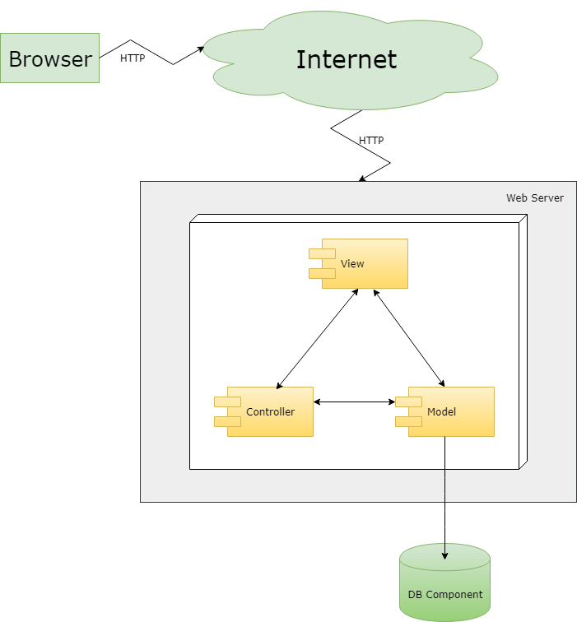

***Figure : Architectural Design***

### MVC Definition

**Model View Controller** or **MVC** as it is popularly called, is a software design pattern for developing web applications. It divides a given application into three interconnected parts. This is done to separate internal representations of information from the ways information is presented to, and accepted from, the user. MVC pattern is made up of the following three parts :

* **Model** − The lowest level of the pattern which is responsible for maintaining data.
* **View** − This is responsible for displaying all or a portion of the data to the user.
* **Controller** − Software Code that controls the interactions between the Model and View.

MVC design pattern decouples these major components allowing for efficient code reuse and parallel development.

### Components

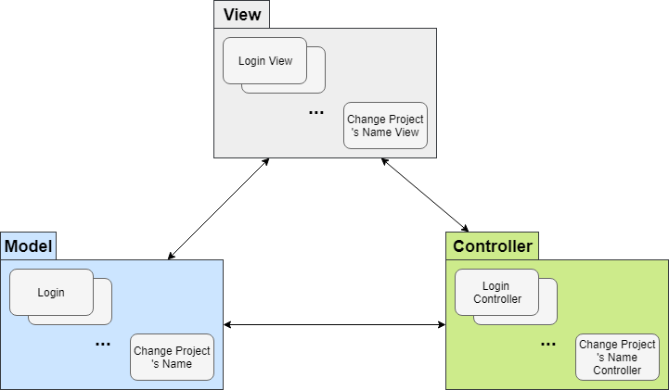

***Figure : Components Diagram for Website***

### Advantages and Disadvantages

#### Advantages

**Faster development process** – MVC supports rapid and parallel development. If an MVC model is used to develop any particular web application then it is possible that one programmer can work on the view while the another can work on the controller to create business logic of the web application.

[**High cohesion**](https://en.wikipedia.org/wiki/Cohesion_(computer_science)) – MVC enables logical grouping of related actions on a controller together. The views for a specific model are also grouped together.

[**Low coupling**](https://en.wikipedia.org/wiki/Loose_coupling) – The very nature of the MVC framework is such that there is low coupling among models, views or controllers

**Ease of modification** – Because of the separation of responsibilities, modification does not affect the entire model so future development or modification is easier

**Multiple views for a model** – Models can have multiple views

**Support for asynchronous technique** – MVC also supports asynchronous technique, which helps developers to develop an application that loads very fast.

#### Disadvantages

**Code navigability** – The framework navigation can be complex because it introduces new layers of abstraction and requires users to adapt to the decomposition criteria of MVC.

**Multi-artifact consistency** – Decomposing a feature into three artifacts causes scattering. Thus, requiring developers to maintain the consistency of multiple representations at once.

**Pronounced learning curve** – Knowledge on multiple technologies becomes the norm. Developers using MVC need to be skilled in multiple technologies.

## **Detail Design**

### CRC Cards (Class-Responsibility-Collaborators)

|  |  |
| --- | --- |
| **Account** | |
| **Responsibilities** | **Collaborators** |
| Register new account | Team  Student |
| Login | Student  Academic staff  Supervisor |
| Logout | Student  Academic staff  Supervisor |
| View profile | Student  Academic staff  Supervisor |
| Edit profile | Student  Academic staff  Supervisor |
| Change password | Student  Academic staff  Supervisor |
| Reset password | Student  Academic staff  Supervisor |
| Create account (for academic staffs/ supervisors) | Administrator(?) |
| Edit account (for academic staffs/ supervisors) | Administrator(?) |
| Delete account | Administrator(?) |
| Search account | Administrator(?) |
| Lock account | Administrator(?) |
| Unlock account | Administrator(?) |
| Approve team | Supervisor |

|  |  |
| --- | --- |
| **Academic staff** | |
| **Responsibilities** | **Collaborators** |
| Checking result | Team  Student |
| Edit meeting | Team  Student  Supervisor |
| Approve request from supervisor | Team  Supervisor |
| Approve request from team-leader | Team  Student |
| Reject request from team-leader | Team  Student |

|  |  |
| --- | --- |
| **Supervisor** | |
| **Responsibilities** | **Collaborators** |
| Manage request | Academic staff  Team  Student |
| Add meeting | Academic staff  Team |

|  |  |
| --- | --- |
| **Student** | |
| **Responsibilities** | **Collaborators** |
| Manage work report | Team |
| Log bug to list | Team |
| Add code/test bugs as task | Team |
| Request to supervisors/academic staff | Academic staff  Supervisor  Team |

|  |  |
| --- | --- |
| **Team** | |
| **Responsibilities** | **Collaborators** |
| Manage task | Team  Supervisor  Student |

### Class Diagram

### Sequence Diagram Examples

#### Create team

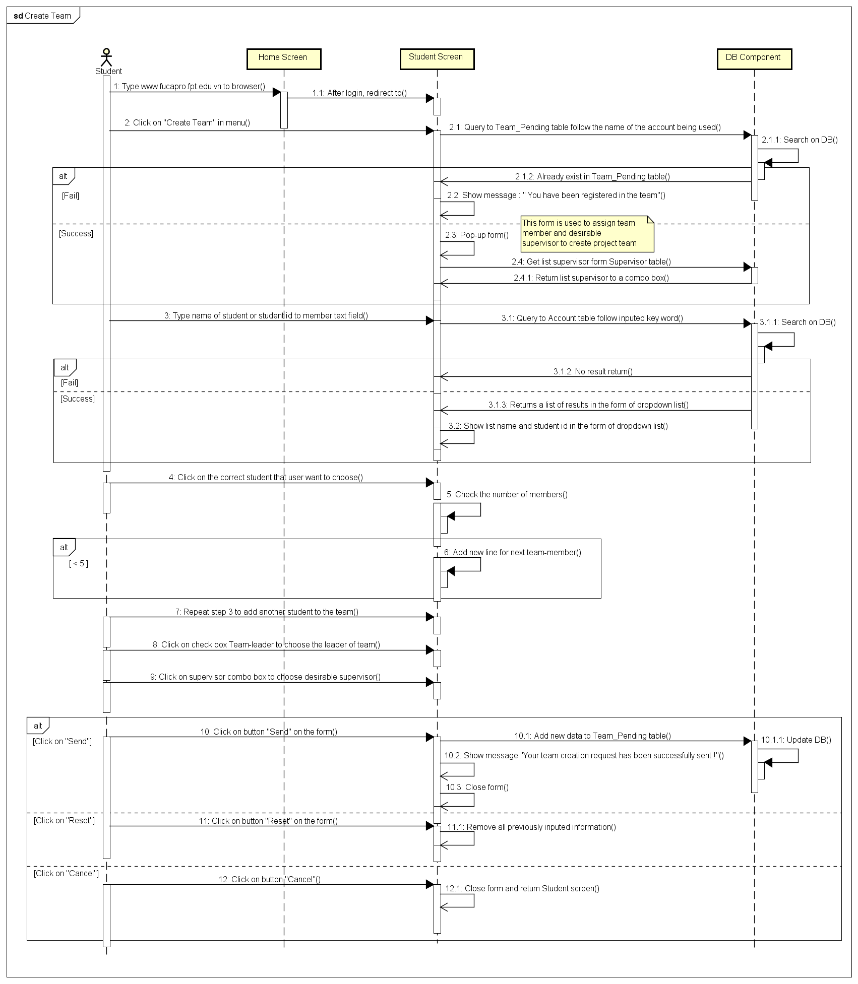

#### Approve team

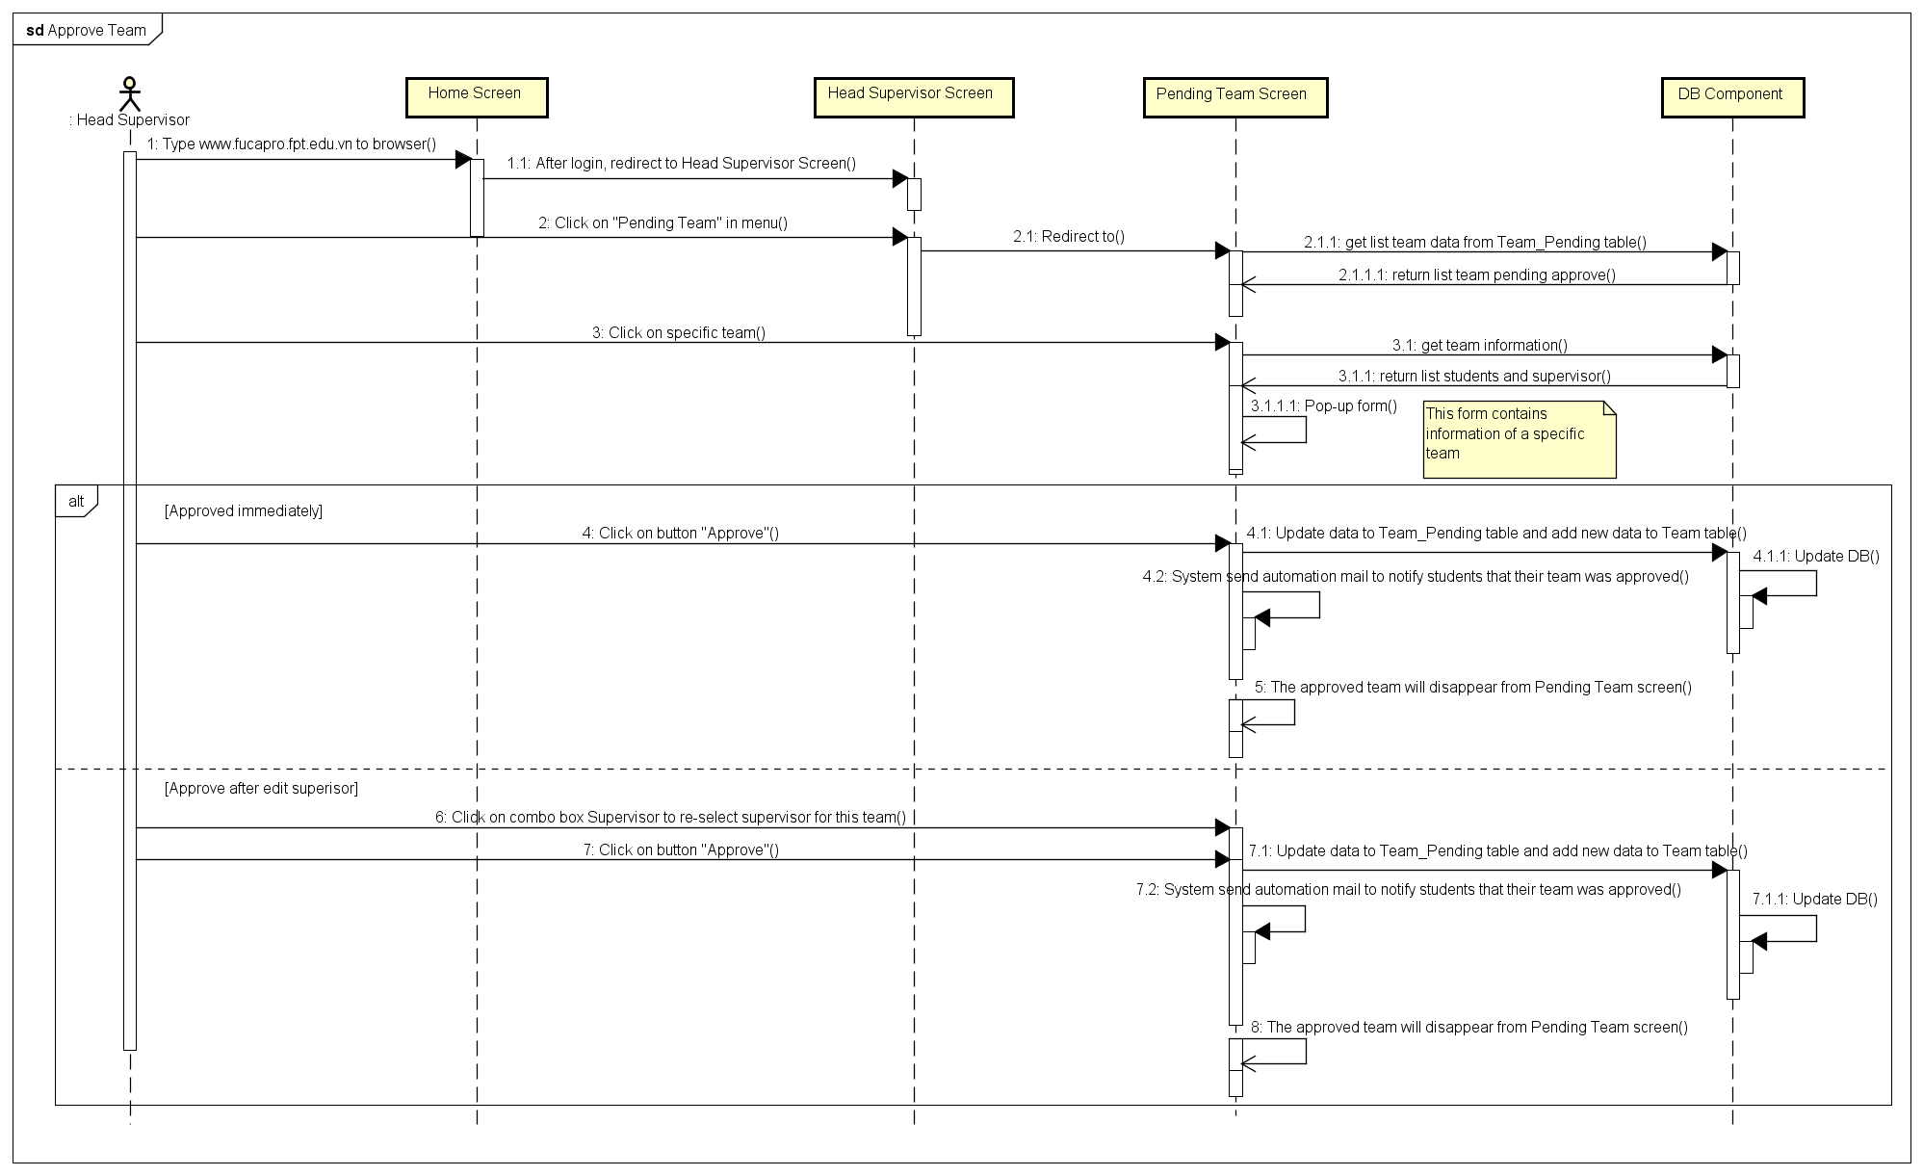

#### Change project’s name

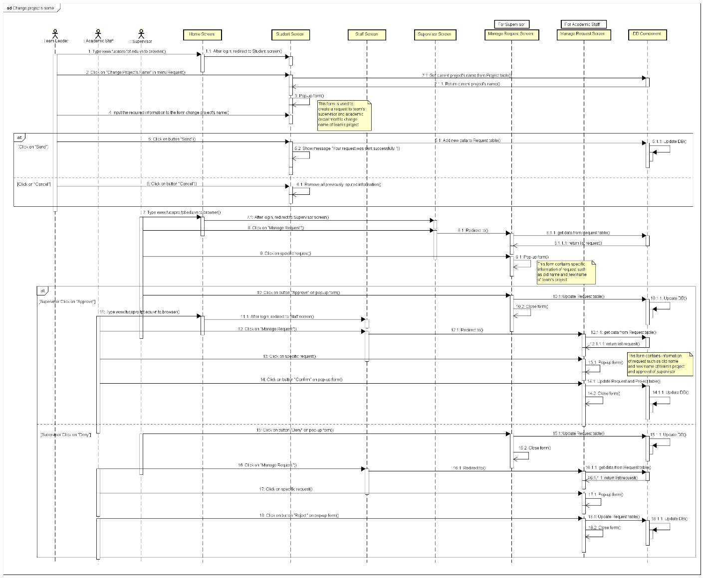

#### Log & Assign bug to task

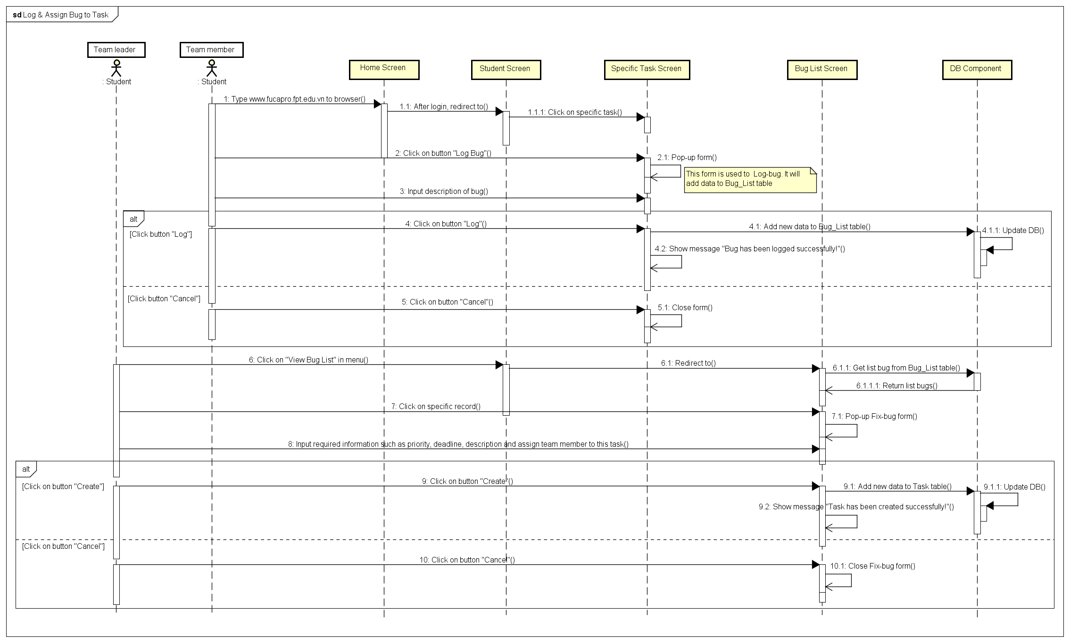

#### Request & Approve meeting room

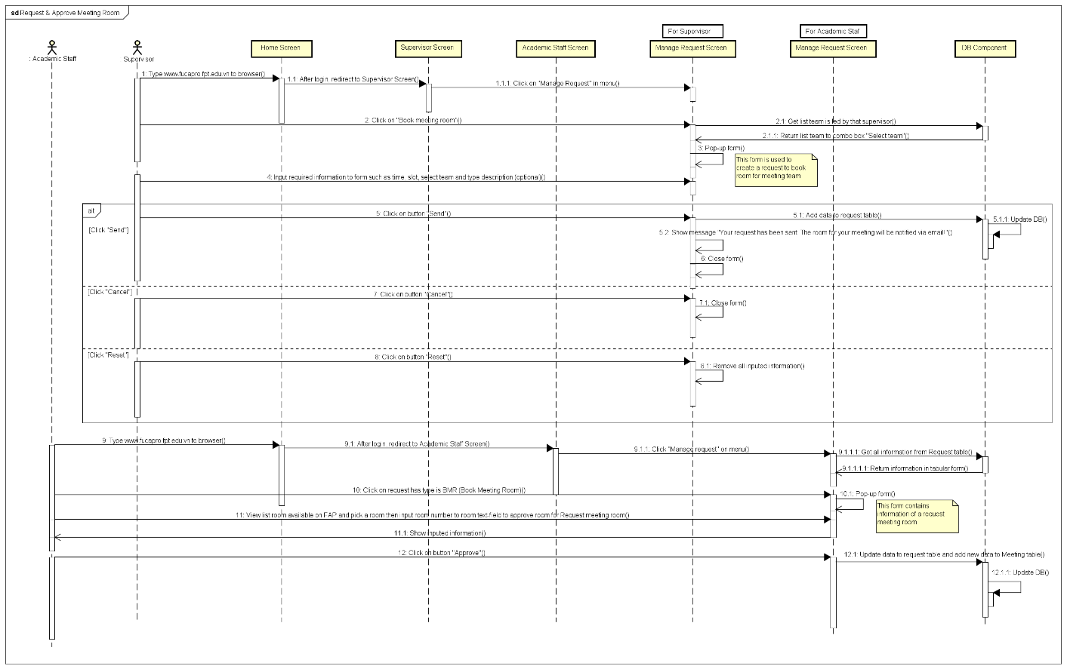

### Entity Relationship Diagram

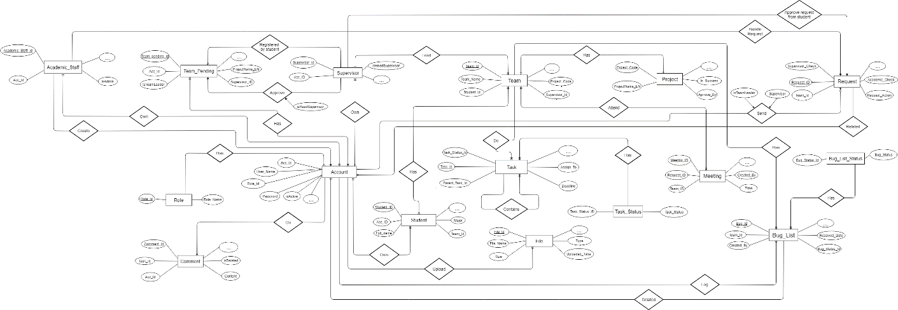

### Database Design

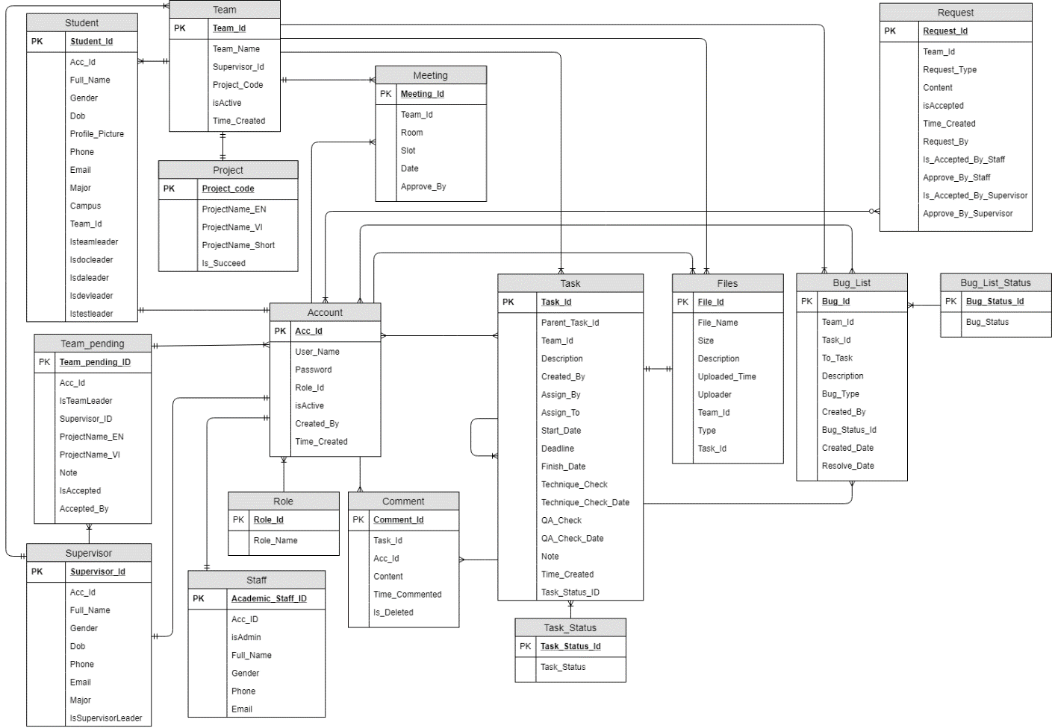

## **Other material (if any)**

# **CHAPTER 5: SOFTWARE TESTING DESCRIPTION (STD)**



## **Introduction**

### Overview

* + - This document describes the approach, testing tool, environment and test schedule used by the testing group to plan and manage the testing of our application. It describes details of test cases. It makes sure that user satisfied with our product.
    - Chapter 5 includes the sections below:
      * Approach
      * Responsibility
      * Testing tool and environment
      * Test plan
      * Test report

### Test Approach

* + - Our application follows a V-Model process to implement testing.

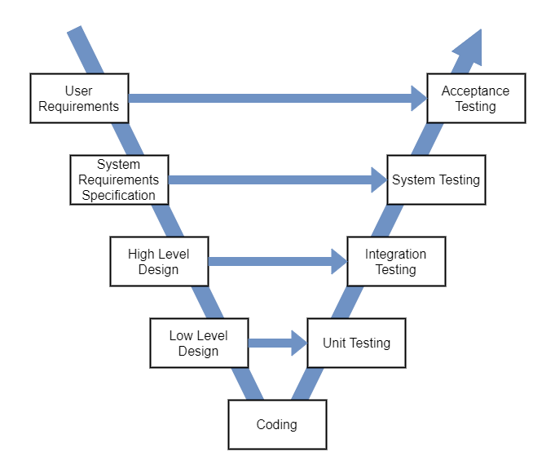

***Figure 14: V-Model***

## **Test Plan**

### Stage of testing

* **Unit Testing**
  + In the first round of testing, the program focuses on specific units or components of the application to determine whether each one is fully functional. One of the biggest benefits of this testing phase is that it can be run every time a piece of code is change and resolved issues as quickly as possible. Unit testing will be done by the developer and approved by the development team leader.
* And rule for filling the result is:
  + Test result pass: Ok
* Test result fail: Fail
* Do not test: Untested
* Cannot test: N/A
* **Integration Testing**
  + After finish unit testing, integration testing will be performed by tester of the project. This testing level is designed to find interface defects between the modules/functions. If any bugs are found, tester have to log bug and assign to developer fix bug and redo fix bug process until it correct.
  + And rule for filling the result is:
* Test result pass: Pass
* Test result fail: Fail
* Do not test: Untested
* Cannot test: N/A
* **System Testing**

After finish integration testing and application complete in the first level, tester will be performed system test. The goal at this level is to evaluate whether the system has complied with all of the outlined requirements and to see that it meets Quality Standards. System test is ended when all test cases are passed.

* **Acceptance Testing**

Acceptance testing is performed in the real environment by user.

In our project, Acceptance testing will be executed by all team members at the user point of view. Determine whether a system satisfies the requirements specified in the requirements analysis phase. Finding defects is not the main focus in this stage.

### Features to be tested

All features that is described on use-case diagram.

### Features not to be tested

Out of scope features will not be tested.

### Testing Tools and Environment

|  |  |
| --- | --- |
| Software | Hardware |
| * PHPStorm. * MySQL * Google Chrome | * Windows 10 Pro 64-bit |

## **Test Cases**

### Unit Test

### Integration Test

|  |  |  |  |  |
| --- | --- | --- | --- | --- |
| Intergration Test Case | Description | Status | Function | Class |
| Login | | | | |
| Test case identifier Test item(s)  Input Specification Output Specification  Environmental needs | IT1 Homepage->Login Check if correct class are call in class Login after tapping Login | Pass | Login() | HomePage Login |
| Test case identifier Test item(s) Input Specification  Output Specification  Environmental needs | IT2 Login->Login  Login input valid Check if correct function are call in class Login IT1 is successed | Pass | ConnectDataBase() | Login |
| Test case identifier Test item(s) Input Specification  Output Specification  Environmental needs | IT3 Login->HomePage  Check if correct class and function are call in class Login IT2 is successed | Pass | Login() | HomePage Login |
| Register Account | | | | |
| Test case identifier Test item(s)  Input Specification Output Specification  Environmental needs | IT0 Login->Register Create register activity Input Check if correct class are call in class Login | Pass | Register (Tap on button) | Register Login |
| Test case identifier Test item(s) Input Specification   Output Specification Environmental needs | IT1 Register->PostUser input valid all field Check if correct class are call in class Register IT0 is successed | Pass | Do (Tap on button) | Register PostUser |
| Test case identifier Test item(s) Input Specification  Output Specification Environmental needs | IT2 PostUser->PostUser PostUser input valid Check if correct function are call in class PostUser IT1 is successed | Pass | ConnectDataBase() | PostUser(?) |

## **Checklists**

### Checklist of Validation

*<Put the checklist here. Describe how it is used and the resulted checklist>*

### Submission Checklist

*<Put the checklist here. Describe how it is used and the resulted checklist>*

## **Other material (if any) (including appendix A)**

APPENDIX A. TEST LOGS

A.n Log for test *n*

A.n.1 Test Results

A.n.2 Incident Report

# **CHAPTER 6: SOFTWARE USER’S MANUAL**



## **Installation Guide**

## **User’s Guide**

## **Other [Optional]**