Hoàng Xuân Thịnh – HE161617

1. **Case study**

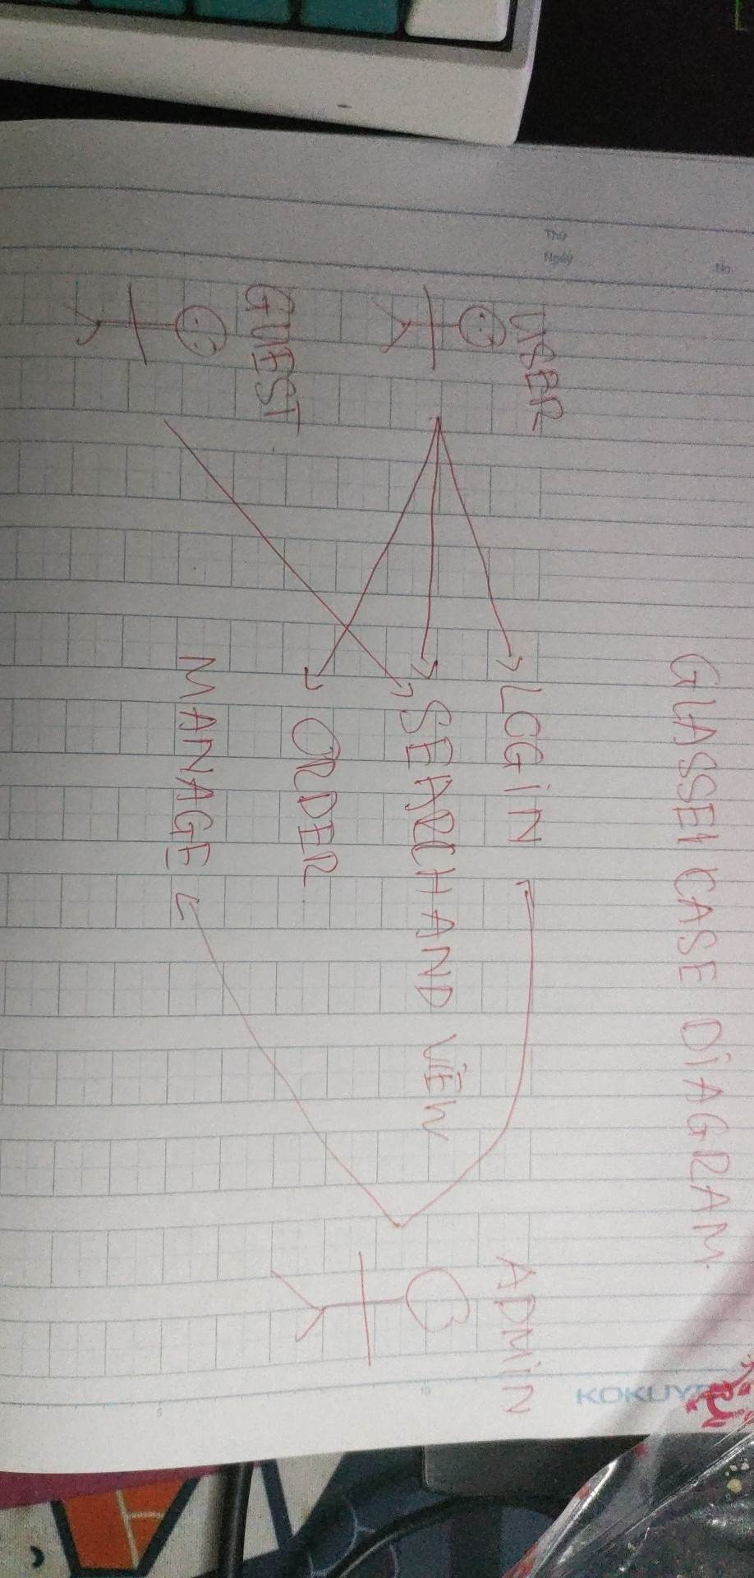

* The Java web source used to develop glasses e-commerce shopping
* Register an account with your username and password
* Authorizing user, admin by filter
* Add to cart don't reload page by using axios
* Design pattern MVC Model
* ...

1. **Database design**

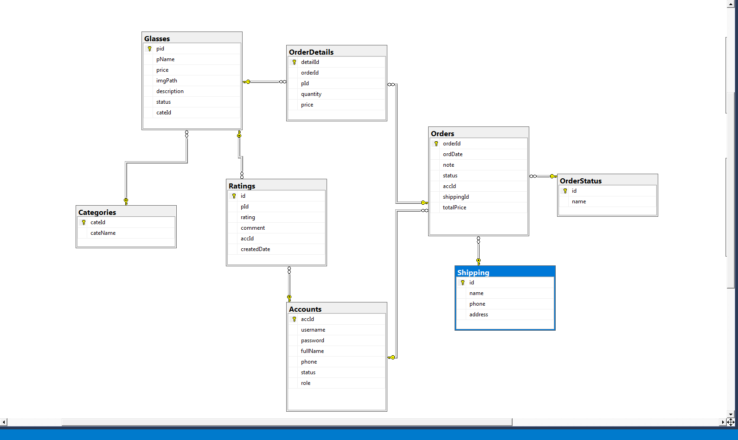

## III. Technology

**1. Frontend**

* HTML, CSS, JS, Bootstrap, jQuery
* JSP - JavaServer Pages
* JSTL - JSP Standard Tag Library
* Axios - Promise based HTTP client for the browser and node.js

...

**2. Backend**

* Servlets - a Java programming language class that is used to extend the capabilities of servers that host applications accessed by means of a request-response programming model
* JDBC - Java Database Connectivity - a Java API to connect and execute the query with the database

**3. Database**

* Microsoft SQL Server - a relational model database server produced by Microsoft

**4. Tool**

* Netbeans
* Java JDK
* Apache Tomcat
* Microsoft SQL Server Management Studio

**5.Libraries**

* Lombok
* JSTL
* sqljdbc4

**IV.System Design**

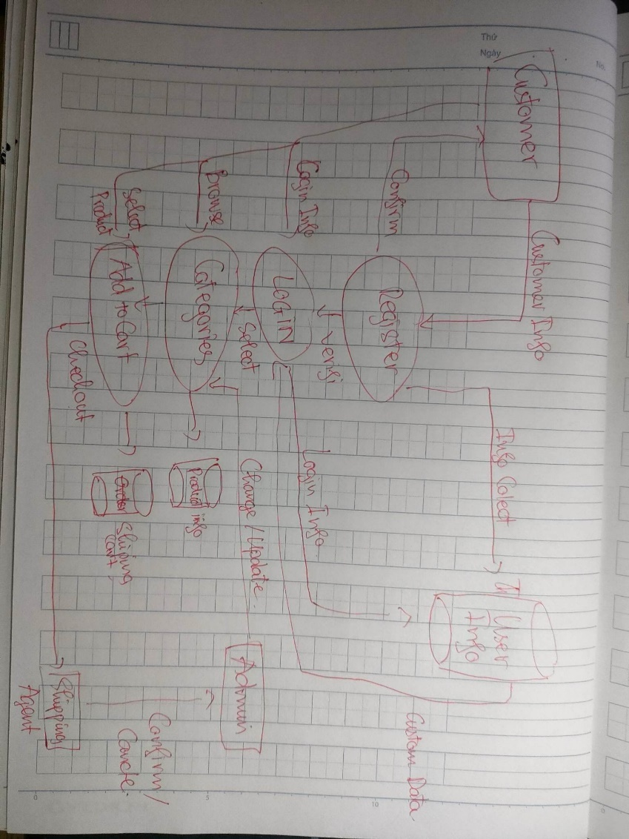

**V.Preview Screeshot**

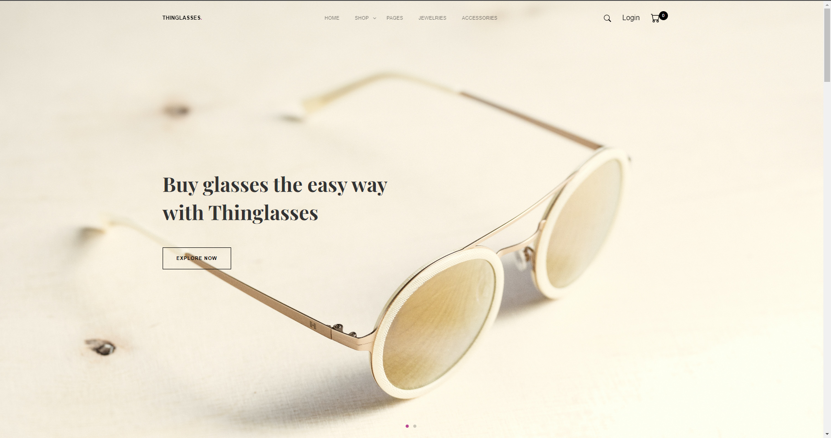 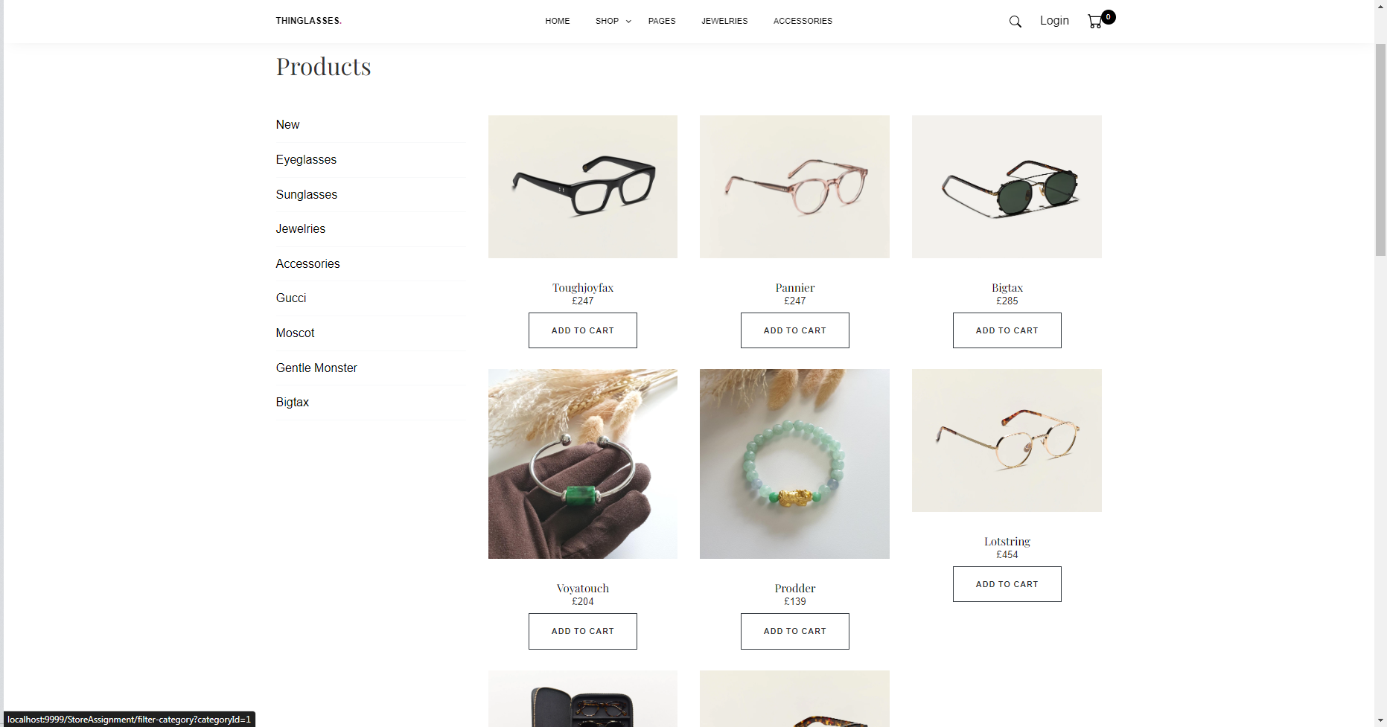 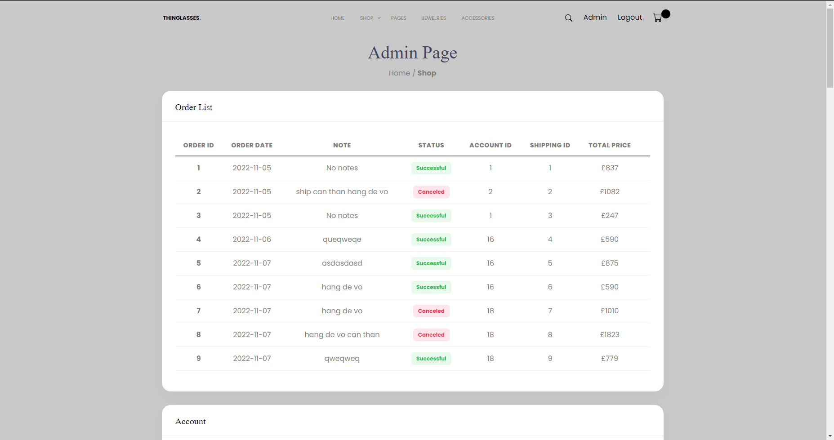 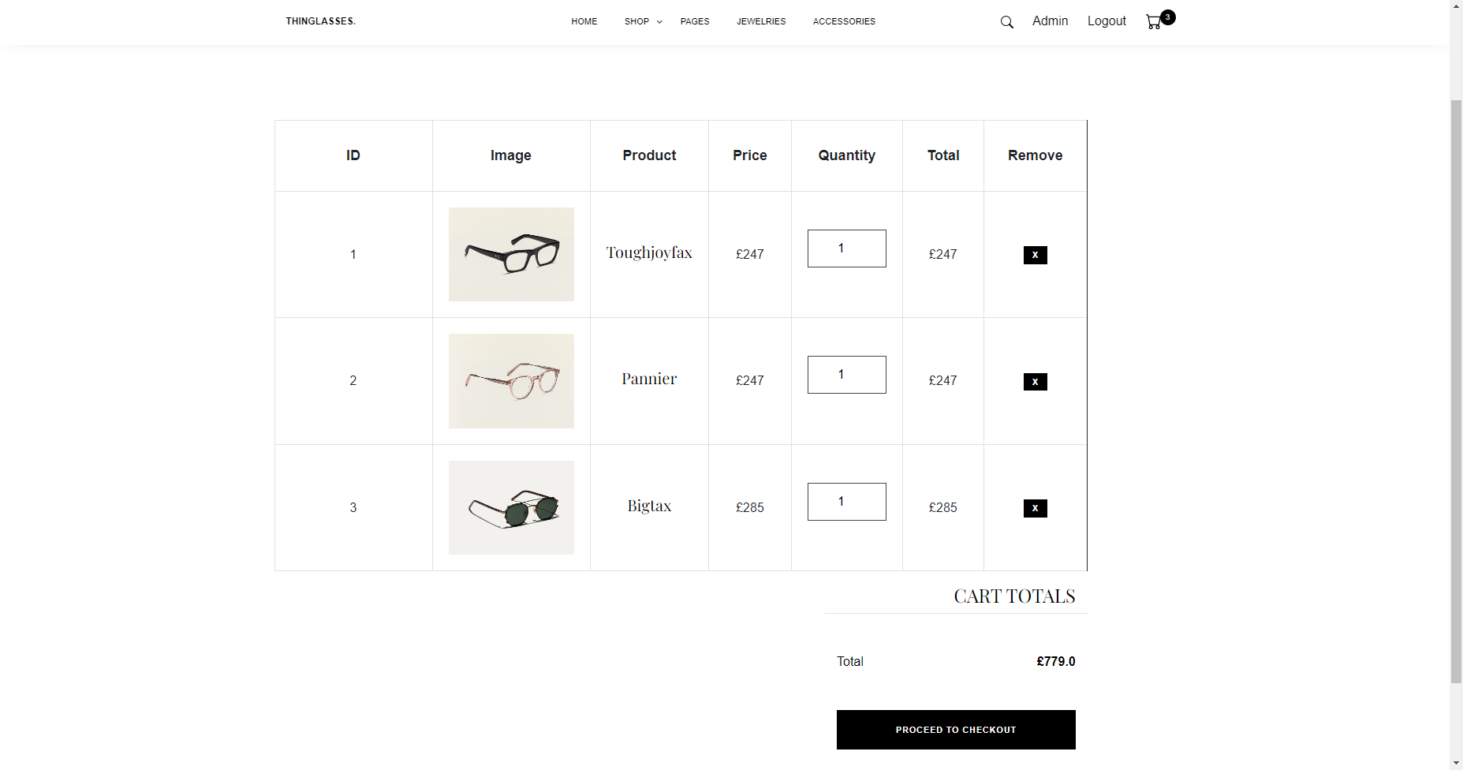 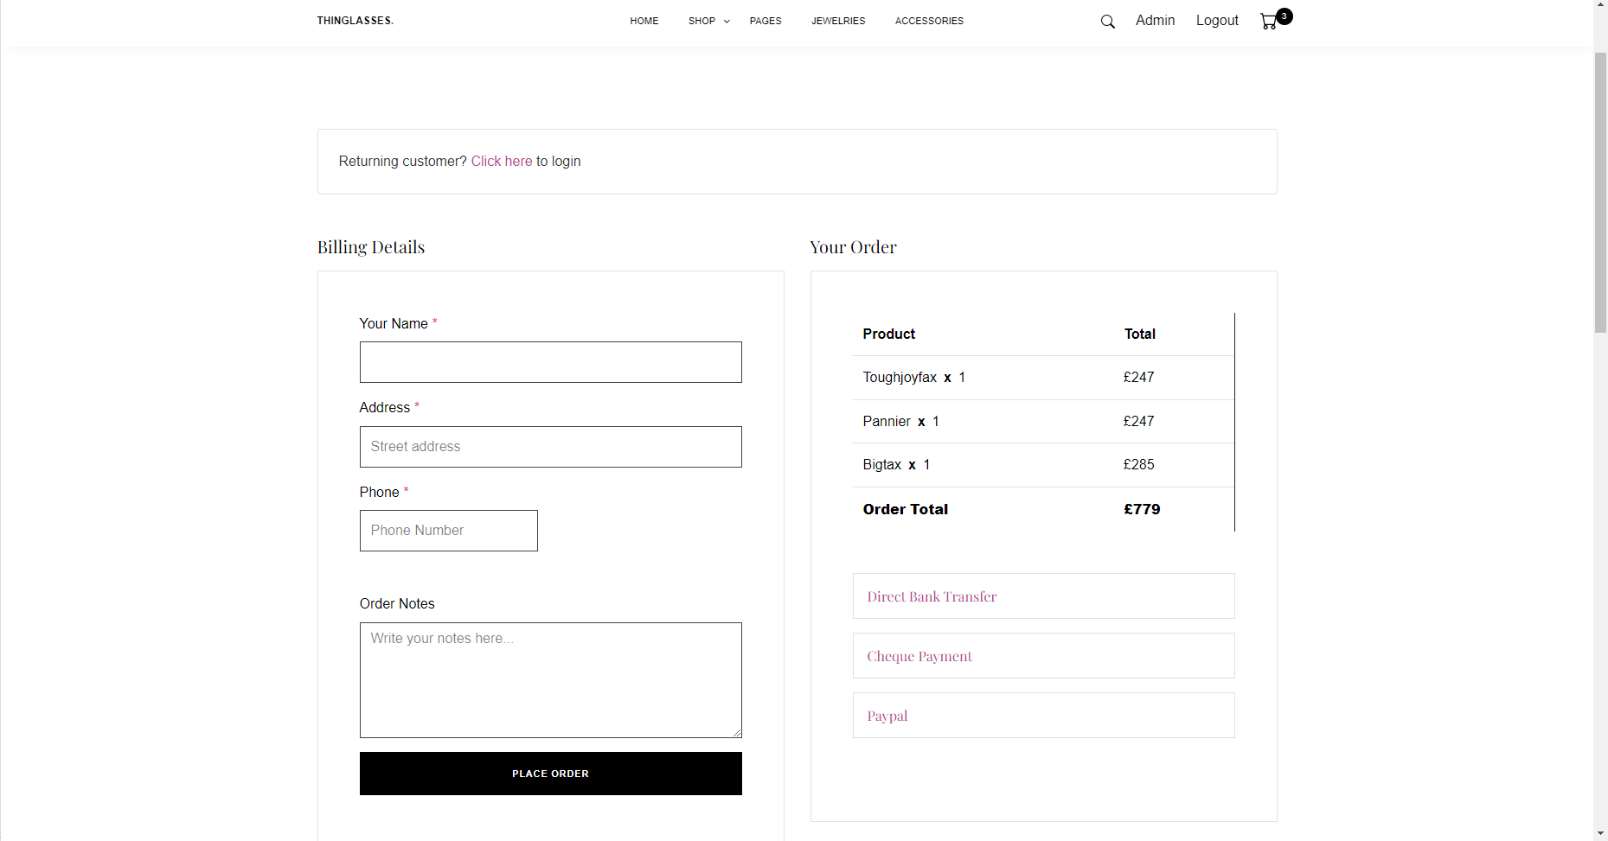 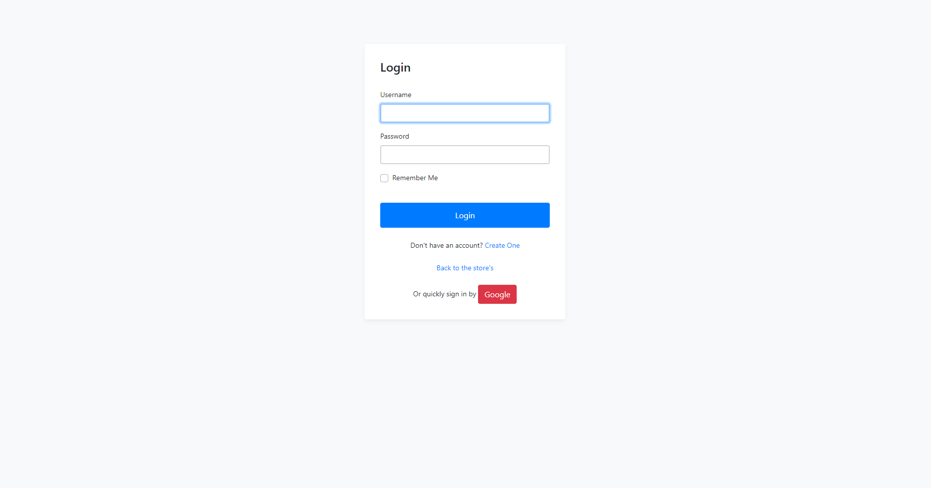 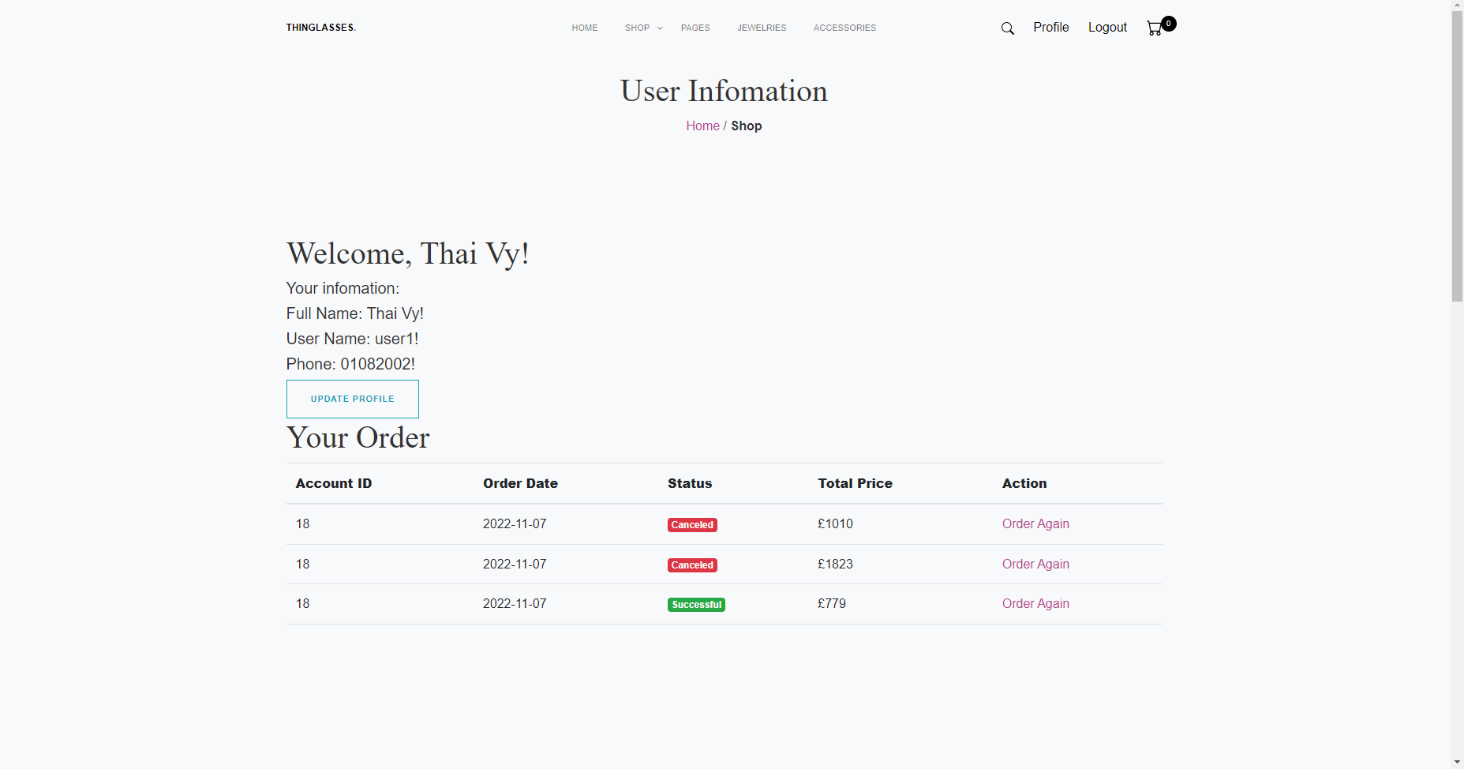 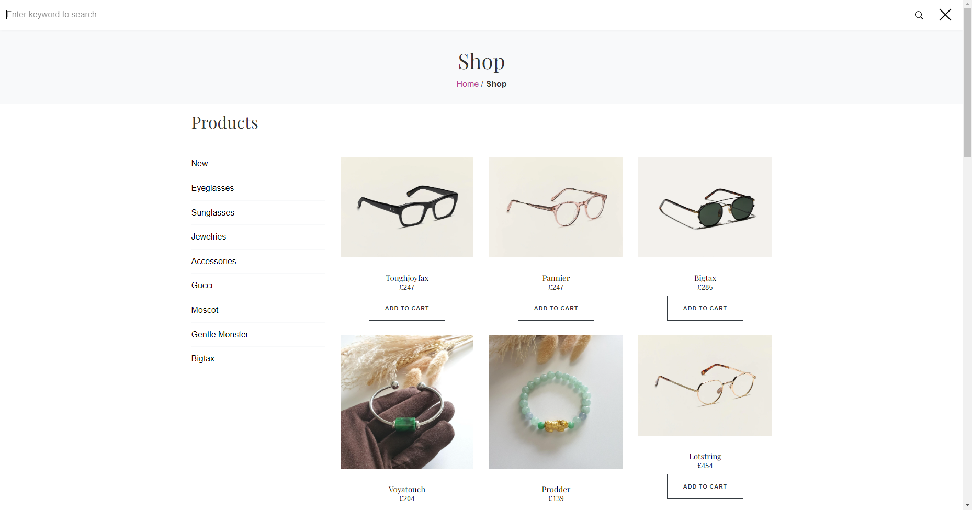

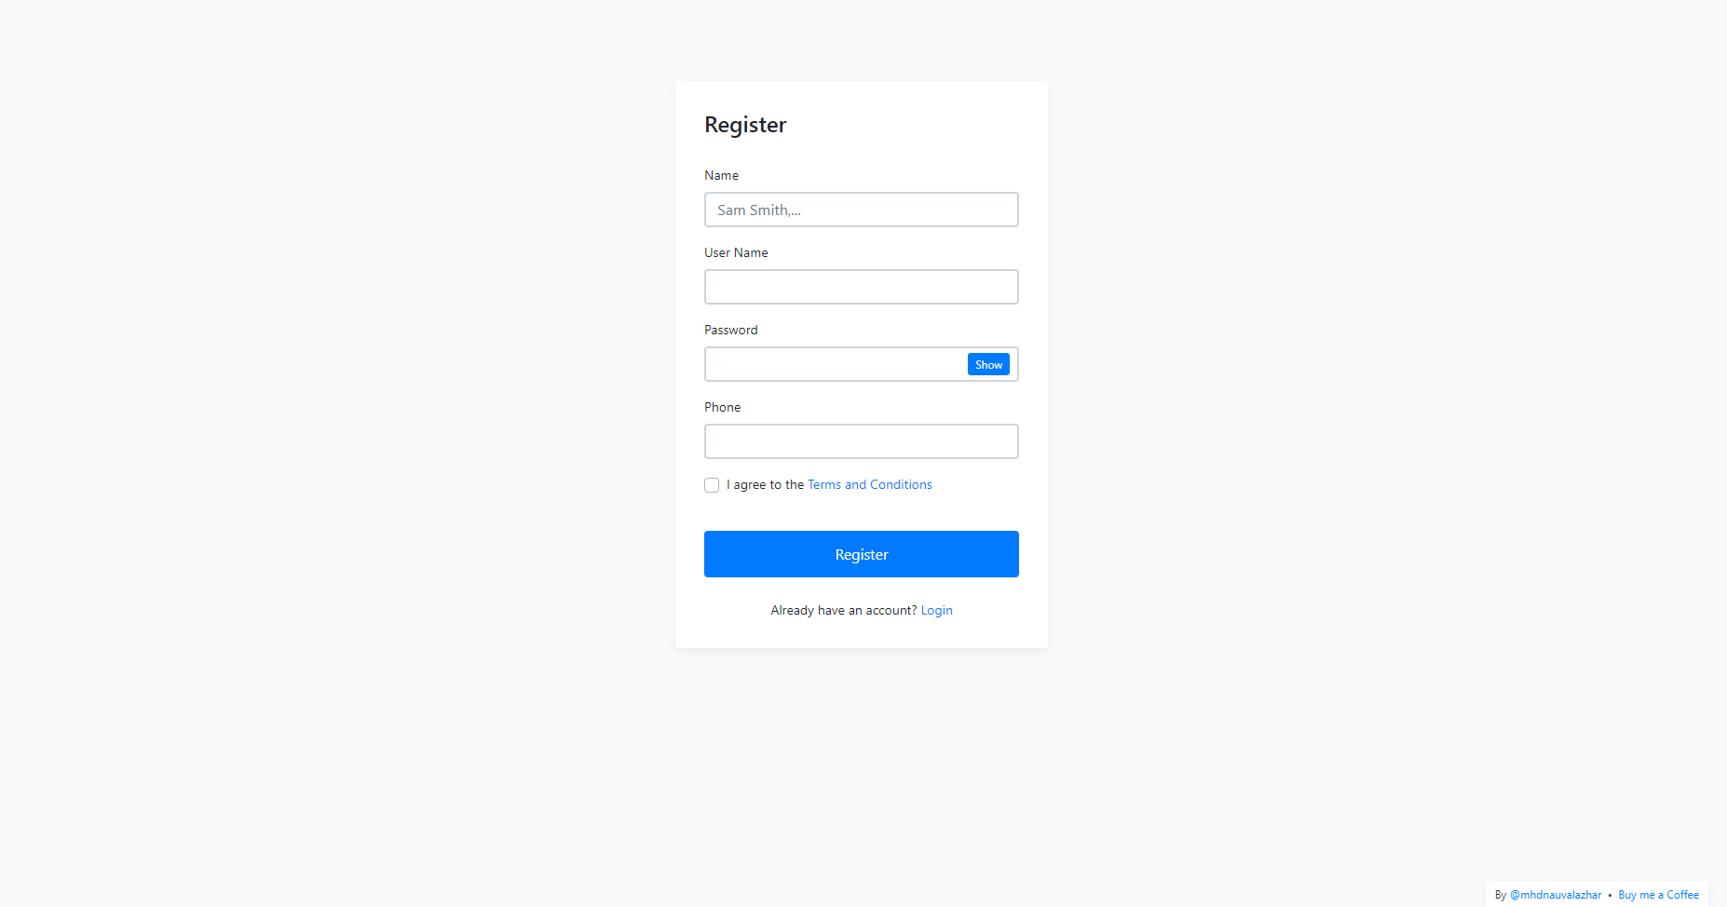

**V.Function**

1. Guest

Login by account ~1

 Register an account ~1

 Search, view

 Add, update, remove cart

1. User Account

 Search, view

 Add, update, remove cart

 Logout

 Update account information

 View, manage orders

Purchase

1. Admin

 Managing items

 Managing accounts

 Managing categories

 Managing orders

 Update admin account information