**Corporate Training System**

|  |  |  |  |
| --- | --- | --- | --- |
| ***Thinh, Le Phuc***  FPT University  Ho Chi Minh City, Vietnam | ***Nguyen, Vo Thach***  FPT University  Ho Chi Minh City, Vietnam | ***Hung, Pham Chanh***  FPT University  Ho Chi Minh City, Vietnam | ***Anh, Dang The***  FPT University  Ho Chi Minh City, Vietnam |

**Abstract** – Statistics prove that companies across the globe invest heavily on employee training and development. For example, employee training and education spends in the United States alone are growing significantly by 14% every year. Besides enhancing knowledge and skills, corporate training has proven to be an important tool to boost employee engagement and retention. However, in Vietnam, corporations are underestimating the importance of training and education. Therefore, companies are having limited and uneffective ways of training their employees. Seeing this problem, we build a system that may change corporations in Vietnam for a better and more efficient in training employees.

1. **INTRODUCTION**

Nowadays, online learning turns out to be more and more practiced. Many corporations start to post their training programs and courses online for their employees. It represents an easy and comfortable method to achieve knowledge in almost every field, from law and accounting, to even human sciences, such as psychology and physics. It represents a great way to study many fields and to boost the level of self-motivation. We can see that e-learning is a great alternative for corporations, especially for companies which can’t afford the time, money, human resources to train their employees. Currently, many corporations are having problems to find a suitable system that can provide them an environment to train staffs, manage training plans and view employees report easier and more effective. We build a system called TRAISY, which allows any corporates to post their training program with ease and privacy on our website. Through our system, staffs can access to training anywhere and anytime, making learning and training more effective, faster and easier. For corporations’ admin and manager, they can manage their programs effortlessly, and view their employees’ statistics.

TRAISY aims to provide all corporations in Vietnam with a professional environment for training staffs. To achieve that goal, the application has to, not only perform its business activities accurately such as course management, learner statistics, and user management, but also assist user with good UX (User experience) and beautiful UI (User interface).

1. **PROBLEM AND SOLUTION**

When implement the TRAISY system, we faced several problems:

1. **Buy or build?**

Video streaming is one of our mandatory functions, so the system must implement this function with these requirement:

* Pro-quality for mobile view.
* Low-latency and wide bandwidth for smooth streaming.
* Flexible and customizable for developer to maintain and upgrade.
* Professional-grade streaming.

What is video streaming? In our application, we apply HTTP Live streaming (HSL). HSL is a streaming protocol that generates multiple versions of the same content (but different resolution/bit rate) and chops these versions into chunks or segments (e.g., two seconds). The segments are provided on a web server and can be downloaded through HTTP standard compliant GET requests. Through multiple versions of same content, HSL also provides “adaptive streaming”, the client can switch to a higher resolution – if bandwidth permits, or to a lower resolution – if bandwidth decreases

At beginning, we found some platforms that let us stream video for free such as YouTube. We did integrate to our system and everything worked well. But soon, we found out that these free systems are hard to modified and the video files have to store at third party storage which makes us hard to manage it.

After that, the team found WOWZA streaming service, a paid streaming server which we realize that meet all of the team’s requirement. With WOWZA, we can manage the storage with ease, and the configuration for server is friendly for developer. However, the cost for this streaming service is expensive at about 1990$ for a lifetime experience, therefore if the team tend to implement this service forever, we have to invest a lot of money in it.

1. **Recommendation**

Like other item-related businesses, TRAISY needs to implement a mechanism to suggest its programs – courses – lectures to users. Collective Intelligence and Collaborative Filtering can be applied to solve the problem.

However, the following problems occur when the development team implements the algorithms:

* The TRAISY application are designed for each corporation, therefore, the programs – courses – lectures of the company may not big enough to implement the suggestion algorithm for users.
* Lack of real data to implement suggestion algorithm.

1. **PowerPoint presentation**

View PowerPoint slides is another mandatory function of our system, this function is important for boosting study outcome for learners.

The problem we meet with PowerPoint presentation is nearly the same with video streaming. We have to decide between using currently available systems for PowerPoint presentation or build our own system for this presentation function.

Our first approach to this problem is using the current available systems. We have tried the integrated system that Microsoft or Google provide us for PowerPoint presentation. But soon, we found out that this approach had several disadvantages:

* For uploading, the PowerPoint slides have to store in third-party storage (e.g. google drive if we use Google plugin PowerPoint presentation). Therefore, it is hard to manage these files.
* The uploading process have to call API of the build-in system, this makes the uploading process slow and not effective.
* For viewing slides, we cannot modify the viewing in HTML for our needs.

Seeing these disadvantages of first approach, we decided to build our own system to upload PowerPoint and view PowerPoint slides. We did manage to overcome those disadvantages above, however, because of the lack of time, the system we build is not fully functional and has some drawbacks such as beautiful UI for view slides.

1. **Plan implementation**

## **Play framework**

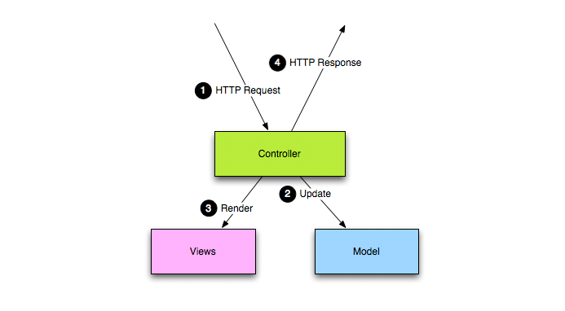

Our application is developed mainly on Play Framework 2.5 which follows the MVC architectural pattern.

This pattern splits the application into separate layers: The model layer, view layer, and controller layer.

• The model layer: Contains data structures and operations that needed for system to operate. Whenever model objects need to be saved into database, they contain JPA annotation for making these operations easier and more flexible.

• The view layer: a HTML file that presents the content and interaction with user. In play framework, views are generated using a templating system. The Controller gets data from the model layer, and then applies a template to render these objects.

• The controller responds to user actions and processes them. For more details, the controller listens for HTTP requests, then extracts relevant data from the request, such as parameter, request headers… and invokes the suitable methods that contains read, update or create the model object. After finishing the process, controllers render the view and then written as an HTTP Response to the user.

## **Wowza streaming service**

We also implement Wowza streaming engine to deliver video content or video lecture to user.

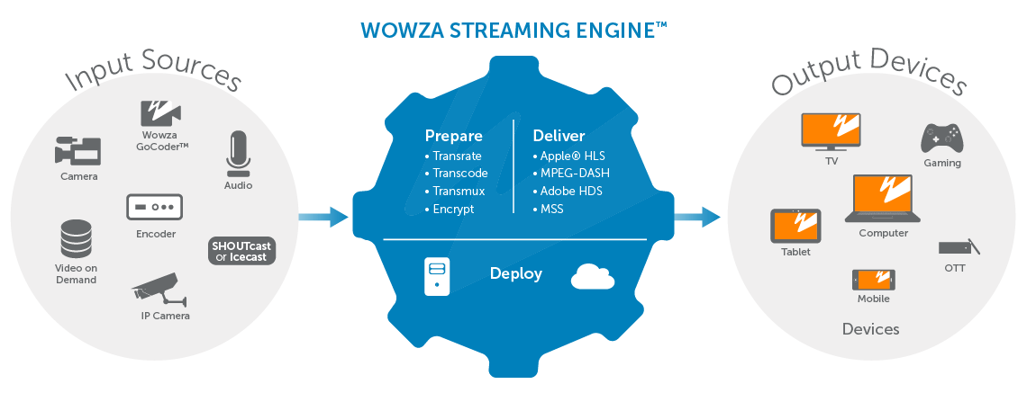

The architecture of WOWZA streaming service has 3 main components:

Input source: We implement VOD (Video on demand) aspect of WOWZA. VOD is a programming system that allows users to request immediate access (watch/listen) to video and audio content whenever a user choose it. The video/audio contents are already stored at the server. By using HLS protocol that we mention above, WOWZA stream the VOD, and deliver its content to users.

Prepare: The output for WOWZA that we implement:

* Protocol: HTTP Live streaming (HSL).
* Codecs: MP4
* Resolution: 720p, 1080p, UHD 4K

Deliver: WOWZA can deliver through these target:

* Devices: Computers, mobile phones and tablets, smart TV.
* Player: Microsoft Silverlight, Apple QuickTime, iOS native player, Android.

## **Algorithm create course URL**

When a user visits a training course in our system, the web will navigate to that course’s page with unique URL for each course.

Each course has its own title and content. However, we need a unique URL that related to the title for web to navigate between courses. The problem is that when a user creates a course, the course title may be duplicated to other course; therefore, we need an algorithm to differentiate between courses that have the same title but different content.

To solve this problem, we should follow these steps:

Each course will be distinguished by its URL that saved in database, which is created through:

1. Lowercase all the course’s title

2. Transfer the course title into non-Unicode characters by removing the Unicode accents and diacritics

3. Replace special characters such as white space with hyphen (-)

4. If the URL is already existed in database, the URL will be appended with a number behind.

5. The URL structure will be as bellow:

• Khoá học HTML: khoa-hoc-html (if course title is not duplicated)

• Khoá học HTML: khoa-hoc-html-1 (if course title is duplicated)

The algorithm above can be viewed as the flow chart below:

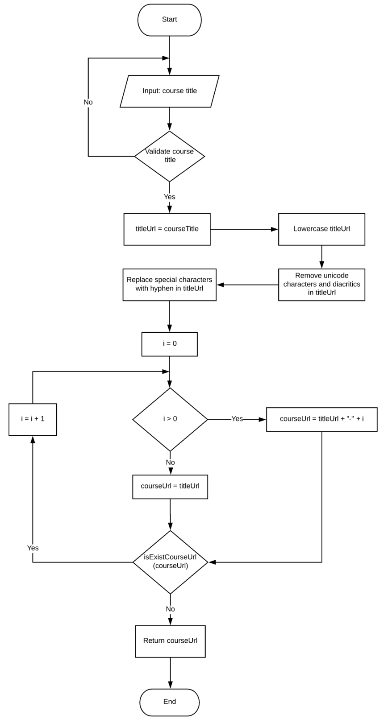

1. **Experiment result and conclusion**

We have executed some testing on our application, below are the results:

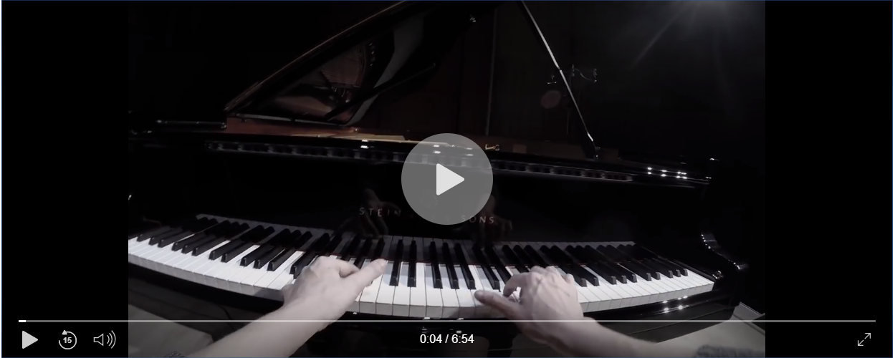

Successfully implement streaming service for video/audio.

**Conclusion**:

After experiment many time, we conclude that WOWZA is suitable and worth for building streaming application.

**Strengths**:

* WOWZA has been widely used in several systems, such as Facebook, Vimeo, Walt Disney.
* Flexible for development, many customizations can be done.
* Professional UI for streaming.
* Support a variety of streaming protocols, devices, and video/audio codecs.

**Weakness**:

* Development cost is high.

**Acknowledgment**

This paper owes massive thanks to Mr. Nguyen Huy Hung at FPT University. He was always support us whenever we ran into troubles or had questions about our project. He consistently allowed this project to be our own work, but steered us in the right direction whenever he thought we needed it.

REFERENCE

1. **Play Framework 2.5** *[Online.]* Available: https://playframework.com/documentation/2.5.x/Home. Accessed on: Jan. 2018.
2. **Wowza Streaming Engine** *[Online.]* Available: <https://www.wowza.com/products/streaming-engine/documentation>. Accessed on: Jan. 2018.
3. **Play Framwork 2.5 Deployment** *[Online.]* Available:

<https://www.playframework.com/documentation/2.5.x/ProductionConfiguration>. Accessed on: April. 2018.

<https://www.playframework.com/documentation/2.5.x/Deploying#using-the-dist-task>. Accessed on: April. 2018.

1. **2O17 TRAINING INDUSTRY REPORT** *[Online.]* Available: <https://trainingmag.com/trgmag-article/2017-training-industry-report> Accessed on: Jan. 2018.