**MINISTRY OF**

**EDUCATION AND TRAINING**

**FPT UNIVERSITY**

Capstone Project Document

**Corporate Training System**

|  |  |
| --- | --- |
| **GROUP 02** | |
| **Group members** | Lê Phúc Thịnh – SE61759 (Leader)  Võ Thạch Nguyên – SE61778  Phạm Chánh Hưng – SE61807  Đặng Thế Anh – SE61372 |
| **Supervisor** | Nguyễn Huy Hùng |
| **Ext. Supervisor** | N/A |
| **Capstone Project code** | CTS |

-Ho Chi Minh City, ***8th January, 2018***-

*This page is intentionally left blank*

Table of Contents

List of Tables 4

Definitions, Acronyms, and Abbreviations 5

A. Report No. 1 Introduction 6

1. Project Information 6

2. Introduction 6

3. Current Situation 6

4. Problem Definition 6

5. Proposed Solution 7

**5.1** **Feature functions** 7

**5.2 Advantages and Disadvantages** 7

6. Functional Requirements 7

7. Role and Responsibility 8

B. Report No.2 Software Project Management Plan 9

1. Problem Definition 9

1.1 Name of this Capstone Project 9

1.2 Problem Abstract 9

**1.3 Project Overview** 9

**2. Project organization** 12

**2.1 Software Process Model** 12

**2.2 Roles and responsibilities** 13

**2.3 Tools and Techniques** 14

**3. Project Management Plan** 15

**3.1 Product Backlog** 15

Refer to Apendix 15

**3.2 Sprint Backlog** 15

Refer to Apendix 15

**3.3 All Meeting Minutes** 15

**4. Coding Convention** 15

C. Report No. 3 Software Requirement Specification 16

**1. User Requirement Specification** 16

**1.1 Learner Requirement** 16

**1.2 Author Requirement** 16

**2. System Requirement Specification** 16

**2.1 External Interface Requirement** 16

**2.2 System Overview Use Case** 17

# List of Tables

Table 1: Roles and Responsibilities 3

# Definitions, Acronyms, and Abbreviations

|  |  |
| --- | --- |
| **Name** | **Definition** |
| CTS | Corporate Training System |

# A. Report No. 1 Introduction

## 1. Project Information

* Project name: **Corporate Training System**
* Project Code: **CTS**
* Product Type: **Website application**
* Start Date: **8th January, 2018**
* End Date: **April, 2018**

## 2. Introduction

In this document, we will introduce a solution for Corporates to train their employees more effectively. Nowadays, many companies are having problem to find a system that can provide them an environment to train new staffs easier.

Based on ours researches and analysis, we proposed a solution for this problem. We build a system, which allows any corporate to post its training program on our website. Through our system, staffs can access to training anywhere and anytime, making learning and training more effective.

Besides, this document also shows our working process and our perspective in the system, designs, architecture and workflow.

## 3. Current Situation

In recent years, e-learning or studying online is becoming more and more widely used. Corporations with an online training system find out their employees are training faster and better than those who do not have access to online learning. However, it seems not easy for each company to build their own training system.

Whenever a Corporate want to develop a system to train their employees, they usually hire a software company to build a system that suitable for their needs with a cheap price. Nevertheless, it’s hard to seek a software company to acquire the two requirements above.

## 4. Problem Definition

From above current situation, we have these disadvantages:

* No platform for any Corporate to train its employees online
* Learner cannot communicate in real time with author to understanding content of that course if they get trouble in learning.
* Learner have to wait for their manager to accept the request before they can begin to learn a course.
* When an author creates a course, they do not need to receive a permission from manager or administrator. Therefore, that course will have a bad influence on learners.
* An author maybe wonders what plan or program that their courses belongs to.

## 5. Proposed Solution

Our proposed solution is to build a system named Corporate Training System (CTS) who has troubles with finding a place to train their employees online.

Corporate Training System is a web application with following functions:

### **Feature functions**

* Manage plan, programs, skills and courses.
* Manage users.
* Manage corporate brand and information.
* Participate to a plan or program.
* Enroll in a course.
* Learn a lecture.
* Take quiz and view quiz result.
* Make statistic report.
* View learners’ report on learning activities
* Manage personal information
* Manage discussion.

### **5.2 Advantages and Disadvantages**

* Advantages:
  + - * + Necessary for all corporate
        + New idea
        + Easy to use application
        + Friendly interface
* Disadvantages:
  + - * + Finding a suitable price for customer.
        + The cost in web application maintenance is high
        + Users’ demand change

## 6. Functional Requirements

Function requirements of the system are listed as below:

* Learner component:
  + View program
  + View study plan
  + Search study course
  + View study course
  + Enroll course
  + Manage profile
  + Manage discussion
  + View learning activity
  + Sign in, Sign out
* Author component:
  + View learner statistic
  + Manage course
* Manager component:
  + Manage training plan
  + Manage user
  + Manage program
  + Manage skill
  + View learners’ report
  + Add learner to program/plan
  + Remove learner from program/plan
* Admin component:
  + Manage corporate’s information and brand
  + Change user’s role
  + Ban user from study

## 7. Role and Responsibility

|  |  |  |  |  |
| --- | --- | --- | --- | --- |
| No | Full Name | Role | Position | Contact |
| 1 | Nguyễn Huy Hùng | Project Manager | Supervisor | hungnh@fpt.edu.vn |
| 2 | Lê Phúc Thịnh | Developer | Leader | thinhlpse61759@fpt.edu.vn |
| 3 | Võ Thạch Nguyên | Developer | Member | nguyenvtse61778@fpt.edu.vn |
| 4 | Phạm Chánh Hưng | Developer | Member | hungpcse61807@fpt.edu.vn |
| 5 | Đặng Thế Anh | Developer | Member | anhdtse61372@fpt.edu.vn |

**Table 1: Roles and Responsibilities**

# B. Report No.2 Software Project Management Plan

## 1. Problem Definition

### 1.1 Name of this Capstone Project

- Official name: Corporate Training System

- Vietnamese name: Hệ thống đào tạo cho doanh nghiệp

- Abbreviation: CTS

### 1.2 Problem Abstract

This project is our concern about development of training online for corporation. We call it Corporate Training System (Traisy). As current in Vietnam, as well as other developed countries, websites and applications for e-study are limited in functions and often focus on only certain companies. For example, many platforms for learning online only contains video lecture. Meanwhile, some systems support many functions but only available to a specific company, such as SAKAI for FPT SOFTWARE.

Those websites that focus on several tasks for e-learning are often designed for international users and thus, are not particularly suitable for Vietnamese people.

The solution is to provide a system for all corporates, especially Vietnamese Corporates, a way to satisfy all their needs of a simple and effective e-training for employees.

**1.3 Project Overview**

**1.3.1 Current Situation**

Below are some problems encountered in this project:

* **Business logic:** Some scopes of project are not clear to every team member in early stage of developments. For example, learners cannot self-enroll their selves into a training program but being enrolled by their manager or admin.
* **Schedule of team member:** team members can have a conflict in meeting schedule because of sick, or class and work schedule, etc.
* **Framework study:** team member have a problem when applying the play framework into project. The team needs an amount of time to get familiar new techniques.
* **Some tools require premium package to access:** For convenience for play framework, we use Intellij IDE, which requires premium account and expensive for our team members.
* **Lack of UI (user interface), UX (user experience) design skill:** Our team members all study IS major and no one has studied UI, UX design. Therefore, that some UI may misunderstand or hard to use with normal user.
* **Knowledge about training plan:** this project is about how a corporation or company trains their employees. The knowledge of this issue is new to members.

**1.3.2 The Proposed System**

The proposed system is Corporate Training System. The system contains a web application for learner, author, manager and admin.

In detail, the web application provides following features:

* For learners:
  + Learners can view study courses. In this function, they can view all resources and lectures of a course they are assigned and through this, they can study any lecturer.
  + Learners can view their learning activities. After a course is enrolled for learners, they can view process of their study.
  + Learners can update their info and manage their discussion.
* For author:
  + Authors can manage their courses. Author has full function to edit their lessons such as update, delete and add.
  + Author can view learner statistic. In this function, author can view all learners’ progress who takes their lectures. By doing this, author can easily improve their lesions.
* For manager:
  + Manager can manage learners. Manager can add a learner to a program/plan, or remove learner from any program/plan of their company.
  + Manager can create, edit or delete a skill.
* For admins:
  + Manage corporate’s information. Admin can edit their corporate’s related information and change company’s logo or brand name.
  + Admin can edit all users’ role.

**1.3.3 Boundaries of the System**

This section suppose that users of the system has stable Internet connection while using.

**The system can:**

* Allow any corporate to register their training program online.
* Allow only author, manager to create courses
* Allow only admin to change role of users
* Learners only allow to search programs/plans or courses that they are enrolled

**Besides, the system cannot:**

* Let the learner to self-enroll their selves

**1.3.4 Development Environment**

1.3.4.1 Hardware requirements

**For server**

|  |  |  |
| --- | --- | --- |
| **Server** | **Minimum Requirements** | **Recommended** |
| **Internet Connection** | Cable, Wi-Fi (4 Mbps) | Cable, Wi-Fi (8 Mbps) |
| **Operating System** | Window Server 2008 | Window Server 2008 |
| **Computer Processor** | Intel® Xeon ® 1.4GHz | Intel® Xeon ® Quad Core (12M Cache, 2.50 GHz) |
| **Computer Memory** | 1GB RAM | 2GB or more |

*Table 2: Hardware Requirement for Server*

**For PC**

|  |  |  |
| --- | --- | --- |
| **PC** | **Minimum Requirements** | **Recommended** |
| **Internet Connection** | Cable, Wi-Fi (4 Mbps) | Cable, Wi-Fi (8 Mbps) |
| **Operating System** | Window 7 | Window 7 or more. |
| **Computer Processor** | Intel® Core i3 1.4GHz | Intel® Core i5 2.50GHz |
| **Computer Memory** | 1GB RAM | 2GB RAM or more |
| **Web Browser** | Firefox (v52 or higher), Chromes (v28 or higher) | Chrome latest stable version |

*Table 4: Hardware Requirement for PC.*

1.3.4.2 Software requirements

|  |  |  |
| --- | --- | --- |
| **Name** | **Name/Version** | **Description** |
| **Environment** | Java JDK 8 | Specification for developing web application |
| **Operating System** | Window 7 | Window 7 or more or Mac OS. |
| **Integrated development environment** | - IntelliJ IDEA 2017.2.3 (Web Service/Staff Web Application Development) - Bracket (Front-end Application Development) | Programming tools |
| **Modeling tool** | StarUML 2.8,  Lucidchart.com | Software modeling tool |
| **Database Management System** | MySQL 5.7 | Used to create & manage the database for system |
|  |  | Java script ? |
| **Source control** | Git hosted by Github.com | Used to source control & version control. |
| **Web browser** | Chrome 28 or higher. | Testing browser |

**2. Project organization**

**2.1 Software Process Model**

This project is developed under Scrum model (Scrum Methodology). We apply Scrum model to capable with current situation in our team. We choose this model due to following reasons:

+ Easy in tracking process: In Scrum, a product backlog (a wish list of tasks that need to be prioritized in a project) is created. Thanks to product backlog, our team can create sprint backlog so that we can tracking member's tasks easier in each sprint.

+ Quality: We agreed with each other that sprint is one week. In specific week, we always have a sprint planning meeting that takes place at the beginning of each sprint, a daily meeting that is held for a brief period (about 15 minutes) each day to allow each member to brief the team on what they did the previous day and a sprint review meeting, this meeting is held at the end of each sprint. With all of this meeting, we can review and guarantee quality of all our works.

+ Fast and convenient: Scrum Methodology is very suitable with our project and team because scrum can work with any technology/ programming language.

+ Easy to manage: Due to short sprints and constant feedback, it becomes easier to cope with the changes. Besides, it is also a lightly controlled method which insists on frequent updating of work progress through regular meetings. Thus, there is clear visibility of the development project.

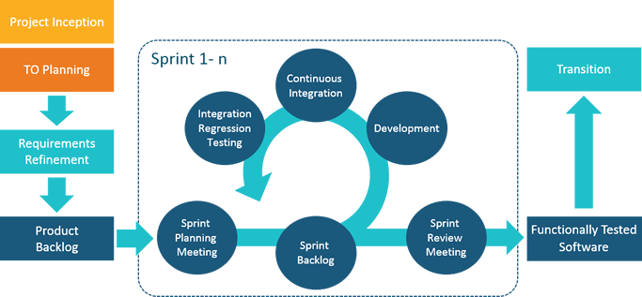

*Figure 1: Agile Scrum Methodology*

For more information:

* <http://scrummethodology.com/>

**2.2 Roles and responsibilities**

|  |  |  |  |
| --- | --- | --- | --- |
| **No** | **Full name** | **Role in Group** | **Responsibilities** |
| **1** | Nguyễn Huy Hùng | Project manager | * Specify user requirement * Control the development process * Give out technique and business analysis support |
| **2** | Lê Phúc Thịnh | Team Leader,  BA, DEV, Tester | * Managing process * Designing database * Clarifying requirements * Prepare documents * GUI Design * Create test plan * Coding * Testing |
| **3** | Võ Thạch Nguyên | Team member, BA, DEV, Tester | * Designing database * Clarifying requirements * Prepare documents * GUI Design * Create test plan * Coding * Testing |
| **4** | Phạm Chánh Hưng | Team member, BA, DEV, Tester | * Designing database * Clarifying requirements * Prepare documents * GUI Design * Create test plan * Coding * Testing |
| **5** | Đặng Thế Anh | Team member, BA, DEV, Tester | * Designing database * Clarifying requirements * Prepare documents * GUI Design * Create test plan * Coding * Testing |

*Table 5: Roles and Responsibilities Details*

**2.3 Tools and Techniques**

|  |  |  |
| --- | --- | --- |
|  | **Tools** | **Techniques** |
| **Front-end** | Bracket | HTML5  CSS3  Javascript  jQuery  Bootstrap |
| **Back-end** | IntelliJ IDEA | JavaEE  Play Framework  JPA |
| **Temporary Storage** | Redis | N/A |

Table 6: Tools and Techniques

**************

Need to edit

**3. Project Management Plan**

**3.1 Product Backlog**

Refer to Apendix

**3.2 Sprint Backlog**

Refer to Apendix

**3.3 All Meeting Minutes**

https://drive.google.com/drive/folders/1WAf1QdqQeW3tomYAzrgIgtoPDhu-GKNg?usp=sharing

**4. Coding Convention**

Java: Using to develop web application and web service.

* Naming Convention:

+ Follows camelcase syntax for naming the class, interface, method and variable.

+ If name is combined with two words, second word will start with uppercase letter always e.g. actionPerformed(), firstName, ActionEvent, ActionListener etc.

* Method names should be verbs.
* Class names should be nouns, in mixed case with first letter of each internal word capitalized.
* Constant names should be all uppercase with words separated by underscore.
* Comment:
* Using /* */ for block comments.
* Using // for line comments.

Android: Using to develop mobile application.

* Follow Field Naming Conventions

+ Other fields start with a lowercase letter.

+ Public static final fields (constants) are ALL_CAPS_WITH_UNDERSCORES.

Using Java coding convention from:

<http://www.oracle.com/technetwork/java/codeconvtoc-136057.html>

Using Android coding convention form:

<https://source.android.com/source/code-style.html>

# C. Report No. 3 Software Requirement Specification

**1. User Requirement Specification**

**1.1 Learner Requirement**

Learner is a person who access to the system as learner role. Learner can use following functions:

* Login
* View course
* View plan
* View program
* Learn lecture
* Take quiz
* View learning activity
* Manage discussion

**1.2 Author Requirement**

* View learner statistic
* Manage course
* Manage lecture
* Manage section
* Manage quiz

**1.3 System admin Requirement**

* Add brand
* Update brand
* Remove brand

**2. System Requirement Specification**

**2.1 External Interface Requirement**

***2.1.1 User Interface***

- The user interface uses Vietnamese.

- The user interface displays best on 1366x768 resolutions on desktop.

***2.1.2 Hardware Interface***

Desktop PC.

***2.1.3 Software Interface***

Web application: work with browsers Firefox (v52 or higher), Chromes (v28 or higher), Internet Explorer (v10 or above) or with any web browser that supports HTML5 & CSS3

***2.1.4 Communication Protocol***

Use HTTP protocol 1.1 for communication between the web browser and the web.

**2.2 System Overview Use Case**

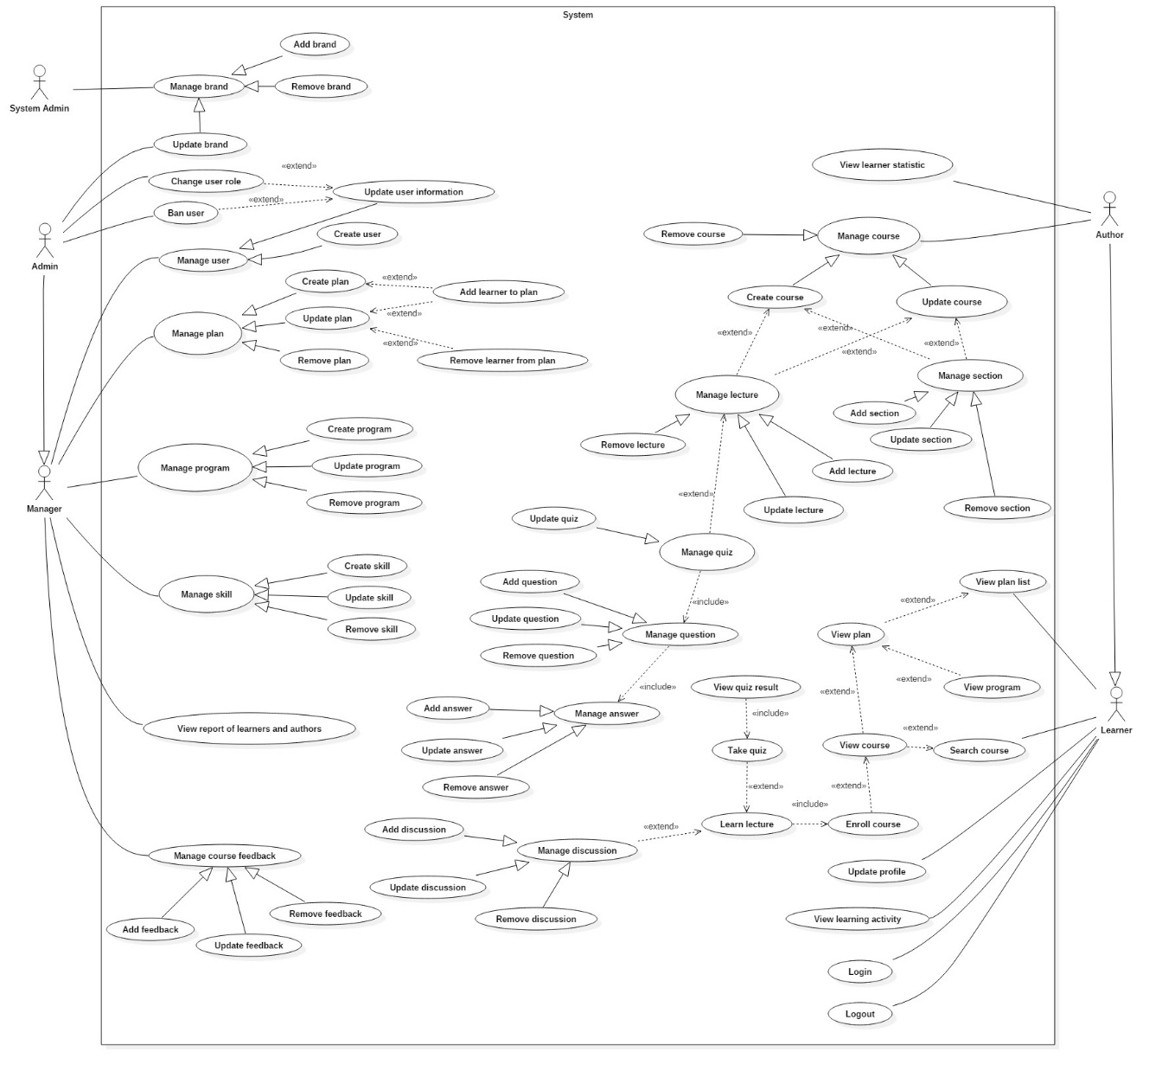

**2.3 List of Use Case**

**2.3.1 <Learner> Overview Use Case**

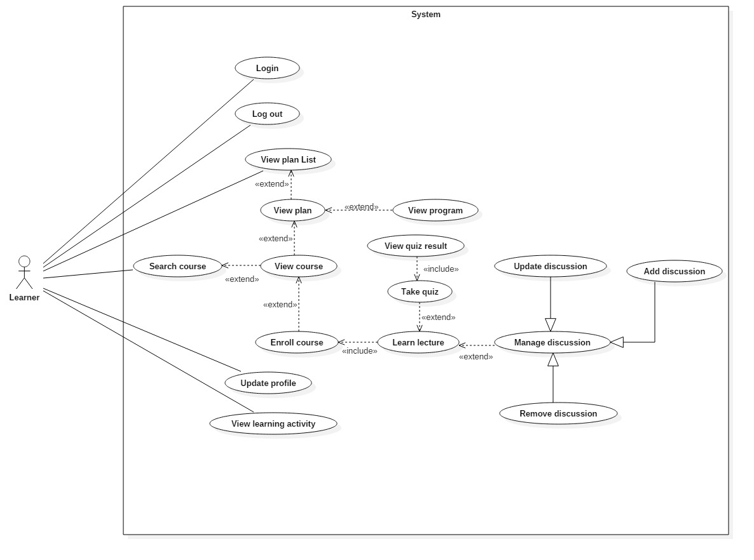

**Figure 1: <Learner> Overview Use Case**

**2.3.1.1 <Learner> Log in**

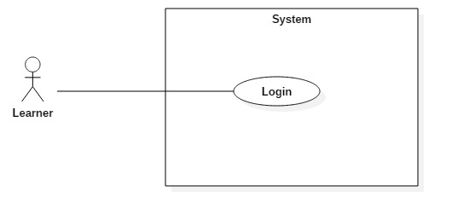

**Figure 2: <Learner> Login (UC_TRAISY1)**

|  |  |  |  |
| --- | --- | --- | --- |
| **USE CASE – UC_ TRAISY1** | | | |
| **Use Case No.** | UC_ TRAISY1 | **Use Case Version** | 0.2 |
| **Use Case Name** | Login | | |
| **Author** | Phạm Chánh Hưng | | |
| **Date** | 23/3/2018 | **Priority** | High |
| **Actor:**   * Learner   **Summary:**   * This use case allows authorized learner to login to system.   **Goal:**   * To login to the system.   **Triggers:**   * Actor sends login command.   **Preconditions:**   * Learner does not login yet.   **Post conditions:**   * Success: Actor accesses the system successfully. * Fail: System shows error messages.   **Main Success Scenario:**   |  |  |  | | --- | --- | --- | | ***Step*** | ***Actor Action*** | ***System Response*** | | 1 | Learner goes to login page | System require information:  Tên đăng nhập: text input  Mật khẩu: text input | | 2 | Learner inputs information  (Username and password) |  | |  |  |  | | 3 | Learner sends command to login (Click “Đăng nhập” button after input login form). | [Exception no.1]  [Exception no.2]  System displays the home page. |   **Alternative Scenario: N/A**  **Exceptions:**   |  |  |  | | --- | --- | --- | | ***No*** | ***Cause*** | ***System Response*** | | 1 | Learner inputs wrong information. | System notices that “Thông tin đăng nhập không hợp lệ” | | 2 | Learner has been inactive by admin/manager | System notices that “Tài khoản đã bị khoá, vui lòng liên hệ quản trị/quản lý để mở khoá” |   **Relationships:** **N/A**  **Business Rules:**   * Username must be at least 5 characters. * Password must be at least 4 characters. * Pasword must be encrypted. | | | |

**2.3.1.2 <Learner> Log out**

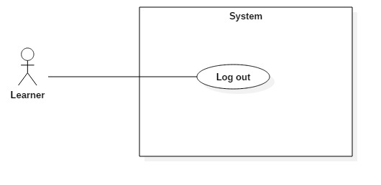

**Figure 3: <Learner> Logout (UC_TRAISY2)**

|  |  |  |  |
| --- | --- | --- | --- |
| **USE CASE – UC_ TRAISY2** | | | |
| **Use Case No.** | UC_ TRAISY2 | **Use Case Version** | 0.2 |
| **Use Case Name** | Logout | | |
| **Author** | Phạm Chánh Hưng | | |
| **Date** | 23/03/2013 | **Priority** | High |
| **Actor:**   * Learner   **Summary:**   * This use case allows user to logout the system.   **Goal:**   * To logout the system.   **Triggers:**   * Actor sends logout command.   **Preconditions:**   * Learner logged in the system.   **Post conditions:**   * Success: User session is removed and system displays login page. * Fail: System displays error messages.   **Main Success Scenario:**   |  |  |  | | --- | --- | --- | | ***Step*** | ***Actor Action*** | ***System Response*** | | 1 | Actor clicks “Đăng xuất” button. |  | |  |  | User session is removed and system displays login page. |   **Alternative Scenario: *N/A***  **Exceptions:**   |  |  |  | | --- | --- | --- | | ***No*** | ***Cause*** | ***System Response*** | | 1 | Learner is not participated in any plan. | System displays page with message: “Bạn chưa tham gia khóa học nào.” |   **Relationships:** **N/A**  **Business Rules:**   * Actor has already accessed to the system. | | | |

**2.3.1.3 <Learner> View plan list**

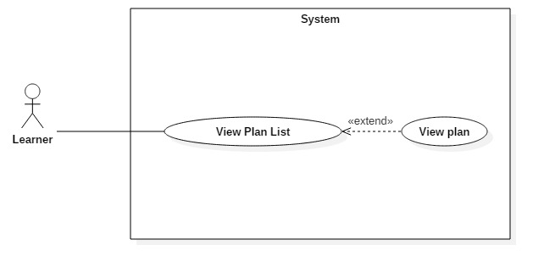

**Figure 4: <Learner> View plan list (UC_TRAISY3)**

|  |  |  |  |
| --- | --- | --- | --- |
| **USE CASE – UC_ TRAISY3** | | | |
| **Use Case No.** | UC_ TRAISY3 | **Use Case Version** | 0.2 |
| **Use Case Name** | View plan list | | |
| **Author** | Phạm Chánh Hưng | | |
| **Date** | 23/03/2013 | **Priority** | High |
| **Actor:**   * Learner   **Summary:**   * This use case allows learners to view all their participated plans.   **Goal:**   * To view information of all plans that he/she has participated in.   **Triggers:**   * Actor sends view plan list command.   **Preconditions:**   * Learner logged in the system.   **Post conditions:**   * Success: System displays all participated plans. * Fail: System displays error messages.   **Main Success Scenario:**   |  |  |  | | --- | --- | --- | | ***Step*** | ***Actor Action*** | ***System Response*** | | 1 | Actor clicks on “Kế hoạch của tôi”. |  | |  |  | System navigates to list of plans that learner participated. |   **Alternative Scenario:**   |  |  |  | | --- | --- | --- | | ***Step*** | ***Actor Action*** | ***System Response*** | | 1 | Actor clicks on “Kế hoạch của tôi” but actor has not participated in any plan. |  | |  |  | System redirects to page with notice “Bạn chưa tham gia kế hoạch nào”. |   **Exceptions:**  **Relationships:**   * Extended by: View Plan   **Business Rules:**   * Participated plans will have progress bar which indicates the learning activity of learner. * Participated plans which are overdue are not accessible by learner. | | | |

**2.3.1.4 <Learner> View plan**

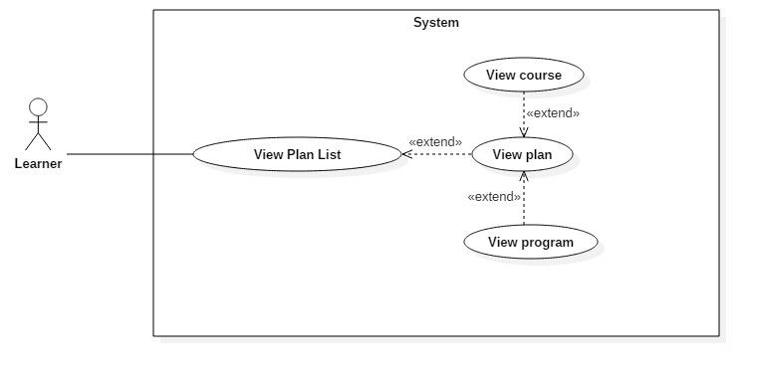

**Figure 5: <Learner> View plan (UC_****TRAISY4)**

|  |  |  |  |
| --- | --- | --- | --- |
| **USE CASE – UC_ TRAISY4** | | | |
| **Use Case No.** | UC_ TRAISY4 | **Use Case Version** | 0.2 |
| **Use Case Name** | View plan | | |
| **Author** | Phạm Chánh Hưng | | |
| **Date** | 23/03/2013 | **Priority** | High |
| **Actor:**   * Learner   **Summary:**   * This use case allows learners to view a participated plan.   **Goal:**   * To view information of a specific plan that he/she has participated in.   **Triggers:**   * Actor sends view plan command.   **Preconditions:**   * Learner logged in the system.   **Post conditions:**   * Success: System displays information of the participated plans. * Fail: System displays error messages.   **Main Success Scenario:**   |  |  |  | | --- | --- | --- | | ***Step*** | ***Actor Action*** | ***System Response*** | | 1 | Actor clicks on a specific plan | [Exception no.1]  [Exception no.2] | |  |  | System navigates to the selected plan’s page with details of plan. |   **Alternative Scenario: *N/A***  **Exceptions:**   |  |  |  | | --- | --- | --- | | ***No*** | ***Cause*** | ***System Response*** | | 1 | Learner has already been removed from the selected plan. | System displays notice: “Bạn chưa tham gia vào khóa học”. Then redirects learner to blank plan page. | | 2 | Theselected plan has been removed by admin/manager of that brand. | System displays notice: “Khóa học đã bị xóa bởi người quản lý”. Then redirects learner to blank plan page |   **Relationships:**   * Extend from: View Plan List * Extended by: View course * Extended by: View program   **Business Rules:**   * Learner must be a participant of the selected plan. * The selected plan must be active ( In duration time ). | | | |

**2.3.1.5 <Learner> Update profile**

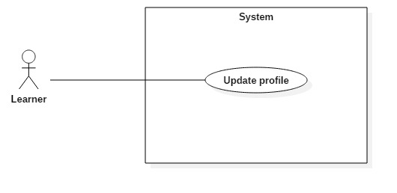

**Figure 6: <Learner> Update profile (UC_TRAISY5)**

|  |  |  |  |
| --- | --- | --- | --- |
| **USE CASE – UC_ TRAISY5** | | | |
| **Use Case No.** | UC_ TRAISY5 | **Use Case Version** | 0.2 |
| **Use Case Name** | Update profile | | |
| **Author** | Phạm Chánh Hưng | | |
| **Date** | 23/03/2013 | **Priority** | High |
| **Actor:**   * Learner   **Summary:**   * This use case allows learners to update their information.   **Goal:**   * To update profile.   **Triggers:**   * Learner sends update profile command.   **Preconditions:**   * Learner logged in the system.   **Post conditions:**   * Success: Account is updated successfully, and system displays the user profile page. * Fail: System displays error messages.   **Main Success Scenario:**   |  |  |  | | --- | --- | --- | | ***Step*** | ***Actor Action*** | ***System Response*** | | 1 | Actor clicks “Thông tin người dùng” | System displays user information page with:  Họ tên: text input  Chức danh: text input  Mật khẩu: text input  Xác nhận lại mật khẩu: text input | | 2 | Actor clicks “Cập nhật” button in the update profile page. | [Exception 1]  [Exception 2] | |  |  | Account is updated successfully and system redirects the user to profile page. |   **Alternative Scenario:N/A**  **Exceptions:**   |  |  |  | | --- | --- | --- | | ***No*** | ***Cause*** | ***System Response*** | | 1 | Learner does not input required fields. | System notices that guest need to input all these field:  - “Họ tên”: System displays warning message: “Họ tên không được trống”.  - “Chức danh”: System displays warning message: “Chức danh không được trống”.  - “Mật khẩu mới”: System displays warning message: “Mật khẩu không được trống”.  - “Xác nhận lại mật khẩu”: System displays warning message: “Xác nhận mật khẩu không được trống”. | | 2 | Learner input wrong some fields with requirement. | System notices that guest need to re-input all these field:  - “Mật khẩu”: System displays warning message: “Mật khẩu phải từ 4 tới 30 ký tự”.  - “Xác nhận lại mật khẩu”: System displays warning message: “Mật khẩu và xác nhận mật khẩu phải giống nhau”. |   **Relationships:** N/A  **Business Rules:**   * Fullname is not null and maximum of 45 characters * Title is not null * Password must be at least 4 characters | | | |

**2.3.1.6 <Learner> View Learning Activity**

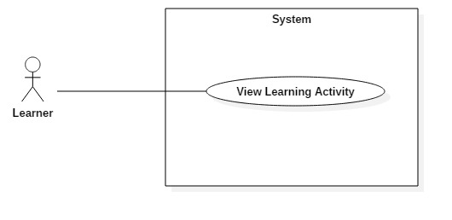

**Figure 7: <Learner> View Learning Activity (UC_TRAISY6)**

|  |  |  |  |
| --- | --- | --- | --- |
| **USE CASE – UC_ TRAISY6** | | | |
| **Use Case No.** | UC_ TRAISY6 | **Use Case Version** | 0.2 |
| **Use Case Name** | View Learning Activity | | |
| **Author** | Phạm Chánh Hưng | | |
| **Date** | 23/3/2018 | **Priority** | High |
| **Actor:**   * Learner   **Summary:**   * This use case allows authorized learner to view process of his/her learning activity.   **Goal:**   * To view process of learning.   **Triggers:**   * Actor sends view process command.   **Preconditions:**   * Learner logged in the system.   **Post conditions:**   * Success: Learners can see their learning process. * Fail: System shows error messages.   **Main Success Scenario:**   |  |  |  | | --- | --- | --- | | ***Step*** | ***Actor Action*** | ***System Response*** | | 1 | Actor clicks to any plan or course in plan/course page | System displays learning activity/ process bar for each course and plan that learner has studied. | |  |  |  |   **Alternative Scenario: N/A**  **Relationships:** **N/A**  **Business Rules:**   * Learner must participate in plan to view learning activity of plan * Learner must enroll in course to view learning activity of course * Learner must study lecture in order to view learning process | | | |

**2.3.1.7 <Learner> Search course**

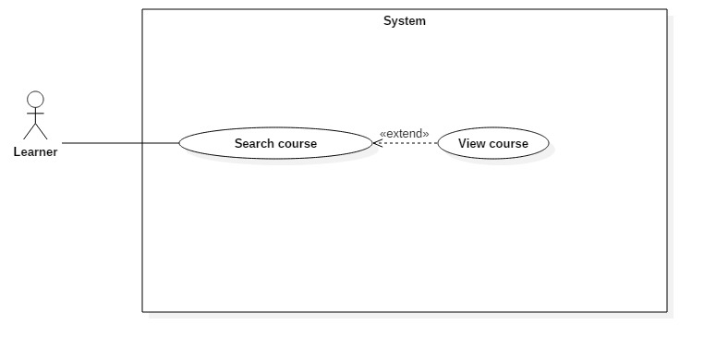

**Figure 8: <Learner> Search course (UC_TRAISY7)**

|  |  |  |  |
| --- | --- | --- | --- |
| **USE CASE – UC_ TRAISY7** | | | |
| **Use Case No.** | UC_ TRAISY7 | **Use Case Version** | 0.2 |
| **Use Case Name** | Search course | | |
| **Author** | Phạm Chánh Hưng | | |
| **Date** | 24/3/2018 | **Priority** | High |
| **Actor:**   * Learner   **Summary:**   * This use case allows authorized learner to search course of plan that his/her has participated in.   **Goal:**   * To search course.   **Triggers:**   * Actor sends search course command.   **Preconditions:**   * Learner logged in the system.   **Post conditions:**   * Success: Learners can see courses with title similar to keyword that learners input. * Fail: System shows error messages.   **Main Success Scenario:**   |  |  |  | | --- | --- | --- | | ***Step*** | ***Actor Action*** | ***System Response*** | | 1 | Actor inputs keyword to searching form and clicks “Tìm khoá học”. | System displays courses of participated plans with title similar to keyword input. | |  |  |  |   **Alternative Scenario:**   |  |  |  | | --- | --- | --- | | ***Step*** | ***Actor Action*** | ***System Response*** | | 1 | Actor input keyword to searching form and clicks “Tìm khoá học”. | System displays no result found with notice “Không tìm thấy khoá học nào”. | |  |  |  |   **Relationships:**   * Extended by: View Course   **Business Rules:**   * Learner must participate in plan to search for courses that publish in that plan * Courses have to be published and active(not overdue) to be searched by learner | | | |

**2.3.1.8 <Learner> View course**

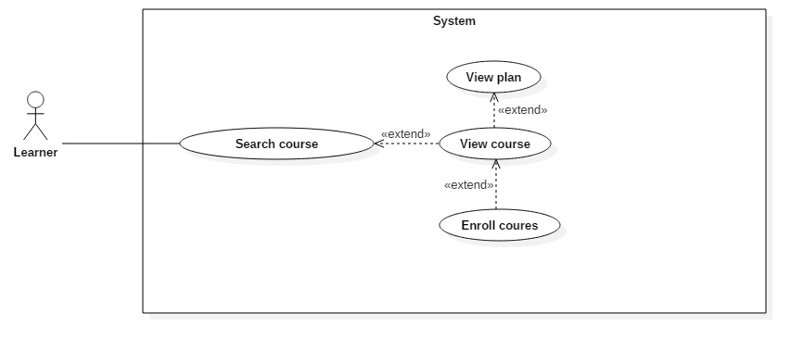

**Figure 9: <Learner> View course (UC_TRAISY8)**

|  |  |  |  |
| --- | --- | --- | --- |
| **USE CASE – UC_ TRAISY8** | | | |
| **Use Case No.** | UC_ TRAISY8 | **Use Case Version** | 0.2 |
| **Use Case Name** | View course | | |
| **Author** | Phạm Chánh Hưng | | |
| **Date** | 24/3/2018 | **Priority** | High |
| **Actor:**   * Learner   **Summary:**   * This use case allows authorized learner to view information of a specific course   **Goal:**   * To view information of course.   **Triggers:**   * Actor sends view course command.   **Preconditions:**   * Learner logged in the system.   **Post conditions:**   * Success: Learners can see information of that course. * Fail: System shows error messages.   **Main Success Scenario:**   |  |  |  | | --- | --- | --- | | ***Step*** | ***Actor Action*** | ***System Response*** | | 1 | Actor clicks on a specific course | [Exception no.1]  [Exception no.2]  [Exception no.3] | |  |  | System navigates to the selected course’s page with details of that course:   * Title of course * Author of course * Start-end date of course * Skills that course belong to * List of lectures that published |   **Alternative Scenario:**   |  |  |  | | --- | --- | --- | | ***Step*** | ***Actor Action*** | ***System Response*** | | 1 | Actor clicks on an empty course |  | |  |  | System navigates to the selected course’s page with no detail of that course. |   **Exceptions:**   |  |  |  | | --- | --- | --- | | ***No*** | ***Cause*** | ***System Response*** | | 1 | Learner has already been removed from the selected course or plan. | System displays notice: “Bạn chưa tham gia vào khóa học”. Then redirects learner to a blank course page. | | 2 | The selected course has been removed by admin/manager or author of that brand. | System displays notice: “Khóa học đã bị xóa bởi người quản lý”. Then redirects learner to a blank course page | | 3 | The plan that course belong to has been removed by admin | System displays notice: “Kế hoạch đã bị xoá bởi người quản lý”. Then redirects learner to a blank course page |   **Relationships:**   * Extended from: View Plan * Extended by: Enroll course * Extend from: Search course   **Business Rules:**   * Learner must participate in plan that courses belong to in order to view information of courses * Courses have to be published and active(not overdue) to be viewed by learner | | | |

**2.3.1.9 <Learner> View program**

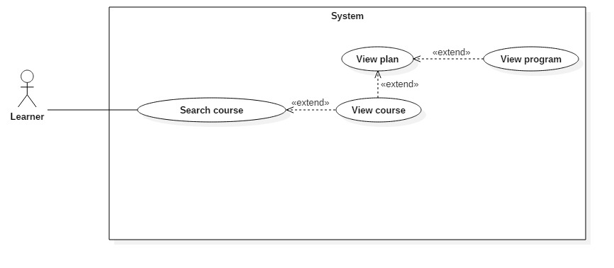

**Figure 10: <Learner> View program (UC_TRAISY9)**

|  |  |  |  |
| --- | --- | --- | --- |
| **USE CASE – UC_ TRAISY9** | | | |
| **Use Case No.** | UC_ TRAISY9 | **Use Case Version** | 0.2 |
| **Use Case Name** | View program | | |
| **Author** | Phạm Chánh Hưng | | |
| **Date** | 24/3/2018 | **Priority** | High |
| **Actor:**   * Learner   **Summary:**   * This use case allows authorized learner to view information of a specific program   **Goal:**   * To view information of program.   **Triggers:**   * Actor sends search program command.   **Preconditions:**   * Learner logged in the system.   **Post conditions:**   * Success: Learners can see information of that program * Fail: System shows error messages.   **Main Success Scenario:**   |  |  |  | | --- | --- | --- | | ***Step*** | ***Actor Action*** | ***System Response*** | | 1 | Actor clicks on a specific program | [Exception no.1]  [Exception no.2] | |  |  | System navigates to the selected program’s page with title of that program and list of active courses that program contains. |   **Alternative Scenario:**   |  |  |  | | --- | --- | --- | | ***Step*** | ***Actor Action*** | ***System Response*** | | 1 | Actor clicks on an empty program |  | |  |  | System navigates to the selected program’s page with only title of that program. |   **Exceptions:**   |  |  |  | | --- | --- | --- | | ***No*** | ***Cause*** | ***System Response*** | | 1 | Learner has already been removed from the selected plan. | System displays notice: “Bạn chưa tham gia vào khóa học”. Then redirects learner to a blank plan page. | | 2 | The selected plan has been removed by admin/manager or author of that brand. | System displays notice: “Kế hoạch đã bị xóa bởi người quản lý”. Then redirects learner to a blank course page |   **Relationships:**   * Extend from: View plan   **Business Rules:**   * Learner must participate in plan that program belong to in order to view information of program * Plan of the specific program must be active for learner to view information | | | |

**2.3.1.10 <Learner> Enroll course**

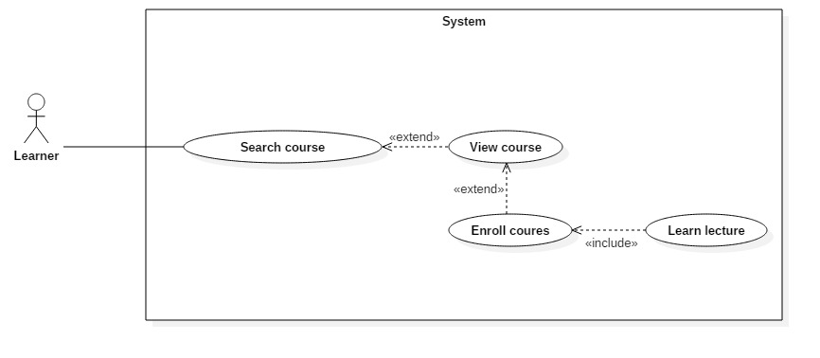

**Figure 11: <Learner> Enroll course (UC_TRAISY10)**

|  |  |  |  |
| --- | --- | --- | --- |
| **USE CASE – UC_ TRAISY10** | | | |
| **Use Case No.** | UC_ TRAISY10 | **Use Case Version** | 0.2 |
| **Use Case Name** | Enroll course | | |
| **Author** | Phạm Chánh Hưng | | |
| **Date** | 24/3/2018 | **Priority** | High |
| **Actor:**   * Learner   **Summary:**   * This use case allows authorized learner to enroll in a specific course   **Goal:**   * To enroll in course.   **Triggers:**   * Actor sends search enroll course command.   **Preconditions:**   * Learner logged in the system.   **Post conditions:**   * Success: Learners are redirected to learning lecture page * Fail: System shows error messages.   **Main Success Scenario:**   |  |  |  | | --- | --- | --- | | ***Step*** | ***Actor Action*** | ***System Response*** | | 1 | Actor clicks “Tham gia” button of a specific course | [Exception no.1]  [Exception no.2]  [Exception no.3] | |  |  | System navigates to learning page with the first published lecture of course. |   **Alternative Scenario:**   |  |  |  | | --- | --- | --- | | ***Step*** | ***Actor Action*** | ***System Response*** | | 1 | Actor clicks “Học tiếp” button of a specific course if actor already enroll in curse |  | |  |  | System navigates to learning page with the next published lecture of course that learner has studied. |   **Exceptions:**   |  |  |  | | --- | --- | --- | | ***No*** | ***Cause*** | ***System Response*** | | 1 | Learner has already been removed from the selected plan. | System displays notice: “Bạn chưa tham gia vào khóa học”. Then redirects learner to a blank learning page. | | 2 | The selected plan has been removed by admin/manager or author of that brand. | System displays notice: “Kế hoạch đã bị xóa bởi người quản lý”. Then redirects learner to a blank learning page | | 3 | The course that user enroll in does not have any publish lecture | System redirects learner to information of that course. |   **Relationships:**   * Extend from: View course * Include : Learn lecture   **Business Rules:**   * Learner must participate in plan that courses belong to in order to enroll in selected course * Courses have to be published and active(not overdue) to be enrolled by learner | | | |

**2.3.1.11 <Learner> Learn lecture**

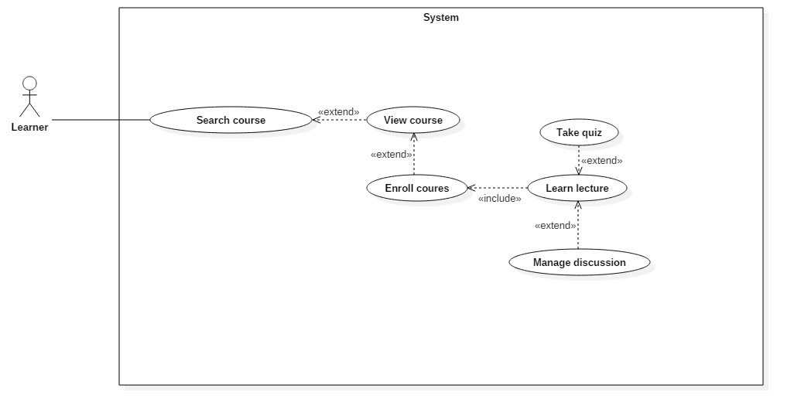

**Figure 12: <Learner> Learn lecture (UC_TRAISY11)**

|  |  |  |  |
| --- | --- | --- | --- |
| **USE CASE – UC_ TRAISY11** | | | |
| **Use Case No.** | UC_ TRAISY11 | **Use Case Version** | 0.2 |
| **Use Case Name** | Learn lecture | | |
| **Author** | Phạm Chánh Hưng | | |
| **Date** | 24/3/2018 | **Priority** | High |
| **Actor:**   * Learner   **Summary:**   * This use case allows authorized learner to learn a specific lecture   **Goal:**   * To learn a course.   **Triggers:**   * Actor sends learn lecture command.   **Preconditions:**   * Learner logged in the system.   **Post conditions:**   * Success: Learners are redirected to learning page of that lecture type * Fail: System shows error messages.   **Main Success Scenario:**   |  |  |  | | --- | --- | --- | | ***Step*** | ***Actor Action*** | ***System Response*** | | 1 | Actor clicks a specific lecture in a course. | [Exception no.1]  [Exception no.2]  [Exception no.3] | |  |  | System navigates to:   * Learning slideshow page if that lecture is PowerPoint type * Learning video page if that lecture is video type * Learning text page if that lecture is of text type * Quiz page if that lecture is of quiz type |   **Alternative Scenario:**  **Scenario 1:**   |  |  |  | | --- | --- | --- | | ***Step*** | ***Actor Action*** | ***System Response*** | | 1 | Actor clicks “Tham gia” button in view course page |  | |  |  | System navigates to learning page with the first published lecture of course. |   **Scenario 2:**   |  |  |  | | --- | --- | --- | | ***Step*** | ***Actor Action*** | ***System Response*** | | 1 | Actor clicks “Học tiếp” button in view course page |  | |  |  | System navigates to learning page with the next published lecture of course that learner has studied. |   **Exceptions:**   |  |  |  | | --- | --- | --- | | ***No*** | ***Cause*** | ***System Response*** | | 1 | Learner has already been removed from the selected plan. | System displays notice: “Bạn chưa tham gia vào khóa học”. Then redirects learner to a blank learning page. | | 2 | The selected plan has been removed by admin/manager or author of that brand. | System displays notice: “Kế hoạch đã bị xóa bởi người quản lý”. Then redirects learner to a blank learning page | | 3 | The lecture that learner clicked has been removed or unpublished by author/manager/admin | System displays notice: “Bài học đã bị xóa bởi người quản lý”. Then redirects learner to course page |   **Relationships:**   * Extend by: Take quiz * Extend by: Manage discussion * Included in : Enroll course   **Business Rules:**   * Learner must participate in plan that courses belong to in order to learn lecture * Lectures have to be published and active(not overdue) to be accessed by learner | | | |

**2.3.1.12 <Learner> Take quiz**

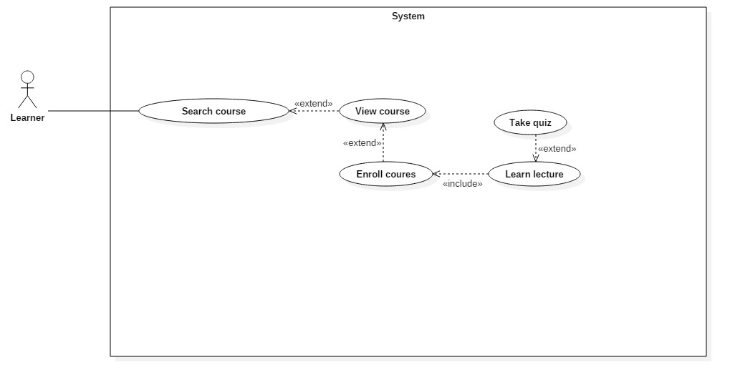

**Figure 13: <Learner> Take quiz (UC_TRAISY12)**

|  |  |  |  |
| --- | --- | --- | --- |
| **USE CASE – UC_ TRAISY12** | | | |
| **Use Case No.** | UC_ TRAISY12 | **Use Case Version** | 0.2 |
| **Use Case Name** | Take quiz | | |
| **Author** | Phạm Chánh Hưng | | |
| **Date** | 24/3/2018 | **Priority** | High |
| **Actor:**   * Learner   **Summary:**   * This use case allows authorized learner to take quiz   **Goal:**   * To take a quiz.   **Triggers:**   * Actor sends take quiz command.   **Preconditions:**   * Learner logged in the system.   **Post conditions:**   * Success: Learners are redirected to take quiz page * Fail: System shows error messages.   **Main Success Scenario:**   |  |  |  | | --- | --- | --- | | ***Step*** | ***Actor Action*** | ***System Response*** | | 1 | Actor clicks on a specific quiz in a course. | [Exception no.1]  [Exception no.2]  [Exception no.3] | |  |  | System navigates to: Quiz page |   **Alternative Scenario:**  **Scenario 1:**   |  |  |  | | --- | --- | --- | | ***Step*** | ***Actor Action*** | ***System Response*** | | 1 | Actor clicks “Tham gia” button in view course page |  | |  |  | System navigates to quiz page if the first lecture of course is quiz. |   **Scenario 2:**   |  |  |  | | --- | --- | --- | | ***Step*** | ***Actor Action*** | ***System Response*** | | 1 | Actor clicks “Học tiếp” button in view course page |  | |  |  | System navigates to quiz page to quiz page if the next lecture of course is quiz. |   **Exceptions:**   |  |  |  | | --- | --- | --- | | ***No*** | ***Cause*** | ***System Response*** | | 1 | Learner has already been removed from the selected plan. | System displays notice: “Bạn chưa tham gia vào khóa học”. Then redirects learner to a blank learning page. | | 2 | The selected plan has been removed by admin/manager or author of that brand. | System displays notice: “Kế hoạch đã bị xóa bởi người quản lý”. Then redirects learner to a blank learning page | | 3 | The quiz that learner clicked has been removed or unpublished by author/manager/admin | System displays notice: “Bài quiz đã bị xóa bởi người quản lý”. Then redirects learner to course page |   **Relationships:**   * Extend from: Learn lecture * Included : View quiz result   **Business Rules:**   * Learner must participate in plan that courses belong to in order to take quiz * Quiz have to be published and active(not overdue) to be accessed by learner | | | |

**2.3.1.13 <Learner> View Quiz result**

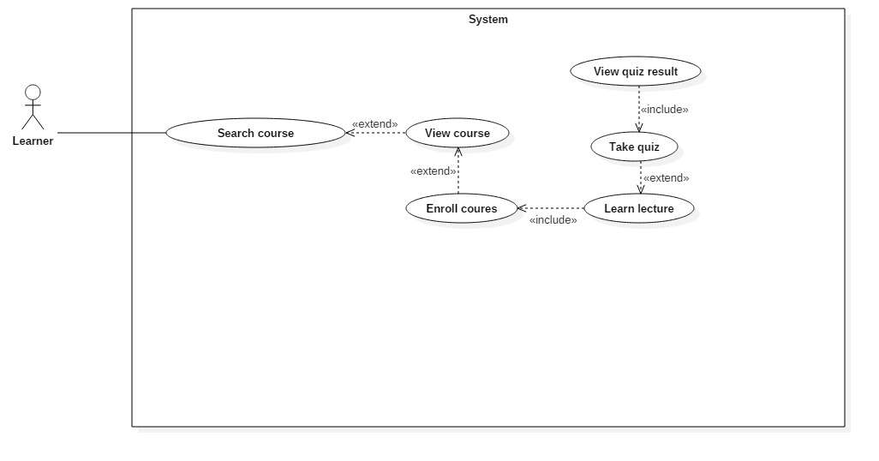

**Figure 14: <Learner> View quiz result (UC_TRAISY13)**

|  |  |  |  |
| --- | --- | --- | --- |
| **USE CASE – UC_ TRAISY13** | | | |
| **Use Case No.** | UC_ TRAISY13 | **Use Case Version** | 0.2 |
| **Use Case Name** | View quiz result | | |
| **Author** | Phạm Chánh Hưng | | |
| **Date** | 24/3/2018 | **Priority** | High |
| **Actor:**   * Learner   **Summary:**   * This use case allows authorized learner to view result of quiz   **Goal:**   * To view result of quiz.   **Triggers:**   * Actor sends view result of quiz command.   **Preconditions:**   * Learner logged in the system.   **Post conditions:**   * Success: Learners are redirected to result of quiz page * Fail: System shows error messages.   **Main Success Scenario:**   |  |  |  | | --- | --- | --- | | ***Step*** | ***Actor Action*** | ***System Response*** | | 1 | Actor clicks on a specific quiz in a course. | [Exception no.1]  [Exception no.2]  [Exception no.3] | |  |  | System navigates to quiz page. | | 2 | Actor finishes a quiz | System navigates to quiz result page |   **Alternative Scenario: N/A**  **Exceptions:**   |  |  |  | | --- | --- | --- | | ***No*** | ***Cause*** | ***System Response*** | | 1 | Learner has already been removed from the selected plan. | System displays notice: “Bạn chưa tham gia vào khóa học”. Then redirects learner to a blank learning page. | | 2 | The selected plan has been removed by admin/manager or author of that brand. | System displays notice: “Kế hoạch đã bị xóa bởi người quản lý”. Then redirects learner to a blank learning page | | 3 | The quiz that learner clicked has been removed or unpublished by author/manager/admin | System displays notice: “Bài quiz đã bị xóa bởi người quản lý”. Then redirects learner to course page |   **Relationships:**   * Included in : Take quiz   **Business Rules:**   * Learner must participate in plan that courses belong to in order to view quiz result * Quiz have to be published and active(not overdue) to be accessed by learner | | | |

**2.3.1.14 <Learner> Add discussion**

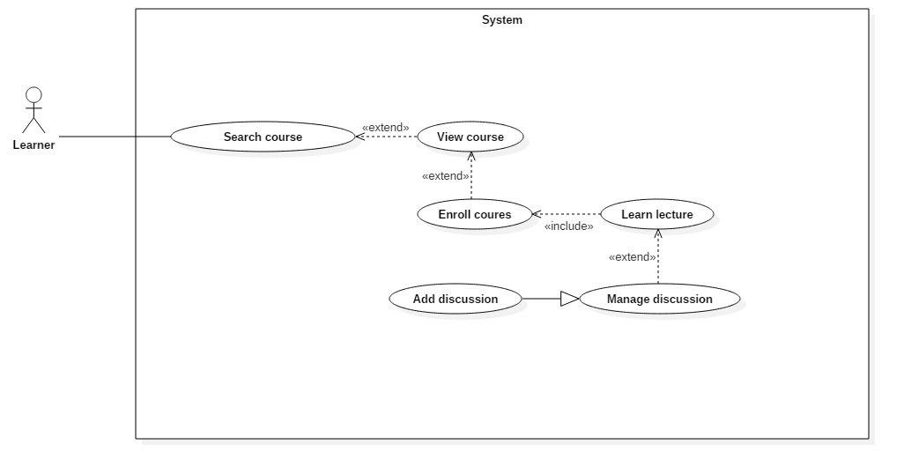

**Figure 15: <Learner> Add discussion (UC_TRAISY14)**

|  |  |  |  |
| --- | --- | --- | --- |
| **USE CASE – UC_ TRAISY14** | | | |
| **Use Case No.** | UC_ TRAISY14 | **Use Case Version** | 0.2 |
| **Use Case Name** | Add discussion | | |
| **Author** | Phạm Chánh Hưng | | |
| **Date** | 24/3/2018 | **Priority** | High |
| **Actor:**   * Learner   **Summary:**   * This use case allows authorized learner to add discussion of a lecture   **Goal:**   * To add discussion of lecture   **Triggers:**   * Actor sends add discussion command.   **Preconditions:**   * Learner logged in the system.   **Post conditions:**   * Success: Learners are successfully add discussion to lecture page * Fail: System shows error messages.   **Main Success Scenario:**   |  |  |  | | --- | --- | --- | | ***Step*** | ***Actor Action*** | ***System Response*** | | 1 | Actor clicks “Thêm thảo luận” button in lecture page |  | |  |  | System displays modal with:  “Nội dung thảo luận”: text area input | | 1 | Actor clicks “Thêm” button | [Exception 1]  [Exception 2] | |  |  | Discussion is added successfully and system notices the player with message “Thêm thảo luận thành công”. |   **Alternative Scenario: N/A**  **Exceptions:**   |  |  |  | | --- | --- | --- | | ***No*** | ***Cause*** | ***System Response*** | | 1 | The lecture that learner add discussion to has been removed or unpublished | System displays notice: “Không thể thêm thảo luận”. Then redirects learner to previous link. | | 2 | Learner does not input required fields. | System notices that guest need to input all these field:  - “Nội dung thảo luận” : System display warning message: “nội dung thảo luận không được trống” |   **Relationships:**   * Abstract use case: Manage discussion   **Business Rules:**   * Learner must participate in plan that courses belong to in order to add discussion * Plan/course/lecture of the discussion belongs to must be published and active in order to add discussion | | | |

**2.3.1.15 <Learner> Update discussion**

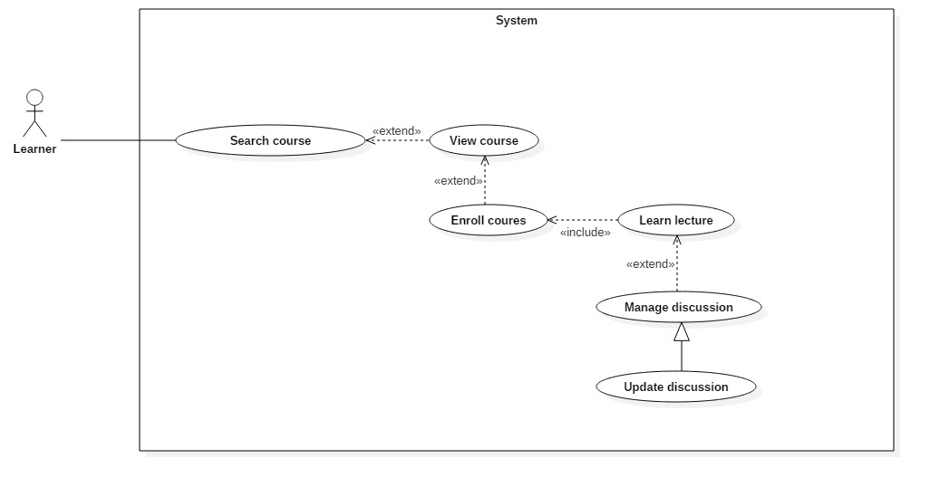

**Figure 16: <Learner> Update discussion (UC_TRAISY15)**

|  |  |  |  |
| --- | --- | --- | --- |
| **USE CASE – UC_ TRAISY15** | | | |
| **Use Case No.** | UC_ TRAISY15 | **Use Case Version** | 0.2 |
| **Use Case Name** | Update discussion | | |
| **Author** | Phạm Chánh Hưng | | |
| **Date** | 24/3/2018 | **Priority** | High |
| **Actor:**   * Learner   **Summary:**   * This use case allows authorized learner to update his/her discussion of a lecture   **Goal:**   * To update discussion of lecture   **Triggers:**   * Actor sends update discussion command.   **Preconditions:**   * Learner logged in the system.   **Post conditions:**   * Success: Learners are successfully update discussion in lecture page * Fail: System shows error messages.   **Main Success Scenario:**   |  |  |  | | --- | --- | --- | | ***Step*** | ***Actor Action*** | ***System Response*** | | 1 | Actor clicks “Sửa thảo luận” button of a discussion in lecture page |  | |  |  | System displays text area with:  “Nội dung thảo luận”: text area input | | 1 | Actor clicks “Lưu” button in page | [Exception 1]  [Exception 2] | |  |  | Discussion is updated successfully and system notices the player with message “Sửa thảo luận thành công”. |   **Alternative Scenario: N/A**  **Exceptions:**   |  |  |  | | --- | --- | --- | | ***No*** | ***Cause*** | ***System Response*** | | 1 | The lecture that updated discussion belongs to has been removed or unpublished | System displays notice: “Không thể sửa thảo luận”. Then redirects learner to previous link. | | 2 | Learner does not input required fields. | System do nothing |   **Relationships:**   * Abstract use case: Manage discussion   **Business Rules:**   * Learner must participate in plan that courses belong to in order to update discussion * Plan/course/lecture of the discussion belongs to must be published and active in order to update discussion | | | |

**2.3.1.16 <Learner> Remove discussion**

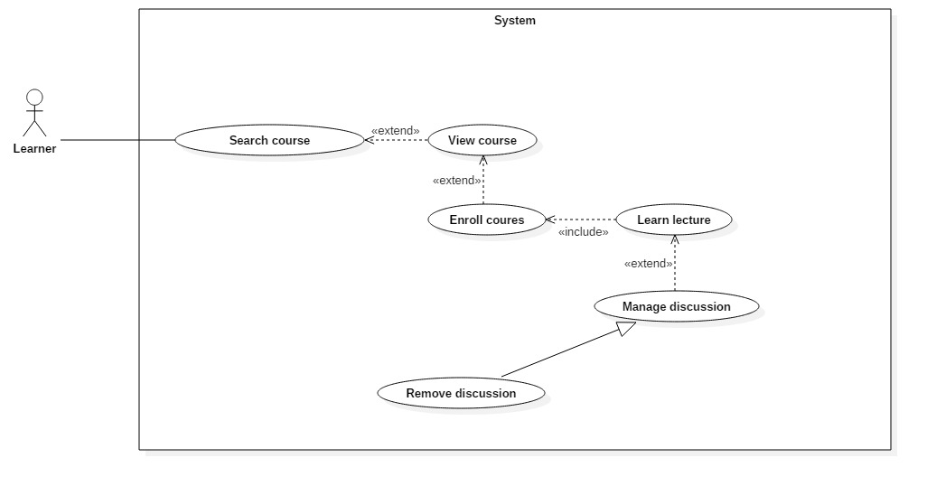

**Figure 17: <Learner> Remove discussion (UC_TRAISY16)**

|  |  |  |  |
| --- | --- | --- | --- |
| **USE CASE – UC_ TRAISY16** | | | |
| **Use Case No.** | UC_ TRAISY16 | **Use Case Version** | 0.2 |
| **Use Case Name** | Remove discussion | | |
| **Author** | Phạm Chánh Hưng | | |
| **Date** | 24/3/2018 | **Priority** | High |
| **Actor:**   * Learner   **Summary:**   * This use case allows authorized learner to remove his/her discussion of a lecture   **Goal:**   * To remove discussion of lecture   **Triggers:**   * Actor sends remove discussion command.   **Preconditions:**   * Learner logged in the system.   **Post conditions:**   * Success: Learners are successfully remove discussion in lecture page * Fail: System shows error messages.   **Main Success Scenario:**   |  |  |  | | --- | --- | --- | | ***Step*** | ***Actor Action*** | ***System Response*** | | 1 | Actor clicks “Xoá thảo luận” button of a discussion in lecture page | [Exception 1]  [Exception 2] | |  |  | Discussion is removed successfully and system notices the player with message “Xoá thảo luận thành công”. |   **Alternative Scenario: N/A**  **Exceptions:**   |  |  |  | | --- | --- | --- | | ***No*** | ***Cause*** | ***System Response*** | | 1 | The lecture that removed discussion belongs to has been removed or unpublished | System do nothing |   **Relationships:**   * Abstract use case: Manage discussion   **Business Rules:**   * Learner must participate in plan that courses belong to in order to update discussion * Plan/course/lecture of the discussion belongs to must be published and active in order to update discussion | | | |

**2.3.2 <Author> Overview Use Case**

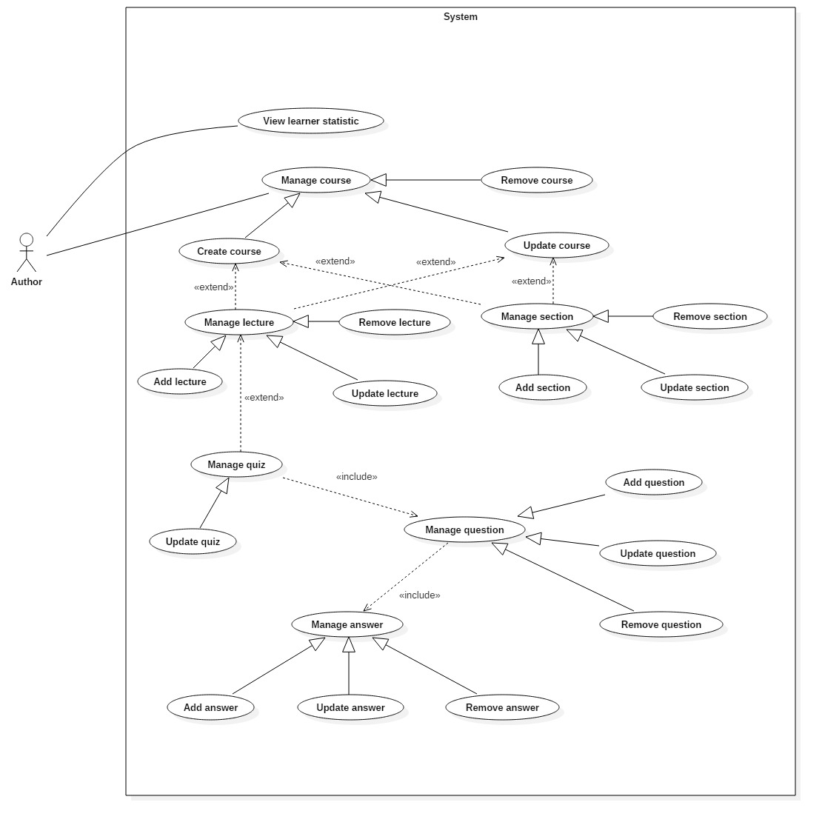

**Figure 18: <Author> Overview Use Case**

***2.3.2.1 <Author> View learner statistic***

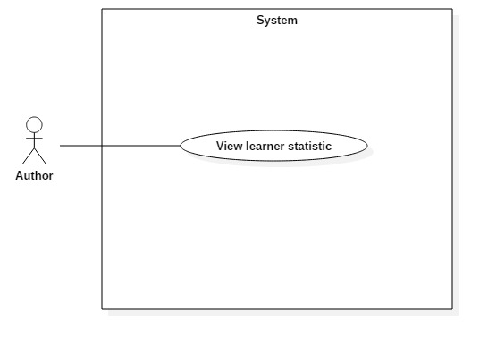

**Figure 19: <Author> View learner statistic (UC_TRAISY17)**

|  |  |  |  |
| --- | --- | --- | --- |
| **USE CASE – UC_TRAISY17** | | | |
| **Use Case No.** | UC_TRAISY17 | **Use Case Version** | 0.2 |
| **Use Case Name** | View learner statistic | | |
| **Author** | Phạm Chánh Hưng | | |
| **Date** | 25/03/2018 | **Priority** | High |
| **Actor:**   * Author   **Summary:**   * This use case allows author to view learner statistic in author’s course.   **Goal:**   * Author views learner statistic to get more details about that course.   **Triggers:**   * Author clicks course’s page which include learner statistic.   **Preconditions:**   * User logged in as author role.   **Post conditions:**   * Success: System displays learner’s process of each course with details of learner. * Fail: System displays error messages.   **Main Success Scenario:**   |  |  |  | | --- | --- | --- | | ***Step*** | ***Actor Action*** | ***System Response*** | | 1 | Actor clicks "Học viên" tab from manage course page. |  | |  |  | System displays page which include:   * List of learner * Learner’s name * Enroll date * Process of learner on each course |   **Alternative Scenario: *N/A***  **Exceptions: N/A**  **Relationships:** **N/A**  **Business Rules:**   * Learner’s statistic only display learners who already enrolled in course * Author can only view statistic of learners belong to author’s courses | | | |

***2.3.2.2 <Author> Create course***

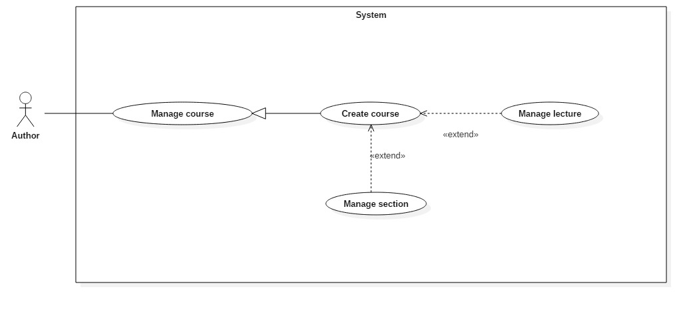

**Figure 20: <Author> Create course(UC_TRAISY18)**

|  |  |  |  |
| --- | --- | --- | --- |
| **USE CASE – UC_** **TRAISY18** | | | |
| **Use Case No.** | UC_ TRAISY18 | **Use Case Version** | 0.2 |
| **Use Case Name** | Create course | | |
| **Author** | Phạm Chánh Hưng | | |
| **Date** | 25/03/2018 | **Priority** | High |
| **Actor:**   * Author   **Summary:**   * This use case allows author to create course.   **Goal:**   * Author successfully creates course in a specific plan.   **Triggers:**   * Author sends create course command.   **Preconditions:**   * User logged in as author role.   **Post conditions:**   * Success: New course is created into database and redirects user to that course’s information page. * Fail: System displays error messages.   **Main Success Scenario:**   |  |  |  | | --- | --- | --- | | ***Step*** | ***Actor Action*** | ***System Response*** | | 1 | Actor clicks "Thêm khoá học" button from manage course page. |  | |  |  | System displays modal with field: “Nhập tên khoá học” requires user to input course name. | | 2 | Actor input course name and clicks “Tạo khoá học” | [Exception no.1]  System redirects actor to that course’s page including details about that course |   **Alternative Scenario: *N/A***  **Exceptions:**   |  |  |  | | --- | --- | --- | | ***No*** | ***Cause*** | ***System Response*** | | 1 | Learner does not input required field or input wrong field’s requirement. | System notices that “Không thể tạo khóa học. Tên khoá học phải lớn hơn 5 ký tự” |   **Relationships:**   * Abstract use case: Manage course * Extended by: Manage lecture * Extended by: Manage section   **Business Rules:**   * The course created will be in a specific program if author select create course in that program. Otherwise, the course created will be in “Another program”. * List course in “Manage course” page will be updated with new course that just created. * When created, the course will be “Unpublished” or “Inactive” as default. * Course title length must be over 5 characters | | | |

***2.3.2.3 <Author> Remove course***

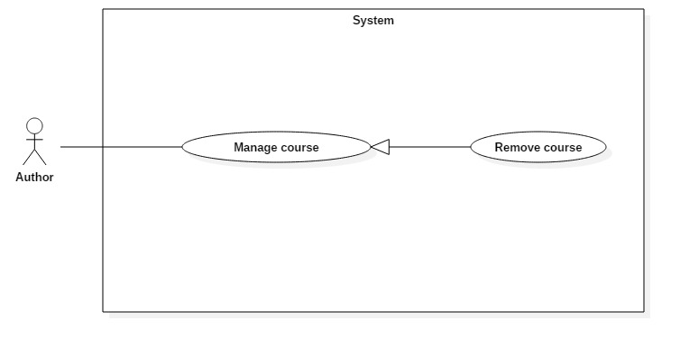

**Figure 21: <Author> Remove course(UC_TRAISY19)**

|  |  |  |  |
| --- | --- | --- | --- |
| **USE CASE – UC_** **TRAISY19** | | | |
| **Use Case No.** | UC_ TRAISY19 | **Use Case Version** | 0.2 |
| **Use Case Name** | Remove course | | |
| **Author** | Phạm Chánh Hưng | | |
| **Date** | 25/03/2018 | **Priority** | High |
| **Actor:**   * Author   **Summary:**   * This use case allows author to remove a specific course.   **Goal:**   * Author successfully remove course in a specific plan.   **Triggers:**   * Author sends remove course command.   **Preconditions:**   * User logged in as author role.   **Post conditions:**   * Success: The course’s status in database will be changed to “-1” and display success message. * Fail: System displays error messages.   **Main Success Scenario:**   |  |  |  | | --- | --- | --- | | ***Step*** | ***Actor Action*** | ***System Response*** | | 1 | Actor clicks "Xoá vĩnh viễn khoá học" button from manage course page. |  | |  |  | System displays popup “Xoá khoá học thành công”. |   **Alternative Scenario: *N/A***  **Exceptions: N/A**  **Relationships:**   * Abstract use case: Manage course   **Business Rules:**   * The removed course’s status will be change to “-1” in database. Therefore, any data such as lecture, section relating to course is not completely deleted from database. * The removed course can be changed to active/publish. * Learner cannot see or access to course that has been removed. * Only author who owns the course can modify. Otherwise, other authors cannot modify | | | |

***2.3.2.4 <Author> Update course***

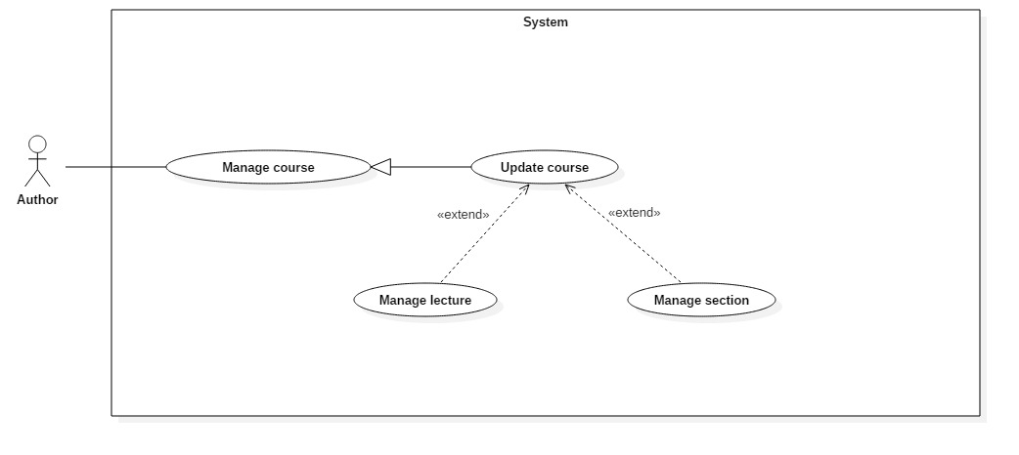

**Figure 22: <Author> Update course(UC_TRAISY20)**

|  |  |  |  |
| --- | --- | --- | --- |
| **USE CASE – UC_** **TRAISY20** | | | |
| **Use Case No.** | UC_ TRAISY20 | **Use Case Version** | 0.2 |
| **Use Case Name** | Update course | | |
| **Author** | Phạm Chánh Hưng | | |
| **Date** | 25/03/2018 | **Priority** | High |
| **Actor:**   * Author   **Summary:**   * This use case allows author to update a specific course.   **Goal:**   * Author successfully update course in a specific plan.   **Triggers:**   * Author sends update course command.   **Preconditions:**   * User logged in as author role.   **Post conditions:**   * Success: The course with new information will be updated in database. * Fail: System displays error messages.   **Main Success Scenario:**   |  |  |  | | --- | --- | --- | | ***Step*** | ***Actor Action*** | ***System Response*** | | 1 | Actor go to “Quản lý khoá học” page | System displays page with following information:   * “Tên khoá học”: text box * “Mô tả” : text area * “Kỹ năng khoá học” : drop down list which list all skills available * Button “Lưu chỉnh sửa” | | 2 | Actor clicks "Lưu chỉnh sửa” button from manage course page. |  | |  |  | [Exception no.1]  System displays popup “Cập nhật thành công”. |   **Alternative Scenario: *N/A***  **Exceptions:**   |  |  |  | | --- | --- | --- | | ***No*** | ***Cause*** | ***System Response*** | | 1 | Learner does not input required field or input wrong field’s requirement. | System notices that “Vui lòng nhập tên khoá học lớn hơn 5 ký tự” |   **Relationships:**   * Abstract use case: Manage course * Extended by: Manage lecture * Extended by: Manage section   **Business Rules:**   * If update successfully, course will be updated in database immediately. * New information will be updated in manage course page * Course title length must be over 5 characters * Skills of course cannot exceed 5 * Only author who owns the course can modify. Otherwise, other authors cannot modify | | | |

***2.3.2.5 <Author> Add lecture***

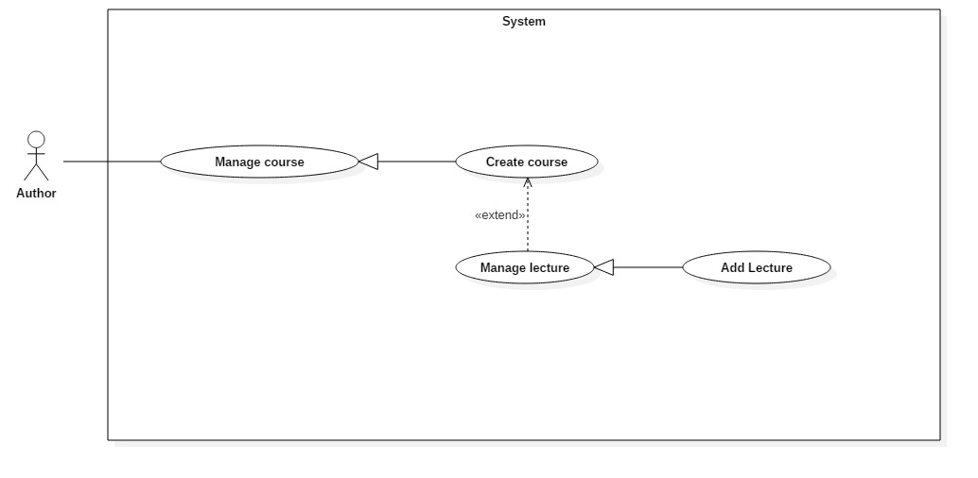

**Figure 23: <Author> Add lecture(UC_TRAISY21)**

|  |  |  |  |
| --- | --- | --- | --- |
| **USE CASE – UC_** **TRAISY21** | | | |
| **Use Case No.** | UC_ TRAISY21 | **Use Case Version** | 0.2 |
| **Use Case Name** | Add lecture | | |
| **Author** | Phạm Chánh Hưng | | |
| **Date** | 25/03/2018 | **Priority** | High |
| **Actor:**   * Author   **Summary:**   * This use case allows author to add a lecture to course.   **Goal:**   * Author successfully add lecture in a specific course.   **Triggers:**   * Author sends add lecture command.   **Preconditions:**   * User logged in as author role.   **Post conditions:**   * Success: The new lecture is created. * Fail: System displays error messages.   **Main Success Scenario:**   |  |  |  | | --- | --- | --- | | ***Step*** | ***Actor Action*** | ***System Response*** | | 1 | Actor clicks "Thêm bài học" button from manage course page. |  | |  |  | System displays modal with field: “Nhập tên bài học” requires user to input lecture name. | | 2 | Actor clicks "Thêm bài mới” button. |  | |  |  | [Exception no.1]  System displays popup “Thêm bài mới thành công”. |   **Alternative Scenario: *N/A***  **Exceptions:**   |  |  |  | | --- | --- | --- | | ***No*** | ***Cause*** | ***System Response*** | | 1 | Learner does not input required field or input wrong field’s requirement. | System notices that “Vui lòng nhập tên bài học lớn hơn 5 ký tự'” |   **Relationships:**   * Abstract use case: Manage lecture   **Business Rules:**   * The lecture created must be in a specific course * List lecture in “Manage course” page will be updated with new lecture that just created * When created, the lecture will be “Unpublished” or “Inactive” as default. * Lecture title length must be over 5 characters and below 80 | | | |

***2.3.2.6 <Author> Update lecture***

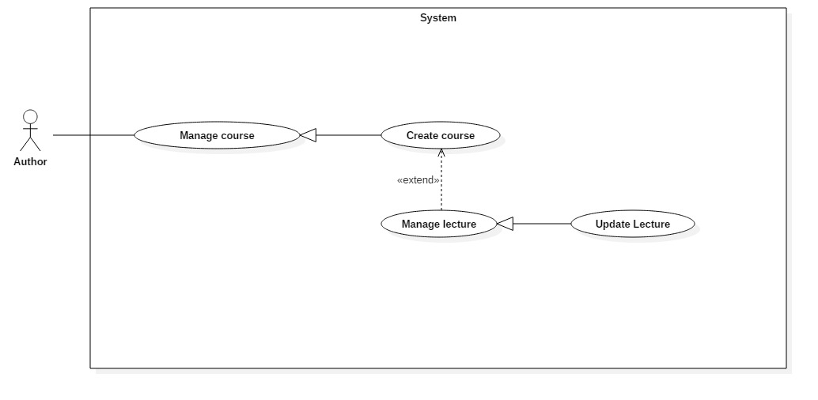

**Figure 24: <Author> Update lecture(UC_TRAISY22)**

|  |  |  |  |
| --- | --- | --- | --- |
| **USE CASE – UC_** **TRAISY22** | | | |
| **Use Case No.** | UC_ TRAISY22 | **Use Case Version** | 0.2 |
| **Use Case Name** | Update lecture | | |
| **Author** | Phạm Chánh Hưng | | |
| **Date** | 25/03/2018 | **Priority** | High |
| **Actor:**   * Author   **Summary:**   * This use case allows author to update a specific lecture.   **Goal:**   * Author successfully update lecture.   **Triggers:**   * Author sends update lecture command.   **Preconditions:**   * User logged in as author role.   **Post conditions:**   * Success: The lecture with new information will be updated in database. * Fail: System displays error messages.   **Main Success Scenario:**   |  |  |  | | --- | --- | --- | | ***Step*** | ***Actor Action*** | ***System Response*** | | 1 | Actor goes to “Quản lý khoá học” page and clicks “Nội dung bài học” tab | System displays page with:   * List of lectures * Publish/unpublish button * Edit button * Delete button | | 2 | Actor clicks Edit button from manage course page. |  | |  |  | System displays page with:   * Name of lecture * Publish/unpublish lecture * Contains of lecture | | 3 | Actor clicks “Lưu bài học” button from manage course page. |  | |  |  | [Exception no.1]  System displays popup “Cập nhật thành công”. |   **Alternative Scenario: *N/A***  **Exceptions:**   |  |  |  | | --- | --- | --- | | ***No*** | ***Cause*** | ***System Response*** | | 1 | Learner does not input required field or input wrong field’s requirement. | System notices that “Vui lòng nhập tên bài học lớn hơn 5 ký tự” |   **Relationships:**   * Abstract use case: Manage lecture   **Business Rules:**   * If update successfully, lecture will be updated in database immediately. * Lecture title length must be over 5 characters * Only author who owns the lecture can modify. Otherwise, other authors cannot modify | | | |

***2.3.2.7 <Author> Remove lecture***

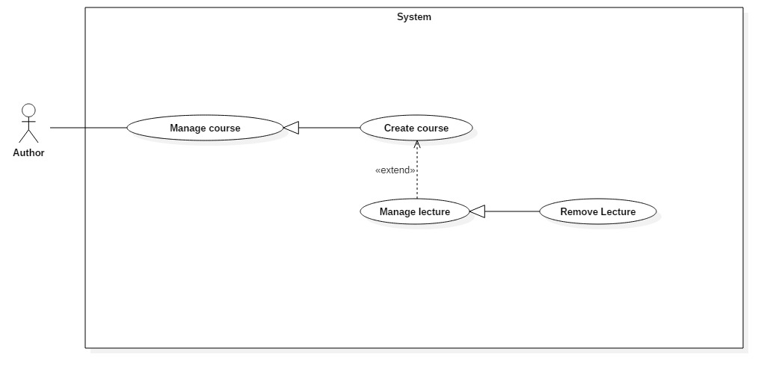

**Figure 25: <Author> Remove lecture(UC_TRAISY23)**

|  |  |  |  |
| --- | --- | --- | --- |
| **USE CASE – UC_** **TRAISY23** | | | |
| **Use Case No.** | UC_ TRAISY23 | **Use Case Version** | 0.2 |
| **Use Case Name** | Remove lecture | | |
| **Author** | Phạm Chánh Hưng | | |
| **Date** | 25/03/2018 | **Priority** | High |
| **Actor:**   * Author   **Summary:**   * This use case allows author to remove a specific lecture.   **Goal:**   * Author successfully remove lecture.   **Triggers:**   * Author sends remove lecture command.   **Preconditions:**   * User logged in as author role.   **Post conditions:**   * Success: The lecture will be removed from database. * Fail: System displays error messages.   **Main Success Scenario:**   |  |  |  | | --- | --- | --- | | ***Step*** | ***Actor Action*** | ***System Response*** | | 1 | Actor goes to “Quản lý khoá học” page and clicks “Nội dung bài học” tab | System displays page with:   * List of lectures * Publish/unpublish button * Edit button * Delete button | | 2 | Actor clicks delete lecture button from manage course page. |  | |  |  | [Exception no.1]  System displays popup “Xoá bài học thành công”. |   **Alternative Scenario: *N/A***  **Exceptions: N/A**  **Relationships:**   * Abstract use case: Manage lecture   **Business Rules:**   * The lecture will be completely removed from database including related information of lecture. * Learner cannot see or access to lecture that has been removed * Only author who owns the lecture can modify. Otherwise, other authors cannot modify | | | |

***2.3.2.8 <Author> Update quiz***

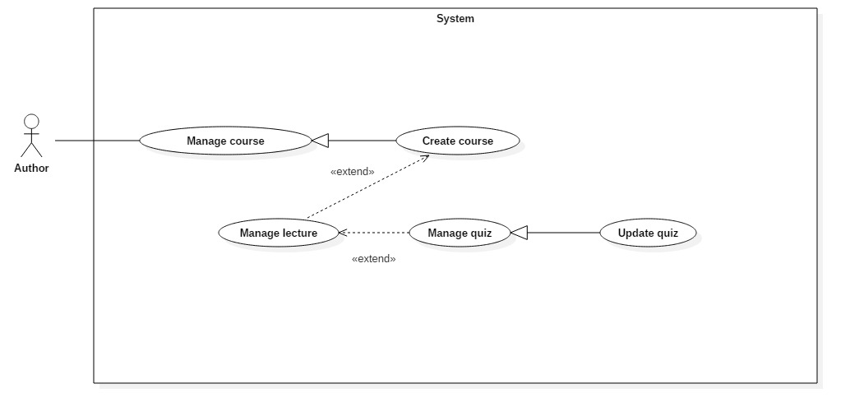

**Figure 26: <Author> Update quiz(UC_TRAISY24)**

|  |  |  |  |
| --- | --- | --- | --- |
| **USE CASE – UC_** **TRAISY24** | | | |
| **Use Case No.** | UC_ TRAISY24 | **Use Case Version** | 0.2 |
| **Use Case Name** | Update quiz | | |
| **Author** | Phạm Chánh Hưng | | |
| **Date** | 25/03/2018 | **Priority** | High |
| **Actor:**   * Author   **Summary:**   * This use case allows author to update a specific quiz.   **Goal:**   * Author successfully update quiz.   **Triggers:**   * Author sends update quiz command.   **Preconditions:**   * User logged in as author role.   **Post conditions:**   * Success: The quiz with new information will be update to database. * Fail: System displays error messages.   **Main Success Scenario:**   |  |  |  | | --- | --- | --- | | ***Step*** | ***Actor Action*** | ***System Response*** | | 1 | Actor goes to “Quản lý bài học” | System displays page with:   * “Thời gian làm bài” * “Điểm thấp nhất” * List of questions * “Lưu” button | | 2 | Actor clicks “Lưu” button |  | |  |  | [Exception no.1]  System displays popup “Cập nhật thành công” |   **Alternative Scenario: *N/A***  **Exceptions:**   |  |  |  | | --- | --- | --- | | ***No*** | ***Cause*** | ***System Response*** | | 1 | Learner does not input required field or input wrong field’s requirement. | System notices that “Không thể chỉnh sửa bài học” |   **Relationships:**   * Abstract use case: Manage quiz   **Business Rules:**   * If update successfully, quiz will be updated in database immediately * Only author who owns the quiz can update, other authors cannot modify | | | |

***2.3.2.9 <Author> Add question***

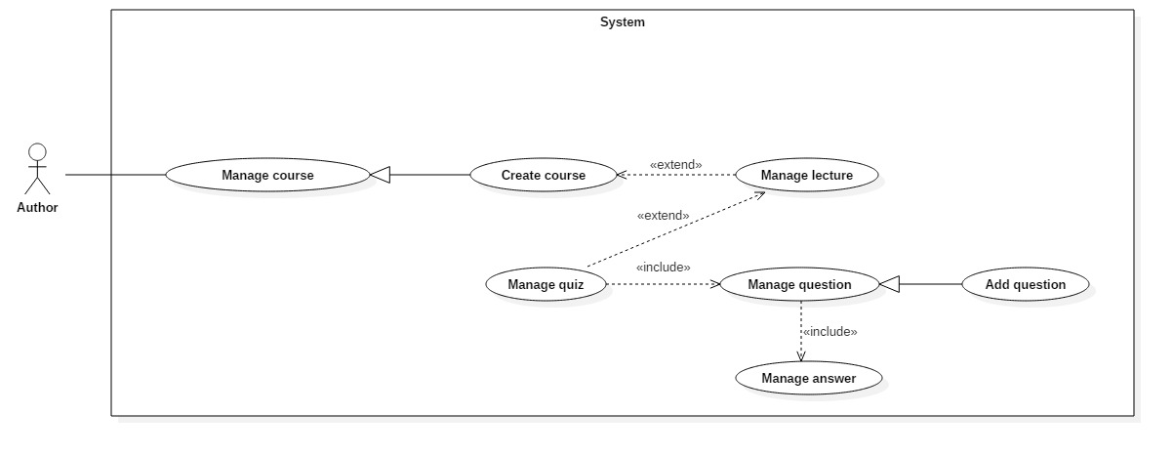

**Figure 27: <Author> Add question(UC_TRAISY25)**

|  |  |  |  |
| --- | --- | --- | --- |
| **USE CASE – UC_** **TRAISY25** | | | |
| **Use Case No.** | UC_ TRAISY25 | **Use Case Version** | 0.2 |
| **Use Case Name** | Add question | | |
| **Author** | Phạm Chánh Hưng | | |
| **Date** | 25/03/2018 | **Priority** | High |
| **Actor:**   * Author   **Summary:**   * This use case allows author to add a question.   **Goal:**   * Author successfully add question.   **Triggers:**   * Author sends add question command.   **Preconditions:**   * User logged in as author role.   **Post conditions:**   * Success: The new question is added to database. * Fail: System displays error messages.   **Main Success Scenario:**   |  |  |  | | --- | --- | --- | | ***Step*** | ***Actor Action*** | ***System Response*** | | 1 | Actor goes to “Quản lý bài học” | System displays page with:   * “Thời gian làm bài” * “Điểm thấp nhất” * List of questions * “Thêm câu hỏi” button | | 2 | Actor clicks “Thêm câu hỏi” button | System displays modal with fields:   * “Nội dung câu hỏi”: text input * “Loại câu hỏi”: dropdown list with types of question * “Câu trả lời” : text input | | 3 | Actor clicks “Thêm” button |  | |  |  | [Exception no.1]  System displays popup “Thêm câu hỏi thành công” |   **Alternative Scenario: *N/A***  **Exceptions:**   |  |  |  | | --- | --- | --- | | ***No*** | ***Cause*** | ***System Response*** | | 1 | Learner does not input required field or input wrong field’s requirement. | System displays notices:   * “Nội dung câu hỏi” field: “Nội dung câu hỏi từ 5 tới 500 ký tự” * “Câu trả lời” field: “Nội dung câu trả lời từ 5-500 ký tự” |   **Relationships:**   * Abstract use case: Manage question   **Business Rules:**   * If add successfully, question will be added in database immediately * There are 3 types of question that author can create: multiple choices, single choice, text type question * Only author who owns the quiz can add question, other authors cannot modify | | | |

***2.3.2.10 <Author> Update question***

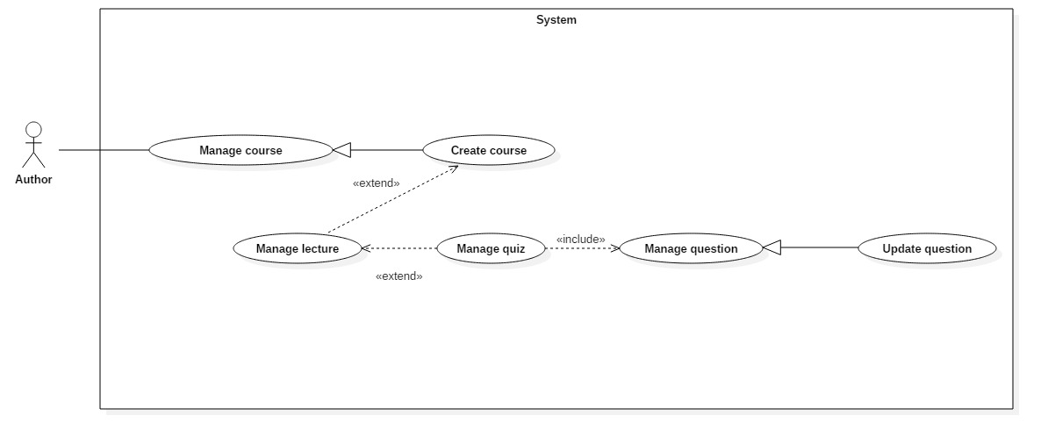

**Figure 28: <Author> Update question(UC_TRAISY26)**

|  |  |  |  |
| --- | --- | --- | --- |
| **USE CASE – UC_** **TRAISY26** | | | |
| **Use Case No.** | UC_ TRAISY26 | **Use Case Version** | 0.2 |
| **Use Case Name** | Update question | | |
| **Author** | Phạm Chánh Hưng | | |
| **Date** | 25/03/2018 | **Priority** | High |
| **Actor:**   * Author   **Summary:**   * This use case allows author to update a question.   **Goal:**   * Author successfully update question.   **Triggers:**   * Author sends update question command.   **Preconditions:**   * User logged in as author role.   **Post conditions:**   * Success: The question with new details is updated to database. * Fail: System displays error messages.   **Main Success Scenario:**   |  |  |  | | --- | --- | --- | | ***Step*** | ***Actor Action*** | ***System Response*** | | 1 | Actor goes to “Quản lý bài học” | System displays page with:   * “Thời gian làm bài” * “Điểm thấp nhất” * List of questions: with dropdown list for each question when clicked * “Thêm câu hỏi” button | | 2 | Actor clicks on a specific question | System will display information about that question which contains:   * Question name: text box * Delete button * List of answer | | 3 | Actor remove focus on question |  | |  |  | [Exception no.1]  System displays popup “Chỉnh sửa thành công” |   **Alternative Scenario: *N/A***  **Exceptions:**   |  |  |  | | --- | --- | --- | | ***No*** | ***Cause*** | ***System Response*** | | 1 | Learner does not input required field or input wrong field’s requirement. | System displays notices:   * “Nội dung câu hỏi” field: “Nội dung câu hỏi từ 5 tới 500 ký tự” * “Câu trả lời” field: “Nội dung câu trả lời từ 5-500 ký tự” |   **Relationships:**   * Abstract use case: Manage question   **Business Rules:**   * If update successfully, question will be updated in database immediately * Only author who owns the quiz can update question, other authors cannot modify | | | |

***2.3.2.11 <Author> Remove question***

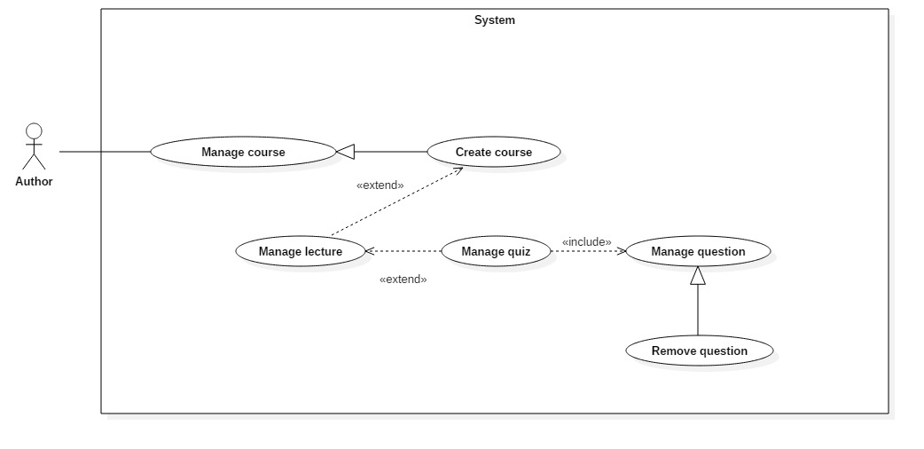

**Figure 29: <Author> Remove question(UC_TRAISY27)**

|  |  |  |  |
| --- | --- | --- | --- |
| **USE CASE – UC_** **TRAISY27** | | | |
| **Use Case No.** | UC_ TRAISY27 | **Use Case Version** | 0.2 |
| **Use Case Name** | Remove question | | |
| **Author** | Phạm Chánh Hưng | | |
| **Date** | 25/03/2018 | **Priority** | High |
| **Actor:**   * Author   **Summary:**   * This use case allows author to remove a question.   **Goal:**   * Author successfully remove question from a quiz.   **Triggers:**   * Author sends remove question command.   **Preconditions:**   * User logged in as author role.   **Post conditions:**   * Success: The question will be deleted from database. * Fail: System displays error messages.   **Main Success Scenario:**   |  |  |  | | --- | --- | --- | | ***Step*** | ***Actor Action*** | ***System Response*** | | 1 | Actor goes to “Quản lý bài học” | System displays page with:   * “Thời gian làm bài” * “Điểm thấp nhất” * List of questions: with delete button for each question * “Thêm câu hỏi” button | | 2 | Actor clicks delete a specific question | System displays modal to confirm delete question | | 3 | Actor clicks confirm |  | |  |  | [Exception no.1]  System displays popup “Xóa câu hỏi thành công” |   **Alternative Scenario: *N/A***  **Exceptions: N/A**  **Relationships:**   * Abstract use case: Manage question   **Business Rules:**   * If delete successfully, question will be delete in database immediately * Only author who owns the quiz can delete question, other authors cannot modify * When delete, all answers or learner process following the question will also be deleted. | | | |

***2.3.2.12 <Author> Add answer***

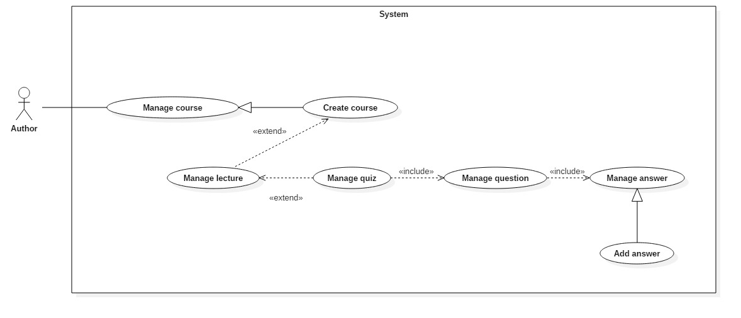

**Figure 30: <Author> Add answer(UC_TRAISY28)**

|  |  |  |  |
| --- | --- | --- | --- |
| **USE CASE – UC_** **TRAISY28** | | | |
| **Use Case No.** | UC_ TRAISY28 | **Use Case Version** | 0.2 |
| **Use Case Name** | Add answer | | |
| **Author** | Phạm Chánh Hưng | | |
| **Date** | 25/03/2018 | **Priority** | High |
| **Actor:**   * Author   **Summary:**   * This use case allows author to add an answer to a specific question.   **Goal:**   * Author successfully adds answer to a question.   **Triggers:**   * Author sends add answer command.   **Preconditions:**   * User logged in as author role.   **Post conditions:**   * Success: The answer will be added to database. * Fail: System displays error messages.   **Main Success Scenario:**   |  |  |  | | --- | --- | --- | | ***Step*** | ***Actor Action*** | ***System Response*** | | 1 | Actor goes to “Quản lý bài học” | System displays page with:   * “Thời gian làm bài” * “Điểm thấp nhất” * List of questions: with delete button for each question * “Thêm câu hỏi” button | | 2 | Actor clicks “Thêm câu hỏi” button | System displays modal with fields:   * “Nội dung câu hỏi”: text input * “Loại câu hỏi”: dropdown list with types of question * “Câu trả lời” : text input | | 3 | Actor input question and answers then click “Thêm” button |  | |  |  | [Exception no.1]  System displays popup “Thêm câu hỏi thành công” |   **Alternative Scenario:**   |  |  |  | | --- | --- | --- | | ***Step*** | ***Actor Action*** | ***System Response*** | | 1 | Actor goes to “Quản lý bài học” | System displays page with:   * “Thời gian làm bài” * “Điểm thấp nhất” * List of questions: with dropdown list for each question when clicked * “Thêm câu hỏi” button | | 2 | Actor clicks on a specific question | System will display information about that question which contains:   * Question name: text box * Delete button * List of answer | | 3 | Actor add answer through update the question (UC_ TRAISY26) |  | |  |  | System displays popup “Chỉnh sửa thành công” |   **Exceptions:**   |  |  |  | | --- | --- | --- | | ***No*** | ***Cause*** | ***System Response*** | | 1 | Learner does not input required field or input wrong field’s requirement. | System displays notices:   * “Nội dung câu hỏi” field: “Nội dung câu hỏi từ 5 tới 500 ký tự” * “Câu trả lời” field: “Nội dung câu trả lời từ 5-500 ký tự” |   **Relationships:**   * Abstract use case: Manage answer   **Business Rules:**   * If add successfully, answer will be added in database immediately * There are 2 types of answer that author can create: choice answer, text answer * Only author who owns the quiz can add answer, other authors cannot modify | | | |

***2.3.2.13 <Author> Update answer***

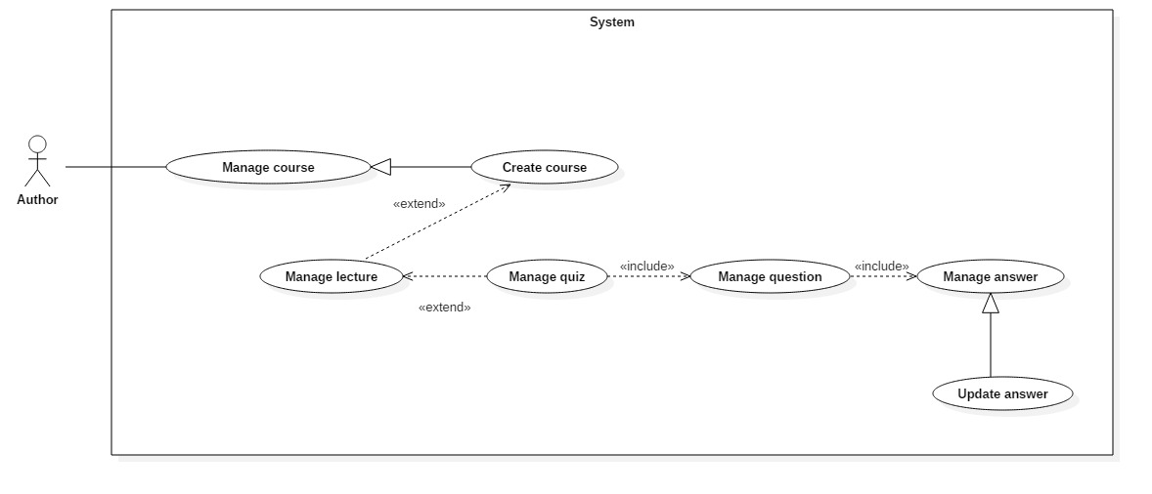

**Figure 30: <Author> Update answer(UC_TRAISY28)**

|  |  |  |  |
| --- | --- | --- | --- |
| **USE CASE – UC_** **TRAISY28** | | | |
| **Use Case No.** | UC_ TRAISY28 | **Use Case Version** | 0.2 |
| **Use Case Name** | Update answer | | |
| **Author** | Phạm Chánh Hưng | | |
| **Date** | 25/03/2018 | **Priority** | High |
| **Actor:**   * Author   **Summary:**   * This use case allows author to update an answer.   **Goal:**   * Author successfully updates a specific answer.   **Triggers:**   * Author sends update answer command.   **Preconditions:**   * User logged in as author role.   **Post conditions:**   * Success: The answer will be updated to database. * Fail: System displays error messages.   **Main Success Scenario:**   |  |  |  | | --- | --- | --- | | ***Step*** | ***Actor Action*** | ***System Response*** | | 1 | Actor goes to “Quản lý bài học” | System displays page with:   * “Thời gian làm bài” * “Điểm thấp nhất” * List of questions: with dropdown list for each question when clicked * “Thêm câu hỏi” button | | 2 | Actor clicks on a specific question | System will display information about that question which contains:   * Question name: text box * Delete button * List of answer | | 3 | Actor remove focus on a specific answer |  | |  |  | [Exception no.1]  System displays popup “Chỉnh sửa thành công” |   **Alternative Scenario:N/A**  **Exceptions:**   |  |  |  | | --- | --- | --- | | ***No*** | ***Cause*** | ***System Response*** | | 1 | Learner does not input required field or input wrong field’s requirement. | System displays notices:   * “Câu trả lời” field: “Nội dung câu trả lời từ 5-500 ký tự” |   **Relationships:**   * Abstract use case: Manage answer   **Business Rules:**   * If update successfully, answer will be updated in database immediately * Only author who owns the quiz can update answer, other authors cannot modify * Type of answer cannot be changed (from choice type to text type or otherwise) * Author can update the correct answers for the question | | | |

***2.3.2.14 <Author> Remove answer***

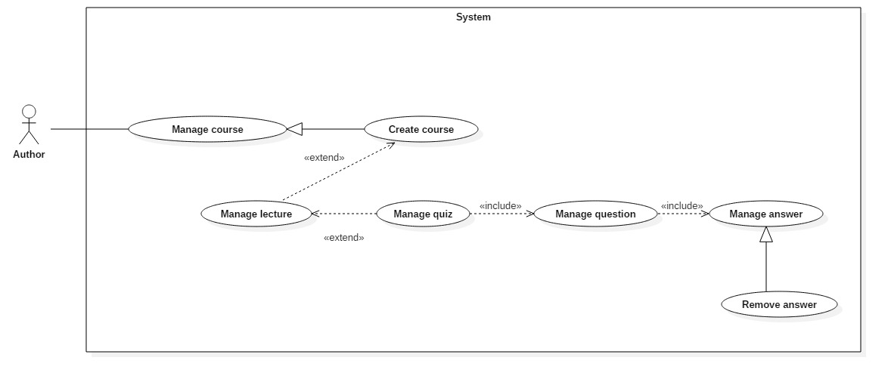

**Figure 31: <Author> Remove answer(UC_TRAISY29)**

|  |  |  |  |
| --- | --- | --- | --- |
| **USE CASE – UC_** **TRAISY29** | | | |
| **Use Case No.** | UC_ TRAISY29 | **Use Case Version** | 0.2 |
| **Use Case Name** | Remove answer | | |
| **Author** | Phạm Chánh Hưng | | |
| **Date** | 25/03/2018 | **Priority** | High |

|  |  |  |  |  |  |  |  |  |  |  |  |  |  |  |  |
| --- | --- | --- | --- | --- | --- | --- | --- | --- | --- | --- | --- | --- | --- | --- | --- |
| **Actor:**   * Author   **Summary:**   * This use case allows author to remove an answer from a question.   **Goal:**   * Author successfully removes a specific answer of a question.   **Triggers:**   * Author sends remove answer command.   **Preconditions:**   * User logged in as author role.   **Post conditions:**   * Success: The answer of question will be removed from database. * Fail: System displays error messages.   **Main Success Scenario:**   |  |  |  | | --- | --- | --- | | ***Step*** | ***Actor Action*** | ***System Response*** | | 1 | Actor goes to “Quản lý bài học” | System displays page with:   * “Thời gian làm bài” * “Điểm thấp nhất” * List of questions: with dropdown list for each question when clicked * “Thêm câu hỏi” button | | 2 | Actor clicks on a specific question | System will display information about that question which contains:   * Question name: text box * Delete button * List of answer with delete button for each answer | | 3 | Actor clicks on delete button on a specific answer |  | |  |  | System displays popup “Chỉnh sửa thành công” |   **Alternative Scenario: N/A**  **Exceptions: N/A**  **Relationships:**   * Abstract use case: Manage answer   **Business Rules:**   * If delete successfully, answer will be delete in database immediately * Only author who owns the quiz can delete answer, other authors cannot modify * When delete, all learner process or related information following the answer will also be deleted. |

***2.3.2.15 <Author> Add section***

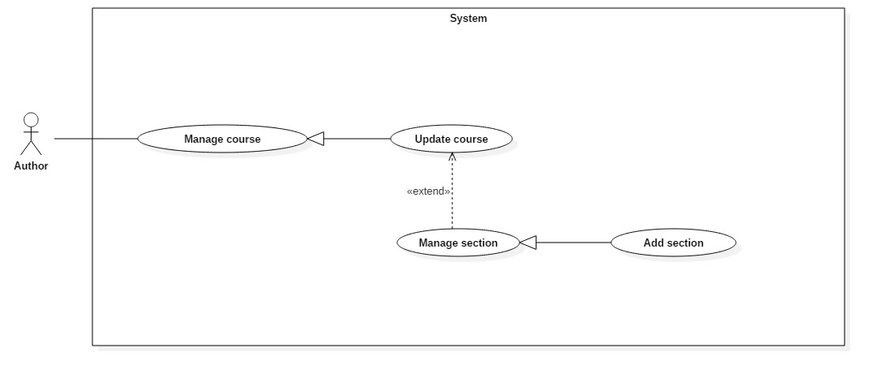

**Figure 32: <Author> Add section(UC_TRAISY30)**

|  |  |  |  |
| --- | --- | --- | --- |
| **USE CASE – UC_** **TRAISY30** | | | |
| **Use Case No.** | UC_ TRAISY30 | **Use Case Version** | 0.2 |
| **Use Case Name** | Add section | | |
| **Author** | Phạm Chánh Hưng | | |
| **Date** | 25/03/2018 | **Priority** | High |

|  |  |  |  |  |  |  |  |  |  |  |  |  |  |  |  |  |  |  |  |  |  |
| --- | --- | --- | --- | --- | --- | --- | --- | --- | --- | --- | --- | --- | --- | --- | --- | --- | --- | --- | --- | --- | --- |
| **Actor:**   * Author   **Summary:**   * This use case allows author to add a section to a specific course.   **Goal:**   * Author successfully adds a section to database.   **Triggers:**   * Author sends add section command.   **Preconditions:**   * User logged in as author role.   **Post conditions:**   * Success: The section of course will be successfully added to database. * Fail: System displays error messages.   **Main Success Scenario:**   |  |  |  | | --- | --- | --- | | ***Step*** | ***Actor Action*** | ***System Response*** | | 1 | Actor clicks "Thêm chương mới" button from manage course page. |  | |  |  | System displays modal with field: “Nhập tên chương” requires user to input section name. | | 2 | Actor clicks "Thêm chương mới” button. |  | |  |  | [Exception no.1]  System displays popup “Thêm chương mới thành công”. |   **Alternative Scenario: *N/A***  **Exceptions:**   |  |  |  | | --- | --- | --- | | ***No*** | ***Cause*** | ***System Response*** | | 1 | Learner does not input required field or input wrong field’s requirement. | System notices that “Vui lòng nhập tên chương học lớn hơn 5 ký tự'” |   **Relationships:**   * Abstract use case: Manage section   **Business Rules:**   * The section created must be in a specific course * List section in “Manage course” page will be updated with new section that just created * Section title length must be over 5 characters and below 80 |

***2.3.2.16 <Author> Update section***

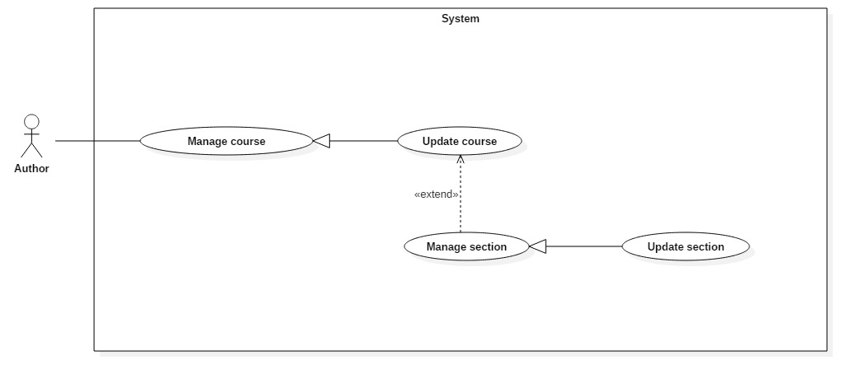

**Figure 33: <Author> Update section(UC_TRAISY31)**

|  |  |  |  |
| --- | --- | --- | --- |
| **USE CASE – UC_** **TRAISY31** | | | |
| **Use Case No.** | UC_ TRAISY31 | **Use Case Version** | 0.2 |
| **Use Case Name** | Update section | | |
| **Author** | Phạm Chánh Hưng | | |
| **Date** | 25/03/2018 | **Priority** | High |

|  |  |  |  |  |  |  |  |  |  |  |  |  |  |  |  |  |  |  |  |  |  |  |  |  |
| --- | --- | --- | --- | --- | --- | --- | --- | --- | --- | --- | --- | --- | --- | --- | --- | --- | --- | --- | --- | --- | --- | --- | --- | --- |
| **Actor:**   * Author   **Summary:**   * This use case allows author to update a specific section.   **Goal:**   * Author successfully updates a section to database.   **Triggers:**   * Author sends update section command.   **Preconditions:**   * User logged in as author role.   **Post conditions:**   * Success: The section with new information will be updated to database. * Fail: System displays error messages.   **Main Success Scenario:**   |  |  |  | | --- | --- | --- | | ***Step*** | ***Actor Action*** | ***System Response*** | | 1 | Actor goes to “Quản lý khoá học” page and clicks “Nội dung bài học” tab | System displays page with:   * List of section * Edit button next to each section | | 2 | Actor clicks Edit button from a specific section. |  | |  |  | System displays edit text that can edit section’s title and confirm button | | 3 | Actor clicks confirm button. |  | |  |  | [Exception no.1]  System displays popup “Cập nhật thành công”. |   **Alternative Scenario: *N/A***  **Exceptions:**   |  |  |  | | --- | --- | --- | | ***No*** | ***Cause*** | ***System Response*** | | 1 | Learner does not input required field or input wrong field’s requirement. | System notices that “Vui lòng nhập tên chương học lớn hơn 5 ký tự'” |   **Relationships:**   * Abstract use case: Manage section   **Business Rules:**   * If update successfully, section will be updated in database immediately * List section in “Manage course” page will be updated with new details of section that just updated * Section title length must be over 5 characters and below 80 * Only author who owns the course can modify. Otherwise, other authors cannot modify |

***2.3.2.17 <Author> Remove section***

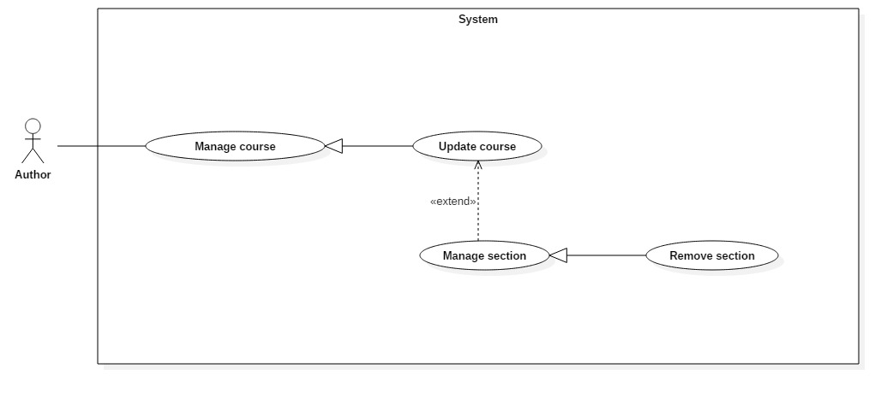

**Figure 34: <Author> Remove section(UC_TRAISY32)**

|  |  |  |  |
| --- | --- | --- | --- |
| **USE CASE – UC_** **TRAISY32** | | | |
| **Use Case No.** | UC_ TRAISY32 | **Use Case Version** | 0.2 |
| **Use Case Name** | Remove section | | |
| **Author** | Phạm Chánh Hưng | | |
| **Date** | 25/03/2018 | **Priority** | High |

|  |  |  |  |  |  |  |  |  |  |  |  |  |  |  |  |  |  |  |
| --- | --- | --- | --- | --- | --- | --- | --- | --- | --- | --- | --- | --- | --- | --- | --- | --- | --- | --- |
| **Actor:**   * Author   **Summary:**   * This use case allows author to remove a specific section.   **Goal:**   * Author successfully removes a section from database.   **Triggers:**   * Author sends remove section command.   **Preconditions:**   * User logged in as author role.   **Post conditions:**   * Success: The section will be removed from database. * Fail: System displays error messages.   **Main Success Scenario:**   |  |  |  | | --- | --- | --- | | ***Step*** | ***Actor Action*** | ***System Response*** | | 1 | Actor goes to “Quản lý khoá học” page and clicks “Nội dung bài học” tab | System displays page with:   * List of section * Delete button for each section | | 2 | Actor clicks delete button from a specific section. |  | |  |  | System displays modal to confirm author’s action | | 3 | Actor clicks confirm button. |  | |  |  | System displays popup “Xoá thành công” |   **Alternative Scenario:N/A**  **Exceptions: N/A**  **Relationships:**   * Abstract use case: Manage section   **Business Rules:**   * The section will be completely removed from database including related information of section. * Learner cannot see or access to section that has been removed * Only author who owns the course can delete the section. Otherwise, other authors cannot modify |

**2.3.3 <System Admin> Overview Use Case**

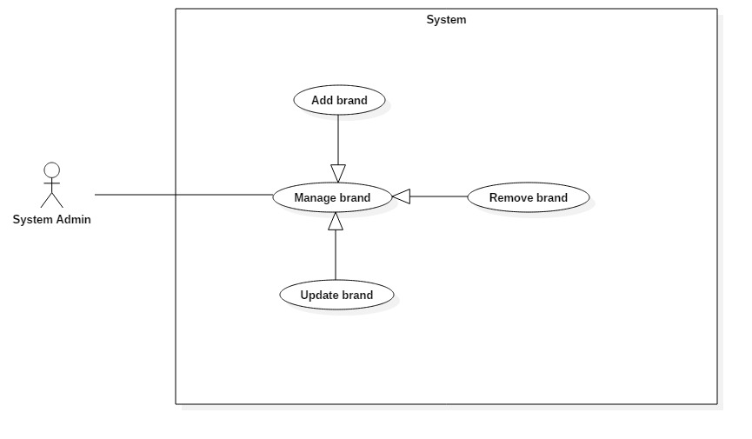

**Figure 35: <System admin> Overview Use Case**

***2.3.3.1 <System Admin> Add brand***

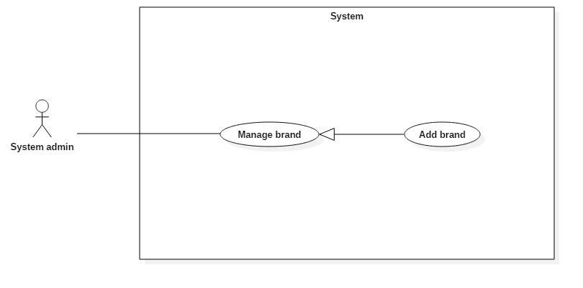

**Figure 36: <System Admin> Add brand (UC_TRAISY33)**

|  |  |  |  |
| --- | --- | --- | --- |
| **USE CASE – UC_ TRAISY33** | | | |
| **Use Case No.** | UC_ TRAISY33 | **Use Case Version** | 0.2 |
| **Use Case Name** | Add brand | | |
| **Author** | Phạm Chánh Hưng | | |
| **Date** | 26/3/2018 | **Priority** | High |
| **Actor:**   * System admin   **Summary:**   * This use case allows authorized system admin to create a brand.   **Goal:**   * To add a new brand to the system.   **Triggers:**   * Actor sends add brand command.   **Preconditions:**   * User logged in as System Admin role.   **Post conditions:**   * Success: Actor successfully adds new brand to the database and system redirects actor to that brand’s details page. * Fail: System shows error messages.   **Main Success Scenario:**   |  |  |  | | --- | --- | --- | | ***Step*** | ***Actor Action*** | ***System Response*** | | 1 | System admin goes to “Quản lý thương hiệu” page | System displays page which include:   * List of all brands that system contains * Add new brand button | | 2 | System admin clicks add new brand button | System displays modal with field: “Nhập tên thương hiệu” requires user to input brand’s name. | |  |  |  | | 3 | System admin clicks “Thêm” button | [Exception no.1]  [Exception no.2]  System redirects user to details of that brand. |   **Alternative Scenario: N/A**  **Exceptions:**   |  |  |  | | --- | --- | --- | | ***No*** | ***Cause*** | ***System Response*** | | 1 | System admin does not input required field | System notices that “Tên thương hiệu không được trống” | | 2 | System admin input wrong requirement field | System notices that “Vui lòng nhập tên thương hiệu không bị trùng” |   **Relationships:**   * Abstract use case: Manage brand   **Business Rules:**   * System admin creates brand for each company before that company’s user can access to the system * System admin cannot create brand name that already exist | | | |

***2.3.3.2 <System Admin> Update brand***

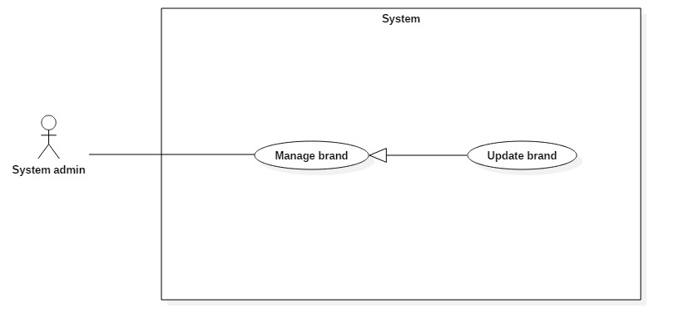

**Figure 37: <System Admin> Update brand (UC_TRAISY34)**

|  |  |  |  |
| --- | --- | --- | --- |
| **USE CASE – UC_ TRAISY34** | | | |
| **Use Case No.** | UC_ TRAISY34 | **Use Case Version** | 0.2 |
| **Use Case Name** | Update brand | | |
| **Author** | Phạm Chánh Hưng | | |
| **Date** | 26/3/2018 | **Priority** | High |
| **Actor:**   * System admin   **Summary:**   * This use case allows authorized system admin to update a specific brand.   **Goal:**   * To update a brand from the system.   **Triggers:**   * Actor sends update brand command.   **Preconditions:**   * User logged in as System Admin role.   **Post conditions:**   * Success: Actor successfully updates a brand to the database. * Fail: System shows error messages.   **Main Success Scenario:**   |  |  |  | | --- | --- | --- | | ***Step*** | ***Actor Action*** | ***System Response*** | | 1 | System admin goes to “Quản lý thương hiệu” page | System displays page which include:   * List of all brands that system contains * Add new brand button | | 2 | System admin clicks on a specific brand in the list | System redirects actor to page which include:   * “Tên thương hiệu” : text field * “Mô tả” : text area * Picture of brand * “Lưu chỉnh sửa” (save) button * Delete brand button | |  |  |  | | 3 | System admin clicks “Lưu chỉnh sửa” button | [Exception no.1]  [Exception no.2]  System shows “Cập nhật thành công” popup |   **Alternative Scenario:**   |  |  |  | | --- | --- | --- | | ***Step*** | ***Actor Action*** | ***System Response*** | | 1 | System admin goes to “Quản lý thương hiệu” page | System displays page which include:   * List of all brands that system contains * Add new brand button | | 2 | System admin clicks add new brand button | System displays modal with field: “Nhập tên thương hiệu” requires user to input brand’s name. | |  |  |  | | 3 | System admin clicks “Thêm” button | System redirects user to details of that brand. | | 4 | System admin can update information of brand through add brand use case (UC_ TRAISY33) | System shows “Cập nhật thành công” popup |   **Exceptions:**   |  |  |  | | --- | --- | --- | | ***No*** | ***Cause*** | ***System Response*** | | 1 | System admin does not input required field | System notices that “Tên thương hiệu không được trống” | | 2 | System admin input wrong requirement field | System notices that “Vui lòng nhập tên thương hiệu không bị trùng” |   **Relationships:**   * Abstract use case: Manage brand   **Business Rules:**   * System admin cannot update brand name with new name that already exist | | | |

***2.3.3.3 <System Admin> Remove brand***

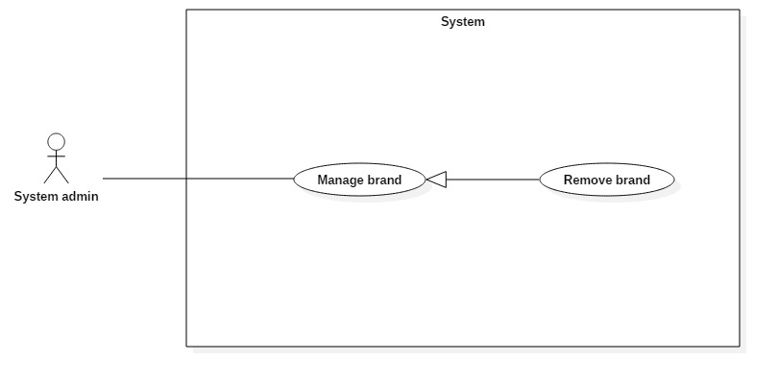

**Figure 38: <System Admin> Update brand (UC_TRAISY35)**

|  |  |  |  |
| --- | --- | --- | --- |
| **USE CASE – UC_ TRAISY35** | | | |
| **Use Case No.** | UC_ TRAISY35 | **Use Case Version** | 0.2 |
| **Use Case Name** | Remove brand | | |
| **Author** | Phạm Chánh Hưng | | |
| **Date** | 26/3/2018 | **Priority** | High |
| **Actor:**   * System admin   **Summary:**   * This use case allows authorized system admin to update a specific brand.   **Goal:**   * To delete a brand from the system.   **Triggers:**   * Actor sends delete brand command.   **Preconditions:**   * User logged in as System Admin role.   **Post conditions:**   * Success: Actor successfully deletes a brand from the database. * Fail: System shows error messages.   **Main Success Scenario:**   |  |  |  | | --- | --- | --- | | ***Step*** | ***Actor Action*** | ***System Response*** | | 1 | System admin goes to “Quản lý thương hiệu” page | System displays page which include:   * List of all brands that system contains * Add new brand button | | 2 | System admin clicks on a specific brand in the list | System redirects actor to page which include:   * “Tên thương hiệu” : text field * “Mô tả” : text area * Picture of brand * “Lưu chỉnh sửa” (save) button * Delete brand button | |  |  |  | | 3 | System admin clicks delete brand button | System shows modal that confirm deletion. | | 4 | System admin clicks confirm button | System shows “Xoá thành công” and redirects actor to list brand page. |   **Alternative Scenario: N/A**  **Exceptions: N/A**  **Relationships:**   * Abstract use case: Manage brand   **Business Rules:**   * The removed brand’s status will be change to “-1” in database. Therefore, any data such as course, program, and lecture relating to brand is not completely deleted from database. * Users that relating to brand cannot see or access to brand that has been removed. | | | |

**2.3.5 < Admin> Overview Use Case**

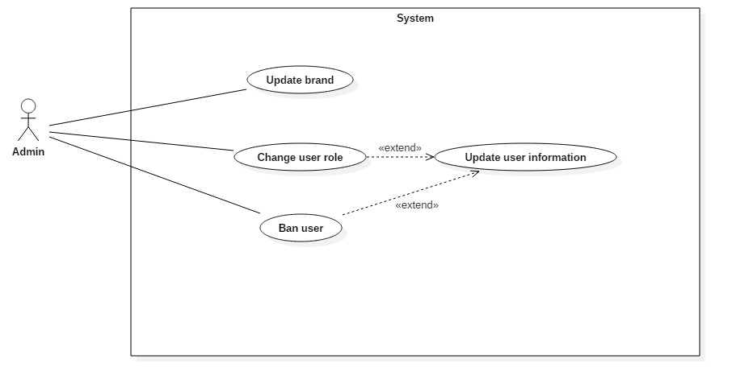

**Figure 35: <Admin> Overview Use Case**

***2.3.5.1 <Admin> Update brand***

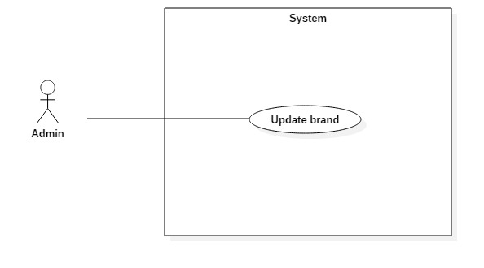

**Figure 36: <Admin> Update brand (UC_TRAISY33)**

|  |  |  |  |
| --- | --- | --- | --- |
| **USE CASE – UC_ TRAISY33** | | | |
| **Use Case No.** | UC_ TRAISY33 | **Use Case Version** | 0.2 |
| **Use Case Name** | Update brand | | |
| **Author** | Phạm Chánh Hưng | | |
| **Date** | 26/3/2018 | **Priority** | High |
| **Actor:**   * Admin   **Summary:**   * This use case allows authorized admin to update his/her brand.   **Goal:**   * To update his/her brand’s information.   **Triggers:**   * Actor sends update brand command.   **Preconditions:**   * User logged in as Admin role.   **Post conditions:**   * Success: Actor successfully updates his/her own brand. * Fail: System shows error messages.   **Main Success Scenario:**   |  |  |  | | --- | --- | --- | | ***Step*** | ***Actor Action*** | ***System Response*** | | 1 | Admin goes to “Quản lý thương hiệu” page | System displays page which include:   * Brand’s name * Brand’s description * Save button * Brand’s image | |  |  |  | | 2 | Admin clicks “Lưu chỉnh sửa” button | [Exception no.1]  [Exception no.2]  System shows “Cập nhật thành công” popup |   **Alternative Scenario: N/A**  **Exceptions:**   |  |  |  | | --- | --- | --- | | ***No*** | ***Cause*** | ***System Response*** | | 1 | Admin does not input required field | System notices that “Tên thương hiệu không được trống” | | 2 | Admin input wrong requirement field | System notices that “Vui lòng nhập tên thương hiệu không bị trùng” |   **Relationships: N/A**  **Business Rules: N/A** | | | |

***2.3.5.2 <Admin> Change user role***

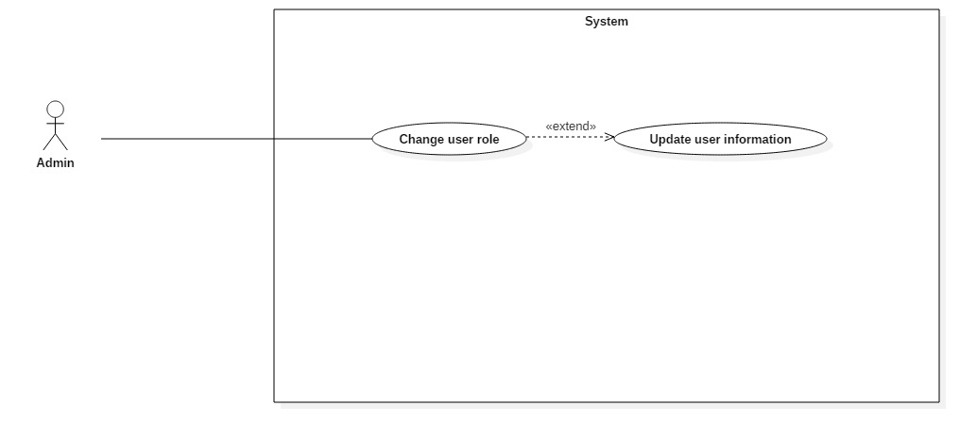

**Figure 36: <Admin> Change user role (UC_TRAISY33)**

|  |  |  |  |
| --- | --- | --- | --- |
| **USE CASE – UC_ TRAISY33** | | | |
| **Use Case No.** | UC_ TRAISY33 | **Use Case Version** | 0.2 |
| **Use Case Name** | Change user role | | |
| **Author** | Phạm Chánh Hưng | | |
| **Date** | 26/3/2018 | **Priority** | High |
| **Actor:**   * Admin   **Summary:**   * This use case allows authorized admin to change user role.   **Goal:**   * To change a specific user’s role.   **Triggers:**   * Actor sends change user role command.   **Preconditions:**   * User logged in as Admin role.   **Post conditions:**   * Success: Actor successfully changes a specific user’s role. * Fail: System shows error messages.   **Main Success Scenario:**   |  |  |  | | --- | --- | --- | | ***Step*** | ***Actor Action*** | ***System Response*** | | 1 | Admin goes to “Quản lý người dùng” page | System displays page which include:   * List of user * Edit button for each user | |  |  |  | | 2 | Admin clicks edit button of a specific user | System displays page which include:   * User’s information * Role’s dropdown list * Save button | | 3 | Admin clicks save button | System displays “Cập nhật thành công” |   **Alternative Scenario: N/A**  **Exceptions: N/A**  **Relationships:**   * Extended by: Update user information   **Business Rules: N/A** | | | |

***2.3.5.3 <Admin> Update user information***



**Figure 36: <Admin> Update user information(UC_TRAISY33)**

|  |  |  |  |
| --- | --- | --- | --- |
| **USE CASE – UC_ TRAISY33** | | | |
| **Use Case No.** | UC_ TRAISY33 | **Use Case Version** | 0.2 |
| **Use Case Name** | Update user information | | |
| **Author** | Phạm Chánh Hưng | | |
| **Date** | 26/3/2018 | **Priority** | High |
| **Actor:**   * Admin   **Summary:**   * This use case allows authorized admin to update a specific user’s details.   **Goal:**   * To update a specific user information.   **Triggers:**   * Actor sends update user command.   **Preconditions:**   * User logged in as Admin role.   **Post conditions:**   * Success: Actor successfully update a specific user information. * Fail: System shows error messages.   **Main Success Scenario:**   |  |  |  | | --- | --- | --- | | ***Step*** | ***Actor Action*** | ***System Response*** | | 1 | Admin goes to “Quản lý người dùng” page | System displays page which include:   * List of user * Edit button for each user | |  |  |  | | 2 | Admin clicks edit button of a specific user | System displays page which include:   * “Mật khẩu”: text field * “Họ và tên”: text field * “Danh hiệu”: text field * “Chức vụ”: dropdown list * “Trạng thái”: dropdown list * Save button | | 3 | Admin clicks save button | [Exception no.1]  System displays “Cập nhật thành công” |   **Alternative Scenario: N/A**  **Exceptions:**   |  |  |  | | --- | --- | --- | | ***No*** | ***Cause*** | ***System Response*** | | 1 | Admin does not input required field | System notices that:  - “Họ tên”: System displays warning message: “Họ và tên phải từ 5 tới 80 ký tự”.  - “Mật khẩu”: System displays warning message: “Mật khẩu phải từ 4 tới 30 ký tự“. |   **Relationships:**   * Extended from: change user role   **Business Rules:**   * “Họ tên” must be from 5 to 80 characters. * “Mật khẩu” must be from 4 to 30 characters. * “Mật khẩu” must be encrypted. * “Tên đăng nhập” must not be edited. | | | |

***2.3.5.3 <******Manager> Add feedback***

**Figure 36: < *Manager* > Add feedback (UC_TRAISY33)**

|  |  |  |  |
| --- | --- | --- | --- |
| **USE CASE – UC_ TRAISY33** | | | |
| **Use Case No.** | UC_ TRAISY33 | **Use Case Version** | 0.2 |
| **Use Case Name** | Add feedback | | |
| **Author** | Võ Thạch Nguyên | | |
| **Date** | 26/3/2018 | **Priority** | High |
| **Actor:**   * Manager   **Summary:**   * This use case allows authorized manager to add a feedback to specific course.   **Goal:**   * To add a feedback to course.   **Triggers:**   * Actor sends add feedback command.   **Preconditions:**   * User logged in as manager role.   **Post conditions:**   * Success: Actor successfully add a feedback to course. * Fail: System shows error messages.   **Main Success Scenario:**   |  |  |  | | --- | --- | --- | | ***Step*** | ***Actor Action*** | ***System Response*** | | 1 | Manager goes to “Đề xuất chỉnh sửa” page | System displays page which include:   * List of discussion * “Thêm phản hồi” button * Menu option for each discussion | |  |  |  | | 2 | Manager clicks “Thêm phản hồi” | System displays modal which include:   * “Nhập tiêu đề”: Text field * “Nội dung đề xuất”: Text area * “Thêm” button | | 3 | Manager clicks “Thêm” button | [Exception no.1]  System displays “Thêm thành công” |   **Alternative Scenario: N/A**  **Exceptions:**   |  |  |  | | --- | --- | --- | | ***No*** | ***Cause*** | ***System Response*** | | 1 | Manager does not input required field | System notices that:  - “Nhập tiêu đề”: System displays warning message: “Tiêu đề phải từ 5 tới 80 ký tự”. |   **Relationships:**   * Abstract use case: Manage course feedback   **Business Rules:**   * “Tiêu đề” must be from 5 to 80 characters. * Discussion belongs to a specific course | | | |

***2.3.5.3 <Manager> Update feedback***

**Figure 36: < *Manager* > Update feedback (UC_TRAISY33)**

|  |  |  |  |
| --- | --- | --- | --- |
| **USE CASE – UC_ TRAISY33** | | | |
| **Use Case No.** | UC_ TRAISY33 | **Use Case Version** | 0.2 |
| **Use Case Name** | Update feedback | | |
| **Author** | Võ Thạch Nguyên | | |
| **Date** | 26/3/2018 | **Priority** | High |
| **Actor:**   * Manager   **Summary:**   * This use case allows authorized manager to update a specific feedback.   **Goal:**   * To update a feedback to database.   **Triggers:**   * Actor sends update feedback command.   **Preconditions:**   * User logged in as manager role.   **Post conditions:**   * Success: Actor successfully update a specific feedback. * Fail: System shows error messages.   **Main Success Scenario:**   |  |  |  | | --- | --- | --- | | ***Step*** | ***Actor Action*** | ***System Response*** | | 1 | Manager goes to “Đề xuất chỉnh sửa” page | System displays page which include:   * List of discussion * “Thêm phản hồi” button * Menu option for each discussion | |  |  |  | | 2 | Manager clicks “Chỉnh sửa” from menu option for each discussion | System displays modal which include:   * “Nhập tiêu đề”: text field that contains that discussion title * “Nội dung đề xuất”: Text area that contains that discussion description * “Lưu” button | | 3 | Manager clicks “Lưu” button | [Exception no.1]  System displays “Sửa phản hồi thành công” |   **Alternative Scenario: N/A**  **Exceptions:**   |  |  |  | | --- | --- | --- | | **No** | **Cause** | **System Response** | | 1 | Manager does not input required field | System notices that:  - “Nhập tiêu đề”: System displays warning message: “Tiêu đề phải từ 5 tới 80 ký tự”. |   **Relationships:**   * Abstract use case: Manage course feedback   **Business Rules:**   * “Tiêu đề” must be from 5 to 80 characters. * Discussion belongs to a specific course * Manager can only edit his/her own discussion. Manager cannot edit other managers’ discussion | | | |

***2.3.5.3 <Manager> Remove feedback***

**Figure 36: < *Manager* > Remove feedback (UC_TRAISY33)**

|  |  |  |  |
| --- | --- | --- | --- |
| **USE CASE – UC_ TRAISY33** | | | |
| **Use Case No.** | UC_ TRAISY33 | **Use Case Version** | 0.2 |
| **Use Case Name** | Remove feedback | | |
| **Author** | Võ Thạch Nguyên | | |
| **Date** | 26/3/2018 | **Priority** | High |
| **Actor:**   * Manager   **Summary:**   * This use case allows authorized manager to remove a specific feedback.   **Goal:**   * To remove a feedback of a course.   **Triggers:**   * Actor sends remove feedback command.   **Preconditions:**   * User logged in as manager role.   **Post conditions:**   * Success: Actor successfully remove a feedback. * Fail: System shows error messages.   **Main Success Scenario:**   |  |  |  | | --- | --- | --- | | **Step** | **Actor Action** | **System Response** | | 1 | Manager goes to “Đề xuất chỉnh sửa” page | System displays page which include:   * List of discussion * “Thêm phản hồi” button * Menu option for each discussion | |  |  |  | | 2 | Manager clicks “Xóa” from menu option for each discussion | System displays modal to confirm user’s action | | 3 | Manager clicks confirm button | System displays “Xóa phản hồi thành công” |   **Alternative Scenario: N/A**  **Exceptions: N/A**  **Relationships:**   * Abstract use case: Manage course feedback   **Business Rules:**   * When discussion is deleted, the discussion is completely removed from database. Therefore, all information that related to discussion such as reply discussion will also be removed * Manager can only delete his/her own discussion. Manager cannot delete other users’ discussion | | | |

**3. Software System Attribute**

**3.1 Usability**

**3.1.1 Graphic User Interface**

All the texts, labels, alerts and messages will be written in Vietnamese

GUI for web application is designed base on material design with Navigation Bar on the left contains the main functions of the application.

**3.1.2 Usability**

The system usability is easy to use that users generally don’t need to look at the document to use including admin and manager.

Icons that indicate the actions should be easy to understand and users will not meet any troubles to recognize the feature of page.

For example:

  

For learners, each lecture has icon that show what type of lecture next to it, which helps learners understand the lecture even before studying it.

For example:

* Indicates video lecture
* Indicates text lecture

**3.2 Reliability**

The data should be backed up every day.

**3.3 Availability**

The web application must be available 24/7.

**3.4 Security**

* System admin has to create each brand for each company to use the system
* Users has to be registered by their admin/manager in order to access to the application.
* Users can not register their own accounts

**3.5 Maintainability**

System is divided into modules.

**3.6 Portability**

The software itself is a web application, therefore it can be used in any platform that has a web browser and can connect to the internet.

**3.7 Performance**

Requests from users are responded in less than 10 seconds at 5 Mbps bandwidth speed.