Primary: p,
Data with ghost: d
Fourier Transform: F[]
Fourier image of primary: F[p]=P
Fourier image of data with ghost: F[d]=D

d(t)=p(t)-p(t-tau)
=> D(omega)=(1-e^(-i*omega*tau))*P(omega)
=> P(omega)=D(omega)/(1-e^(-i*omega*tau))
D(omega)*(1-e^(i*omega*tau))
=---------------------------------------
(1-e^(i*omega*tau))(1-e^(-i*omega*tau))+epsilon
epsilon is to stabilize the formula.

Example of source ghost removing from source signature in the effect of epsilon.

Source depth is 5.0 m
Water velocity is 1545.8 m/s

tau=2.0*5.0/1545.8;

In the case we use the approximation of 1500 for water velocity.

tau=2.0*5.0/1500.0;

Case1: use approximation of v water (1500 m/s)

epsilon=0.0002
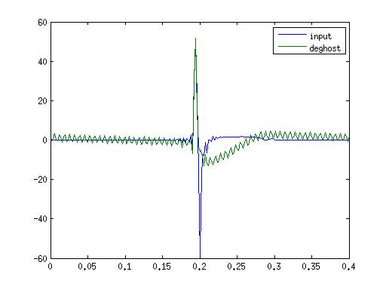

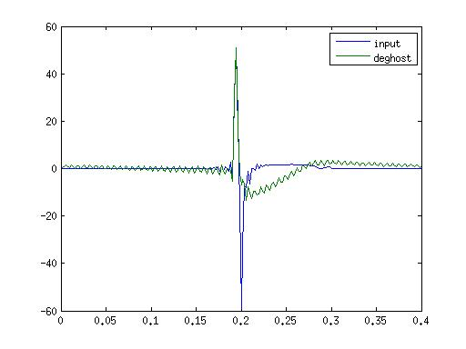
epsilon = 0.002

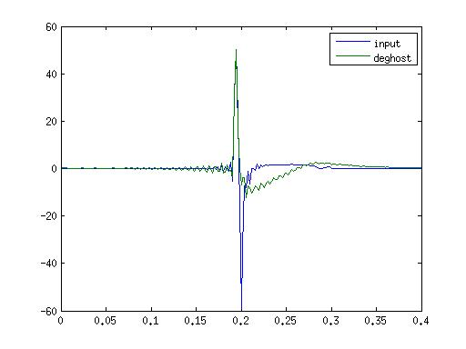
epsilon = 0.02

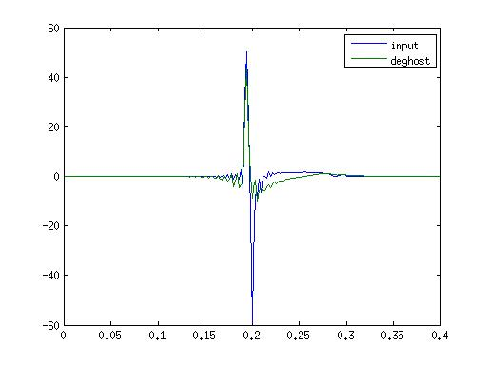
epsilon = 0.2

Case2: use almost exact v water (1545.8 m/s)

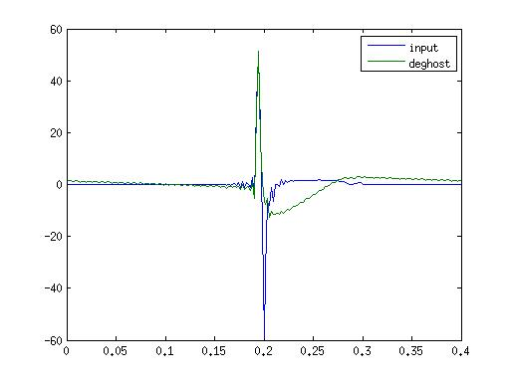
epsilon = 0.0002

epsilon = 0.002

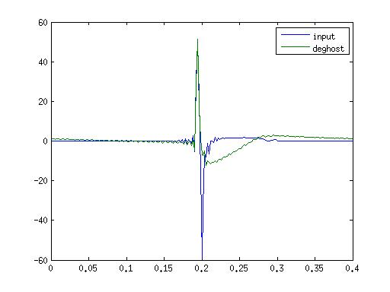

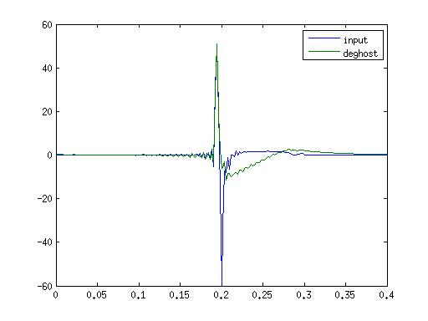
epsilon = 0.02

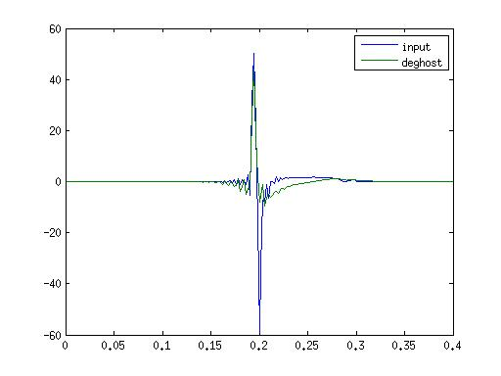
epsilon = 0.2

Conclusion:
+ With the big eps, the output of deghost is more stable even with some error in input parameters.

