LeThinh

MSSV:18521437

**Lab 1**

**Github: https://github.com/Thinhle2701/Web-application-excersise**

Ex 1:

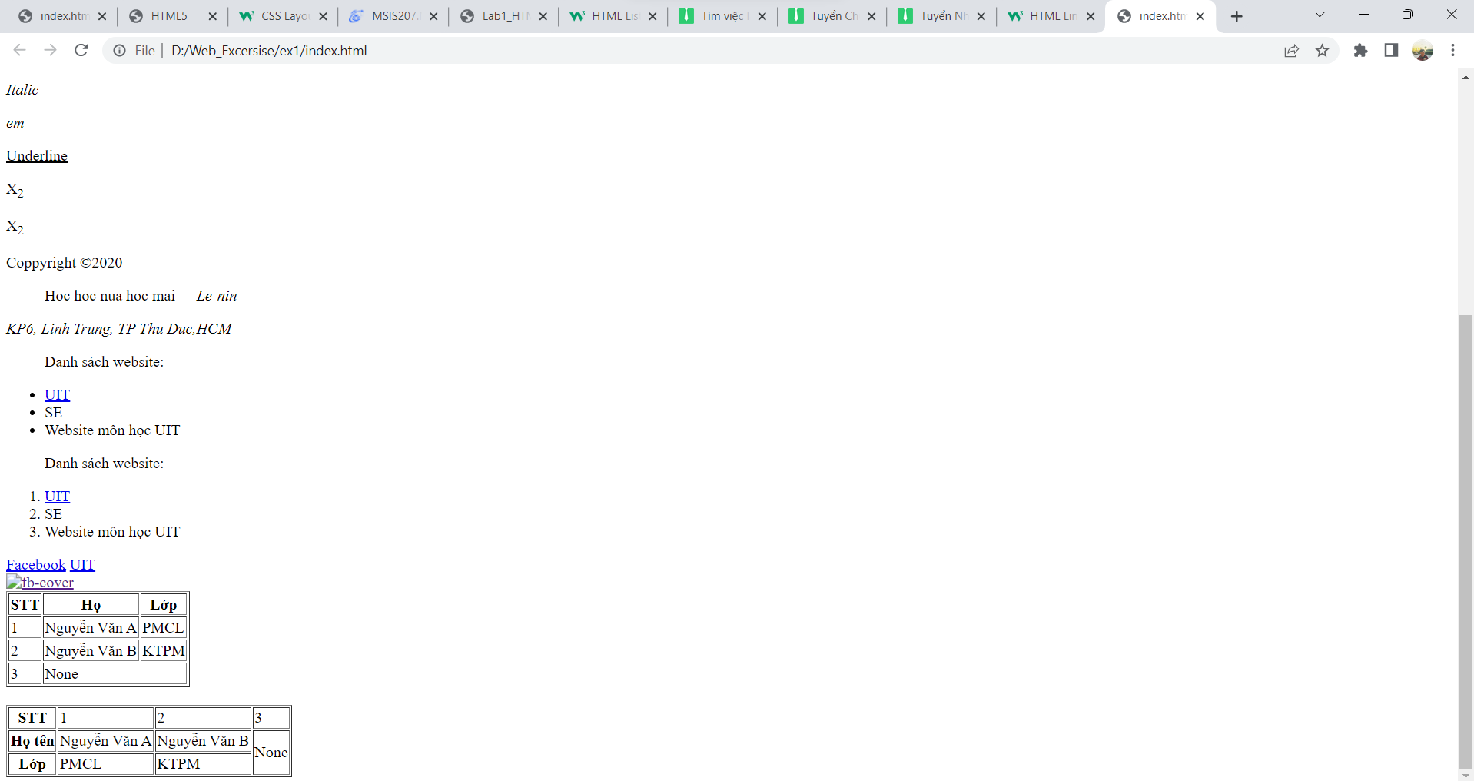

Ex 2:

Ex 3:

