**EE214 Digital Circuits Laboratory**

EXP3 – Fibonacci Detector

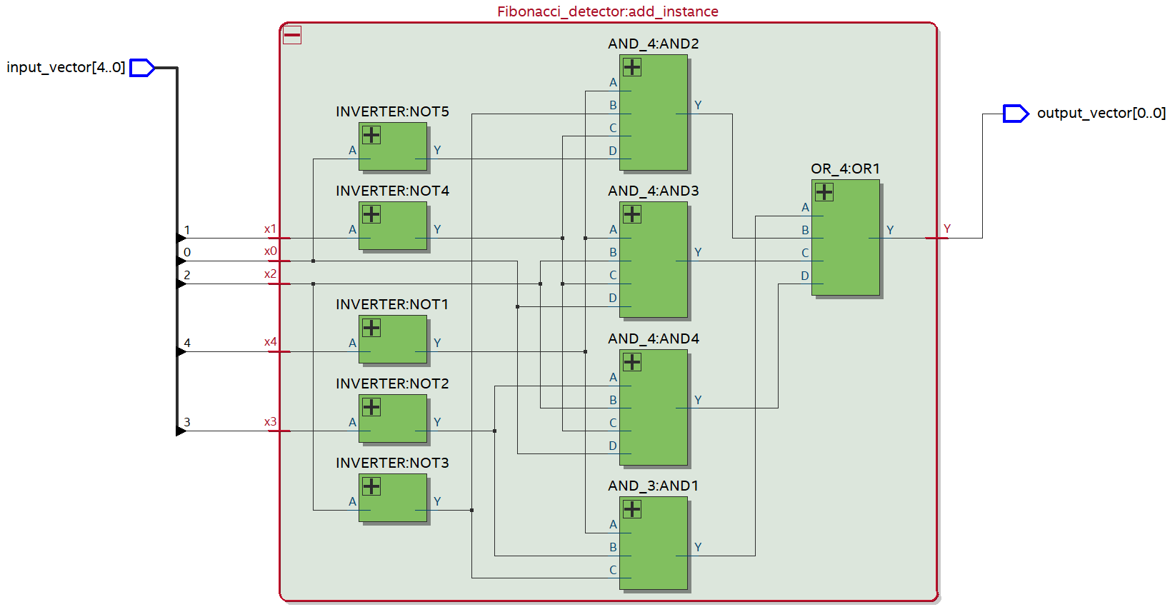**RTL Viewer:**

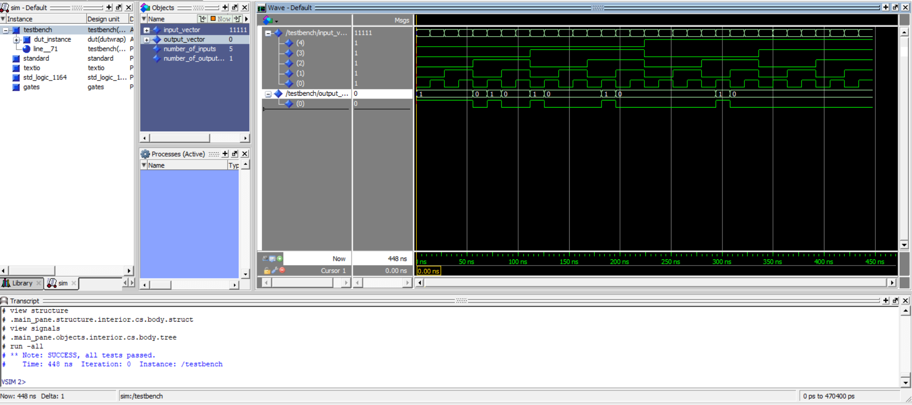**RTL Simulation:**

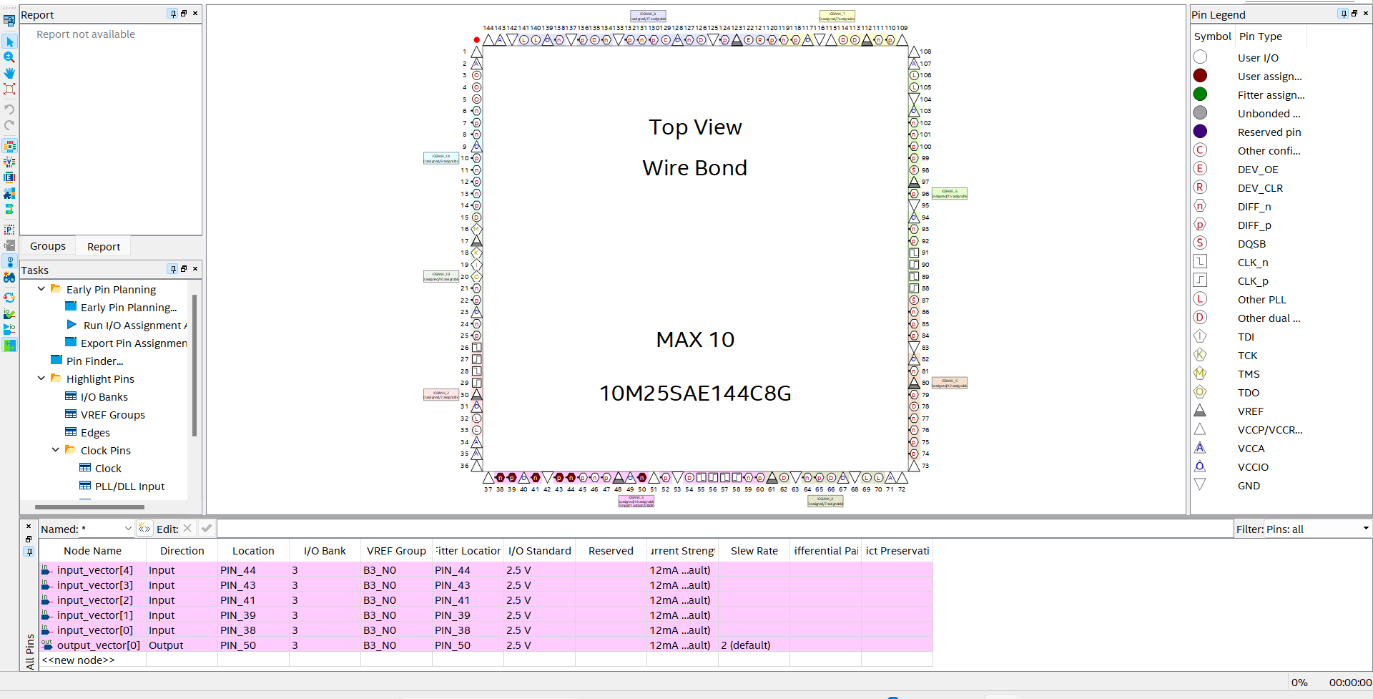**Pin Planner:**

**Manual verification using Xen-10 board:**

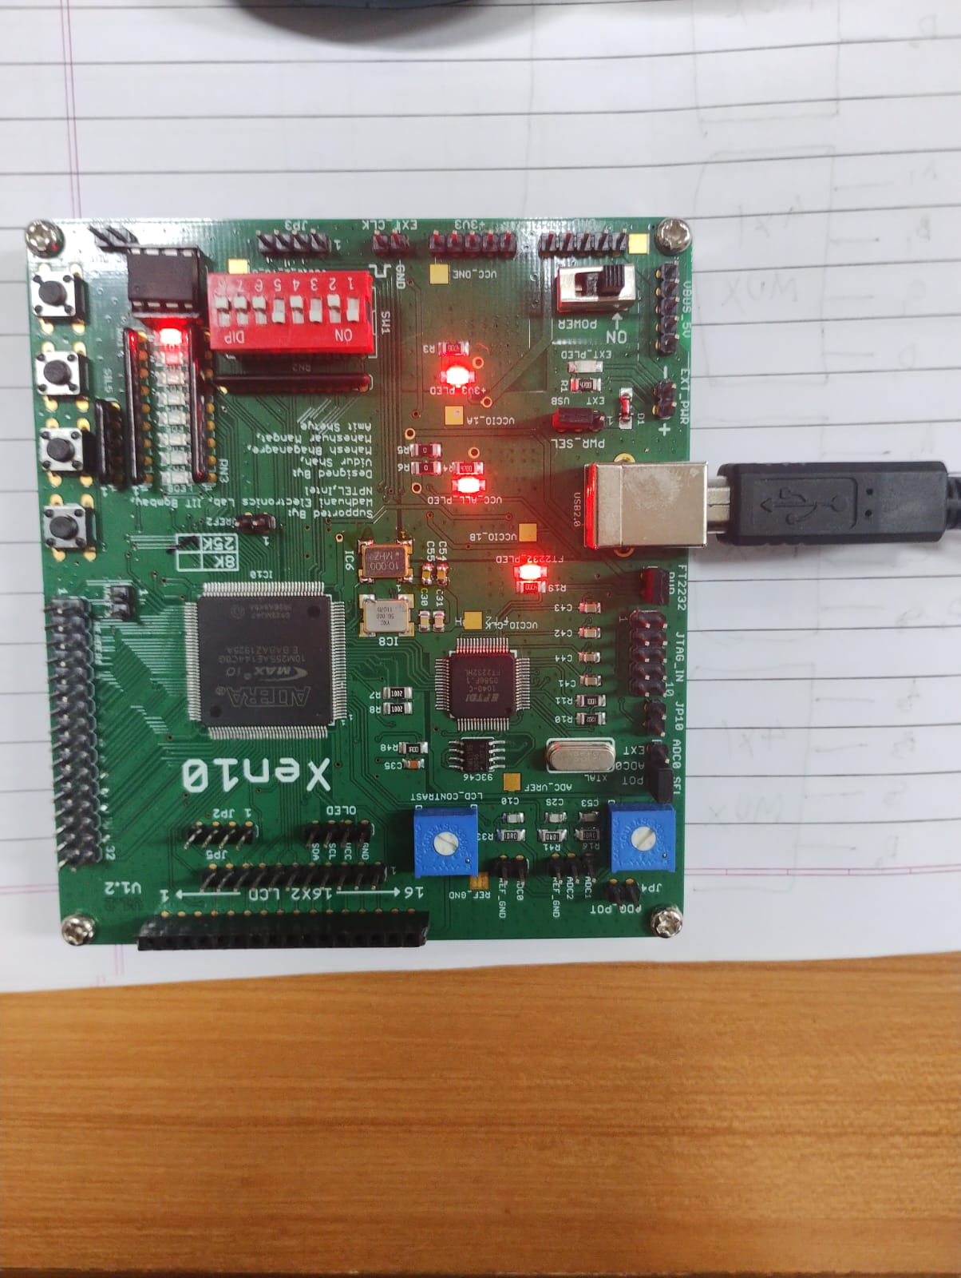

**Lab journal:**

