**EE214 Digital Circuits Laboratory**

EXP4 – BCD Adder

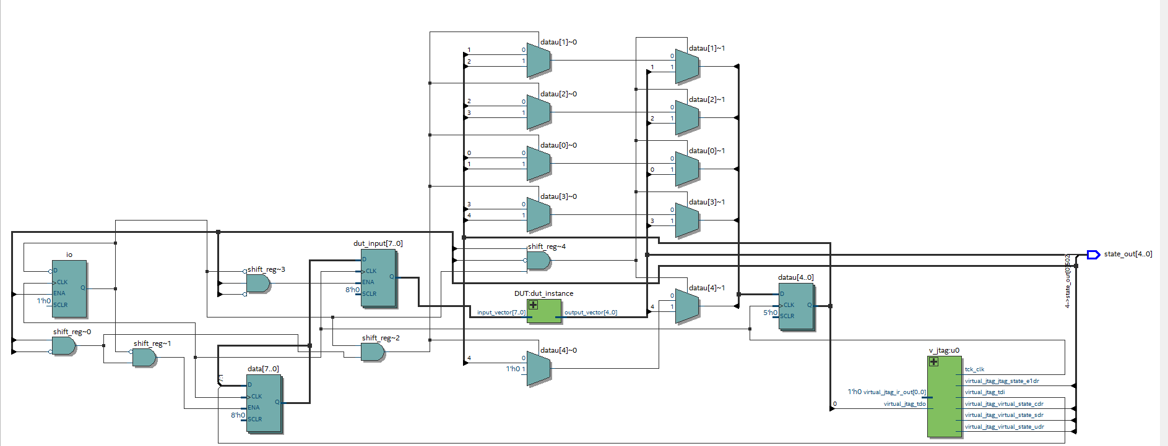**RTL Viewer:**

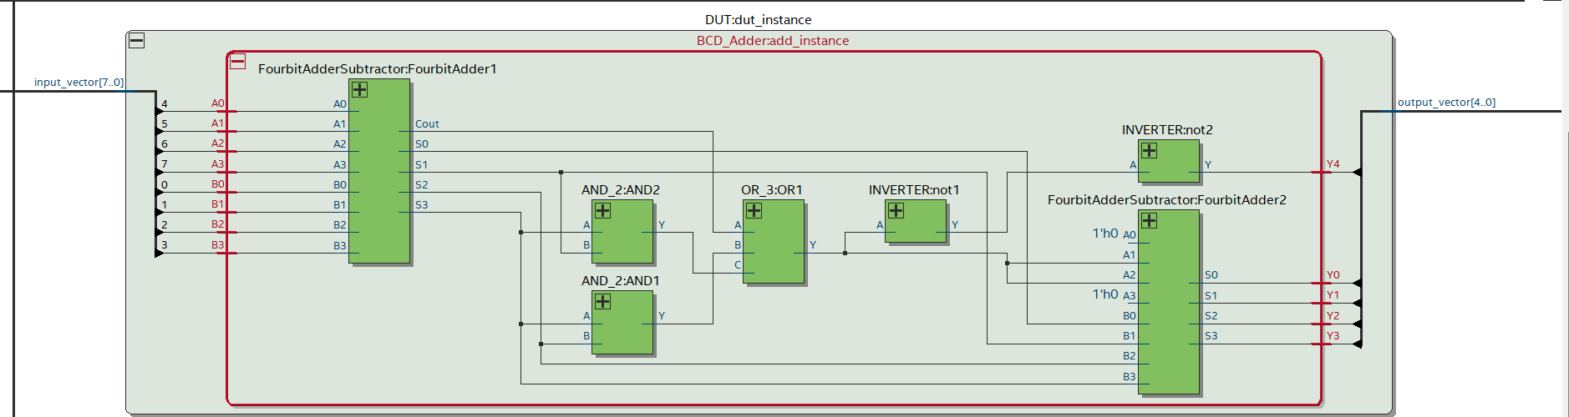

**RTL Simulation:**

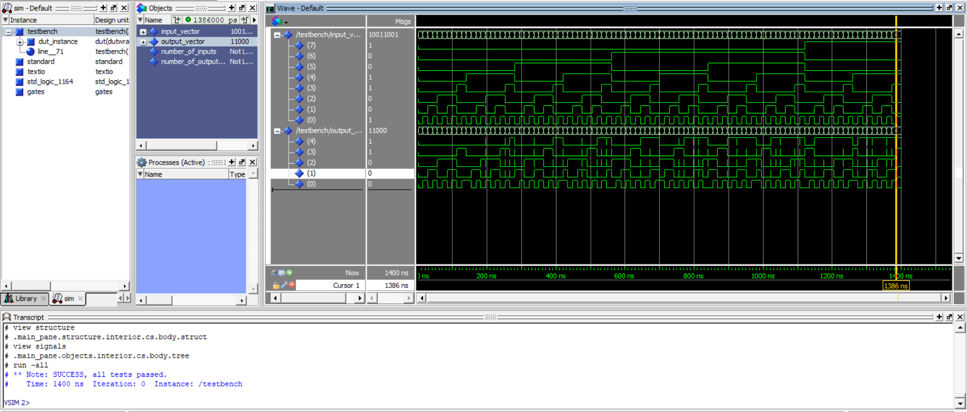Note: SUCCESS, all tests passed.

**Scanchain based testing:**

All tests were successful.

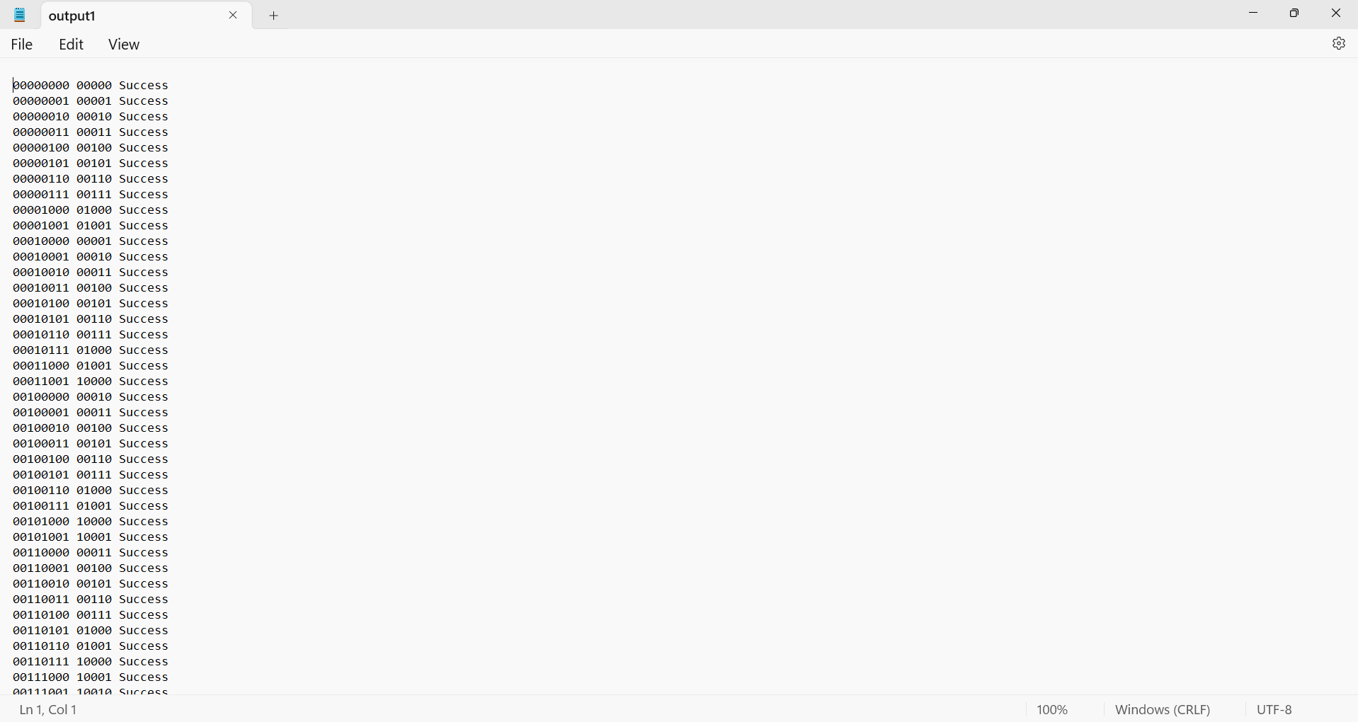

**Lab Journal:**

A rough pen-paper design of the circuit verified by the TA.

