**EE214 Digital Circuits Laboratory**

EXP5 – Behavioral and Dataflow Modelling

Swarup Dasharath Patil

22b3953

**RTL Viewer:**

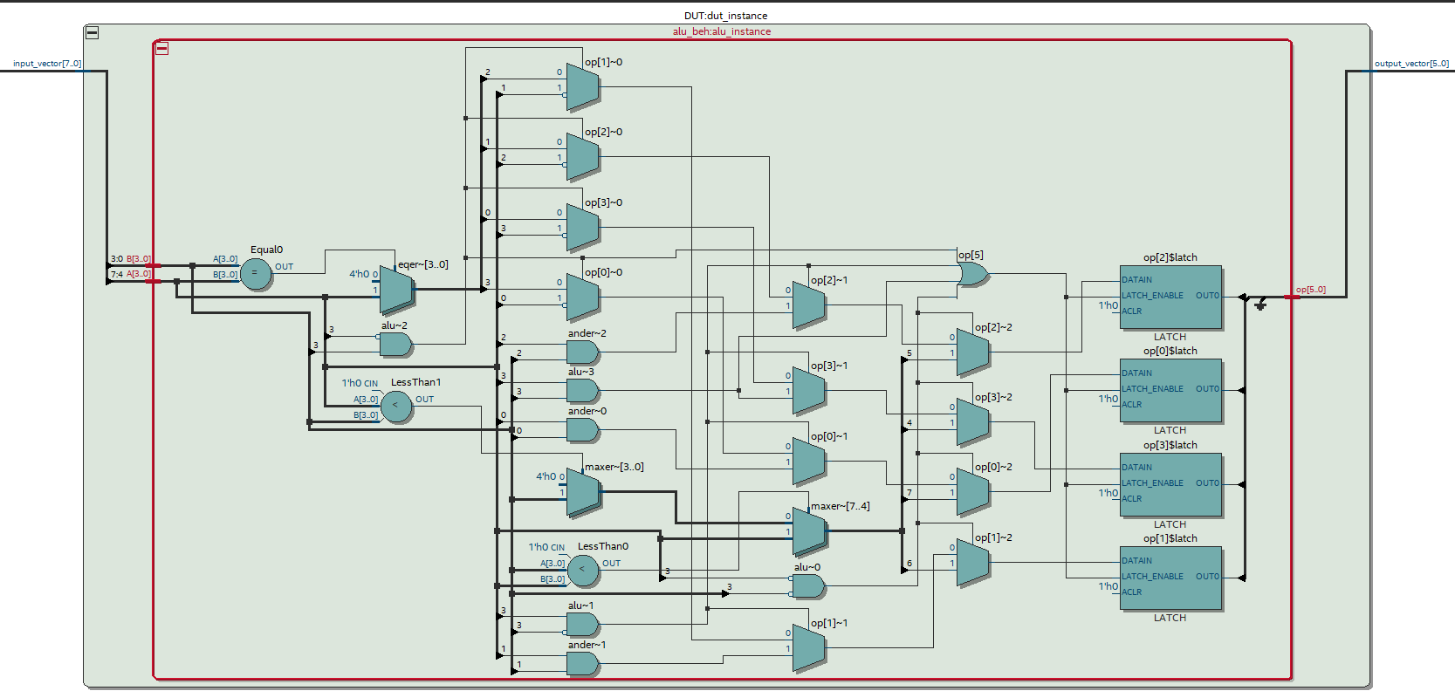

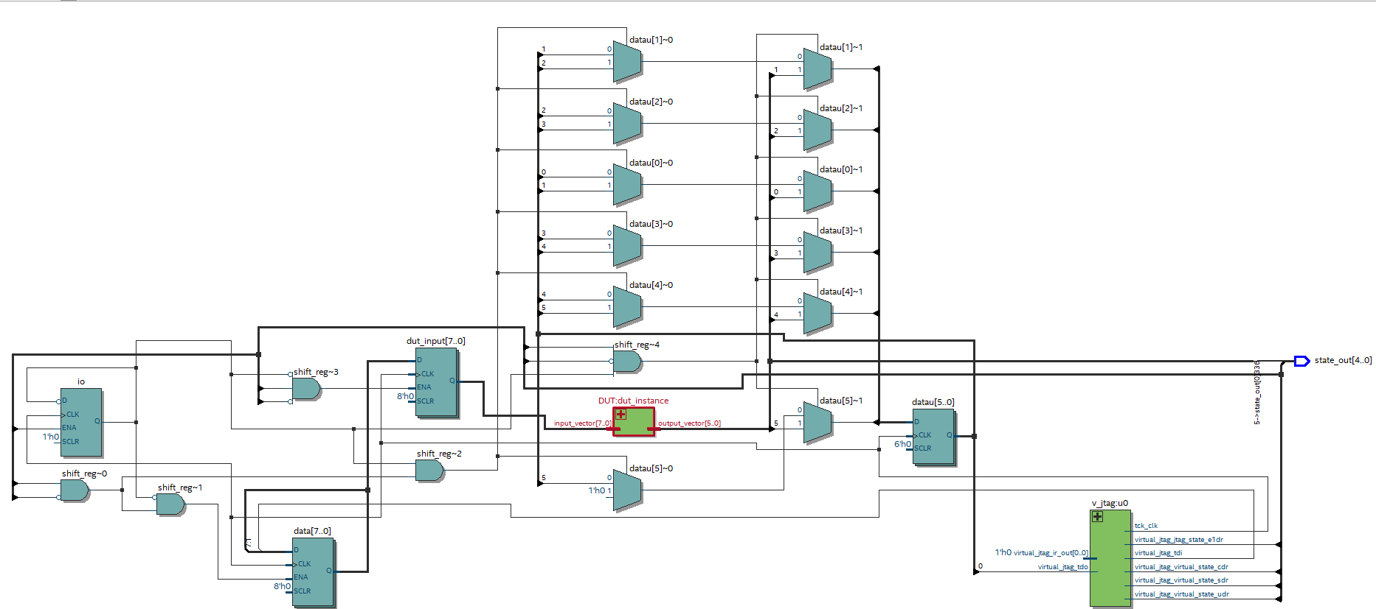

**RTL Simulation:**

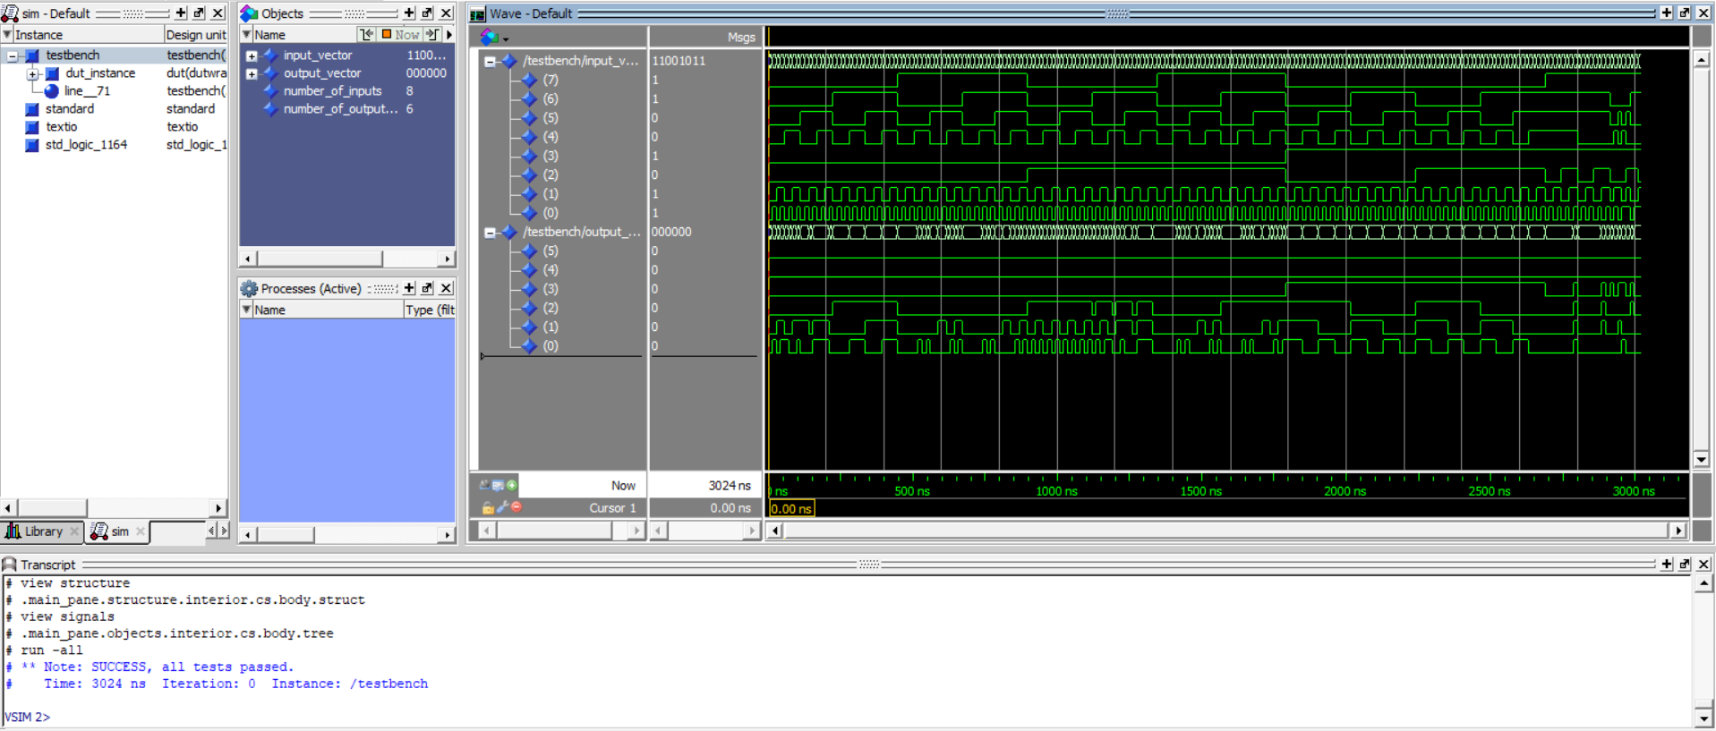Note: SUCCESS, all tests passed.

**Scanchain based testing:**

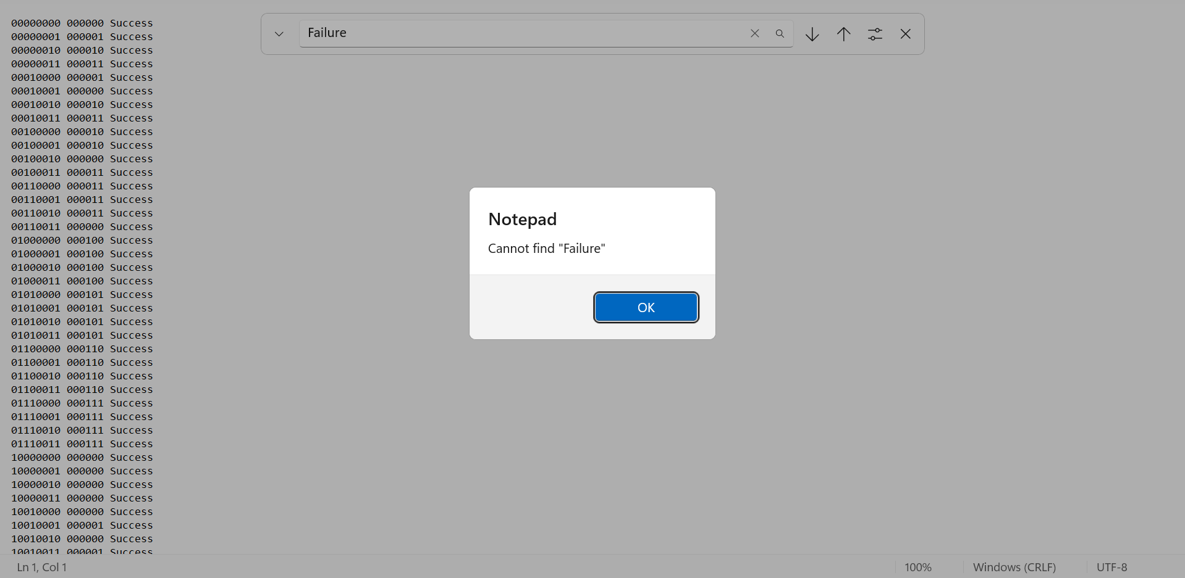All tests were successful.

**Lab Journal:**

A rough pen-paper design of the circuit verified by the TA.

