**EE214 Digital Circuits Laboratory**

EXP6 – Sequence Generator

Swarup Dasharath Patil

22b3953

**RTL Viewer:**

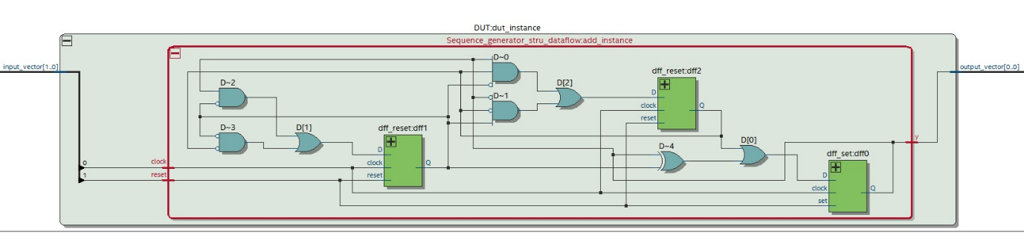

**RTL Simulation:**

Note: SUCCESS, all tests passed.

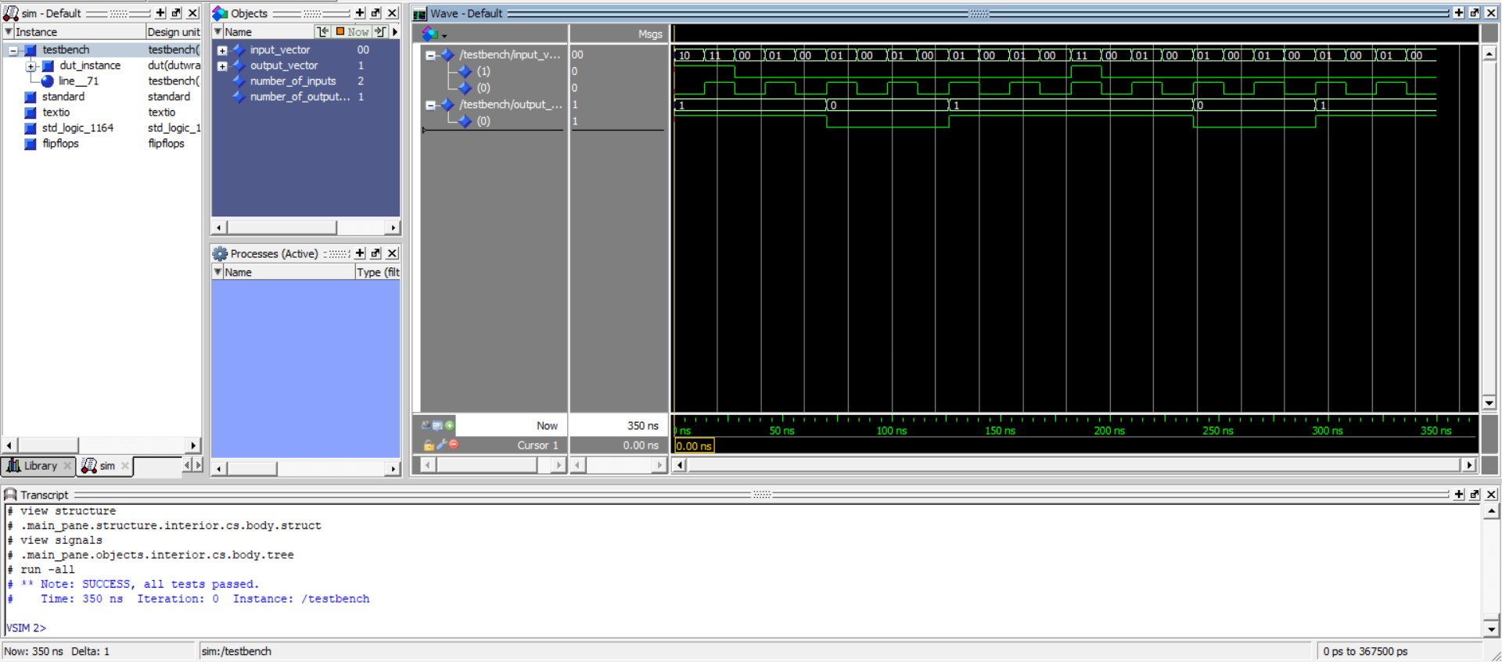

**Scanchain based testing:**

All tests were successful.

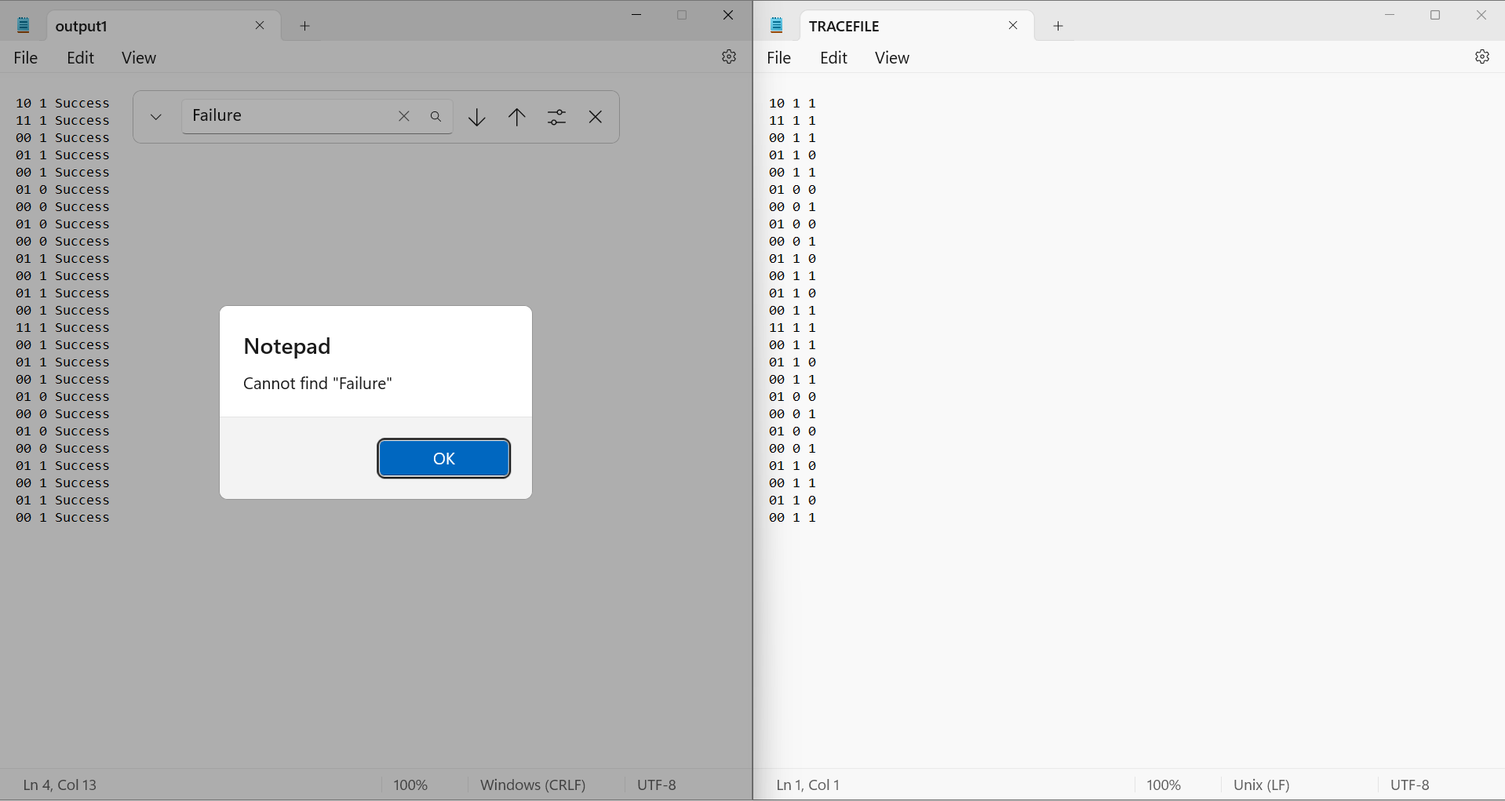

**Lab Journal:**

A state diagram to generate the states so that LSB of the states will generate the required sequence and from the state table with the help of K-Maps generate equations for DFF inputs in terms of present state and reset verified by the TA.

