**Attendance System with Face Recognition**

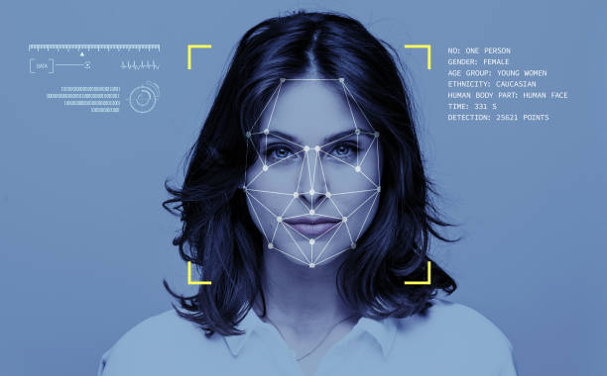

**WiDS Project**

Swarup Dasharath Patil

22b3953

<https://github.com/Think-Code-Think/WIDS.git>

**Contents**

**1.** **Introduction**

1.1 Project Overview

1.2 Objectives

1.3 Scope

**2.** **Key Features**

2.1 Face Recognition

2.2 OpenCV/CV2 Integration

2.3 CSV/Excel Storage

2.4 Real-time Tracking

**3.** **Motivation**

3.1 Challenges in Traditional Attendance Systems

3.2 Project Goals

**4.** **Technologies Used**

4.1 Python

4.2 Face Recognition Library

4.3 OpenCV/CV2

4.4 CSV/Excel

**5. Usage**

5.1 Enrollment

5.2 Recognition

5.3 Attendance Logging

**6. Learning Plan**

6.1 Week 1: Python Basics and NumPy

6.1.1 Introduction to Python

6.1.2 Introduction to NumPy

6.1.3 Introduction to OpenCV

6.2 Week 2: Advanced OpenCV and Project Setup

6.2.1 Mini Project: Counting Objects in OpenCV

6.2.2 Face Detection and Recognition with OpenCV

6.3 Week 3: Project Implementation and Documentation

6.3.1 CSV/Excel File Handling

6.3.2 Algorithm for Capturing Data using OpenCV

6.3.3 Documentation

**7. Project Implementation**

**8. Conclusion**

8.1 Summary of Achievements

8.2 Lessons Learned

8.3 Future Enhancements

**9. References**

**1. Introduction**

1.1 Project Overview

The Smart Attendance System with Face Recognition represents a novel approach to address the shortcomings of traditional attendance tracking systems. By incorporating facial recognition technology, the project seeks to modernize attendance processes prevalent in educational institutions. The objective is to create an accurate, efficient, and contactless system for recording student attendance.

1.2 Objectives

The primary objectives of the project include the implementation of facial recognition technology for student identification, real-time face detection using OpenCV, and the use of CSV/Excel formats for structured attendance record storage. The overarching goal is to provide instantaneous updates during live sessions, ensuring up-to-date and accurate attendance information.

1.3 Scope

The scope of the project encompasses the enrollment of students' faces during the initial setup, real-time recognition during live sessions, and the logging of successful matches in a CSV/Excel file. The implementation is designed to be scalable, accommodating various class sizes and environments.

**2. Key Features**

2.1 Face Recognition

The Face Recognition library was chosen for its robust capabilities in identifying and authenticating students based on facial features. This library serves as the cornerstone of the system's facial recognition functionality, employing deep learning techniques to achieve high accuracy.

2.2 OpenCV/CV2 Integration

OpenCV, an open-source computer vision library, is seamlessly integrated for efficient image processing. The library's extensive capabilities are harnessed for real-time face detection, providing the system with the ability to handle video streams and images effectively.

2.3 CSV/Excel Storage

To ensure structured and accessible attendance records, the system utilizes CSV and Excel file formats. These files store not only student IDs and names but also corresponding date and time stamps, facilitating easy retrieval and analysis of attendance data. The decision to use these formats is rooted in their widespread compatibility and ease of integration with other data analysis tools.

2.4 Real-time Tracking

Real-time tracking is a critical feature that ensures attendance records are instantaneously updated during live sessions. This feature enhances the system's ability to provide accurate and up-to-date information, reducing the likelihood of errors associated with traditional methods.

**3. Motivation**

3.1 Challenges in Traditional Attendance Systems

Traditional attendance systems are often characterized by manual processes, time consumption, and susceptibility to errors. The motivation behind the project is to address these challenges and offer a modernized solution that significantly improves efficiency and accuracy.

3.2 Project Goals

The overarching goals of the project include the modernization of attendance tracking, enhanced security through facial recognition technology, and the mitigation of risks associated with impersonation. By leveraging advanced technologies, the system aims to set a new standard for attendance management.

**4. Technologies Used**

4.1 Python

Python was selected as the primary programming language for its versatility, extensive libraries, and ease of integration. The rich ecosystem of Python facilitates rapid development and experimentation.

4.2 Face Recognition Library

The Face Recognition library, chosen for its user-friendly interface and accuracy, implements state-of-the-art algorithms for face recognition. The library's documentation (<https://pypi.org/project/face-recognition/>) serves as a valuable resource for understanding its capabilities and usage.

4.3 OpenCV/CV2

OpenCV is a fundamental component of the project, providing essential functions for image processing and computer vision. The library's documentation (<https://pypi.org/project/opencv-python/>) was extensively referenced for understanding and implementing face detection and recognition algorithms.

4.4 CSV/Excel

For structured data storage, the system utilizes CSV and Excel formats. The decision to use these formats was based on their simplicity, widespread support, and compatibility with various data analysis tools.

**5. Usage**

5.1 Enrollment

During the initial setup, students' faces are enrolled in the system. This process involves capturing facial features, extracting relevant information, and creating a database for subsequent recognition during live sessions.

5.2 Recognition

The recognition phase occurs in real-time during live sessions. The system employs the Face Recognition library and OpenCV to detect and match faces against the enrolled database. The recognition results are instantaneous, contributing to the accurate tracking of attendance.

5.3 Attendance Logging

Successful matches during recognition are logged in a CSV/Excel file, creating a comprehensive record of attendance. Each log entry includes student IDs, names, and corresponding date and time information. This structured format facilitates easy retrieval and analysis of attendance data.

**6. Learning Plan**

6.1 Week 1: Python Basics and NumPy

Introduction to Python:

The first week focused on installing Python and a code editor, followed by a comprehensive study of basic syntax, variables, and data types. Concepts such as if statements, loops, functions, and the concept of scope were explored in depth.

Introduction to NumPy:

NumPy was introduced, covering the importation of the library, working with arrays, and performing basic operations. Practical exercises included extensive practice with NumPy arrays and their manipulation.

Introduction to OpenCV:

The week concluded with an exploration of OpenCV's documentation. Practical applications included learning to read and display images using OpenCV and applying basic image processing techniques such as blurring, resizing, and thresholding to sample images.

6.2 Week 2: Advanced OpenCV and Project Setup

Mini Project: Counting Objects in OpenCV:

A mini project was undertaken to count the number of coins in a given picture. This practical application provided insights into advanced OpenCV techniques, including area and arc length calculation for distinguishing between geometries.

Face Detection and Recognition with OpenCV:

The second week delved into the understanding and implementation of face detection and recognition algorithms using OpenCV. This included studying various algorithms and understanding their strengths and limitations.

6.3 Week 3: Project Implementation and Documentation

CSV/Excel File Handling:

The third week focused on file handling in Python, specifically learning how to read and write CSV or Excel files. Practical exercises involved implementing code to store attendance records in the desired structured format.

Algorithm for Capturing Data using OpenCV:

An algorithm for capturing frames displayed on the screen and saving them to a designated folder was implemented. Each frame was labeled with the user ID and a timestamp for efficient storage. This process involved understanding the intricacies of OpenCV's video capture and image processing functionalities.

Documentation:

A comprehensive documentation process was initiated to capture each step of the implementation. The documentation includes detailed explanations of the code, algorithms, and design decisions. It serves as a valuable resource for understanding the project and aids in future maintenance and enhancements.

**7. Project Implementation**

The given below is a short explanation of the final code.

1. Initialization and Imports:

- The necessary libraries are imported, including OpenCV for computer vision, OS for file handling, datetime for time-related functions, face_recognition for face recognition tasks, and csv for handling CSV file operations.

2. Function - `add_new_face`:

- This function adds a new face to the system.

- It prompts the user to enter their name and captures a photo using the webcam.

- The photo is saved with the user's ID as the filename, and the face encoding is obtained using

face_recognition.

- The new face is then added to a dictionary of known faces.

3. Function - `take_and_save_photo`:

- This function handles the process of capturing and saving photos using the webcam.

- Users are instructed to look into the camera, enter their name and user ID, and press the spacebar to capture a photo.

- Captured photos are saved in a specified folder.

- Users can press 'q' to quit the program during photo capturing.

4. Function - `recognize_faces_webcam`:

- This function performs real-time face recognition using the webcam.

- It compares face encodings of detected faces with known faces.

- When a match is found, pressing 'p' logs the attendance in a CSV file along with the current timestamp.

- Instructions are displayed to the user, and rectangles are drawn around recognized faces.

- Users can press 'q' to quit the program during face recognition.

5. Main Execution Block:

- The main execution block initializes the save folder and a dictionary to store known faces.

- It calls the `take_and_save_photo` function to capture and add new faces to the system.

- After capturing photos, it calls the `recognize_faces_webcam` function for real-time face recognition and attendance logging.

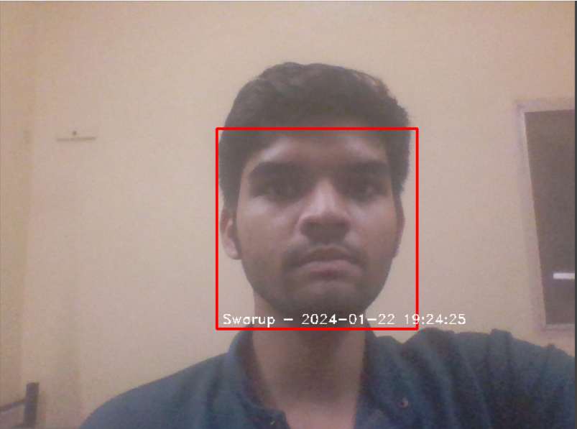

Usage:

1. Run the script.

2. Users are prompted to look into the camera, enter their information, and capture a photo.

3. Captured photos are saved in a designated folder.

4. Real-time face recognition is performed using the webcam, and attendance is logged when prompted.

5. Users can press 'q' to quit the program during photo capturing or face recognition.

Note: Ensure that the required libraries are installed before running the script, and make sure the webcam is connected and functional.

**8. Conclusion**

8.1 Summary of Achievements

The Smart Attendance System with Face Recognition represents a significant achievement in modernizing attendance tracking systems. By successfully implementing facial recognition technology, leveraging Python, and integrating advanced image processing techniques, the system achieves the goals of accuracy, efficiency, and security.

8.2 Lessons Learned

Throughout the development process, valuable lessons were learned. Proficiency in Python, understanding facial recognition algorithms, and effective use of image processing libraries were among the key takeaways. The iterative nature of the learning plan allowed for a gradual and comprehensive understanding of each concept.

8.3 Future Enhancements

To further refine the system, future enhancements could include additional features such as automated enrollment, optimization of recognition algorithms, and integration with cloud-based storage for enhanced scalability. Continuous improvement and adaptation to emerging technologies are essential for the sustained success of the Smart Attendance System.

**9. References**

<https://pypi.org/project/face-recognition/>

<https://pypi.org/project/opencv-python/>

<https://github.com/ageitgey/face_recognition>

<https://medium.com/@ageitgey/machine-learning-is-fun-part-4-modern-face-recognition-with-deep-learning-c3cffc121d78>

<https://www.analyticsvidhya.com/blog/2022/04/face-recognition-system-using-python/>

<https://www.geekering.com/categories/computer-vision/anilyadav/realtime-face-detection-and-recognition-using-python/>