AUB ONLINE
Landing Page Request Form
One form per programme. Complete it, send it back with your image folder, and we build the funnel from it.

Prepared by Think Orion · October 2026 · Version 1.0

What this form produces
Every AUB Online programme gets the same three-page funnel. The example images in this form are the live pages for the MA in Computing in Education, Faculty of Arts and Sciences — the first programme built to this pattern.
You do not need to write any copy. Give us the facts and the assets; we write, design, build and test the pages, and send you a preview link to review before anything goes live.

1. Cold-audience page
The long page, for people who have never heard of the programme. It carries the full argument: what the qualification is, who it is for, the curriculum, the faculty, the cost, the entry requirements and the FAQs.


2. In-market page
The short page, for people already searching for this qualification. The form sits in the hero so an interested visitor never has to scroll to enquire.
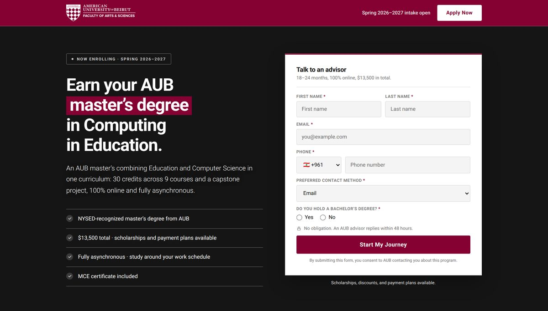

3. Thank-you page
What the enquirer sees after submitting. It sets expectations for the callback, offers a self-booking link, and keeps selling while the lead is warm.
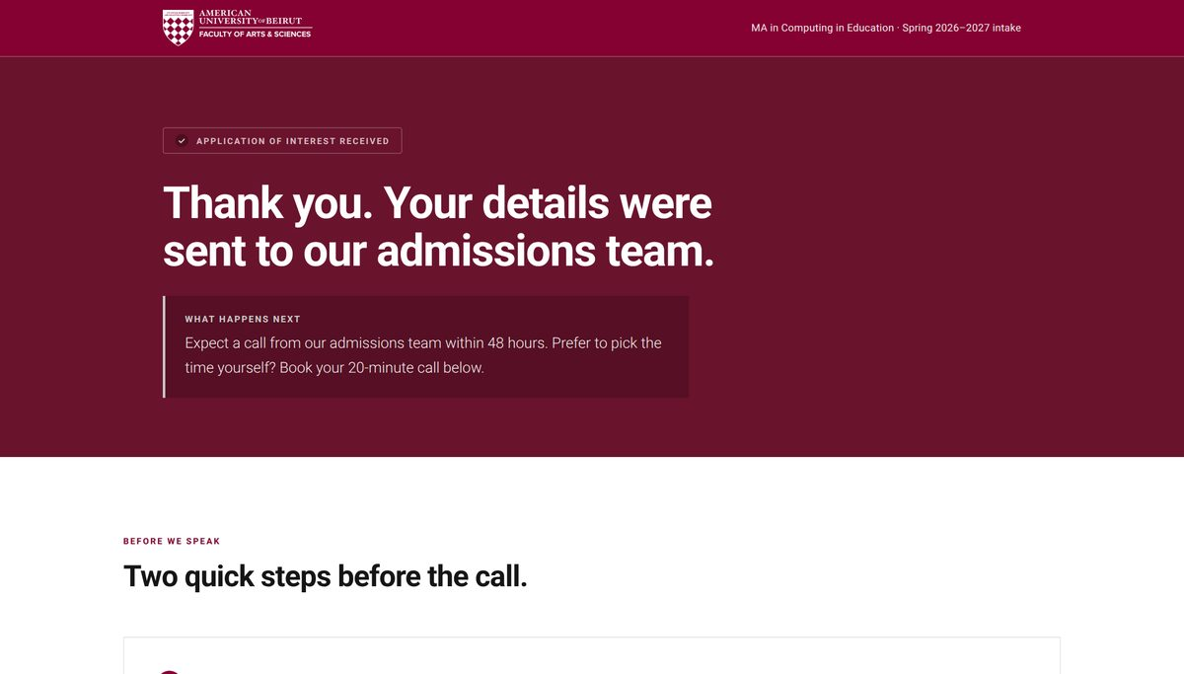

The sections you are filling in
Three sections of the page are built almost entirely from what you supply. These are where this form spends most of its questions, so it is worth seeing what they become.

Curriculum
Every course, each one expanding to a short description and the instructor who teaches it.
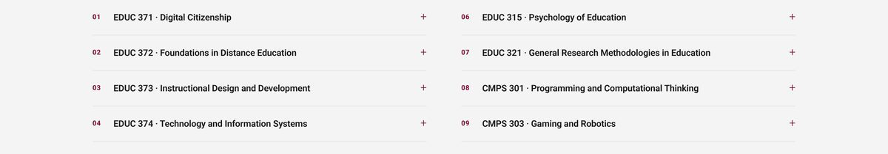

Faculty
Every instructor, with a portrait and a role line. Clicking a card opens that person’s full biography in a panel, so a long academic CV never crowds the page.
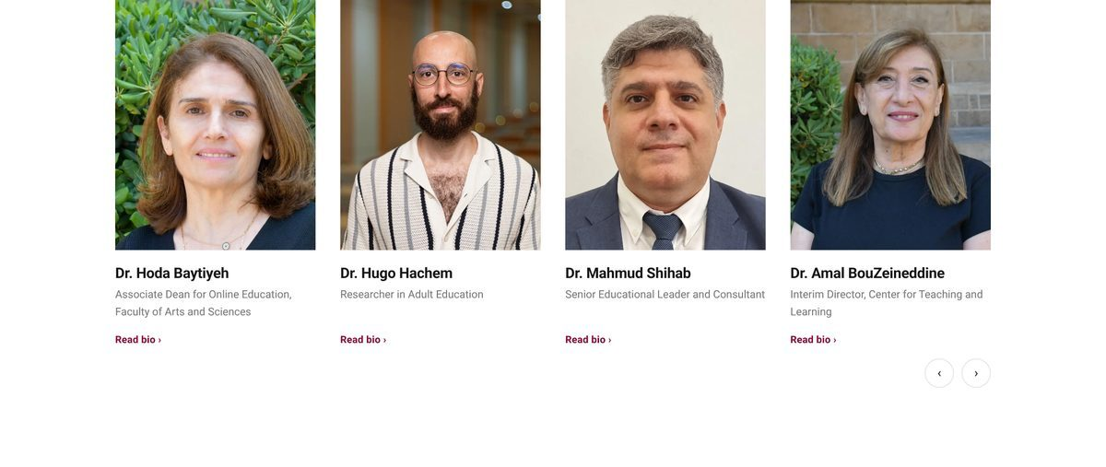

Student testimonials
Real quotes from real students, named, with photographs where they have agreed to it.
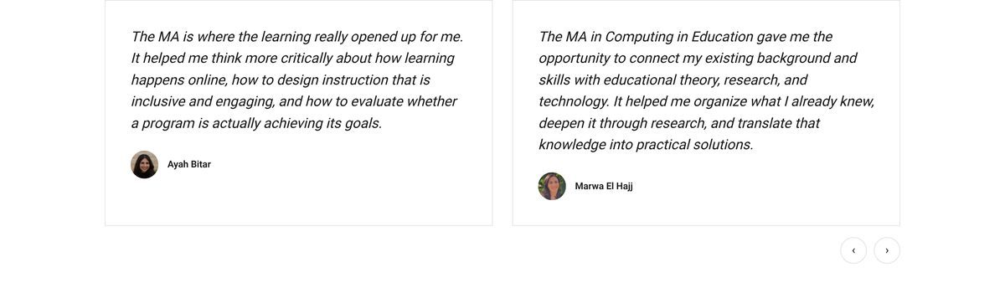

See them working
The pages are interactive — open these and click through the curriculum, the faculty cards and the sliders.
Cold audience https://raw.githack.com/Think-Orion/landing-pages/claude/aub-fas-ma-computing-education-6bcyjd/AUB/FAS/online-ma-computing-in-education/Cold_Audience_dc.html
In-market https://raw.githack.com/Think-Orion/landing-pages/claude/aub-fas-ma-computing-education-6bcyjd/AUB/FAS/online-ma-computing-in-education/In-Market_Hero_Form_dc.html
Thank you https://raw.githack.com/Think-Orion/landing-pages/claude/aub-fas-ma-computing-education-6bcyjd/AUB/FAS/online-ma-computing-in-education/Thank_You_dc.html
These are working previews, not the published pages.

How to fill this in
Six rules that save a fortnight
1. One form per programme. Do not combine two programmes in one form, even where they share courses.
2. Photographs go in a separate folder, never pasted into this document. Name each file after the person: faculty-baytiyeh.jpg, student-othman.jpg. A photo pasted into a Word file arrives with no name attached to it, and we cannot tell who is who.
3. Write TBC rather than guessing. A blank we chase is cheap; a wrong fact that reaches a published page is not.
4. Give us the full text, not a summary. We shorten; we cannot lengthen. This is especially true of biographies.
5. Every number needs an owner. Fees, credits and durations must come from someone who can approve them, because they end up on a page that people make decisions from.
6. Consent before photographs. No student quote or photograph goes on a page without written permission. See section J.

What to send back
- This document, completed, as a .docx or a Google Doc link — whichever is easier for you.
- One folder (or zip) of photographs, named as described above.
- Any existing material you already have: a factsheet PDF, a prospectus page, an approved fee schedule, a brochure. Even an out-of-date one helps.
Send it to your Think Orion contact. We will come back within two working days with a list of anything missing, and a preview link once the pages are built.

A. Programme at a glance
Field | Your answer
Faculty
e.g. Faculty of Arts and Sciences
Programme name in full
Exactly as it should appear on the page
Award
MA, MSc, Graduate Diploma, Certificate…
Credits
Total credits to complete
Duration
Typical and maximum, e.g. 18-24 months
Total cost
And cost per credit if you quote one
Scholarships or payment plans
What exists, and who qualifies
Delivery
Fully online, blended, synchronous or asynchronous
Language of instruction
Next intake
Term and year, e.g. Spring 2026-2027
Application deadline
Accreditation or recognition
Any body that recognises the award
Programme page on aub.edu.lb
The existing URL, if there is one

B. Who it is for
This is the part that decides whether the page works. Answer in your own words — full sentences are fine, bullet points are fine.
Field | Your answer
Who is the ideal student?
Role, career stage, country. Be specific.
What are they trying to achieve?
The outcome they want, not the course content
What stops them enrolling?
The objection you hear most often
What makes this programme different?
From the nearest alternative, at AUB or elsewhere
What do graduates go on to do?
Roles, promotions, destinations
Anything we must not say
Claims that are not approved, or wording to avoid

C. Curriculum
One block per course. Copy the block as many times as you need. If a course has no confirmed instructor yet, write TBC — we will leave it off the page rather than guess.
Course 1
Course code and title
e.g. EDUC 373 · Instructional Design and Development
One or two sentences on what the student learns
Plain language, not the catalogue entry
Instructor(s)
Full name, spelled as it should appear
Course 2
Course code and title
e.g. EDUC 373 · Instructional Design and Development
One or two sentences on what the student learns
Plain language, not the catalogue entry
Instructor(s)
Full name, spelled as it should appear
Course 3
Course code and title
e.g. EDUC 373 · Instructional Design and Development
One or two sentences on what the student learns
Plain language, not the catalogue entry
Instructor(s)
Full name, spelled as it should appear

A warning from the first build
Our FAS pages credited one instructor in the curriculum and a different one in a student quote, for the same course. Both were real people. Please make sure the instructor named against each course is the person teaching it now.

D. Faculty
One block per instructor. We need the complete biography — we shorten it for the card and keep the full text in the panel behind it.
Instructor 1
Name, with title
Dr., Prof., or none — exactly as they wish to be shown
Role line
One line, e.g. Professor, Department of Computer Science
Full biography
Paste the whole thing. We will not add or invent anything.
Photo filename
The file in your image folder, e.g. faculty-surname.jpg
Photo consent given?
Yes / No
Instructor 2
Name, with title
Dr., Prof., or none — exactly as they wish to be shown
Role line
One line, e.g. Professor, Department of Computer Science
Full biography
Paste the whole thing. We will not add or invent anything.
Photo filename
The file in your image folder, e.g. faculty-surname.jpg
Photo consent given?
Yes / No
Instructor 3
Name, with title
Dr., Prof., or none — exactly as they wish to be shown
Role line
One line, e.g. Professor, Department of Computer Science
Full biography
Paste the whole thing. We will not add or invent anything.
Photo filename
The file in your image folder, e.g. faculty-surname.jpg
Photo consent given?
Yes / No

E. Student testimonials
Quotes carry more weight than anything we can write. Send more than you think we need — we select the ones that answer the objections in section B.
Testimonial 1
The quote, in full
Their words, as they wrote or said them
Student name
As they wish to be credited
Which programme
They may have done more than one
Graduate or current student?
Photo filename
If they have agreed to a photograph
Written consent held for quote and photo?
Yes / No — we cannot publish without it
Testimonial 2
The quote, in full
Their words, as they wrote or said them
Student name
As they wish to be credited
Which programme
They may have done more than one
Graduate or current student?
Photo filename
If they have agreed to a photograph
Written consent held for quote and photo?
Yes / No — we cannot publish without it
Testimonial 3
The quote, in full
Their words, as they wrote or said them
Student name
As they wish to be credited
Which programme
They may have done more than one
Graduate or current student?
Photo filename
If they have agreed to a photograph
Written consent held for quote and photo?
Yes / No — we cannot publish without it

F. Admissions
Field | Your answer
Entry requirements
Degree, grade, experience, English language
Documents required to apply
How to apply
The steps, in order
Application fee
Who assesses applications, and how long it takes
Common reasons applicants are rejected
Helps us screen poor-fit leads out early

G. Advisor and contact
Field | Your answer
Advisor name
The person whose name appears beside the form
Role title
Photo filename
Response time we can promise
e.g. within 48 hours
Call booking link
Calendly or similar, if there is one
Phone and WhatsApp number
If you want them shown

H. Where the data goes
Without these the pages can be built but not launched. If you do not know an answer, tell us who does.
Field | Your answer
Where should form submissions go?
CRM, endpoint, or the person who manages it
Fields the CRM requires
So the form matches what your team expects
Thank-you page destination
Ours, or an existing URL of yours
Analytics and tag manager IDs
GTM, GA4, Meta pixel, LinkedIn
Privacy policy URL
Terms of use URL
Cookie or data-protection notice URL
Factsheet or brochure PDF
Filename, or a link to the current version

I. Brand assets
Field | Your answer
Faculty logo
Vector if possible, white and full-colour versions
Hero photography
Any approved imagery of the faculty, campus or students
Social media handles for the footer
The faculty’s own accounts
Any brand rules we must follow
Colours, fonts, wording conventions

J. Approvals and consent
This section is not administrative
Named quotes and photographs of real students are personal data. We will not publish a student’s name, words or face without written permission held by AUB, and we will ask for it before launch. Faculty photographs need the same.
Field | Your answer
Who approves the programme facts?
Fees, credits, duration, entry requirements
Who approves the marketing copy?
Who holds the student consents?
Name and email
Who holds the faculty photo consents?
Is there a legal or compliance review?
If so, who and how long it takes
Target launch date

K. Anything else
Known contradictions, figures still being argued over, things that changed recently, anything that caught you out last time. This box is more useful than it looks.

Before you send it back
A quick check against the things that most often come back incomplete.
- Section A has a fee and a credit count that agree with each other.
- Every course in section C names an instructor, or says TBC.
- Every instructor in section D has a full biography, not a summary.
- Every photo filename in this form exists in the image folder, spelled identically.
- No photographs have been pasted into this document.
- Section J names a real person against each approval.
- Anything you are unsure of says TBC rather than a best guess.

Questions about any of this, ask your Think Orion contact before filling in a section you are unsure about. It is always faster than correcting it afterwards.

