University Systems Implementation Report

Introduction
This report presents a comprehensive analysis of the design, implementation, and testing of three automated university administration systems developed using Bash and Python. These systems address common operational challenges in file management, library book borrowing, and examination submissions, ensuring efficiency, automation, and data integrity.
The three tasks implemented are:
- Task 1: University File Management & Automated Backup System (Bash)
- Task 2: Library Smart Borrowing System (Python)
- Task 3: University Examination Submission & Similarity Detection System (Bash & Python)
These solutions align with operating system administration concepts, emphasizing file management, automation, scheduling, and data integrity. Each task was rigorously tested to ensure efficiency, usability, and security.

Task 1 - University File Management & Automated Backup System

Design and Implementation
Task 1 was developed using pure Bash scripting to handle essential file operations and automate backups, ensuring compliance with system administration best practices. The key functionalities include:
- File Operations: Listing, moving, renaming, deleting, and restoring files.
- Automated Backup: Files are backed up with timestamps, and old backups are deleted if the backup directory exceeds 500MB.
- Logging System: Tracks file modifications and backup actions.

Key Code Implementation
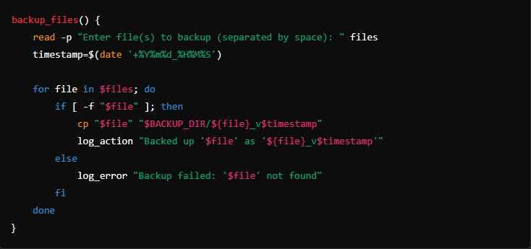
This function allows users to back up selected files by creating a copy of each file with a timestamped version in the backup directory. Before backing up, it verifies whether the specified file exists to prevent errors. Additionally, it logs each backup operation for traceability and system auditing.

Challenges and Solutions
- Ensuring POSIX compliance: The script avoids sed and awk, instead using find, printf, and loops for file operations.
- Automating storage management: A backup size check ensures disk space is not exceeded.

Execution and Expected Output
- Run the script: bash file_manager.sh
- Select menu options for file operations.
- Backups are automatically stored, and logs are maintained in backup_log.txt.

Task 2 - Library Smart Borrowing System
Task 2 was implemented in Python to process book borrowing requests using FIFO and Priority Scheduling. The system ensures fairness in book allocation by managing a structured queue.
- FIFO Scheduling: Serves students in the order requests were made.
- Priority Scheduling: Students with higher priority (1-10) are served first.
- Logging System: Tracks all book borrowings and maintains an audit log.
Task 2 also includes unit tests to validate the correct functionality of both FIFO and Priority Scheduling mechanisms. These tests ensure that book requests are processed correctly according to the selected method.

Key Code Implementation
Book Request Processing System
This function processes book requests based on FIFO or priority scheduling:
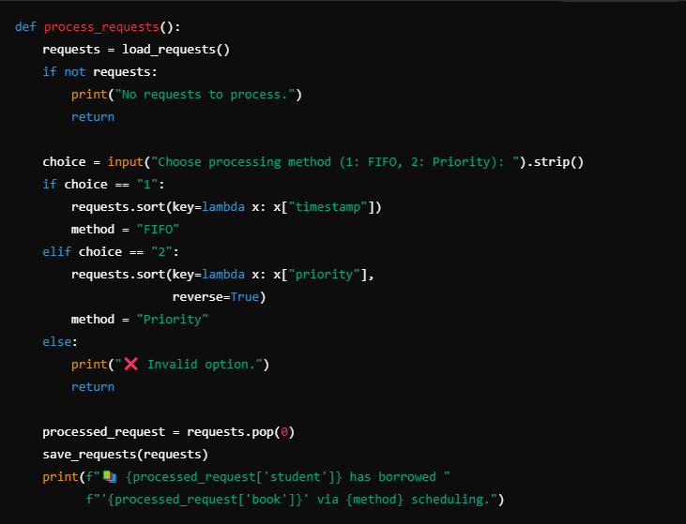
This function retrieves and processes book requests based on the scheduling method selected by the user. If FIFO is chosen, requests are sorted by their timestamp, ensuring that students receive books in the order they requested them. If Priority scheduling is selected, requests are sorted in descending order of priority, meaning students with the highest priority value are served first.

Testing Framework for Scheduling
The system includes structured unit tests to validate FIFO and Priority-based scheduling:
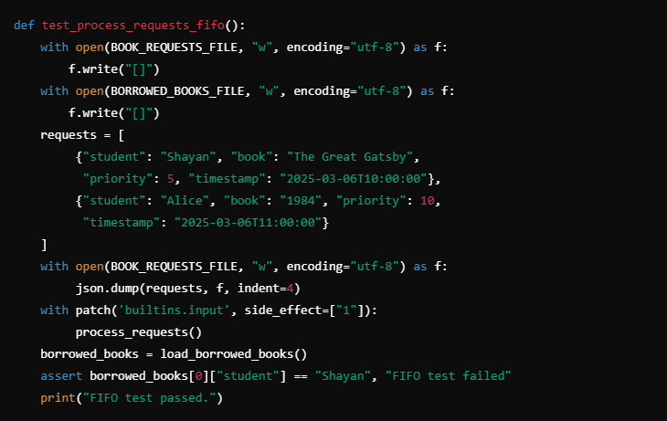
This function simulates a FIFO-based scheduling system by generating dummy book requests with different timestamps. It writes these test requests to a file, forces FIFO processing by selecting option 1, and then checks whether the earliest request (Shayan’s) is processed first. If the function works correctly, it logs the correct processing order and prints a success message.

Challenges and Solutions
Challenges:
- Handling Concurrent Requests: If two students request the same book at the same time, ensuring correct queue management was difficult.
- Data Consistency: Managing priority and FIFO queues without data loss required structured file storage.
- Ensuring Proper Logging: Keeping a structured log that correctly reflects book transactions.
Solutions:
- Implemented file locks to prevent race conditions.
- Used JSON-based data storage to ensure data persistence.
- Developed unit tests to validate queue processing logic.

Execution and Expected Output
Execution Steps:
- Run python library_system.py
- Select View Books, Request Book, and Process Requests
- Choose either FIFO or Priority scheduling.
- For test function run the script: python library_system.py test
Expected Output:
- Students requesting books get processed based on FIFO or priority.
- The borrowed_books.txt file stores issued book details.
- The book_requests.txt file stores all book requests before getting processed.
- Logs are maintained in library_log.txt

Task 3 - Examination Submission & Similarity Detection

Design and Implementation
Task 3 consists of three scripts: a Bash script and a Python script that perform identical operations for file submission, validation, and duplicate detection. The Python version offers enhanced logging and validation mechanisms, it also has similarity detection using Python for detecting plagiarism.

Key Code Implementation
Assignment Submission System (Bash Version)
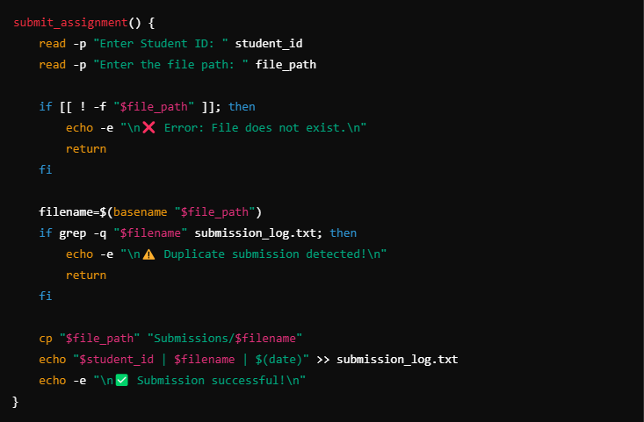
This function handles student assignment submissions, ensuring files are properly stored and logged. It first checks if the file exists before proceeding to prevent errors. If the file has already been submitted, it detects duplicates and prevents re-submission, ensuring data integrity.
Plagiarism Detection System
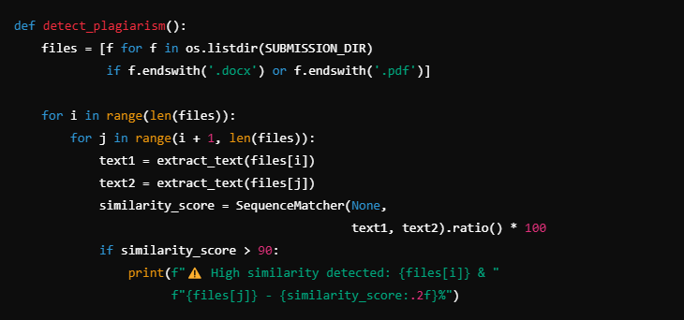
This function detects similarities between submitted assignments by extracting text from PDF and DOCX files and comparing their content. It calculates a similarity percentage between two files and flags any pair that has 90% or higher similarity, helping prevent academic misconduct.

Challenges and Solutions
Challenges:
- Ensuring Unique Submissions: Some students might try to submit duplicate files with different names.
- Detecting Plagiarism Efficiently: Handling large text comparisons without performance issues.
- Cross-Platform Compatibility: Making sure the submission system runs on different environments.
Solutions:
- Implemented filename + content hashing to detect duplicates.
- Used optimized text similarity algorithms like SequenceMatcher to compare files efficiently.
- Designed both Bash and Python implementations to support different system configurations.

Execution and Expected Output
- Execution Steps:
- Run the Bash or Python submission system:
- bash submission_system.sh
- python submission_system.py

- Submit assignments and check for duplicate detection.

- Run plagiarism detection:
- python plagiarism_detection.py

- Expected Output:
- Students receive a confirmation message upon successful submission.
- Duplicate submissions are rejected with a warning.
- Plagiarism detection flags similar assignments.

GitHub
For installation instructions, execution steps, and complete source code, please visit the official GitHub repository:
Advanced OS Scripting Solutions

The repository contains:
- Setup instructions to ensure all dependencies are installed.
- Usage guidelines for each script.
- Test cases to validate functionality.

Conclusion
The implementation of these three automated systems demonstrates a strong alignment with advanced operating system principles. These solutions not only improve administrative efficiency but also reinforce best practices in system automation, ensuring scalability and reliability in real-world applications.

References
- Apple Inc. (2024) Automator (macOS). Available at: https://en.wikipedia.org/wiki/Automator_%28macOS%29 (Accessed: March 2025).
- Wikipedia Contributors (2024) Automounter. Available at: https://en.wikipedia.org/wiki/Automounter (Accessed: March 2025).
- Wikipedia Contributors (2024) EMCO MoveOnBoot. Available at: https://en.wikipedia.org/wiki/EMCO_MoveOnBoot (Accessed: March 2025).
- Wikipedia Contributors (2024) Tabbles - File Tagging System. Available at: https://en.wikipedia.org/wiki/Tabbles (Accessed: March 2025).
- Lifewire (2024) Unlocking the Power of File Managers. Available at: https://www.lifewire.com/unlocking-the-power-of-file-managers-8735872 (Accessed: March 2025).
- GNU Project (2025) Bash Reference Manual. Available at: https://www.gnu.org/software/bash/manual/bash.html (Accessed: March 2025).
- Python Software Foundation (2025) The Python Language Reference. Available at: https://docs.python.org/3/reference/ (Accessed: March 2025).
- Linux Handbook (2025) Bash Scripting Guide. Available at: https://linuxhandbook.com/bash-scripting/ (Accessed: March 2025).

