


Module Code & Module Title
CC6012NI Data and Web Development

Assessment Type
Semester

Student Name: Utsav Bajracharya
London Met ID: 22068185
College ID: np01cp4a220340
Assignment Due Date: 26th March 2025
Assignment Submission Date: 26th March 2025
Word Count: 4794
I confirm that I understand my coursework needs to be submitted online via Google Classroom under the relevant module page before the deadline for my assignment to be accepted and marked. I am fully aware that late submissions will be treated as non-submission and a mark of zero will be awarded.
Table of Contents
1. Introduction 2
1.1 Background 2
1.2 Aims and Objectives 3
1.3Textual Analysis 5
2. Initial Entity Relationships Diagram(ERD)\ 8
3. Normalization 9
3.1UNF: 9
3.2 1NF: 9
3.3 2NF: 9
3.3 3NF: 10
4. Integration and Assumptions 11
4.1Integration of the Project 11
4.2 Assumptions in System Design 12
4.3Milestone Assumptions 13
5. Final Entity Relationship Diagram 14
6. Data Dictionary 15
7. Script 20
7.1 Create Statement 20
7.2 Insert Statement 29
8. Forms 37
8.1 Home Page 37
8.2 Basic Webforms 38
9. User Manual 44
10. Testing 54
11. Further Works 73
12. Tools and Technology used 74
13. Conclusion 75
14. Appendix 76

Figure 1:Textual Analysis of User and Project 5
Figure 2:Textual Analysis of Project and Task 5
Figure 3:Textual Analysis of Task and Subtask 6
Figure 4:Textual Analysis of User and Task 6
Figure 5:Textual Analysis of Project and Milestone 6
Figure 6:Textual Analysis of Task and Comment 6
Figure 7:Textual Analysis of Task and Resource 7
Figure 8:Textual analysis of user and Comment 7
Figure 9: Initial Entity Relationship Diagram 8
Figure 10:Final Entity Relationship Diagram 14
Figure 11: Creating Table Comment 20
Figure 12: Creating table milestone 20
Figure 13: Creating table Project 21
Figure 14:Creating table Resource 22
Figure 15:Creating Table Subtask 22
Figure 16: Creating table Task 23
Figure 17:Creating User Table 24
Figure 18: Creating User_Project Table 24
Figure 19:Create User_Project_Task Table 25
Figure 20:Altering all the tables 26
Figure 21: Displaying users info 30
Figure 22:: Inserting values in Project table 31
Figure 23:Displaying project table 33
Figure 24:: Inserting values in Task Table 34
Figure 25:Home Page 37
Figure 26: Sidepanel Nav Barr 37
Figure 27: User Page 38
Figure 28:User Page 38
Figure 29:Project Page 39
Figure 30:Project Page 40
Figure 31:Milestone Page 41
Figure 32:Milestone Page 41
Figure 33:Task Page 42
Figure 34:Subtask Page 43
Figure 35:Basic Form of User 55
Figure 36:Adding New User Details 56
Figure 37:Newly added User Detail 57
Figure 38:Basic Forms of Project 59
Figure 39: Adding New Project Details 60
Figure 40:Adding New Subtask Details 62
Figure 41:Dropdown menu of Task_Id 63
Figure 42: Adding new Details in Milestone Table 67
Figure 43:Adding new Milestone Details 71
Figure 44:Details of Milestone Table 72

Table 1:Test For CRUD in User 54
Table 2:Test For CRUD of Project 58
Table 3:Test for CRUD of SUBTASK 62
Table 4:Test For DRUD of MILESTONE TABLE 66

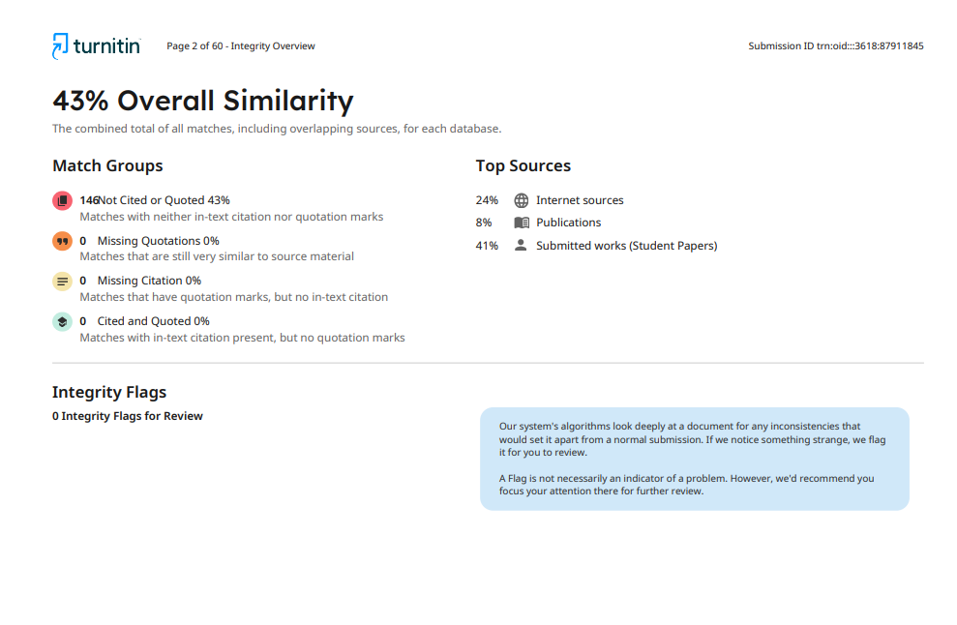
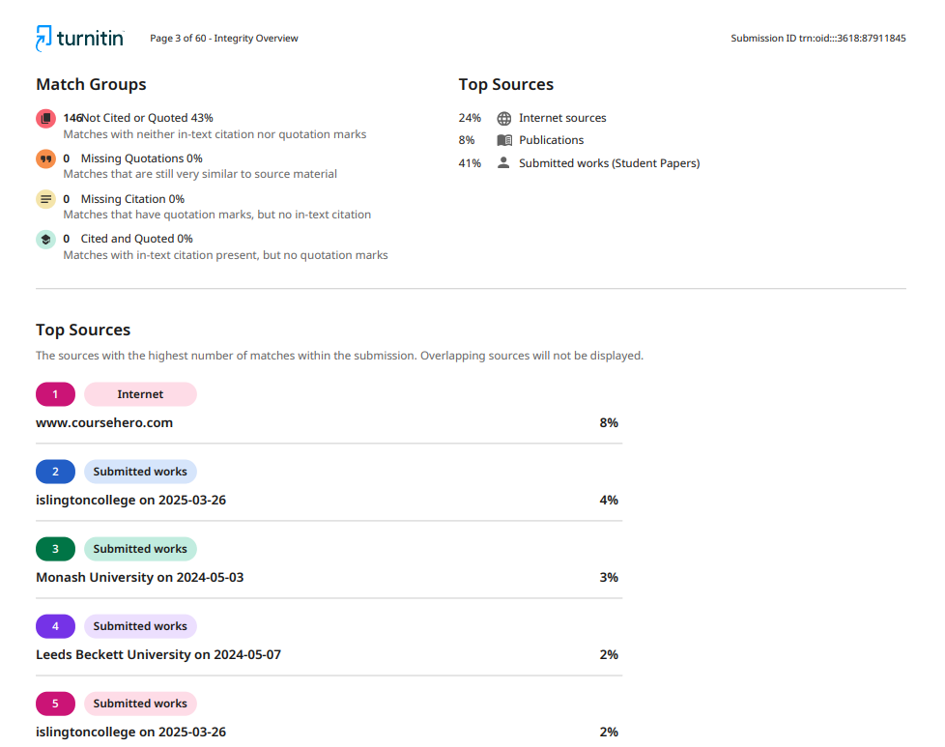

Introduction

1.1 Background
One of the key priorities for organizations in this fast-paced world is effective project management so their deadlines can be met, resources allocated properly, and workflow improved. An effectively set-up database is of much importance to an organization in order to store, retrieve, and manipulate information related to projects most effectively.
In a bid to handle such challenges, a Project Management System has been designed where a database is given at the center which integrates users, projects, tasks, milestones, and sub-tasks in a way that the progress of the project can be tracked and monitored effectively.
Most organizations are faced with a nightmare due to a series of projects in progress and/or parallel running; related information is generally spread on various platforms. Without a structured approach, project data turns out to be inconsistent and results in delays and inefficiency. The course focus is on designing and implementing a relational database that enforces data consistency, integrity, and availability.The database-driven web application is designed using an ERD to visualize the inter-relationships of the various components. Normalization has been done within UNF, 1NF, 2NF, and 3NF to get convincing performance out of the database and remove any type of redundancy from the data, administrative in this database. SQL scripts are used in the definition of the database schema, insertion of data, and retrieval of records in making the system 100% operational.
An organization can benefit from the implementation of the Project Management System:
Better team cooperation will be felt
Tracking and monitoring of milestones can be done in real-time
Effective time management and distribution of resources
Centralization of data storage to ensure its security and availability

1.2 Aims and Objectives
The course work primarily details the design and implementation of a functional normalized database system and its web interface for project management.
System Objectives:
Graphically design a relational database that models either real-world project management workflow in such a manner that it is both scalable and efficient.
One has to develop an Entity-Relationships Diagram that exhibits the key relationships between users, projects, tasks, milestones, subtasks, and resources.
The subsequent step in this case will be the structuring of the database and normalization for achieving UNF, 1NF, 2NF, 3NF, thereby eliminating redundancy and achieving consistency.
This will be followed by the implementation of the database by using the SQL scripts created during structuring.
CREATE scripts to define the schema.
• INSERT scripts for inserting the data.
• SELECT statements for retrieval and filtering of records.
Integrate the database with a user interface that will enable the users to:
• Create, update, and delete projects;
• Assign tasks and milestones to users;
• Monitor progress by way of queries and reports.
Test the system to make sure it works well in performing: 1. Basic functionality testing (CRUD operations). 2. Query database testing (records retrieval and filtering). 3. Performance testing (transaction of simultaneous interactions by numerous users). Document the development process and tools/challenges faced in designing the Project Management System.
Successful execution of the work outlined above will go a long way in increasing efficiency in tracking projects, organizing data, and ensuring seamless collaboration between project stakeholders.

1.3Textual Analysis
User - Project: ( Many-to-Many)
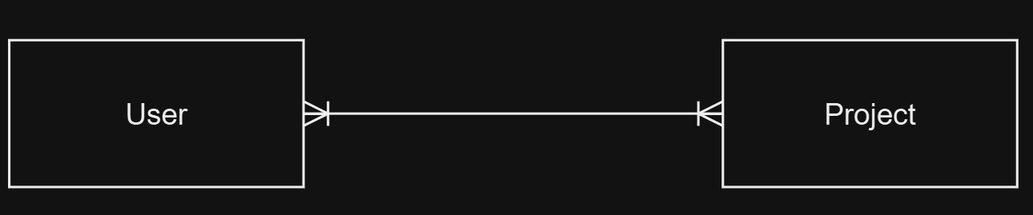
Figure 1:Textual Analysis of User and Project

A user can be in multiple projects, and a project can have multiple users.

Project - Task: (One-to-Many)
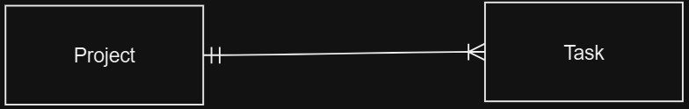
Figure 2:Textual Analysis of Project and Task

A project may consist of multiple tasks, but each task is associated with only one specific project.

Task - Subtask: (One-to-Many)
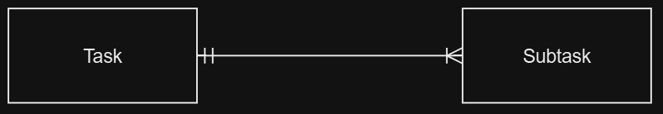
Figure 3:Textual Analysis of Task and Subtask

A task can have multiple subtasks, but each subtask belongs to one task.
User - Task: (Many-to-Many)
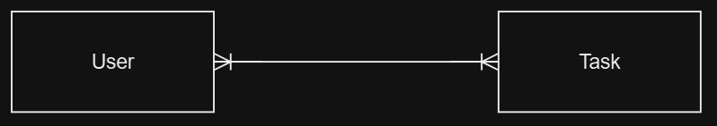
Figure 4:Textual Analysis of User and Task

A user can work on multiple tasks, and a task can involve multiple users.
Project – Milestone: (One-to-Many)
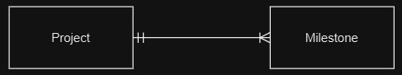
Figure 5:Textual Analysis of Project and Milestone

A project can have many milestones. Each milestone is tied to a single project.
Task - Comment: (One-to-Many)
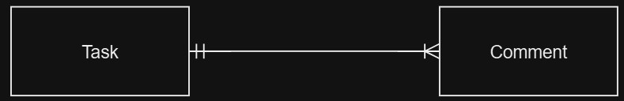
Figure 6:Textual Analysis of Task and Comment

A task may have several comments, but each comment is tied to a single specific task Task - Resource: (One-to-Many)
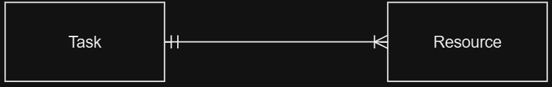
Figure 7:Textual Analysis of Task and Resource

A task can require multiple resources, but a resource is linked to one task.
User-Comment(One to Many(Optional))
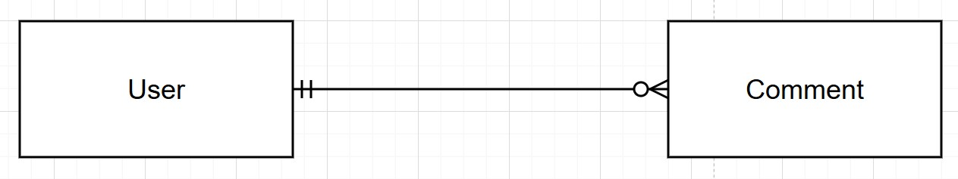
Figure 8:Textual analysis of user and Comment

User can give multiple comment ,user can also give no comment.

Initial Entity Relationships Diagram(ERD)\
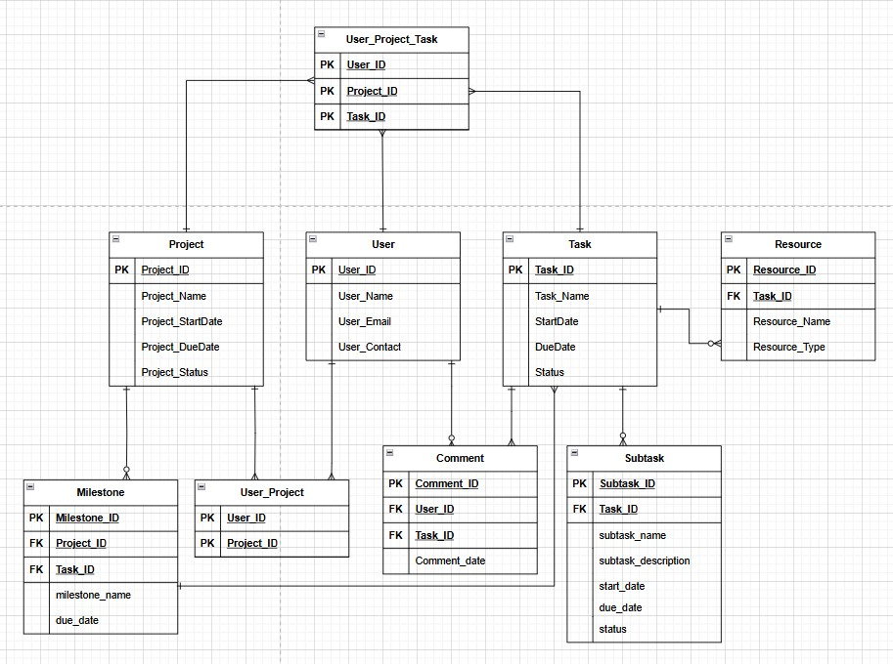
Figure 9: Initial Entity Relationship Diagram

Normalization
The idea of normalization is to have a database free from redundancies and update anomalies. Normalization involves creating tables with proper relationships between them, following a few rules whose main goal is to save data and have a more flexible database. Redundant data consumes disk space unnecessarily and leads to maintenance challenges. When data exists in multiple locations, any updates must be applied consistently across all instances.

3.1UNF:
User(user_id, user_name, user_email, user_contact, { project_id, project_name, project_startdate, project_duedate, project_status, {task_id, task_name, startdate, duedate, status}})

3.2 1NF:
User-1: (user_id, user_name, user_email, user_contact)
User_Project-1: (project_id, project_name, project_startdate, project_duedate, project_status, user_id*)
Note: A single user can belong to multiple projects, and a project can have multiple users.
Task -1 : (task_id, task_name, startdate, duedate, status, project_id*, user_id*)
Note: 1 user can be part of multiple tasks for the same project and project can be assigned to multiple users.

3.3 2NF:
User -2 : (user_id, user_name, user_email, user_contact)
Project -2 (project_id, project_name, project_startdate, project_duedate, project_status)
User_Project – 2(user_id*,project_id*)
Note : A single user can belong to multiple projects, and a project can have multiple users.
Task-2 : (task_id, task_name, startdate, duedate, status)
User_Project_Task-2: (user_id*, project_id*, task_id*)
Note : A single user can be assigned to multiple tasks, and a task can involve multiple users. Tasks are also tied to projects.

3.3 3NF:
For User-2, user_id → user_name → X user_id → user_email → X user_id → user_contact → X
Note : No transitive dependency was found in User -2 table therefore
User -3 : (user_id, user_name, user_email, user_contact)

For Project-2,
project_id → project_name → X project_id → project_ startdate → X project_id → project_ duedate → X project_id → project_ status → X
Note : No transitive dependency was found in Project -2 table therefore
Project -3 (project_id, project_name, project_startdate, project_duedate, project_status)

For Task-2,
Task_id → task_name→ X
Task_id → startdate→ X Task_id → duedate→ X
Task_id →status→ X
Note : No transitive dependency was found in Task -2 table therefore
Task-3: (task_id, task_name, startdate, duedate, status)

Integration and Assumptions

4.1Integration of the Project
Project Management System Integration
The PMS is the realization of the need to bundle all these components together so that information can move smoothly between them, coupled with the ease of operation across modules. It is developed from a relational model that links a variety of entities like Users, Projects, Tasks, Milestones, Subtasks, Comments, and Resources.
Database and Web Application Integration
The database acts as the back of the system, while the web application functions as the users' front to interact with the stored data. The major steps followed in this process are as follows: Database Design & Implementation:
Designed using Entity-Relationship Diagrams (ERD). Normalized tables have been created to maintain data consistency and minimize redundancy. SQL scripts have been created for table creation and inserting initial data.
Web Application Development:
The back-end logic was done using ASP.NET with C#. The front-end was designed using HTML, CSS, JavaScript, and Bootstrap for better responsiveness.
Data Flow between Components:
Users can create new projects, modify them, and delete them through the application interface. Tasks and subtasks, which are dynamically assigned, get updated in real-time. Milestones are linked to projects for progress tracking. Comments and resources are attached to tasks to increase collaboration.
Security & Data Integrity:
User authentication and authorization mechanisms keep unauthorized users out. A proper constraint and relationship between tables maintained referential integrity.

4.2 Assumptions in System Design
Project Management System was developed considering certain assumptions which helped in faster implementation, thus ensuring the efficiency of work.
User Assumptions
Each user has a unique user ID (Primary Key). Users are assigned to multiple projects and multiple tasks. User roles, like Project Manager, Developer, and Tester, are predefined in the system.
Project Assumptions
There is at least one user for a project. Each project has its start and due date for making the timeline structured. It may have multiple tasks that are related to one project, but every task has to be associated with a project.
Task & Subtask Assumptions
Tasks are the main building blocks of projects. Subtasks are optional, but then, one can divide complex tasks into smaller ones so that they can be managed effectively. For each task, a status field is required (active, completed, or inactive).

4.3Milestone Assumptions
A project can have as many milestones, whereas a single milestone can be associated with only one project. Therefore, a milestone associated with a project cannot be an independent milestone. They are usually critical points of progress and are often associated with tasks.
Comment and Collaboration Assumptions
A user can comment on a task more than once. To maintain chronology, comments are saved with timestamps. The task does not require comments; therefore, they are optional.
Resource Assumptions
These are all the resources that are committed to a task. Each resource is associated with a task and is needed to complete the assigned task. Another name for hardware, software, or any other material is a resource. There can be a number of resources for a single task, but then a single resource will be related to a single task.

Final Entity Relationship Diagram
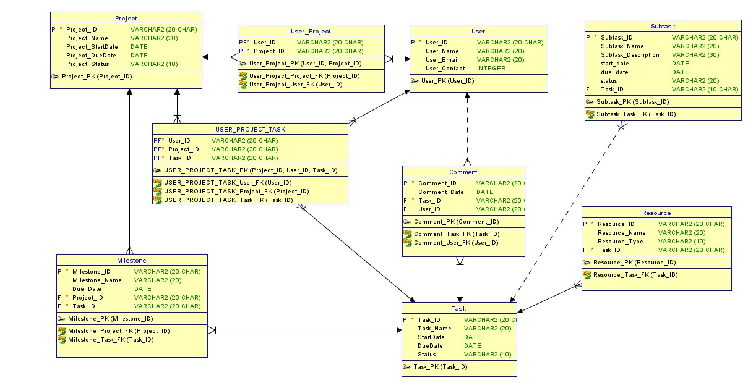
Figure 10:Final Entity Relationship Diagram

Data Dictionary

Project Table
Attribute Name | Data Type | Description | Constraints
Project_ID | VARCHAR2(20) | Unique identifier for each project. | Primary Key
Project_Name | VARCHAR2(20) | Name of the project. | Not Null
Project_StartDate | DATE | Start date of the project. | Not Null
Project_DueDate | DATE | Due date for project completion. | Not Null
Project_Status | VARCHAR2(20) | Current status of the project. (Active, Completed, Pending) | Not Null

User Table
Attribute Name | Data Type | Description | Constraints
User_ID | VARCHAR2(20) | Unique identifier for each user. | Primary Key
User_Name | VARCHAR2(20) | Full name of the user. | Not Null
User_Email | VARCHAR2(20) | Email address of the user. | Not Null
User_Contact | INTEGER | Contact number of the user. | Not Null

User_Project Table
Attribute Name | Data Type | Description | Constraints
User_ID | VARCHAR2(20) | Foreign key referencing User table. | Primary Key (Composite)
Project_ID | VARCHAR2(20) | Foreign key referencing Project table. | Primary Key (Composite)

User_Project_Task Table
Attribute Name | Data Type | Description | Constraints
User_ID | VARCHAR2(20) | Foreign key referencing User table. | Primary Key (Composite)
Project_ID | VARCHAR2(20) | Foreign key referencing Project table. | Primary Key (Composite)
Task_ID | VARCHAR2(20) | Foreign key referencing Task table. | Primary Key (Composite)

Milestone Table
Attribute Name | Data Type | Description | Constraints
Milestone_ID | VARCHAR2(20) | Unique identifier for each milestone. | Primary Key
Milestone_Name | VARCHAR2(20) | Name of the milestone. | Not Null
Due_Date | DATEs | Deadline for the milestone. | Not Null
Project_ID | VARCHAR2(20) | Foreign key referencing Project table. | Not Null
Task_ID | VARCHAR2(20) | Foreign key referencing Task table. | Not Null

Task Table
Attribute Name | Data Type | Description | Constraints
Task_ID | VARCHAR2(20) | Unique identifier for each task. | Primary Key
Task_Name | VARCHAR2(20) | Name of the task. | Not Null
StartDate | DATE | Start date of the task. | Not Null
DueDate | DATE | Expected completion date of the task. | Not Null
Status | VARCHAR2(20) | Current task status (Pending, Active, Completed). | Not Null

Subtask Table
Attribute Name | Data Type | Description | Constraints
Subtask_ID | VARCHAR2(20) | Unique identifier for each subtask. | Primary Key
Subtask_Name | VARCHAR2(20) | Name of the subtask. | Not Null
Subtask_Description | VARCHAR2(20) | Description of the subtask. | Not Null
Due_date | DATE | Due date of the subtask. | Not Null
Status | VARCHAR2(20) | Status of the subtask (Pending, Completed, In Progress). | Not Null
Task_ID | VARCHAR2(20) | Foreign key referencing Task table. | Not Null

Comment Table
Attribute Name | Data Type | Description | Constraints
Comment_ID | VARCHAR2(20) | Unique identifier for each comment. | Primary Key
Comment_Date | DATE | Date when the comment was made. | Not Null
Task_ID | VARCHAR2(20) | Foreign key referencing Task table. | Not Null
User_ID | VARCHAR2(20) | Foreign key referencing User table. | Not Null

Resource Table
Attribute Name | Data Type | Description | Constraints
Resource_ID | VARCHAR2(20) | Unique identifier for each resource. | Primary Key
Resource_Name | VARCHAR2(20) | Name of the resource. | Not Null
Resource_Type | VARCHAR2(20) | Type of resource (Hardware, Software, etc.). | Not Null
Task_ID | VARCHAR2(20) | Foreign key referencing Task table. | Not Null

Script

7.1 Create Statement
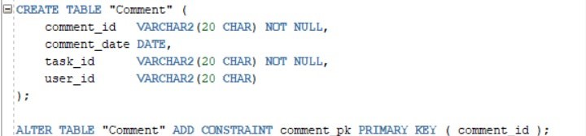
Figure 11: Creating Table Comment

CREATE TABLE "Comment" ( comment_id VARCHAR2(20 CHAR) NOT NULL, comment_date DATE, task_id VARCHAR2(20 CHAR) NOT NULL, user_id VARCHAR2(20 CHAR)
);

ALTER TABLE "Comment" ADD CONSTRAINT comment_pk PRIMARY KEY ( comment_id );
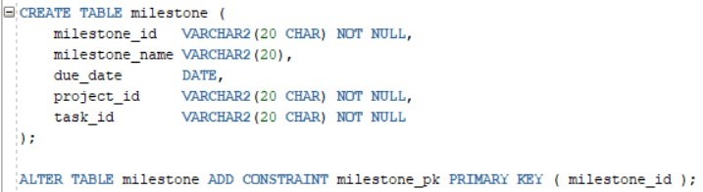
Figure 12: Creating table milestone

CREATE TABLE milestone ( milestone_id VARCHAR2(20 CHAR) NOT NULL, milestone_name VARCHAR2(20),
due_date DATE, project_id VARCHAR2(20 CHAR) NOT NULL, task_id VARCHAR2(20 CHAR) NOT NULL
);

ALTER TABLE milestone ADD CONSTRAINT milestone_pk PRIMARY KEY ( milestone_id );
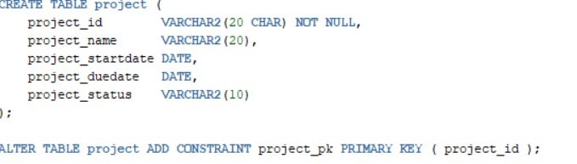
Figure 13: Creating table Project

CREATE TABLE project ( project_id VARCHAR2(20 CHAR) NOT NULL, project_name VARCHAR2(20), project_startdate DATE, project_duedate DATE, project_status VARCHAR2(10)
);

ALTER TABLE project ADD CONSTRAINT project_pk PRIMARY KEY ( project_id );

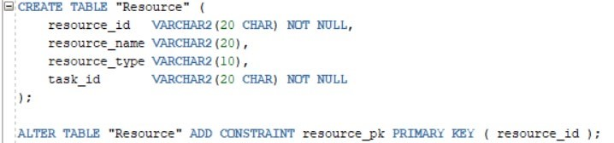
Figure 14:Creating table Resource

CREATE TABLE "Resource" ( resource_id VARCHAR2(20 CHAR) NOT NULL, resource_name VARCHAR2(20), resource_type VARCHAR2(10), task_id VARCHAR2(20 CHAR) NOT NULL
);

ALTER TABLE "Resource" ADD CONSTRAINT resource_pk PRIMARY KEY ( resource_id );

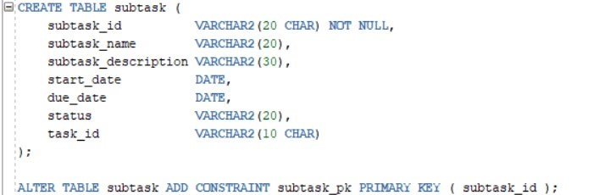
Figure 15:Creating Table Subtask

CREATE TABLE subtask (
subtask_id VARCHAR2(20 CHAR) NOT NULL, subtask_name VARCHAR2(20), subtask_description VARCHAR2(30),
start_date DATE, due_date DATE, status VARCHAR2(20), task_id VARCHAR2(10 CHAR)
);

ALTER TABLE subtask ADD CONSTRAINT subtask_pk PRIMARY KEY ( subtask_id );
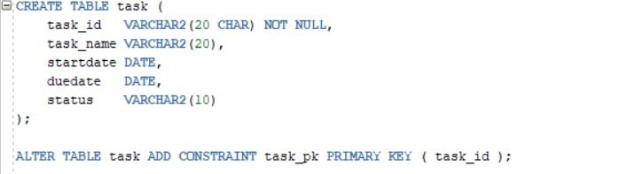
Figure 16: Creating table Task

CREATE TABLE task ( task_id VARCHAR2(20 CHAR) NOT NULL, task_name VARCHAR2(20), startdate DATE, duedate DATE, status VARCHAR2(10)
);

ALTER TABLE task ADD CONSTRAINT task_pk PRIMARY KEY ( task_id );

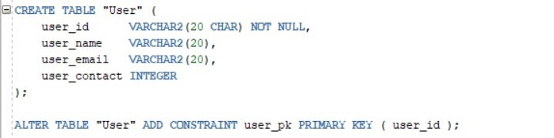
Figure 17:Creating User Table

CREATE TABLE "User" ( user_id VARCHAR2(20 CHAR) NOT NULL, user_name VARCHAR2(20), user_email VARCHAR2(20), user_contact INTEGER
);

ALTER TABLE "User" ADD CONSTRAINT user_pk PRIMARY KEY ( user_id );

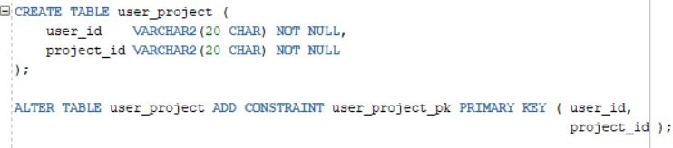
Figure 18: Creating User_Project Table

CREATE TABLE user_project ( user_id VARCHAR2(20 CHAR) NOT NULL, project_id VARCHAR2(20 CHAR) NOT NULL );

ALTER TABLE user_project ADD CONSTRAINT user_project_pk PRIMARY KEY ( user_id, project_id );

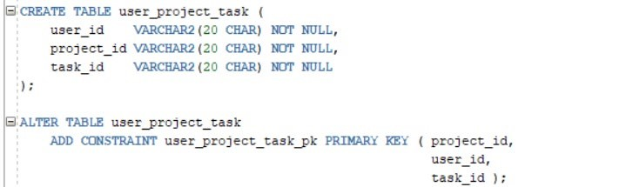
Figure 19:Create User_Project_Task Table

CREATE TABLE user_project_task ( user_id VARCHAR2(20 CHAR) NOT NULL, project_id VARCHAR2(20 CHAR) NOT NULL, task_id VARCHAR2(20 CHAR) NOT NULL
);

ALTER TABLE user_project_task
ADD CONSTRAINT user_project_task_pk PRIMARY KEY ( project_id, user_id, task_id );

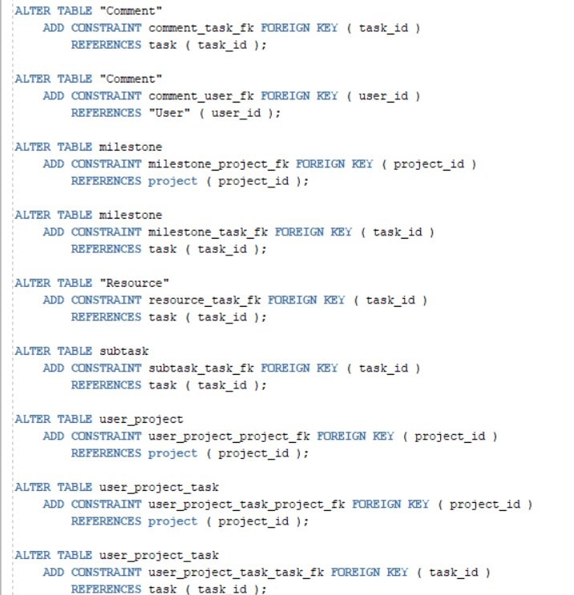
Figure 20:Altering all the tables

ALTER TABLE "Comment"
ADD CONSTRAINT comment_task_fk FOREIGN KEY ( task_id ) REFERENCES task ( task_id );

ALTER TABLE "Comment"
ADD CONSTRAINT comment_user_fk FOREIGN KEY ( user_id )
REFERENCES "User" ( user_id );

ALTER TABLE milestone
ADD CONSTRAINT milestone_project_fk FOREIGN KEY ( project_id )
REFERENCES project ( project_id );

ALTER TABLE milestone
ADD CONSTRAINT milestone_task_fk FOREIGN KEY ( task_id )
REFERENCES task ( task_id );

ALTER TABLE "Resource"
ADD CONSTRAINT resource_task_fk FOREIGN KEY ( task_id )
REFERENCES task ( task_id );

ALTER TABLE subtask
ADD CONSTRAINT subtask_task_fk FOREIGN KEY ( task_id )
REFERENCES task ( task_id );

ALTER TABLE user_project
ADD CONSTRAINT user_project_project_fk FOREIGN KEY ( project_id )
REFERENCES project ( project_id );

ALTER TABLE user_project_task
ADD CONSTRAINT user_project_task_project_fk FOREIGN KEY ( project_id )
REFERENCES project ( project_id );

ALTER TABLE user_project_task
ADD CONSTRAINT user_project_task_task_fk FOREIGN KEY ( task_id ) REFERENCES task ( task_id );

ALTER TABLE user_project_task
ADD CONSTRAINT user_project_task_user_fk FOREIGN KEY ( user_id ) REFERENCES "User" ( user_id );

ALTER TABLE user_project
ADD CONSTRAINT user_project_user_fk FOREIGN KEY ( user_id ) REFERENCES "User" ( user_id );

7.2 Insert Statement
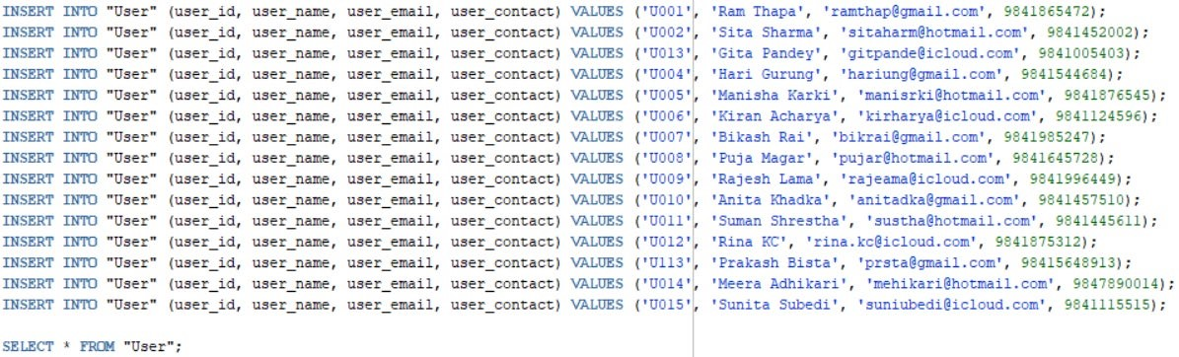
Figure 10:Inserting Value in User Table
INSERT INTO "User" (user_id, user_name, user_email, user_contact) VALUES ('U001', 'Ram Thapa', 'ramthap@gmail.com', 9841865472);
INSERT INTO "User" (user_id, user_name, user_email, user_contact) VALUES ('U002', 'Sita Sharma', 'sitaharm@hotmail.com', 9841452002);
INSERT INTO "User" (user_id, user_name, user_email, user_contact) VALUES ('U013', 'Gita Pandey', 'gitpande@icloud.com', 9841005403);
INSERT INTO "User" (user_id, user_name, user_email, user_contact) VALUES ('U004', 'Hari Gurung', 'hariung@gmail.com', 9841544684);
INSERT INTO "User" (user_id, user_name, user_email, user_contact) VALUES ('U005', 'Manisha Karki', 'manisrki@hotmail.com', 9841876545);
INSERT INTO "User" (user_id, user_name, user_email, user_contact) VALUES ('U006', 'Kiran Acharya', 'kirharya@icloud.com', 9841124596);
INSERT INTO "User" (user_id, user_name, user_email, user_contact) VALUES ('U007', 'Bikash Rai', 'bikrai@gmail.com', 9841985247);
INSERT INTO "User" (user_id, user_name, user_email, user_contact) VALUES ('U008', 'Puja Magar', 'pujar@hotmail.com', 9841645728);
INSERT INTO "User" (user_id, user_name, user_email, user_contact) VALUES ('U009', 'Rajesh Lama', 'rajeama@icloud.com', 9841996449);
INSERT INTO "User" (user_id, user_name, user_email, user_contact) VALUES ('U010', 'Anita Khadka', 'anitadka@gmail.com', 9841457510);
INSERT INTO "User" (user_id, user_name, user_email, user_contact) VALUES ('U011', 'Suman Shrestha', 'sustha@hotmail.com', 9841445611);
INSERT INTO "User" (user_id, user_name, user_email, user_contact) VALUES ('U012', 'Rina KC', 'rina.kc@icloud.com', 9841875312);
INSERT INTO "User" (user_id, user_name, user_email, user_contact) VALUES ('U113', 'Prakash Bista', 'prsta@gmail.com', 98415648913);
INSERT INTO "User" (user_id, user_name, user_email, user_contact) VALUES ('U014', 'Meera Adhikari', 'mehikari@hotmail.com', 9847890014);
INSERT INTO "User" (user_id, user_name, user_email, user_contact) VALUES ('U015', 'Sunita Subedi', 'suniubedi@icloud.com', 9841115515);

SELECT * FROM "User";
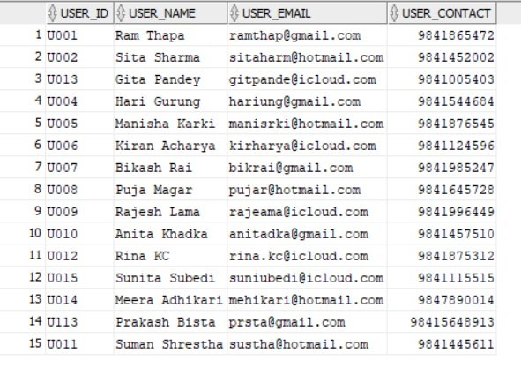
Figure 21: Displaying users info

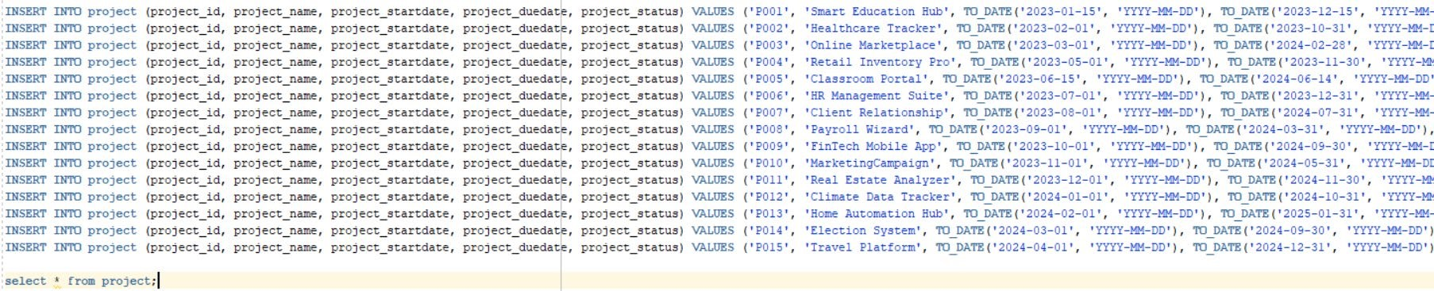
Figure 22:: Inserting values in Project table

INSERT INTO project (project_id, project_name, project_startdate, project_duedate, project_status)
VALUES ('P001', 'SmartCity Automation', TO_DATE('2025-01-01', 'YYYY-MM-DD'), TO_DATE('2025-1231', 'YYYY-MM-DD'), 'Active');
INSERT INTO project (project_id, project_name, project_startdate, project_duedate, project_status)
VALUES ('P002', 'Block Integration', TO_DATE('2025-02-01', 'YYYY-MM-DD'), TO_DATE('2025-08-31', 'YYYY-MM-DD'), 'Active');
INSERT INTO project (project_id, project_name, project_startdate, project_duedate, project_status)
VALUES ('P003', 'AI-Powered CRM Tool', TO_DATE('2025-03-01', 'YYYY-MM-DD'), TO_DATE('2025-0930', 'YYYY-MM-DD'), 'Active');
INSERT INTO project (project_id, project_name, project_startdate, project_duedate, project_status)
VALUES ('P004', 'Healthcare App', TO_DATE('2025-04-01', 'YYYY-MM-DD'), TO_DATE('2025-11-30', 'YYYY-MM-DD'), 'Active');
INSERT INTO project (project_id, project_name, project_startdate, project_duedate, project_status)
VALUES ('P005', 'E-Learning Platform', TO_DATE('2025-05-01', 'YYYY-MM-DD'), TO_DATE('2025-1015', 'YYYY-MM-DD'), 'Active');
INSERT INTO project (project_id, project_name, project_startdate, project_duedate, project_status)
VALUES ('P006', 'IoTDevice Management', TO_DATE('2025-06-01', 'YYYY-MM-DD'), TO_DATE('202512-15', 'YYYY-MM-DD'), 'Active');
INSERT INTO project (project_id, project_name, project_startdate, project_duedate, project_status)
VALUES ('P007', 'Energy Tracker', TO_DATE('2025-07-01', 'YYYY-MM-DD'), TO_DATE('2026-01-31', 'YYYY-MM-DD'), 'Active');
INSERT INTO project (project_id, project_name, project_startdate, project_duedate, project_status)
VALUES ('P008', 'Virtual Reality Game', TO_DATE('2025-08-01', 'YYYY-MM-DD'), TO_DATE('2026-0228', 'YYYY-MM-DD'), 'Active');
INSERT INTO project (project_id, project_name, project_startdate, project_duedate, project_status) VALUES ('P009', 'ChatbotSystem', TO_DATE('2025-09-01', 'YYYY-MM-DD'), TO_DATE('2026-03-31', 'YYYY-MM-DD'), 'Active');
INSERT INTO project (project_id, project_name, project_startdate, project_duedate, project_status)
VALUES ('P010', 'Digital Marketing AI', TO_DATE('2025-10-01', 'YYYY-MM-DD'), TO_DATE('2026-04-15', 'YYYY-MM-DD'), 'Active');
INSERT INTO project (project_id, project_name, project_startdate, project_duedate, project_status)
VALUES ('P011', 'Smart Farming System', TO_DATE('2025-11-01', 'YYYY-MM-DD'), TO_DATE('2026-0531', 'YYYY-MM-DD'), 'Active');
INSERT INTO project (project_id, project_name, project_startdate, project_duedate, project_status)
VALUES ('P012', 'Cybersecurity', TO_DATE('2025-12-01', 'YYYY-MM-DD'), TO_DATE('2026-06-30', 'YYYY-MM-DD'), 'Active');
INSERT INTO project (project_id, project_name, project_startdate, project_duedate, project_status)
VALUES ('P013', 'E-Commerce Upgrade', TO_DATE('2026-01-01', 'YYYY-MM-DD'), TO_DATE('2026-0731', 'YYYY-MM-DD'), 'Active');
INSERT INTO project (project_id, project_name, project_startdate, project_duedate, project_status)
VALUES ('P014', 'Digital Twin System', TO_DATE('2026-02-01', 'YYYY-MM-DD'), TO_DATE('2026-08-15', 'YYYY-MM-DD'), 'Active');
INSERT INTO project (project_id, project_name, project_startdate, project_duedate, project_status)
VALUES ('P015', 'Supply Chain AI', TO_DATE('2026-03-01', 'YYYY-MM-DD'), TO_DATE('2026-09-30',
'YYYY-MM-DD'), 'Active');
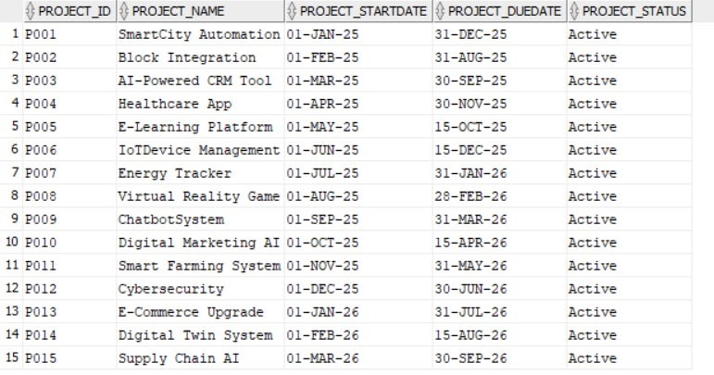
Figure 23:Displaying project table

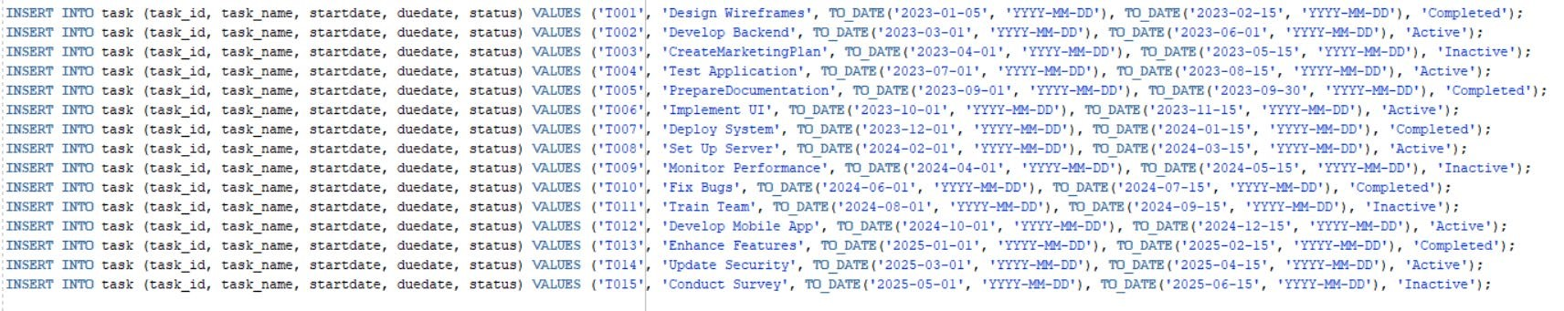
Figure 24:: Inserting values in Task Table

INSERT INTO task (task_id, task_name, startdate, duedate, status) VALUES ('T001', 'Project Kickoff', TO_DATE('2025-01-10', 'YYYY-MM-DD'), TO_DATE('2025-01-15', 'YYYY-MM-DD'), 'Completed');
INSERT INTO task (task_id, task_name, startdate, duedate, status) VALUES ('T002',
'RequirementGathering', TO_DATE('2025-01-16', 'YYYY-MM-DD'), TO_DATE('2025-01-31', 'YYYY-MM-
DD'), 'Completed');
INSERT INTO task (task_id, task_name, startdate, duedate, status) VALUES ('T003', 'Wireframe
Design', TO_DATE('2025-02-01', 'YYYY-MM-DD'), TO_DATE('2025-02-15', 'YYYY-MM-DD'), 'Active');
INSERT INTO task (task_id, task_name, startdate, duedate, status) VALUES ('T004',
'PrototypeDevelopment', TO_DATE('2025-02-16', 'YYYY-MM-DD'), TO_DATE('2025-03-10', 'YYYY-MM-
DD'), 'Active');
INSERT INTO task (task_id, task_name, startdate, duedate, status) VALUES ('T005',
'FeedbackSession', TO_DATE('2025-03-11', 'YYYY-MM-DD'), TO_DATE('2025-03-15', 'YYYY-MM-DD'),
'Inactive');
INSERT INTO task (task_id, task_name, startdate, duedate, status) VALUES ('T006', 'Backend
Development', TO_DATE('2025-03-16', 'YYYY-MM-DD'), TO_DATE('2025-05-01', 'YYYY-MM-DD'),
'Active');
INSERT INTO task (task_id, task_name, startdate, duedate, status) VALUES ('T007', 'Frontend
Integration', TO_DATE('2025-05-02', 'YYYY-MM-DD'), TO_DATE('2025-06-15', 'YYYY-MM-DD'), 'Active');
INSERT INTO task (task_id, task_name, startdate, duedate, status) VALUES ('T008', 'System Testing', TO_DATE('2025-06-16', 'YYYY-MM-DD'), TO_DATE('2025-07-15', 'YYYY-MM-DD'), 'Inactive');
INSERT INTO task (task_id, task_name, startdate, duedate, status) VALUES ('T009', 'Bug Fixing',
TO_DATE('2025-07-16', 'YYYY-MM-DD'), TO_DATE('2025-08-15', 'YYYY-MM-DD'), 'Active');
INSERT INTO task (task_id, task_name, startdate, duedate, status) VALUES ('T010', 'Final
Deployment', TO_DATE('2025-08-16', 'YYYY-MM-DD'), TO_DATE('2025-09-01', 'YYYY-MM-DD'),
'Active');
INSERT INTO task (task_id, task_name, startdate, duedate, status) VALUES ('T011', 'User Training',
TO_DATE('2025-09-02', 'YYYY-MM-DD'), TO_DATE('2025-09-15', 'YYYY-MM-DD'), 'Completed'); INSERT INTO task (task_id, task_name, startdate, duedate, status) VALUES ('T012', 'Performance
Testing', TO_DATE('2025-09-16', 'YYYY-MM-DD'), TO_DATE('2025-10-15', 'YYYY-MM-DD'), 'Active');
INSERT INTO task (task_id, task_name, startdate, duedate, status) VALUES ('T013', 'Post-launch
Support', TO_DATE('2025-10-16', 'YYYY-MM-DD'), TO_DATE('2025-11-15', 'YYYY-MM-DD'), 'Inactive');
INSERT INTO task (task_id, task_name, startdate, duedate, status) VALUES ('T014', 'Phase 2 Planning', TO_DATE('2025-11-16', 'YYYY-MM-DD'), TO_DATE('2025-12-15', 'YYYY-MM-DD'), 'Completed');
INSERT INTO task (task_id, task_name, startdate, duedate, status) VALUES ('T015', 'Phase 2
Execution', TO_DATE('2025-12-16', 'YYYY-MM-DD'), TO_DATE('2026-02-15', 'YYYY-MM-DD'), 'Active');

Forms

8.1 Home Page
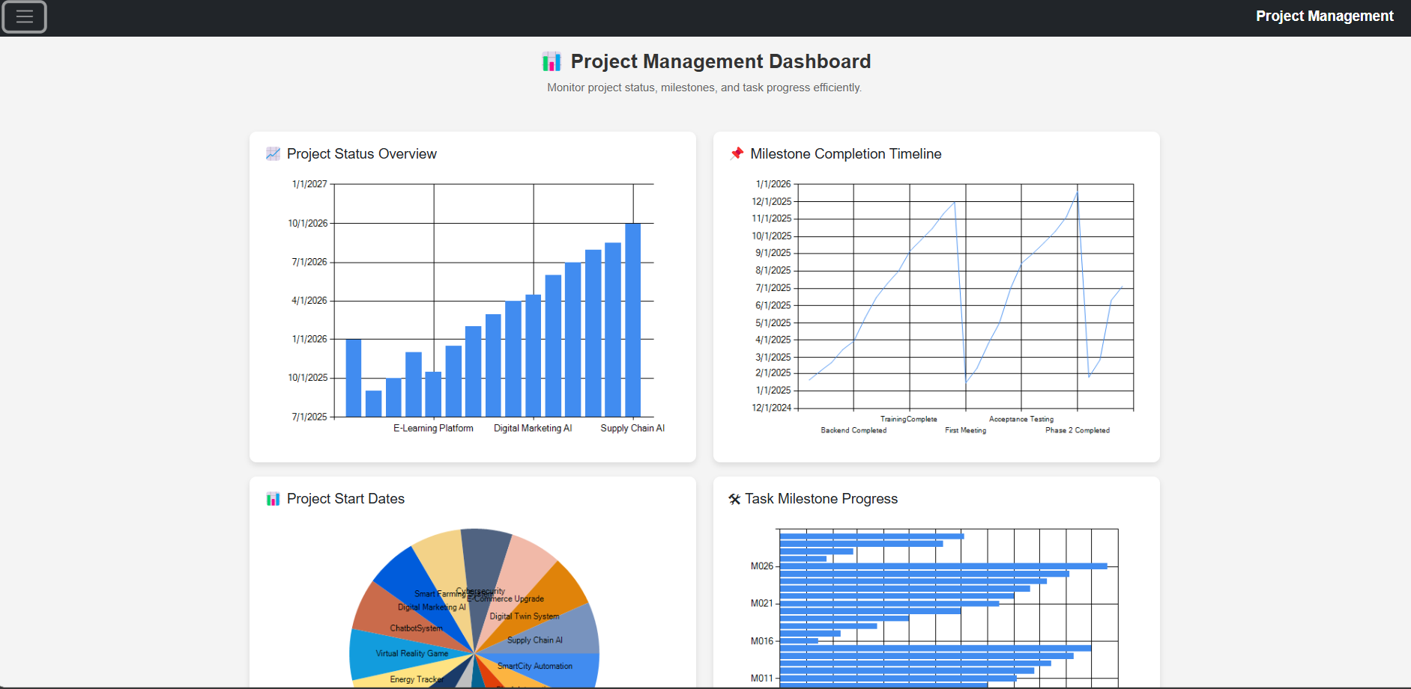
Figure 25:Home Page
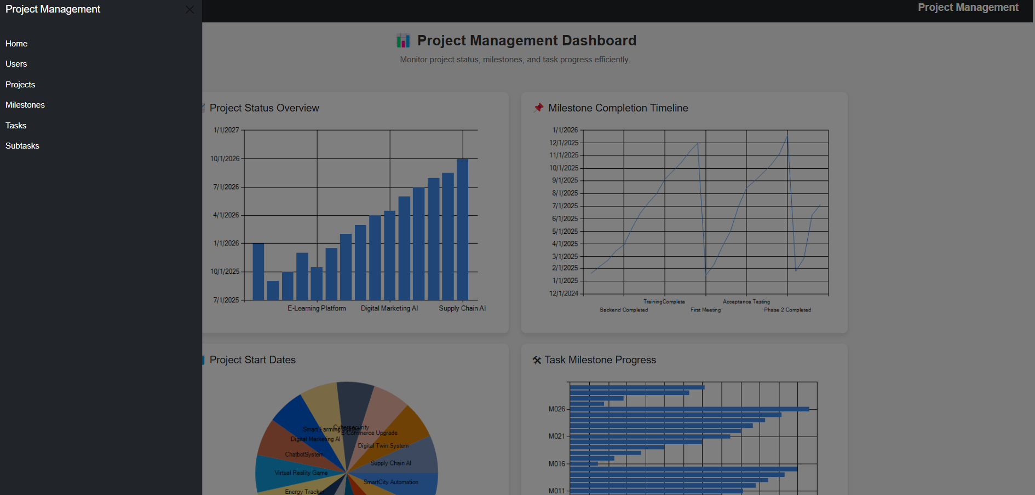
Figure 26: Sidepanel Nav Barr

8.2 Basic Webforms
User
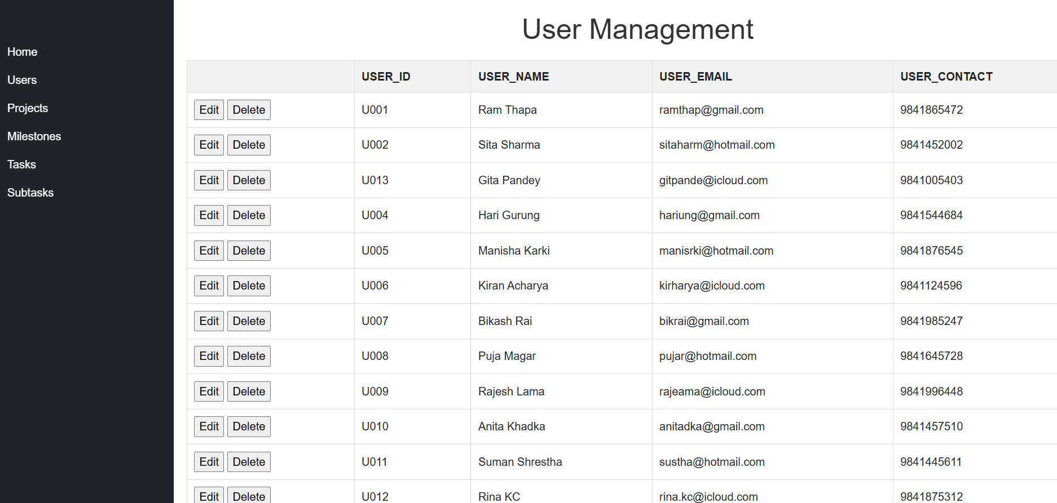
Figure 27: User Page
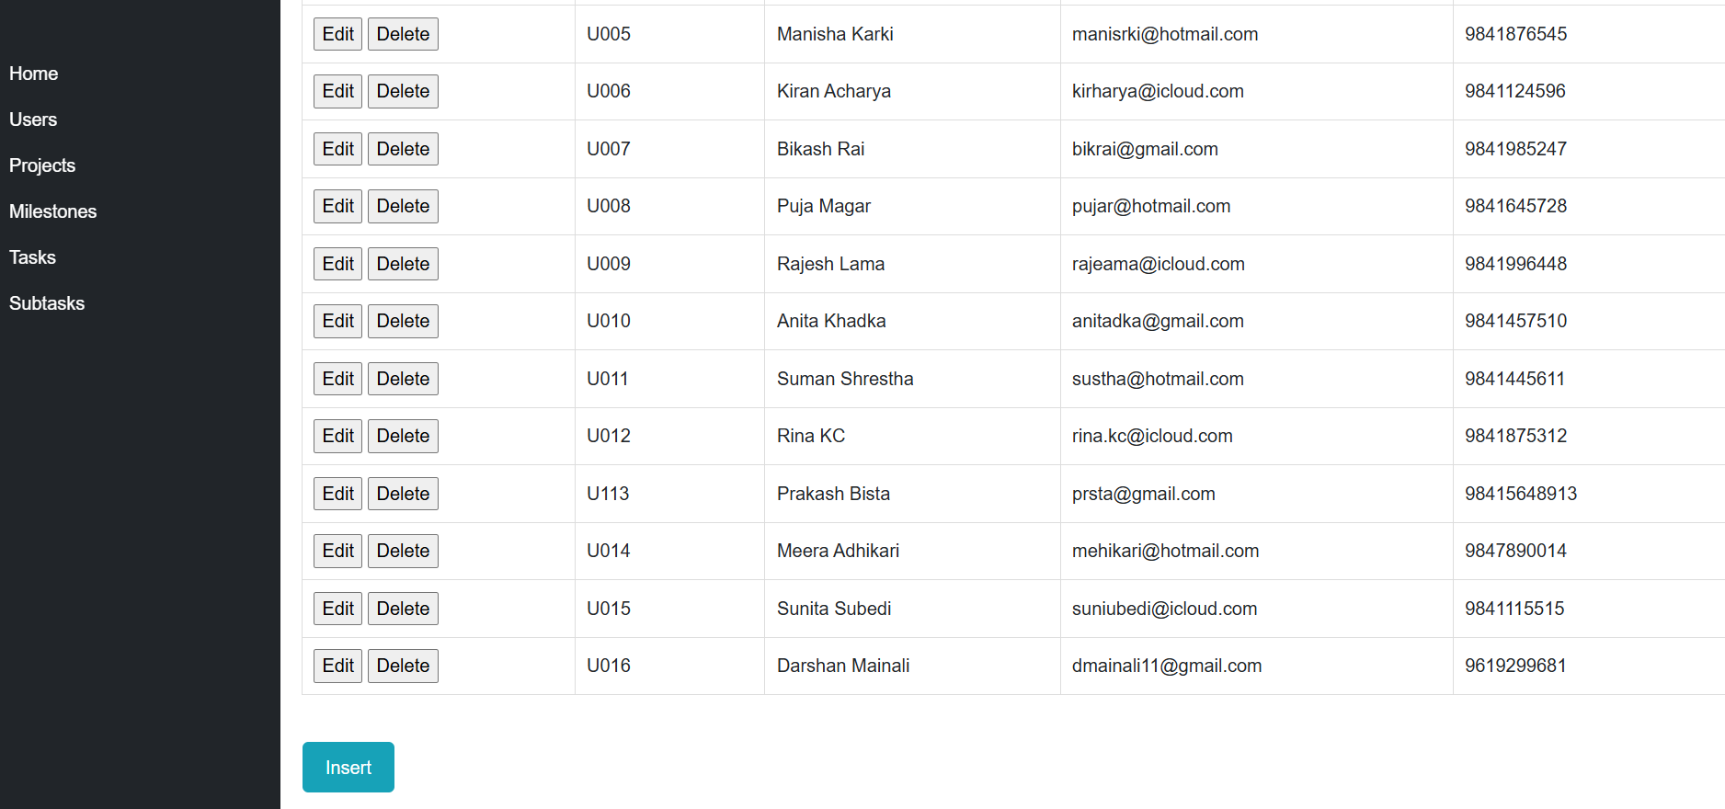
Figure 28:User Page

Project
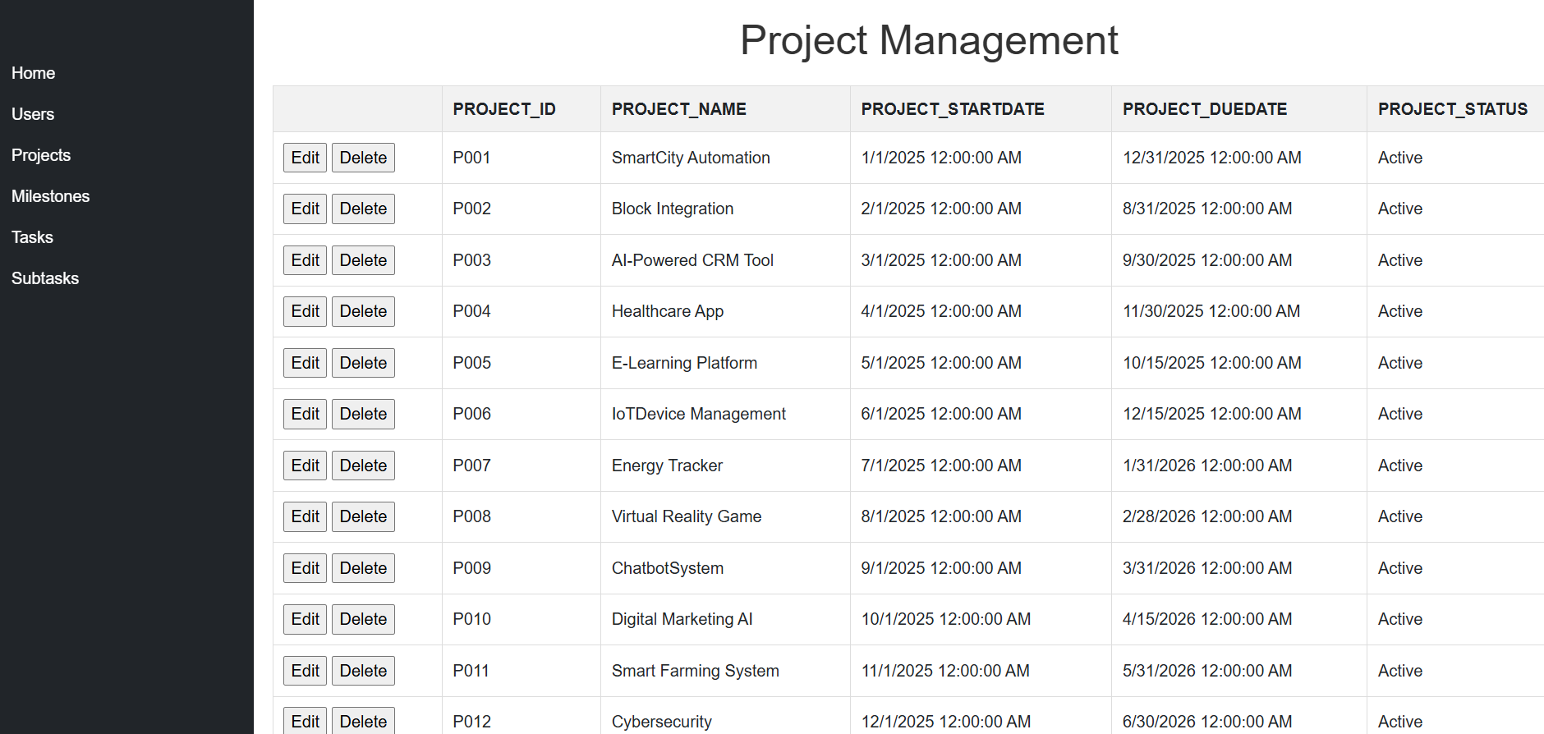
Figure 29:Project Page

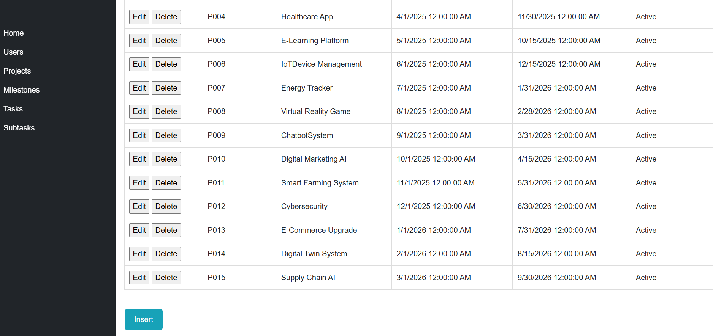
Figure 30:Project Page

Milestone
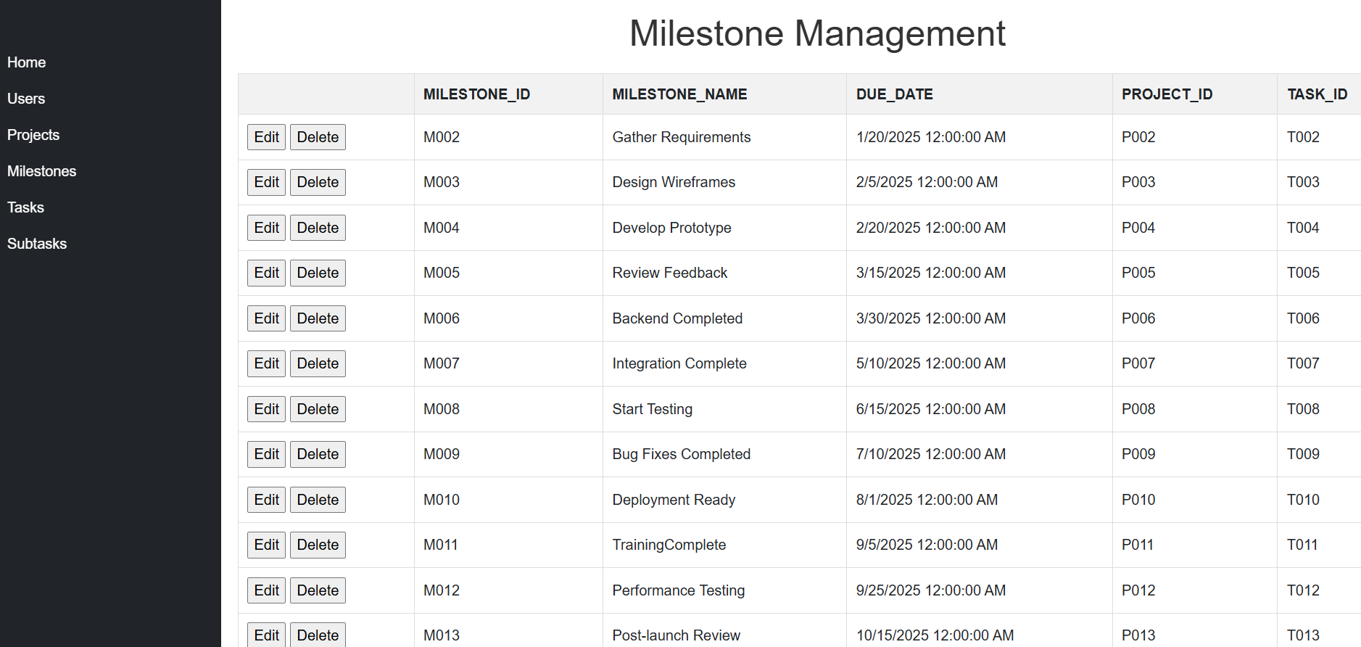
Figure 31:Milestone Page

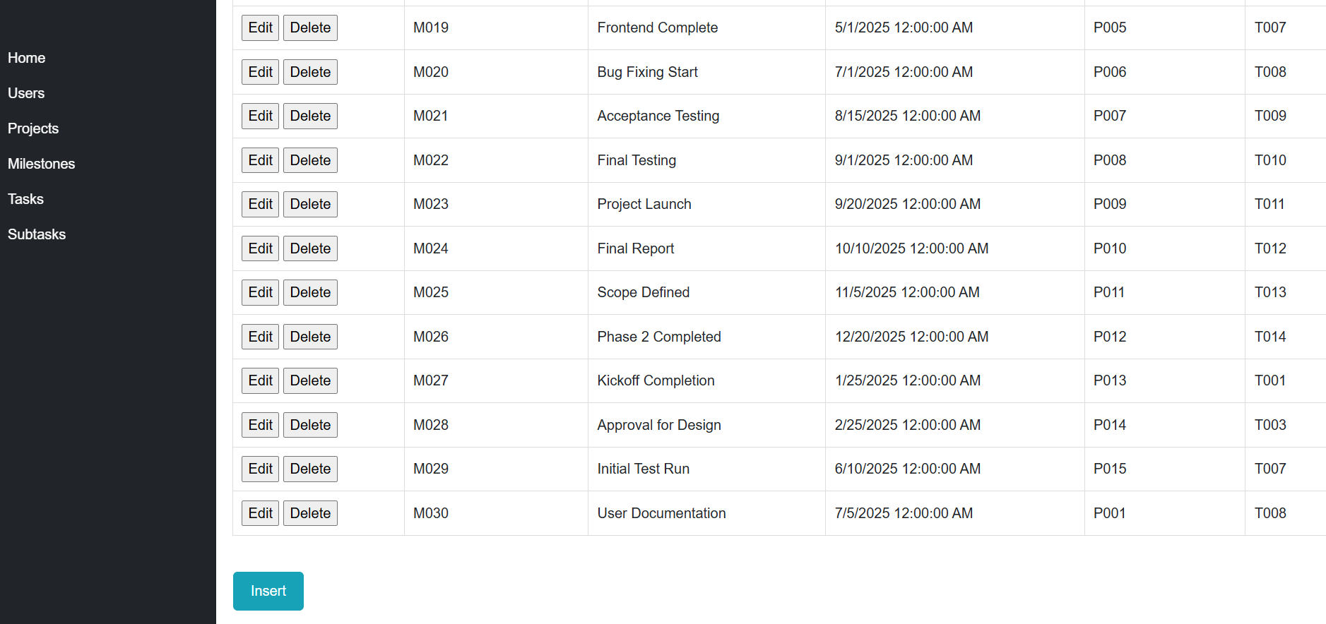
Figure 32:Milestone Page

Task
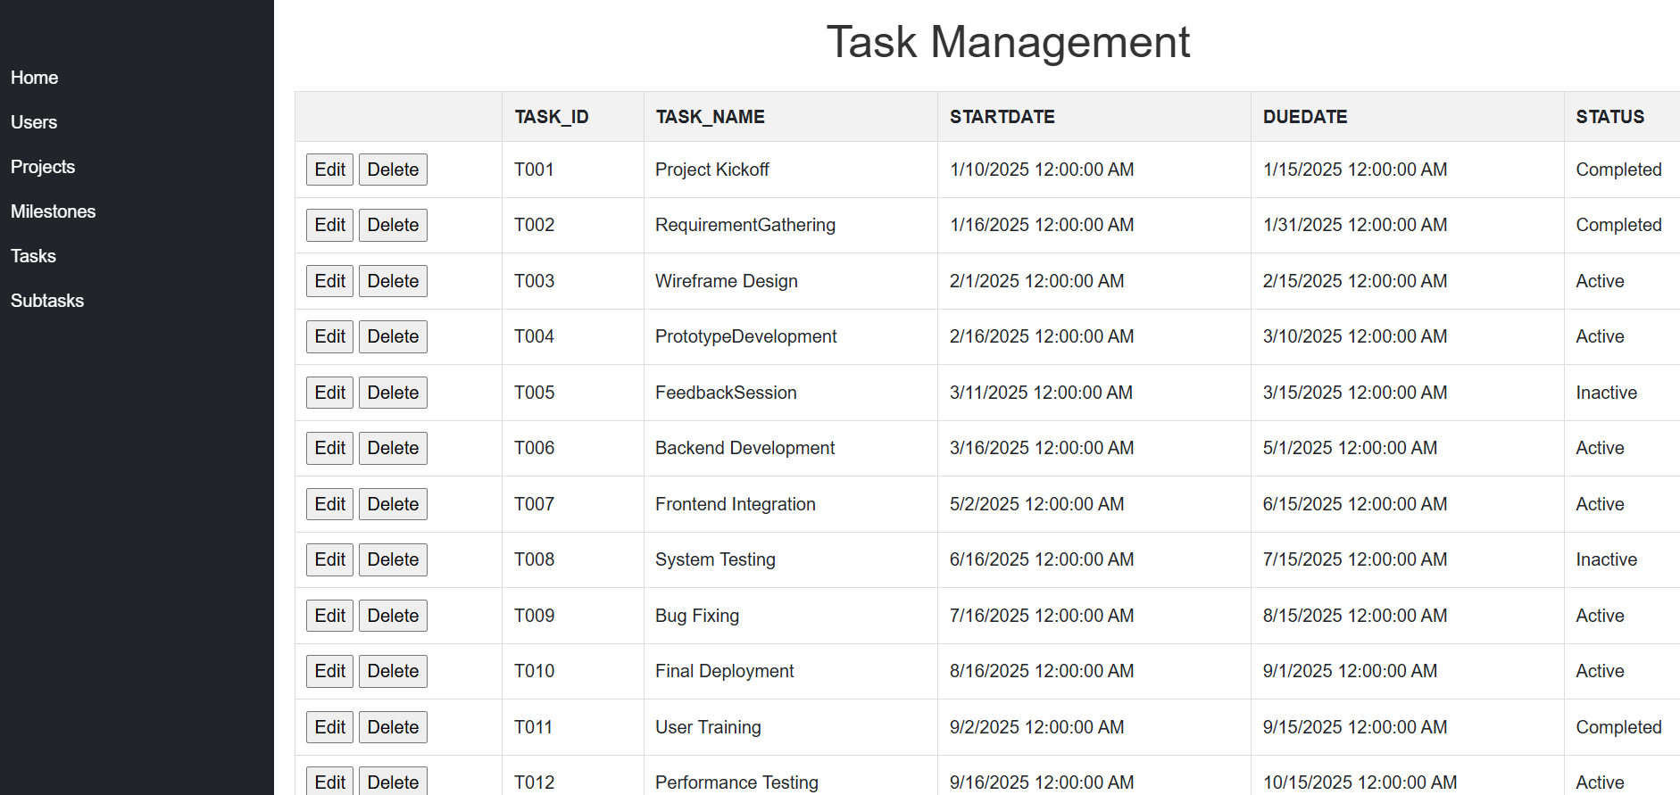

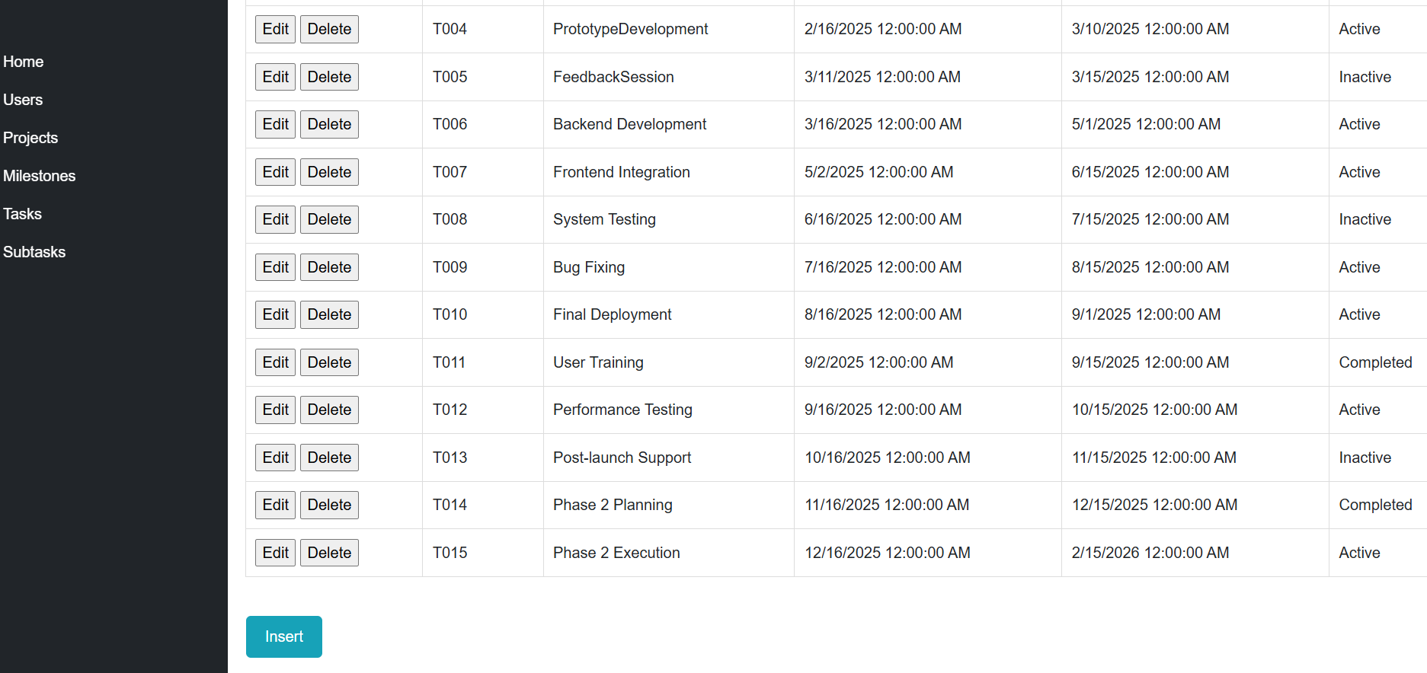
Figure 33:Task Page
Subtask
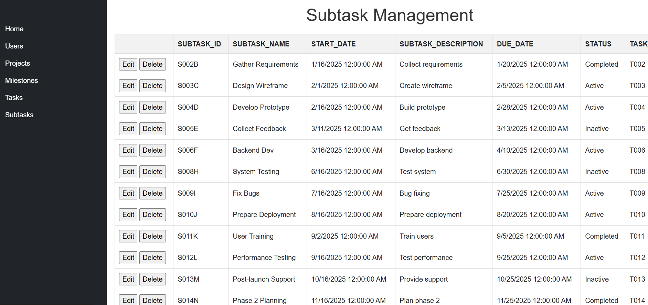
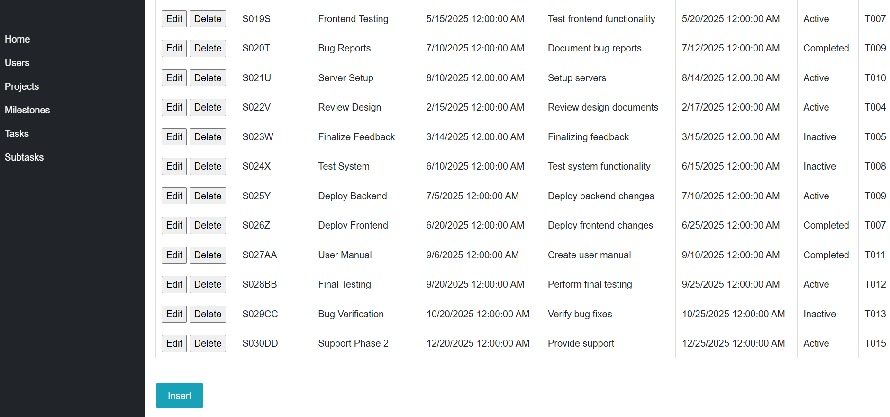
Figure 34:Subtask Page

User Manual

User Page

Click edit to edit
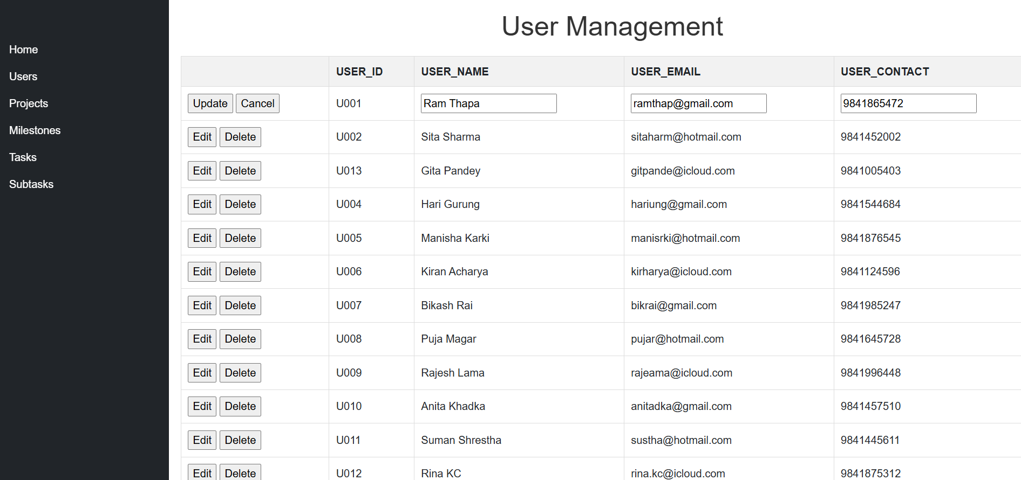
Click update to update data
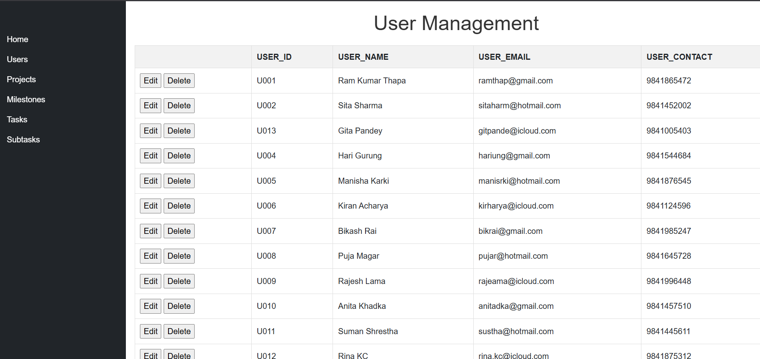
Updated Data
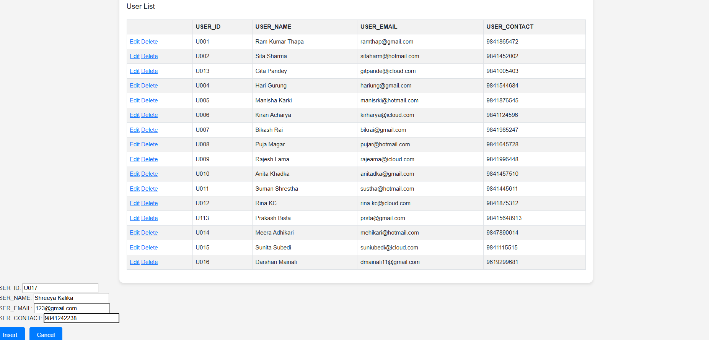
Click Insert to Insert Data
Deleted Data
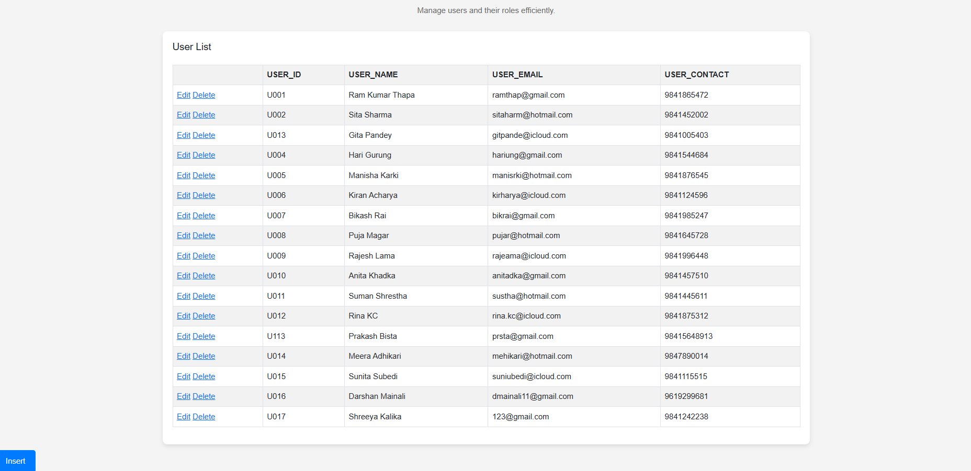
Deleted Data
Data Inserted

Project Page
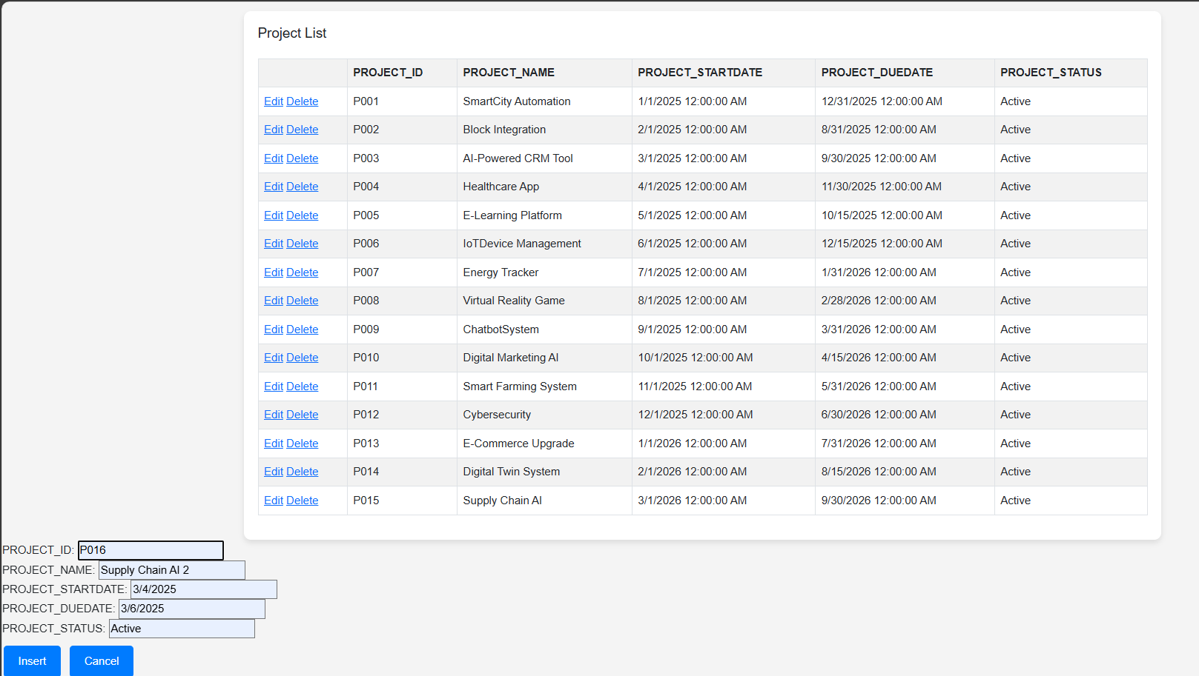
Click Insert to Insert Data

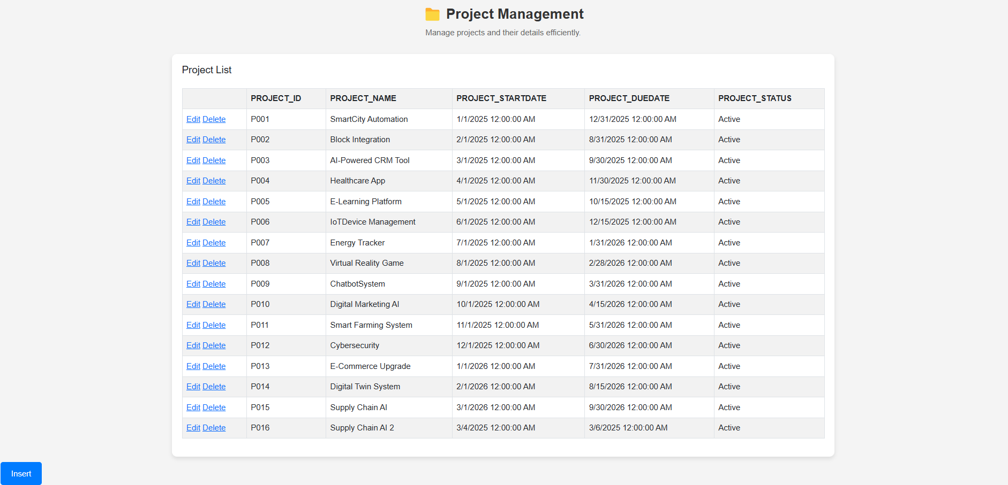
Data Inserted

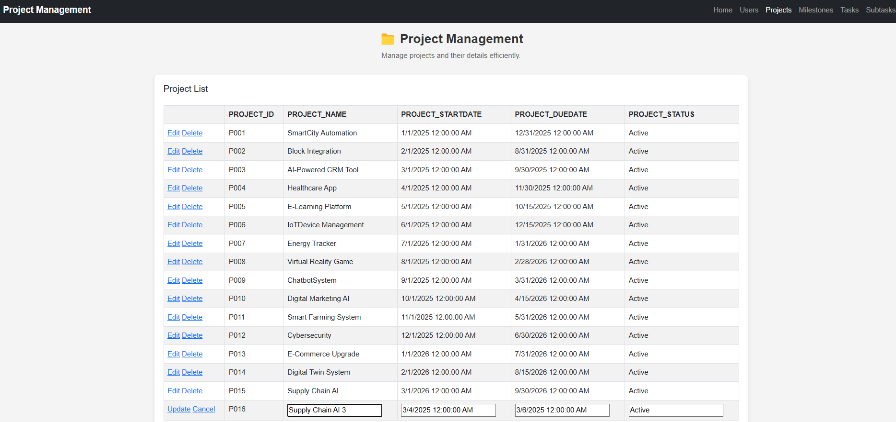
Click edit to Update
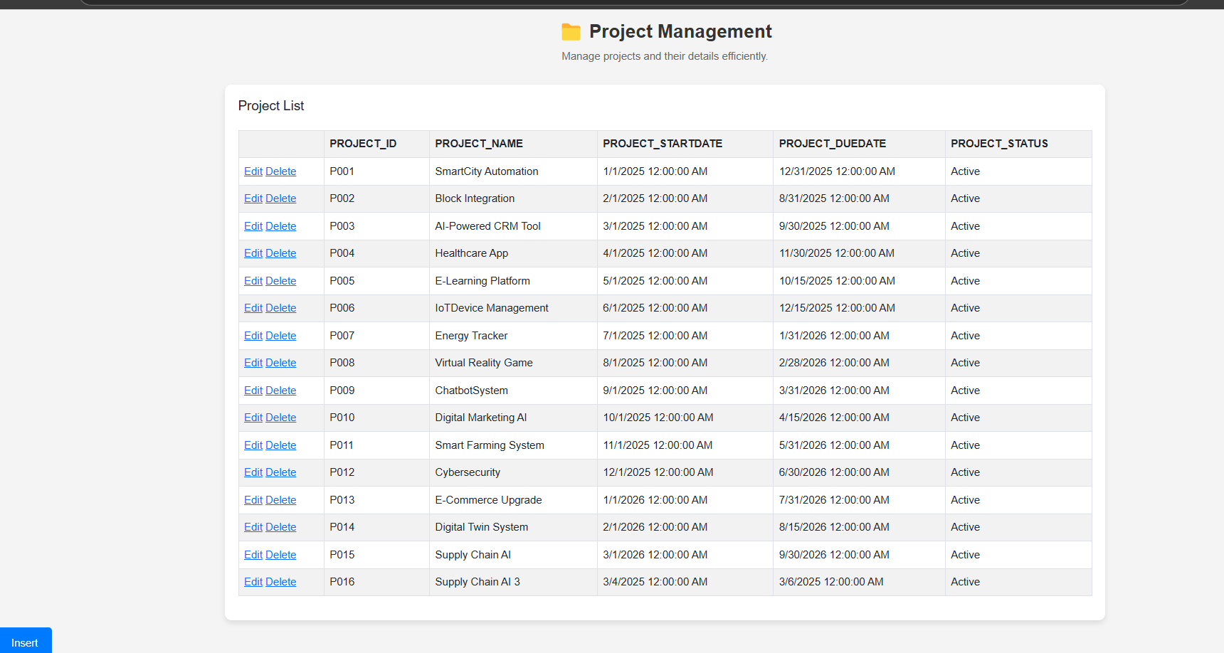
Updated Data

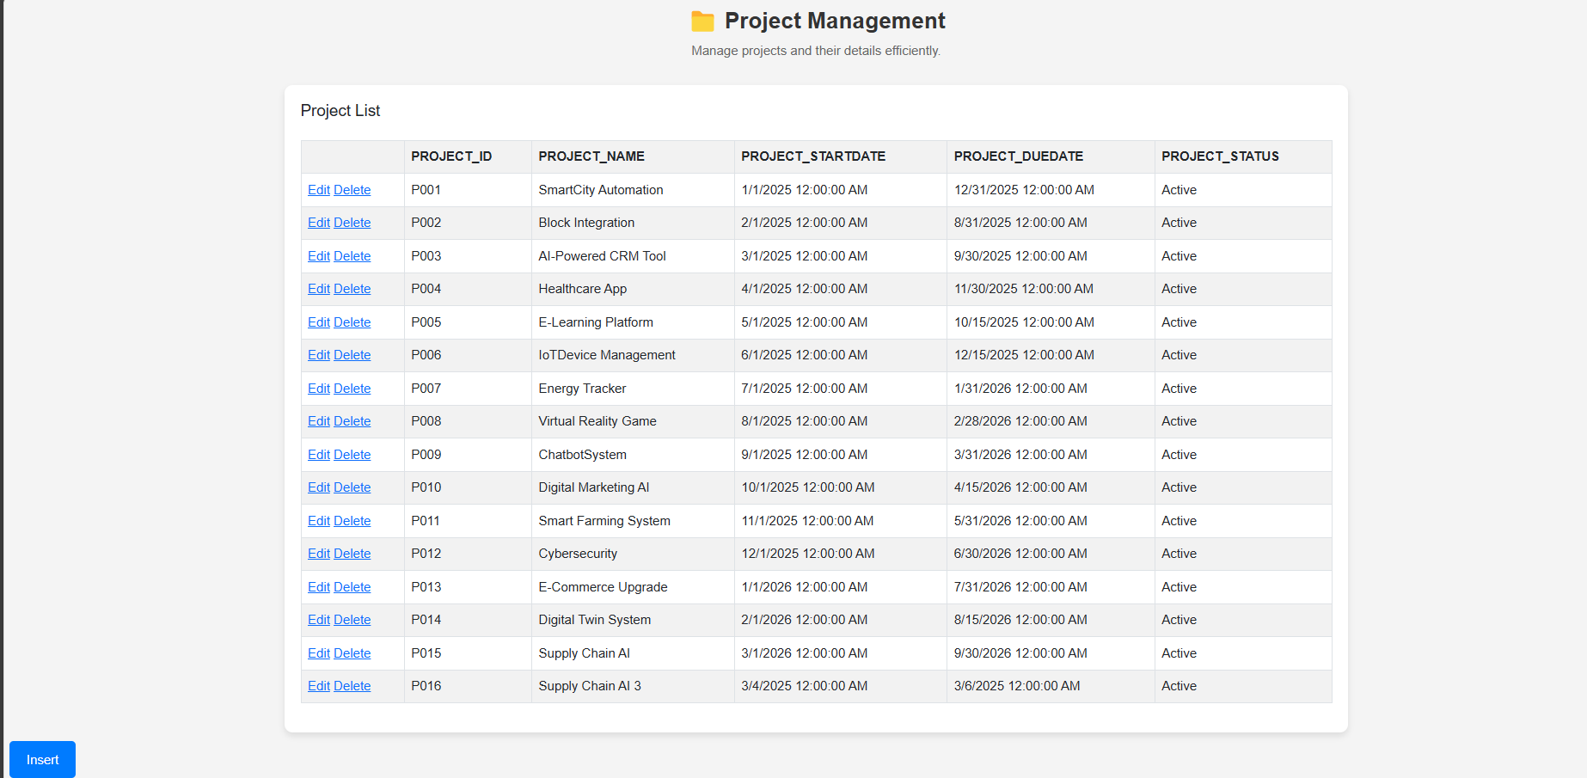
Click Delete to Delete Data
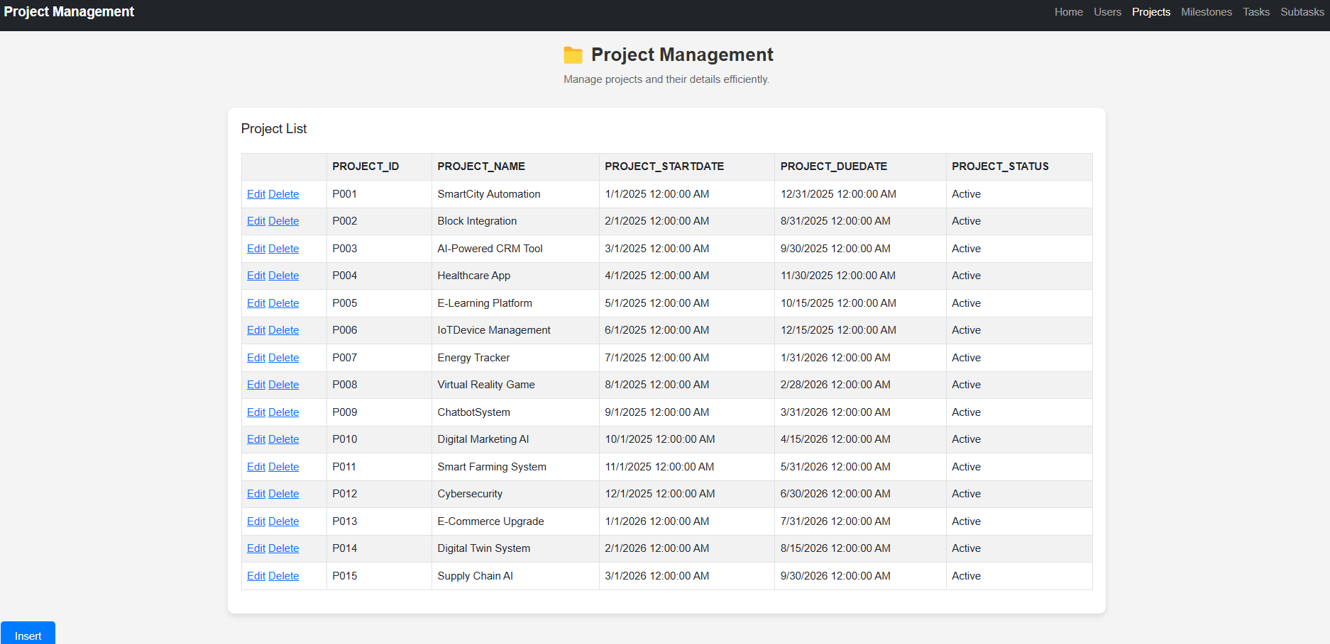
Deleted Data

Task T
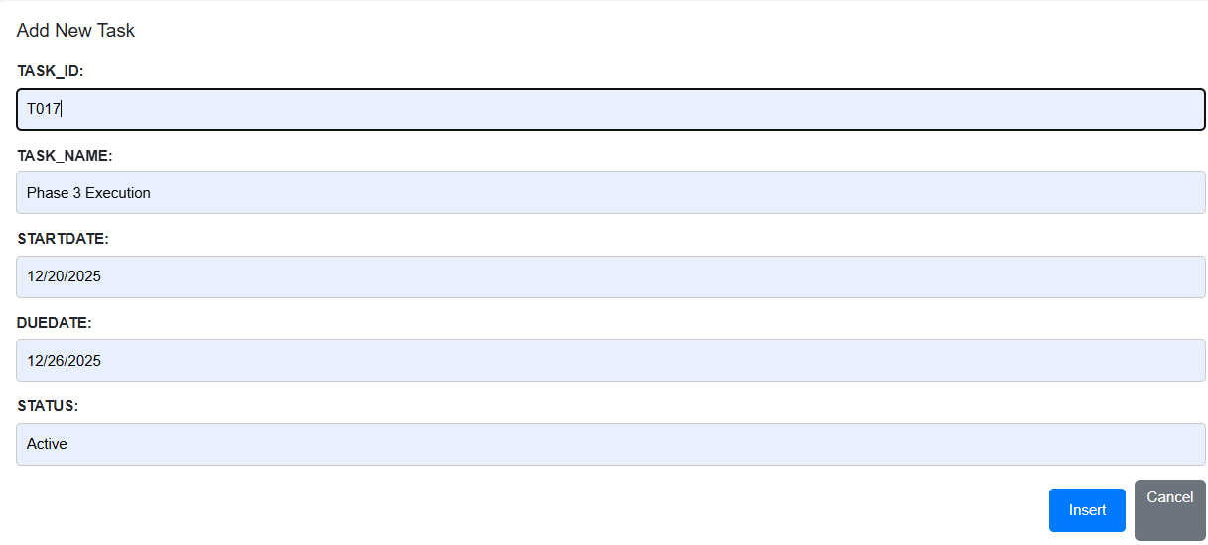
Click Insert to Insert Data
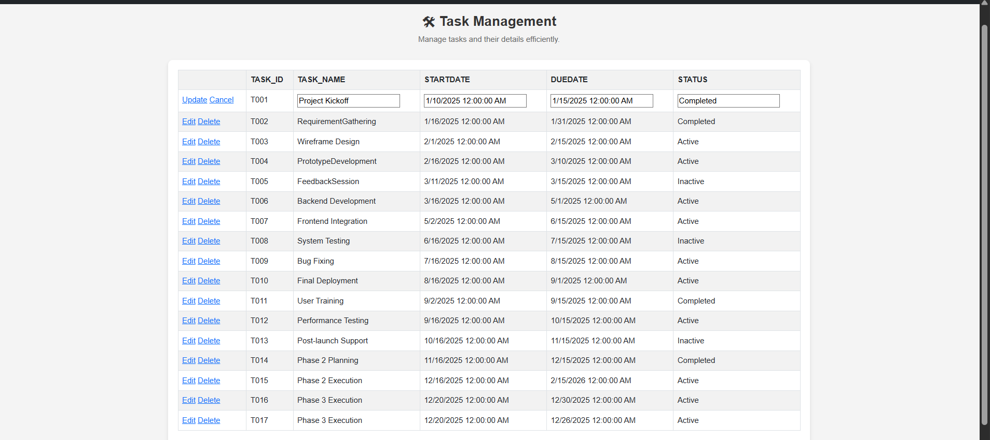
Updated Data
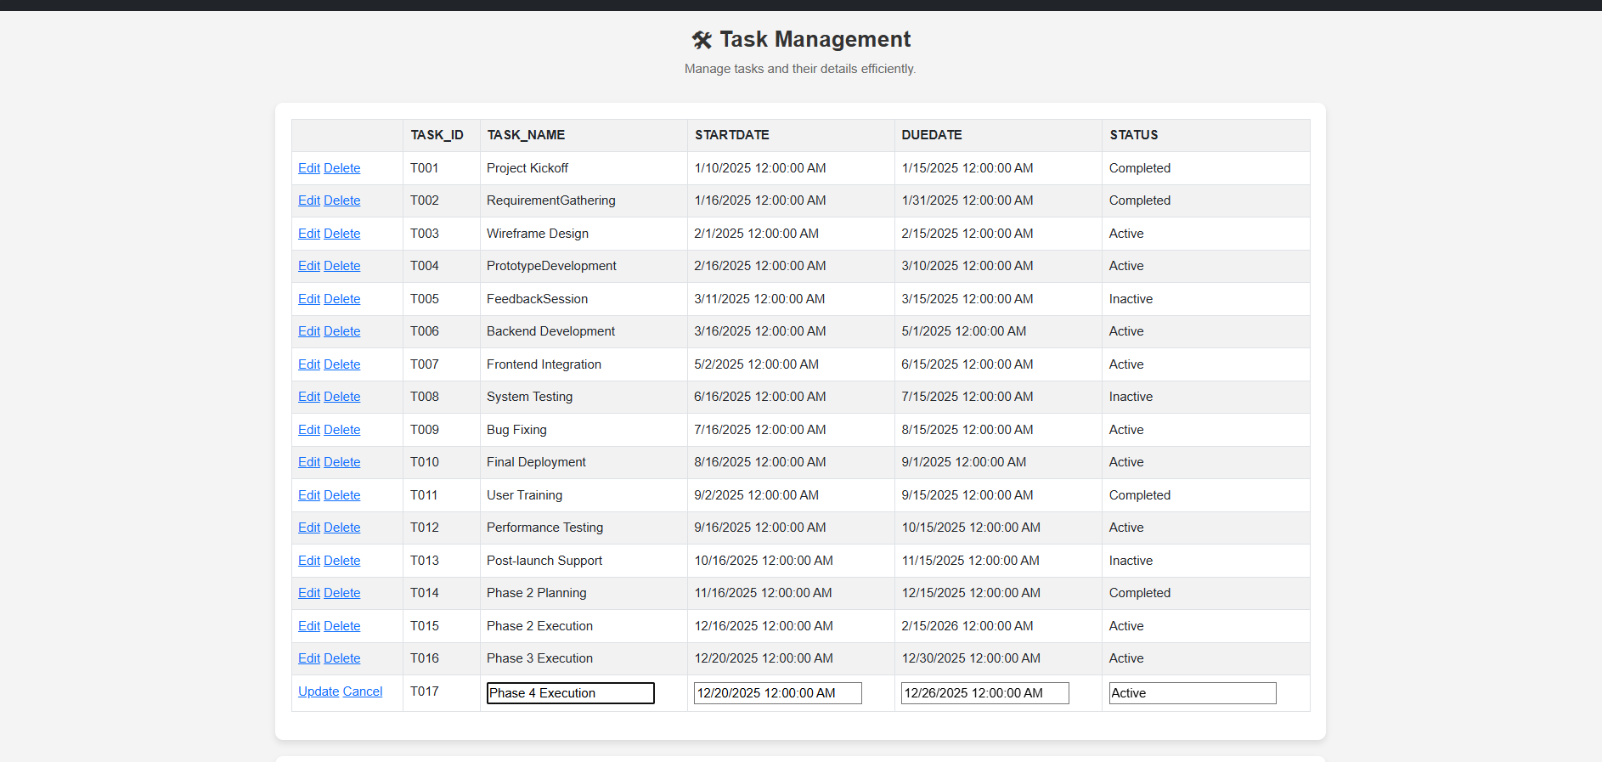
Click Insert to Insert Data
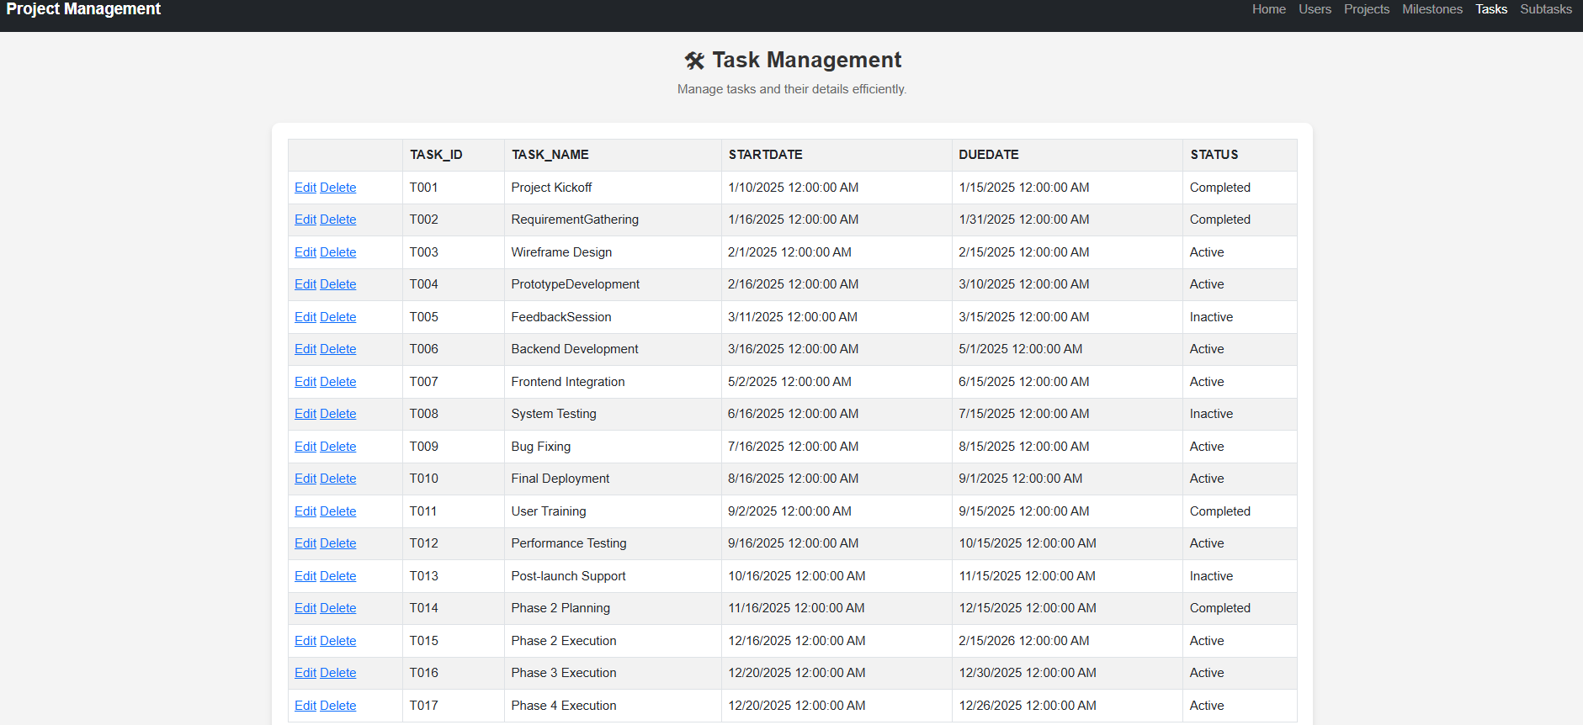
Updated Data
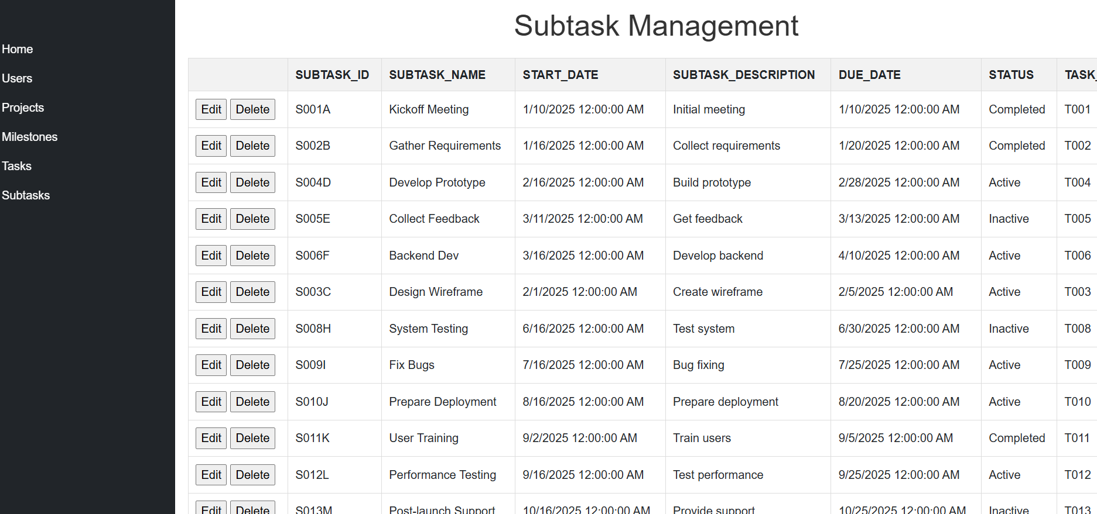
Click Delete to Delete Data
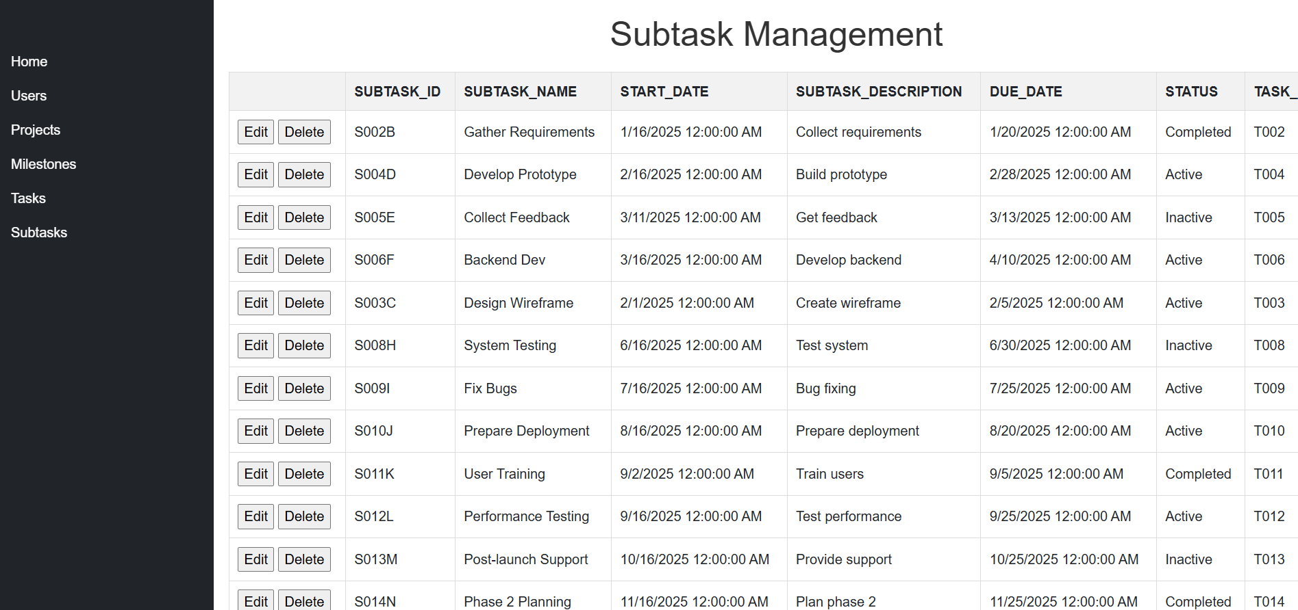
Deleted Data

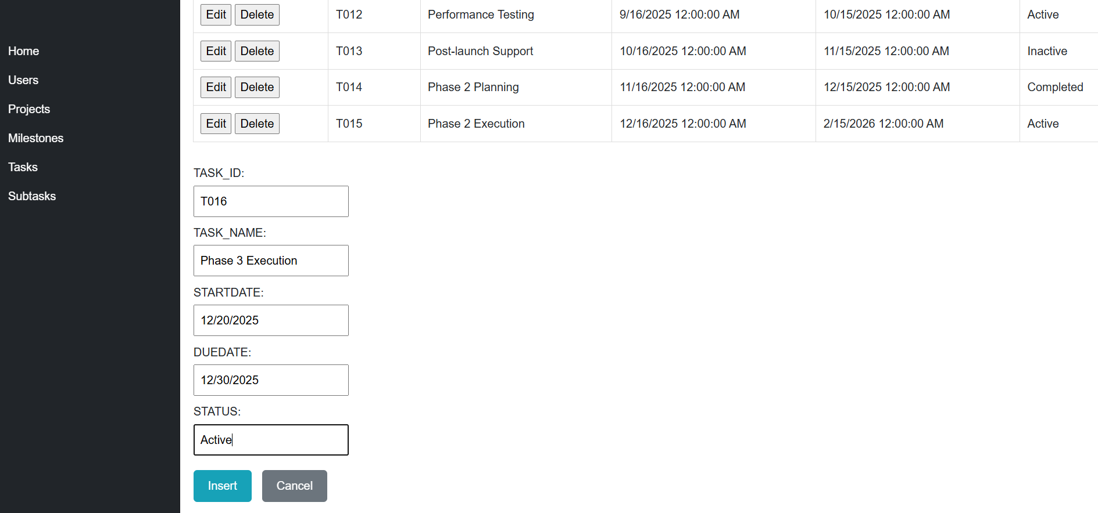
Insert Data
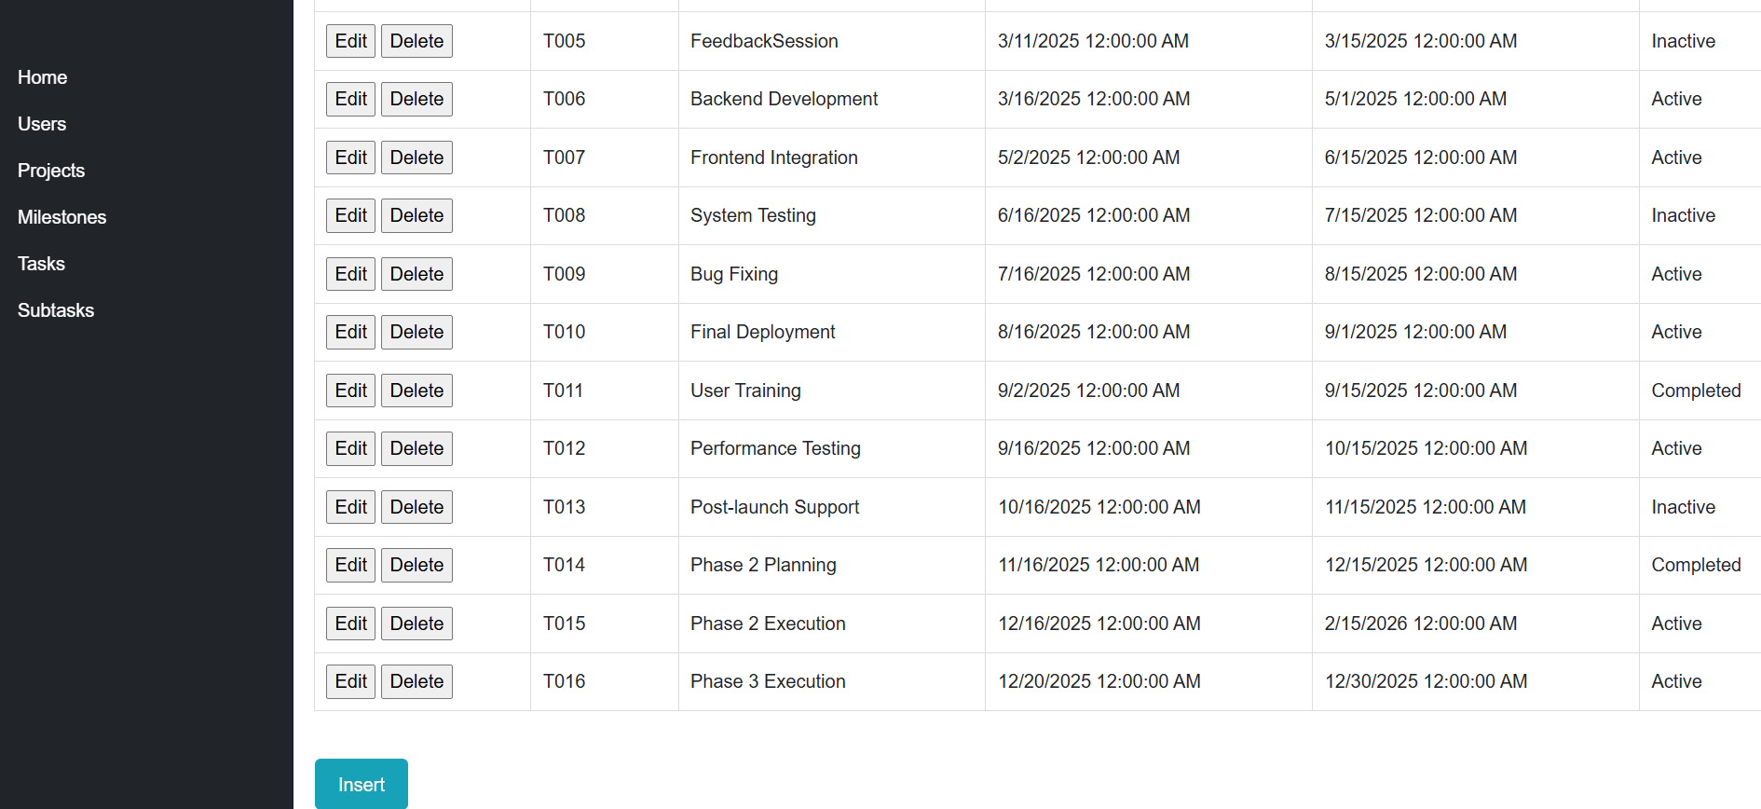
Data Inserted

Testing
Test No: | 1
Objective | To Test the create, read, update, and delete of user table
Action: | For table creation:  Click Insert Button  USER_ID = U016  USER_NAME = Darshan Mainali  USER_EMAIL = dmainali11@gmail.com  USER_CONTACT =9619299681  For Update:  - Click on the edit button  - Update some value  - Click on the update button.  For Table Deletion:  Click on Delete Table
Expected Result: | The CRUD operation should be executed successfully.
Actual Result: | The execution of the CRUD operation was observed to be successful.
Conclusion: | The test was successful
Table 1:Test For CRUD in User

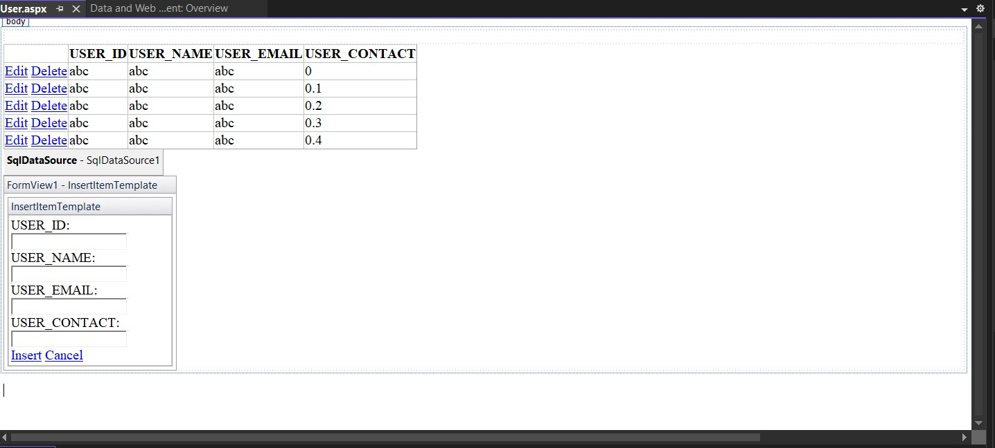
Figure 35:Basic Form of User

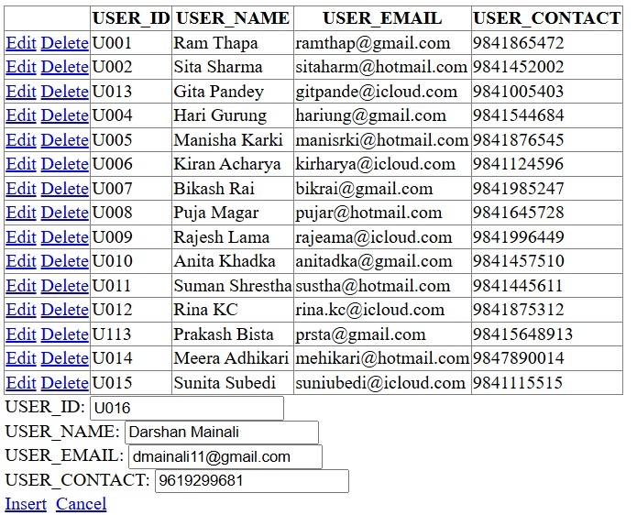
Figure 36:Adding New User Details
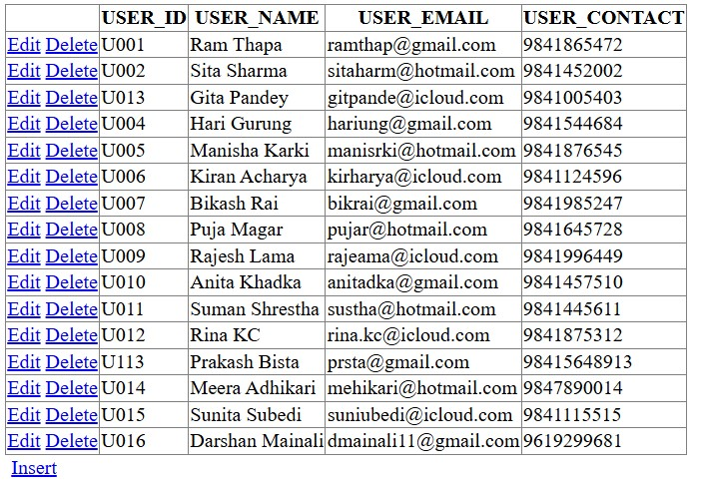
Figure 37:Newly added User Detail

Test No: | 2
Objective | To Test the create, read, update, and delete of project table
Action | For table creation:  Click Insert Button  PROJECT_ID = P016  PROJECT_NAME = AI_Automation  PROJECT_STARTDATE = 3/4/25  PROJECT_DUEDATE =3/6/25  PROJECT_STATUS=Active  For Update:  - Click on the edit button  - Update some value  - Click on the update button.  For Table Deletion:  Click on Delete Table
Expected Result: | The CRUD operation should be executed successfully.
Actual Result: | The execution of the CRUD operation was observed to be successful.
Conclusion: | The test was successful
Table 2:Test For CRUD of Project
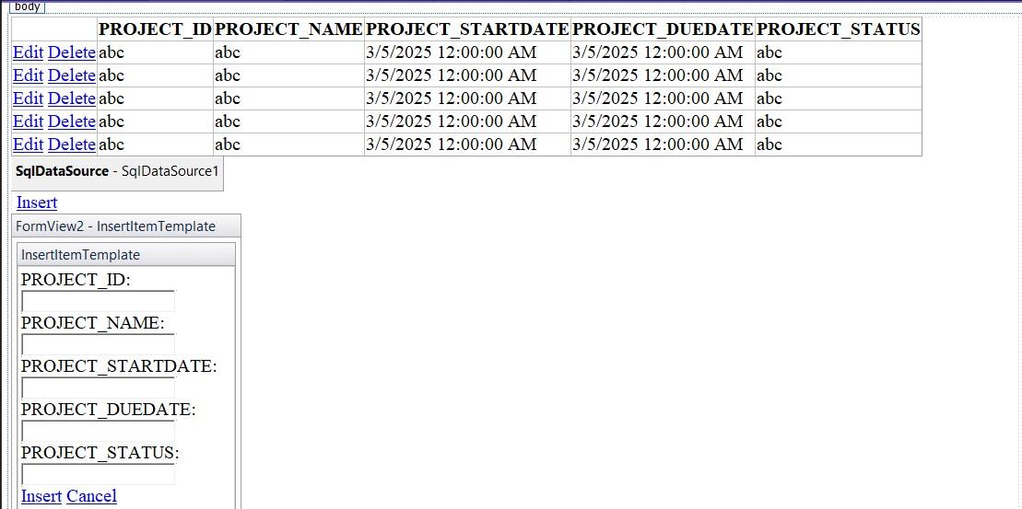
Figure 38:Basic Forms of Project

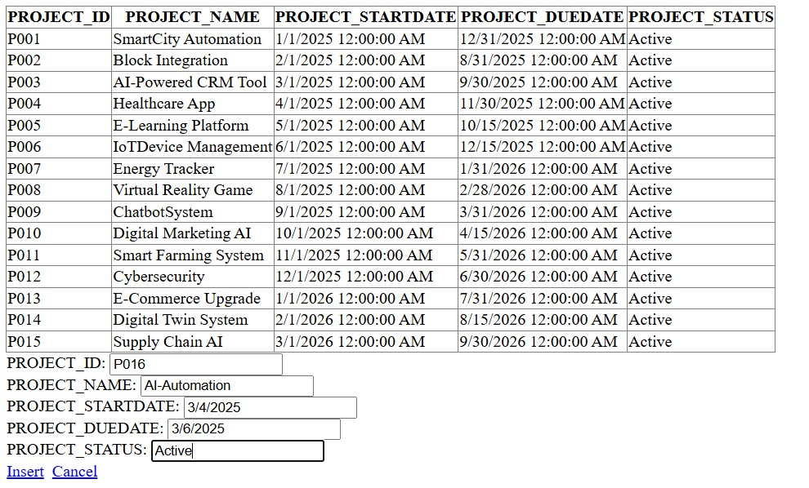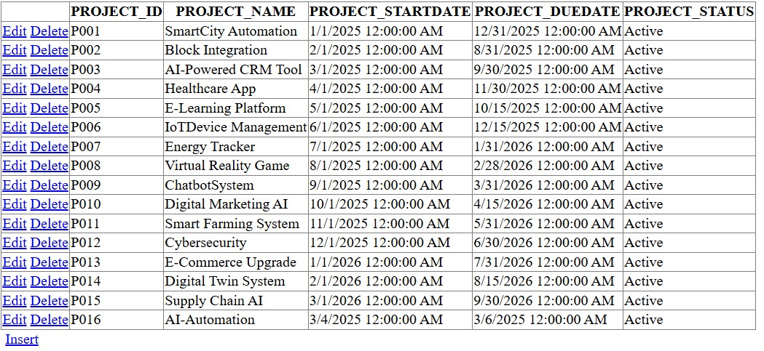
Figure 39: Adding New Project Details

Test No: | 3
Objective | To Test the create, read, update, and delete of Subtask table
Action | For table creation:  Click Insert Button  SUBTASK_ID = P016  SUBTASK_NAME = Support Phase 3  SUBTASK_DESCRIPTION = Provide Support  STARTDATE =12/25/2025  DUEDATE=12/31/2025  STATUS =Active  TASKID=T015  For Update:  - Click on the edit button  - Update some value  - Click on the update button.  For Table Deletion:  Click on Delete Table
Expected Result: | The CRUD operation should be executed successfully.
Actual Result: | The execution of the CRUD operation was observed to be successful.
Conclusion: | The test was successful
Table 3:Test for CRUD of SUBTASK
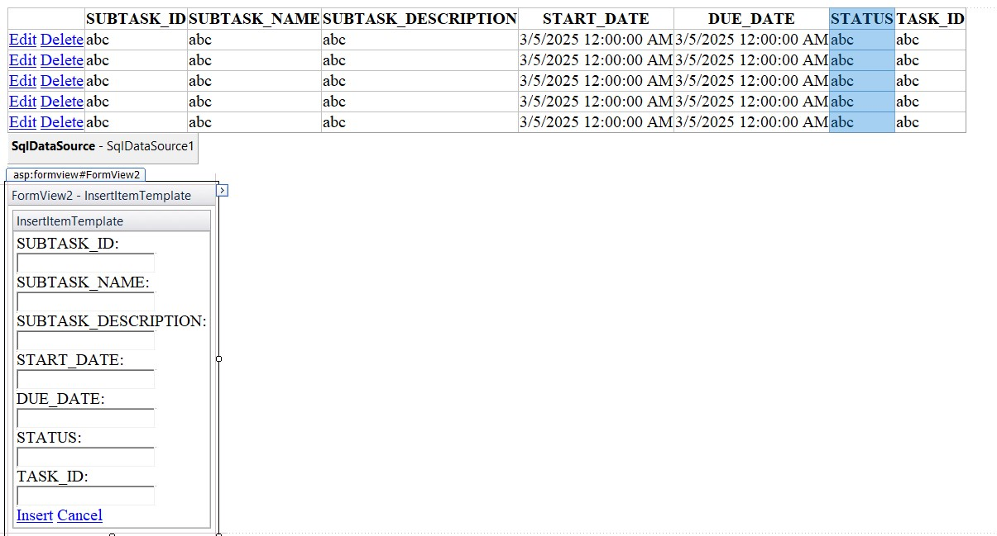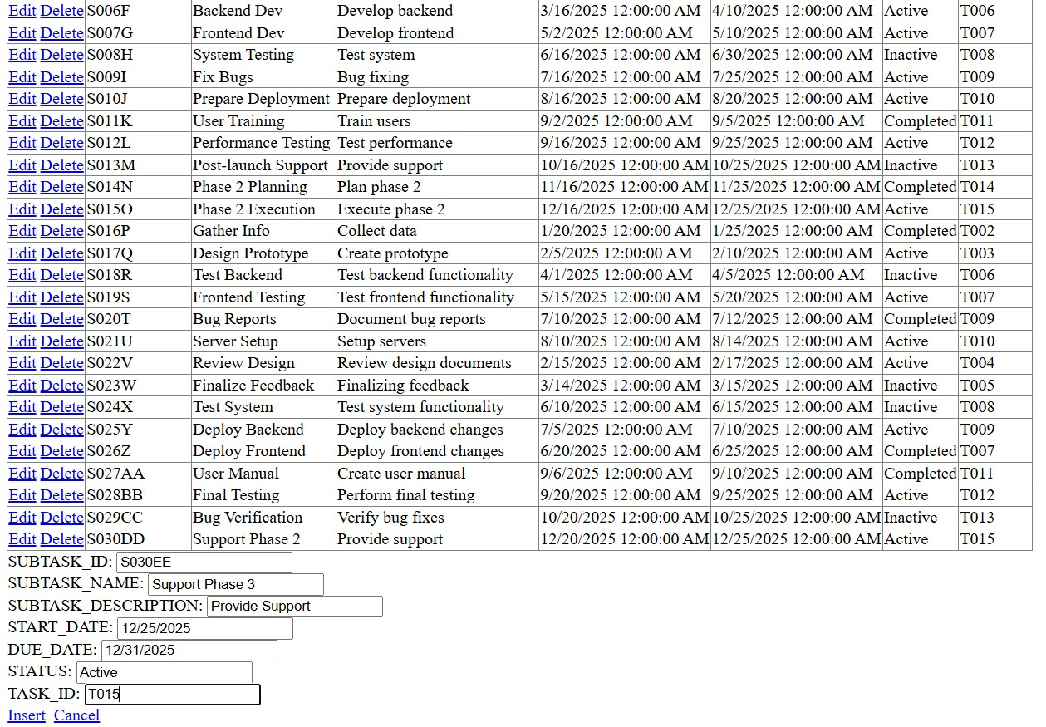
Figure 40:Adding New Subtask Details

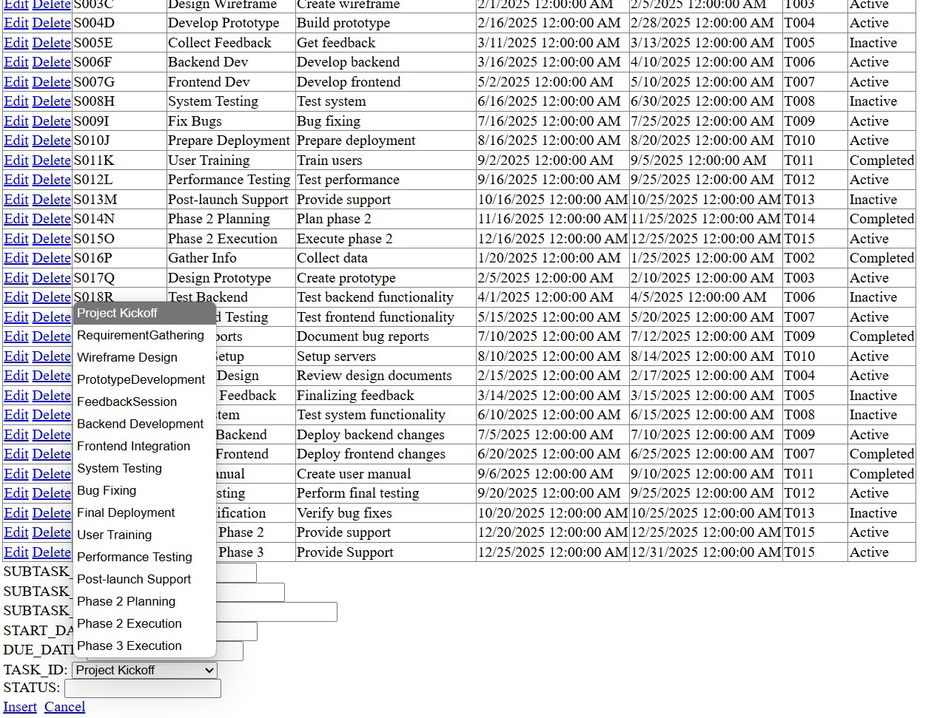
Figure 41:Dropdown menu of Task_Id

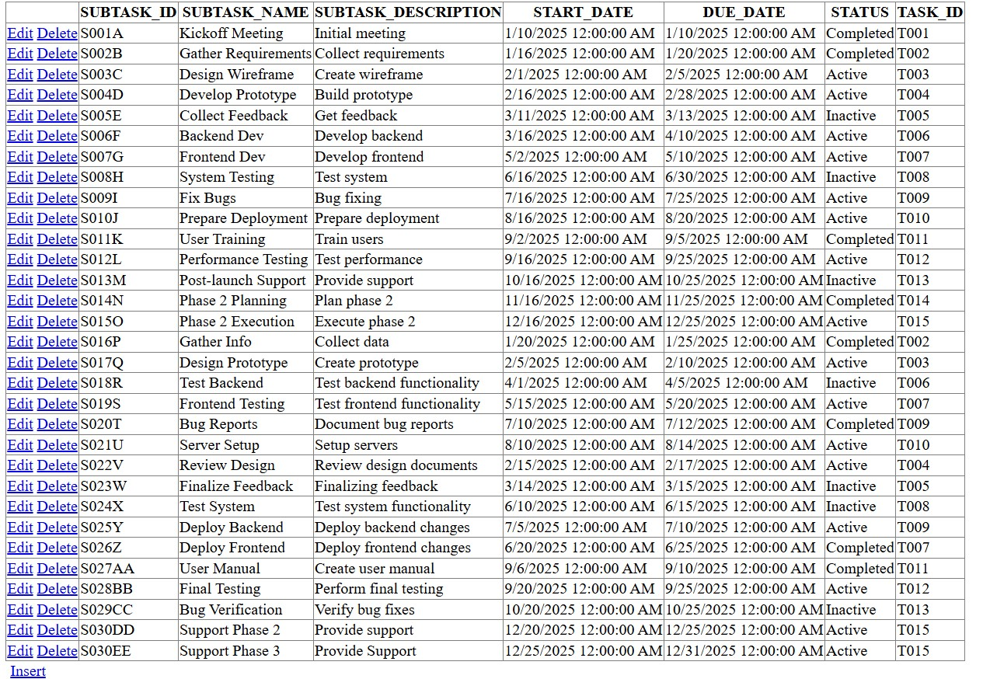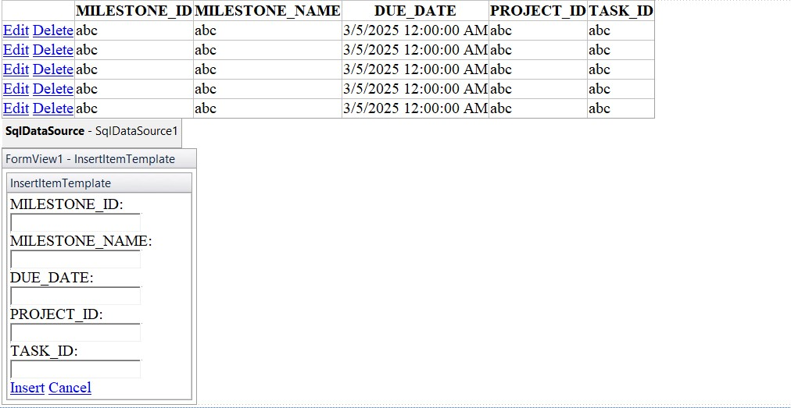

Test No: | 4
Objective | To Test the create, read, update, and delete of Milestone table
Action | For table creation:  Click Insert Button  MILESTONE_ID = P016  MILESTONE_NAME = Support Phase 3  DUEDATE = Provide Support  TASK_ID =Project Kickoff  PROJECT_ID=Smart City Automation  For Update:  - Click on the edit button  - Update some value  - Click on the update button.  For Table Deletion:  Click on Delete Table
Expected Result: | The CRUD operation should be executed successfully.
Actual Result: | The execution of the CRUD operation was observed to be successful.
Conclusion: | The test was successful
Table 4:Test For DRUD of MILESTONE TABLE
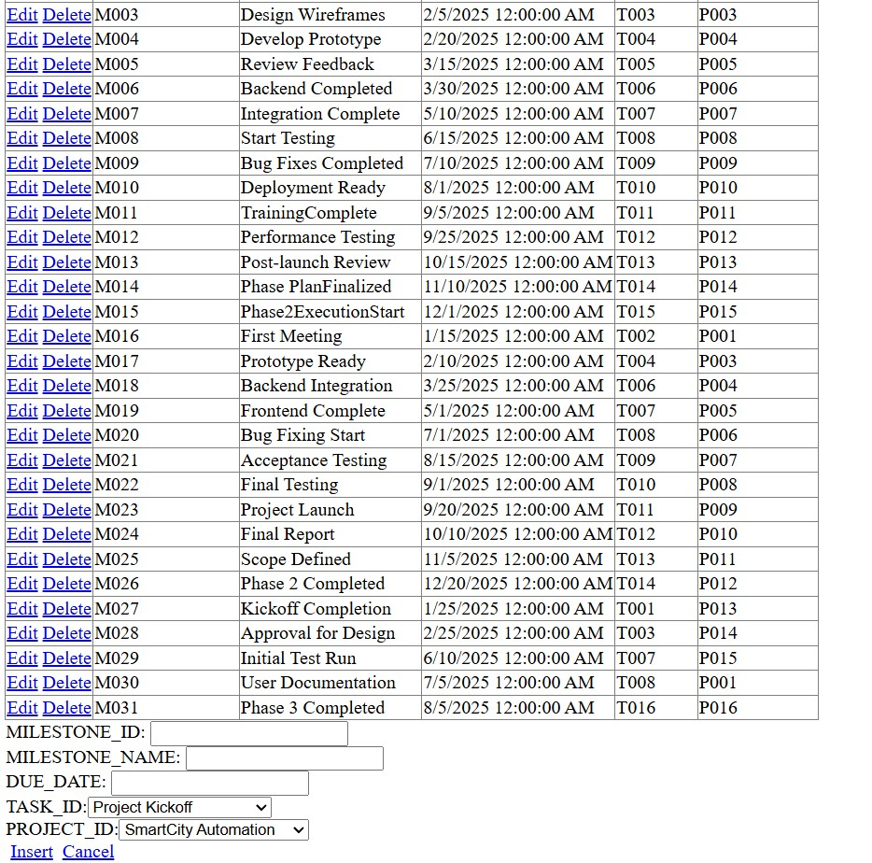
Figure 42: Adding new Details in Milestone Table

Test No: | 5
Objective | To Test the create, read, update, and delete of Subtask table
Action | For table creation:  Click Insert Button  TASK_ID = T016  TASK_NAME = Phase 3 Execution  STARTDATE =12/20/2025  DUEDATE=12/26/2025  STATUS =Active  For Update:  - Click on the edit button  - Update some value  - Click on the update button.  For Table Deletion:  Click on Delete Table
Expected Result: | The CRUD operation should be executed successfully.
Actual Result: | The execution of the CRUD operation was observed to be successful.
Conclusion: | The test was successful

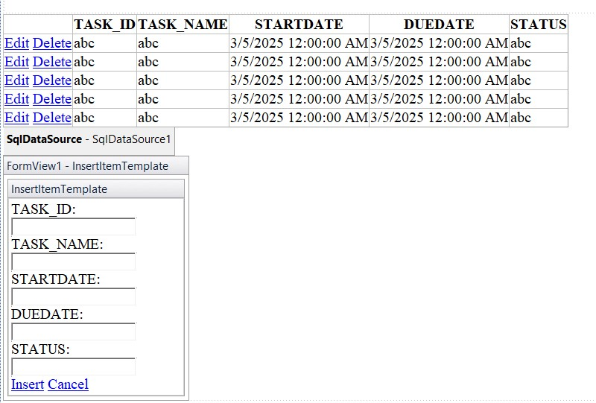
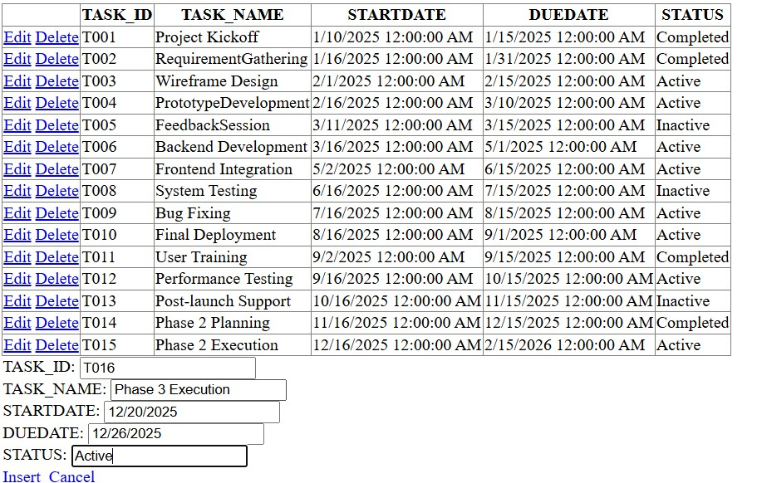
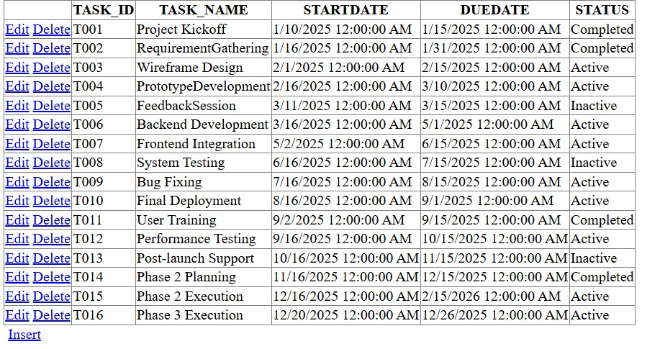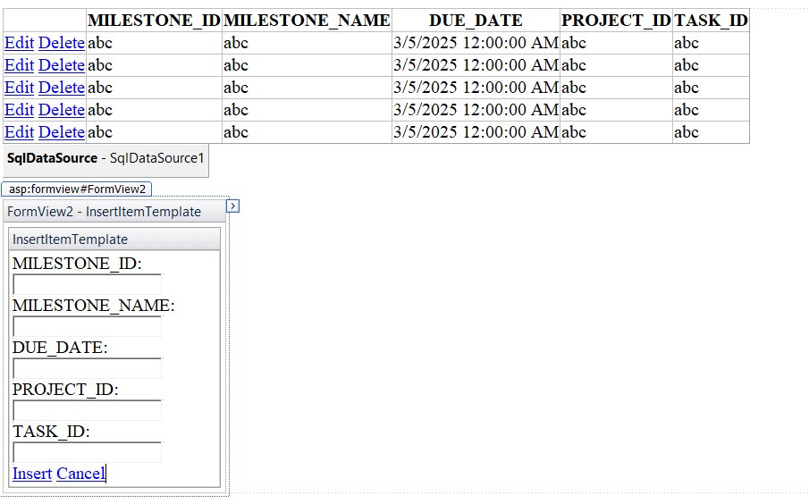
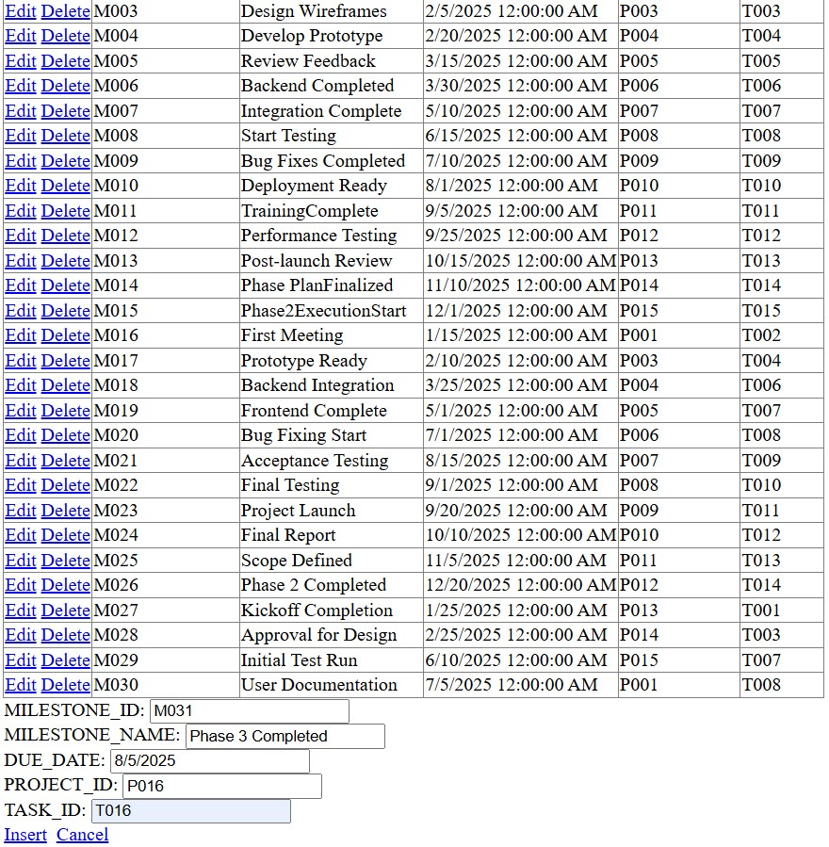
Figure 43:Adding new Milestone Details

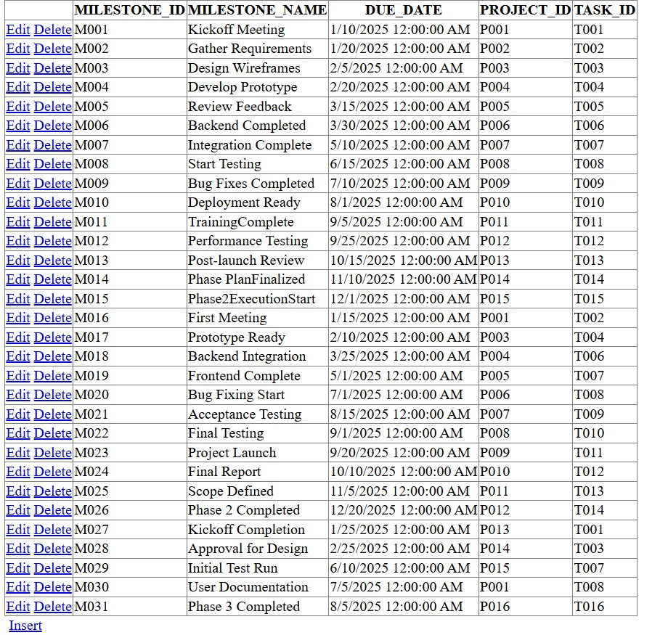
Figure 44:Details of Milestone Table

Further Works
Grasping the Idea of Databases
I learned how to organize and store information in a database. Tools like Data Modeler and SQL Developer helped me see how different pieces of data connect, much like organizing files in folders so everything makes sense.
Getting Comfortable with Basic SQL
I practiced writing simple commands to add, update, or remove data—imagine it as giving clear instructions to a digital assistant so that it knows exactly what to do with the information.
Creating a Simple Web Interface
Using ASP.NET Web Forms, I built a basic webpage that lets users interact with the system. This was like setting up a user-friendly form where someone can easily enter or retrieve information without needing to understand the complex background work.
Learning to Use Visual Studio
Visual Studio became my go-to workspace for writing and testing code. It was like having a well-organized toolbox that made the process of building both the look and the functionality of the system much smoother.
Sketching Out Ideas with Draw.io
I used Draw.io to draw simple diagrams that planned out the system. Think of it as doodling a rough blueprint to understand the flow of the project, which helped in keeping things clear and organized.

Tools and Technology used
Tools Used:
- Data Modeler: Designed and visualized the database structure.
- SQL Developer: Managed and manipulated the database data.
- Visual Studio: Developed, tested, and debugged the application.
- ASP.NET Web Forms: Built the user-friendly web interface.

Conclusion
The User Management System is concerned with the procedure applied towards managing users within a project environment. It features an intuitive interface where administrators can easily add, edit, or delete users. It can be easily connected to a database, structured among different users' privileged roles, and is highly navigable.
This project was approached systematically; meant designing a database based on relationships, providing a clear schema, and a user-friendly front-end. The system should be able to manage users effectively so that it would greatly affect better project organization and coordination.
It was successful, but some potential areas for future improvement are implementing role-based access control, introducing advanced search and filter options, and enhancing security features. Continuous testing and user feedback will help refine the system further.
In essence, the User Management System provides a tough but flexible solution for administrating users. Therefore, user handling becomes easier while maintaining the effectiveness and consistency of data so it remains a useful tool in any project or organizational environment.

Appendix
