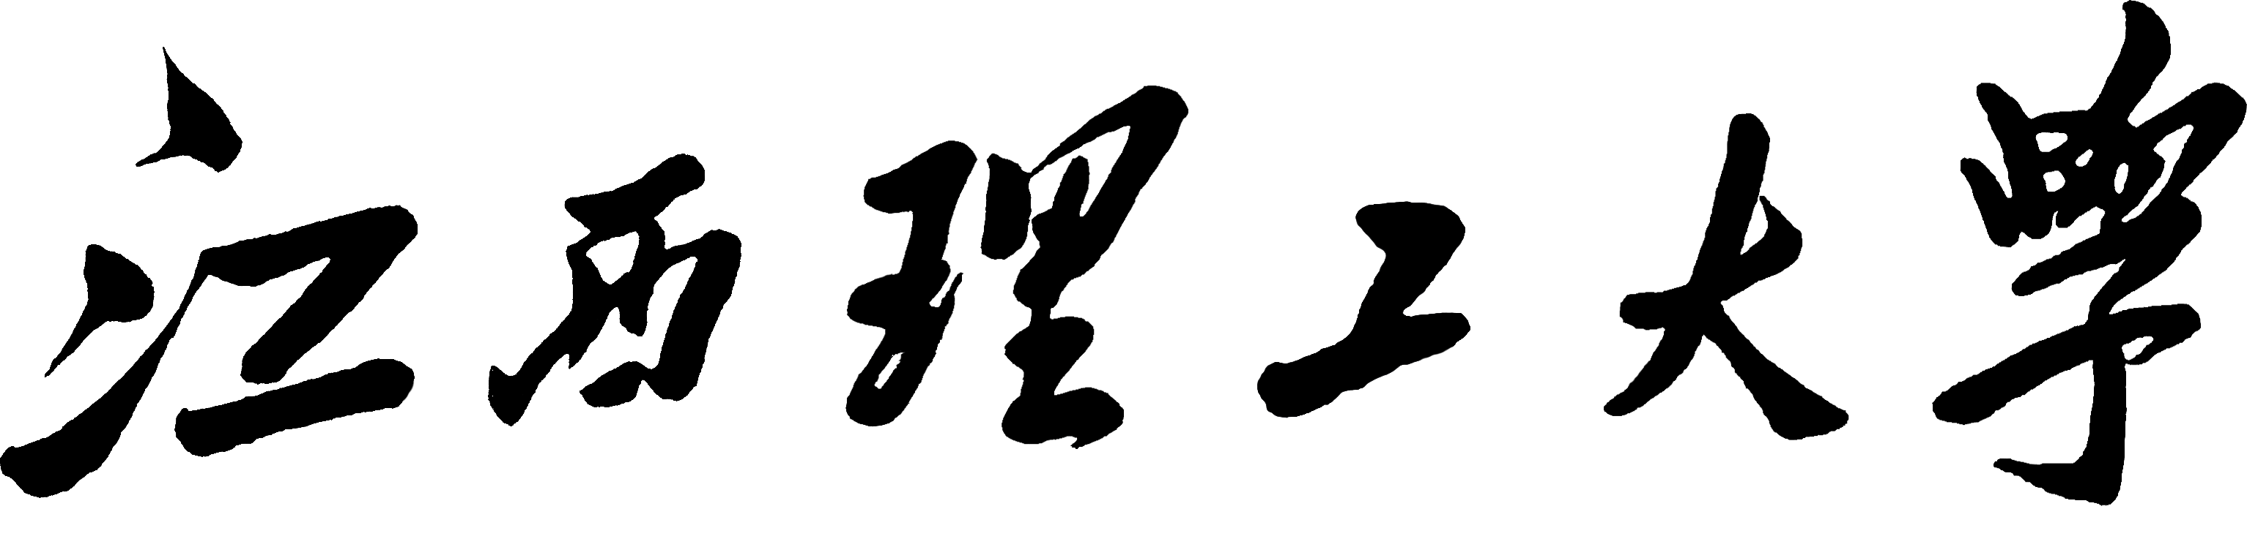

实验二 三维图形变换设计
- 实验内容：
1.创建模型图案的坐标数据模型；
2.调用函数并设置相关参数完成对图案的缩放、平移、旋转、对称等三维变换；
3.观察实验结果是否达到预期效果。

- 实验目标：
1.掌握三维平移、缩放、旋转、对称、和错切变换的数学原理；
2.在理解图像变换原理的基础上编程实现图像的各种变换。

- 实验要求：
- 掌握三维图形的齐次坐标表示方法；
2.熟悉平移、比例、旋转、对称、错切变换的矩阵及矩阵的乘法运算；
3.实现三维图形的基本变换，如缩放、平移、旋转、对称、错切变换等；
4.调试所编程序，能正确运行出设计要求结果。

- 相关论证：
- 三维平移变换： 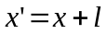 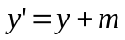 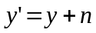
三维平移矩阵为：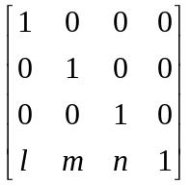
- 三维缩放：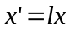 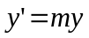 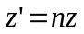
三维缩放矩阵为：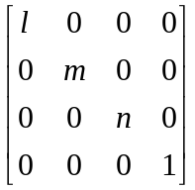
- 绕x轴旋转变换：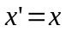 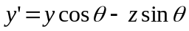 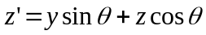
绕x轴旋转变换矩阵为：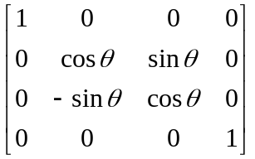
- 关于x轴对称变换： 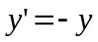 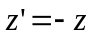
关于x轴对称变换矩阵为：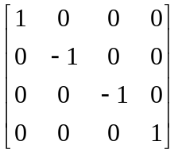

- 关键代码：
#include <stdio.h>
#include <stdlib.h>
#include <math.h>
#include <conio.h>
#include <graphics.h>

#define rad 0.0174532925
#define NUMBER 24

float
u[NUMBER]={60.,20.,20.,80.,80.,60.,60.,0.,0.,60.,80.,0.,0.,0.,0.,0.,20.,20.,0.,0.,0.,80.,0.,0.},
v[NUMBER]={20.,60.,60.,0.,0.,20.,20.,20.,20.,20.,0.,0.,20.,20.,60.,60.,60.,60.,60.,60.,0.,0.,0.,0.},
w[NUMBER]={30.,30.,0.,0.,90.,90.,30.,30.,90.,90.,90.,90.,90.,30.,30.,0.,0.,30.,30.,0.,0.,0.,0.,90.};
int ipen[NUMBER]={3,2,2,2,2,2,2,2,2,2,3,2,2,3,2,2,2,3,2,3,2,2,3,2};
int kind[NUMBER]={0,0,0,0,0,0,0,0,0,0,0,0,0,0,0,0,0,0,0,0,1,1,0,1};
void draw(float sf,float xc,float yc,float tranm[][4]);
void axono2d(float sf,float ox,float oy,float bta,float afa,float x[],float y[],float z[],int kp[],int kl[],int mp);
void plot(float x,float y,int ip,int lk);
void initm(float unitm[][4]);
void mult4x4(float ma[][4],float mb[][4],float mc[][4]);
void transform(float x0,float y0,float z0,float *x,float *y,float *z,float tranm[][4]);
void translation(float l,float m,float n,float tranm[][4]);
void scaling(float sx,float sy,float sz,float tranm[][4]);
void rotationx(float xc,float yc,float zc,float alta,float tranm[][4]);
void rotationy(float xc,float yc,float zc,float beta, float tranm[][4]);
void rotationz(float xc,float yc,float zc,float gama, float tranm[][4]);
void projectx(float i,float m,float n,float tranm[][4]);
void projecty(float i,float m,float n,float tranm[][4]);
void projectz(float i,float m,float n,float tranm[][4]);
void mirrxoy(float l,float m,float n,float tranm[][4]);
void mirrxoz(float l,float m,float n,float tranm[][4]);
void mirryoz(float l,float m,float n,float tranm[][4]);
void shearing(float a,float b,float c,float d,float e,float f,float tranm[][4]);

main()
{
int j,m=NUMBER;
int gd=DETECT,gm;
float tm[4][4]={0.};
initgraph(&gd,&gm,"C:\\JMSOFT\\DRV");
settextstyle(3,0,2);
outtextxy(170,4,"3D GRAPHICS TRANSFORMATION");
setwritemode(1);
initm(tm);

for(j=1;j<=15;j++)
{
setcolor(j);
translation(0.,0.,-10.*j,tm);
draw(1.,300.,350.,tm);
}

for(j=1;j<=15;j++)
{
setcolor(j);
translation(-10.*j,0.,0.,tm);
draw(1.,300.,350.,tm);
}

for(j=1;j<=15;j++)
{
setcolor(j);
translation(0.,10.*j,0.,tm);
draw(1.,300.,250.,tm);
}

for(j=1;j<=15;j++)
{
setcolor(j);
rotationx(0.,0.,0.,24.*j,tm);
draw(1.,320.,240.,tm);
}

for(j=1;j<=15;j++)
{
setcolor(j);
rotationy(0.,0.,10.,24.*j,tm);
draw(1.,320.,240.,tm);
}
for(j=1;j<=15;j++)
{
setcolor(j);
rotationz(0.,0.,10.,24.*j,tm);
draw(1.,320.,240.,tm);
}
for(j=1;j<=15;j++)
{
setcolor(j);
scaling(0.2*j,0.2*j,0.2*j,tm);
draw(1.,320.,240.,tm);
}

setwritemode(0);
axono2d(1.,320.,240.,-45.,35.2667,u,v,w,ipen,kind,NUMBER);
projectx(-80.,0.,0.,tm);
draw(1.,320.,240.,tm);
projecty(0.,-80.,0.,tm);
draw(1.,320.,240.,tm);
projectz(0.,0.,-80.,tm);
draw(1.,320.,240.,tm);
getch();
cleardevice();
axono2d(1.,320.,240.,-45.,35.2667,u,v,w,ipen,kind,NUMBER);
mirrxoy(0.,0.,-60.,tm);
draw(1.,320.,240.,tm);
mirrxoz (0.,-60.,0.,tm);
draw(1.,320.,240.,tm);
mirryoz(-60.,0.,0.,tm);
draw(1.,320.,240.,tm);

getch();
closegraph();
}

void draw(float sf,float xc,float yc,float tranm[][4])
{
int i,m=NUMBER;
float *px,*py,*pz,xu,yv,zw;
float ul[NUMBER],vl[NUMBER],wl[NUMBER];
px=&xu;
py=&yv;
pz=&zw;
for(i=0;i<m;i++)
{
transform(u[i],v[i],w[i],px,py,pz,tranm);
ul[i]=*px;
vl[i]=*py;
wl[i]=*pz;
}
axono2d(sf,xc,yc,-45.,35.2667,ul,vl,wl,ipen,kind,m);
getch();
axono2d(sf,xc,yc,-45.,35.2667,ul,vl,wl,ipen,kind,m);
}

void axono2d(float sf,float ox,float oy,float bta,float afa,float x[],float y[],float z[],int kp[],int kl[],int mp)
{
float bf,af,ca,cb,cg,sg,xp,yp,zp;
int i;
bf=bta*rad;
af=afa*rad;
cb=cos(bf);
ca=cos(af);
for(i=0;i<mp;i++)
{
if(x[i]==0)
xp=ox-sf*z[i]*cb;
else
xp=ox+sf*(x[i]-z[i]*cb);
if(y[i]==0)
yp=oy+sf*z[i]*ca;
else
yp=oy-sf*(y[i]-z[i]*ca);
plot(xp,yp,kp[i],kl[i]);
}
}

void plot(float x,float y,int ip,int lk)
{
if(ip==3)
moveto((int)x,(int)y);
else
{
if(lk==0)
setlinestyle(USERBIT_LINE,0xFFFF,3);
else
setlinestyle(USERBIT_LINE,0xF00F,1);
lineto((int)x,(int)y);
}
}

void initm(float unitm[][4])
{
int n;
for(n=0;n<4;n++)
{
unitm[n][0]=0;
unitm[n][1]=0;
unitm[n][2]=0;
unitm[n][3]=0;
unitm[n][n]=1;
}
}

void mult4x4(float ma[][4],float mb[][4],float mc[][4])
{
int mi,mj,mk;
for(mi=0;mi<4;mi++)
{
for(mj=0;mj<4;mj++)
{
mc[mi][mj]=0;
for(mk=0;mk<4;mk++)
mc[mi][mj]=mc[mi][mj]+ma[mi][mk]*mb[mk][mj];
}
}
}

void transform(float x0,float y0,float z0,float *x,float *y,float *z,float tranm[][4])
{
float xu,yv,zw,h;
xu=tranm[0][0]*x0+tranm[1][0]*y0+tranm[2][0]*z0+tranm[3][0];
yv=tranm[0][1]*x0+tranm[1][1]*y0+tranm[2][1]*z0+tranm[3][1];
zw=tranm[0][2]*x0+tranm[1][2]*y0+tranm[2][2]*z0+tranm[3][2];
h=tranm[0][3]*x0+tranm[1][3]*y0+tranm[2][3]*z0+tranm[3][3];
(*x)=xu/h;
(*y)=yv/h;
(*z)=zw/h;
}

void translation(float l,float m,float n,float tranm[][4])
{
initm(tranm);
tranm[3][0]=l;
tranm[3][1]=m;
tranm[3][2]=n;
}

void scaling(float sx,float sy,float sz,float tranm[][4])
{
initm(tranm);
tranm[0][0]=sx;
tranm[1][1]=sy;
tranm[2][2]=sz;
}

void rotationx(float xc,float yc,float zc,float alfa,float tranm[][4])
{
initm(tranm);
tranm[1][1]=cos(rad*alfa);
tranm[1][2]=sin(rad*alfa);
tranm[2][1]=-tranm[1][2];
tranm[2][2]=tranm[1][1];
tranm[3][1]=-yc*tranm[1][1]+zc*tranm[1][2]+yc;
tranm[3][2]=yc*tranm[1][2]+zc*tranm[1][1]+zc;
}

void rotationy(float xc,float yc,float zc,float beta,float tranm[][4])
{
initm(tranm);
tranm[0][0]=cos(rad*beta);
tranm[2][0]=sin(rad*beta);
tranm[0][2]=-tranm[2][0];
tranm[2][2]=tranm[0][0];
tranm[3][0]=-xc*tranm[0][0]-zc*tranm[2][0]+xc;
tranm[3][2]=xc*tranm[2][0]-zc*tranm[0][0]+zc;
}

void rotationz(float xc,float yc,float zc,float gama,float tranm[][4])
{

initm(tranm);
tranm[0][0]=cos(rad*gama);
tranm[0][1]=sin(rad*gama);
tranm[1][0]=-tranm[0][1];
tranm[1][1]=tranm[0][0];
tranm[3][0]=-xc*tranm[0][0]+yc*tranm[0][1]+xc;
tranm[3][1]=-xc*tranm[0][1]+yc*tranm[0][0]+yc;
}

void projectx(float l,float m,float n,float tranm[][4])
{
initm(tranm);
tranm[0][0]=0;
tranm[3][0]=l;
tranm[3][1]=m;
tranm[3][2]=n;
}

void projecty(float l,float m,float n,float tranm[][4])
{
initm(tranm);
tranm[1][1]=0;
tranm[3][0]=l;
tranm[3][1]=m;
tranm[3][2]=n;
}

void projectz(float l,float m,float n,float tranm[][4])
{
initm(tranm);
tranm[2][2]=0;
tranm[3][0]=l;
tranm[3][1]=m;
tranm[3][2]=n;
}

void mirrxoy(float l,float m,float n,float tranm[][4])
{
initm(tranm);
tranm[2][2]=-1.;
tranm[3][0]=l;
tranm[3][1]=m;
tranm[3][2]=n;
}

void mirrxoz(float l,float m,float n,float tranm[][4])
{
initm(tranm);
tranm[1][1]=-1.;
tranm[3][0]=l;
tranm[3][1]=m;
tranm[3][2]=n;
}

void mirryoz(float l,float m,float n,float tranm[][4])
{
initm(tranm);
tranm[0][0]=-1.;
tranm[3][0]=l;
tranm[3][1]=m;
tranm[3][2]=n;
}

void shearing(float a,float b,float c,float d,float e,float f,float tranm[][4])
{
initm(tranm);
tranm[0][1]=a;
tranm[0][2]=b;
tranm[1][0]=c;
tranm[1][2]=e;
tranm[2][0]=d;
tranm[2][1]=f;
}

- 结果分析：
在课堂学习理论的基础上编程实现三维图像的缩放、平移、旋转、对称变换。使我对三维图像变换的原理有了更加深刻的了解，并且提高了自己图形学编程的能力。
