Covid19
# Part A: Dataset Understanding and Preparation
# 1. Import the COVID-19 dataset
library(dplyr)
##
## Attaching package: 'dplyr'
## The following objects are masked from 'package:stats':
##
## filter, lag
## The following objects are masked from 'package:base':
##
## intersect, setdiff, setequal, union
covid <- read.csv(
"https://raw.githubusercontent.com/datasets/covid-19/main/data/countries-aggregated.csv"
)
# View dataset structure
str(covid)
## 'data.frame': 161568 obs. of 5 variables:
## $ Date : chr "2020-01-22" "2020-01-23" "2020-01-24" "2020-01-25" ...
## $ Country : chr "Afghanistan" "Afghanistan" "Afghanistan" "Afghanistan" ...
## $ Confirmed: int 0 0 0 0 0 0 0 0 0 0 ...
## $ Recovered: int 0 0 0 0 0 0 0 0 0 0 ...
## $ Deaths : int 0 0 0 0 0 0 0 0 0 0 ...
# 2. Display first 10 and last 10 records
head(covid, 10)
## Date Country Confirmed Recovered Deaths
## 1 2020-01-22 Afghanistan 0 0 0
## 2 2020-01-23 Afghanistan 0 0 0
## 3 2020-01-24 Afghanistan 0 0 0
## 4 2020-01-25 Afghanistan 0 0 0
## 5 2020-01-26 Afghanistan 0 0 0
## 6 2020-01-27 Afghanistan 0 0 0
## 7 2020-01-28 Afghanistan 0 0 0
## 8 2020-01-29 Afghanistan 0 0 0
## 9 2020-01-30 Afghanistan 0 0 0
## 10 2020-01-31 Afghanistan 0 0 0
tail(covid, 10)
## Date Country Confirmed Recovered Deaths
## 161559 2022-04-07 Zimbabwe 246870 0 5455
## 161560 2022-04-08 Zimbabwe 246925 0 5457
## 161561 2022-04-09 Zimbabwe 246925 0 5457
## 161562 2022-04-10 Zimbabwe 246958 0 5457
## 161563 2022-04-11 Zimbabwe 247010 0 5460
## 161564 2022-04-12 Zimbabwe 247094 0 5460
## 161565 2022-04-13 Zimbabwe 247160 0 5460
## 161566 2022-04-14 Zimbabwe 247208 0 5462
## 161567 2022-04-15 Zimbabwe 247237 0 5462
## 161568 2022-04-16 Zimbabwe 247237 0 5462
# 3. Identify total rows and columns
total_rows <- nrow(covid)
total_columns <- ncol(covid)
total_rows
## [1] 161568
total_columns
## [1] 5
# 4. List variables and data types
sapply(covid, class)
## Date Country Confirmed Recovered Deaths
## "character" "character" "integer" "integer" "integer"
# 5. Convert Date column into Date format
covid$Date <- as.Date(covid$Date, format = "%Y-%m-%d")
# 6. Healthcare significance of variables
# Confirmed: Total reported COVID-19 cases
# Recovered: Number of patients who recovered
# Deaths: Total deaths caused by COVID-19
# Part B: Data Cleaning and Preprocessing
# 1. Check for missing (NA) values
colSums(is.na(covid))
## Date Country Confirmed Recovered Deaths
## 0 0 0 0 0
# 2. Handle missing values
covid$Confirmed[is.na(covid$Confirmed)] <- 0
covid$Recovered[is.na(covid$Recovered)] <- 0
covid$Deaths[is.na(covid$Deaths)] <- 0
# 3. Detect outliers using IQR method
detect_outliers <- function(x) {
Q1 <- quantile(x, 0.25)
Q3 <- quantile(x, 0.75)
IQR <- Q3 - Q1
which(x < (Q1 - 1.5 * IQR) | x > (Q3 + 1.5 * IQR))
}
out_confirmed <- detect_outliers(covid$Confirmed)
out_recovered <- detect_outliers(covid$Recovered)
out_deaths <- detect_outliers(covid$Deaths)
length(out_confirmed)
## [1] 24545
length(out_recovered)
## [1] 31400
length(out_deaths)
## [1] 25193
# 4. Handle outliers (capping method)
cap_outliers <- function(x) {
Q1 <- quantile(x, 0.25)
Q3 <- quantile(x, 0.75)
IQR <- Q3 - Q1
lower <- Q1 - 1.5 * IQR
upper <- Q3 + 1.5 * IQR
x[x < lower] <- lower
x[x > upper] <- upper
return(x)
}
covid$Confirmed <- cap_outliers(covid$Confirmed)
covid$Recovered <- cap_outliers(covid$Recovered)
covid$Deaths <- cap_outliers(covid$Deaths)
# 5. Create cleaned dataset
covid_clean <- covid
# Part C: Data Manipulation
# 1. Filter dataset for a specific country
india_data <- covid_clean %>%
filter(Country == "India")
head(india_data,10)
## Date Country Confirmed Recovered Deaths
## 1 2020-01-22 India 0 0 0
## 2 2020-01-23 India 0 0 0
## 3 2020-01-24 India 0 0 0
## 4 2020-01-25 India 0 0 0
## 5 2020-01-26 India 0 0 0
## 6 2020-01-27 India 0 0 0
## 7 2020-01-28 India 0 0 0
## 8 2020-01-29 India 0 0 0
## 9 2020-01-30 India 1 0 0
## 10 2020-01-31 India 1 0 0
# 2. Extract data for year 2020
data_2020 <- covid_clean %>%
filter(format(Date, "%Y") == "2020")
head(data_2020,10)
## Date Country Confirmed Recovered Deaths
## 1 2020-01-22 Afghanistan 0 0 0
## 2 2020-01-23 Afghanistan 0 0 0
## 3 2020-01-24 Afghanistan 0 0 0
## 4 2020-01-25 Afghanistan 0 0 0
## 5 2020-01-26 Afghanistan 0 0 0
## 6 2020-01-27 Afghanistan 0 0 0
## 7 2020-01-28 Afghanistan 0 0 0
## 8 2020-01-29 Afghanistan 0 0 0
## 9 2020-01-30 Afghanistan 0 0 0
## 10 2020-01-31 Afghanistan 0 0 0
# 3. Create new column: Active_Cases
covid_clean <- covid_clean %>%
mutate(Active_Cases = Confirmed - Recovered - Deaths)
head(covid_clean, 10)
## Date Country Confirmed Recovered Deaths Active_Cases
## 1 2020-01-22 Afghanistan 0 0 0 0
## 2 2020-01-23 Afghanistan 0 0 0 0
## 3 2020-01-24 Afghanistan 0 0 0 0
## 4 2020-01-25 Afghanistan 0 0 0 0
## 5 2020-01-26 Afghanistan 0 0 0 0
## 6 2020-01-27 Afghanistan 0 0 0 0
## 7 2020-01-28 Afghanistan 0 0 0 0
## 8 2020-01-29 Afghanistan 0 0 0 0
## 9 2020-01-30 Afghanistan 0 0 0 0
## 10 2020-01-31 Afghanistan 0 0 0 0
# 4. Group by country and calculate totals
country_summary <- covid_clean %>%
group_by(Country) %>%
summarise(
Total_Confirmed = max(Confirmed),
Total_Deaths = max(Deaths),
Total_Recovered = max(Recovered)
)
head(country_summary, 10)
## # A tibble: 10 × 4
## Country Total_Confirmed Total_Deaths Total_Recovered
## <chr> <dbl> <dbl> <dbl>
## 1 Afghanistan 178387 7676 44931.
## 2 Albania 274462 3496 44931.
## 3 Algeria 265739 6874 44931.
## 4 Andorra 40709 155 14380
## 5 Angola 99194 1900 39582
## 6 Antarctica 11 0 0
## 7 Antigua and Barbuda 7535 135 1239
## 8 Argentina 637775 11247 44931.
## 9 Armenia 422747 8621 44931.
## 10 Australia 637775 6779 24203
# 5. Top 10 countries with highest confirmed cases
top_10_countries <- country_summary %>%
arrange(desc(Total_Confirmed)) %>%
head(10)
top_10_countries
## # A tibble: 10 × 4
## Country Total_Confirmed Total_Deaths Total_Recovered
## <chr> <dbl> <dbl> <dbl>
## 1 Argentina 637775 11247 44931.
## 2 Australia 637775 6779 24203
## 3 Austria 637775 11247 44931.
## 4 Azerbaijan 637775 9705 44931.
## 5 Bangladesh 637775 11247 44931.
## 6 Belarus 637775 6899 44931.
## 7 Belgium 637775 11247 31130
## 8 Bolivia 637775 11247 44931.
## 9 Brazil 637775 11247 44931.
## 10 Bulgaria 637775 11247 44931.
# Part D:Data Visualization (Using ggplot2)
library(ggplot2)
# 1. Scatter Plot
# Relationship between Confirmed Cases and Deaths
ggplot(covid_clean,
aes(x = Confirmed, y = Deaths)) +
geom_point(color = "darkred", alpha = 0.5) +
labs(
title = "Confirmed COVID-19 Cases vs Deaths (Country-wise)",
x = "Total Confirmed Cases (log scale)",
y = "Total Deaths (log scale)"
) +
theme_minimal()
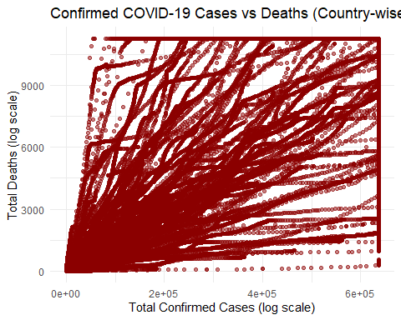
# 2. Line Charts
# a) Trend of confirmed cases over time for a selected country (India)
india_data <- covid_clean %>% filter(Country == "India")
ggplot(india_data, aes(x = Date, y = Confirmed)) +
geom_line(color = "blue") +
labs(
title = "COVID-19 Confirmed Cases Over Time (India)",
x = "Date",
y = "Confirmed Cases"
) +
theme_minimal()
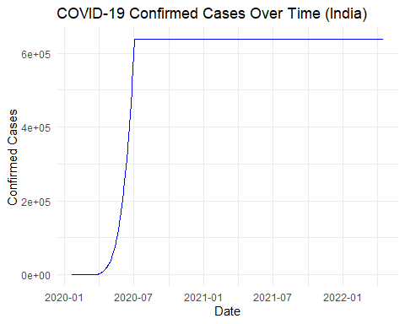
# b) Compare confirmed cases for three countries
countries_data <- covid_clean %>%
filter(Country %in% c("India", "United States", "Brazil"))
ggplot(countries_data, aes(x = Date, y = Confirmed, color = Country)) +
geom_line() +
labs(
title = "Comparison of Confirmed COVID-19 Cases",
x = "Date",
y = "Confirmed Cases"
) +
theme_minimal()
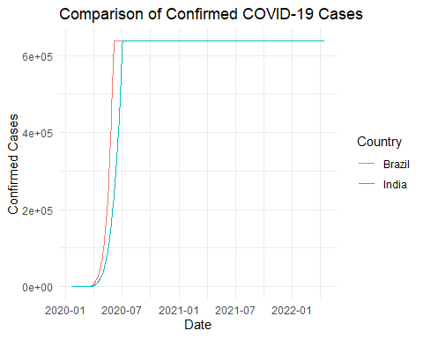
# 3. Bar Charts
# a) Vertical bar chart – Top 10 countries by total deaths
top_deaths <- covid_clean %>%
group_by(Country) %>%
summarise(Total_Deaths = as.numeric(sum(Deaths))) %>%
arrange(desc(Total_Deaths)) %>%
slice_head(n = 10)
ggplot(top_deaths, aes(x = reorder(Country, -Total_Deaths), y = Total_Deaths)) +
geom_bar(stat = "identity", fill = "darkred") +
#scale_x_log10(labels = scales::comma) +
labs(
title = "Top 10 Countries by Total COVID-19 Deaths",
x = "Country",
y = "Total Deaths"
) +
theme(
axis.text.x = element_text(angle = 45, hjust = 1)
)
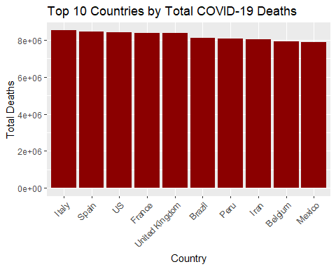
# b) Horizontal bar chart – Recovered cases by country (Top 10)
top_recovered <- covid_clean %>%
group_by(Country) %>%
summarise(Total_Recovered = as.numeric(sum(Recovered))) %>%
arrange(desc(Total_Recovered)) %>%
slice_head(n = 10)
ggplot(top_recovered, aes(x = Total_Recovered, y = reorder(Country, Total_Recovered))) +
geom_bar(stat = "identity", fill = "darkgreen") +
labs(
title = "Top 10 Countries by Recovered COVID-19 Cases",
x = "Recovered Cases",
y = "Country"
) +
scale_x_continuous(labels = scales::comma) +
theme_minimal()
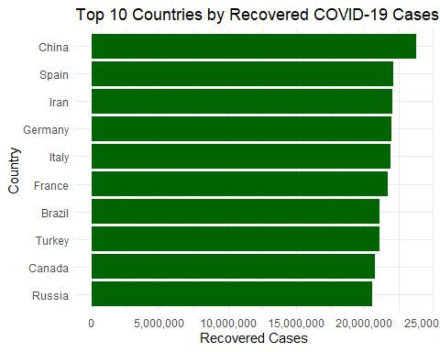
# 4. Histograms
# a) Histogram of Confirmed Cases
ggplot(covid_clean, aes(x = log10(Confirmed + 1))) +
geom_histogram(fill = "steelblue", bins = 30) +
labs(
title = "Log-Transformed Distribution of Confirmed COVID-19 Cases",
x = "log10(Confirmed + 1)",
y = "Frequency"
) +
theme_minimal()
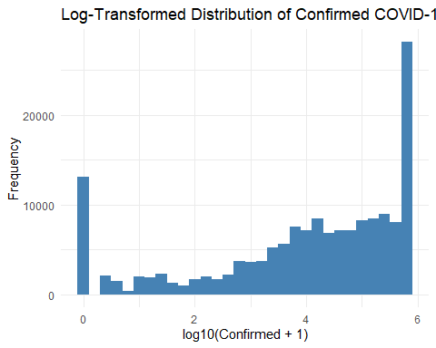
{b) Interpret the histogram in terms of healthcare impact.
Healthcare Interpretation: The histogram shows a right-skewed distribution, indicating that most countries have low to moderate case counts, while a few countries experience extremely high case loads, stressing healthcare infrastructure.}
# 5. Box Plots
# a) Box plot for Confirmed Cases
library(tidyr)
library(dplyr)
covid_long <- covid_clean %>%
select(Confirmed, Deaths) %>%
pivot_longer(
cols = c(Confirmed, Deaths),
names_to = "Type",
values_to = "Count"
)
ggplot(covid_long, aes(x = Type, y = log10(Count + 1), fill = Type)) +
geom_boxplot(alpha = 0.7, outlier.color = "red") +
labs(
title = "COVID-19 Cases vs Deaths (log10(x + 1))",
y = "log10(Count + 1)",
x = NULL
) +
theme_minimal(base_size = 14) +
theme(
plot.title = element_text(hjust = 0.5, face = "bold"),
legend.position = "none"
)
