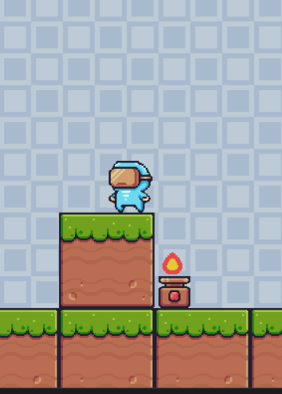

PYTHON PLATFORMER

side-scrolling platform (for gaming)

In-plant Training |Python | 10-07-2023

Project By: Tiya H. Bhavsar

Year: TYCO-A

Roll No.: 40

# PLATFORM WRAP-UP

Platformers are a classic genre.

Basically, a platformer is a game where you control a character who can jump and move around on platforms. The goal is usually to get to the end of the level, but there might also be enemies to defeat or collectibles to find.

As for the use of platforms outside of gaming, there are a lot of possibilities. Platforms can be used to create all sorts of interactive applications, such as educational games, simulations, and data visualizations. They can also be used to build web applications, mobile apps, and desktop apps.

In the platformer…..(made by me for eg. Gaming) :

User can enjoy having:

* control on his game
* add on own features in the code
* add up levels by setting Traps ‘n Terrains
* Pixel Perfect Collision
* Animated Characters
* All kinds of Animations
* Various Themes
* Generation of Terrain/Objects
* Right- left and up-down scrolling screen
* Strong fundamental understanding of Python
* Change/Modify the character, terrain, background, animations and generate levels

## user database

User database can be created by a user or a group of users for their own purposes. It is typically used to store data that is specific to the user or group, such as customer records, product inventory, or financial data. User databases can be created on any type of database server, but they are most commonly created on SQL Server.

There are two main types of user databases:

System databases: These are databases that are created by the database server itself and are used to store system data, such as login information, database configuration settings, and error logs.

User-created databases: These are databases that are created by users and are used to store data that is specific to the user or group.

* User credentials saved in database with security
* Better control over activities
* Zero Trust
* TD and TP features