Design for a “Perception and Identification of Random Effects” Experiment

# Background

Perception of randomness or in other words the human ability to perceive structured vs. unstructured events has been subject to quite some studies. Being able to identify structure and patterns as well as being able to generate random behavior is important for survival and is for example involved in classical conditioning.

Prior studies about the perception of randomness have shown that the human understanding of randomness can be flawed and biased. The gambler's fallacy for example describes the belief that an event is less likely to occur in the future if it has occurred more frequently in the past (or vice versa), although the probability of such events does not depend on what has happened in the past (Kahneman & Tversky, 1972). Another misconception is the overalternation bias which states that for example in a random coin flip series generation task participants tend to alternate between heads and tails more often than in a truly random series.

While other studies use mostly judgment of random sequences and generation of random sequences tasks, we are going to replicate an experiment by Zhao et al from 2014. In this experiment we compare performance in a *discrimination* vs. an *identification* task to understand the conceptualization of randomness.

# Hypothesis

Having a correct and concrete conceptualization of randomness should lead to high accuracy in discriminating a border between randomly and non-randomly generated stimuli. Likewise this conceptualization should also lead to similar performance in a task asking for identification of a randomly generated stimulus (exact descriptions of the two tasks are provided below). So we apply the hypothesis used in the original paper:

*“Hypothesis 1:* The probability of correctly identifying stimuli from R and N coincides with the ease of distinguishing between the two sources.”

Where R is a random source and N is a non-random source.

# Design

## Materials

Each stimulus consists of a $60×60$ matrix. The matrix is either separated horizontally or vertically in half, for each stimulus determined at random. Each cell of the matrix can either have one of two colors. In the original paper these two colors were green and blue, we changed it to visually impaired friendly blue and orange.

While one half of the matrix is generated at random, the other half is generated using a stochastic algorithm. In this algorithm which is called “ $switch\left(x\right)$”, $xϵ\left[0,1\right]$ is the switch rate which determines the probability that the th cell is set to the opposite value of the th cell. In all cases, the color of the first cell is chosen randomly. For a switch rate of $x=1$ the cells perfectly alternate in color, for a switch rate of $x=0$ the cells all have the same color. In both cases the outcome is determined by the first cell. A switch rate of $x=0.5$ behaves like a fair coin and assigns one of the two colors at random to a cell. A switch rate of $x<0.5$ or $x>0.5$ has longer or shorter runs than expected from a random source, respectively.

In both conditions the switch rate of the non-random half is between 0 and 1 in steps of 0.02, consequently leading to 51 levels. Each level is repeated 10 times, so that we end up with 510 trials. The difference in stimulus between the two experimental conditions *discrimination* and *identification* is that for the *identification* task there is a 50-pixel gap horizontally or vertically oriented showing the separation of the two halves.

The whole experiment was implemented in _magpie, a minimal architecture for the portable generation of interactive experiments. _magpie is written in CSS, Javascript and HTML (https://magpie-ea.github.io/magpie-site/). The “ $switch\left(x\right)$” algorithm described above is implemented using the Javascript function Math.random(), a function that generates a random floating number between 0 and 1 (1 exclusive). The sequence generated by the “ $switch\left(x\right)$” algorithm is then used to insert the respective colors pixel-wise into a canvas object, which is then enlarged by a factor of 3 and transformed into an image.

Example Pictures of stimuli from the discrimination task:

## 

## Example stimuli from the identification task:

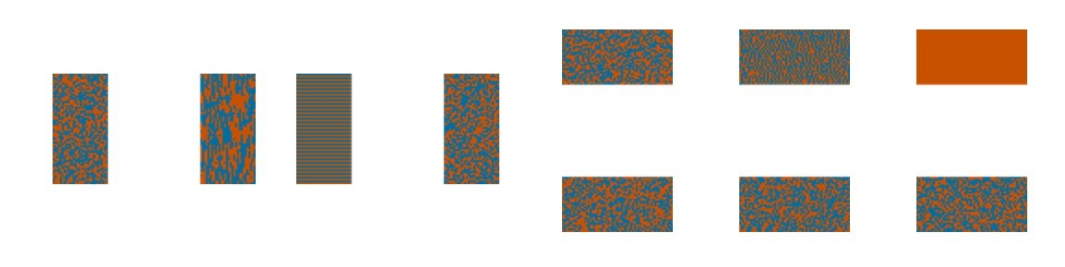

## Procedure

The whole experiment is constructed in _magpie and consists of 3 parts:

1. introduction and instructions
2. test phase
3. post-experiment questionnaire

The participants are first welcomed to the experiment and are then at random assigned to one of two different experimental groups, *discrimination* or *identification*.

They will receive different instructions depending on their experimental condition which are specified below. Instructions will not only be shown in English but also in German, as we expect the majority of participants to come from Germany.

In both cases stimuli are shown for 1,500 ms followed by a blank screen until a response is entered. The order of the stimuli is shuffled before each participant's trials.

In the *discrimination* condition, the participants are shown the stimuli: matrices without separation gap. Their task is then to discriminate the two halves by indicating whether a separating line should be placed horizontally or vertically by pressing the ‘v’ key for vertical and the ‘h’ key for horizontal. Instructions of the discrimination condition do not include mentioning randomness or probability. We added one additional sentence (the first) to the original instructions taken from the paper:

In each trial of the experiment, you will see a square made up of two colors.

Each matrix can be divided into two halves either horizontally or vertically. The two halves are generated from different processes. Your task is to judge the orientation of the boundary between the two halves, by pressing v key for vertical or h key for horizontal.

In jedem Durchgang des Experiments wirst du ein zweifarbiges Viereck sehen.

Jede Matrix kann horizontal oder vertikal in zwei Hälften geteilt werden. Die beiden Hälften werden aus unterschiedlichen Prozessen erzeugt. Deine Aufgabe besteht darin, die Ausrichtung der Grenze zwischen den beiden Hälften zu beurteilen, indem du die v-Taste für vertikal oder die h-Taste für horizontal drücken.

In the *identification* condition, the presented stimuli are matrices with a horizontally or vertically oriented gap, separating the random half from the one with the different switch rate. These stimuli are also shuffled for each participant before their trial. The task is then to decide which of the two halves was more likely generated by a random process. This is done by pressing one of the 4 arrow keys indicating which half was generated at random.

The instructions are again taken from the original paper with an additional first sentence:

In each trial of the experiment, you will see a square made up of two colors.

Each matrix is divided into two halves either horizontally or vertically. The two halves are separated by a gap. One half is generated from a random process and the other from a nonrandom process. Your task is to identify which half is more likely to be produced by a random process than a nonrandom process. Press the top or bottom arrow key if the division is horizontal, and left or right if vertical.

In jedem Durchgang des Experiments wirst du ein zweifarbiges Viereck sehen.

Jede Matrix ist entweder horizontal oder vertikal in zwei Hälften geteilt. Die beiden Hälften sind durch einen Spalt getrennt. Eine Hälfte wird aus einem zufälligen Prozess und die andere aus einem nicht-zufälligen Prozess erzeugt. Deine Aufgabe besteht darin, zu identifizieren, welche Hälfte eher durch einen zufälligen Prozess erzeugt wird als durch einen nicht-zufälligen Prozess. Drücke die obere oder untere Pfeiltaste, wenn die Teilung horizontal ist, und nach links oder rechts, wenn sie vertikal ist.

There is no practice trial or feedback regarding the correctness of the responses as in the original experiment to study the initial conceptualization of randomness.

After the experiment is finished the participants have the chance to leave additional socio-demographic information (age, gender, native language) and feedback. Furthermore, they will be asked in free question form if they have an idea what the experiment is about, which was also done in the original setting of the experiment.

### Further References

Zhao, J., Hahn, U., & Osherson, D. (2014). Perception and identification of random events. Journal of Experimental Psychology: Human Perception and Performance, 40(4), 1358–1371. [https://doi.org/10.1037/a0036816](https://doi.apa.org/doi/10.1037/a0036816)

Kahneman, D., & Tversky, A. (1972). Subjective probability: A judgment of representativeness. *Cognitive Psychology, 3*(3), 430–454. https://doi.org/10.1016/0010-0285(72)90016-3