**STANDARD DEVIATION**

To define standard deviation, you need to define

another term called variance. In simple terms, standard

deviation is the square root of variance

**Example for Standard Deviation**

The following data represent the percentage

return on investment for 10 mutual funds per

annum. Calculate the sample standard deviation.

12, 14, 11, 18, 10.5, 11.3, 12, 14, 11, 9

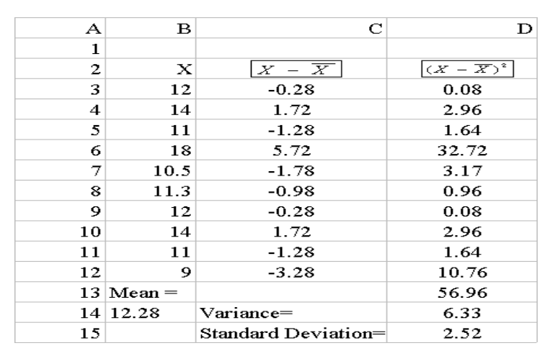

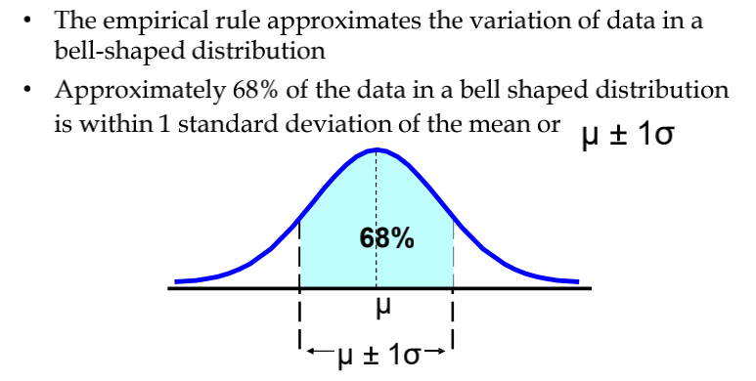

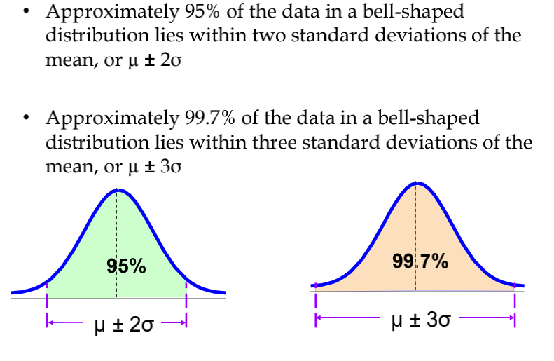

To summarise :

One standard deviation around the mean contains 68% of the data.

Two standard deviation around the mean contains 95% of the data

Three standard Deviation around the mean contains 99.7% of the data.