|  |  |
| --- | --- |
|  |  |

RSPD-W21

Design

Sample Play

The following design will be implemented when building the app:

Testing design sample:

Programming Fundamentals 202110, Harman, 000825162

Do you want to play with 1 or 2 weapon sets?

1 or 2> 1

Difficulty easy, hard? (type i for more info about game modes)

e, h> e

Player Wins :0.0

Comp Wins :0.0

Weapons Remaining:

Player: Rock: 1 Paper: 1 Scissors: 1 Dynamite: 1

Comp: Rock: 1 Paper: 1 Scissors: 1 Dynamite: 1

Your Move (RPSD)> r

Player uses Rock

Comp uses Scissors

!!!!!!!!!!!!!

!Player Wins!

!!!!!!!!!!!!!

Player Wins :1.0

Comp Wins :0.0

Weapons Remaining:

Player: Rock: 0 Paper: 1 Scissors: 1 Dynamite: 1

Comp: Rock: 1 Paper: 1 Scissors: 0 Dynamite: 1

Your Move (RPSD)> s

Player uses Scissors

Comp uses Rock

!!!!!!!!!!!!

!Comp Wins !

!!!!!!!!!!!!

Player Wins :1.0

Comp Wins :1.0

Weapons Remaining:

Player: Rock: 0 Paper: 1 Scissors: 0 Dynamite: 1

Comp: Rock: 0 Paper: 1 Scissors: 0 Dynamite: 1

Your Move (RPSD)> d

Player uses Dynamite

Comp uses Dynamite

!!!!!!!!!!!!

!It's a Tie!

!!!!!!!!!!!!

Non-Replicable item Dynamite cannot be built again for the player!

Non-Replicable item Dynamite cannot be built again for the Comp!

Same type of Both Weapons remains, Remaining arsenal is Seized!

Game Over:

----------------------------------------------------------------

Both Players fought Fiercely, The Battle has resulted in Tie!

----------------------------------------------------------------

Thank You for Playing!

Major Functions

1. Def weaponSetisEmpty(weaponSet): Takes weapon set as argument and return True if the given weapon set is empty other wise False:

Pseudocode:

|  |  |
| --- | --- |
| INPUT | GET weaponSet  SET i=0  SET flag = True |
| PROCESSING | LOOP THROUGH weaponSet WHILE i < LENGTH of weaponSet  If VALUE at POSITION i at weaponSet >=0  SET flag=False  BREAK LOOP  ELSE  Flag=True  END IF  INCREMENT i by 1  END LOOP |
| OUTPUT | Return flag |

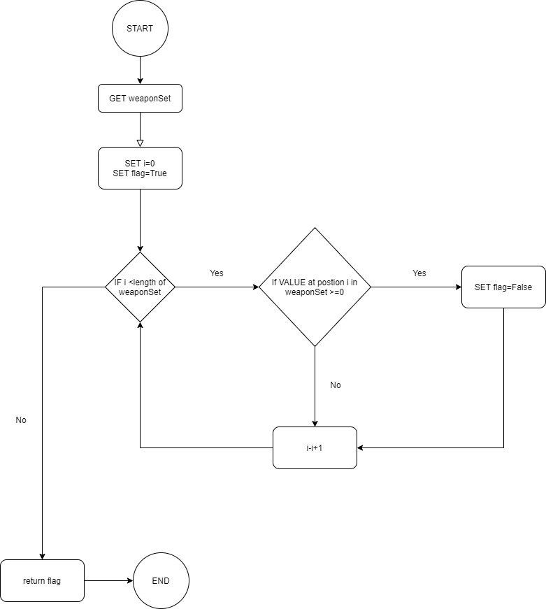

2. def isWinner(weapon,counter): Takes two arguments as weapon and its counter and return True weapon is a winner otherwise False

|  |  |
| --- | --- |
| INPUT | GET weapon  GET counter  SET flag=False |
| PROCESSING | IF weapon==ROCK and counter==SCISSOR THEN  SET flag = True  IF weapon==ROCK and counter==PAPER THEN  SET flag = False  IF weapon==ROCK and counter==DYNAMITE THEN  SET flag = False  IF weapon==PAPER and counter==ROCK THEN  SET flag = True  IF weapon==PAPER and counter==SCISSOR THEN  SET flag = False  IF weapon==PAPER and counter==DYNAMITE THEN  SET flag = False  IF weapon==SCISSOR and counter==PAPER THEN  SET flag = True  IF weapon==SCISSOR and counter==ROCK THEN  SET flag = False  IF weapon==SCISSOR and counter==DYNAMITE THEN  SET flag = True  IF weapon==DYNAMITE and counter==ROCK THEN  SET flag = True  IF weapon==DYNAMITE and counter==PAPER THEN  SET flag = True  IF weapon==DYNAMITE and counter==SCISSOR THEN  SET flag = False  ELSE  SET flag = False  END IF |
| OUTPUT | Return flag |

Flow chart:

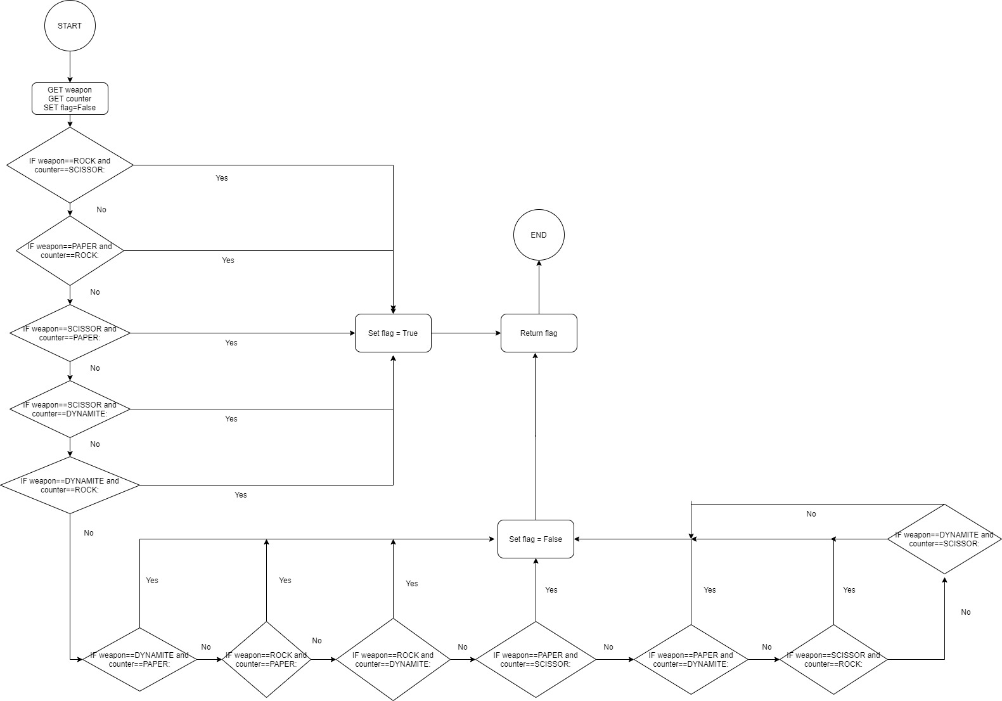

Minor Functions

1. def getWeaponName(weapon): returns a string as the name of the weapon passed

2. defisInt(s): checks if the given string value is integer or not

2. def getInsult(weapon,counter): gets weapon and its counter as arguments and returns a proper victor insult as String.

Pseudo Code of main Game:

|  |  |
| --- | --- |
| INPUT | GET weaponSet quantity  GET difficulty  SET ROCK=0  SET PAPER=1  SET SCISSORS=2  SET DYNAMITE=3  SET weaponSetPlayer=0  SET weaponSetComp=0  SET compWins=0  SET playerWins=0 |
| PROCESSING | IF difficulty = hard THEN  GET answer FROM User TO ADD extra weapon  IF answer = yes  GET extra weapon  ADD extra weapon to weaponSetPlayer  END IF  ADD extra DYNAMITE to weaponSetComp  END IF  PRINT compWins and playerWins  PRINT weaponSetPlayer and weaponSetComp  SET run=True  LOOP WHILE run=True  GET playerMove  DECREMENT playerMove from weaponSetPlayer  GET CompMove  DECREMENT compMove from weaponSetComp  CHECK WINNER by CALLING isWinner for playerMove and compMove  IF isWinner = True THEN  INCREMENT playerWins by 1  END IF  CHECK WINNER by CALLING isWinner for compMove and playerMove  IF isWinner = True THEN  INCREMENT compWins by 1  END IF  IF isWinner = False FOR both playerMoves THEN  IF difficulty = hard THEN  INCREMENTcompWins by 0.5  INCREMENT compMove in weaponSetComp  END IF  IF playerMove NOT EQUALS DYNAMITE THEN  INCREMENT playerMove in weaponSetPlayer  END IF  END IF  IF difficulty = easy THEN  IF playerMove NOT EQUALS DYNAMITE THEN  INCREMENT playerMove in weaponSetPlayer  END IF  IF compMove NOT EQUALS DYNAMITE THEN  INCREMENT compMove in weaponSetcomp  END IF  END IF  CHECK FOR INFINITE PLAY CASE  CHECK IF player or comp IS WINNER  IF player or comp IS WINNER THEN  PRINT winMessage  SET run=False  END IF |
| OUTPUT | PRINT winMessage |

Testing

1.weaponisEmpty

|  |  |
| --- | --- |
| Trace1:  weaponSet=[0,0,1,0]  I=0  Flag=True | Trace2:  weaponSet=[0,0,0,0]  I=0  Flag=True |
| Trace a:  I=0  Flag=True  Trace b:  I=1  Flag=True  Trace c:  I=2  Flag=False  Break  Flag returned | Trace a:  I=0  Flag=True  Trace b:  I=1  Flag=True  Trace c:  I=2  Flag=True  Trace d:  I=3  Flag=True  Flag returned |

2. isWinner

|  |  |  |
| --- | --- | --- |
| Trace1:  Weapon=stone  Counter=scissor  Flag=False | Trace2:  Weapon=scissor  Counter=stone | Trace3:  Weapon=stone  Counter=stone |
| Trace a:  Flag=True  Flag returned | Trace a:  Flag=False  Flag returned | Trace a:  Flag=Flase  Flag returned |

3. Testing Finished Code:

--------------------------- Start-----------------------------

Programming Fundamentals 202110, Harman, 000825162

Do you want to play with 1 or 2 weapon sets?

1 or 2>

Please, enter a valid Positive Integer value.

Do you want to play with 1 or 2 weapon sets?

1 or 2> e

Please, enter a valid Positive Integer value.

Do you want to play with 1 or 2 weapon sets?

1 or 2> 1

Difficulty easy, hard? (type i for more info about game modes)

e, h> e

Player Wins :0.0

Comp Wins :0.0

Weapons Remaining:

Player: Rock: 1 Paper: 1 Scissors: 1 Dynamite: 1

Comp: Rock: 1 Paper: 1 Scissors: 1 Dynamite: 1

Your Move (RPSD)> r

Player uses Rock

Comp uses Scissors

Rock crushed Scissor!

!!!!!!!!!!!!!

!Player Wins!

!!!!!!!!!!!!!

Player Wins :1.0

Comp Wins :0.0

Weapons Remaining:

Player: Rock: 0 Paper: 1 Scissors: 1 Dynamite: 1

Comp: Rock: 1 Paper: 1 Scissors: 0 Dynamite: 1

Your Move (RPSD)> s

Player uses Scissors

Comp uses Rock

Rock crushed Scissor!

!!!!!!!!!!!!

!Comp Wins !

!!!!!!!!!!!!

Player Wins :1.0

Comp Wins :1.0

Weapons Remaining:

Player: Rock: 0 Paper: 1 Scissors: 0 Dynamite: 1

Comp: Rock: 0 Paper: 1 Scissors: 0 Dynamite: 1

Your Move (RPSD)> p

Player uses Paper

Comp uses Paper

Paper cannot harm Paper

!!!!!!!!!!!!

!It's a Tie!

!!!!!!!!!!!!

Player gets new ammunation for Paper

Comp gets new ammunation for Paper

Player Wins :1.0

Comp Wins :1.0

Weapons Remaining:

Player: Rock: 0 Paper: 1 Scissors: 0 Dynamite: 1

Comp: Rock: 0 Paper: 1 Scissors: 0 Dynamite: 1

Your Move (RPSD)> d

Player uses Dynamite

Comp uses Dynamite

Both Dynamites exploded and annihilating each other!

!!!!!!!!!!!!

!It's a Tie!

!!!!!!!!!!!!

Non-Replicable item Dynamite cannot be built again for the player!

Non-Replicable item Dynamite cannot be built again for the Comp!

Same type of Both Weapons remains, Remaining arsenal is Siezed!

Player Wins :1.0

Comp Wins :1.0

Weapons Remaining:

Player: Rock: 0 Paper: 0 Scissors: 0 Dynamite: 0

Comp: Rock: 0 Paper: 0 Scissors: 0 Dynamite: 0

Game Over:

----------------------------------------------------------------

Both Players fought Fiercely, The Battle has resulted in Tie!

----------------------------------------------------------------

Thank You for Playing!

Discussion:

1. Organizing code:

RSPD utilizes various functions to provide seamless and smooth gaming experience.

It uses functions like weaponSetisEmpty to know if the weaponSet of a player is empty, winner of a Round is decided by calling the isWinner function that outputs true if the player win the round otherwise False. GetWeaponName helps to generate output messages when using weapons.

getInsult is used generate proper taunts when one player beats the other and therefore outputs it on the console.

Hardmode Boolean variable is used to switch between easy mode and hard mode when playing the game.

Scores and remaining weapons are printed in sequence in each round and before checking the overall winner of the game.

Overall winner is decided by a simple if elif statements and is checked after every end of the round

Infinite play is detected before checking for overall winner to ensure that game does not go indefinitely when the same type of weapon is left (As According to the rule of RSPD , Tie will result in giving the players their weapons back(except for dynamite), if same kind of weapons is left at the end then the round will always result in a tie and both players will get their weapons back and game continue infinitely ).

Victor is declared by ending the overall game and printing the victor’s name

2.Explaining Hard Mode:

Hard mode implements two extra rules to the game:

1.) Computer begins with one extra Dynamite and Comp's dynamite can be replicated on Tie. Player can choose 1 additional ammunition to add to it's current weapon loadout except Scissors.

2.) Tie will result in player loss (comp will gain half point by the RULE: Win by default).

Hard mode puts pressure on player as tie also results in partial player loss and hence losing does not remains the only way to give point to your enemy.

Comp’s dynamite becomes replicable and player will always have less scissor than dynamites . Therefore probability of first loss increases dramatically as a tie with dynamite will not only result in giving your opponent points but also resupply them with more dynamite while you lost your weapon.

To win Hard Mode, player will need to destroy dynamites of the comp and then gain points by using its own dynamite and the additional weapon along with remaining arsenal:

**Player is asked for additional weapon in Hard Mode. What if Player chose not to take the additional weapon, is it Possible to Win?**

Yes, it is possible to win even if the comp has extra weapon. It may seems impossible to win in such situation, as even if you gain every point by using your arsenal, the comp will win by default as it will have one more weapon than the player at the end. However, there is a trick to win the game in such scenario:

To win such a game, player must force the game to the state of infinite Play where same type of weapons remained. The computer will detect the state and will seize all weapons regardless the quantity of that type of weapon. When this happens if player happens to have more points than comp then it will result in a Win.

END