

WEB APP DESIGN AND DEVELOPMENT

GOTIN - FINAL PROJECT DOCUMENT

(SUBMISSION DATE: December 6, 2017)

GUIDED BY :

PROF. MR. ANIRUDHATREYA RAJAGOPALAN

SUBMITTED BY :

* AMAN WANGDE
* RAMYA BALASUBRAMANIAN
* VEENA GOVADA
* PRATIK SHETTY
* GIDEON PINTO
* HEYAO ZHANG
* ZHE LIU
* HARIPRASATH PERIYASAMY

TABLE OF CONTENTS

Introduction………………………………………………..3

User Screens……………………………………………….3

Technologies Used………………………………….……..9

Project Architecture………………………………………10

Conclusion…………………………………………….….11

References…………………………………………….….11

**Introduction:**

Our website is aimed at providing the best job search facilities to job seekers with its ease of use and salient features. Not only is it a portal for job seekers, it also has the provisions for employers to post their jobs. It is built with the cutting-edge technologies and has a great user interface. It has provisions for creating accounts, searching for jobs, applying for jobs as well as posting for jobs. Many a needy job seekers have used our website and had fruitful results by getting the jobs they desire. This website is tailored to help me search for jobs based on their qualifications and preferences. The website also has a great ease of navigation and provides for a visually appealing and easy to use interface.

**User Screens:**

**User Login Page:**

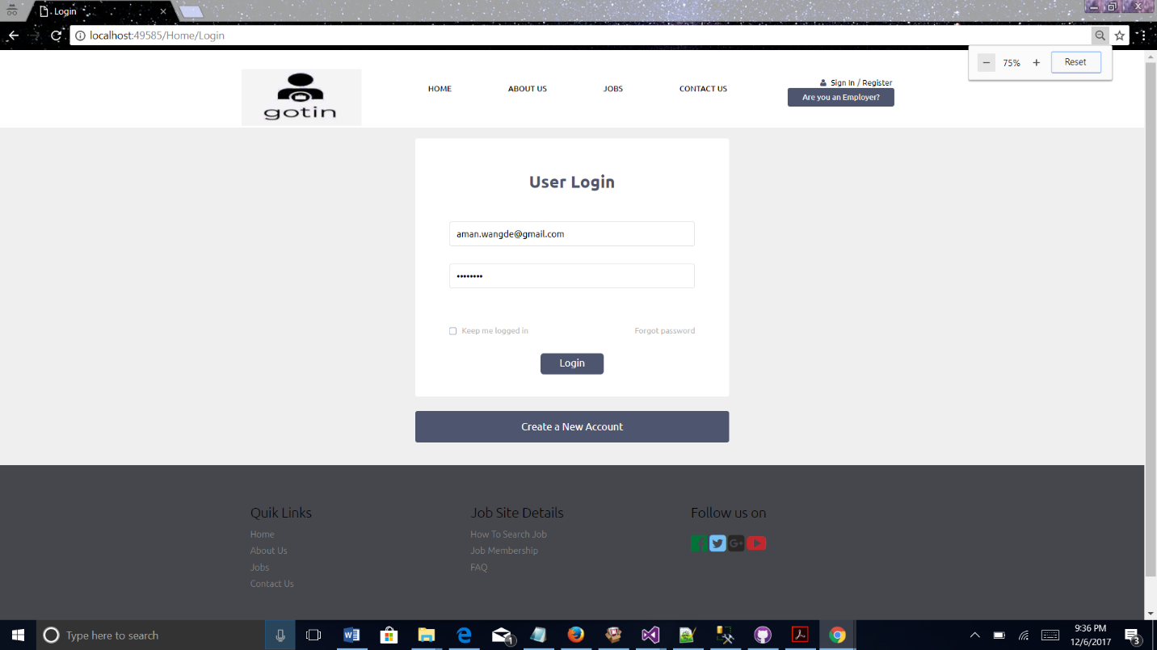

This is the Login page of the project, where users can sign in to their accounts with user ID and password.

Users who don’t have account can sign up through Create New Account button. In this user also has options for forgot password and keep me logged In.

Forgot password useful in the case users didn’t remember their credentials. Keep me logged in is useful for remembering the users every time they visit the page.

**Create Account Page:**

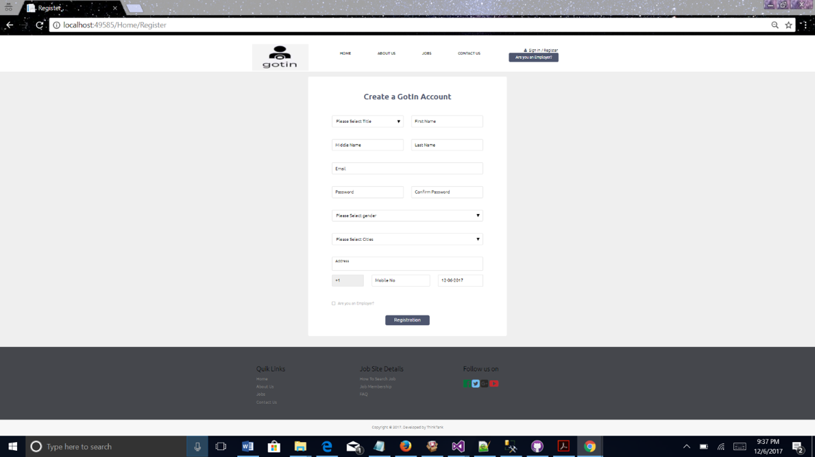

When user doesn’t have the account, they should register in the portal by entering their first, middle, last, available user name(email) and password. This is the same signup form for both the employee and employer. It also has the option for gender and the city in which they want job search. User can provide the address and mobile number to get the nearby job alerts.

**Forgot Password Page:**

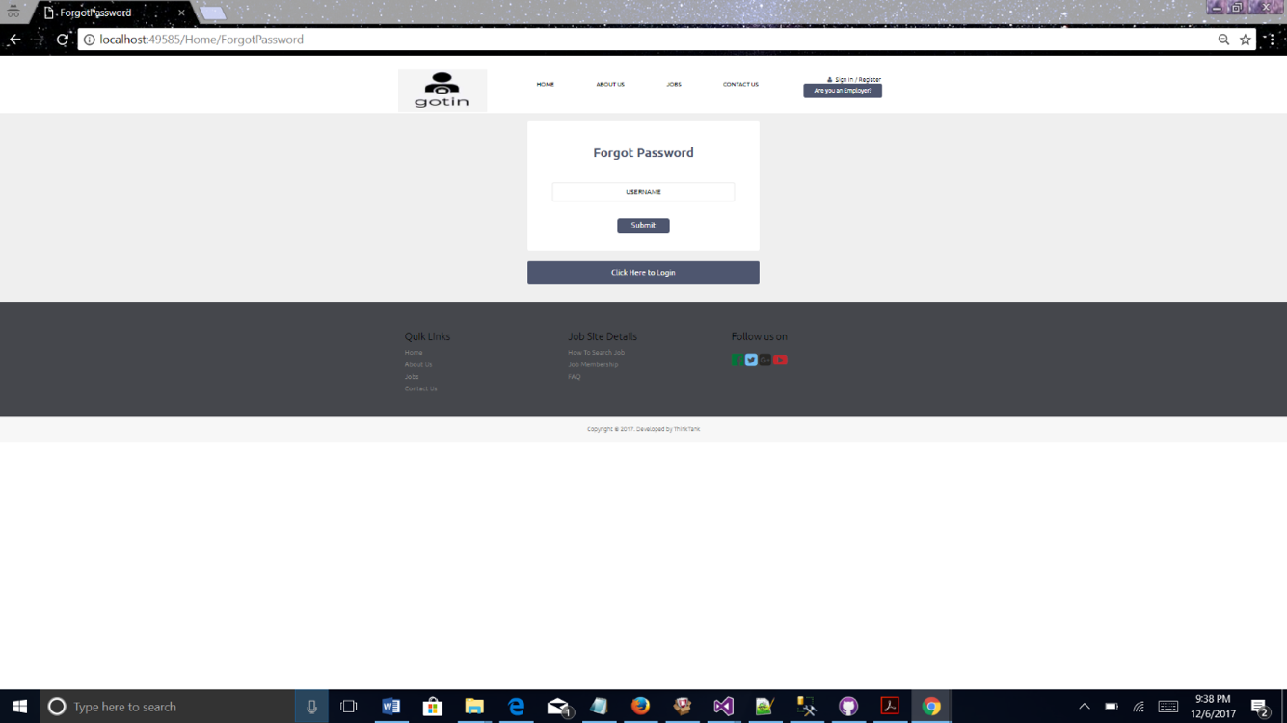

This page is useful for the user in case they forgot their credentials to login. By submitting the username user can get the credentials back through their email.

**Home Page:**

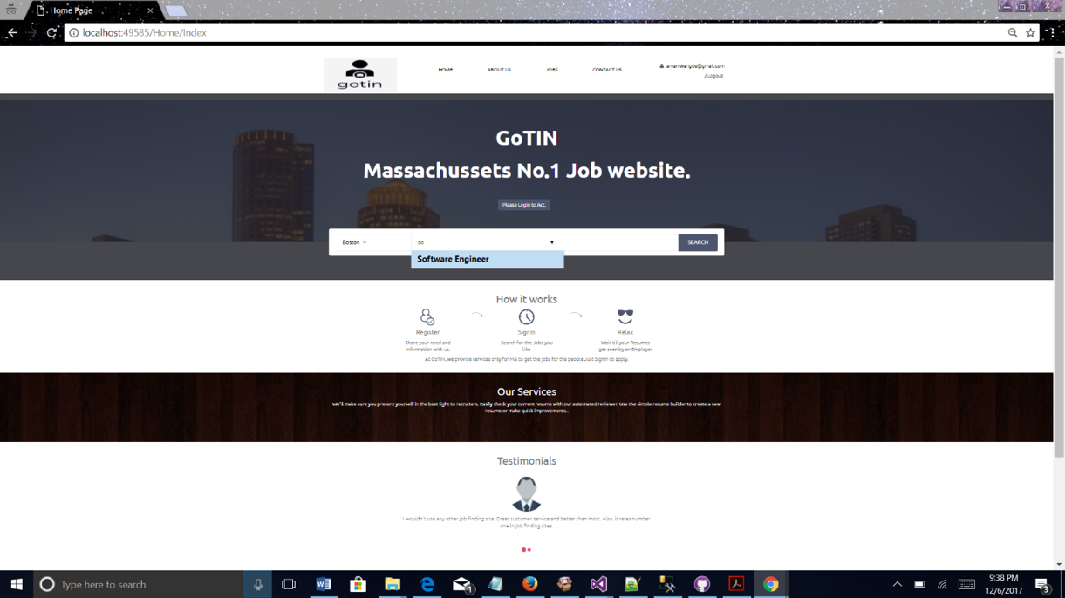

This is the home page of the project. Here user can start their job search by entering the job title/ job role. In home page, they can find the testimonials and the information about the website like how it works. In home page, we also included the information about the services we provide for the user

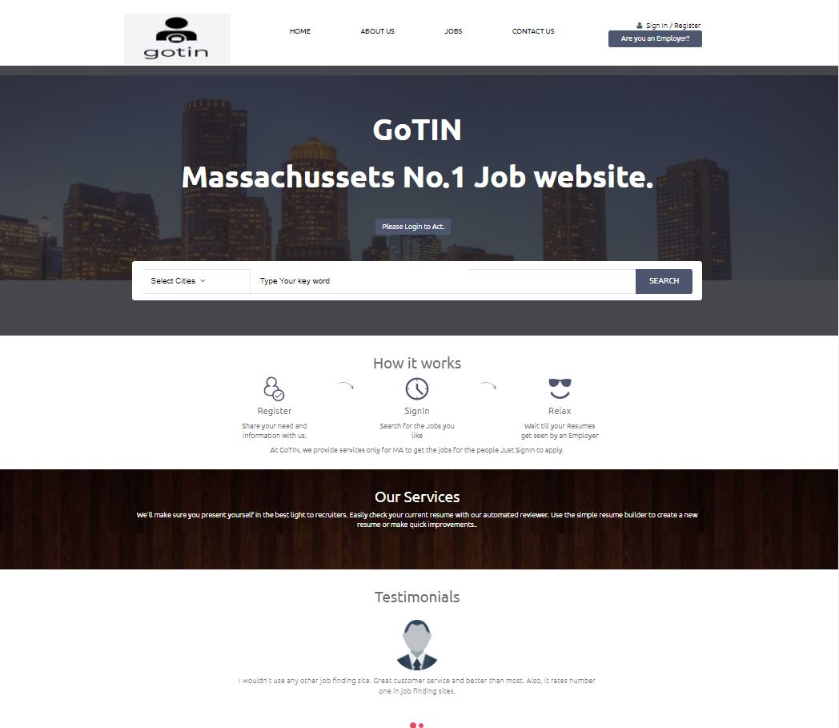

If user didn’t have account, the home gives the register option. For there user can create the account.

**Job listings page:**

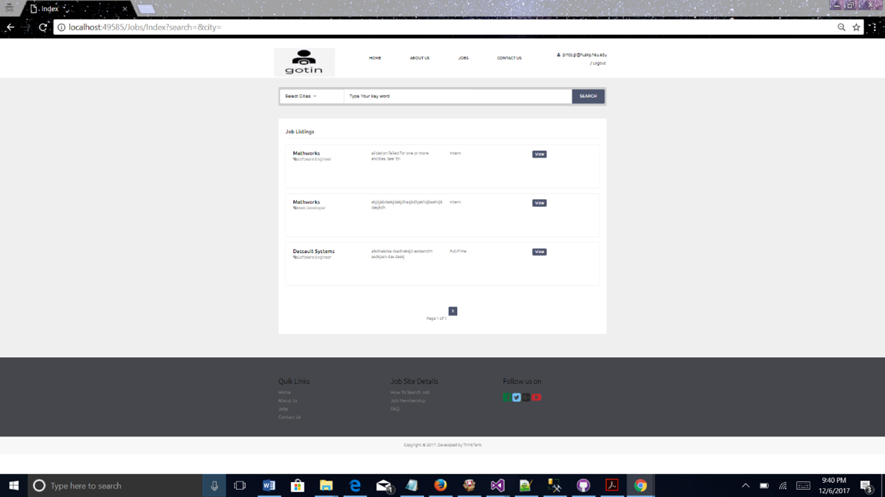

When the user clicks on the search button by entering the city and role, it navigates job listings page where user can find all the available jobs related to the entered jo title. If number are jobs are more job listings will be divide among pages like page1, page 2..etc.

**Details Page:**

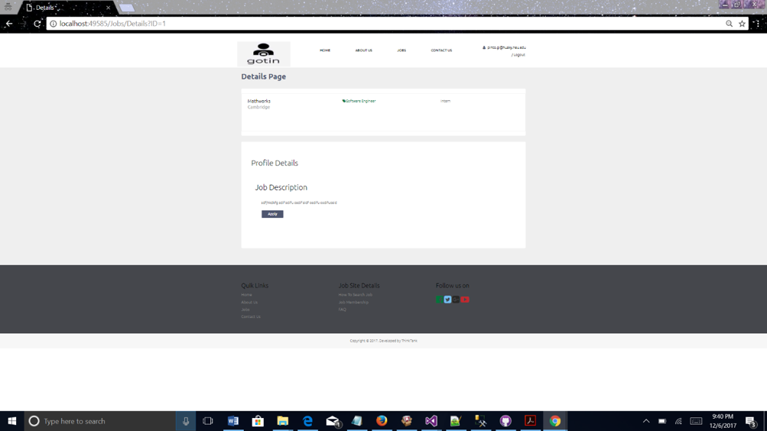

When user clicks on view button in Job listings page, it takes to details page of the selected job. There user can see detailed description of the job with Apply button. Apply button is for applying for selected job.

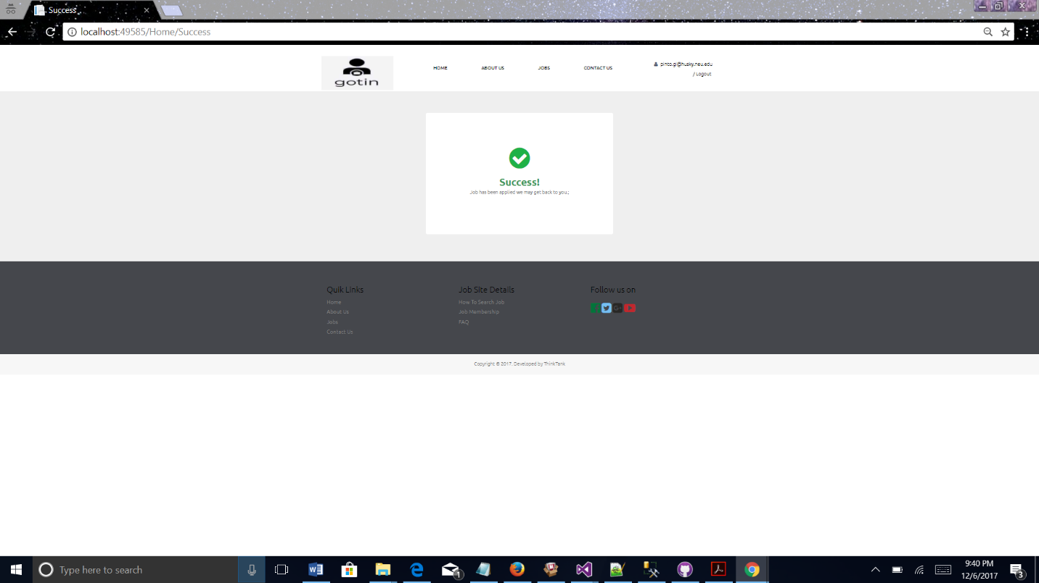

Once user is done with the on application of the job, it gives the success message saying that your application successfully submitted.

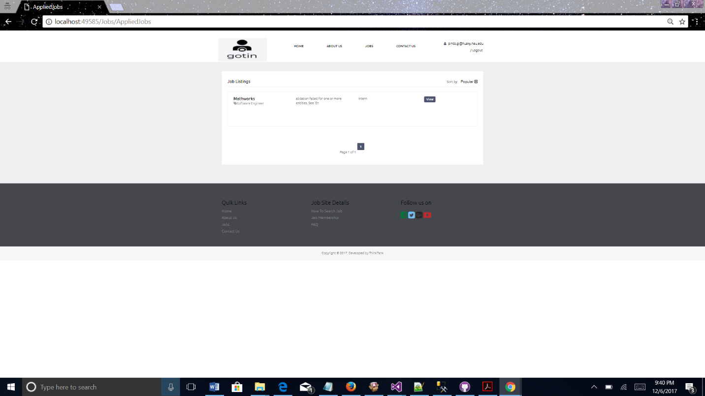

Even in our website user can sort the jobs in the resulted job search by its popularity.

**About us page:**

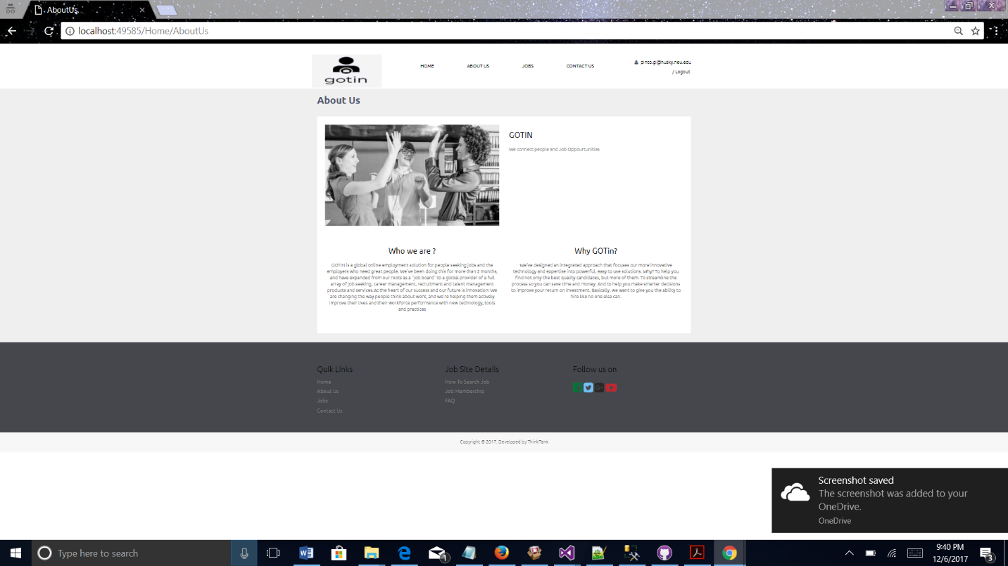

About us page explains about the GOTin job search website. Uses and benefits of GOTin and How it works.

**Contact Us page:**

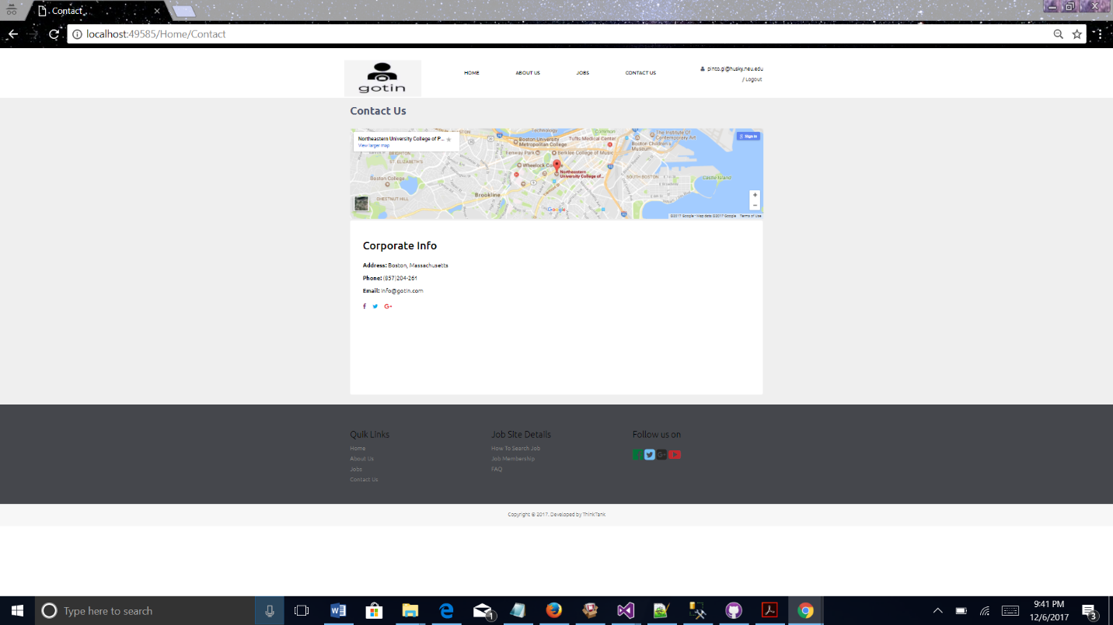

This page gives useful information for contacting the GOTin. Organizations can contact the GOTin personally to advertise about the company as well as about their job opening in the organization.

**Job Posting Page:**

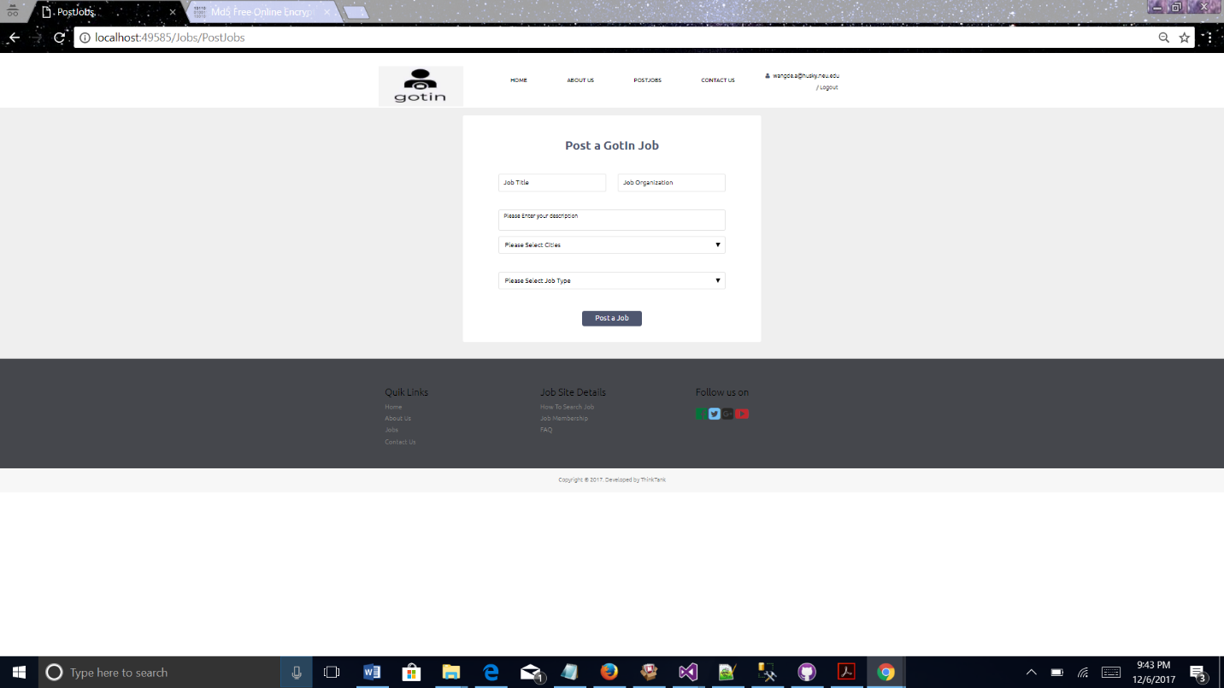

Employer can post the job opening in their company. They must provide the details like job title, organization, city and Job type. For job posting, employer should register with GOTin by selecting the check box for employer in the create account page.

**Technologies Used:**

The entire GOTin web application is developed with the help of following Technologies

* Client Side – HTML, CSS , JavaScript including frameworks like jQuery, Bootstrap.
* Server side - .NET MVC 4
* Database – SQL Server.

**Project Architecture:**

The Model-View-Controller patters divides the application into three main components: the model, the view and the controller. The MVC framework is defined in the **System.Web.Mvc** assembly.

We have used the MVC framework in our application: The framework includes the following three components:

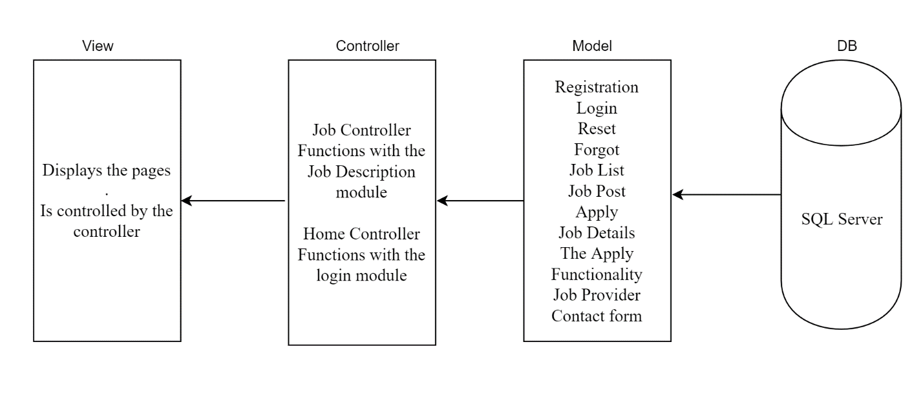

MVC Architecture of GOTIN

**Models:** Models are those parts of the application that possess the logic for the application’s data domain. In our application, the model is more like a conceptual separation. The application reads a dataset and send it to the view.

On our website, the user can register, login, reset password, request a new password, search for a job and apply for a job from the listings available. If you are an Employer, you will be redirected to a different page where you can post a job listing which will be reflected on the website.

**View:** Views are those components that displays the application’s user interface. Typically, this is created using the model’s data. The application user interface contains the search functionality through which the user can search for jobs and apply for one from the available listings.

**Controllers:** Controllers are the components that handle the user interaction and work with the model and ultimately select a view to render that displays UI. In our application, the view only displays information; the controller handles and responds to user input and interaction. For example, the controller handles query string values and passes these values to the model, which in turn might use these values to query the database.

**Database:**

Our application provides the user credentials to the SQL Server.

The Entity Framework is to generate a model that is made of three distinct pieces:

**The Conceptual Layer** is the object-oriented representation of the database. Our application uses .NET classes to query the data and perform inserts, updates and deletes.

The storage layer represents the underlying database i.e. the tables, views, primary keys, foreign keys, stored procedures etc.

The Conceptual layer is joined to the Storage layer using **the Mapping Layer.**

**Conclusion:**

Thus, as seen, the various features that are provided and the ease with which the user can manoeuvre through the website make GOTIN an ultimate solution for job search. It provides for the search for a variety of jobs based on different skillsets and caters to a large audience. The number of jobs posted on the site are also very large and are posted by employers of small, medium and large sized firms. This makes it a one stop destination for all those seeking jobs.

**Code Repository:**

The link for code repository is given below:

<https://github.com/Thinktankwebdev/GOTIN/tree/master/ThinkTankJobApp>

**Reference:**

* NA(December,2017) Indeed online job portal Retrieved from <https://www.indeed.com/>
* NA(December,2017) Monster Jobs Retrieved from <https://www.monster.com/>
* NA(December,2017) NU Careers Retrieved from <https://nucareers.northeastern.edu/notLoggedIn.htm>