

《编译系统设计实践》

实验项目二：LR(1) 语法分析程序实验

学号： 102300404
姓名： 胡跃
年级： 2023
学院：计算机与大数据
专业： 软件工程

本组其它成员：学号 102300403 姓名 朱茜茜
学号 102300405 姓名 杨雅婷
学号 102300406 姓名 叶芷

实验时间：2025－2026学年第二学期
任课教师：陈晖

一、实验目的与任务
根据课程文法编制 LR(1) 分析程序，对输入符号串自下而上分析；输出 LR(1) 分析表与分析过程中的状态栈、符号栈、剩余输入与动作（对应教材图 4-36、4-38）。
文法中 bool 在工程中记为 boolExpr。实现包：edu.groupname.compiler.parser 与 grammar。

二、功能描述
- 输出语法分析表：ACTION(状态, 终端符)=移进/s/规约，GOTO(状态, 非终端符)=状态；格式参考教材图 4-38。
- 输出分析过程：每步“状态栈 | 符号栈 | 剩余输入 | 动作”（ParseReporter.formatStep）。
- 分析成功时 accepted=true；无动作项时记录 SyntaxError并 accepted=false。
- 分析表静态构造；对 else 的移进/规约冲突按悬空 else 优先移进。
- ExperimentDemo 输出「实验二：LR(1) 语法分析」小节。

三、程序结构描述

3.1 函数/方法说明
类 | 函数原型 | 参数含义 | 返回值 | 功能
Parser | ParserResult parse(List<Token> tokens) | tokens：词法 Token 序列 | ParserResult | 语法分析接口
LR1Parser | ParserResult parse(List<Token> tokens) | stateStack、symbolStack、cursor | accepted、trace、errors | LR(1) 驱动分析
LR1Parser | static ParsingTable buildParsingTableForGrammar(Grammar g) | 课程文法 | ParsingTable | 构造 ACTION/GOTO
LR1Parser | Set<LR1Item> closure(...) | FIRST集、项目核 | 闭包项目集 | LR(1) 闭包
LR1Parser | Set<LR1Item> goTo(...) | 状态、文法符号 | GOTO 项目集 | 状态转移
ParsingTable | ActionEntry getAction(int state, String terminal) | 状态、终结符 | ActionEntry | 查移进/规约/接受
ParsingTable | GotoEntry getGoto(int state, String nonTerminal) | 状态、非终结符 | GotoEntry | 规约后 GOTO
ParseReporter | List<String> formatTrace(List<ParseTraceStep>) | trace 列表 | List<String> | 分析栈输出
Grammar | static Grammar defaultLabGrammar() | 无 | Grammar | 实验文法
ExperimentDemo | void printReport(...) | parserResult | void | 打印分析表与 trace

3.2 函数调用关系图
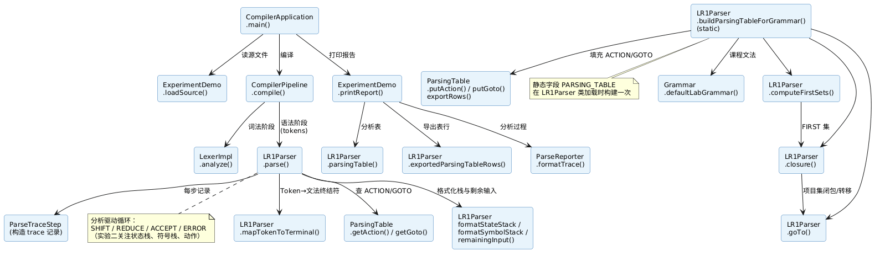
图1 LR(1) 语法分析模块函数调用关系图

3.3 程序总体执行流程图
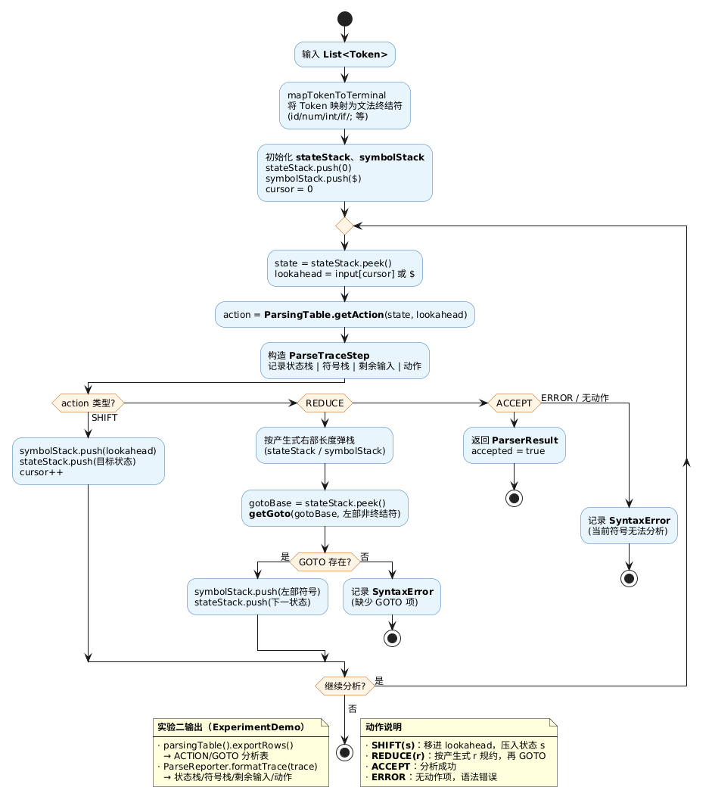
图2 LR1Parser.parse 总体执行流程图

四、LR(1) 分析表与栈结构设计

4.1 ParsingTable
- ACTION 键 (state, terminal)，值 SHIFT(s)/REDUCE(r)/ACCEPT/ERROR。
- GOTO 键 (state, nonTerminal)，值为规约后状态号。
- exportRows() 导出为 ACTION(...)=... / GOTO(...)=... 文本行。

4.2 分析栈与 ParseTraceStep
结构 | 含义 | 示例
stateStack | 状态号栈 | [0, 3, 4, 5]
symbolStack | 文法符号栈 | [$, {, decls, stmts]
剩余输入 | 未读终结符 | id = num ; } $
动作 | ACTION 显示 | s22 / r4 / err

输出格式与教材图 4-38 一致。

五、LR(1) 算法概要
- FIRST集：computeFirstSets() 迭代求解。
- 项目集：closure、goTo；buildParsingTableForGrammar 填 ACTION/GOTO。
- 分析：getAction 执行 shift/reduce/accept/error。

六、程序关键源代码
以下摘自工程 parser、grammar 包，行号与仓库一致。

6.1 LR1Parser.parse
public ParserResult parse(List<Token> tokens) {
List<ParseTraceStep> trace = new ArrayList<>();
List<CompileError> errors = new ArrayList<>();
List<Integer> reduced = new ArrayList<>();
List<String> semanticActions = new ArrayList<>();
List<Quadruple> quadruples = new ArrayList<>();
SemanticContext semanticContext = new SemanticContext();

List<String> input = tokens.stream().map(this::mapTokenToTerminal).toList();
int cursor = 0;

Deque<Integer> stateStack = new ArrayDeque<>();
Deque<String> symbolStack = new ArrayDeque<>();
Deque<SemanticAttribute> valueStack = new ArrayDeque<>();
stateStack.push(0);
symbolStack.push(END_MARKER);
valueStack.push(SemanticAttribute.empty());
while (true) {
int state = stateStack.peek();
String lookahead = cursor < input.size() ? input.get(cursor) : END_MARKER;
ActionEntry action = parsingTable.getAction(state, lookahead);
String actionLabel = action.display();
trace.add(new ParseTraceStep(
formatStateStack(stateStack),
formatSymbolStack(symbolStack),
remainingInput(input, cursor),
actionLabel
));
if (action.type() == ActionEntry.ActionType.SHIFT) {
if ("{".equals(lookahead)) {
semanticContext.enterScope();
semanticActions.add("ENTER_SCOPE");
}
if ("}".equals(lookahead)) {
semanticContext.exitScope();
semanticActions.add("EXIT_SCOPE");
}
if ("while".equals(lookahead) || "do".equals(lookahead)) {
semanticContext.ir().pushBreakTarget(semanticContext.ir().freshLabel());
}
symbolStack.push(lookahead);
if (END_MARKER.equals(lookahead)) {
valueStack.push(SemanticAttribute.empty());
} else {
Token shifted = tokens.get(cursor);
valueStack.push(SemanticAttribute.fromShift(shifted, lookahead));
}
stateStack.push(action.target());
cursor++;
continue;
}
if (action.type() == ActionEntry.ActionType.REDUCE) {
int productionIndex = action.target();
if (productionIndex < 0 || productionIndex >= grammar.productions().size()) {
SourcePosition pos = cursor < tokens.size() ? tokens.get(cursor).position() : SourcePosition.UNKNOWN;
errors.add(new SyntaxError("规约产生式索引非法: r" + productionIndex, pos));
return new ParserResult(false, trace, errors, reduced, semanticActions, quadruples);
}
Production p = grammar.productions().get(productionIndex);
List<SemanticAttribute> rhsAttributes = new ArrayList<>();
for (int i = 0; i < p.right().size(); i++) {
if (!symbolStack.isEmpty()) {
symbolStack.pop();
}
if (!valueStack.isEmpty()) {
rhsAttributes.add(valueStack.pop());
}
if (stateStack.size() > 1) {
stateStack.pop();
}
}
Collections.reverse(rhsAttributes);
SemanticReduceHandler.ReduceOutcome outcome =
SemanticReduceHandler.reduce(productionIndex, rhsAttributes, semanticContext);
semanticActions.addAll(outcome.actions());
if (productionIndex == 0) {
quadruples = new ArrayList<>(outcome.attribute().code());
}
int gotoBase = stateStack.peek();
GotoEntry gotoEntry = parsingTable.getGoto(gotoBase, p.left());
if (gotoEntry == null) {
SourcePosition pos = cursor < tokens.size() ? tokens.get(cursor).position() : SourcePosition.UNKNOWN;
errors.add(new SyntaxError(
"缺少 GOTO 项: (" + gotoBase + ", " + p.left() + ")",
pos
));
return new ParserResult(false, trace, errors, reduced, semanticActions, quadruples);
}
symbolStack.push(p.left());
valueStack.push(outcome.attribute());
stateStack.push(gotoEntry.nextState());
reduced.add(productionIndex);
continue;
}
if (action.type() == ActionEntry.ActionType.ACCEPT) {
return new ParserResult(true, trace, List.of(), reduced, semanticActions, quadruples);
}
SourcePosition pos = cursor < tokens.size() ? tokens.get(cursor).position() : SourcePosition.UNKNOWN;
errors.add(new SyntaxError("语法错误，当前符号: " + lookahead, pos));
return new ParserResult(false, trace, errors, reduced, semanticActions, quadruples);
}

6.2 buildParsingTableForGrammar
private static ParsingTable buildParsingTableForGrammar(Grammar grammar) {
LR1Parser builder = new LR1Parser(grammar);
ParsingTable table = new ParsingTable();
Map<String, Set<String>> first = builder.computeFirstSets();

Set<LR1Item> startState = builder.closure(Set.of(new LR1Item(-1, 0, END_MARKER)), first);
List<Set<LR1Item>> states = new ArrayList<>();
Map<Set<LR1Item>, Integer> stateIds = new LinkedHashMap<>();
Map<String, Integer> transitions = new HashMap<>();
states.add(startState);
stateIds.put(startState, 0);

for (int i = 0; i < states.size(); i++) {
Set<LR1Item> state = states.get(i);
for (String symbol : grammar.symbols()) {
Set<LR1Item> next = builder.goTo(state, symbol, first);
if (next.isEmpty()) {
continue;
}
Integer id = stateIds.get(next);
if (id == null) {
id = states.size();
states.add(next);
stateIds.put(next, id);
}
transitions.put(i + "::" + symbol, id);
}
}

for (int i = 0; i < states.size(); i++) {
Set<LR1Item> state = states.get(i);
for (LR1Item item : state) {
if (item.productionIndex() == -1 && item.dotPosition() == 1 && END_MARKER.equals(item.lookahead())) {
table.putAction(i, END_MARKER, ActionEntry.accept());
continue;
}
Production production = item.productionIndex() == -1
? new Production(AUGMENTED_START, List.of(grammar.startSymbol()))
: grammar.productions().get(item.productionIndex());
if (item.dotPosition() < production.right().size()) {
String nextSymbol = production.right().get(item.dotPosition());
Integer target = transitions.get(i + "::" + nextSymbol);
if (target == null) {
continue;
}
if (grammar.terminals().contains(nextSymbol)) {
table.putAction(i, nextSymbol, ActionEntry.shift(target));
} else if (grammar.nonTerminals().contains(nextSymbol)) {
table.putGoto(i, nextSymbol, new GotoEntry(target));
}
} else if (item.productionIndex() >= 0) {
table.putAction(i, item.lookahead(), ActionEntry.reduce(item.productionIndex()));
}
}
}
return table;

6.3 closure / goTo
private Set<LR1Item> closure(Set<LR1Item> kernel, Map<String, Set<String>> first) {
Set<LR1Item> closure = new LinkedHashSet<>(kernel);
boolean changed = true;
while (changed) {
changed = false;
Set<LR1Item> snapshot = new LinkedHashSet<>(closure);
for (LR1Item item : snapshot) {
Production p = productionOf(item.productionIndex());
if (item.dotPosition() >= p.right().size()) {
continue;
}
String next = p.right().get(item.dotPosition());
if (!grammar.nonTerminals().contains(next)) {
continue;
}
List<String> beta = new ArrayList<>();
for (int i = item.dotPosition() + 1; i < p.right().size(); i++) {
beta.add(p.right().get(i));
}
beta.add(item.lookahead());
Set<String> lookaheads = firstOfSequence(beta, first);
for (int pi = 0; pi < grammar.productions().size(); pi++) {
Production candidate = grammar.productions().get(pi);
if (!candidate.left().equals(next)) {
continue;
}
for (String la : lookaheads) {
if (EPSILON.equals(la)) {
continue;
}
LR1Item newItem = new LR1Item(pi, 0, la);
if (closure.add(newItem)) {
changed = true;
}
}
}
}
}
return closure;
}

private Set<LR1Item> goTo(Set<LR1Item> state, String symbol, Map<String, Set<String>> first) {
Set<LR1Item> moved = new LinkedHashSet<>();
for (LR1Item item : state) {
Production p = productionOf(item.productionIndex());
if (item.dotPosition() < p.right().size() && symbol.equals(p.right().get(item.dotPosition()))) {
moved.add(new LR1Item(item.productionIndex(), item.dotPosition() + 1, item.lookahead()));
}
}
if (moved.isEmpty()) {
return Set.of();
}
return closure(moved, first);
}

6.4 ParsingTable
public void putAction(int state, String terminal, ActionEntry entry) {
String mapKey = key(state, terminal);
ActionEntry existing = action.get(mapKey);
if (existing != null && !existing.equals(entry)) {
ActionEntry resolved = resolveShiftReduceConflict(terminal, existing, entry);
if (resolved != null) {
action.put(mapKey, resolved);
return;
}
conflicts.put(mapKey, existing.display() + " -> " + entry.display());
}
action.put(mapKey, entry);
}

/**
* 悬空 else：对 lookahead 为 else 的 shift/reduce 冲突，优先移进（绑定最近 if）。
*/
private static ActionEntry resolveShiftReduceConflict(String terminal, ActionEntry existing, ActionEntry incoming) {
if (!"else".equals(terminal)) {
return null;
}
boolean existingShift = existing.type() == ActionEntry.ActionType.SHIFT;
boolean incomingShift = incoming.type() == ActionEntry.ActionType.SHIFT;
if (existingShift && !incomingShift) {
return existing;
}
if (incomingShift && !existingShift) {
return incoming;
}
return null;
}

6.5 Grammar.defaultLabGrammar
public static Grammar defaultLabGrammar() {
Set<String> terminals = Set.of(
"{", "}", "(", ")", "[", "]", ";",
"id", "num", "real", "true", "false",
"if", "else", "while", "do", "break",
"int", "float", "bool",
"=", "||", "&&", "==", "!=", "<", "<=", ">=", ">", "+", "-", "*", "/", "!",
"$"
);
Set<String> nonTerminals = Set.of(
"program", "block", "decls", "decl", "type", "basic", "stmts", "stmt",
"loc", "boolExpr", "join", "equality", "rel", "expr", "term", "unary", "factor"
);
List<Production> productions = List.of(
Production.of("program", "block"),
Production.of("block", "{", "decls", "stmts", "}"),
Production.of("decls", "decls", "decl"),
Production.of("decls"),
Production.of("decl", "type", "id", ";"),
Production.of("type", "type", "[", "num", "]"),
Production.of("type", "basic"),
Production.of("basic", "int"),
Production.of("basic", "float"),
Production.of("basic", "bool"),
Production.of("stmts", "stmts", "stmt"),
Production.of("stmts"),
Production.of("stmt", "loc", "=", "boolExpr", ";"),
Production.of("stmt", "if", "(", "boolExpr", ")", "stmt"),
Production.of("stmt", "if", "(", "boolExpr", ")", "stmt", "else", "stmt"),
Production.of("stmt", "while", "(", "boolExpr", ")", "stmt"),
Production.of("stmt", "do", "stmt", "while", "(", "boolExpr", ")", ";"),
Production.of("stmt", "break", ";"),
Production.of("stmt", "block"),
Production.of("loc", "loc", "[", "boolExpr", "]"),
Production.of("loc", "id"),
Production.of("boolExpr", "boolExpr", "||", "join"),
Production.of("boolExpr", "join"),
Production.of("join", "join", "&&", "equality"),
Production.of("join", "equality"),
Production.of("equality", "equality", "==", "rel"),
Production.of("equality", "equality", "!=", "rel"),
Production.of("equality", "rel"),
Production.of("rel", "expr", "<", "expr"),
Production.of("rel", "expr", "<=", "expr"),
Production.of("rel", "expr", ">=", "expr"),
Production.of("rel", "expr", ">", "expr"),
Production.of("rel", "expr"),
Production.of("expr", "expr", "+", "term"),
Production.of("expr", "expr", "-", "term"),
Production.of("expr", "term"),
Production.of("term", "term", "*", "unary"),
Production.of("term", "term", "/", "unary"),
Production.of("term", "unary"),
Production.of("unary", "!", "unary"),
Production.of("unary", "-", "unary"),
Production.of("unary", "factor"),
Production.of("factor", "(", "boolExpr", ")"),
Production.of("factor", "loc"),
Production.of("factor", "num"),
Production.of("factor", "real"),
Production.of("factor", "true"),
Production.of("factor", "false")
);

6.6 ParseReporter
public static List<String> formatTrace(List<ParseTraceStep> trace) {
return trace.stream()
.map(ParseReporter::formatStep)
.collect(Collectors.toList());
}

public static String formatStep(ParseTraceStep step) {
return String.format(
"状态栈=%s | 符号栈=%s | 剩余输入=%s | 动作=%s",
step.stateStack(),
step.symbolStack(),
step.input(),
step.action()
);

七、测试数据与运行结果（≥3 组）
来自 docs/test-output/*.txt「实验二」章节（scripts/export-test-outputs.ps1 导出），与控制台一致。

测试组 1：基础声明（sample1_basic）
输入（samples/sample1_basic.src）：
{ int a; a = 1; }
语法分析表（节选 ACTION）：
（ACTION 2579 项，GOTO 612 项；格式：KIND(状态, 符号)=动作）
ACTION(0, {) = s3
ACTION(100, break) = s18
ACTION(100, do) = s21
ACTION(100, id) = s20
ACTION(100, if) = s19
ACTION(100, while) = s17
ACTION(100, {) = s23
ACTION(100, }) = s159
ACTION(101, !) = s52
ACTION(101, () = s50
ACTION(101, -) = s57
ACTION(101, false) = s55
分析过程（前段 … 末段）：
状态栈=[0] | 符号栈=[$] | 剩余输入={ int id ; id = num ; } $ | 动作=s3
状态栈=[0, 3] | 符号栈=[$, {] | 剩余输入=int id ; id = num ; } $ | 动作=r3
状态栈=[0, 3, 4] | 符号栈=[$, {, decls] | 剩余输入=int id ; id = num ; } $ | 动作=s10
状态栈=[0, 3, 4, 10] | 符号栈=[$, {, decls, int] | 剩余输入=id ; id = num ; } $ | 动作=r7
状态栈=[0, 3, 4, 5] | 符号栈=[$, {, decls, basic] | 剩余输入=id ; id = num ; } $ | 动作=r6
状态栈=[0, 3, 4, 6] | 符号栈=[$, {, decls, type] | 剩余输入=id ; id = num ; } $ | 动作=s13
...
状态栈=[0, 3, 4, 7, 22] | 符号栈=[$, {, decls, stmts, }] | 剩余输入=$ | 动作=r1
状态栈=[0, 1] | 符号栈=[$, block] | 剩余输入=$ | 动作=r0
状态栈=[0, 2] | 符号栈=[$, program] | 剩余输入=$ | 动作=acc
分析结果：accepted = true

测试组 2：if-else（sample2_if_else）
输入（samples/sample2_if_else.src）：
{
int x;
if (x >= 0) x = x + 1;
else x = 0;
}
语法分析表（节选 ACTION）：
（ACTION 2579 项，GOTO 612 项；格式：KIND(状态, 符号)=动作）
ACTION(0, {) = s3
ACTION(100, [) = r5
ACTION(100, id) = r5
ACTION(101, !) = s70
ACTION(101, () = s72
ACTION(101, -) = s73
ACTION(101, false) = s67
ACTION(101, id) = s68
ACTION(101, num) = s71
ACTION(101, real) = s66
ACTION(101, true) = s69
ACTION(102, !) = s53
分析过程（前段 … 末段）：
状态栈=[0] | 符号栈=[$] | 剩余输入={ int id ; if ( id >= num ) id = id + num ; else id = num ; } $ | 动作=s3
状态栈=[0, 3] | 符号栈=[$, {] | 剩余输入=int id ; if ( id >= num ) id = id + num ; else id = num ; } $ | 动作=r3
状态栈=[0, 3, 4] | 符号栈=[$, {, decls] | 剩余输入=int id ; if ( id >= num ) id = id + num ; else id = num ; } $ | 动作=s10
状态栈=[0, 3, 4, 10] | 符号栈=[$, {, decls, int] | 剩余输入=id ; if ( id >= num ) id = id + num ; else id = num ; } $ | 动作=r7
状态栈=[0, 3, 4, 8] | 符号栈=[$, {, decls, basic] | 剩余输入=id ; if ( id >= num ) id = id + num ; else id = num ; } $ | 动作=r6
状态栈=[0, 3, 4, 7] | 符号栈=[$, {, decls, type] | 剩余输入=id ; if ( id >= num ) id = id + num ; else id = num ; } $ | 动作=s22
...
状态栈=[0, 3, 4, 6, 16] | 符号栈=[$, {, decls, stmts, }] | 剩余输入=$ | 动作=r1
状态栈=[0, 2] | 符号栈=[$, block] | 剩余输入=$ | 动作=r0
状态栈=[0, 1] | 符号栈=[$, program] | 剩余输入=$ | 动作=acc
分析结果：accepted = true

测试组 3：while / do-while（sample3_loop）
输入（samples/sample3_loop.src）：
{
int i;
i = 0;
while (i < 5) i = i + 1;
do i = i - 1; while (i > 0);
}
语法分析表（节选 ACTION）：
（ACTION 2579 项，GOTO 612 项；格式：KIND(状态, 符号)=动作）
ACTION(0, {) = s3
ACTION(100, [) = r5
ACTION(100, id) = r5
ACTION(101, break) = r12
ACTION(101, do) = r12
ACTION(101, id) = r12
ACTION(101, if) = r12
ACTION(101, while) = r12
ACTION(101, {) = r12
ACTION(101, }) = r12
ACTION(102, !) = s53
ACTION(102, () = s55
分析过程（前段 … 末段）：
状态栈=[0] | 符号栈=[$] | 剩余输入={ int id ; id = num ; while ( id < num ) id = id + num ; do id = id - num ; while ( id > num ) ; } $ | 动作=s3
状态栈=[0, 3] | 符号栈=[$, {] | 剩余输入=int id ; id = num ; while ( id < num ) id = id + num ; do id = id - num ; while ( id > num ) ; } $ | 动作=r3
状态栈=[0, 3, 4] | 符号栈=[$, {, decls] | 剩余输入=int id ; id = num ; while ( id < num ) id = id + num ; do id = id - num ; while ( id > num ) ; } $ | 动作=s9
状态栈=[0, 3, 4, 9] | 符号栈=[$, {, decls, int] | 剩余输入=id ; id = num ; while ( id < num ) id = id + num ; do id = id - num ; while ( id > num ) ; } $ | 动作=r7
状态栈=[0, 3, 4, 7] | 符号栈=[$, {, decls, basic] | 剩余输入=id ; id = num ; while ( id < num ) id = id + num ; do id = id - num ; while ( id > num ) ; } $ | 动作=r6
状态栈=[0, 3, 4, 6] | 符号栈=[$, {, decls, type] | 剩余输入=id ; id = num ; while ( id < num ) id = id + num ; do id = id - num ; while ( id > num ) ; } $ | 动作=s22
...
状态栈=[0, 3, 4, 5, 21] | 符号栈=[$, {, decls, stmts, }] | 剩余输入=$ | 动作=r1
状态栈=[0, 2] | 符号栈=[$, block] | 剩余输入=$ | 动作=r0
状态栈=[0, 1] | 符号栈=[$, program] | 剩余输入=$ | 动作=acc
分析结果：accepted = true

测试组 4：语法错误
输入：{ int a; } }
分析过程（末几步）：
状态栈=[0, 3, 4, 6, 22, 38] | 符号栈=[$, {, decls, type, id, ;] | 剩余输入=} } $ | 动作=r4
状态栈=[0, 3, 4, 8] | 符号栈=[$, {, decls, decl] | 剩余输入=} } $ | 动作=r2
状态栈=[0, 3, 4] | 符号栈=[$, {, decls] | 剩余输入=} } $ | 动作=r11
状态栈=[0, 3, 4, 5] | 符号栈=[$, {, decls, stmts] | 剩余输入=} } $ | 动作=s21
状态栈=[0, 3, 4, 5, 21] | 符号栈=[$, {, decls, stmts, }] | 剩余输入=} $ | 动作=err
分析结果：
accepted = false
语法错误: 语法错误，当前符号: } @ SourcePosition[line=1, column=12]
验证：LR1ParserTest.rejectsSyntaxErrorInput。

八、实验总结
- 完成了任务书要求的 LR(1) 分析表输出与分析栈跟踪输出。
- 分析表静态构造，输出格式与教材图 4-36、4-38 对应。
- 测试组 1–3 来自 test-output 导出；组 4 验证多余 } 拒绝分析。
为实验三语法制导翻译与中间代码生成提供基础。

