**Exercise 1: Control Structures**

**Scenario 1:** The bank wants to apply a discount to loan interest rates for customers above 60 years old.

**Question:** Write a PL/SQL block that loops through all customers, checks their age, and if they are above 60, apply a 1% discount to their current loan interest rates.

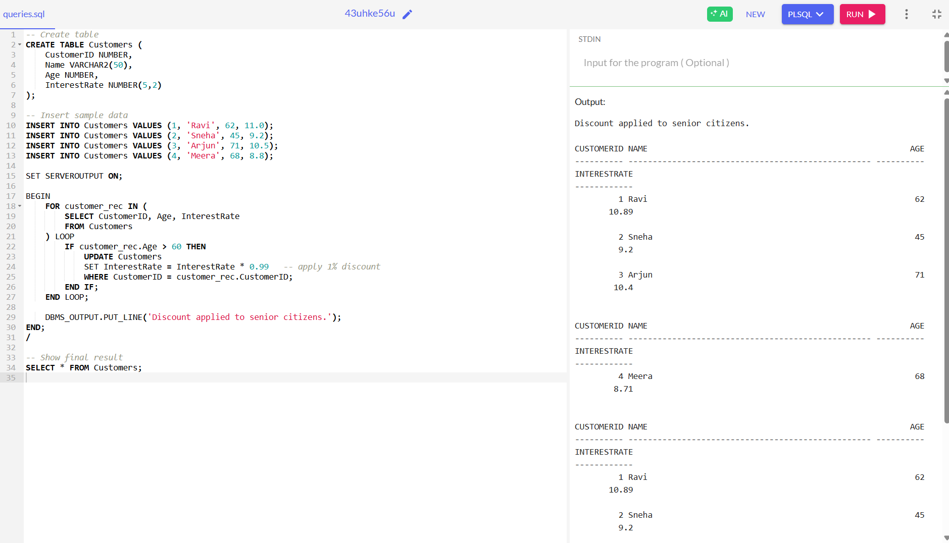

**Exercise 3: Stored Procedures**

**Scenario 1:** The bank needs to process monthly interest for all savings accounts.

**Question:** Write a stored procedure **ProcessMonthlyInterest** that calculates and updates the balance of all savings accounts by applying an interest rate of 1% to the current balance.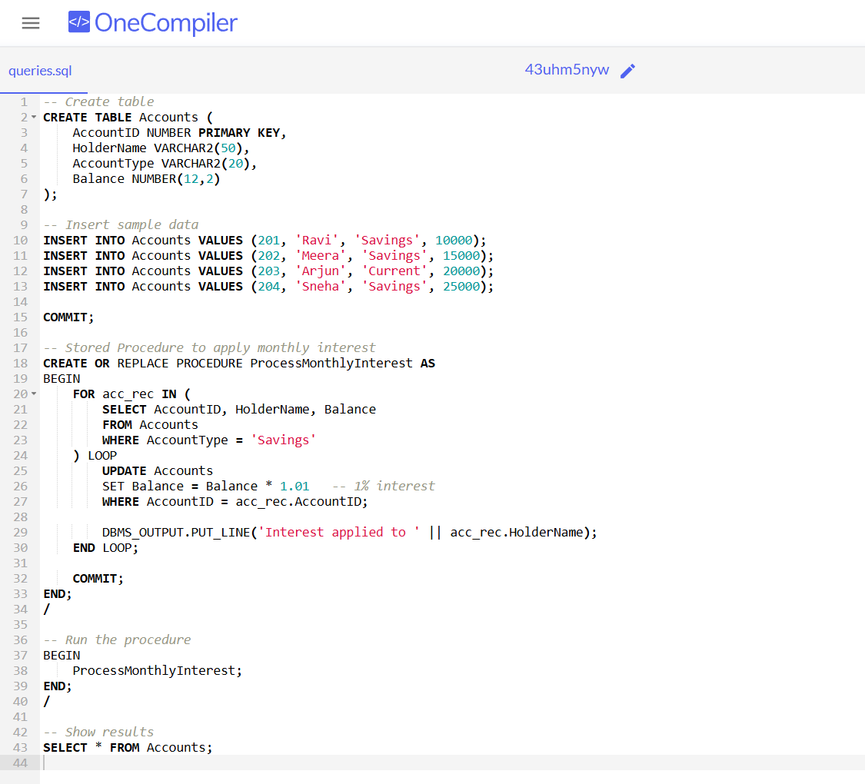

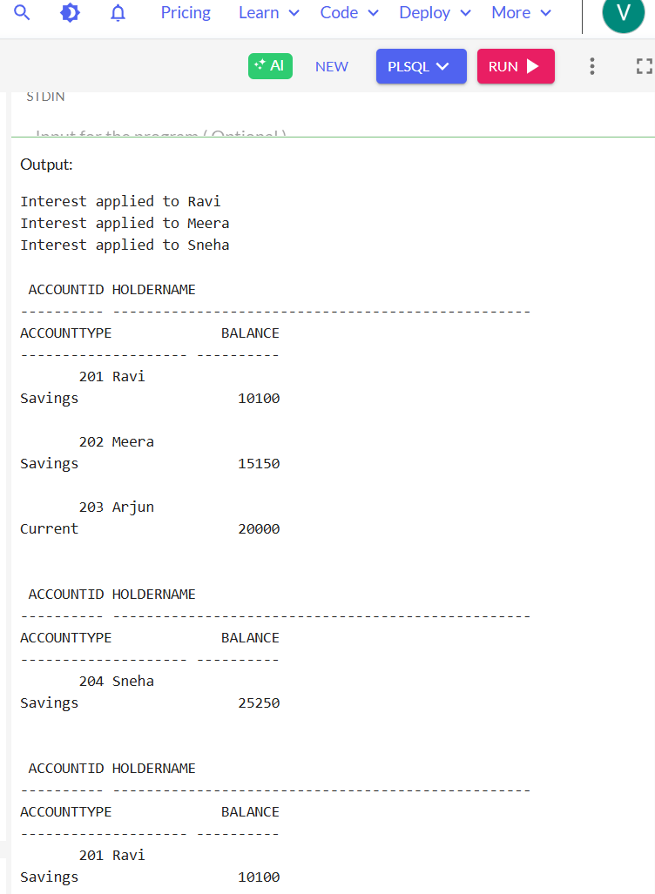

**Exercise 4: Functions**

**Scenario 1:** Calculate the age of customers for eligibility checks.

**Question:** Write a function CalculateAge that takes a customer's date of birth as input and returns their age in years.

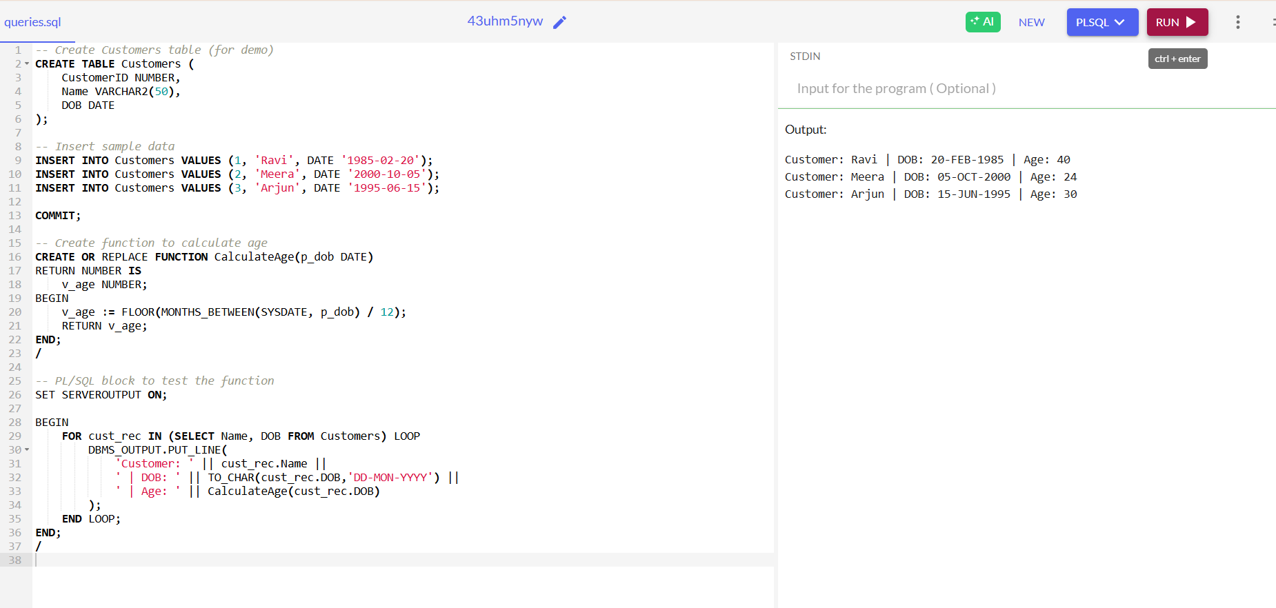

**Scenario 2:** The bank needs to compute the monthly installment for a loan.

* + **Question:** Write a function **CalculateMonthlyInstallment** that takes the loan amount, interest rate, and loan duration in years as input and returns the monthly installment amount.

