FDX Project: Financial Data Exchange
Project Type: Web Application
Purpose: Partner Payment Management System
The FDX (Financial Data Exchange) project is an internal web application designed to streamline and manage partner payment processes within the organization.

Key Modules
FDX Registry
- Maintains partner information and registration details.
Onboarding Module
- Handles the complete partner onboarding workflow.
FDX Certificate Portal
- Manages issuance and renewal of certificates for secure data exchange.

What is a Branching Strategy?
A branching strategy is a structured way of managing how code is developed, tested, and released using different branches in Git.

Its purpose is to:
- separate development, testing, and production environments
- ensure stable releases
- avoid conflicts
- support continuous integration and continuous deployment (CI/CD)
A good branching strategy clearly defines:
- which branch developers should commit to
- which branch is used for testing
- which branch is used for production releases
- how code flows from one branch to another
- what pipelines or environments are associated with each branch

Types of Branching Strategies
1. GitFlow Branching Strategy
- One of the most widely used strategies.
- Uses multiple long-running branches:
  - main/master – stable production code
  - develop – integration branch for new features
  - feature branches
  - release branches
  - hotfix branches
- Best for large projects with scheduled releases.

2. Trunk-Based Development
- All developers commit to main (single branch).
- Very fast CI/CD

3. Feature Branching
- Each feature has its own branch:
  - feature/login
  - feature/cart
  - feature/ui-update

4. Release Branching
- A separate release/ branch is created for each release:
  - release/v1.0
  - release/v2.0

5. Environment-Based Branching
- Separate branches for each deployment environment:
  - dev
  - staging
  - production
- Each branch represents an environment.
- Code flows from dev → staging → production.
- Very common in CI/CD setups.

6. Hotfix Branching
- Urgent fixes are done from production:
  - hotfix/issue-123
- After fixing, merged back into production and staging/dev.

Branching Strategy Used in Your Project
In our project, we followed a multi-environment branching strategy aligned with our CI/CD deployment flow.
We maintained three primary branches: dev, staging, and production, and each branch was associated with its own GitHub repository and Jenkins pipeline.
The code flowed through these branches sequentially to ensure quality, stability, and controlled release management.

Development Branch (dev)
- This is the branch where developers push their day-to-day code changes.
- A dedicated Jenkins pipeline builds and deploys the dev branch automatically.
- The dev environment is accessed through a static load balancer IP, without any domain name or SSL/TLS certificate.
Purpose:
Quick testing, Initial verification of new features, Early bug detection
Staging Branch (staging)
- Once the dev branch pipeline runs successfully and features are validated, the code is promoted/merged to the staging branch.
- Staging also has a separate Jenkins pipeline for build and deployment.
- Staging environment uses a domain name and SSL/TLS certificate, attached to its load balancer.
- URL example: staging-registry-financialdataexchange.org
Purpose:
- Pre-production validation

Production Branch (production)
- After the staging environment is tested and approved, the code is promoted/merged to the production branch.
- Production has its own Jenkins pipeline and production load balancer.
- The production system is accessed through the main domain: financialdataexchange.org
- Purpose:
    - Final deployment
    - Live user access

Development branch Github repo and project folders and file:

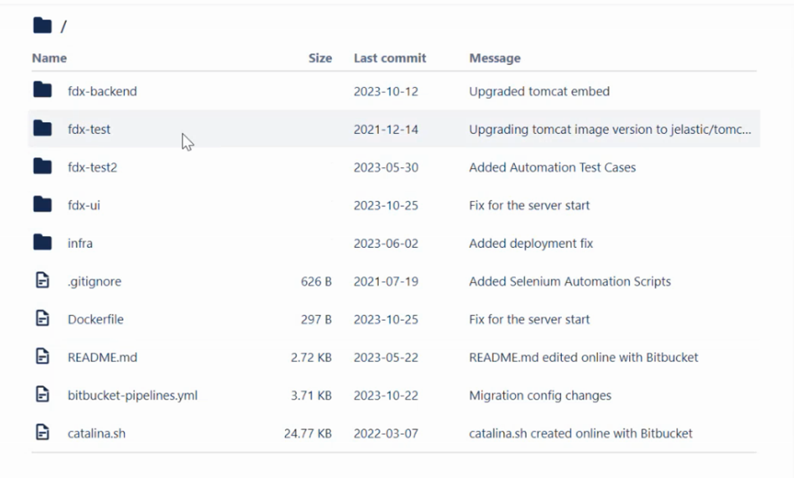

This is the source code structure inside your dev branch repository, and the same structure is maintained for staging and production branches.

Each branch (dev, staging, production) contains the full project code
fdx-backend/
fdx-test/
fdx-test2/
fdx-ui/
infra/
.gitinore
Dockerfile
README.md
bitbucket-pipelines.yml
catalina.sh

In our project, the developers mainly worked on the backend, frontend, and test modules.
As a DevOps engineer, my primary focus was on the operational and deployment components of the repository, especially:
- infra/ Folder
- Pipeline File (bitbucket-pipelines.yml or Jenkinsfile)
- Dockerfile (Containerization)

Source Code Management (SCM)
In my project:
👉 We used GitHub as our Source Code Management (SCM) tool.

What GitHub was used for:
- Storing and managing application source code
- Creating and maintaining branches (dev, staging, production)
- Managing code changes using pull requests
- Version control and rollback
- Integrating with CI/CD pipelines (Jenkins / AWS CodeBuild)
- Collaboration between developers and DevOps team

CI/CD Using Jenkins
In our project, we implemented a Continuous Integration and Continuous Deployment (CI/CD) pipeline using Jenkins. Jenkins automated the entire build, test, and deployment process for our dev, staging, and production environments.

CI/CD Using Jenkins With AWS CodeBuild
In our project, we used Jenkins as the CI/CD orchestrator, and AWS CodeBuild as the build service to compile, test, and package the application.
Jenkins pipelines were responsible for:
- Triggering builds whenever code was pushed to GitHub (dev, staging, production branches)
- Sending the source code to AWS CodeBuild

Instead of building code on Jenkins agents, we used AWS CodeBuild to perform the build.
CodeBuild handled:
- Installing required dependencies
- Running build commands (npm, Maven, Docker build, etc.)
- Creating build artifacts (UI build folder, WAR/JAR, Docker image)
- Uploading artifacts to S3
Why CodeBuild?
- Fully managed build service
- Scales automatically
- No need to manage build servers
- Provides build logs, build history, and CloudWatch integration

FULL CI/CD PIPELINE (BUILD + DEPLOY)
A CI/CD pipeline for a frontend (React) application typically has two major stages:

CI — BUILD STAGE
Goal: Convert source code into a production-ready build that can be deployed.

Checkout the UI repository
- Pull the latest code from GitHub/GitLab/Bitbucket.
Install dependencies
- Run npm install
- Downloads React + build tools (Webpack, Babel, etc.)
Inject environment configurations
- Replace placeholders (API_URL, SSO_URL, CLIENT_ID) using:
    - sed (Linux-based replacement)
- This ensures build is environment-specific:
    - dev → dev API URL
    - staging → staging API URL
    - production → prod API URL
Run the UI build
- npm run build
- Generates optimized static files inside:
- dist/ OR build/
Store artifacts
- The final output is a collection of static files:
    - HTML
    - JavaScript
    - CSS
    - Images

CD — DEPLOY STAGE
Goal: Deploy the built static assets to a hosting service (S3, CloudFront).

Deploy to AWS S3 + CloudFront
Ideal for static UI hosting.
Steps:
- Authenticate to AWS (IAM credentials)
Pipeline uses environment variables:
  - AWS_ACCESS_KEY_ID
  - AWS_SECRET_ACCESS_KEY
  - AWS_REGION

- Upload build files to S3
Using: aws s3 sync dist/ s3://bucket –delete

- Invalidate CloudFront
Ensures new UI loads immediately: aws cloudfront create-invalidation --paths "/*"
Why S3 + CloudFront?
- Cheap static hosting
- Global CDN distribution
    - CDN stands for Content Delivery Network. It speeds up content delivery by caching files on servers worldwide, closer to users.
CDN Role in S3 + CloudFront:
    - CloudFront acts as AWS's CDN, pulling static files from an S3 bucket and storing copies at edge locations globally. This reduces latency since users fetch from the nearest server instead of the distant S3 origin. It directly enables fast page loads and global distribution listed in the query.

Interview-Ready Explanation
In our project, we implemented a complete CI/CD pipeline for the frontend UI using a two-stage process: Build and Deploy.

In the Build Stage, the pipeline pulls the latest code from GitHub, installs all npm dependencies, and performs environment-specific configuration injection. We use sed to replace variables like API URLs or SSO endpoints so that the build becomes environment-dependent.

Once configuration is applied, we run npm run build, which generates a production-optimized static bundle inside the dist/ folder. These build artifacts are stored for the next stage.

In the Deploy Stage, the pipeline authenticates to the cloud provider (AWS ). For AWS, we use the aws-cli image. We configure IAM credentials, then run aws s3 sync to upload the static files to an S3 bucket that serves as our UI hosting layer.

We also trigger a CloudFront cache invalidation to ensure users receive the latest UI assets immediately. This results in a fully automated deployment from code commit to production.

Overall, the pipeline ensures consistent builds, zero manual intervention, faster releases, and environment-specific configuration during build time. It supports dev, staging, and production deployments with the same reusable pipeline steps.

script
Step-by-step explanation:

cd ./fdx-ui
Moves into the front-end UI project folder.

sed commands (very important)
These lines replace placeholder variables in your Jenkins declarative pipeline config file with real environment values.

Example:
sed -i "s|{API_URL}|$GCLOUD_API_ENDPOINT|" src/api/fdxregistryapi.js

What it means:
- Your UI code contains placeholders like {API_URL}, {SSO_ROOT_URL}, {SSO_CLIENT_ID}
- The CI pipeline injects real values during build time
- This ensures your UI communicates with the correct backend (API) and authentication server (SSO)

npm install
Installs all front-end packages listed in package.json.
Examples:
- React
- Axios
- Material UI
- Build tools (webpack, vite, babel, etc.)
npm run build
Creates an optimized production build.

This compiles React code into static files:
fdx-ui/dist/
index.html
main.js
assets/
This is what you deploy to: S3 + CloudFront

FULL EXPLANATION OF THE JENKINS DECLARATIVE PIPELINE – UI Build stages (refer VSC groovy script)
1. pipeline { }
This defines a Jenkins Declarative Pipeline.
Everything related to stages, environment variables, steps, etc., lives inside this block.

2. agent any
This tells Jenkins:
- Run the pipeline on any available agent / node.

3. environment { }
This block declares all environment variables required in the pipeline.

UI Environment Variables (from Jenkins Credentials)
- API_URL = credentials('api-url')
- SSO_ROOT_URL = credentials('sso-root-url')
- SSO_CLIENT_ID = credentials('sso-client-id')
AWS Credentials
- AWS_ACCESS_KEY_ID = credentials('aws-access-key-id')
- AWS_SECRET_ACCESS_KEY = credentials('aws-secret-access-key')
Static Deployment Values
- AWS_REGION = "ap-south-1"
- S3_BUCKET_NAME = "fdx-ui-prod"
- CLOUDFRONT_DISTRIBUTION_ID = "E12345ABCDE"

Meaning:
- Jenkins will securely inject these values from its Credentials Manager.
- These replace placeholders inside your React UI code.
- Values differ for dev, stage, prod.

Jenkins will securely inject these values from its Credentials Manager.
It means:
- Your API_URL, SSO_ROOT_URL, AWS credentials, etc.
- Are NOT hardcoded inside the Jenkinsfile
- They are stored safely inside Jenkins → Manage Jenkins → Credentials
So Jenkins injects them into the pipeline at runtime.

Where exactly do we configure these credentials?
Jenkins Dashboard → Manage Jenkins → Credentials → (global)

ID (used inside Jenkinsfile) | Type | What it stores
api-url | Secret text | https://dev-api.example.com
sso-root-url | Secret text | https://dev-sso.example.com
sso-client-id | Secret text | DEV-CLIENT-123

How does one Jenkins pipeline work for Dev, Staging, and Prod?
Method 1 — Multibranch Pipeline (Most Common)
- Jenkinsfile is the same for all branches.

Method 2— Separate Jenkins Jobs for Dev, Stage, Prod

4. stages { }
Contains all steps of the CI/CD process.
Stage 1: Checkout Code
What it does:
- Pulls the latest UI source code from GitHub.
- Ensures Jenkins builds the most recent commit.

Stage 2: Install Dependencies

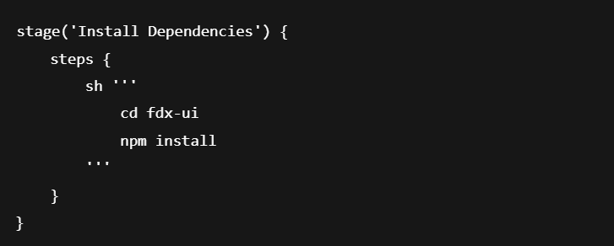

What happens here:
- Goes inside the UI folder.
- Runs npm install to download React dependencies.
- Includes:
- React
- Webpack / Babel
- Axios
- UI libraries (Material-UI)
- Build tools

Why?
Without dependencies, the React build cannot run.

Stage 3: Apply Environment Configuration

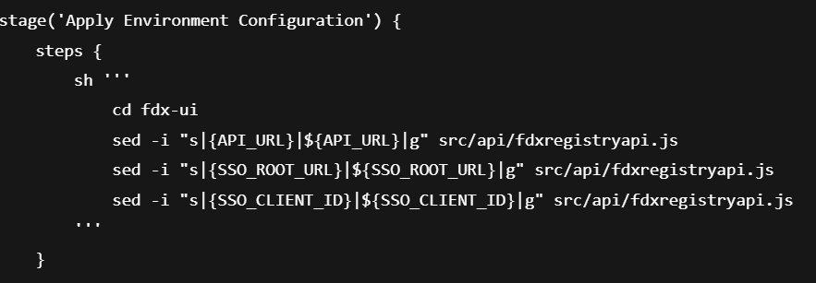

Purpose:
React builds are static → they CANNOT read environment variables at runtime.
So Jenkins must inject values BEFORE building.

✔ What each command does:
sed -i replaces placeholders inside your JS file:
- {API_URL} → Actual backend API URL
- {SSO_ROOT_URL} → Actual authentication server URL
- {SSO_CLIENT_ID} → Actual OAuth/SSO client ID

Why important?
This ensures the UI connects to:
- Correct backend
- Correct SSO service
- Correct environment (dev/stage/prod)

Stage 4: Build UI

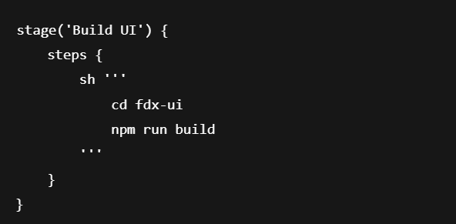

What happens here?
npm run build compiles React code into optimized static files:
fdx-ui/build/
- index.html
- main.js
- css/
- assets/
These are:
- Minified
- Bundled
- Optimized
- Ready for production

Why needed?
This output is what gets deployed to:
- AWS S3
- CloudFront CDN

Summary of Jenkins Build Flow
Step | Explanation
1️⃣ Checkout code | Pull latest GitHub code
2️⃣ Install dependencies | Download all node modules
3️⃣ Inject environment configs | Replace placeholders with real values
4️⃣ Build UI | Generate production build

Now let’s prepare a professional, clear interview answer explaining:
- How DEV, STAGING, PROD deployments happen
- Why separate Jenkins jobs
- How Jenkinsfile works in each job
- How the flow looks end-to-end
This will make you sound confident and experienced.

How Staging & Production Deployment Happens ?
**“In our project, each environment had its own Jenkins Job and its own Jenkinsfile.
We did not use a multi-branch pipeline because our environments had different configuration, credentials, and approval workflows.”**

1. Separate Jenkins Jobs for Each Environment

Jenkins Job | Deploys To | Trigger
fdx-ui-dev | Development | Automatic on commit
fdx-ui-staging | Staging | Manual trigger or after dev approval
fdx-ui-prod | Production | Manual + approval required

This is very common in enterprise setups.

2. Separate Jenkinsfiles per environment
“Each environment had its own Jenkinsfile because the configs were different.
For example, DEV used dev API URL and dev S3 bucket,
staging used staging API URL and staging bucket,
prod used prod URLs and prod S3 bucket.”

Means:
- DEV → Reads dev credentials
- STAGING → Reads staging credentials
- PROD → Reads prod credentials

3. Why separate pipelines? (Interviewer will like this)
“We kept environments isolated because production required
stricter security, approvals, and rollback mechanisms.
So using separate jobs allowed us to customize each pipeline easily.”

Reasons companies do this:
✔ Different credentials per environment
✔ Different S3 buckets / CloudFront distributions
✔ PROD requires approval (dev does not)
✔ Safer to isolate deployments
✔ Easy rollback
✔ Audit and logging per environment

4. How Code Moves from Dev → Staging → Prod
“Developers push code to the dev branch →
Jenkins dev pipeline builds and tests the UI →
After validation, we manually trigger the staging job →
After UAT sign-off, we trigger the production job.”

5. How deployment happens in staging and prod (simple explanation)
“The Jenkinsfile is almost the same across all environments.
Only the credentials and environment variables change.
Example:
DEV uses fdx-ui-dev S3 bucket
STAGING uses fdx-ui-staging
PROD uses fdx-ui-prod.”

6. Simple interview-friendly example of your explanation
Do you have separate pipelines for dev, staging, and production?

“Yes. In our setup, we had separate Jenkins jobs for each environment.
Each job had its own Jenkinsfile where we used environment-specific values such as API_URL, S3 bucket name, and CloudFront ID.
The dev pipeline ran automatically on every commit, while staging and production were triggered manually after approvals.
This approach gave us clean separation between environments and better control of production deployments.”

If they ask why you didn’t use multi-branch?
“Because staging and production require approvals, manual triggers, and stricter credential handling. Separate jobs made governance easier.”

THE JENKINS DEPLOYMENT PIPELINE (refer VS Code groovy script)
This section explains the Deployment Phase of your UI CI/CD pipeline.

1. stage('Deploy to S3')
This stage uploads your built UI application (React build output) to AWS S3, where it is hosted.

2. withEnv([...])

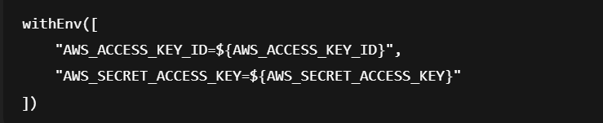

✔ What this means:
- Jenkins securely loads AWS credentials from the Jenkins Credentials Manager
- These values are injected as environment variables inside the shell block

Why?
Because the AWS CLI requires:
- AWS_ACCESS_KEY_ID
- AWS_SECRET_ACCESS_KEY
to authenticate.

For reference:
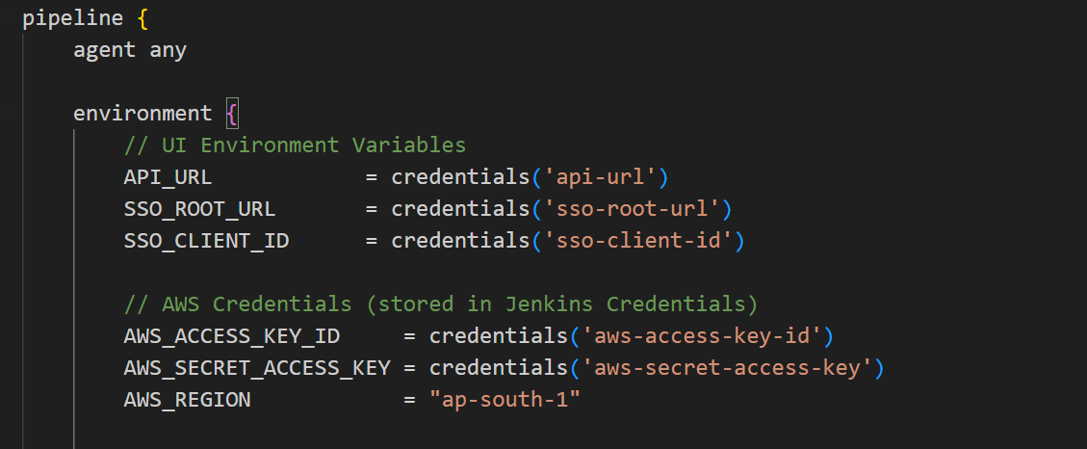

3. AWS CLI configuration
Inside the sh block:
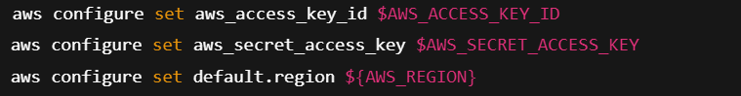

Explanation:
This step configures AWS CLI credentials inside the Jenkins agent.
- The pipeline tells AWS CLI which AWS account to use
- And which region: example ap-south-1
This is required before running any AWS CLI commands
(like S3 upload or CloudFront invalidation).

4. Upload UI Build Output to S3
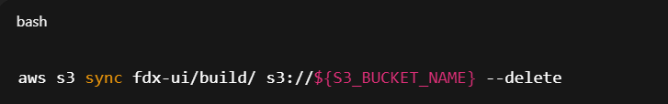

Important: This is the actual deployment.
What aws s3 sync does:
- Compares your local React build folder (fdx-ui/build/)
- With the S3 bucket where UI is hosted
- Uploads new files
- Deletes old files using --delete
- Only uploads changed files (faster)
This ensures the S3 bucket always contains the latest UI version.

Why S3?
React UI is static.
S3 is perfect for static hosting because:
- Cheap
- Fast
- Highly available
- No servers required
Note:
Many companies deploy UIs to S3 + CloudFront.
Sync = Synchronize the local folder with the S3 bucket

5. stage('Invalidate CloudFront Cache')
After deployment, users may still see the old UI because CloudFront caches the files.
So we must invalidate the cache.

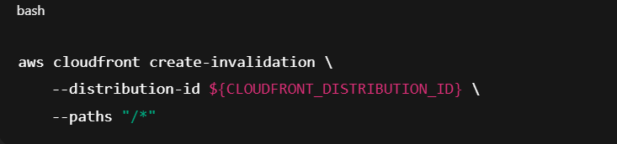

What this means:
- Tells CloudFront to delete all cached versions (/*)
- Forces CloudFront to fetch fresh files from S3
- Ensures users immediately see new UI changes
Without this step → users might still see old pages for minutes or hours.

Summary of Jenkins Deployment Phase
1️⃣ Configure AWS CLI
Authenticate with AWS so that deployment commands work.
2️⃣ Sync UI build folder to S3
Deploy static files (HTML, JS, CSS) to the hosting bucket.
3️⃣ Remove old versions (--delete)
Ensures bucket stays clean.
4️⃣ Invalidate CloudFront cache
Forces new UI to load globally.

🚀 End-to-End UI Deployment Flow in Jenkins (Build + Deploy)
✔ Replace environment variables using sed
✔ Build React UI → produces optimized static files
✔ Upload static files to AWS S3
✔ Invalidate CloudFront cache
✔ New UI is instantly visible to users

we need to install AWS CLI in Jenkins?
YES — if your Jenkins pipeline uses AWS commands, such as:
- aws s3 sync (for uploading UI build to S3)
- aws ecr get-login-password (for pushing Docker images to ECR)

If your Jenkins pipeline uses AWS commands, you must install AWS CLI on the Jenkins agent.

Where should AWS CLI be installed?
It depends on where Jenkins runs the pipeline:
1️⃣ Jenkins Master / Controller
If pipelines run on the controller → Install AWS CLI there.
2️⃣ Jenkins Agent Node (most common)
If you use a Linux agent (EC2, VM, container) → Install AWS CLI on that agent.

How to Install AWS CLI on Jenkins Agent (Linux)
curl "https://awscli.amazonaws.com/awscli-exe-linux-x86_64.zip" -o "awscliv2.zip"
unzip awscliv2.zip
sudo ./aws/install
aws –version
Jenkins CI/CD Pipeline Flow (UI → S3 → Backend Build)
Backend Pipeline:
Once UI deployment succeeds, Jenkins automatically moves to the next stage (Build FDX Registry API).

We use a single Jenkins declarative pipeline where the UI is built and deployed to S3 using AWS CLI. After the UI deployment, the pipeline continues to build the backend using a Docker-based Maven agent with Java 17, generates a WAR file, and archives it for Docker image creation and Kubernetes deployment. This provides a unified and automated CI/CD flow for both UI and backend.

Pipeline Execution Environment
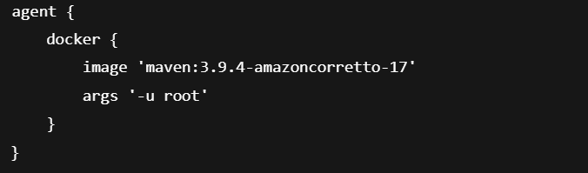

Jenkins runs backend stages inside a Docker container.
The image contains:
- Maven 3.9.4
- Java 17 (Amazon Corretto)
This guarantees:
- Same Java version
- Same Maven version
- No dependency conflicts
args '-u root' runs the container as root so system packages can be installed.
After UI deployment, Jenkins spins up this container and continues execution.

1. Stage – Install Dependencies
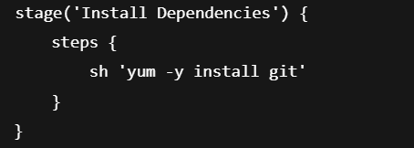

Installs Git inside the container.
Required for:
- Maven plugins
- SCM operations during build
This stage prepares the backend build environment.

2. Stage – Build Backend (FDX Registry API)
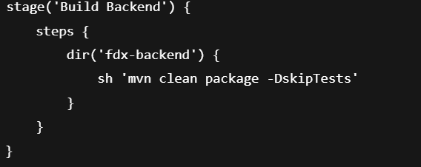

Step-by-step:
- Jenkins moves into fdx-backend directory.
- Runs Maven build:
      - Cleans previous builds
      - Compiles backend code
      - Packages application into a WAR file
      - Skips tests for faster CI
Output:
fdx-backend/target/fdxregistryapi.war
This WAR file is the deployable backend artifact.

3. Stage – Archive Artifact
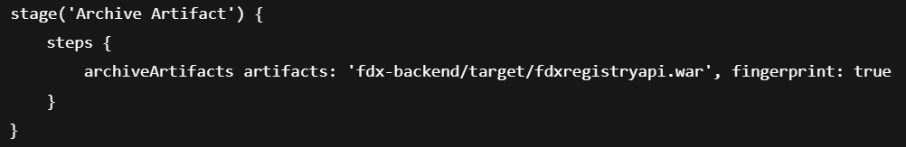

Jenkins stores the WAR file in build history.
Enables:
- Docker image creation
- Traceability using fingerprints
- Rollback support
Backend build output is now preserved.

How the Entire Pipeline Ends
If all stages succeed pipeline → pipeline status is SUCCESS.
UI is deployed to S3
- Backend WAR is built and archived
- Pipeline is marked SUCCESS
If any stage fails → pipeline stops and is marked FAILED.
- Pipeline stops immediately
- Status is FAILED

Note:
your pipeline can start with agent any, and later stages can use a Docker agent (Refer VS code).
agent any at pipeline level:
- Allows Jenkins to pick any available node
Stage-level Docker agents:
- UI build uses Node image
- Backend build uses Maven + Java image

Final Step: Build, Push & Deploy Registry Image
This final stage takes the already-built backend artifact, packages it into a Docker image, pushes the image to Amazon ECR, and deploys it to a EKS Kubernetes cluster.

Dockerfile
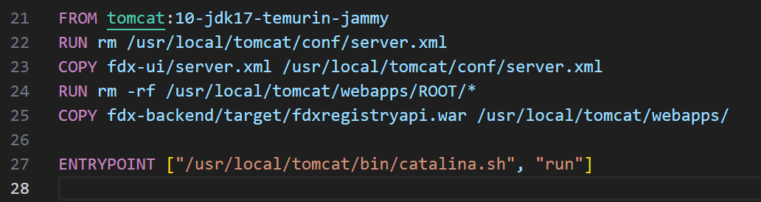

Line by Line Explanation
1️⃣ FROM
- This is the base image.
- Uses Apache Tomcat 10 with:
  - JDK 17 (Temurin distribution)
  - Ubuntu Jammy (22.04)
- This image already has:
  - Java installed
  - Tomcat installed and configured
- You don’t need to install Java or Tomcat manually.
👉 Meaning:
“Start my image from an official Tomcat + Java environment.”

2️⃣ RUN (remove default server.xml)
- Deletes the default Tomcat server.xml.
- You want to replace it with your custom configuration.

3️⃣ COPY (custom server.xml)
- Copies your custom server.xml into the Tomcat config directory.
- This file may contain:
  - Custom port (ex: 8080 / 80)
  - SSL / TLS config
  - Performance tuning
👉 Meaning:
“Use my project-specific Tomcat configuration.”

4️⃣ RUN (remove default ROOT app)
- Deletes Tomcat’s default ROOT application.
👉 Why?
- To avoid conflicts
- To ensure only your application is deployed

5️⃣ COPY (backend WAR file)
- Copies the already-built WAR file into Tomcat’s webapps directory.
- When Tomcat starts:
- It automatically deploys this WAR file

6️⃣ ENTRYPOINT
- Defines what runs when the container starts.

Build, Push & Deploy Registry Image Jenkins pipeline:
In Jenkins, we build a Docker image tagged with the Git commit ID, authenticate to Amazon ECR using IAM, push the image to ECR, and deploy it to an Amazon EKS cluster using Kubernetes manifests, enabling rolling updates with zero downtime.

stage('Build & Push Docker Image to ECR') {
environment {
AWS_REGION = 'ap-south-1'
AWS_ACCOUNT_ID = '123456789012'
ECR_REPO = 'fdx-registry'
DOCKER_BUILDKIT = '0'
}
steps {
sh '''
GIT_COMMIT_SHORT=${GIT_COMMIT:0:7}

docker build -t ${ECR_REPO}:${GIT_COMMIT_SHORT} -f Dockerfile .

aws ecr get-login-password --region $AWS_REGION \
| docker login --username AWS --password-stdin \
${AWS_ACCOUNT_ID}.dkr.ecr.${AWS_REGION}.amazonaws.com

docker tag ${ECR_REPO}:${GIT_COMMIT_SHORT} \
${AWS_ACCOUNT_ID}.dkr.ecr.${AWS_REGION}.amazonaws.com/${ECR_REPO}:${GIT_COMMIT_SHORT}

docker push ${AWS_ACCOUNT_ID}.dkr.ecr.${AWS_REGION}.amazonaws.com/${ECR_REPO}:${GIT_COMMIT_SHORT}
'''
}
}

Simple way:
In Jenkins, we build the Docker image using the Git commit ID as a tag, authenticate with Amazon ECR using IAM, push the image, and deploy it to an Amazon EKS cluster.

Steps:
1️⃣ Disable Docker BuildKit
export DOCKER_BUILDKIT=0
- Turns off Docker BuildKit (new Docker build engine).
- Use traditional Docker build instead of BuildKit.

2️⃣ Create short Git commit ID
export GIT_COMMIT_SHORT=${GIT_COMMIT:0:7}
- Jenkins automatically provides GIT_COMMIT

3️⃣ Build Docker image
docker build -t fdx-registry:${GIT_COMMIT_SHORT} -f Dockerfile .
Builds Docker image using:
- Dockerfile in current directory
Image name format:
- <AWS_ACCOUNT_ID>.dkr.ecr.<region>.amazonaws.com/<repository-name>:<commit-id>
- Example: 123456789012.dkr.ecr.ap-south-1.amazonaws.com/regtomcat:a1b2c3d
Meaning:
Package the backend WAR into a Tomcat Docker image.

4️⃣ Authenticate to AWS ECR
aws ecr get-login-password --region ap-south-1 \
| docker login --username AWS --password-stdin <AWS_ACCOUNT_ID>.dkr.ecr.ap-south-1.amazonaws.com
- Uses IAM role or Jenkins credentials

5️⃣ Tag Docker image for ECR
docker tag fdx-registry:${GIT_COMMIT_SHORT} \
<AWS_ACCOUNT_ID>.dkr.ecr.ap-south-1.amazonaws.com/fdx-registry:${GIT_COMMIT_SHORT}

6️⃣ Push Docker image to ECR
docker push <AWS_ACCOUNT_ID>.dkr.ecr.ap-south-1.amazonaws.com/fdx-registry:${GIT_COMMIT_SHORT}

Q&A:
Q1. How do you authenticate Docker to AWS ECR?
We authenticate using AWS IAM by running aws ecr get-login-password and passing the token to Docker login.
This allows Docker to push images to ECR securely.

Q2. Why is authentication required before pushing an image to ECR?
ECR is a private registry, so Docker must authenticate using AWS IAM credentials to get permission to push images.
Q3. Why do we tag the Docker image for ECR?
Docker images must be tagged with the ECR repository URI so Docker knows where to push the image.

Q4. How do you tag a Docker image for ECR?
docker tag app:commit-id \
<account-id>.dkr.ecr.ap-south-1.amazonaws.com/app:commit-id

Q5. Why use Git commit ID as the image tag?
It ensures versioning, traceability, and rollback—each deployment maps to a specific code commit.

Interview-style question:
When you say IAM credentials for authenticating Docker to ECR, do you mean IAM role–based authentication or access key and secret key–based authentication?
Ans:
Both are possible, but best practice is IAM Role–based authentication.
IAM Role–based authentication (Recommended)
- Jenkins runs on an EC2 instance
- An IAM role is attached to the EC2
- The role has permissions like:
- AmazonEC2ContainerRegistryFullAccess
- No access key or secret key is stored anywhere
How it works:
- AWS automatically provides temporary credentials
- aws ecr get-login-password uses the role behind the scenes

Access Key & Secret Key–based authentication
- Used when:
- Jenkins is not on EC2
- On-prem servers
- AWS credentials are stored in:
- Jenkins credentials store
- Environment variables

In our setup, Docker authentication to ECR is done using an IAM role attached to the Jenkins EC2 instance, so no access keys are stored. If Jenkins is outside AWS, we use access key and secret key stored securely in Jenkins credentials.

✅ NEXT STAGES (After Push to ECR)
After pushing the image, the pipeline is doing:
- Kubernetes setup
- Cluster authentication
- Manifest preparation
- Application deployment

7️⃣ Install kubectl (Kubernetes CLI)
AWS equivalent:
- Install kubectl on Jenkins or deployment VM
- Required to interact with Kubernetes cluster

AWS equivalent commands
Install kubectl (same kubectl, not AWS-specific)
curl -LO https://dl.k8s.io/release/$(curl -L -s https://dl.k8s.io/release/stable.txt)/bin/linux/amd64/kubectl chmod +x kubectl
sudo mv kubectl /usr/local/bin/
kubectl version –client

Install AWS CLI (required)
sudo apt update
sudo apt install -y awscli
aws –version

Configure kubectl to talk to EKS (AWS-specific step)
aws eks update-kubeconfig \
--region <region> \
--name <eks-cluster-name>
Note:
kubectl must be installed on the machine where deployment commands are executed.
In your case (Jenkins CI/CD):
- If Jenkins is triggering kubectl apply, then
✅ Install kubectl on the Jenkins server (Jenkins EC2/VM)

8️⃣ Verify CLI & Environment Configuration
aws configure list
Purpose:
Verify AWS region, account, and credentials are correctly set.
9️⃣ Connect to Kubernetes Cluster
aws eks update-kubeconfig \
--region <region> \
--name <cluster-name>
Purpose:
Configure kubeconfig so kubectl can talk to the cluster.

🔟 Move to Kubernetes Manifests Directory
cd Infra/
Purpose:
Access Kubernetes YAML files (deployment, service, ingress, backend).

1️⃣1️⃣ Update Image Tag in Deployment YAML
Assumptions (AWS variables)
AWS_ACCOUNT_ID=123456789012
AWS_REGION=ap-south-1
ECR_REPO_NAME=fdx-backend
COMMIT_ID=$GIT_COMMIT

sed "s|AWS_ECR_IMAGE|${AWS_ACCOUNT_ID}.dkr.ecr.${AWS_REGION}.amazonaws.com/${ECR_REPO_NAME}:${COMMIT_ID}|g" deployment.yaml.tpl > deployment.yaml

We dynamically replace the Docker image in the Kubernetes deployment file with the AWS ECR image URI and Git commit ID using sed before applying it with kubectl.

Purpose:
Ensure Kubernetes deploys the new Docker image.

1️⃣2️⃣ Deploy to Kubernetes

kubectl apply -f deployment.yaml
kubectl apply -f service.yaml
kubectl apply -f ingress.yaml

Purpose:
Deploy / update application in Kubernetes.

1️⃣3️⃣ Rolling Update (Zero Downtime)
- Kubernetes Deployment performs:
  - Rolling update automatically
  - One pod replaced at a time
- No downtime for users
Purpose:
Update application without service interruption.

FINAL PIPELINE FLOW (AWS – End to End)
- Build backend artifact
- Build Docker image
- Push image to ECR
- Authenticate to Kubernetes cluster
- Update image tag in YAML
- Apply Kubernetes manifests
- Kubernetes performs rolling update

Connect to Kubernetes Cluster and Authenticate to Kubernetes cluster
This command:
aws eks update-kubeconfig \
--region ap-south-1 \
--name fdx-eks-cluster
❌ It does NOT connect immediately
✅ It only configures access

Step-by-step: how it actually works
Jenkins / VM already has:
- aws cli installed
- kubectl installed
- IAM permissions to access EKS (Example: eks:DescribeCluster)

aws eks update-kubeconfig executes
AWS CLI:
- Calls AWS API → DescribeCluster
- Fetches:
  - EKS API server endpoint
  - Cluster CA certificate

kubeconfig file is created/updated
File location:
~/.kube/config

It adds:
- Cluster endpoint
- Certificate authority
- Auth method (AWS IAM)

IAM authentication is wired automatically
In kubeconfig:
users:
- name: arn:aws:eks:...
user:
exec:
command: aws
args:
- eks
- get-token

This means:
- When kubectl runs
- It calls aws eks get-token
- AWS validates IAM identity
- Temporary token is generated

Now kubectl can talk to EKS
When Jenkins runs:
kubectl get nodes
kubectl apply -f deployment.yaml

Interview-ready explanation (perfect answer)
The aws eks update-kubeconfig command configures the kubeconfig file by fetching cluster details from AWS and setting up IAM-based authentication. This allows kubectl running on Jenkins to securely communicate with the EKS cluster and deploy applications.

Simple way:
When you run:
aws eks update-kubeconfig --region ap-south-1 --name fdx-eks-cluster
AWS CLI writes entries into ~/.kube/config.

What exactly gets added/ writes (real example)
1. Cluster endpoint (WHERE to connect)
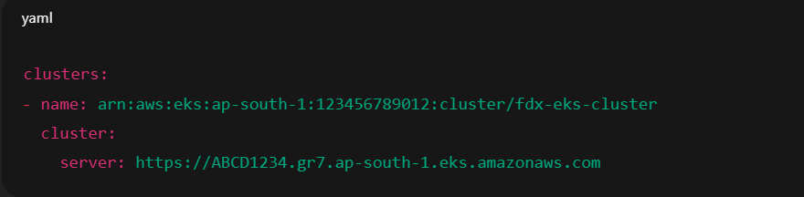
Meaning:
- kubectl now knows the EKS API server URL

2. Certificate authority (HOW to trust it)
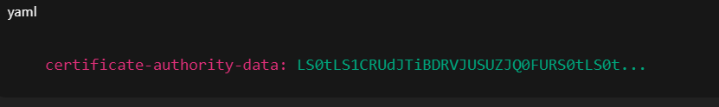

Meaning:
- Prevents man-in-the-middle attacks
- Ensures secure TLS communication

3. Auth method (WHO you are – IAM)
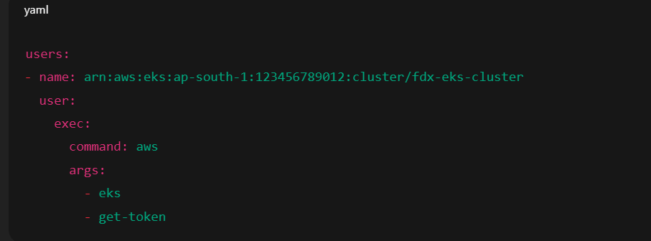

Meaning:
- kubectl will call AWS CLI
- AWS generates a temporary IAM token
- EKS validates IAM role/user

In simple English (best explanation)
When the kubeconfig file is created or updated, AWS CLI stores the EKS cluster’s API endpoint, security certificate, and IAM-based authentication method so kubectl knows where to connect, how to trust the cluster, and how to authenticate securely.

Steps to Attach IAM Role to EC2 (Jenkins Server)
The Jenkins EC2 instance must have an IAM role attached so AWS can authenticate kubectl to EKS.
Type:
- EC2 IAM Role (Instance Profile)
- Minimum required permissions : eks:DescribeCluster.
Usually attached via:
- AmazonEKSClusterPolicy (read cluster info)
- (Optionally) AmazonEKSWorkerNodePolicy – not mandatory for Jenkins

1️⃣ Create IAM Role
- Go to AWS Console → IAM → Roles
- Click Create role
- Trusted entity: AWS service
- Use case: EC2
- Click Next

2️⃣ Attach Required Policies
Attach these policies:
- ✅ AmazonEKSClusterPolicy
(Allows eks:DescribeCluster)
(Optional, if needed)
- AmazonEKSServicePolicy
Click Next → Create role

3️⃣ Attach Role to EC2 Instance
- Go to EC2 → Instances
- Select Jenkins EC2
- Click Actions → Security → Modify IAM role
- Select Jenkins-EKS-Access-Role
- Click Update IAM role
✔ Role attached instantly (no reboot needed)

4️⃣ Verify Role on EC2
Login to Jenkins EC2 and run:
$ aws sts get-caller-identity
You should see the role ARN, not a user.

One-line Interview Answer
We create an EC2 IAM role with EKS permissions and attach it to the Jenkins instance. AWS CLI then uses this role to authenticate kubectl securely with the EKS cluster.

Below is a single, clean, end-to-end Jenkins Declarative Pipeline that covers everything you listed:
This Jenkins pipeline builds the backend artifact, packages it into a Docker image, pushes it to Amazon ECR, authenticates with an EKS cluster, updates Kubernetes manifests with the new image tag, and deploys the application using rolling updates for zero downtime.

Key Interview Highlights (Say Confidently)
- Git commit ID used for image versioning
- IAM-based authentication for ECR & EKS
- kubectl apply triggers rolling updates
- No hard-coded secrets
- Fully automated CI/CD

CI/CD Pipeline Stages
Build → Push → Deploy (Jenkins + ECR + EKS)

Stage 1️⃣: Install Dependencies
Install required tools like git, docker, curl

Stage 2️⃣: Build Backend Application
- Jenkins builds the backend using Maven
- Generates a .war file

Stage 3️⃣: Archive Build Artifact
Archive the WAR file in Jenkins

Stage 4️⃣: Build Docker Image
- Create a Docker image using Dockerfile
- Tag image with Git commit ID
Interview note:
Docker image is built using the Git commit ID to ensure versioning.

Stage 7️⃣: Install kubectl & AWS CLI
Install Kubernetes CLI and AWS CLI

Stage 8️⃣: Configure kubectl for EKS
What happens:
- Update kubeconfig for EKS access
- aws eks update-kubeconfig
Interview note:
This allows Jenkins to communicate with the EKS control plane.

Stage 9️⃣: Verify Cluster Connectivity
Check node status
- kubectl get nodes

Stage 🔟: Prepare Kubernetes Manifests
Replace image tag dynamically in deployment YAML
Interview note:
- Ensures Kubernetes deploys the latest Docker image.

Stage 1️⃣1️⃣: Deploy to Kubernetes
Apply deployment, service, and ingress manifests
$ kubectl apply

Stage 1️⃣2️⃣: Rolling Update (Zero Downtime)
Kubernetes replaces pods gradually
Interview note:
Rolling updates ensure zero downtime by replacing pods one at a time.

30-Second Interview Summary
Our Jenkins CI/CD pipeline builds the backend, packages it into a Docker image, pushes it to Amazon ECR, connects to an EKS cluster, updates Kubernetes manifests with the new image, and deploys it using rolling updates for zero downtime.

Generated deployment.yaml
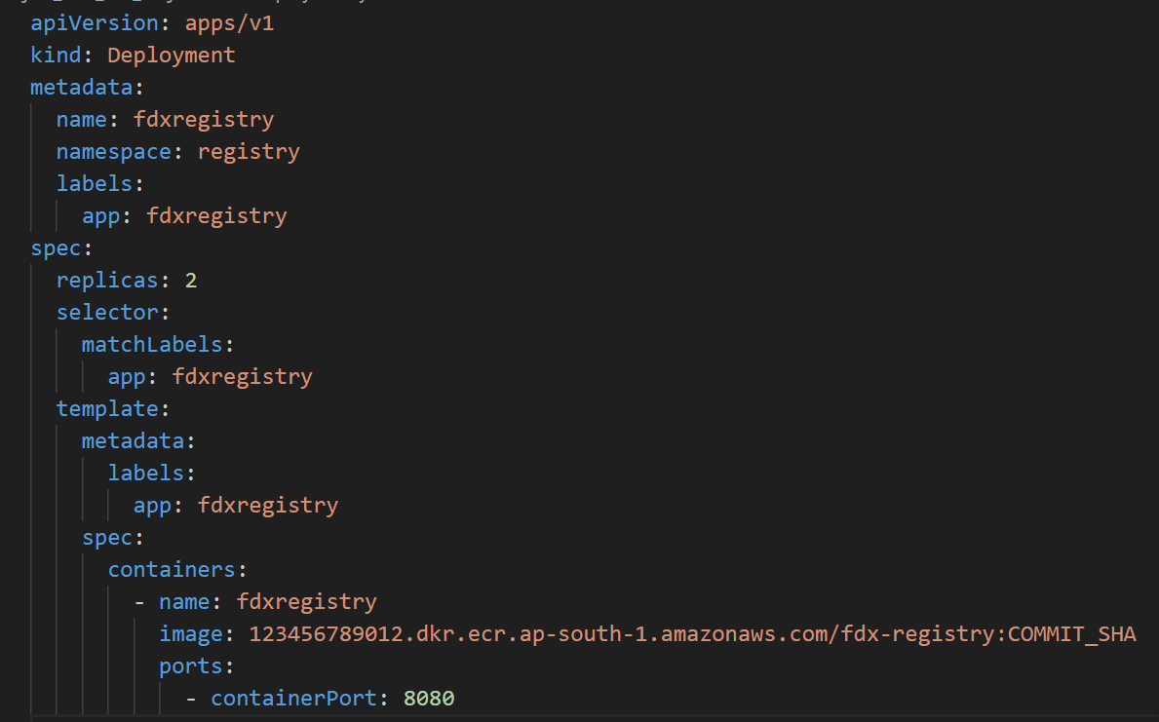

In Jenkins, COMMIT_SHA is replaced dynamically using sed with the actual Git commit ID.

Short & Simple Explanation (Interview Ready)
- apiVersion / kind: Defines this as a Kubernetes Deployment
- metadata: Name, namespace, and labels for identification
- replicas: 2: Runs two pods for high availability
- selector: Links Deployment to its pods using labels
- container image: Pulled from Amazon ECR, tagged with Git commit ID
- containerPort: Application runs on port 8080
- rolling update: Kubernetes replaces pods gradually → zero downtime

Generated service.yaml
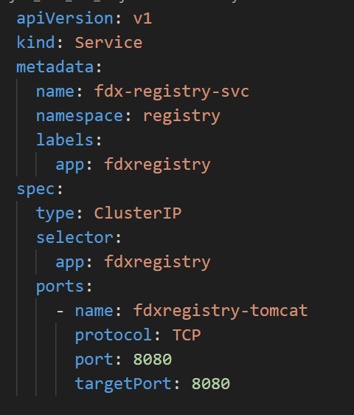

Short & Simple Explanation (Interview Ready)
- kind: Service → Exposes the application inside the Kubernetes cluster
- type: ClusterIP → Internal service (used by Ingress or other services)
- selector → Routes traffic to pods with label app: fdxregistry
- port 8080 → Service listens on port 8080
- targetPort 8080 → Traffic is forwarded to container’s Tomcat port

Generated ingress.yaml (AWS EKS – ALB Ingress)
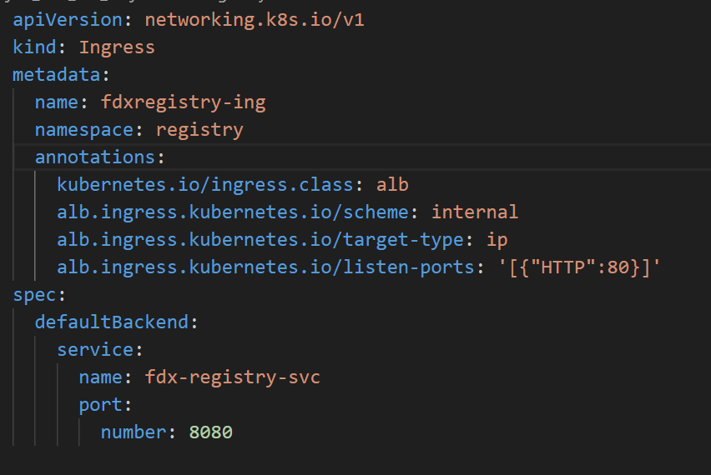

This uses AWS ALB Ingress Controller / AWS Load Balancer Controller.
Short & Simple Explanation (Interview Ready)
- kind: Ingress → Manages external access to services
- ALB ingress class → Uses AWS Application Load Balancer
- scheme: internal → Creates an internal ALB (not internet-facing)
- defaultBackend → Routes all traffic to fdx-registry-svc
- port 8080 → Forwards traffic to Tomcat service

This Ingress uses an internal AWS Application Load Balancer to route traffic to the fdxregistry service running on port 8080 inside the EKS cluster.

Annotations
Annotations are key–value metadata used to give extra instructions to Kubernetes or external controllers, without affecting pod selection or scheduling.

One-line interview answer
Annotations provide additional configuration to Kubernetes resources and are mainly used by controllers like AWS ALB Ingress Controller to control load balancer behavior.

Ingress:
This is an AWS ALB Ingress (Internal).
Why?
- kubernetes.io/ingress.class: alb
→ Uses AWS Application Load Balancer (ALB) via the AWS Load Balancer Controller
- alb.ingress.kubernetes.io/scheme: internal
→ Creates an internal (private) ALB, accessible only within the VPC
- defaultBackend
→ All incoming traffic is routed to a single service

Interview-ready one-liner
This is an internal AWS ALB-based Kubernetes Ingress, used to route traffic inside the VPC to a backend service in an EKS cluster.

Here are the types of Ingress
1️⃣ Based on Ingress Controller (Most Important)
ALB Ingress (AWS)
- Uses AWS Application Load Balancer
- Common in EKS
- Supports:
- Host-based routing
- Path-based routing
- Internal / Internet-facing
Example:
kubernetes.io/ingress.class: alb
NGINX Ingress
- Most widely used
- Runs as a pod inside the cluster
- Works on any Kubernetes platform

Example:
kubernetes.io/ingress.class: nginx

GCE / GKE Ingress (GCP)
- Uses Google Cloud Load Balancer
- GCP-specific

What is Ingress?
Ingress is a Kubernetes object that defines rules for routing external HTTP/HTTPS traffic to services inside the cluster.
- It is only a configuration (YAML)
- It does not route traffic by itself

Example:
kind: Ingress

What is an Ingress Controller?
An Ingress Controller is the actual component that implements the Ingress rules and routes traffic.
Runs as:
- A pod (NGINX, Traefik), or
- A managed service (AWS ALB)

Example (AWS EKS)
- Ingress → YAML file with routing rules
- Ingress Controller → AWS Load Balancer Controller
- Result → Creates an Application Load Balancer (ALB)

Practically how Ingress → Ingress Controller → ALB works in AWS EKS, using your service (fdx-registry-svc).
You already have:
1️⃣ Service
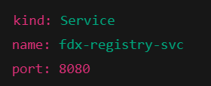

2️⃣ Ingress
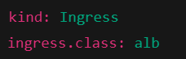
3️⃣ Ingress Controller
- AWS Load Balancer Controller
- Installed in EKS (usually in kube-system namespace)

🔁 Practical Flow (What Actually Happens)
STEP 1️⃣ — User sends request
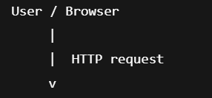
User hits an ALB DNS name (later created automatically).

STEP 2️⃣ — Ingress Controller is already running
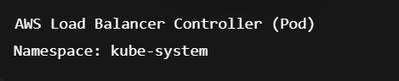

What it does continuously:
- Watches Kubernetes API
- Looks for Ingress objects with:
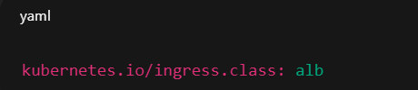

STEP 3️⃣ — You apply the Ingress YAML

Your Ingress:
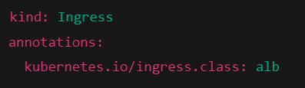
👉 Kubernetes stores this Ingress object
👉 Nothing routes traffic yet

STEP 4️⃣ — Ingress Controller detects Ingress
The AWS Load Balancer Controller sees:
“Oh! A new Ingress with class = alb”
Now it automatically does this 👇

STEP 5️⃣ — Controller creates AWS ALB (Automatically)
In AWS:
- An Application Load Balancer is created
- Scheme:
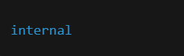
- Listener:


👉 You did NOT create ALB manually

STEP 6️⃣ — Controller maps ALB → Service
Your Ingress says:
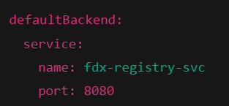

So controller configures ALB like this:
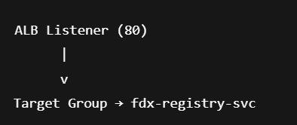

STEP 7️⃣ — Service routes traffic to Pods
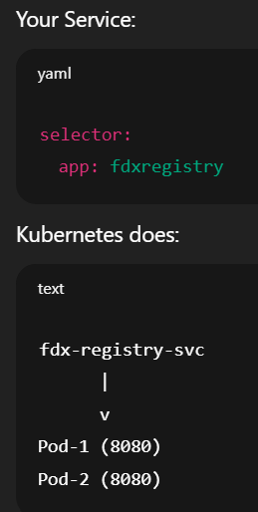

STEP 8️⃣ — Full End-to-End Traffic Flow
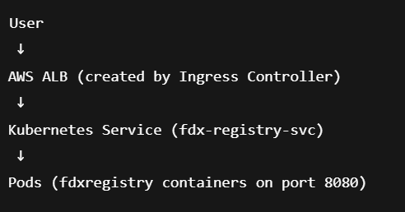

Check Ingress
$ kubectl get ingress -n registry

How Domain + TLS/SSL Works with ALB Ingress (AWS EKS)
You do NOT modify the ALB manually.
Everything is done via Ingress annotations.

Overall Flow (After SSL)
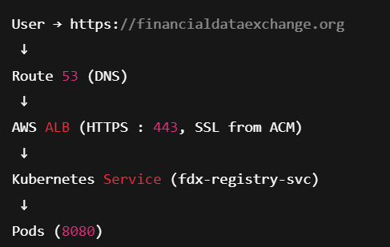

STEP 1️⃣ Create SSL/TLS Certificate (ACM)
- Go to AWS Certificate Manager (ACM)
- Request a public certificate for:
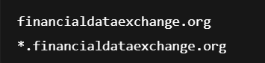
- Validate via DNS (recommended)
- Certificate status → Issued
📌 ACM certificate must be in the same region as ALB

STEP 2️⃣ Update Ingress YAML (Most Important)
Add ALB SSL annotations to your existing Ingress.
Updated ingress.yaml
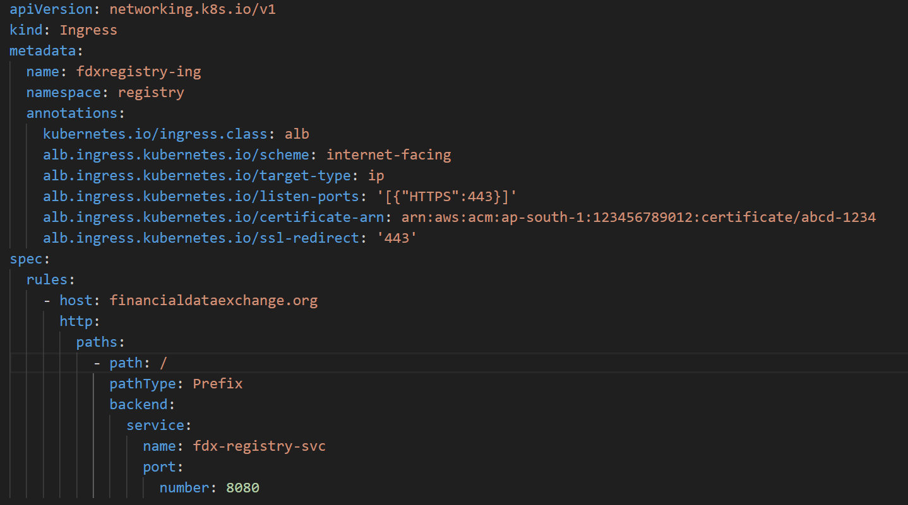
STEP 3️⃣ Apply Ingress

👉 What happens automatically:
- AWS Load Balancer Controller:
  - Updates ALB
  - Adds HTTPS listener (443)
  - Attaches ACM certificate
  - Enables SSL termination

STEP 4️⃣ Attach Domain Name (Route 53)
- Go to Route 53 → Hosted Zones
- Select your domain
- Create A Record
- Choose:
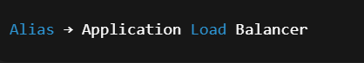
- Select the auto-created ALB
📌 No IP address required
STEP 5️⃣ Final Result
- Browser hits:
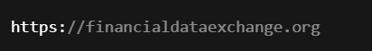
- SSL handled by ALB
- Traffic forwarded to service → pods on port 8080

Interview-Ready Explanation (3 Lines)
We attach SSL by adding ACM certificate annotations to the Ingress.
The AWS Load Balancer Controller updates the auto-created ALB with HTTPS and TLS termination.
The domain name is mapped to the ALB using a Route 53 alias record.

Key Interview Notes (Say Confidently)
- SSL termination happens at ALB, not pod
- Certificates are managed by ACM
- Domain mapping is done via Route 53
- No manual ALB changes — Ingress controls everything

What is SSL?
SSL (Secure Sockets Layer) is a security protocol used to encrypt data between a client (browser) and a server.
❌ SSL is deprecated (SSLv2, SSLv3 are no longer secure)

What is TLS?
TLS (Transport Layer Security) is the modern and secure version of SSL.
- Used today in all HTTPS communication
- More secure and efficient than SSL
- Current versions:
- TLS 1.2
- TLS 1.3

What is Route 53?
Amazon Route 53 is AWS’s managed Domain Name System (DNS) service that translates human-readable domain names into IP addresses or AWS resources.

How Route 53 fits in your project (EKS case)
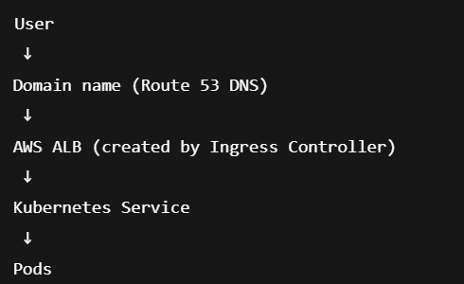

Why Route 53?
It provides highly available DNS with native AWS integration, health checks, and advanced routing options.

Post-Deployment Checks in AWS EKS (UI + CLI)
1️⃣ Check Pods Status (Kubernetes)
$ kubectl get pods -n <namespace>

Verify:
- STATUS = Running
- READY = 1/1 or 2/2

2️⃣ Check Deployment Health
$ kubectl get deployment -n <namespace>

Verify:
- Desired = Available = Ready replicas

3️⃣ Check Service
$ kubectl get svc -n <namespace>

Verify:
- Correct service type (ClusterIP / NodePort)
- Correct port mapping

4️⃣ Check Ingress
$ kubectl get ingress -n <namespace>

Verify:
- ALB ADDRESS is created
- Hostname is populated
Interview line:
Confirms Ingress is created and ALB is attached.

5️⃣ AWS Console → Load Balancer (Very Important)
Go to:
EC2 → Load Balancers
Check:
- ALB exists
- Scheme: internal / internet-facing
- Listener:
  - HTTP 80
  - HTTPS 443 (if SSL enabled)
Interview line:
I verify that the ALB is created automatically by the Ingress Controller.

6️⃣ AWS Console → Target Groups
Check:
- Targets are registered
- Status = healthy
7️⃣ Check Domain & SSL (If Configured)
8️⃣ Application UI Check (Most Important)
What to do:
- Open application URL
- Login / test API
- Verify UI loads correctly
9️⃣ Check Logs
$ kubectl logs <pod-name> -n <namespace>

Interview line:
Logs help identify runtime or application errors.

🔟 Monitor Metrics (Optional but Good)
Check:
- CloudWatch
- CPU / Memory
- ALB request count & latency
Interview line:
We monitor metrics to ensure performance stability.

30-Second Interview Answer
After deployment, I verify pod and deployment health, check services and ingress, confirm ALB and target group health in AWS, validate domain and SSL, test the UI, and monitor logs and metrics to ensure the application is running correctly.

Below is a clear, structured list of metrics, what to monitor, and how to check each one.
1️⃣ Pod & Container Level (Kubernetes)
- CPU usage
- Memory usage
- Pod restarts
- Pod status (Running / CrashLoopBackOff)
How to Check
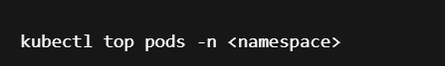
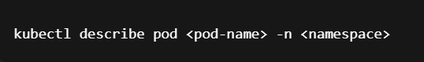
Interview line
I monitor pod-level CPU, memory usage, and restart count to detect application or resource issues.
2️⃣ Node Level (Worker Nodes / EC2)
Metrics to Monitor
- CPU utilization
- Disk usage
- Network I/O
How to Check
- AWS Console → CloudWatch → Metrics → EC2
Key metrics:
- CPUUtilization
- NetworkIn
- NetworkOut
- DiskReadOps / DiskWriteOps

3️⃣ Cluster Level (EKS Control Plane)
Metrics to Monitor
- API server latency
- API request errors
- Scheduler health
How to Check
- AWS Console → EKS → Cluster → Monitoring tab
Or:
CloudWatch → Container Insights
Interview line
I monitor control plane health to ensure cluster stability.

4️⃣ Load Balancer Level (ALB – Very Important)
Metric | What it Means
RequestCount | Number of requests
TargetResponseTime | Application latency
HTTPCode_Target_5XX | App-side errors
HTTPCode_ELB_5XX | Load balancer errors
HealthyHostCount | Healthy targets

How to Check
AWS Console → CloudWatch → Metrics → ApplicationELB

Interview line
ALB metrics help identify traffic spikes, latency, and backend failures.

5️⃣ Application Logs (Very Important)
What to Monitor
- Errors
- Exceptions
- Slow responses
How to Check


Or via:
CloudWatch Logs (if configured)

Interview line
Logs help diagnose application-level issues beyond metrics.

6️⃣ Kubernetes Events (Hidden but Important)
What to Monitor
- Pod crashes
- Scheduling failures
- Image pull errors
How to Check
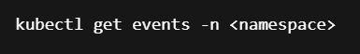

Interview line
Events give real-time insights into cluster behavior and failures.

7️⃣ Alerts & Alarms (Production-Ready)
Common Alerts
- High CPU (>80%)
- High memory usage
- Pod restart count > threshold
- ALB 5XX errors
- Unhealthy targets
How to Configure
- CloudWatch Alarms
Interview line
- We configure CloudWatch alarms to proactively detect issues.

In EKS, I monitor metrics at pod, node, cluster, and load balancer levels using kubectl and CloudWatch. I track CPU, memory, pod restarts, ALB latency and error rates, and application logs, and set alarms to detect issues early.

✅ Kubernetes Pod Statuses & Reasons
1️⃣ Pending
- Pod is created but not running yet
Common reasons:
- No available worker nodes
- Insufficient CPU / memory
How to check:
$ kubectl describe pod <pod-name>

2️⃣ Running
- Pod is scheduled and at least one container is running

3️⃣ Succeeded
- Pod completed successfully
- Mostly for Jobs / CronJobs

4️⃣ Failed
- Pod terminated and will not restart
Common reasons:
- Application exited with non-zero code
- Job failed

5️⃣ Unknown
- Kubernetes cannot get pod status from node
Common reasons:
- Node is down
- Network issue between node and control plane

Container-Level States (Very Important)
🔥 CrashLoopBackOff
- Container keeps crashing and Kubernetes keeps restarting it
Common reasons:
- Application crash
- Wrong startup command
- Missing config or env variable
- Port already in use
Check with:
$ kubectl logs <pod-name>

🔥 ImagePullBackOff
- Kubernetes cannot pull the Docker image
Common reasons:
- Wrong image name or tag
- Image not present in ECR
- Missing ECR permissions
- Incorrect imagePullSecret

🔥 ErrImagePull
- First attempt to pull image failed
Common reasons:
- Same as ImagePullBackOff (earlier stage)

🔥 CreateContainerConfigError
- Container configuration is invalid
Common reasons:
- Wrong environment variables
- Missing ConfigMap / Secret
- Invalid volume mount

🔥 RunContainerError
- Container failed during startup - Permission issues

🔥 OOMKilled
Container killed due to Out Of Memory
Common reasons:
- Memory limit too low
- Memory leak in application

🔥 ContainerCreating
- Kubernetes is creating container
Common reasons for delay:
- Large image size
- Volume mounting delay

🔹 Terminating
Pod is shutting down
Common reasons:
- Deployment update
- Manual delete
- Node drain

Real production issue:
🔴 Pod Status Seen
- ContainerStatusUnknown with exit code 137

✅ What is the REAL Reason?
Exit code 137 = OOMKilled (Out Of Memory)

👉 This means:
The container was forcefully killed by the Linux kernel because it exceeded its memory limit.

How to CONFIRM this (Commands)
1️⃣ Describe the pod
$ kubectl describe pod fdxregistry-655fbb9b79-xnjw4 -n registry
Look for:


2️⃣ Check container limits
$ kubectl get pod fdxregistry-655fbb9b79-xnjw4 -n registry -o yaml
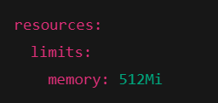

3️⃣ Check node memory pressure
$ kubectl describe node <node-name>


🛠️ How to FIX this (Production-safe)
✅ Option 1: Increase memory limits
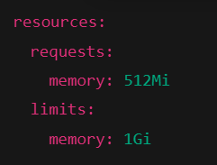

✅ Option 2: Tune JVM memory (Very important for Java/Tomcat)
If this is a Java app, add:
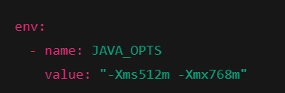

✅ Option 3: Scale pods
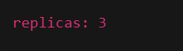
- Use HPA as a supporting mechanism

Q&A
How do pods communicate with each other in Kubernetes?
Pods in Kubernetes communicate with each other using cluster networking and Services, where each pod gets a unique IP and Services provide stable access and load balancing.

how technically?
Kubernetes uses a flat network model where all pods can reach each other directly, and kube-proxy routes traffic from Services to the correct pods.

What is networking in k8s?
Kubernetes networking ensures seamless pod-to-pod communication using a flat IP model implemented through CNI plugins, with Services handling discovery and load balancing.
Slightly expanded (still short)
- Every Pod has its own IP
- No NAT between pods
- Pods can communicate pod-to-pod, node-to-node
- Services provide stable access and load balancing
- Implemented using CNI plugins (Calico, Flannel, Cilium, etc.)

What is kube-proxy?
kube-proxy is a Kubernetes network component that enables Service-to-Pod communication by routing and load-balancing traffic to the correct pods.

What is CNI?
CNI means Container Network Interface.
What CNI actually does
- Assigns an IP address to each pod
- Connects pods to the cluster network
- Enables pod-to-pod and pod-to-service communication.

CNI is the networking standard used by Kubernetes to connect pods to the network through plugins.

Examples of CNI plugins
- Calico
- Flannel
- Cilium
- Weave
- AWS VPC CNI (used in EKS)
🔐 Kubernetes Security Concepts
1️⃣ Authentication – Who are you?
- Authentication verifies who is accessing the cluster.
Methods:
- Certificates
- Tokens
- IAM (EKS)
- Service Accounts

2️⃣ Authorization (RBAC) – What can you do?
- RBAC defines what actions a user or service can perform in the cluster.
Uses:
- Roles / ClusterRoles
- RoleBindings / ClusterRoleBindings

3️⃣ Network Security – Who can talk to whom?
- Uses Network Policies
- Controls pod-to-pod traffic
- Enforced by CNI plugins
Network policies restrict communication between pods for isolation.

4️⃣ Pod Security – How pods run
Controls:
- Privileged containers
- Root user
- Host access
Pod security ensures containers run with least privilege.

5️⃣ Secrets Management – Protect sensitive data
Store:
- Passwords
- Tokens
- Certificates
Methods:
- Kubernetes Secrets
- AWS Secrets Manager (EKS)
Secrets are used to securely store and inject sensitive data into pods.

6️⃣ Image Security – Safe container images
- Use trusted images
- Scan for vulnerabilities
- Use minimal base images – lightweight, stripped-down foundation images (like Alpine or distroless)
Image security prevents vulnerable or malicious images from running.

7️⃣ Node & Infrastructure Security
- Secure worker nodes
- OS patching
- Disable SSH access
- Use IAM roles - Using IAM roles means granting permissions to EC2 worker nodes through an IAM role instead of using access keys or passwords. Each worker node (EC2) has an IAM role attached
Node security protects the underlying infrastructure.

8️⃣ API Server Security
- Central control point
- Secured via:
- TLS
- Authentication
- Authorization
The API server is the most critical component and must be strongly secured.

9️⃣ Audit & Monitoring
- Auditing and monitoring help detect and respond to security incidents.

