**MA/CSSE 473 – Design and Analysis of Algorithms**

**Convex Hull Implementation (60 points)**

Implement the recursive Convex Hull algorithm found on pages 150-153 of the Levitin textbook.

For input, your program should read a textfile containing integer coordinates of a collection of points (no duplicates), at most 10 points per line. The program should calculate the convex hull of this collection of points, and print it to standard output. Your program should also draw the points and the convex hull, similar to the example here.

Here is sample input containing 25 randomly-generated points (in the file **25.txt**):

(102,212), (241,196), (154,80), (350,200), (333,308), (215,169), (116,249), (200,400), (147,109), (150,60)

(225,100), (30,40), (171,140), (198,357), (319,494), (330,500), (350,400), (309,403), (229,302), (291,242)

(170,193), (20,140), (310,500), (178,86), (159,310)

and an output window showing the points and their convex hull (in the file **25.png**)

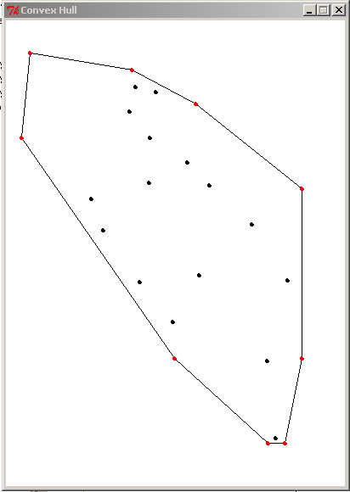

Note that this display uses standard graphics coordinates, where the origin is at the upper left, and positive y direction is downward. [This folder](ConvexHullFiles) contains some larger input files, and their corresponding output windows. All of these collections happen to have the same convex hull.

The coordinates of any points in files that I give you will be non-negative integers that are small enough to be displayed in a 1280 × 1024 window.

This is an individual assignment. The due date will be announced later, but it will be no earlier than Monday, October 13. Other sample input files may be added.

You should report on the execution time of your program for various size inputs.

Be careful that your code for reading the input is not Ω(N2).