Payment and shipping methods, shopify Pakistan:
- Shipping method supported: https://apps.shopify.com/tcscourier
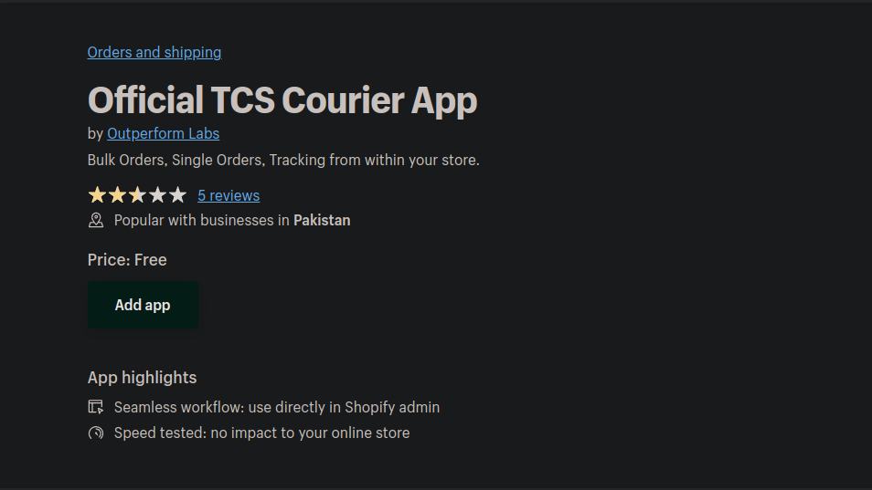
- Currently these payment methods are officially supported by Shopify: https://www.shopify.com/ie/payment-gateways/pakistan
