Github Link:
Project Title: Predicting air quality levels using advanced machine learning algorithms for environmental insights

Student Name: Theja Sri B , Thirisha M , Sweka M , Thiyagarajan S , Venkatesh R
Register Number: 513523205051,513523205052,513523205050,513523205053,513523205056
Institution: Annai Mira College of Engineering and Technology
Department: B.Tech(IT)
Date of Submission: 02-05-2025
Github Repository Link: [Update the project source code to your Github Repository]

1.Problem Statement
- Air pollution poses a significant threat to environmental and human health worldwide. Accurate prediction of air quality levels can help in proactive policy planning, public health protection, and timely alerts to reduce exposure to harmful pollutants. Traditional methods of air quality monitoring rely on expensive sensor networks and often lack predictive capabilities.

- This project aims to leverage advanced machine learning algorithms to predict air quality levels (e.g., AQI - Air Quality Index) using historical environmental and meteorological data. By developing predictive models, this research seeks to offer insights into air quality trends, identify key pollution contributors, and support data-driven environmental decision-making.

2. Project Objectives

- To collect and preprocess historical air quality and weather data.

- To explore feature engineering techniques relevant to air pollution prediction.

- To implement and compare machine learning models (e.g., Random Forest, Gradient Boosting, LSTM, etc.) for AQI prediction.

- To evaluate model performance using appropriate regression or classification metrics.

- To visualize predictions and provide interpretable environmental insights.

3. Flowchart of the Project Workflow
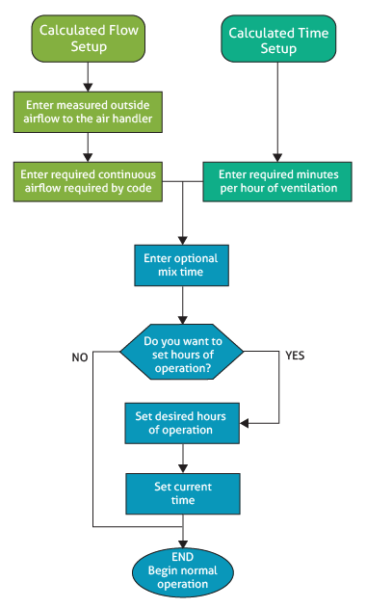

4. Data Description
- Dataset Name: Air Quality Data
- Source: Kaggle, UCI Repository
- Type of Data: Time-series, structured
- Records and Features: Thousands, pollutants & weather
- Target Variable: AQI, PM2.5 levels
- Static or Dynamic: Dynamic (real-time) or static
- Attributes Covered: Pollutants, meteorology, location

5. Data Preprocessing
- Data Collection: Kaggle, APIs
- Data Cleaning: Missing values, duplicates
- Feature Engineering: Pollutants, weather, timestamps
- Normalization & Scaling: Min-Max, Standardization
- Time-Series Processing: Lag features, seasonal trends
- Model Selection: Random Forest, LSTM
- Evaluation Metrics: RMSE, MAE, R²

6. Exploratory Data Analysis (EDA)
- Univariate Analysis: Examines individual pollutant distributions (PM2.5, NO2) using histograms, box plots, and summary statistics.
- Bivariate Analysis: Identifies relationships between pollutants and meteorological factors using scatter plots and correlation matrices.
- Key Insights: Detects trends, seasonal variations, and anomalies in air quality data, helping refine predictive models.

7. Feature Engineering
- Lag features from historical pollutant values
- Meteorological factors like temperature, humidity, and wind speed
- Time-based attributes such as hour, day, and season
- Spatial features including location-based data

8. Model Building
- Data preprocessing to clean and normalize pollutant levels
- Selecting suitable machine learning models like Random Forest, LSTM
- Optimizing hyperparameters for better accuracy
- Splitting data into training, validation, and test sets

9. Visualization of Results & Model Insights
- Visualization: Use scatter plots, heatmaps, and time-series graphs to analyze pollutant trends.
- Model Insights: Evaluate feature importance, interpret predictions, and assess accuracy using metrics like RMSE and R².
- Decision Support: Provide actionable insights for policymakers and environmental monitoring

10. Tools and Technologies Used

Data Sources: Kaggle, APIs

Programming: Python, R

Libraries: TensorFlow, Scikit-learn

Data Processing: Pandas, NumPy

Visualization: Matplotlib, Seaborn

Models: Random Forest, LSTM

Deployment: AWS, Google Cloud

11. Team Members and Contributions
1. M.SWEKA – Data Collection and Integration: Responsible for sourcing datasets, connecting APIs, and preparing the initial dataset for analysis.

2. R.VENKATESH – Data Cleaning and EDA: Cleans and preprocesses data, performs exploratory analysis, and generates initial insights.

3. M.THIRISHA – Feature Engineering and Modeling: Works on feature extraction and selection; develops and trains machine learning models.

4. S.THIYAGARAJAN – Evaluation and Optimization: Tunes hyperparameters, validates models, and documents performance metrics.

5. B.THEJA SRI Documentation and Presentation: Compiles reports, prepares visualizations, and handles presentation and optional deployment. BH7

