Angular Java Script Mid-Sem Project

1.Project Title: Restaurant Menu and Ordering System using Angular and TypeScript
Submitted by:
- Team members: Thirisha Babu Velu
Ramya R
Manshvi Jain
Adityan S Pillai
- Roll Number: 2460464
2460427
2460404
2460312
- College E-mail id: thirisha.babu@btech.christuniversity.in
r.ramya@btech.christuniversity.in
manshvi.jain@btech.christuniversity.in
adityan.s@btech.christunivesity.in
Course: Angular Java Script
Instructor Name:
Institution: Christ University
Date of Submission: 23.01.2026

2.Abstract:
- This project focuses on designing and developing a Restaurant Menu and Ordering System using Angular and TypeScript. The application allows users to browse menu items, view detailed descriptions, add dishes to a cart, and place orders through a structured checkout process.
- The system demonstrates core Angular concepts such as components, routing, services, dependency injection, forms, observables, and Angular Material UI. A mock backend using JSON Server or static JSON files is used to simulate real-world data interactions.
3.Objectives:
- To build a dynamic restaurant menu application using Angular.
- To understand component-based architecture in Angular.
- To implement routing and navigation using Angular Router.
- To manage application state using services and dependency injection
- To use template-driven and reactive forms with validation.
4.Scope of the Project:
- Front-end web application using Angular
- Uses mock backend (JSON Server / static JSON)
- No real payment gateway integration
- Responsive design for desktop and mobile devices
.

5.Tools & Technologies Used:
Tool/Technology | Purpose
Angular (v17+) | Front-end framework
TypeScript | Programming language
Angular Material | UI components
Node.js | Runtime environment
Angular CLI | Project scaffolding
JSON Server | Mock backend
VS Code | VS Code
6.System Architecture:
The application follows Angular’s modular architecture:
- Components handle UI.
- Services handle business logic & data
- Routing Module manages navigation
- Models define data structures
- Angular Material handles UI design

7.Components Description

1. Navbar Component
Displays navigation links
Links to Menu, Cart, and Checkout
Uses Angular Material Toolbar

2. Menu List Component
Displays all menu items
Uses *ngFor for listing dishes
Filters items by category
Shows price using CurrencyPipe

3. Menu Detail Component
Displays full details of a selected item
Uses route parameter /menu/:id
Shows ingredients, description, and price

4. Cart Component
Displays selected items
Allows increase/decrease quantity
Calculates total price dynamically

5. Order Form / Checkout Component
Uses Reactive Forms
Collects customer details
Validates email, required fields
Places order and shows confirmation dialog

8.Angular Material UI Components Used:
Tools | Usage
MatToolbar | Navigation bar
MatCard | Menu item display
MatButton | Actions
MatIcon | Icons
MatDialog | Order confirmation
MatSnackBar | Notifications
MatGridList | Responsive layout
9.Observables and Error Handling
• RxJS Observables used for async data
• HTTP Interceptors for error handling
• SnackBar displays success or failure messages
10.Testing and Integration:
- Verified navigation between pages
- Tested cart updates and checkout
- Validated forms and UI responsiveness.
- Checked application on mobile and desktop
11.Sample Code:
//index.html
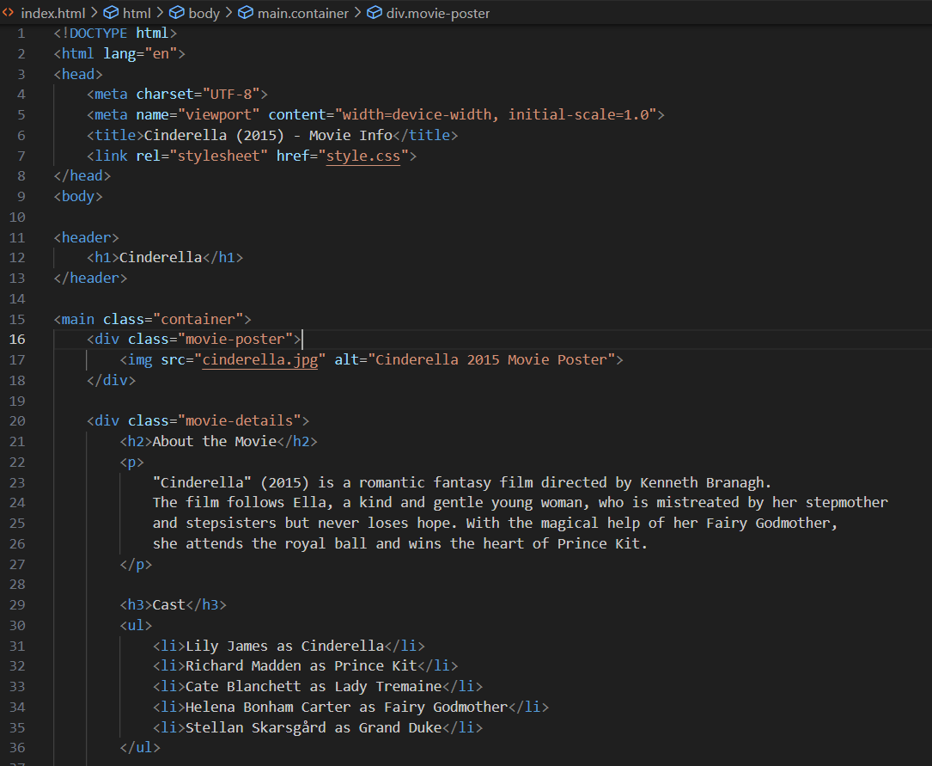
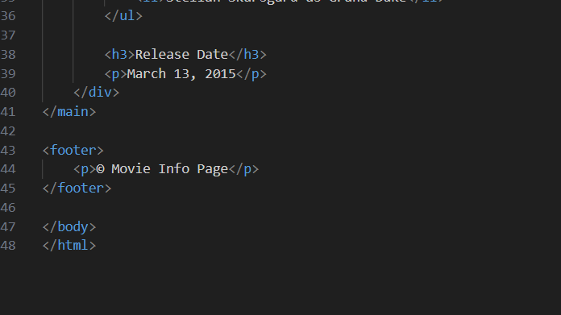
//style.css
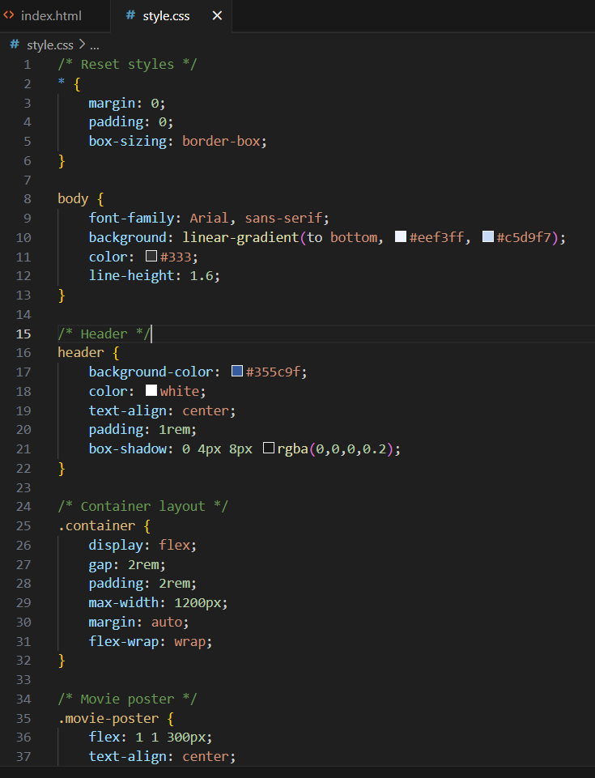
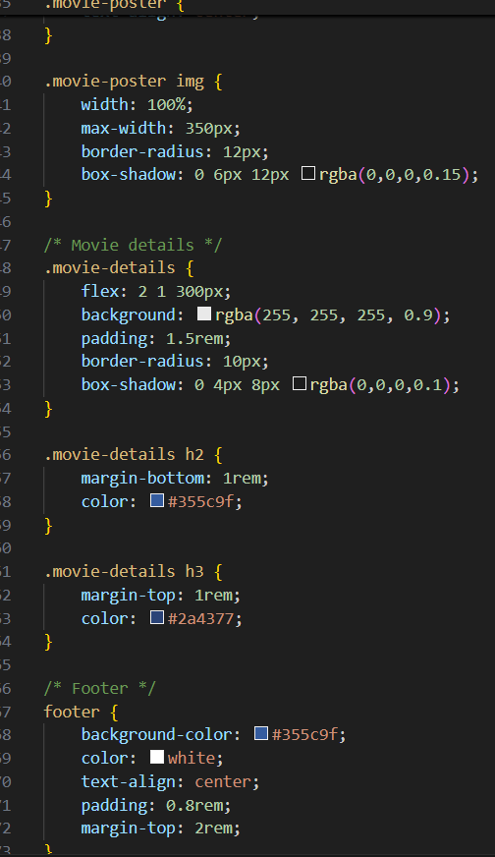
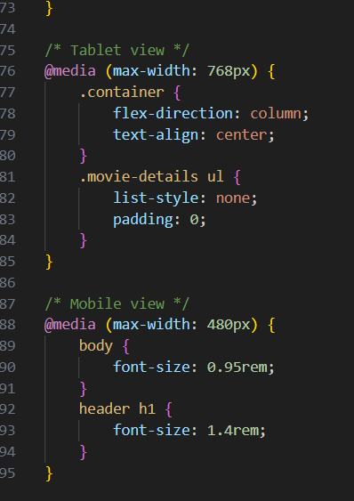
12.Screenshots of Final Output:
- Output as seen on laptop
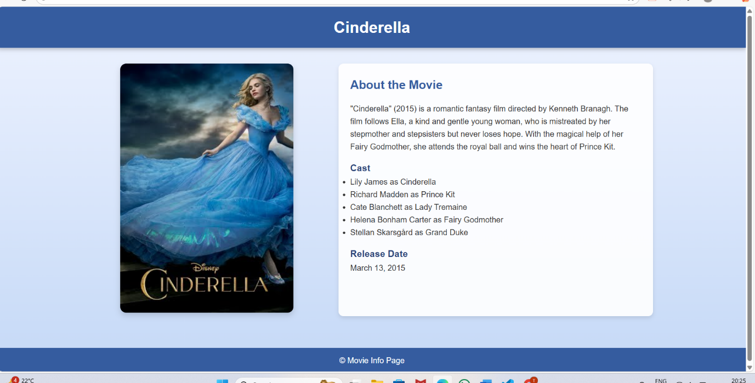
- Output as seen on mobile phone

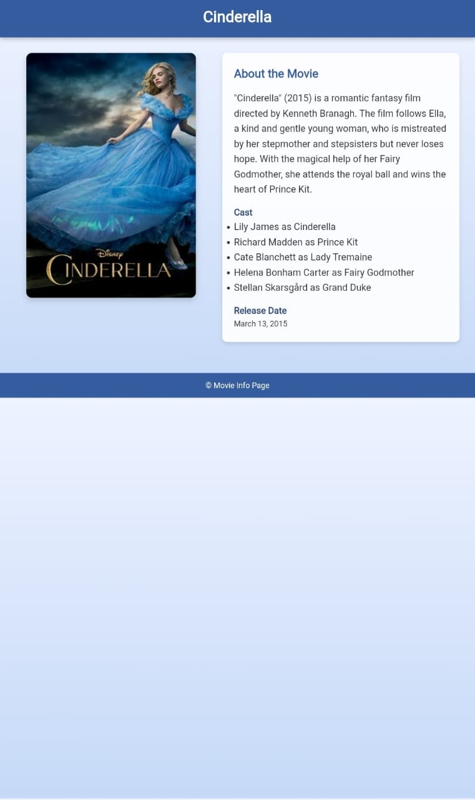
13.Outcome:
- Fully functional restaurant ordering system
- Clean and responsive UI
- Strong understanding of Angular fundamentals.
- Real-world application development experience
14.Future Enhancements:
- Backend integration with database
- User authentication
- Online payment gateway
- Order history feature
- Admin dashboard for menu management
15.Conclusion:
This project successfully demonstrates the development of a modern, component-based Angular application. It strengthened knowledge of Angular architecture, TypeScript, routing, services, forms, and Material UI while simulating a real-world restaurant ordering system.
16.References:
- L&T LMS: https://learn.lntedutech.com/Landing/MyCourse
- Angular Documentation
- RxJS Documentation
- Angular Material Docs

