3. Explain the benefits of cloud computing, such as cost savings, scalability, flexibility, and accessibility

Cloud computing is a technology that provides computing resources over the internet. Utilizing cloud software has several benefits. First off, it offers a high degree of freedom and scaling, making it simple for businesses to ramp up or down their processing resources as required without having to spend money on pricey hardware or software. Significant expense reductions may result from this.

Second, because data can be viewed from any location with an internet link, cloud computing makes it simple to collaborate and access data remotely. Teams may work together more easily as a result, regardless of where they live.

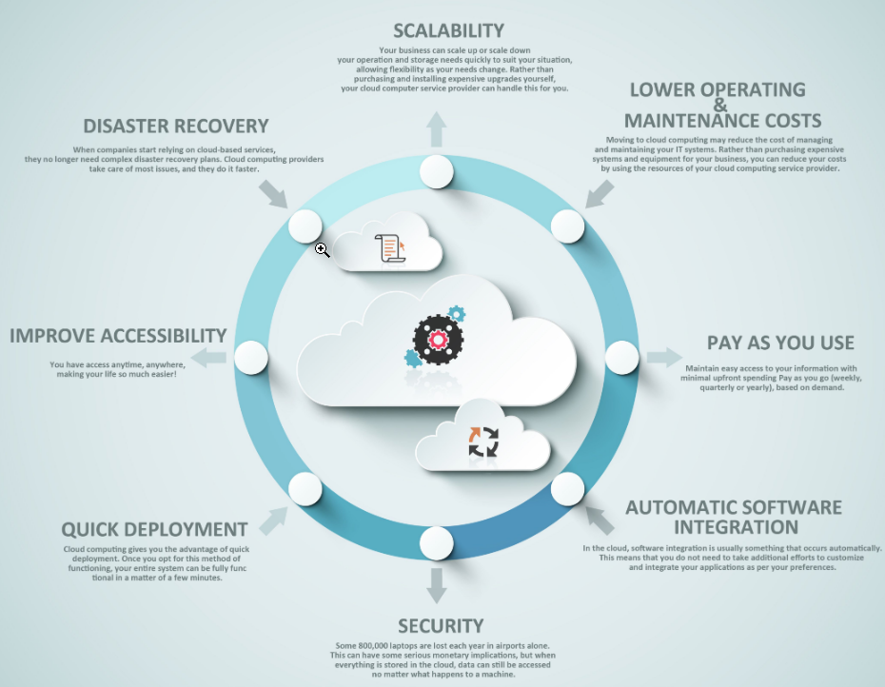

**Scalability**

In cloud computing, scalability is the ability of a system to handle increasing workloads or traffic while preserving peak efficiency and dependability. It makes it possible to quickly adapt computing resources, like storage and computational capacity, to changes in demand. As a result, a cloud computing system can easily and rapidly add or subtract resources to meet shifting user demands without compromising the level of service. To put it another way, scalability enables a cloud computing system to manage increased traffic or burden without experiencing delays, outages, or other performance issues, guaranteeing users always have access to dependable and consistent computing services.

Ex: If a company experiences a sudden surge in traffic to its website, with a scalable cloud computing   
 system, the company can quickly and easily add servers to its infrastructure to handle the increased   
 traffic

**Cost Savings:**

Compared to conventional IT solutions, cloud computing can be more affordable because you only pay for the computing tools you use. As a result, there is no longer a need for substantial initial expenditure on pricey infrastructure, software, or hardware, as well as continuing upkeep and upgrades. Additionally, when you use them, cloud service companies frequently give flexible pricing options. Businesses that experience fluctuations in demand may find this pay-as-you-go business strategy to be especially advantageous because it allows them to rapidly adapt their utilization to meet those requirements without incurring extra costs. Therefore, by taking advantage of cloud computing's advantages, businesses can lower their total IT costs while still having access to the computing power they need to operate their operations.

Ex: Company looking to migrate its on-premises email and collaboration software to the cloud. In the   
 traditional on-premises model, the company would need to purchase and maintain its email servers,   
 storage infrastructure, and software licenses.

**Flexibility**:

Businesses and people can access data and applications through the cloud from any location with an internet link. As a result, users can easily work from anywhere, including at home or while traveling. Additionally, cloud computing gives users the flexibility to rapidly adjust resources up or down based on their requirements. Due to their adaptability, companies can change their IT tools in response to their workload and evolving requirements.

Saving money is another advantage of cloud computing freedom. Businesses must spend a lot of money on expensive hardware and software in conventional IT settings to satisfy their computing requirements. However, with cloud computing, companies can avoid early investments in pricey equipment and only pay for the resources they use. The pay-as-you-go business strategy enables organizations to lower IT expenses and improve agility.

Cloud computing's adaptability enables companies to rapidly adjust to shifting market circumstances. Businesses may need to add new services or apps to their IT infrastructure as they develop and progress. Businesses can rapidly open new resources, try out new apps, and extend their infrastructure with cloud computing without incurring significant initial costs or taking a long time to set everything up.

Furthermore, cloud computing frees up time for companies to concentrate on their primary skills as opposed to running their IT infrastructure. Businesses can concentrate on providing value to their clients by outsourcing the management of the core infrastructure to cloud providers. Businesses can remain competitive, develop, and set themselves apart from the competition thanks to this flexibility.

Ex: For a company that needs to quickly launch a new application to support a new product line, with   
 cloud computing, the company can quickly provision the necessary computing resources, including   
 compute instances, storage and networking, in minutes or hours.

**Accessibility**

One of the main benefits of cloud computing is accessibility, which enables users to access processing tools and services from any location and on any internet-connected device. By doing away with specialized on-premises infrastructure, cloud computing enables users to access their apps, data, and services from anywhere. Users now can work online, communicate with coworkers in other cities, and get mobile access to resources.

The accessibility of cloud computing enables businesses to accept remote work, giving workers the freedom to work from home or other places. This adaptability contributes to a better work-life balance, shorter commutes, and higher output. Additionally, cloud computing enables companies to grow their staff without having to spend extra money on infrastructure, tools, or office space.

Additionally, cloud computing accessibility enables seamless cooperation across various places and time zones. Teams can collaborate on projects and exchange data in real time, no matter where they are, with the help of cloud-based collaboration tools. This degree of cooperation and adaptability can aid organizations in accelerating decision-making and stimulating invention.

Ex: A company that has employees working from different locations around the world. With cloud   
 computing, employees can access the company's resources and services from anywhere, using any   
 device with an internet connection. The company can provision virtual desktops, applications, and data   
 on the cloud, which can be accessed securely from any location.

Finally, since data is kept in safe data centers with cutting-edge security measures in place, cloud computing offers a high degree of security. This can aid in defending against cyberattacks and data leaks.

In general, cloud computing enables businesses to acquire and control their computing resources in a manner that is flexible, affordable, and secure, allowing them to concentrate on their primary business activities.

References

<https://www.salesforce.com/products/platform/best-practices/benefits-of-cloud-computing/>

<https://www.ibm.com/topics/cloud-computing-benefits>

<https://cloud.google.com/learn/advantages-of-cloud-computing>

<https://docs.aws.amazon.com/whitepapers/latest/aws-overview/six-advantages-of-cloud-computing.html>

<https://www.globaldots.com/resources/blog/cloud-computing-benefits-7-key-advantages-for-your-business/>