Architecture, Memory Organization, and Fixed-Point Analysis
FPGA-Based 3×3 CNN Convolution Accelerator for Edge-AI Vision

1. Architecture Overview
The accelerator computes a single-channel 3×3 convolution over a 32×32 grayscale image using same (zero-padded) convolution, producing a 32×32 output feature map of 1024 pixels. It is a fully streaming design: one 8-bit pixel enters per clock cycle and, after an initial fill latency, one 16-bit output pixel is produced per clock cycle. This sustained one-output-per-cycle rate is the primary throughput target, as the Figure of Merit measures throughput in output pixels per cycle.
The design is partitioned along a strict control/datapath separation. The datapath modules are deliberately "dumb" — they perform mechanical operations (shifting, multiplying, accumulating, saturating) and hold no knowledge of their position within the frame. All positional state — row and column counters, pipeline-fill tracking, image-border detection, and output-valid generation — is owned by a single Control Unit. This separation keeps the stall logic in one place: a single enable signal, derived from valid_in, gates every sequential element, so an input stall freezes the entire pipeline coherently with no risk of two modules disagreeing about frame position.
Datapath. Incoming pixels stream into a two-stage line-buffer chain that reconstructs three vertically adjacent image rows. A 3×3 array of tap registers slides horizontally across those rows to form the convolution window each cycle. Border taps are masked to zero under control of four edge flags to implement zero padding. The nine window pixels are multiplied by nine programmable 8-bit signed coefficients in the MAC array, summed in a 20-bit accumulator, and reduced to a 16-bit signed result by a saturation stage with an optional ReLU clip.
Control. The Control Unit tracks the current output position and asserts top_edge, left_edge, right_edge, and bottom_edge when the window straddles an image boundary, and drives the en enable to the datapath. It generates valid_out so that exactly 1024 valid outputs are emitted in raster order.
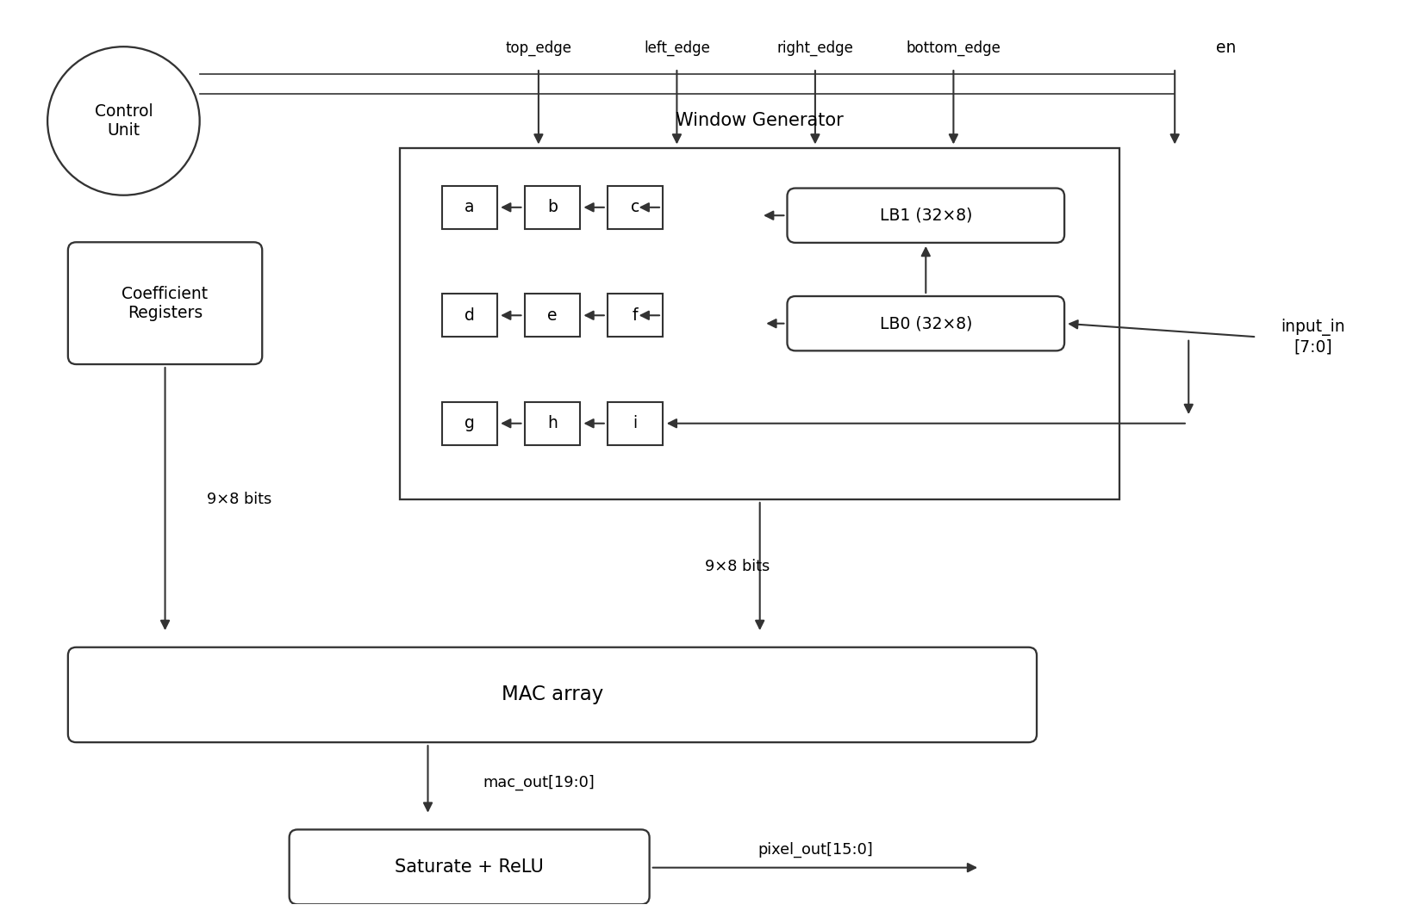
Figure 1. Top-level block diagram. Control Unit drives the four edge flags and the en enable; input_in cascades through LB0 → LB1 to reconstruct three rows; the 3×3 tap array feeds the MAC array, then Saturate + ReLU produces pixel_out.

2. Memory and Line-Buffer Organization
Forming a 3×3 window from a raster pixel stream requires simultaneous access to three vertically adjacent rows. A naïve approach would store the whole image and read a neighborhood each cycle, but that wastes memory and bandwidth. The standard efficient solution is a line-buffer sliding-window structure: only the two most recent rows are retained, and the window slides across them as new pixels arrive.
Two line buffers, LB0 and LB1, are chained in series. The incoming pixel input_in is the newest pixel of the bottom window row; it also feeds LB0. The output of LB0 — delayed by exactly one image row — is the newest pixel of the middle window row and feeds LB1. The output of LB1 — delayed by two image rows — is the newest pixel of the top window row. Three horizontal tap-register chains (three registers each) shift these three streams sideways to complete the nine-pixel window.
Line-buffer depth = 32. Each line buffer is 32 entries deep (one full image row). The vertical delay between adjacent window rows must equal one image row, and that entire delay is supplied by the line buffer; the horizontal tap registers move within a row and contribute no vertical delay. The two axes are independent, so the depth equals IMG_W = 32, not IMG_W − 3. This was verified in simulation by sweeping the depth and confirming that only depth 32 yields a vertically aligned 3×3 window.
No BRAM — the key FoM decision. The Figure of Merit penalizes each block RAM by a factor of 100 in the denominator, versus 1 per LUT and 50 per DSP. The line buffers are therefore implemented as flip-flop / distributed-LUTRAM shift registers, not block RAM. The total storage required is tiny: two buffers of 32 × 8 bits, i.e. 512 bits, plus the nine 8-bit tap registers — well under what distributed logic absorbs cheaply. Mapping this into a single BRAM would add 100 penalty units to the denominator for no benefit; keeping it in fabric contributes only a modest LUT/FF count and eliminates the ×100 term entirely.
Storage element | Size | Implementation
Line buffer LB0 | 32 × 8 bits | FF / distributed LUTRAM shift register
Line buffer LB1 | 32 × 8 bits | FF / distributed LUTRAM shift register
Tap registers (a–i) | 9 × 8 bits | Flip-flops
Block RAM (BRAM) | 0 | None — eliminated by design
Table 1. Memory organization. All storage is in fabric; zero block RAM is used, removing the ×100 BRAM term from the FoM denominator.

3. Fixed-Point and Bit-Width Analysis
All arithmetic is fixed-point. Input pixels are 8-bit unsigned (Q8.0, range 0–255), matching 8-bit grayscale. Kernel coefficients are 8-bit signed (Q8.0 integer by default, range −128 to +127); signed coefficients are required because edge-detection kernels such as Sobel and Laplacian contain negative weights. The datapath widths below are not chosen but derived from worst-case bit growth, then confirmed against measured ranges from the Python golden model.
Product width. Each tap multiplies an 8-bit unsigned pixel by an 8-bit signed coefficient. The extreme product is 255 × (−128) = −32,640, and 255 × 127 = +32,385, both of which fit in a 16-bit signed value (range −32,768 to +32,767).
Accumulator width. Nine such products are summed. The worst-case magnitude is 9 × 255 × 128 = 293,760, which requires 20 bits signed to represent losslessly. The accumulator is therefore 20 bits — the minimum width that guarantees no overflow for any 8-bit unsigned image and any 8-bit signed kernel. Widening beyond 20 bits would be wasteful; narrowing below 20 would risk silent overflow.
Output width and saturation. The output is 16-bit signed (the specified minimum). Because the 20-bit accumulator can exceed the 16-bit range in principle, the result is passed through a saturating stage that clamps to [−32,768, +32,767] rather than wrapping or truncating, which avoids gross artifacts from overflow. The golden model applies the identical clamp so hardware and reference remain bit-exact. An optional ReLU stage (disabled by default) clips negative results to zero as a post-processing bonus.
Signal | Format | Width | Worst-case range
Input pixel | Q8.0 unsigned | 8 | 0 … 255
Coefficient | Q8.0 signed | 8 | −128 … 127
Product (per tap) | signed | 16 | −32,640 … 32,385
Accumulator | signed | 20 | −293,760 … 293,760
Output pixel | signed, saturated | 16 | −32,768 … 32,767
Table 2. Bit-width derivation from worst-case growth. Each stage width is the minimum that avoids loss.
Measured ranges (golden-model evidence). The theoretical 20-bit accumulator bound assumes a pathological kernel. For the actual target kernels, the measured accumulator ranges over the test images (random, horizontal ramp, ring, and an all-maximum stress image) are far smaller, and no real kernel saturates the 16-bit output:
Kernel | Measured acc range | 16-bit output status
identity | 0 … 255 | within range
sobel_x | −1,020 … 1,020 | within range
sobel_y | −1,020 … 1,020 | within range
sharpen | −762 … 1,003 | within range
laplacian | −756 … 787 | within range
box (integer sum) | 0 … 2,295 | within range
Table 3. Measured accumulator ranges from the Python golden model across all test images. The 20-bit accumulator is sized for the theoretical worst case (293,760); real edge kernels use a small fraction of it, and none saturate the 16-bit output — the saturation stage is a correctness guarantee, not a routine operation.
This two-part result is the justification for the chosen widths: the 20-bit accumulator guarantees losslessness for any admissible input, while the measured ranges confirm that the 16-bit saturating output is more than adequate for the intended edge-detection workload, with saturation serving as a safety clamp rather than a frequent event.

