1. You have an Azure subscription that contains the resources shown in the following table.  
     
   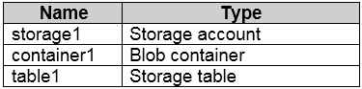  
     
   You need to perform the tasks shown in the following table.  
     
   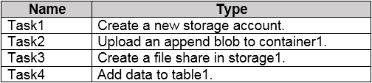

Answer:

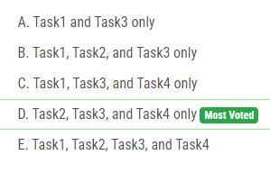

1. You have an Azure AD user named User1 and a read-access geo-redundant storage (RA-GRS) account named contoso2023.  
     
   You need to meet the following requirements:  
     
   • User1 must be able to write blob data to contoso2023.  
   • The contoso2023 account must fail over to its secondary endpoint.  
     
   Which two settings should you configure? To answer, select the appropriate settings in the answer area.

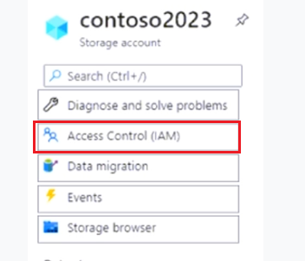

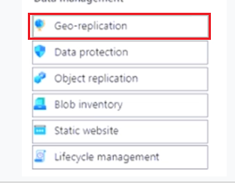

1. You have an Azure subscription that contains a storage account named storage1.  
   You plan to create a blob container named container1.  
   You need to use customer-managed key encryption for container1.  
   Which key should you use?

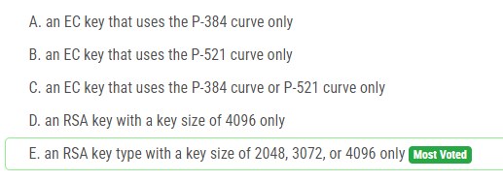

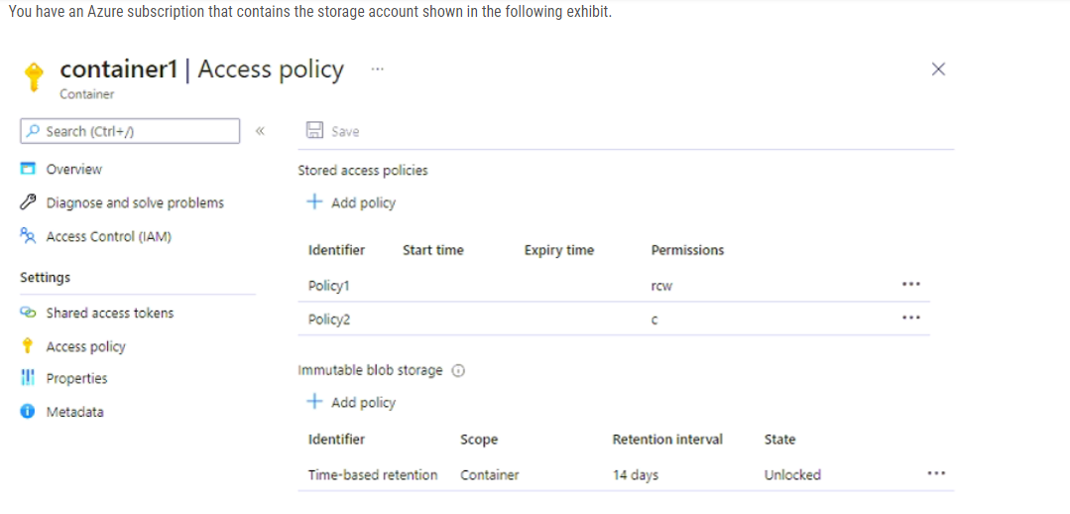

Answer:

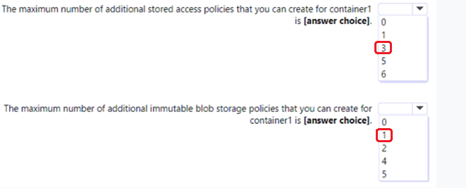

1. You have an Azure subscription. The subscription contains a storage account named storage1 that has the lifecycle management rules shown in the following table.  
     
   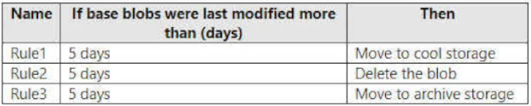  
     
   On June 1, you store a blob named File1 in the Hot access tier of storage1.  
     
   What is the state of File1 on June 7?

Answer :

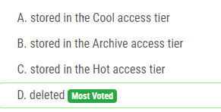

1. You have an Azure subscription that contains the storage accounts shown in the following table.  
     
   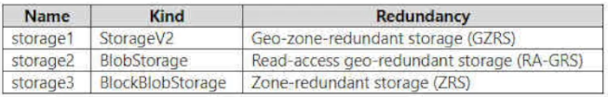  
     
   You need to identify which storage accounts support lifecycle management, and which storage accounts support moving data to the Archive access tier.  
     
   Which storage accounts should you use? To answer, select the appropriate options in the answer area.

Answer :

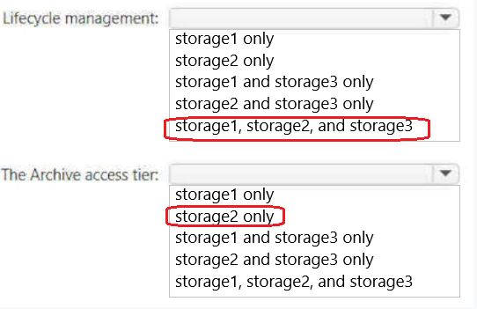

1. You plan to create an Azure Storage account named storage1 that will contain a file share named share1.  
   You need to ensure that share1 can support SMB Multichannel. The solution must minimize costs.  
   How should you configure storage?

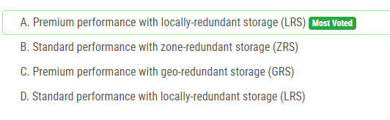

1. You have an Azure subscription that contains a storage account named storage1.  
   You plan to use conditions when assigning role-based access control (RBAC) roles to storage1.  
   Which storage1 services support conditions when assigning roles?

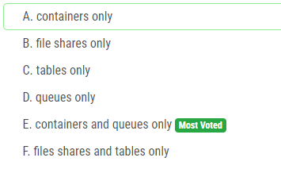

1. You have an Azure Storage account that contains 5,000 blobs accessed by multiple users.  
   You need to ensure that the users can view only specific blobs based on blob index tags.  
   What should you include in the solution?

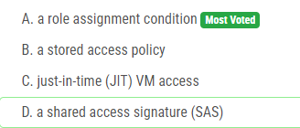

1. You have an Azure Storage account named storage1.  
   For storage1, you create an encryption scope named Scope1.  
   Which storage types can you encrypt by using Scope?

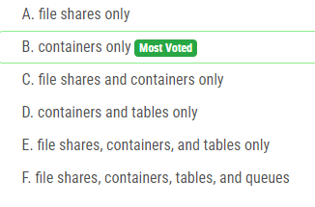

1. You have an Azure subscription that contains a virtual machine named VM1.  
     
   To VM1, you plan to add a 1-TB data disk that meets the following requirements:  
   • Provides data resiliency in the event of a datacenter outage.  
   • Provides the lowest latency and the highest performance.  
   • Ensures that no data loss occurs if a host fails.  
   You need to recommend which type of storage and host caching to configure for the new data disk.

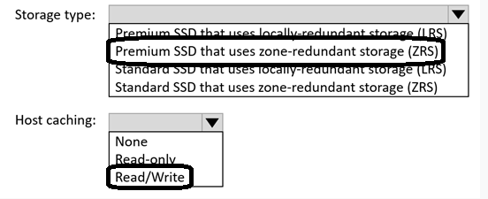

1. You have an Azure virtual machine named VM1 and an Azure key vault named Vault1.  
   On VM1, you plan to configure Azure Disk Encryption to use a key encryption key (KEK).  
   You need to prepare Vault1 for Azure Disk Encryption.  
   Which two actions should you perform on Vault1? Each correct answer presents part of the solution.

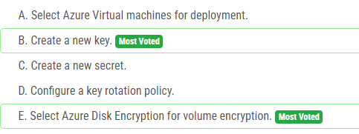

1. You have an Azure subscription that contains a virtual machine named VM1 and an Azure key vault named KV1.  
   You need to configure encryption for VM1. The solution must meet the following requirements:  
   • Store and use the encryption key in KV1.  
   • Maintain encryption if VM1 is downloaded from Azure.  
   • Encrypt both the operating system disk and the data disks.  
   Which encryption method should you use?

