## **Web Application Screenshots**

## **Home Page**

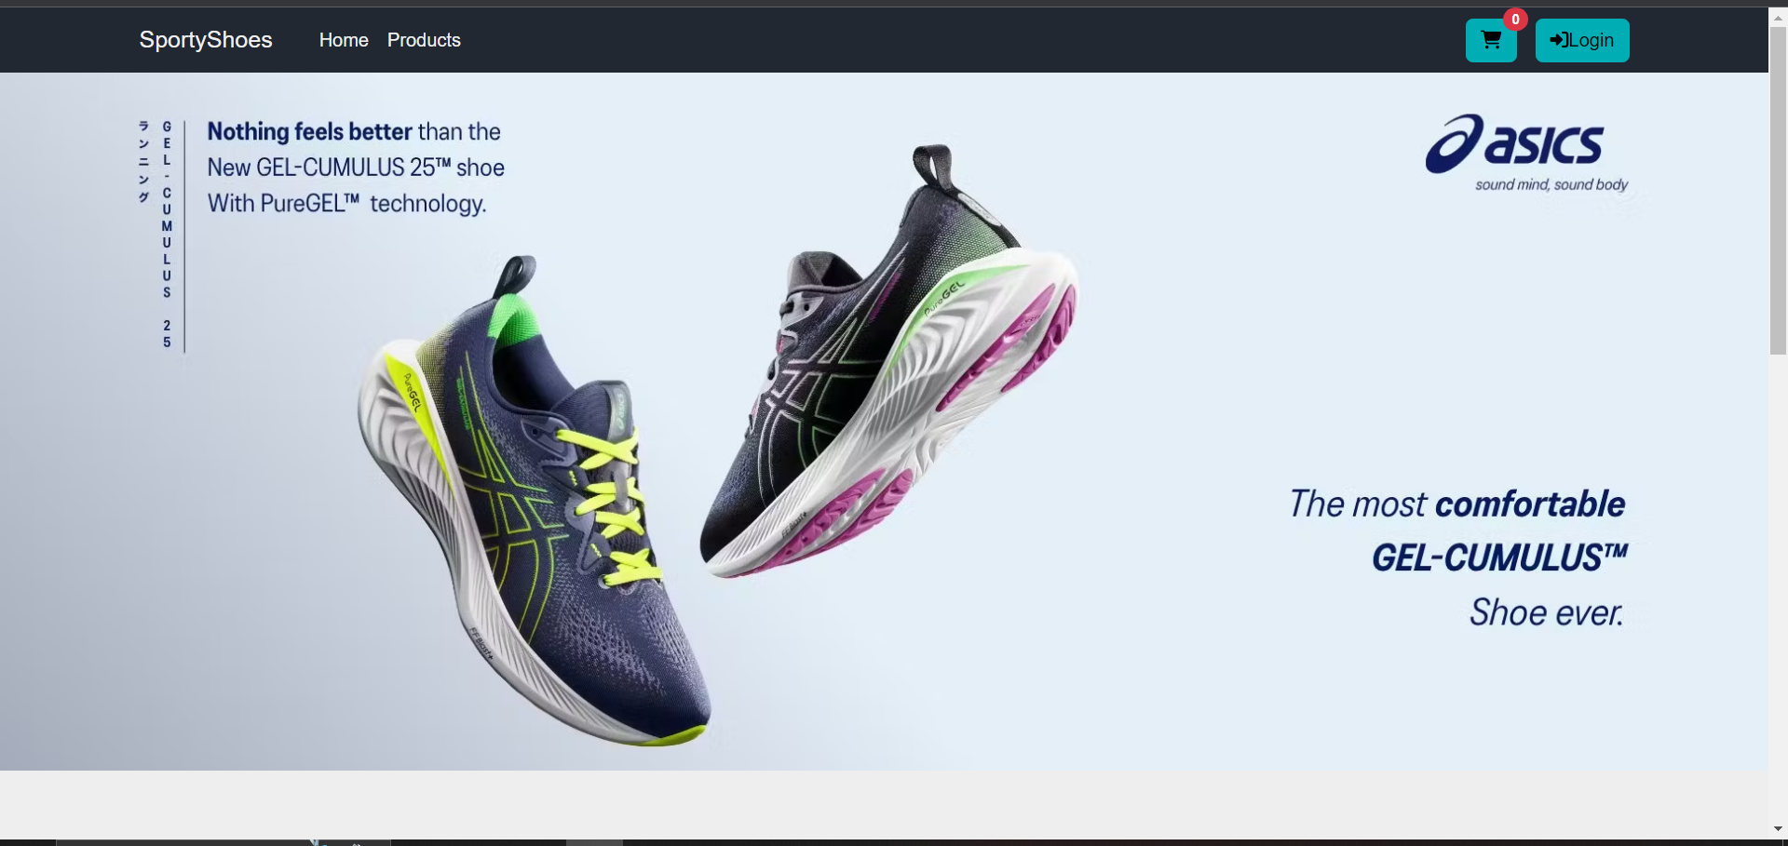

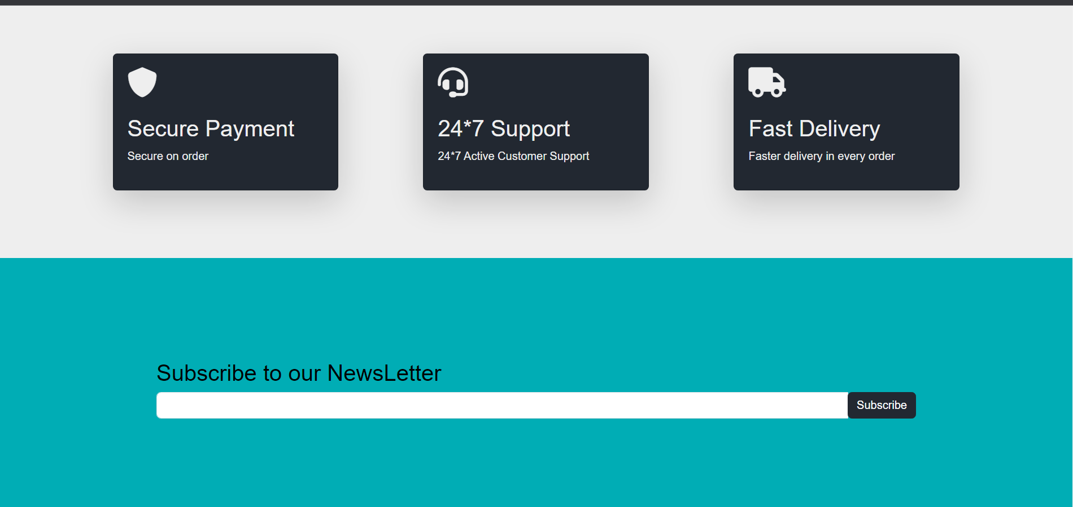 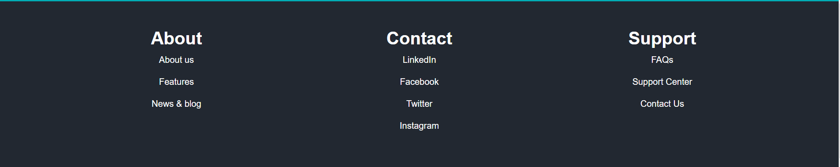

## **Products and Products description Page**

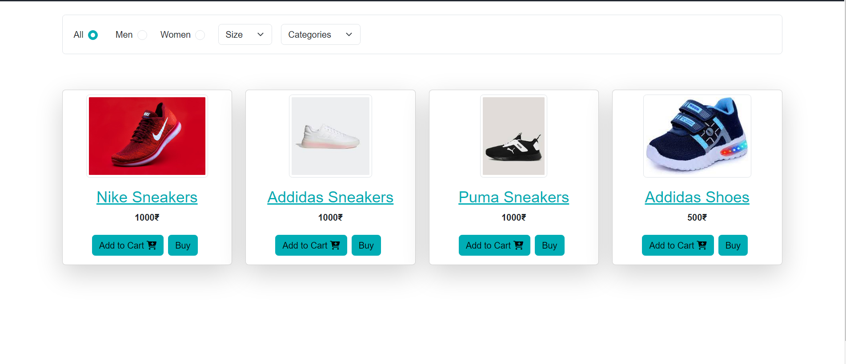

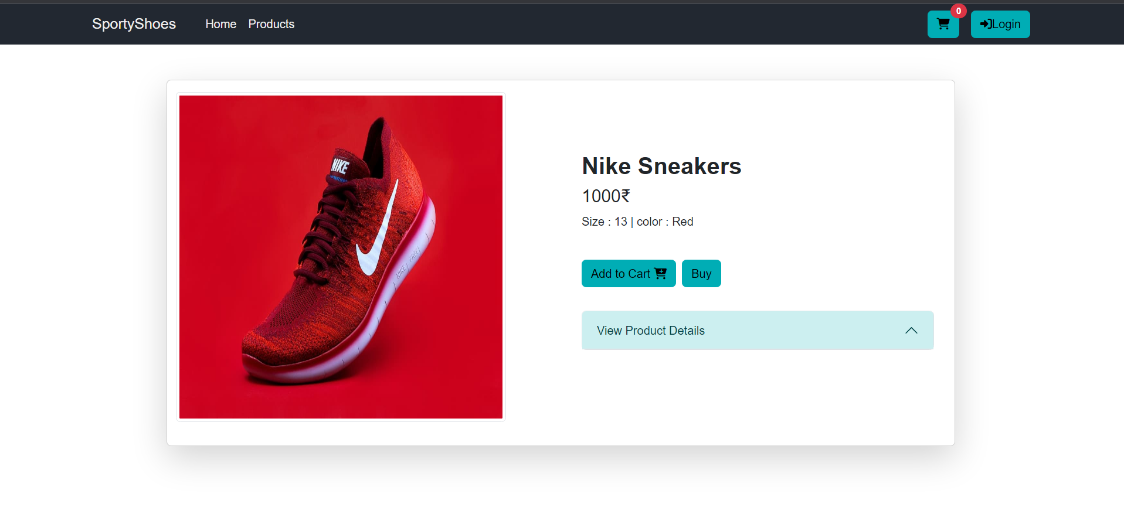

## **Login Page for Both user as well as admin**

## 

## **If user logs in**



## **If Admin logs in**

## 

## **Cart page**

## 

## **Order successful page**

## 