Day9

Thirumal.A

727721eucs171

1)

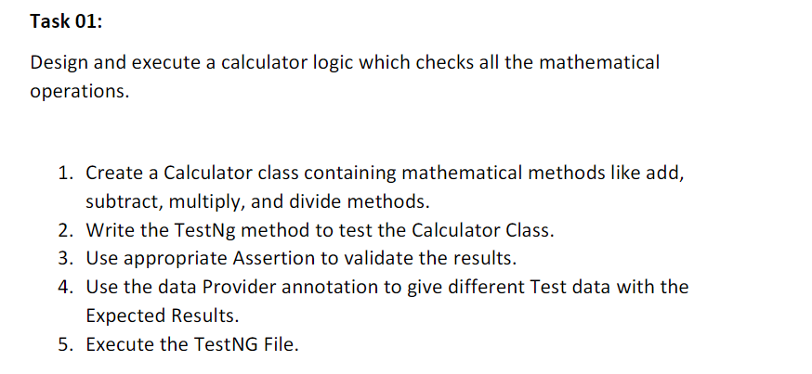

Coding:

package Day9;

import org.testng.annotations.Test;

import org.testng.annotations.DataProvider;

public class CE1 {

@Test(dataProvider = "dp")

public void add(Integer n1, Integer n2) {

System.out.println("Add : "+(n1+n2));

}

@Test(dataProvider = "dp")

public void sub(Integer n1,Integer n2) {

System.out.println("Sub : "+(n1-n2));

}

@Test(dataProvider = "dp")

public void mul(Integer n1,Integer n2) {

System.out.println("Mul : "+(n1*n2));

}

@Test(dataProvider = "dp")

public void div(Integer n1,Integer n2) {

System.out.println("DIv : "+(n1/n2));

}

@DataProvider

public Object[][] dp() {

return new Object[][] {

new Object[] { 40, 10 },

new Object[] { 200, 20 },

};

}

}

Output:

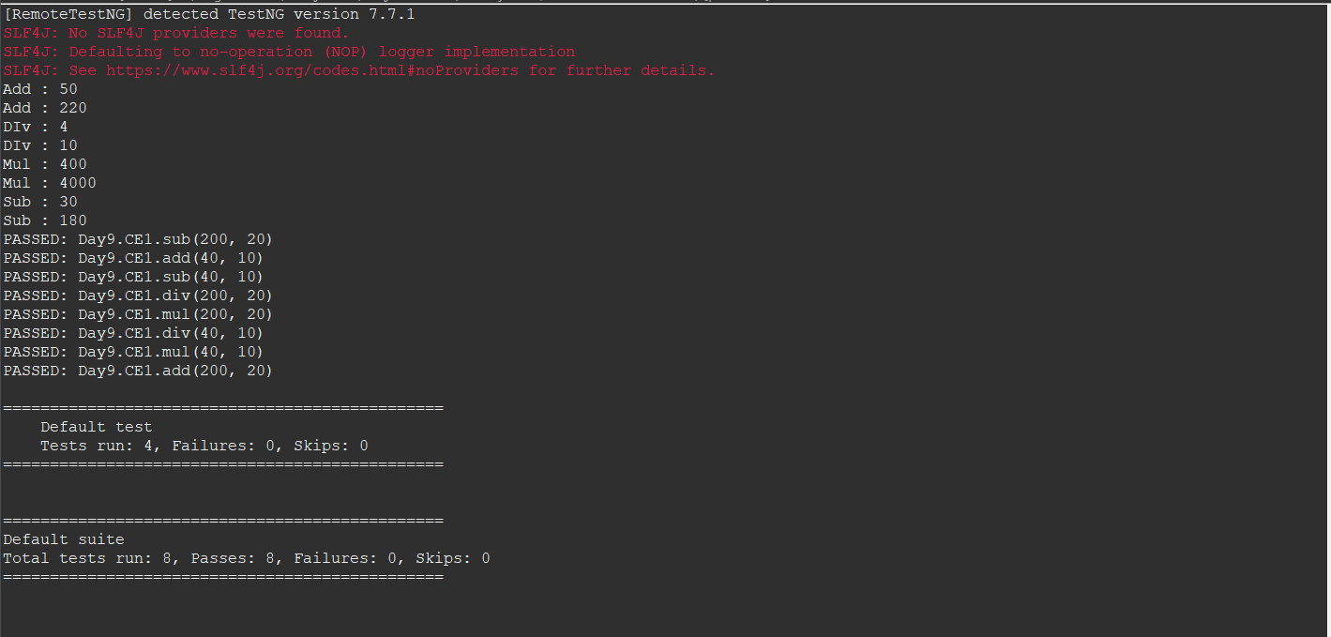

2 & 3)

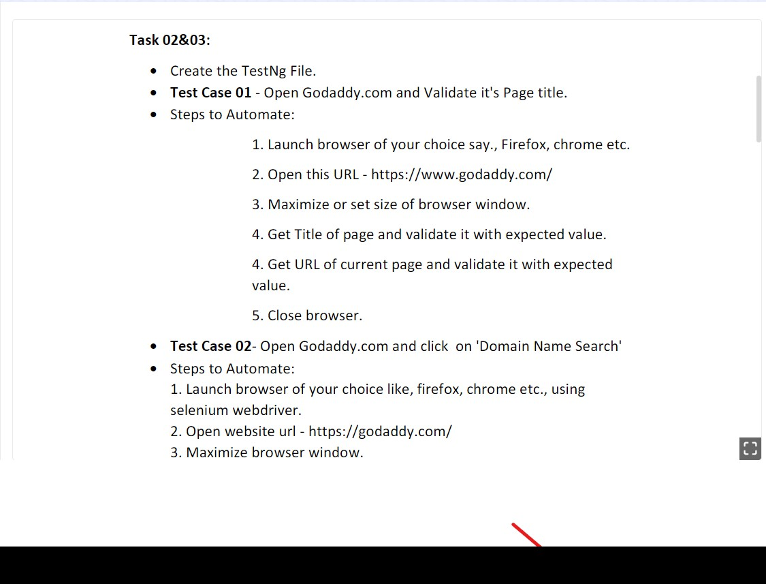

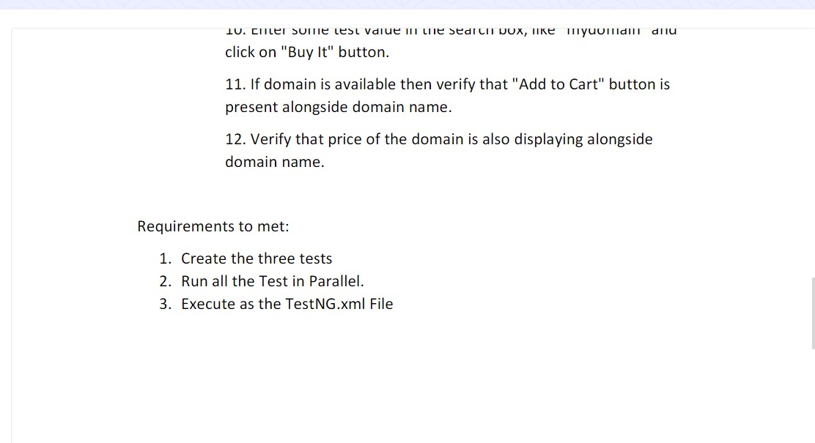

Coding:

package Day9;

import org.testng.annotations.Test;

import io.github.bonigarcia.wdm.WebDriverManager;

import org.testng.annotations.BeforeMethod;

import java.util.concurrent.TimeUnit;

import org.openqa.selenium.By;

import org.openqa.selenium.WebDriver;

import org.openqa.selenium.WebElement;

import org.openqa.selenium.chrome.ChromeDriver;

import org.openqa.selenium.chrome.ChromeOptions;

import org.testng.Assert;

import org.testng.annotations.AfterMethod;

public class CE2 {

WebDriver driver;

*@Test*

public void case1() {

String text = driver.getTitle();

String expected="Domain Names, Websites, Hosting & Online Marketing Tools - GoDaddy IN";

Assert.*assertEquals*(text,expected);

System.***out***.print("Both the title are Matched");

}

*@SuppressWarnings*("deprecation")

*@Test*

public void case2() throws InterruptedException

{

driver.manage().timeouts().~~implicitlyWait~~(3000, *TimeUnit*.***MILLISECONDS***);

driver.findElement(By.*xpath*("/html/body/header/div/section/div/div[1]/nav/div[2]/div[1]/ul/li[1]/button")).click();

Thread.*sleep*(2000);

driver.findElement(By.*xpath*("/html/body/header/div/section/div/div[1]/nav/div[2]/div[1]/ul/li[1]/div/div[2]/div[1]/ul/li[2]/a")).click();

Thread.*sleep*(3000);

System.***out***.println("Test case 2 Success");

}

*@Test*

public void case3() throws InterruptedException {

driver.findElement(By.*xpath*("/html/body/header/div/section/div/div[1]/nav/div[2]/div[1]/ul/li[1]/button")).click();

Thread.*sleep*(3000);

driver.findElement(By.*xpath*("/html/body/header/div/section/div/div[1]/nav/div[2]/div[1]/ul/li[1]/div/div[2]/div[1]/ul/li[2]/a")).click();

Thread.*sleep*(3000);

String tit = "Domain Names, Websites, Hosting & Online Marketing Tools - GoDaddy IN";

String exp = driver.getTitle();

Assert.*assertEquals*(tit, exp);

System.***out***.println(exp);

Thread.*sleep*(3000);

WebElement search = driver.findElement(By.*xpath*("//*[@id=\"8469f0c3-e08f-4343-9756-ce0390b0d581\"]"));

search.isDisplayed();

System.***out***.println("Search Bar Checked");

WebElement buy = driver.findElement(By.*xpath*("/html/body/main/section[1]/section/section/div/div/section/div/div[1]/div/div/div[2]/button"));

buy.isDisplayed();

System.***out***.println("Buy Checked");

Thread.*sleep*(3000);

driver.findElement(By.*xpath*("//*[@id=\"8469f0c3-e08f-4343-9756-ce0390b0d581\"]")).sendKeys("site");

Thread.*sleep*(10000);

driver.findElement(By.*xpath*("/html/body/main/section[1]/section/section/div/div/section/div/div[1]/div/div/div[2]/button")).click();

Thread.*sleep*(25000);

WebElement cart = driver.findElement(By.*xpath*("//*[@id=\"hcCartIcon\"]"));

cart.isDisplayed();

System.***out***.println("Cart checked");

Thread.*sleep*(3000);

WebElement price = driver.findElement(By.*xpath*("/html/body/main/div/div/div/div/div[2]/div[1]/div[1]/div[1]/div/div[1]/div[2]/div[1]/div/span/span"));

System.***out***.println(price.getText());

}

*@BeforeMethod*

public void beforeClass() throws InterruptedException {

ChromeOptions co=new ChromeOptions();

co.addArguments("--remote-allo w-origins=*");

WebDriverManager.*chromedriver*().setup();

driver=new ChromeDriver();

driver.get("https://www.godaddy.com/");

driver.manage().window().maximize();

Thread.*sleep*(6000);

}

*@AfterMethod*

public void afterClass() throws InterruptedException {

Thread.*sleep*(6000);

driver.close();

}

}

XML File:

<?xml version="1.0" encoding="UTF-8"?>

<suite parallel="methods" name="Suite">

<test name="Test">

<classes>

<class name="Day9.CE2" />

</classes>

</test> <!-- Test -->

</suite> <!-- Suite -->

Output:

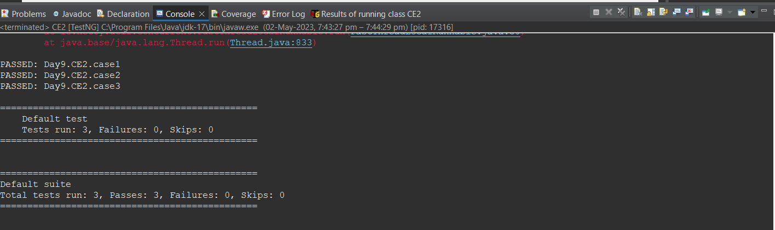

4)

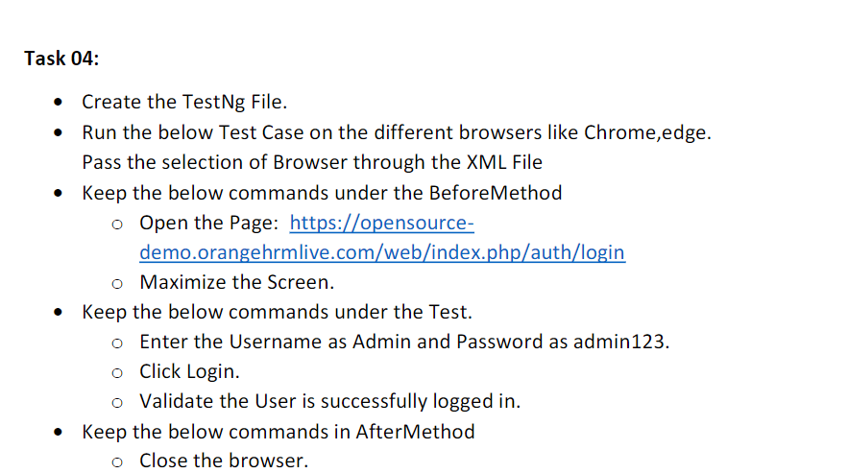

Coding:

package Day9;

import org.testng.annotations.Test;

import io.github.bonigarcia.wdm.WebDriverManager;

import org.testng.annotations.BeforeMethod;

import org.testng.annotations.Parameters;

import org.openqa.selenium.By;

import org.openqa.selenium.WebDriver;

import org.openqa.selenium.chrome.ChromeDriver;

import org.openqa.selenium.chrome.ChromeOptions;

import org.openqa.selenium.edge.EdgeDriver;

import org.openqa.selenium.edge.EdgeOptions;

import org.testng.Assert;

import org.testng.annotations.AfterMethod;

public class CE4 {

WebDriver driver;

@Test

public void url() throws InterruptedException {

driver.findElement(By.xpath("/html/body/div/div[1]/div/div[1]/div/div[2]/div[2]/form/div[1]/div/div[2]/input")).sendKeys("Admin");

Thread.sleep(4000);

driver.findElement(By.xpath("/html/body/div/div[1]/div/div[1]/div/div[2]/div[2]/form/div[2]/div/div[2]/input")).sendKeys("admin123");

Thread.sleep(3000);

driver.findElement(By.xpath("/html/body/div/div[1]/div/div[1]/div/div[2]/div[2]/form/div[3]/button")).click();

Thread.sleep(3000);

String txt = "Dashboard";

String login = driver.findElement(By.xpath("/html/body/div/div[1]/div[1]/header/div[1]/div[1]/span/h6")).getText();

Assert.assertEquals(txt, login);

}

@Parameters({"browser"})

@BeforeMethod

public void beforeMethod(String browser1) throws InterruptedException {

if(browser1.equals("chrome")) {

ChromeOptions co=new ChromeOptions();

co.addArguments("--remote-allow-origins=*");

WebDriverManager.chromedriver().setup();

driver=new ChromeDriver();

driver.get("https://opensource-demo.orangehrmlive.com/web/index.php/auth/login");

driver.manage().window().maximize();

Thread.sleep(6000);

}

else if(browser1.equals("edge")) {

EdgeOptions co=new EdgeOptions();

co.addArguments("--remote-allow-origins=*");

WebDriverManager.edgedriver().setup();

driver=new EdgeDriver();

driver.get("https://opensource-demo.orangehrmlive.com/web/index.php/auth/login");

driver.manage().window().maximize();

Thread.sleep(6000);

}

}

@AfterMethod

public void afterMethod() {

driver.close();

}

}

XML file:

<?xml version="1.0" encoding="UTF-8"?>

<!DOCTYPE suite SYSTEM "https://testng.org/testng-1.0.dtd">

<suite parallel="false" name="Suite">

<test name="Test">

<classes>

<class name="Day9.CE4"/>

<parameter name = "browser" value="edge"></parameter>

</classes>

</test> <!-- Test -->

</suite> <!-- Suite -->

Output:

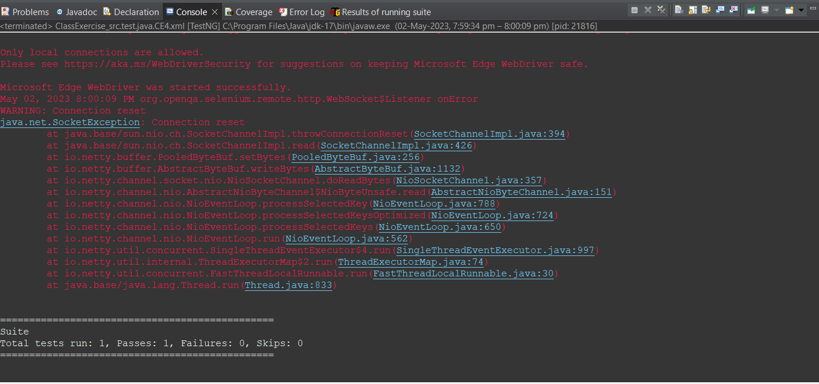

5)

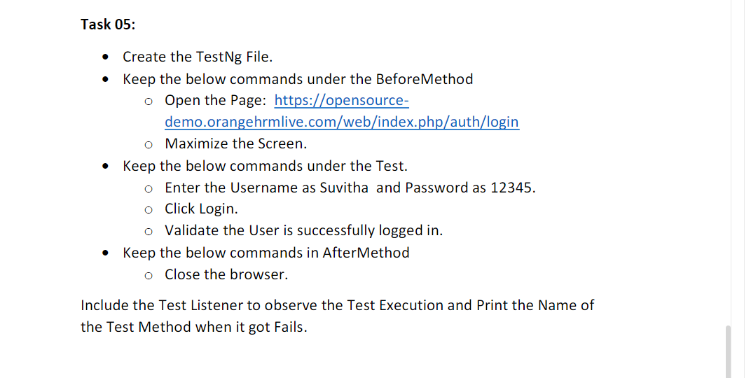

Coding:

package Day9;

import org.testng.annotations.Test;

import io.github.bonigarcia.wdm.WebDriverManager;

import org.testng.annotations.BeforeMethod;

import org.openqa.selenium.By;

import org.openqa.selenium.WebDriver;

import org.openqa.selenium.edge.EdgeDriver;

import org.openqa.selenium.edge.EdgeOptions;

import org.testng.Assert;

import org.testng.annotations.AfterMethod;

public class CE5 {

WebDriver driver;

@Test

public void url() throws InterruptedException {

driver.findElement(By.xpath("/html/body/div/div[1]/div/div[1]/div/div[2]/div[2]/form/div[1]/div/div[2]/input")).sendKeys("Suvitha");

Thread.sleep(4000);

driver.findElement(By.xpath("/html/body/div/div[1]/div/div[1]/div/div[2]/div[2]/form/div[2]/div/div[2]/input")).sendKeys("12345");

Thread.sleep(3000);

driver.findElement(By.xpath("/html/body/div/div[1]/div/div[1]/div/div[2]/div[2]/form/div[3]/button")).click();

Thread.sleep(3000);

String txt = "Dashboard";

String login = driver.findElement(By.xpath("/html/body/div/div[1]/div[1]/header/div[1]/div[1]/span/h6")).getText();

Assert.assertEquals(txt, login);

}

@BeforeMethod

public void beforeMethod() throws InterruptedException {

EdgeOptions co=new EdgeOptions();

co.addArguments("--remote-allow-origins=*");

WebDriverManager.edgedriver().setup();

driver=new EdgeDriver();

driver.get("https://opensource-demo.orangehrmlive.com/web/index.php/auth/login");

driver.manage().window().maximize();

Thread.sleep(6000);

}

@AfterMethod

public void afterMethod() {

driver.close();

}

}

XML file:

<?xml version="1.0" encoding="UTF-8"?>

<!DOCTYPE suite SYSTEM "https://testng.org/testng-1.0.dtd">

<suite parallel="false" name="Suite">

<listeners>

<listener class-name="Day9.Listener1"></listener></listeners>

<test name="Test">

<classes>

<class name="Day9.CE5"/>

</classes>

</test> <!-- Test -->

</suite> <!-- Suite -->

Listener file:

package Day9;

import org.testng.ITestContext;

import org.testng.ITestListener;

import org.testng.ITestResult;

public class Listener1 implements ITestListener{

public void onFinish(ITestContext context) {

// TODO Auto-generated method stub

}

public void onStart(ITestContext context) {

// TODO Auto-generated method stub

System.out.println("On Start"+context.getName());

}

public void onTestFailedButWithinSuccessPercentage(ITestResult result) {

// TODO Auto-generated method stub

System.out.println("onTestFailedButWithinSuccessPercentage"+result.getName());

}

public void onTestFailedWithTimeout(ITestResult result) {

// TODO Auto-generated method stub

System.out.println("onTestFailedWithTimeout"+result.getName());

}

public void onTestFailure(ITestResult result) {

// TODO Auto-generated method stub

System.out.println("onTestFailure"+result.getName());

}

public void onTestSkipped(ITestResult result) {

// TODO Auto-generated method stub

System.out.println("onTestSkipped"+result.getName());

}

public void onTestStart(ITestResult result) {

// TODO Auto-generated method stub

System.out.print("On test start"+result.getTestName());

}

public void onTestSuccess(ITestResult result) {

// TODO Auto-generated method stub

System.out.print("onTestSuccess"+result.getTestName());

}

}

Output:

