**AIM:** **Android application is to allow users to set and cancel an alarm using a TimePicker and a ToggleButton.**

EXP NO: Add3

DATE:

TITLE : Application for Alarm

**MainActivity.java**:

import android.os.Bundle;  
import android.widget.CompoundButton;  
import android.widget.TimePicker;  
import android.widget.ToggleButton;  
  
import androidx.appcompat.app.AppCompatActivity;  
public class MainActivity extends AppCompatActivity {

private TimePicker timePicker;  
    private ToggleButton alarmToggle;  
  
    @Override  
    protected void onCreate(Bundle savedInstanceState) {  
        super.onCreate(savedInstanceState);  
        setContentView(R.layout.*activity_main*);  
          
        timePicker = findViewById(R.id.*timePicker*);  
        alarmToggle = findViewById(R.id.*alarmToggle*);  
          
        alarmToggle.setOnCheckedChangeListener(new CompoundButton.OnCheckedChangeListener() {  
            @Override

public void onCheckedChanged(CompoundButton buttonView, boolean isChecked) {  
                if (isChecked) {  
                    setAlarm();  
                } else {  
                    cancelAlarm();  
                }  
            }  
        });  
    }  
  
    private void setAlarm() {  
        int hour = timePicker.getCurrentHour();  
        int minute = timePicker.getCurrentMinute();  
          
    }  
  
    private void cancelAlarm() {  
    }  
}

Roll NO: 229X1A3311

**activity_main.xml:**

?xml version="1.0" encoding="utf-8"?>  
<androidx.constraintlayout.widget.ConstraintLayout xmlns:android="http://schemas.android.com/apk/res/android"  
    xmlns:app="http://schemas.android.com/apk/res-auto"  
    xmlns:tools="http://schemas.android.com/tools"  
    android:layout_width="match_parent"  
    android:layout_height="match_parent">

<TimePicker  
        android:id="@+id/timePicker"  
        android:layout_width="wrap_content"  
        android:layout_height="wrap_content"  
        android:layout_marginTop="50dp"  
        app:layout_constraintEnd_toEndOf="parent"  
        app:layout_constraintStart_toStartOf="parent"  
        app:layout_constraintTop_toTopOf="parent" />  
  
    <ToggleButton  
        android:id="@+id/alarmToggle"  
        android:layout_width="wrap_content"  
        android:layout_height="wrap_content"  
        android:layout_marginTop="20dp"  
        android:text="Alarm On"  
        android:textOff="Alarm Off"  
        app:layout_constraintBottom_toBottomOf="parent"  
        app:layout_constraintEnd_toEndOf="parent"  
        app:layout_constraintStart_toStartOf="parent"  
        app:layout_constraintTop_toBottomOf="@id/timePicker" />  
  
</androidx.constraintlayout.widget.ConstraintLayout>

Roll NO: 229X1A3311

**Output:**

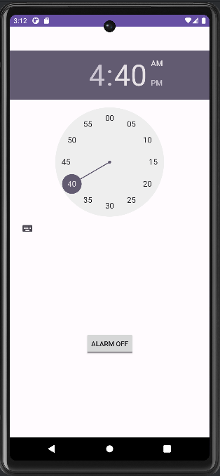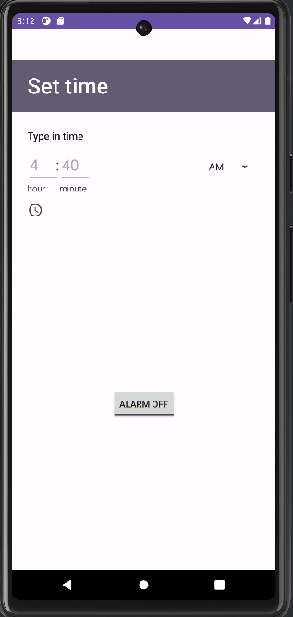

Roll NO: 229X1A3311

ROLL NO: 229X1A3311