**Bus Booking System**

**Technical Design Document**

|  |  |  |  |
| --- | --- | --- | --- |
|  | **Prepared By / Last Updated By** | **Reviewed By** | **Approved By** |
| **Name** | 1. Thirumanikandan Rajasekar  2. Sameera Hussainar  3.Gibi John |  |  |
| **Role** | POD Leader  POD Member  POD Member |  |  |
| **Signature** |  |  |  |
| **Date** |  |  |  |

**Table of Contents**

**1.0 Introduction** **3**

**1.1 Purpose of this document** **3**

**1.2 Project overview** **3**

**2.0 Solution Summary** **3**

**2.1 Scope** **3**

**2.2 Assumptions** **3**

**2.3 Dependencies** **4**

**2.4 Risks** **4**

**3.0 Schematic Diagram** **5**

**4.0 System Design** **6**

**4.1 Proposed design** **6**

**4.2 Component inventory** **6**

**5.0 Database Design** **7**

**5.1 Data Model** **7**

**5.2 Tables Structure** **8**

**6.0 Appendices** **9**

**6.1 Glossary** **9**

**6.2 Other** **9**

**7.0 Terms & Conditions** **9**

**8.0 Change Log** **9**

# 

# 1.0 Introduction

## 1.0 Purpose of this document

The purpose of this document is to document the technical design, component details and Database design. This will also capture the scope, assumptions, risk, dependencies of this project.

## Project overview

The main objective of bus booking system is to manage the details of bus, ticket booking and seats.It manage all the information about bus , customer and seats.This project is totally built at administrative end and thus only the administrator is guaranteed the access.The purpose of the project is to built an application program to reduce the manual work managing the bus booking .

# 2.0 Solution Summary

## 2.0 Scope

This reservation system has three parts. First it helps the customer to enquire the availability of seats in a particular bus at particular date, the second part helps them to reserve the ticket and with third module they can cancel a reserved ticket .The current bus booking system relies on buying the tickets from conductor for commuting to and from a location through public transportation .This task is tedious if the number of commuters is large .So this system will be easy for all the commuters to travel through public transportation .

## 2.1 Assumptions

* Administrators have access to add and remove user in database.
* Administrator and User can login with their credentials.
* Administrators can add vehicle, bus details and driver details.
* Users have access to cancel the ticket within given time period.

## 2.2 Dependencies

1. Hardware Requirement:

● Developer Laptop with 16GB RAM

1. Software Requirement:
   * Springboot
   * MySQL
   * Docker
   * AWS - ECS

## 2.3 Risks

* As its web portal, Security features might not be implemented.
* As all developers are new, might not be able to complete all modules.
* Any problem in module integration may be collapse the whole project.

# 3.0 Schematic Diagram

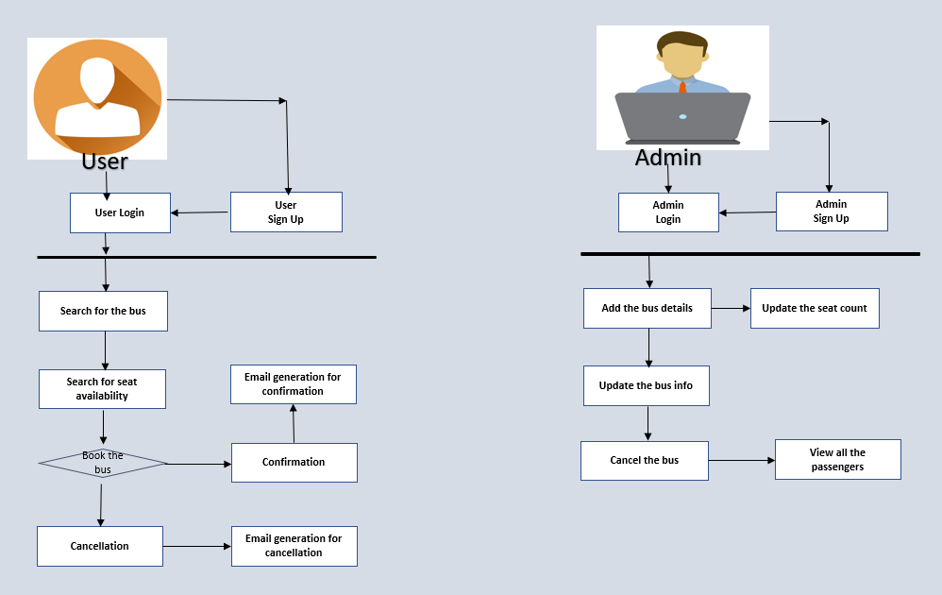

# 4.0 System Design

## 4.0 Proposed design

1. **Admin Module:**
   * Admin Login - After successful login with username and password. Admin will be redirected to admin dashboard.
   * Admin is the key user of this entire bus booking system.

.

* + Admin can add/update bus timing, amount, bus details and driver details.

1. **User Module:**
   * User land into Reservation dashboard when successfully logged in with correct username and password.
   * User can search for the bus by providing source and destination
   * Modify reservation or cancel a particular reservation within the given period of time.

## 4.1 Component inventory

**● Components:**

1. Administrator
2. User

# 

# 5.0 Database Design

## 5.0 Data Model

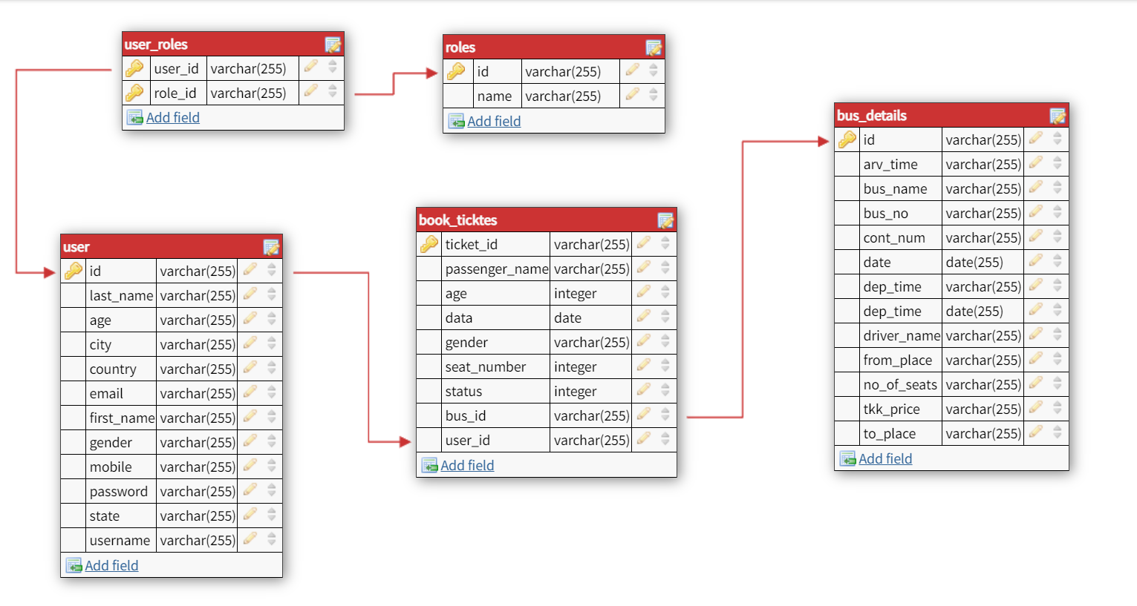

# 6.0 Appendices

## 6.0 Glossary

|  |  |
| --- | --- |
| **Acronyms** | **Definitions** |
| BBS | Bus Booking System |

## 

# 7.0 Terms & Conditions

***Disclaimer: Please do not circulate or distribute this document outside of***

***UST Network, We have a Zero Tolerance Policy. Kindly adhere to 100%***

***Compliance at all times.***

# 8.0 Change Log

*Please note that this table needs to be maintained even if a Configuration Management tool is used.*

|  |  |  |  |  |
| --- | --- | --- | --- | --- |
|  | **Changes made** | | | |
| V<n.n> | *<If the change details are not explicitly documented in the table below, reference should be provided here>* | | | |
| Page no | Changed by | Effective date | Changes effected |
|  |  |  |  |
|  |  |  |  |
|  |  |  |  |
|  |  |  |  |