Ex.No. 9: Count time between two clicks using jquery
Aim
To write a jquery program to count the number of milliseconds between the two click events on a paragraph.
Source Code
Clickcount.html
<html>
<head>
<script src="https://code.jquery.com/jquery-1.10.2.js"></script>
<title>Count the number of milliseconds between the two click events on a paragraph</title>
</head>
<body bgcolor=”tan”>
<font size=”22”>
<p >Count the number of milliseconds between the two click events on a paragraph </p>
<div>Click on the above paragraph</div>
</font>
<script>
var lastt, tdiff;
$( "p" ).click(function( event ) { if (lastt) {
tdiff = event.timeStamp - lastt;
$( "div" ).append( "Time since last event: " + tdiff + "<br>" ); }
else {
$( "div" ).append( "<br>Click again.<br>" );}
lastt = event.timeStamp;});
</script>
</body>
</html>
Output
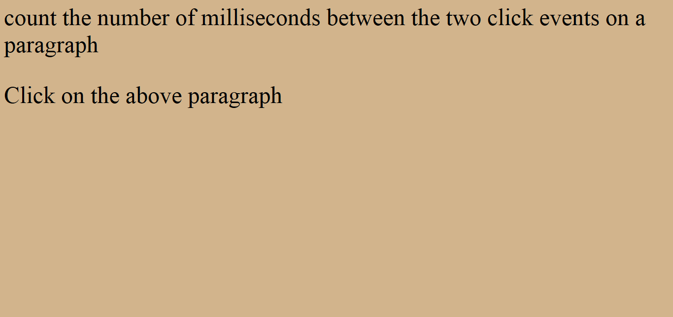

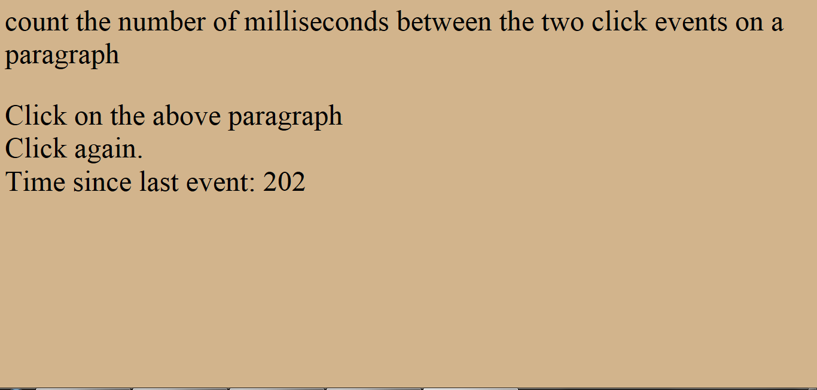

Result
Thus the jquery program to count the number of milliseconds between the two click events on a paragraph was written and executed successfully.

