**Note: Step 4 and 5 has the exact information for validating the sponsor entered password.**

1. Password field has required field validation.
2. The below method is called to check the password validity for Desmoines.

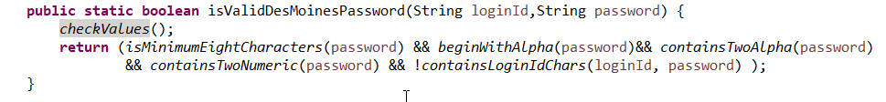

1. Before validate the sponsor entered password, We are checking the password configuration parameters

3.1 Minimum length and maximum length should be greater than zero

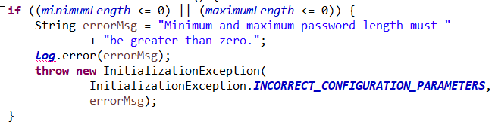

* 1. Maximum length should be greater than minimum length.

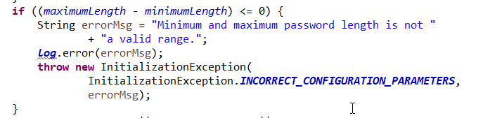

* 1. Confirming the Alphabetic, numeric and special character check

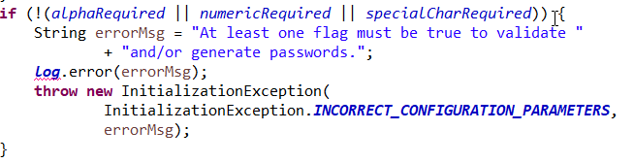

1. Validate the sponsor entered password

4.1. Password should have minimum 8 character length.



4.2. Password must begin with alpha character. 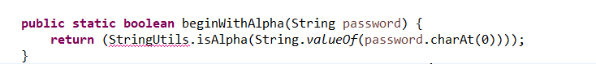

4.3 Password must contain minimum two alpha characters.

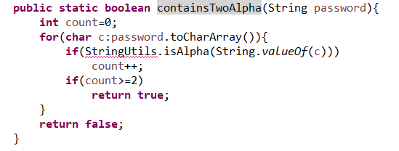

4.4 password must contain at least two numeric characters.

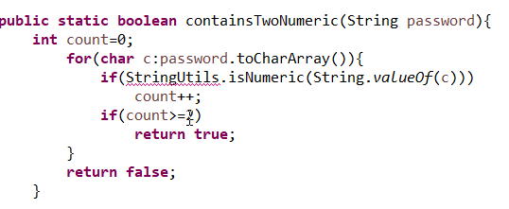

4.5. Password must not contain all or part of user account name

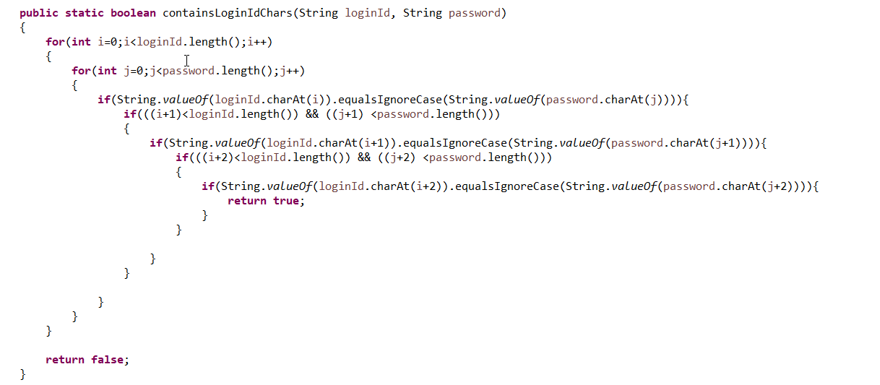

4.6 Password and confirm password equality check



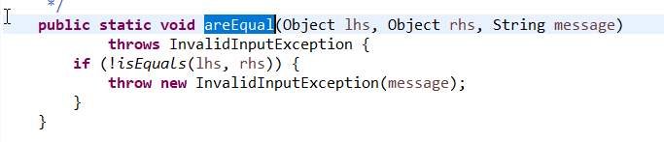

1. One extra logic is added for change password/reset password along with above validation.

5.1. Password cannot be similar to the previous four passwords.

