Multi-student face recognition attendance system

Haritha Kadali
Department of Computer Science and Engineering
Bapatla Engineering College
(Autonomous)
(Affiliated to Acharya Nagarjuna University)
Bapatla, India
kadaliharitha23@gmail.com
Nikitha Sree Sai Bathula
Department of Computer Science and Engineering
Bapatla Engineering College
(Autonomous)
(Affiliated to Acharya Nagarjuna University)
Bapatla, India
bnikithachowdary@gmail.com
Lakshmi Thirupathi Rao Dirisala
Department of Computer Science and Engineering
Bapatla Engineering College
(Autonomous)
(Affiliated to Acharya Nagarjuna University)
Bapatla, India
raot14693@gmail.com

Supriya Doppalapudi
Department of Computer Science and Engineering
Bapatla Engineering College
(Autonomous)
(Affiliated to Acharya Nagarjuna University)
Bapatla, India
Supriya.doppalapudi77@gmail.com

Abstract Our cutting-edge system redefines attendance management by leveraging advanced face recognition technology, tailored specifically for low-light conditions. Simultaneously capturing multiple students' faces, it ensures uninterrupted attendance tracking, minimizing classroom disruptions. Real-time processing guarantees swift and precise recording, alleviating administrative burdens and reducing errors. Its scalable design caters to varying class sizes and organizational structures, offering adaptability and flexibility. Integrated privacy measures ensure robust data security, while intuitive interfaces streamline operation for administrators and educators alike. Through seamless integration and user-centric design, our solution empowers educational institutions to optimize attendance management effortlessly. With a focus on efficiency, accuracy, and adaptability, it heralds a new era in attendance tracking technology, enhancing operational effectiveness and student engagement.
Keywords— cutting-edge system, face recognition technology, leveraging, , alleviating, accuracy, adaptability, flexibility.

Introduction
[1]According to the previous attendance management system, the accuracy of the datacollected is the biggest issue. This is because the attendance might not be recorded personally by the original person, in another word, the attendance of a particular person can be taken by a third party without the realization of the institution which violates the accuracy of the data. For example, student A is lazy to attend a particular class, so student B helped him/her to sign for the attendance which in fact student A didn‟t attend the class, but the system overlooked this matter due to no enforcement practiced. Supposing the institution establish an enforcement, it might need to waste a lot of human resource and time which in turn will not be practical at all. Thus, all the recorded attendance in the previous system is not reliable for analysis usage. The second problem of the previous system is where it is too time consuming. Assuming the time taken for a student to sign his/her attendance on a 3-4 paged name list is approximately 1 minute. In 1 hour, only approximately 60 students can sign their attendance which is obviously inefficient and time consuming. The third issue is with the accessibility of those information by the legitimate concerned party. For an example, most of the parents are very concerned to track their child‟s actual whereabouts to ensure their kid really attend the classes in college/school. However in the previous system, there are no ways for the parents to access such information. Therefore, evolution is needed to be done to the previous system to improve efficiency, data accuracy and provides accessibility to the information for those legitimate party.
Convert these matter into the existing system is it caputers single person at a time and it does not properly works in a low light conditions and in the proposed system captures multiple students at a time by this it decreases time complexity

Related Work
In this section, we provide the relevant background on previous work similar to the system. Recently sentiment
analysis is one such topic which is upgrading continuosly..
Our paper presents a Facial Recognition Attendance System developed using Python and OpenCV. Led by Dr. V Suresh, the system accurately identifies individuals in real-time, capturing facial images and matching them against a database. Accepted on March 5, 2020, our findings are published.
The work delves into the intricacies of attendance management systems, highlighting the prevalent issues faced due to manual recording practices and the absence of stringent enforcement measures Moreover, the time-consuming nature of manual attendance recording further compounds the inefficiencies of the existing systems, making them impractical for large-scale usage.In response to these challenges, our research endeavors to introduce a novel solution in the form of a facial recognition attendance system. By harnessing the capabilities of facial recognition technology, we aim to revolutionize the traditional attendance management process. This innovative system promises to streamline attendance tracking by automating the recording process, thereby mitigating the risks associated with manual data entry.Through the implementation of facial recognition technology, our objectives are twofold: to enhance the accuracy of attendance records and to improve accessibility for stakeholders such as educators, administrators, and parents. By eliminating the need for manual intervention, our system seeks to ensure data integrity while providing stakeholders with convenient access to attendance information. Ultimately, our project aspires to set new standards in attendance management, offering a seamless and efficient solution for educational institutions and organizations alike.

Proposed Model
Our proposed system employs cutting-edge face recognition algorithms and specialized hardware to capture multiple students' faces simultaneously, even in low-light conditions. Real-time processing ensures swift attendance recording, enhancing administrative efficiency. Additionally, the system automatically sends email notifications to parents for any student absences and delivers monthly performance reports to their mobile phones as text messages. With a focus on accuracy, reliability, and usability, this system represents a significant advancement in attendance management technology for educational institutions.[2]

The proposed model can be divided into following modules

User Interface:
This study introduces a comprehensive user interface design for a face recognition attendance system, featuring distinct login privileges for administrators, faculty members, and students. Administrators possess overarching control with rights to add faculty members, manage student records, and oversee system operations. Faculty members are empowered to add students, take attendance, and access attendance records. Students, with limited access, can view their own attendance history. Through this hierarchical access structure, the system optimizes administrative efficiency, empowers faculty members with attendance management capabilities, and provides students with personalized attendance insights.

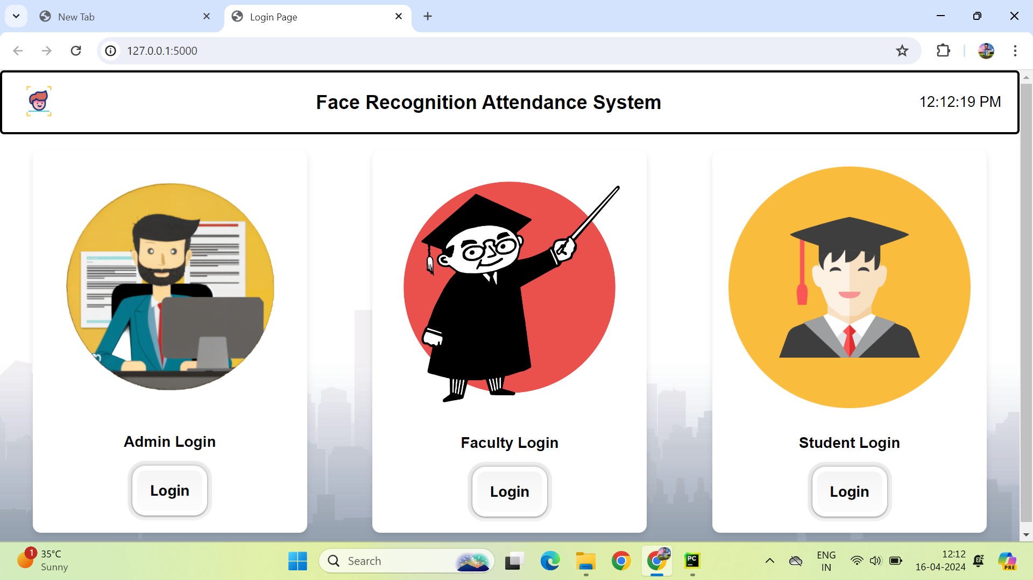

Feature Selection:
Ensure ethical compliance and collect images representing diverse demographics, lighting conditions, expressions, poses, and environmental factors. Annotate with identity labels, maintain data quality, and prioritize privacy. Split for validation and testing, using cross-validation techniques. By following these steps, a comprehensive dataset can train a facial recognition model to accurately represent real-world face diversity.

Data Processing and Sentiment Analysis:
To enhance the quality and standardize the collected images for training, various techniques are employed. [6] Normalization is applied to adjust the range of pixel values, ensuring consistency across images. Resizing is performed to standardize the dimensions, facilitating uniform processing by the model. Additionally, techniques like cropping, rotation, and color adjustment may be utilized to further enhance image quality and improve model performance. By preprocessing the data in this manner, the facial recognition model can be trained more effectively, leading to higher accuracy and robustness in real-world scenarios.

Recommendation Generation:
Recommendations for a face recognition attendance system include personalized attendance insights, automated alerts for irregular patterns, analysis of attendance data with academic performance metrics, predictive analytics for future trends, and integration with learning management systems for streamlined processes. User engagement through interactive dashboards and a feedback mechanism ensures continuous improvement, while compliance with data privacy regulations maintains security. These recommendations aim to enhance attendance management and support student success initiatives effectively.

The working model may be represented diagramatically as follows:
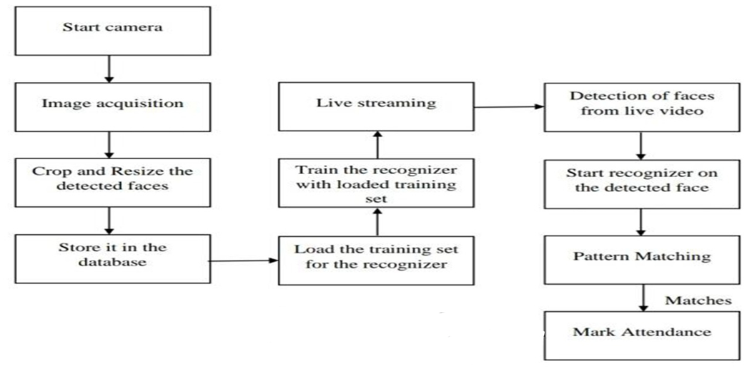

Experiments
Experiments for a face recognition attendance system involve a systematic approach beginning with data collection, where a diverse dataset of facial images is amassed, encompassing various demographics, lighting conditions, and facial expressions. Following data preprocessing to standardize and enhance image quality, relevant features are extracted using techniques such as facial landmark detection and deep learning-based methods. The chosen face recognition model is then trained and validated using cross-validation techniques to optimize performance and ensure robustness. Hyperparameter tuning is performed to fine-tune model parameters, balancing accuracy and efficiency. Subsequently, the trained model undergoes testing on a separate dataset to evaluate real-world effectiveness and performance metrics such as accuracy and precision. Scalability testing assesses the system's capability to handle varying workloads and organizational needs. Finally, user feedback is collected to inform iterative improvements, ensuring the system meets the requirements of educational institutions for accurate and efficient attendance tracking.

Dataset
Creating a dataset for a face recognition attendance system involves recruiting diverse participants and conducting photo sessions in varied lighting conditions to capture 10 photos dynamically. Participants are instructed to adjust expressions and poses between shots, ensuring dataset robustness. Encouraging diversity, participants wear different outfits and accessories. Privacy and consent are prioritized, with explicit participant consent obtained. The dataset is annotated with identity labels and undergoes preprocessing to standardize image sizes and quality. Quality control measures are applied, removing low-quality or redundant images. Finally, the dataset is documented and made available for research, respecting privacy and ethical considerations. Through this approach, a comprehensive dataset is created for training a face recognition attendance system.

Preprocessing
Preprocessing the collected images for training involves techniques like normalization and resizing to enhance quality and standardize them. Normalization adjusts the range of pixel values, ensuring consistency across images, while resizing standardizes dimensions, facilitating uniform processing by the model. Additionally, techniques such as cropping and rotation may be applied to further enhance image quality and improve model performance. By preprocessing the data in this manner, the facial recognition model can be trained more effectively, leading to higher accuracy and robustness in real-world scenarios.

Face Detection
To implement a face detection algorithm, two popular approaches are commonly used: Haar cascades and Histogram of Oriented Gradients (HOG). Haar cascades utilize a machine learning-based classifier to detect objects by sliding a window over an image and applying the classifier to identify predefined features. OpenCV provides pre-trained Haar cascade classifiers for face detection, enabling straightforward implementation. On the other hand, HOG is a feature descriptor technique that computes gradient histograms of image patches to identify regions with high gradient magnitudes and orientations characteristic of faces.
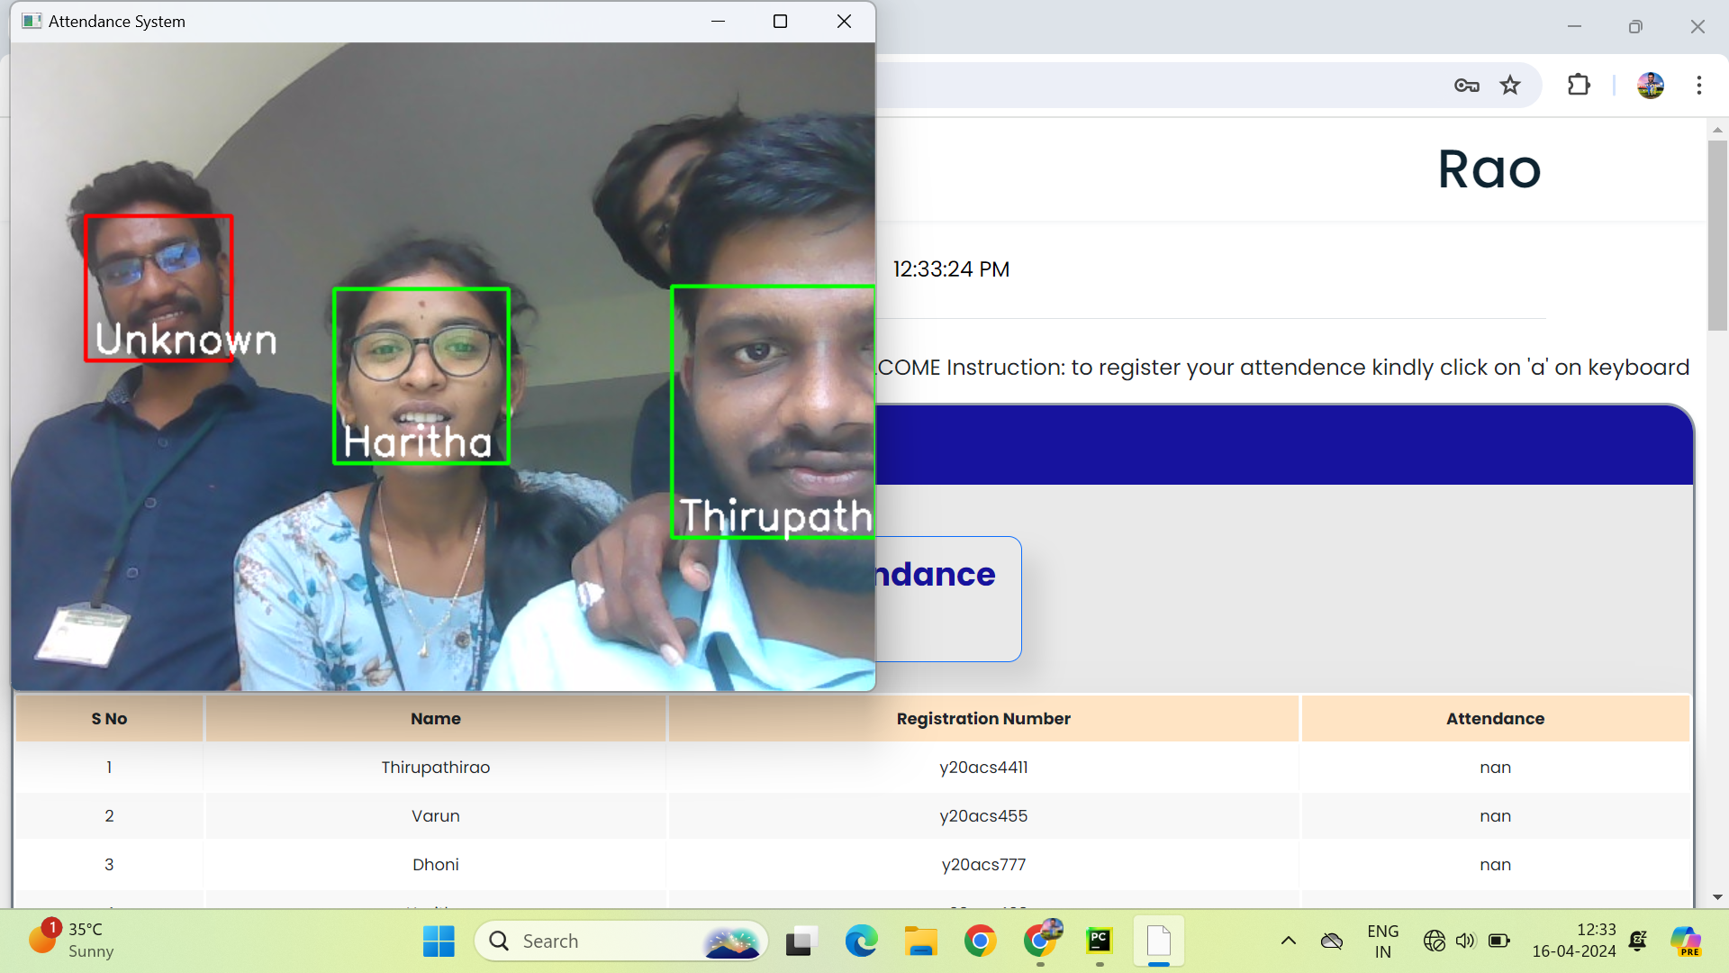

Libraries such as scikit-image or dlib offer pre-trained HOG detectors for face detection, which scan images at various scales and locations. While Haar cascades are faster, HOG-based detectors generally offer higher accuracy. By selecting the appropriate algorithm based on speed and accuracy requirements, developers can effectively implement face detection within images or video streams.

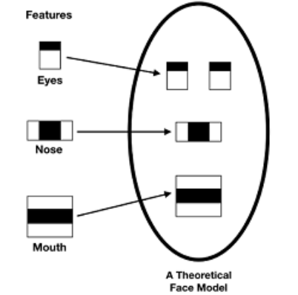

Feature Extraction
In feature extraction for face recognition using the Haar cascade algorithm, relevant characteristics are extracted from detected faces to facilitate subsequent recognition tasks. This method relies on predefined features, such as edges, corners, and textures, to detect faces within images or video streams. Once a face is detected, the algorithm extracts geometric features such as the position of eyes, nose, and mouth, providing spatial information crucial for alignment and identification. These facial landmarks serve as key points for further analysis and feature extraction. Additionally, the algorithm may capture textural patterns within facial regions, aiding in distinguishing between individuals. Overall, the Haar cascade algorithm's feature extraction process focuses on identifying and leveraging distinctive facial attributes to enable accurate and efficient face recognition.

Conclusion
In conclusion, the development of a face recognition attendance system represents a significant advancement in attendance management technology for educational institutions. By harnessing the power of facial recognition algorithms and sophisticated data processing techniques, such systems offer a seamless and efficient solution for tracking attendance in classrooms and other academic settings. Through a systematic approach encompassing data collection, preprocessing, model training, and validation, these systems can accurately identify individuals and record attendance in real-time, minimizing administrative burdens and improving operational efficiency. Furthermore, the integration of additional features such as personalized attendance insights, automated alerts, and predictive analytics enhances the system's functionality and utility, supporting proactive decision-making and student success initiatives. Overall, face recognition attendance systems represent a valuable tool for educational institutions seeking to streamline attendance management processes and enhance overall operational effectiveness.

Acknowledgment

The authors would like to thank Ass. Prof. Mrs. Karuna , Bapatla Engineering College, Bapatla for guiding throughout the work and the authors would also thank research paper writers for providing base to our Work

.References
[1]. “Attendance System Using NFC Technology with Embedded Camera on Mobile Device” (Bhise, Khichi, Korde,Lokare, 2023)

[2]. K.SenthamilSelvi, P.Chitrakala, A.AntonyJenitha, "Face Recognition Based Attendance Marking System", IJCSMC, Vol. 3, Issue.
2, February 2024.

[3]. “Fingerprint Based Attendance System Using Microcontroller and LabView” (Kumar Yadav, Singh, Pujari, Mishra, 2022)

[4]. “RFID based Student Attendance System” (Hussain, Dugar, Deka, Hannan, 2022)

[5]. OpenCvDocumentation -https://opencv.org

[6]. Numpy - https://numpy.org

