LAB Logbook

Lab 1
Week-1
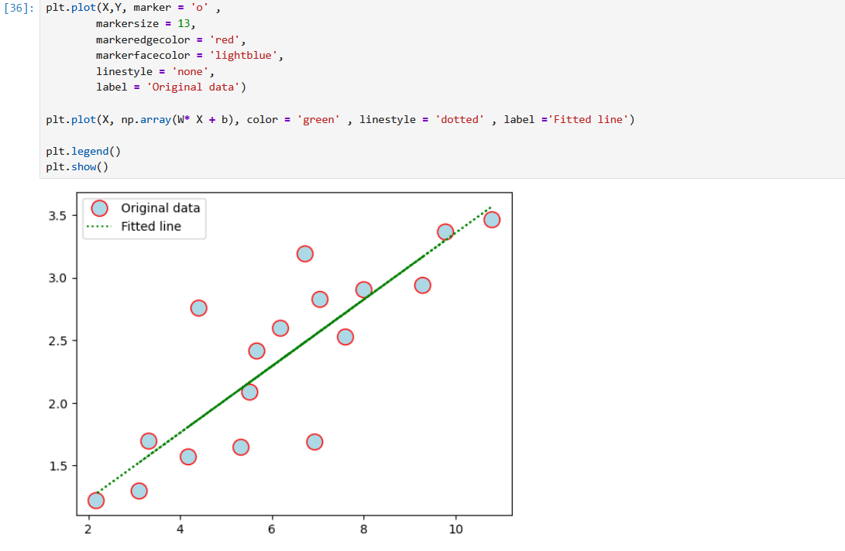

Lab 2
Week – 2:
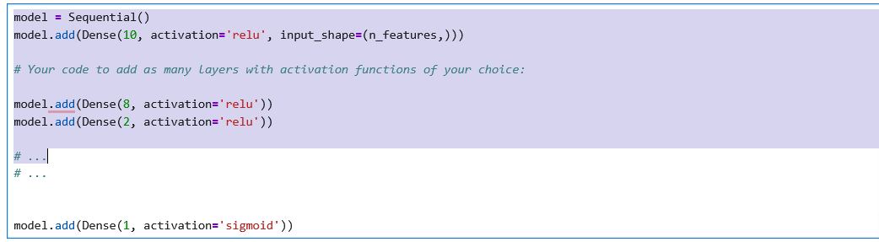
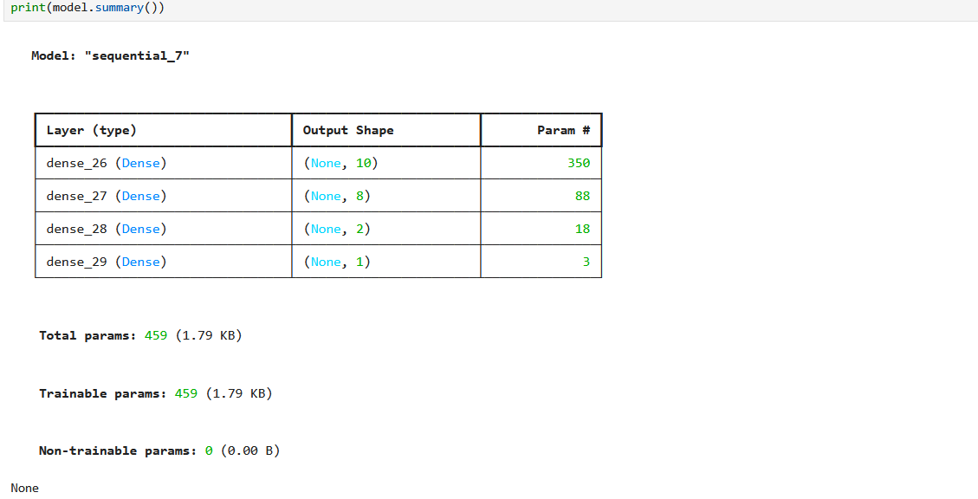

O1​=0.866
O2​=0.866​

Lab 3
Week-3
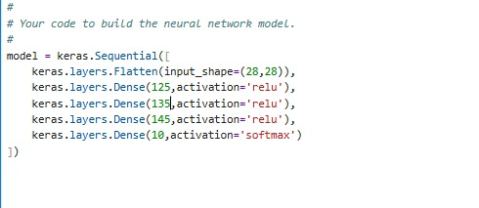
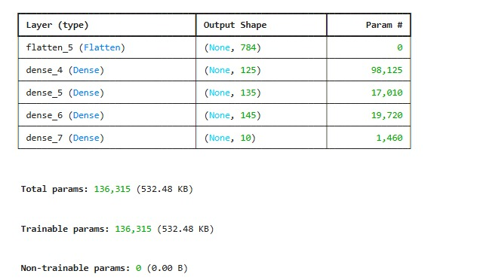
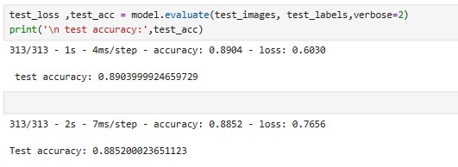
Lab 4
Lab 5

Lab 6

Lab 7

Lab 8

Lab 9

Lab 10

Lab 11

Lab 12

