📘 SOP: AWS 3-TIER ARCHITECTURE (PRODUCTION-STYLE)

🎯 AIM
To design and implement a highly available, scalable, and secure 3-tier architecture on AWS using native AWS services.

🧠 OVERVIEW
What is 3-Tier Architecture?
A 3-tier architecture separates an application into three layers:

🧱 Layers
🌐 1. Presentation Layer
Handles incoming user traffic
- DNS → Route53
- Load Balancer → ALB

⚙️ 2. Application Layer
Processes requests
- EC2 instances
- Auto Scaling Group (ASG)

🗄️ 3. Data Layer
Stores application data
- RDS (MySQL)

🔁 Request Flow
User → Route53 → ALB → ASG → EC2 → RDS → Response

🖼️ Architecture Diagram
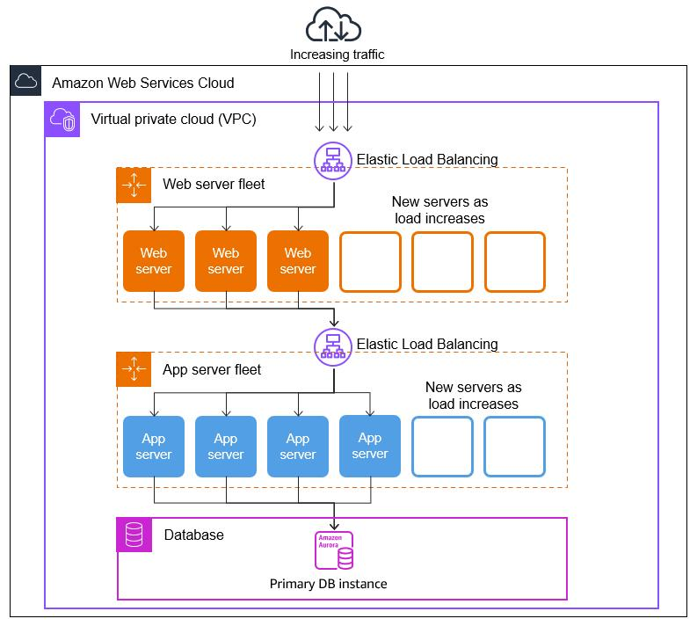
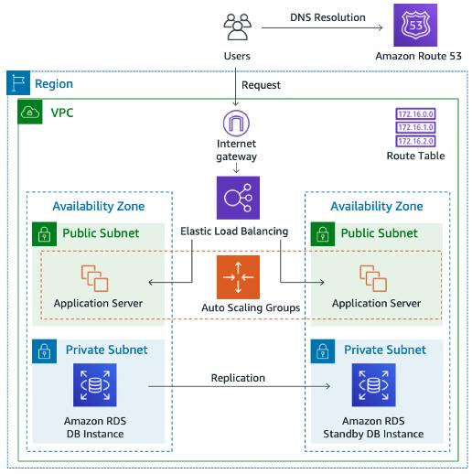
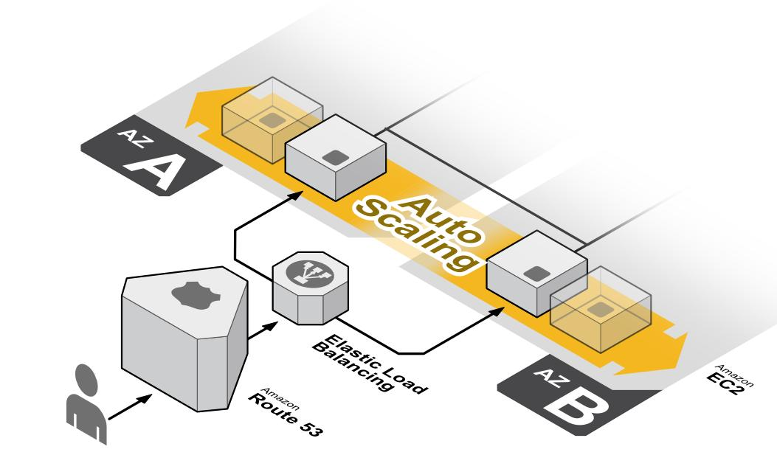
6

🧰 SERVICES USED
Service | Purpose
Route53 | DNS
ACM | SSL
ALB | Load balancing
ASG | Scaling
EC2 | App servers
RDS | Database
VPC | Networking

🏗️ IMPLEMENTATION (STEP-BY-STEP)

🔹 STEP 1: CREATE VPC
📍 VPC → Create VPC
Name: prod-vpc
CIDR: 10.0.0.0/16

➕ Create Subnets
Type | CIDR | AZ
Public-1 | 10.0.1.0/24 | AZ1
Public-2 | 10.0.2.0/24 | AZ2
Private-1 | 10.0.3.0/24 | AZ1
Private-2 | 10.0.4.0/24 | AZ2

🌐 Internet Gateway
- Create IGW
- Attach to VPC

📡 Route Tables
Public RT
0.0.0.0/0 → IGW
Attach to public subnets

Private RT
(No internet route)
Attach to private subnets

🖼️ Reference
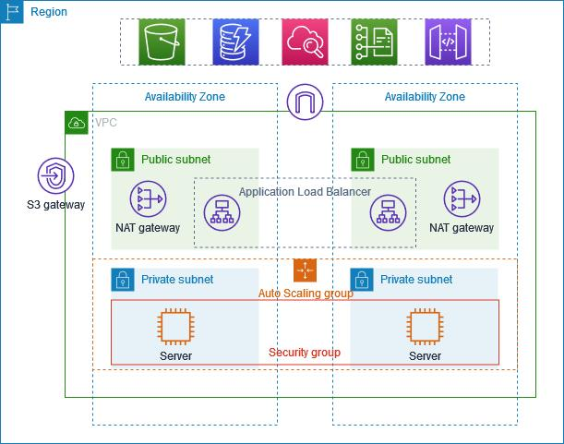
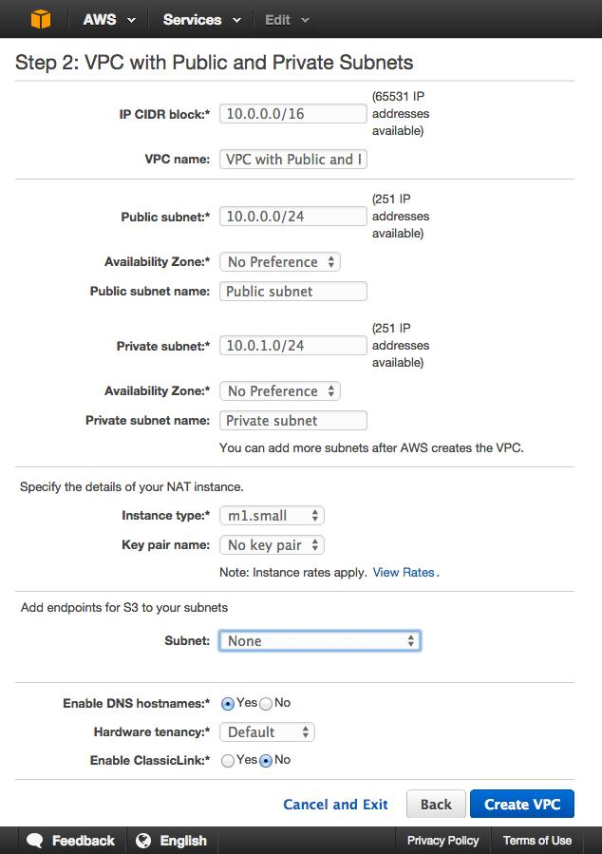
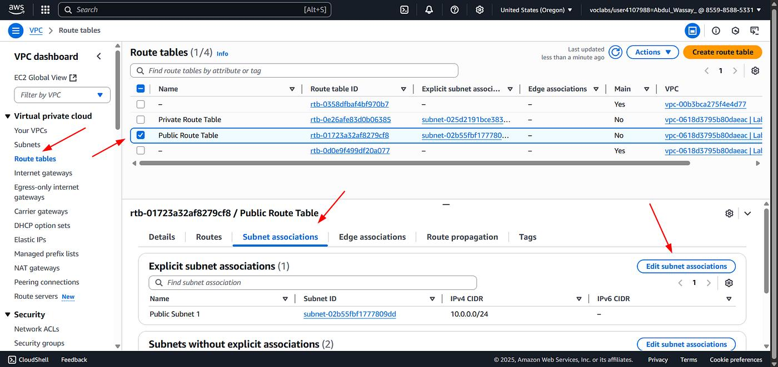
7

🔐 STEP 2: SECURITY GROUPS

ALB-SG
Inbound:
80 → 0.0.0.0/0
443 → 0.0.0.0/0

EC2-SG
Inbound:
80 → ALB-SG
22 → Your IP

RDS-SG
Inbound:
3306 → EC2-SG

🗄️ STEP 3: CREATE RDS (DATABASE)
📍 RDS → Create DB
Engine: MySQL
Public Access: NO
VPC: prod-vpc
Subnets: private
SG: RDS-SG

🖼️ Reference
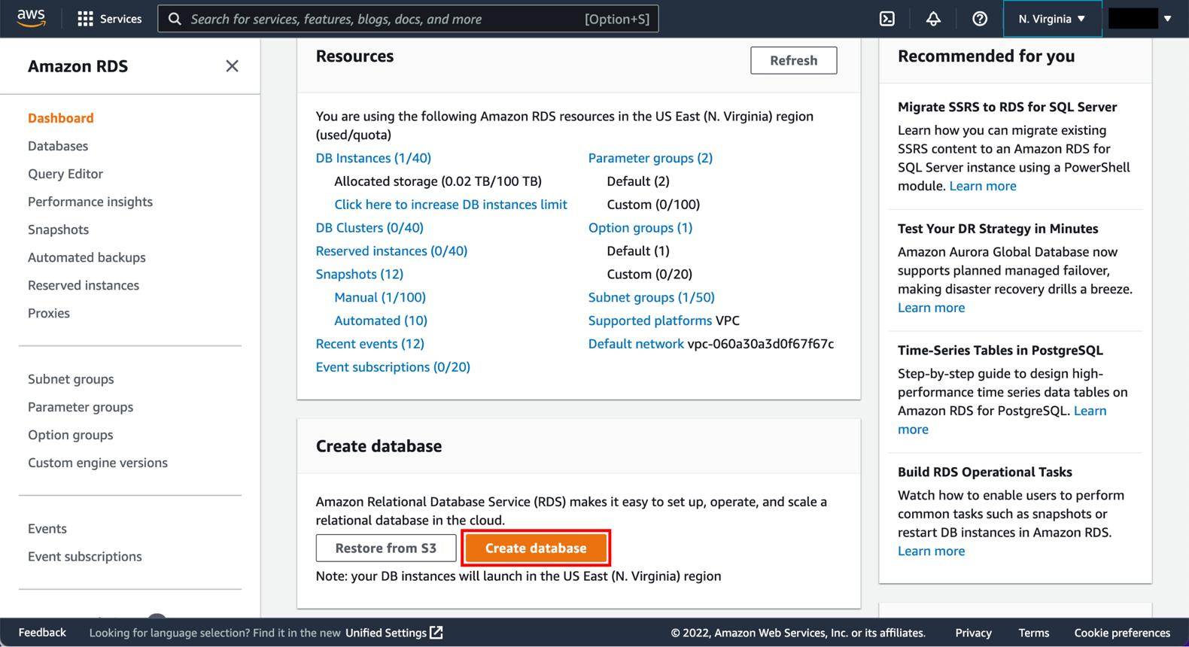
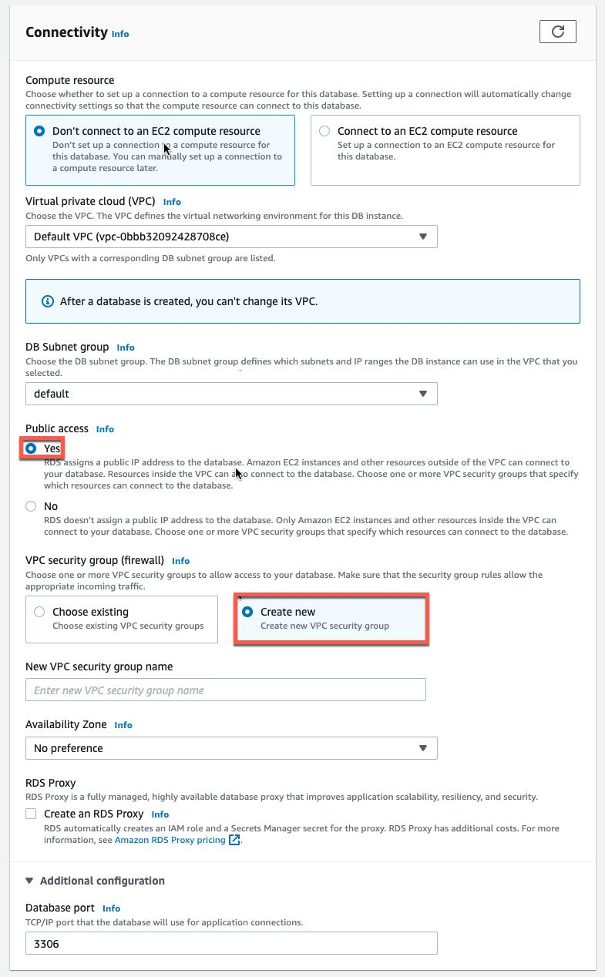
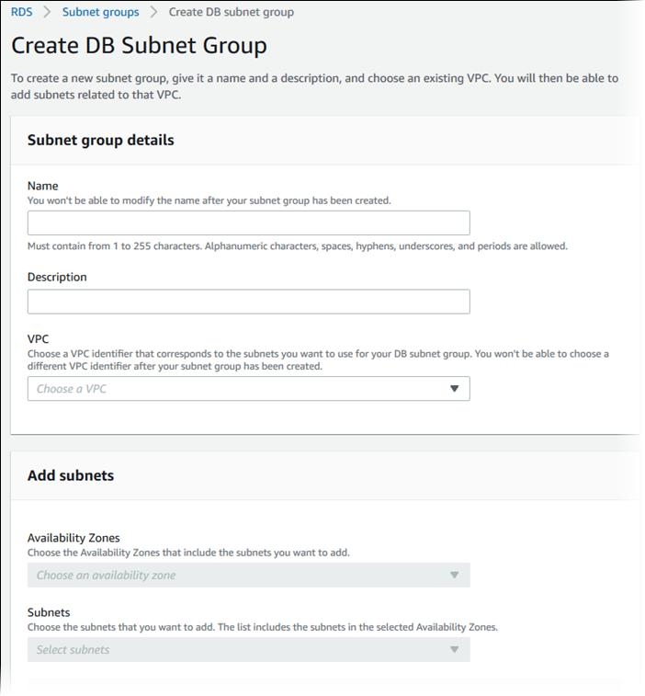
7

⚙️ STEP 4: CREATE LAUNCH TEMPLATE
📍 EC2 → Launch Templates

🛠️ Configuration
AMI: Amazon Linux 2
Instance: t2.micro
SG: EC2-SG

📜 User Data
#!/bin/bash
yum update -y
yum install -y httpd
echo "Hello from 3-tier $(hostname)" > /var/www/html/index.html
systemctl start httpd
systemctl enable httpd

📈 STEP 5: AUTO SCALING GROUP (WITH SCALING)

📍 Create ASG
Min: 1
Desired: 2
Max: 4
Subnets: Private

📊 Scaling Policy
Type: Target Tracking
Metric: CPU Utilization
Target: 50%

🧪 Test Scaling
sudo yum install stress -y
stress --cpu 2 --timeout 300

🖼️ Reference
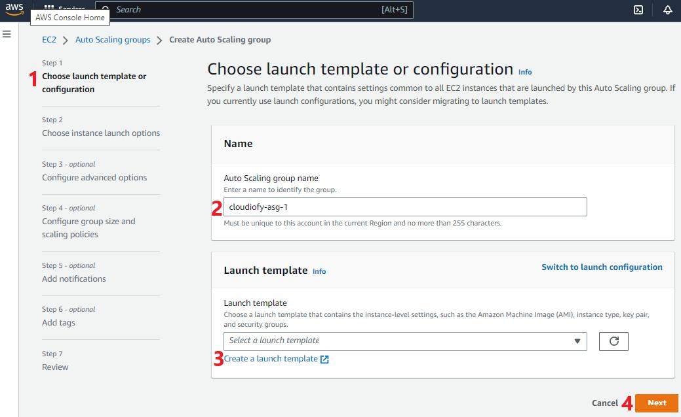
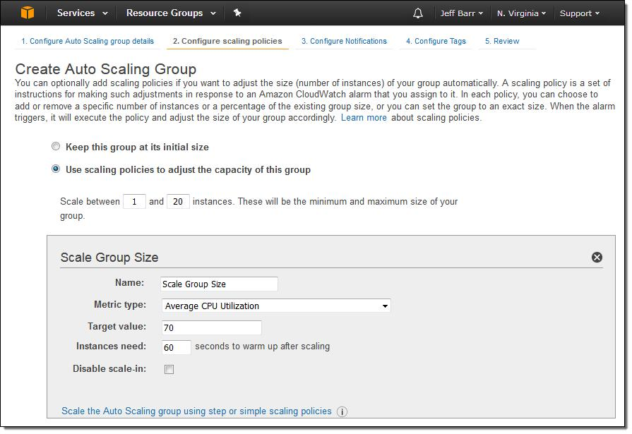
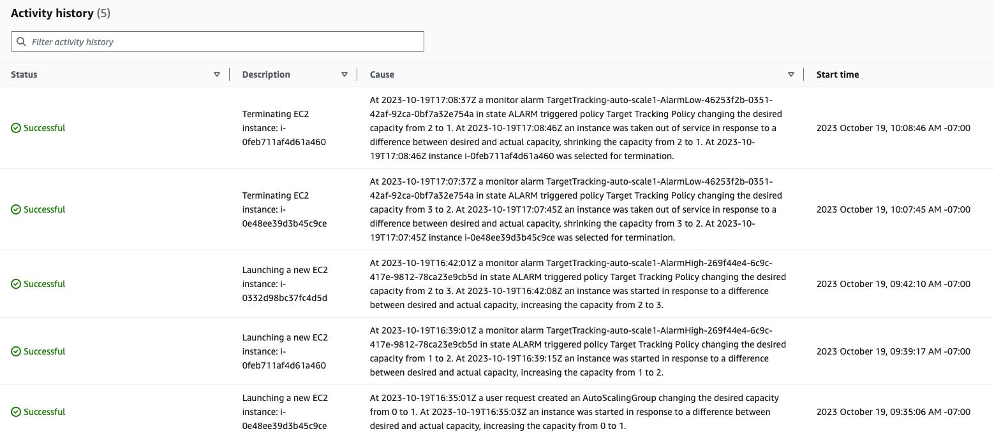
6

🎯 STEP 6: TARGET GROUP
Type: Instance
Protocol: HTTP
Port: 80
Health check: /

🌐 STEP 7: APPLICATION LOAD BALANCER
Scheme: Internet-facing
Subnets: Public
SG: ALB-SG

Attach Target Group

🖼️ Reference
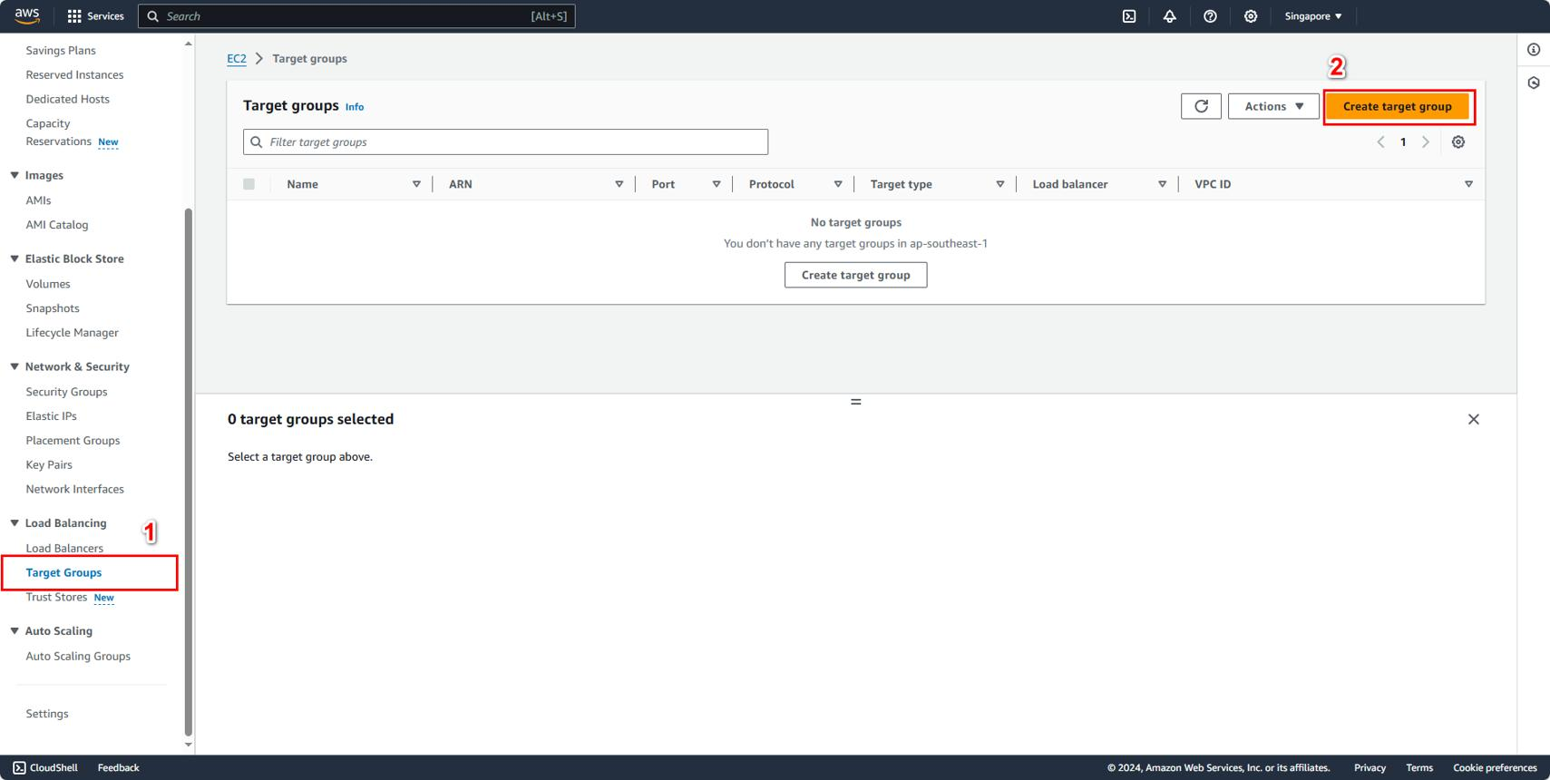
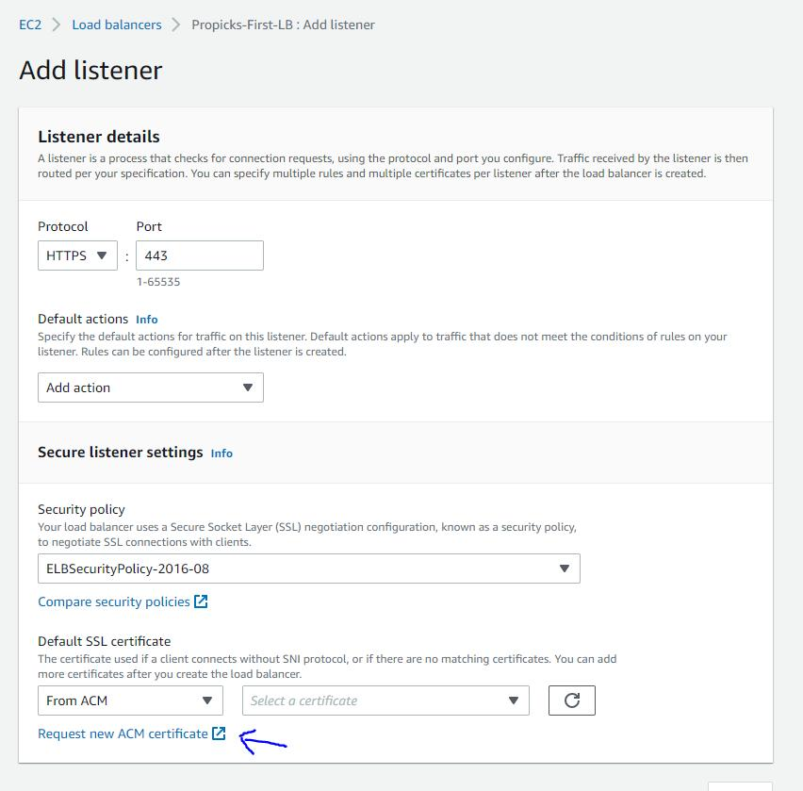
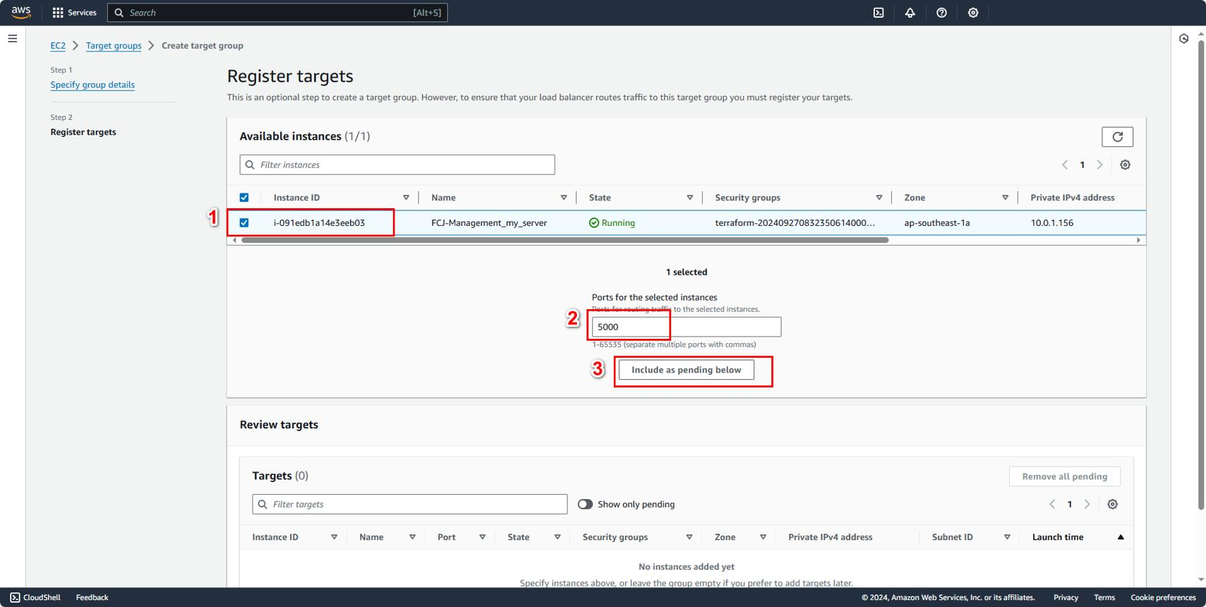
6

🔐 STEP 8: ENABLE HTTPS
📍 ACM
- Request certificate
- DNS validation

Attach to ALB
- Add HTTPS (443)
- Redirect HTTP → HTTPS

🌍 STEP 9: ROUTE53

Create Hosted Zone
Domain: yourdomain.com

Create Records
A (Alias) → ALB
www → ALB

🖼️ Reference
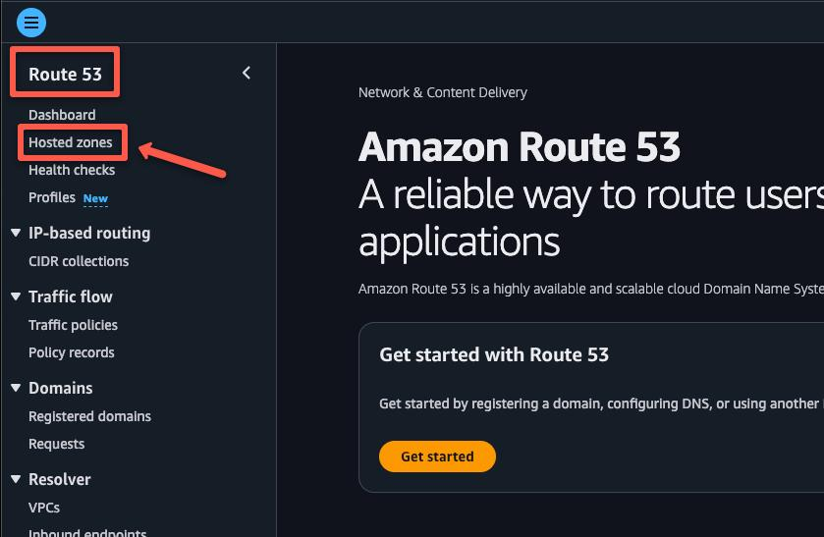
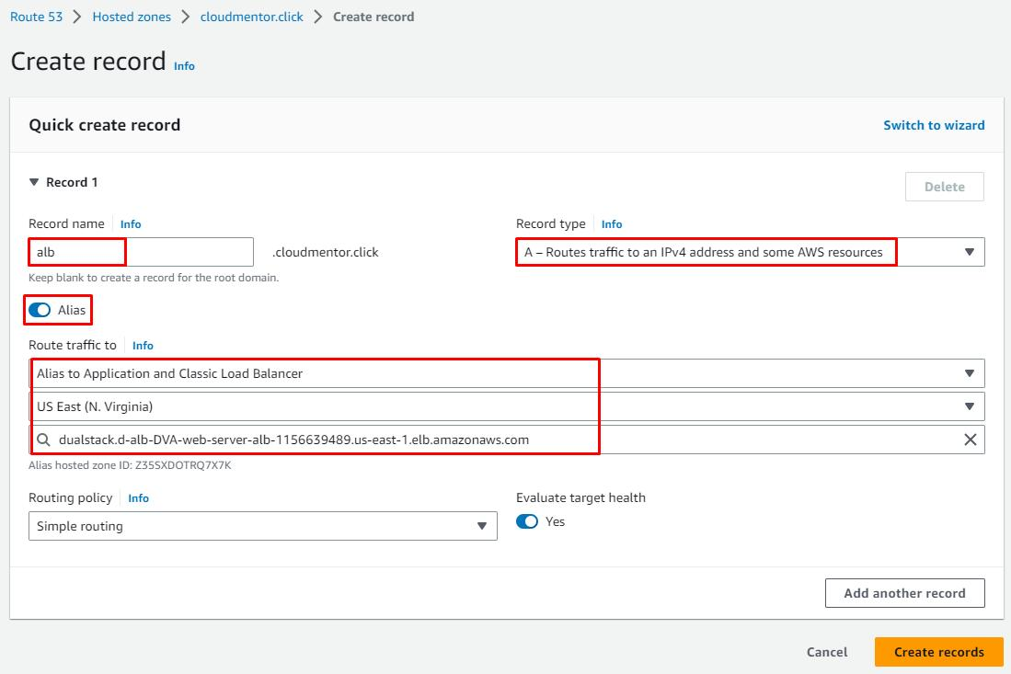
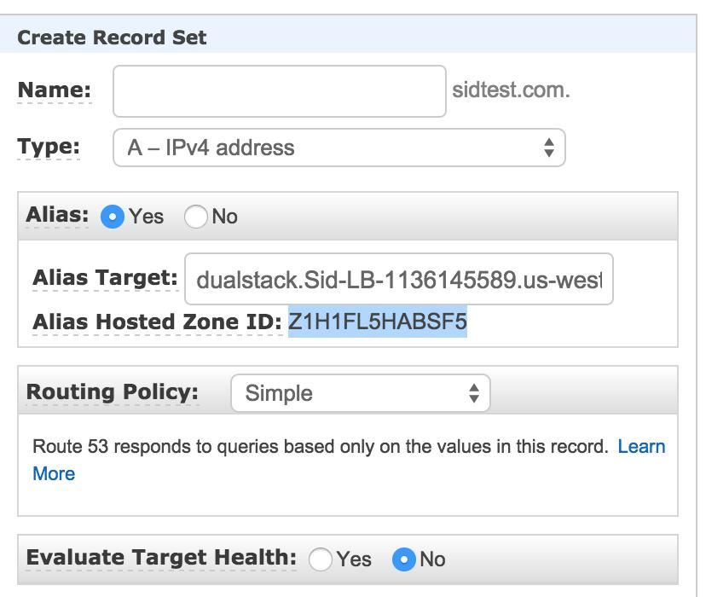
6

🧪 STEP 10: TESTING
http://domain → redirects to https
https://domain → loads app

🧹 CLEANUP (VERY IMPORTANT)

Delete in order
1. Route53 records (optional)
2. ALB
3. Target Group
4. ASG
5. Launch Template
6. EC2
7. RDS
8. VPC

🚀 IMPROVEMENTS (PRODUCTION)

🔐 Security
✔ IAM roles instead of SSH
✔ SSM Session Manager
✔ WAF

⚡ Performance
✔ CloudFront CDN
✔ Caching layer

📈 Scalability
✔ Multi-AZ RDS
✔ Read replicas
✔ Advanced scaling policies

🛡️ Reliability
✔ Multi-AZ setup
✔ Health checks
✔ Automated backups

📌 GITHUB README SECTION (ADD AT END)

🚀 What This Project Demonstrates
- Full 3-tier architecture on AWS
- Scalable + highly available system

🧱 Architecture
Route53 → ALB → ASG → EC2 → RDS

🎯 Key Achievements
✔ Auto scaling working
✔ Load balancing working
✔ HTTPS enabled
✔ Secure DB layer

🧠 Learnings
✔ Real production architecture
✔ DNS + ALB integration
✔ Scaling + fault tolerance

🔥 Production Checklist (3-Tier Architecture)
✔ Domain → Route53
✔ Route53 → ALB (Alias record)
✔ ACM → SSL certificate issued
✔ ALB → HTTPS (443) listener
✔ HTTP → HTTPS redirect configured
✔ ALB → Target Group attached
✔ Target Group → Auto Scaling Group
✔ Launch Template → EC2 configuration
✔ ASG → Desired/Min/Max capacity set
✔ ASG → Target tracking scaling (CPU)
✔ EC2 → Private subnets (no public access)
✔ RDS → Private subnet (no public access)
✔ Security Groups → Layered access control
- ALB → Public access
- EC2 → Only from ALB
- RDS → Only from EC2
✔ Multi-AZ deployment → High availability
✔ Health checks → Enabled (Target Group)

📌 GitHub README Block
## Phase 4: AWS 3-Tier Architecture (Production Setup)
### 🚀 Components Implemented
- Custom VPC with public & private subnets
- Internet Gateway & Route Tables
- Application Load Balancer (ALB)
- Target Group with health checks
- Launch Template for EC2 instances
- Auto Scaling Group (ASG) with scaling policy
- EC2 instances in private subnets
- RDS MySQL database in private subnet
- Route53 hosted zone with alias record
- ACM SSL certificate for HTTPS
---
### 🔁 Request Flow
User → Route53 → ALB → Target Group → EC2 → RDS → Response
---
### 📊 Scaling Behavior
- Target tracking scaling based on CPU (50%)
- Automatic scale-out during high load
- Automatic scale-in when load decreases
---
### 🔐 Security Implementation
- No public access to EC2 instances
- No public access to RDS
- Security group-based communication between layers
- HTTPS enforced using ACM + ALB
---
### 🎯 Key Outcomes

- Built a production-style 3-tier architecture
- Achieved high availability using Multi-AZ setup
- Implemented auto scaling and load balancing
- Secured application and database layers
---
### 🧠 Learnings
- End-to-end AWS architecture design
- DNS → ALB → EC2 → RDS integration
- Auto scaling and health check mechanisms
- Network isolation using VPC and subnets
---
### 🧹 Cleanup
- Deleted ALB, ASG, EC2, RDS after testing
- Retained ACM certificate (free)
- Avoided unnecessary AWS costs
---
### 🏁 Conclusion
This phase demonstrates how real-world scalable and secure applications are deployed on AWS using a 3-tier architecture.

