🚀 PHASE 1: ELB + TARGET GROUP (Hands-on)

User → Load Balancer → Target Group → EC2
🧱 Step 1: Launch EC2 Instances
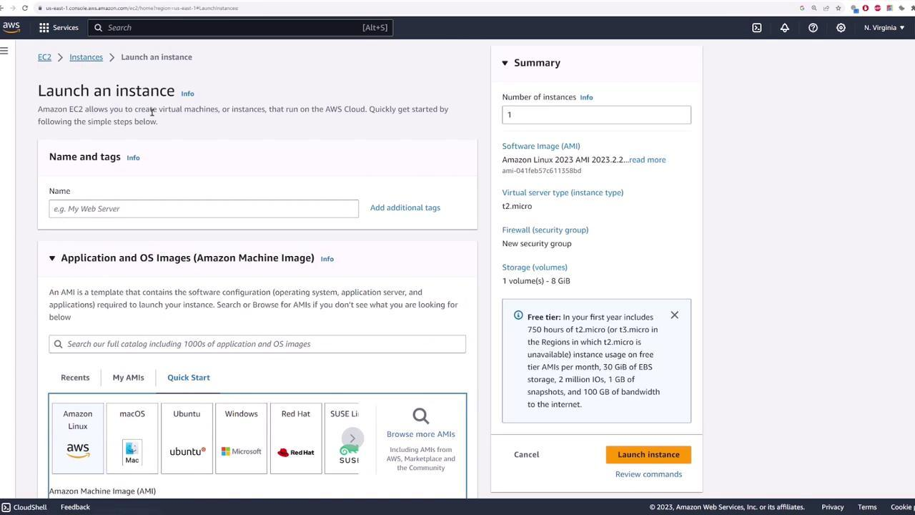
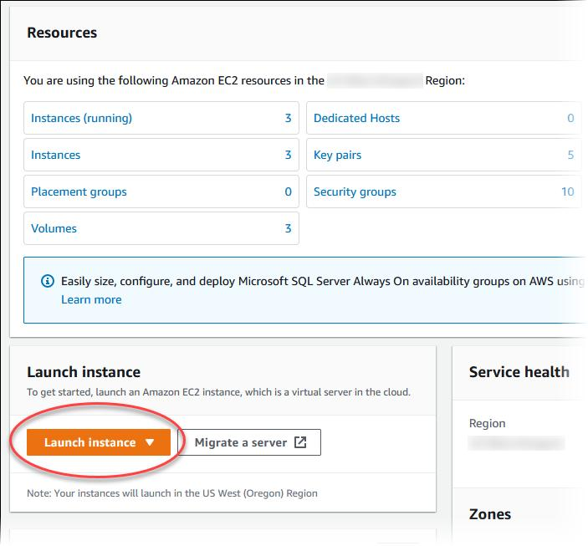
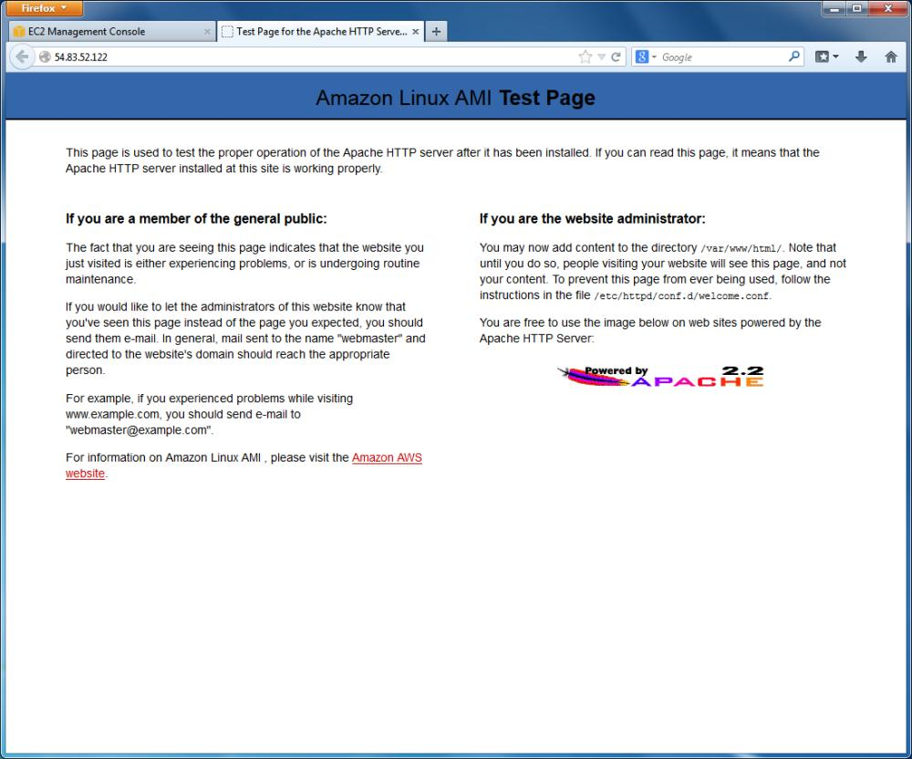
6
Do this:
- Go to AWS Console → EC2
- Launch 2 instances
  - Name:
    - web-1
    - web-2
  - AMI: Amazon Linux 2
  - Instance type: t2.micro (free tier)
  - Key pair: create/download
  - Security group:
    - Allow:
      - SSH (22)
      - HTTP (80)

🔧 Add User Data (VERY IMPORTANT)
Paste this in User Data section:
#!/bin/bash
yum update -y
yum install httpd -y
systemctl start httpd
systemctl enable httpd
echo "Hello from $(hostname)" > /var/www/html/index.html
👉 This makes each EC2 show its hostname in browser

🧱 Step 2: Create Target Group (TG)
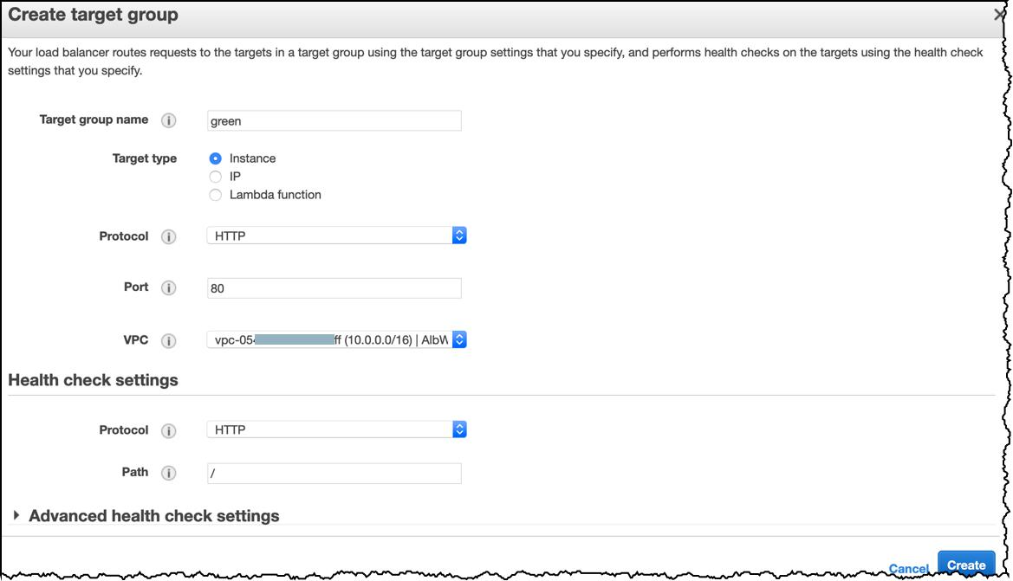
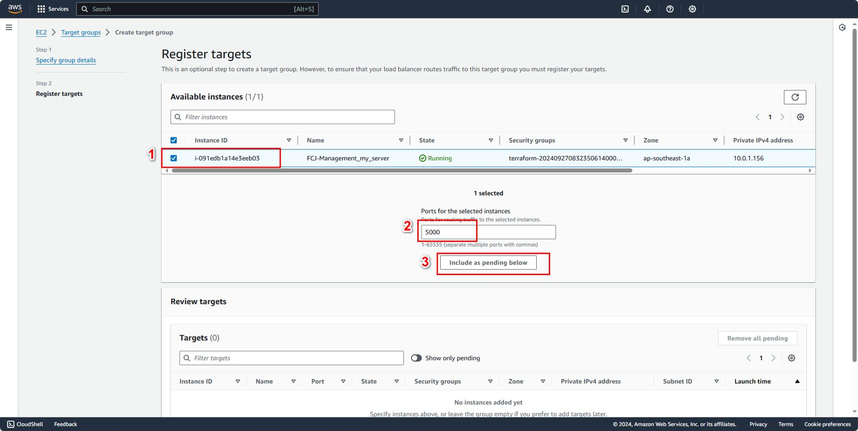
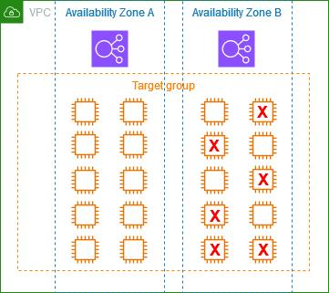
5
Steps:
- Go to EC2 → Target Groups
- Click Create Target Group
- Settings:
  - Type: Instances
  - Protocol: HTTP
  - Port: 80
  - Name: tg-web
- Health Check:
  - Path: /
  - Protocol: HTTP
- Register instances:
  - Select both EC2 instances

🧱 Step 3: Create Application Load Balancer (ALB)
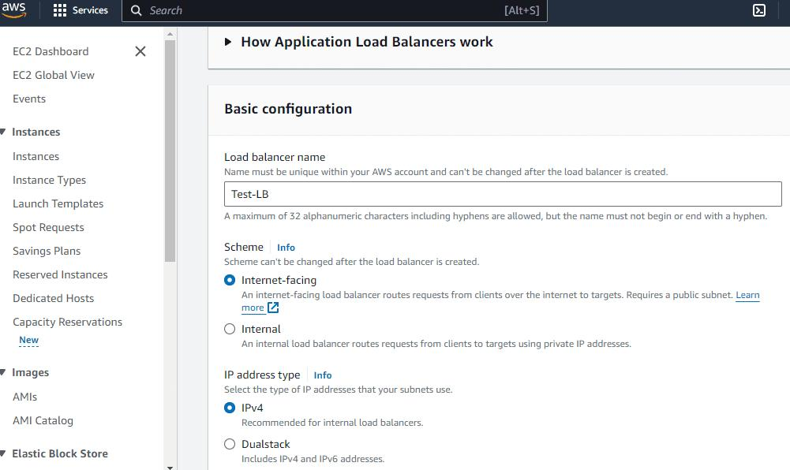
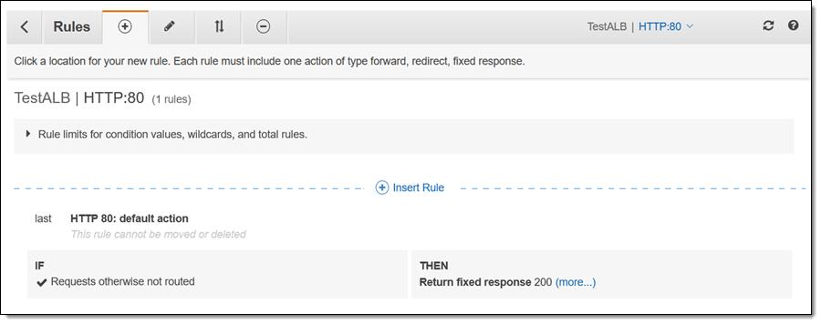
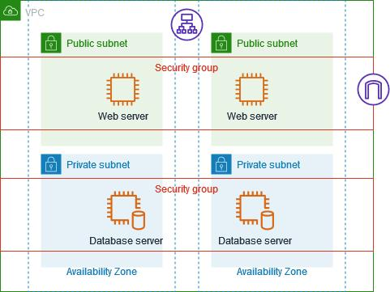
5
Steps:
- Go to EC2 → Load Balancers
- Click Create Load Balancer
- Choose:
👉 Application Load Balancer

Configuration:
- Name: alb-web
- Scheme: Internet-facing
- IP: IPv4

Networking:
- Select your VPC
- Select at least 2 subnets (important!)

Security Group:
- Allow:
  - HTTP (80)

Listener:
- HTTP : 80
- Forward to:
👉 tg-web

🧪 Step 4: Test It
- Copy ALB DNS name
Example:
http://alb-web-123456.ap-south-1.elb.amazonaws.com
- Open in browser

🎯 Expected Result:
Refresh multiple times:
Hello from ip-xxx-xxx-xxx-1
Hello from ip-xxx-xxx-xxx-2
👉 That means Load Balancer is distributing traffic

🧠 What You Just Learned
- What is a Load Balancer
- What is a Target Group
- Health checks
- Traffic distribution across EC2

🧪 Mini Experiments (Do These!)
Try:
- Stop one EC2 → see traffic goes to other
- Break health check (change path) → see instance marked unhealthy
- Add 3rd EC2 → register in TG

📘 SOP: Deploying AWS ALB + Target Group + EC2 (Phase 1)
🧭 Objective
Set up a basic load-balanced architecture:
User → ALB → Target Group → EC2 Instances

🏗️ Architecture Overview
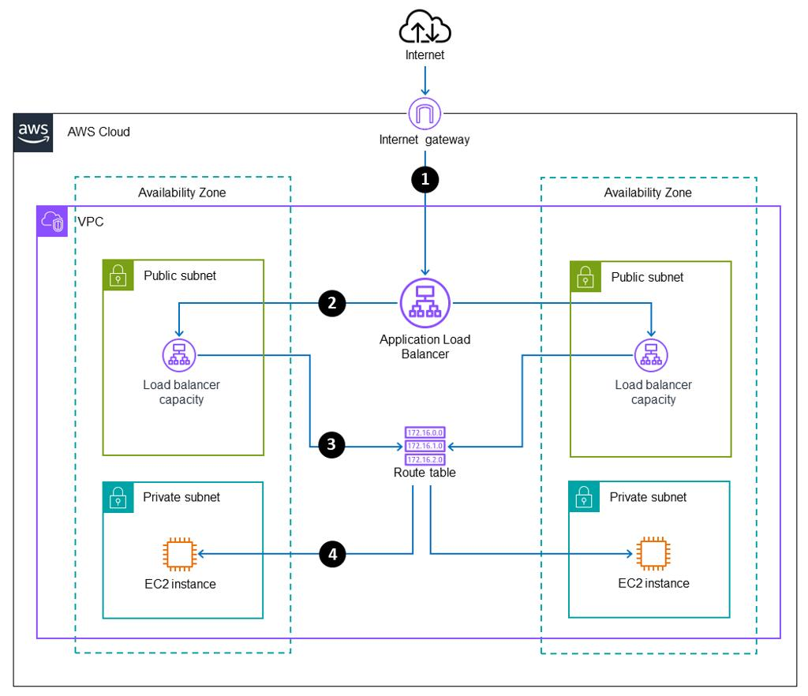
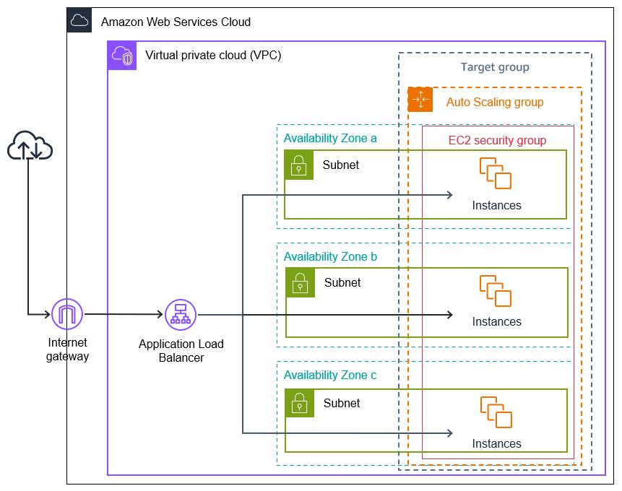

6

🔧 Prerequisites
- AWS Account
- Basic knowledge of:
  - Amazon EC2
  - Elastic Load Balancing
- Key Pair created in AWS

🚀 Step 1: Launch EC2 Instances
📍 Navigation
AWS Console → EC2 → Launch Instance

⚙️ Configuration
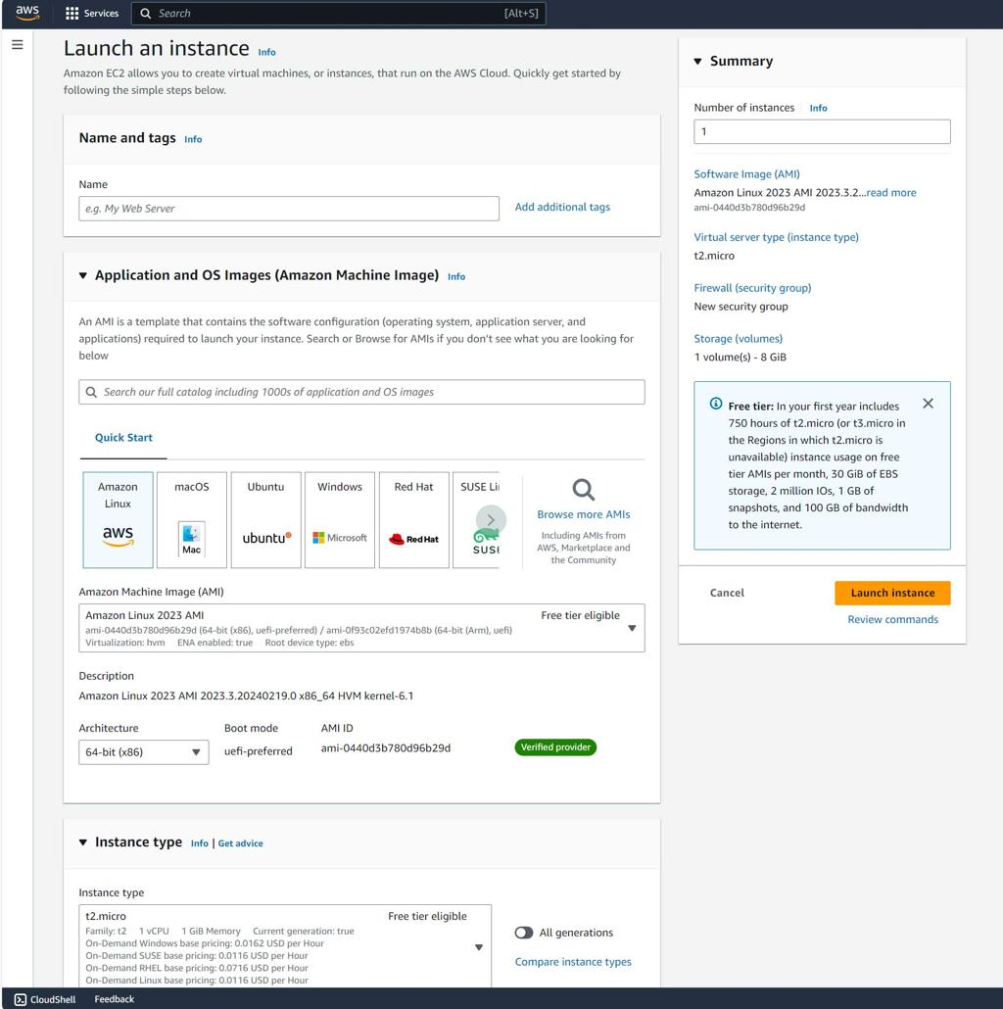
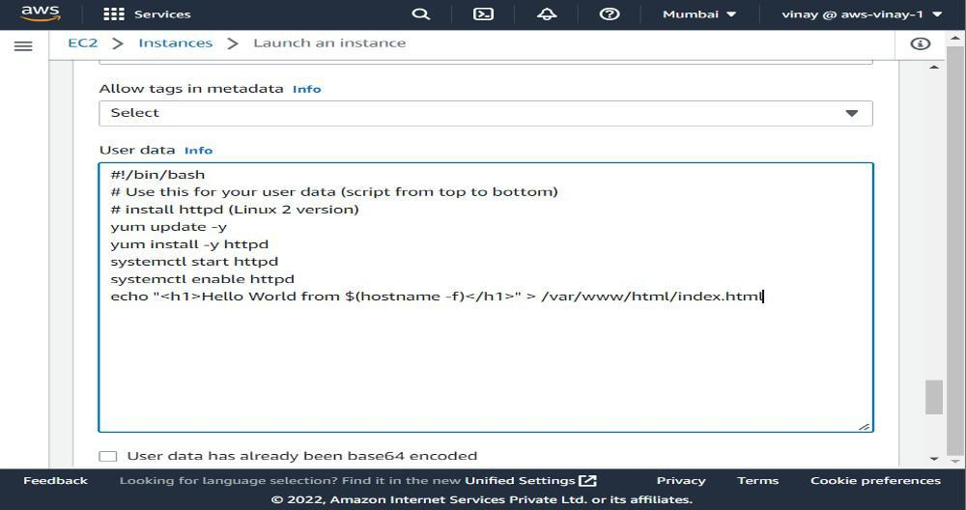

7
🔹 Instance Details
Parameter | Value
Name | web-1, web-2
AMI | Amazon Linux 2
Instance Type | t2.micro
Count | 2

🔹 Security Group
Allow:
- SSH (22) → Your IP
- HTTP (80) → Anywhere (0.0.0.0/0)

🔹 User Data Script
#!/bin/bash
yum update -y
yum install httpd -y
systemctl start httpd
systemctl enable httpd
echo "Hello from $(hostname)" > /var/www/html/index.html

✅ Validation
- Copy EC2 Public IP
- Open in browser:
http://<EC2-PUBLIC-IP>
Expected:
Hello from ip-xxx

🎯 Step 2: Create Target Group
📍 Navigation
EC2 → Target Groups → Create Target Group

⚙️ Configuration

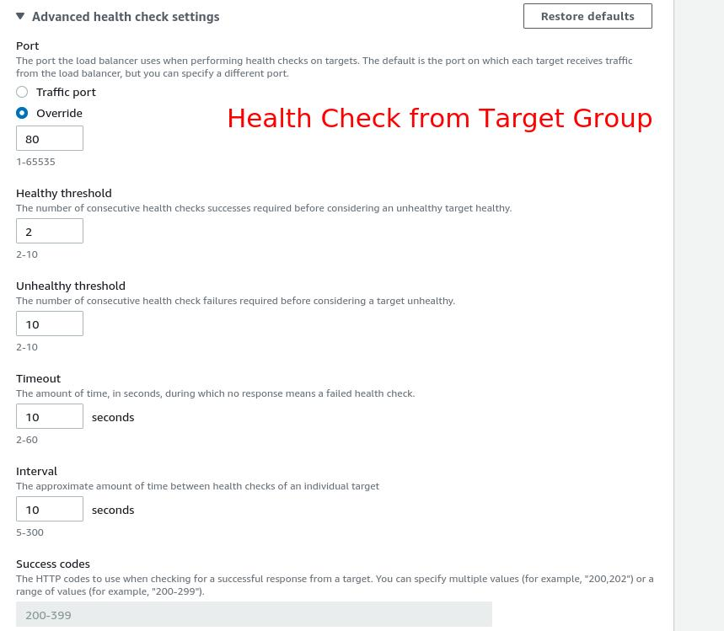

7
Parameter | Value
Target Type | Instances
Protocol | HTTP
Port | 80
Name | tg-web

🔹 Health Check Settings
Parameter | Value
Path | /
Protocol | HTTP

🔹 Register Targets
- Select both EC2 instances
- Click Include as pending below
- Create Target Group

✅ Validation
- Check Target Health
- Status should be:
Healthy

🌐 Step 3: Create Application Load Balancer
📍 Navigation
EC2 → Load Balancers → Create Load Balancer

⚙️ Configuration

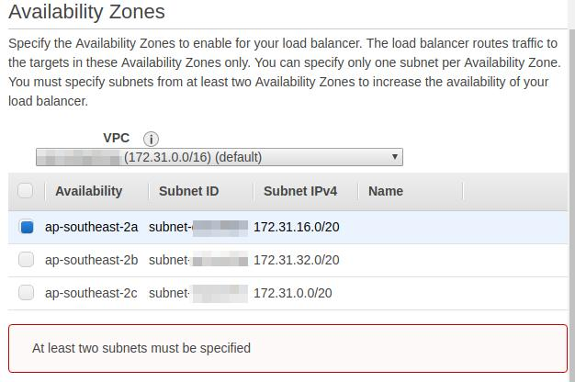
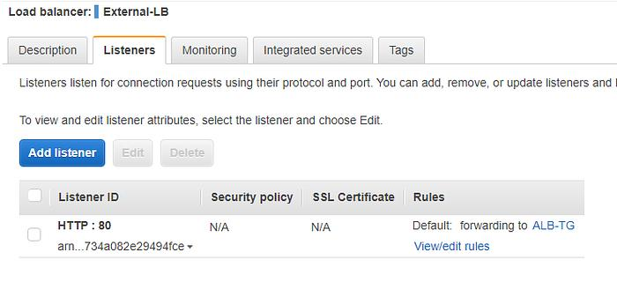
6

🔹 Basic Settings
Parameter | Value
Name | alb-web
Scheme | Internet-facing
IP Type | IPv4

🔹 Network Mapping
- Select your VPC
- Select at least 2 subnets (different AZs)

🔹 Security Group
Allow:
- HTTP (80) → 0.0.0.0/0

🔹 Listener
Protocol | Port | Action
HTTP | 80 | Forward to tg-web

✅ Create ALB

🧪 Step 4: Testing Load Balancer
📍 Get ALB DNS
Example:
http://alb-web-123456.ap-south-1.elb.amazonaws.com

🔁 Test Behavior
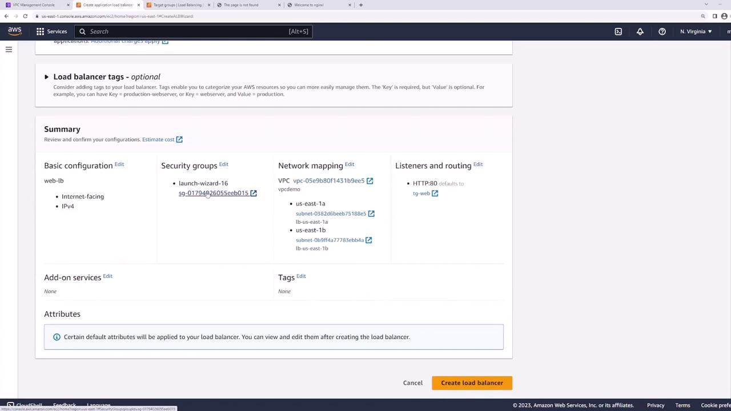
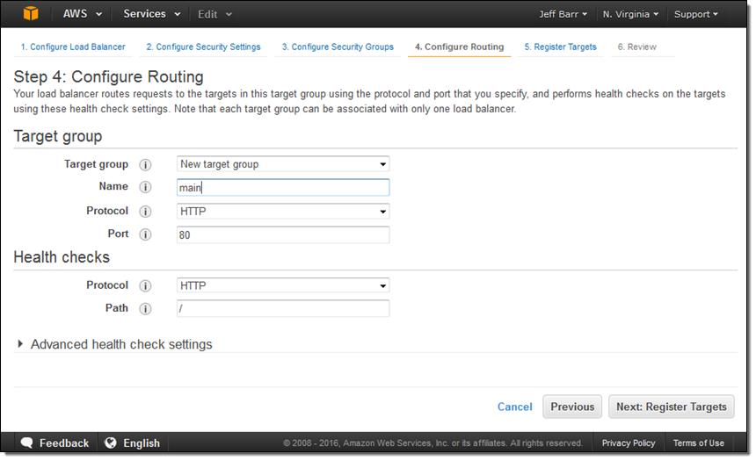
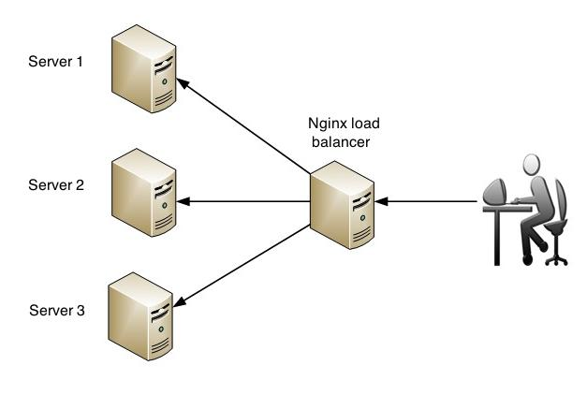
5
Expected Output (on refresh):
Hello from ip-1
Hello from ip-2

🧠 Key Concepts
🔹 What is ALB?
- Layer 7 Load Balancer
- Routes traffic based on HTTP rules
🔹 What is Target Group?
- Logical group of backend instances
- Performs health checks
🔹 Why TG is important?
- Decouples Load Balancer from instances
- Enables dynamic scaling (used in ASG later)

🧪 Practice Exercises
- Stop one EC2 → Check traffic flow
- Change health check path → Observe failure
- Add new EC2 → Register to TG

🧹 Cleanup (Important)
To avoid charges:
- Terminate EC2 instances
- Delete Target Group
- Delete Load Balancer

📌 GitHub README Structure Suggestion
# AWS Hands-on Labs
## Phase 1: ALB + Target Group + EC2
- Architecture Diagram
- Step-by-step setup
- Screenshots
- Testing results
- Learnings

