📘 SOP: Phase 4 — Domain + HTTPS + ALB (Production Setup)

🧭 Objective
Expose application securely using your domain:
User → Domain → DNS (Route53) → ALB (HTTPS) → Target Group → EC2

🏗️ Final Architecture
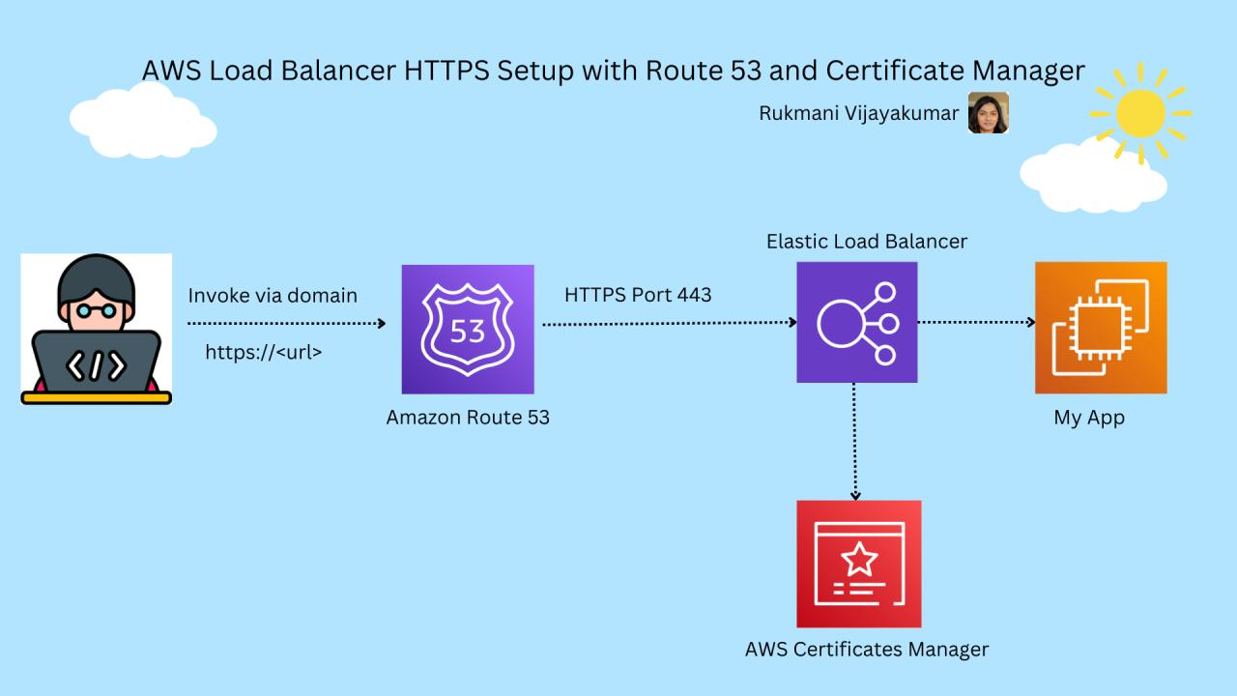
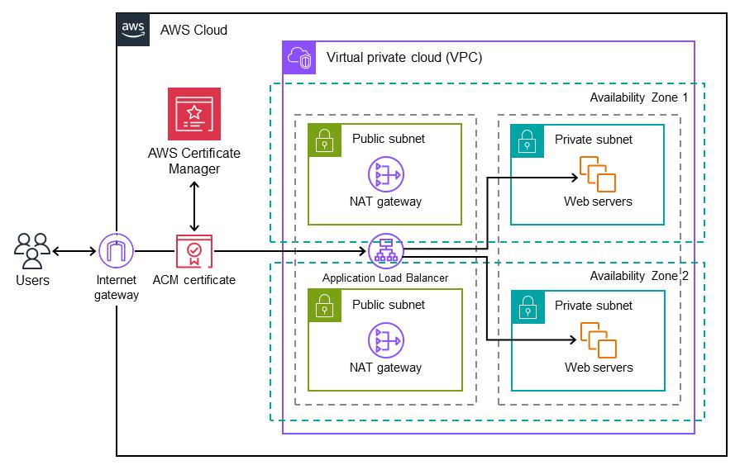
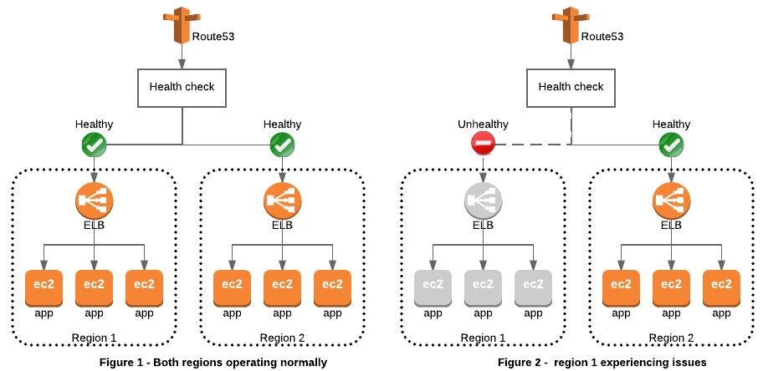
6

🔧 Assumptions (Minimal)
- You have a domain in GoDaddy
- AWS account ready
- No infra exists (fresh setup)

🚀 Step 1: Create EC2 (Backend App)
📍 EC2 → Launch Instance
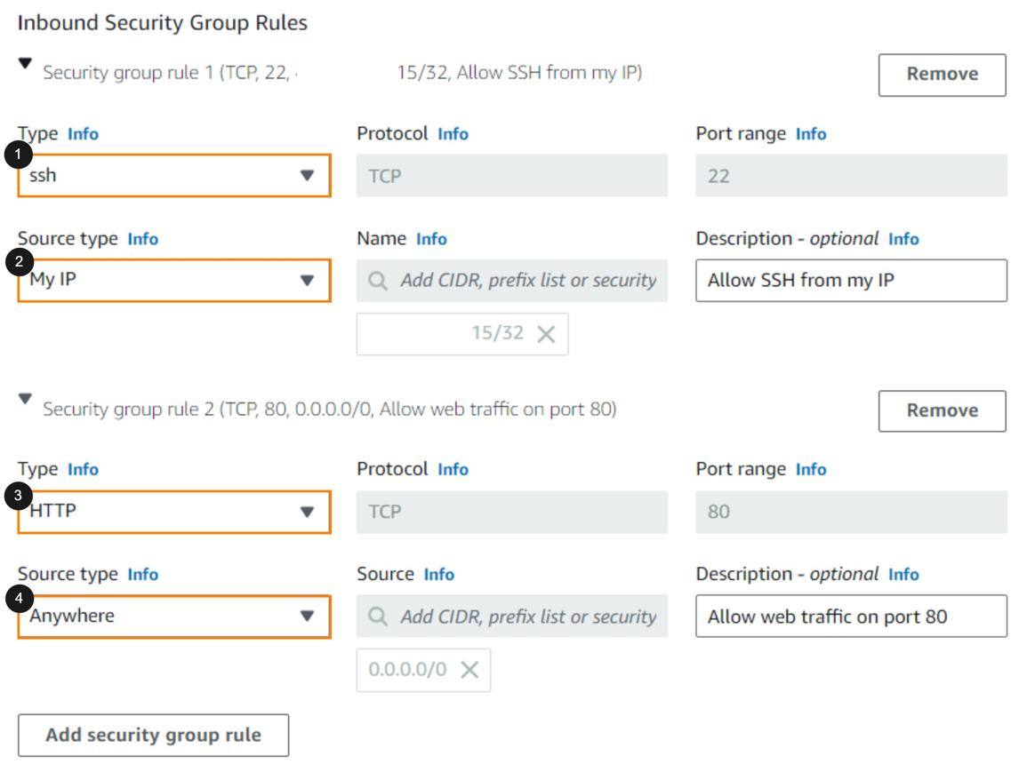
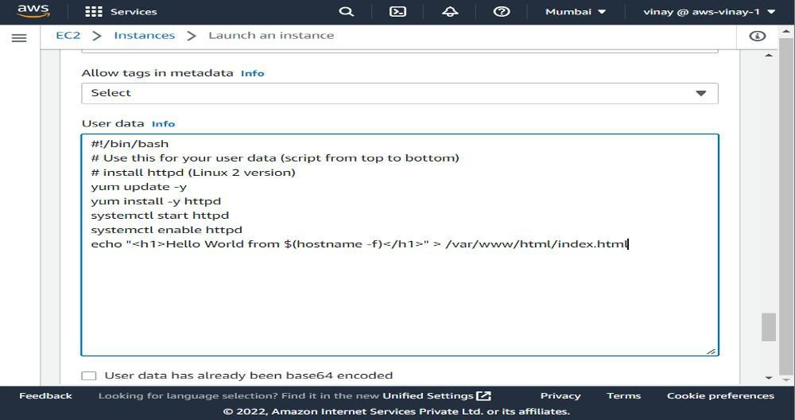
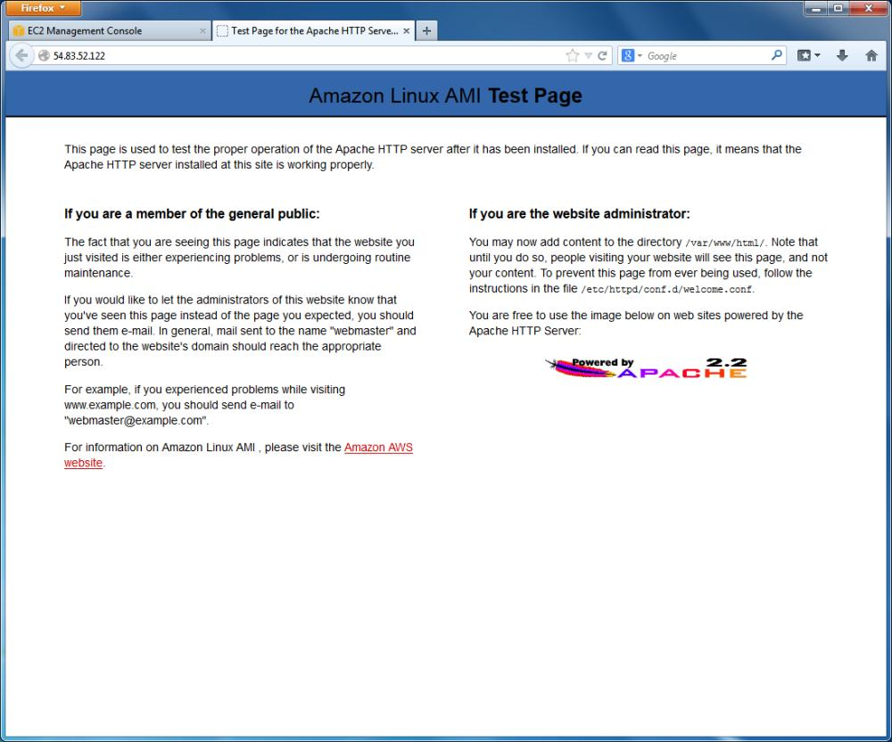
6

🔹 Config
Setting | Value
Name | web-server
AMI | Amazon Linux 2
Type | t2.micro
SG | allow HTTP (80), SSH (22)

🔹 User Data
#!/bin/bash
yum update -y
yum install httpd -y
systemctl start httpd
systemctl enable httpd
echo "Phase 4 App Running on $(hostname)" > /var/www/html/index.html

✅ Validate
http://<EC2-PUBLIC-IP>

🎯 Step 2: Create Target Group
📍 EC2 → Target Groups → Create
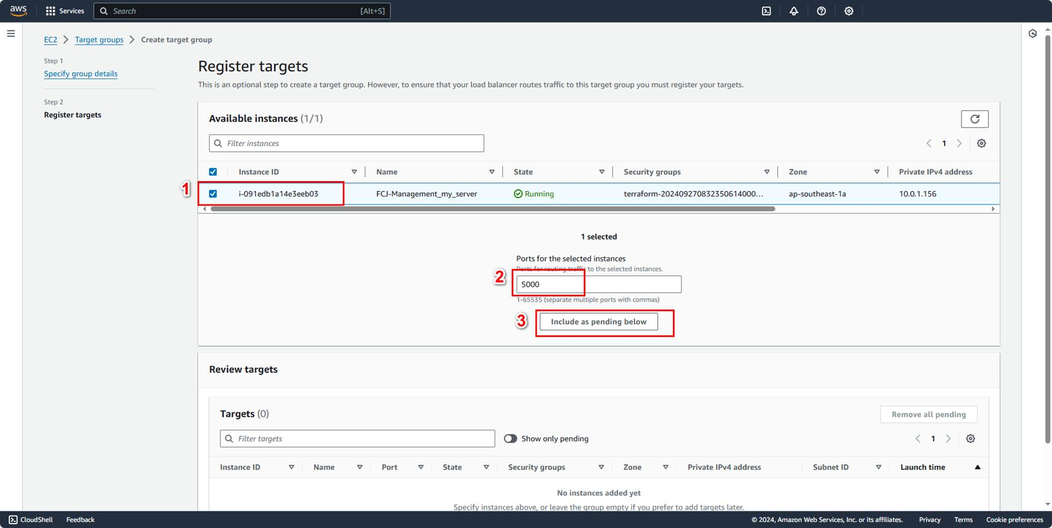
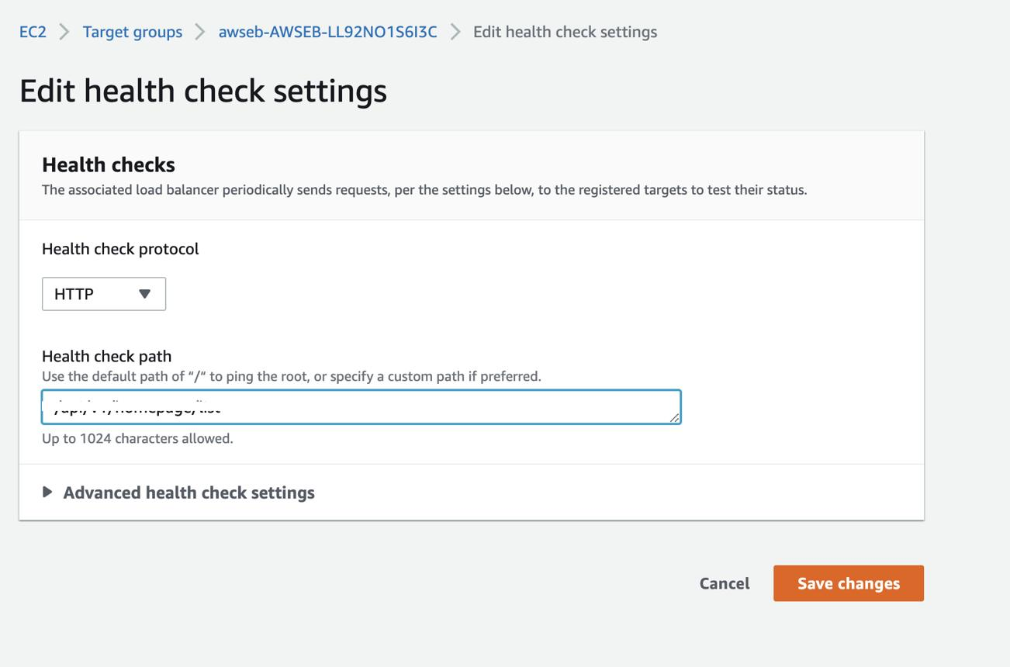
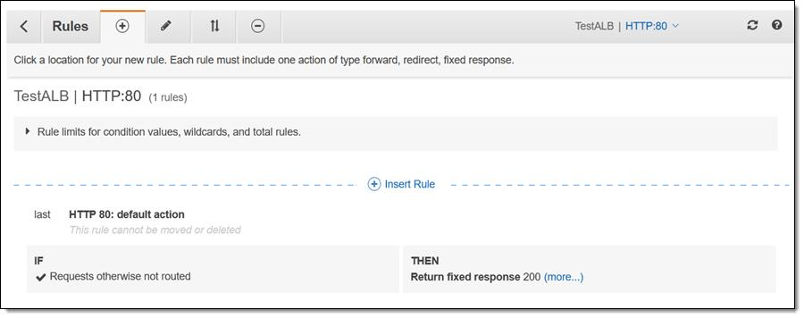
6

Config
Setting | Value
Type | Instances
Protocol | HTTP
Port | 80
Health Check | /

👉 Register EC2 instance

🌐 Step 3: Create ALB
📍 EC2 → Load Balancers → Create
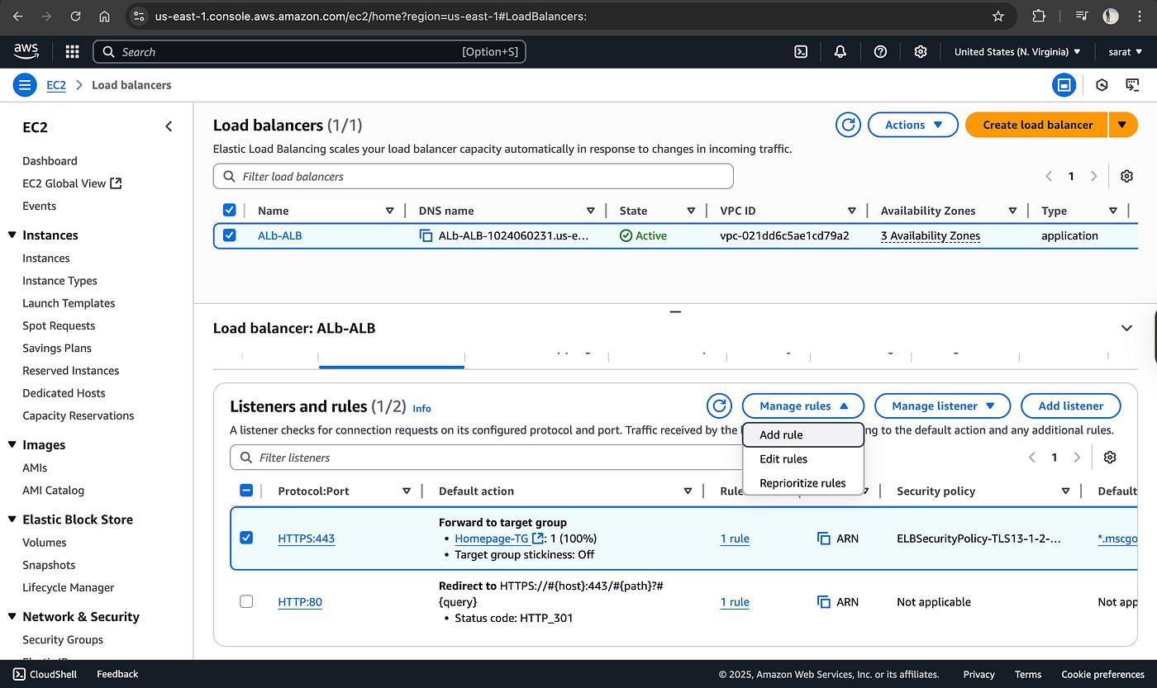
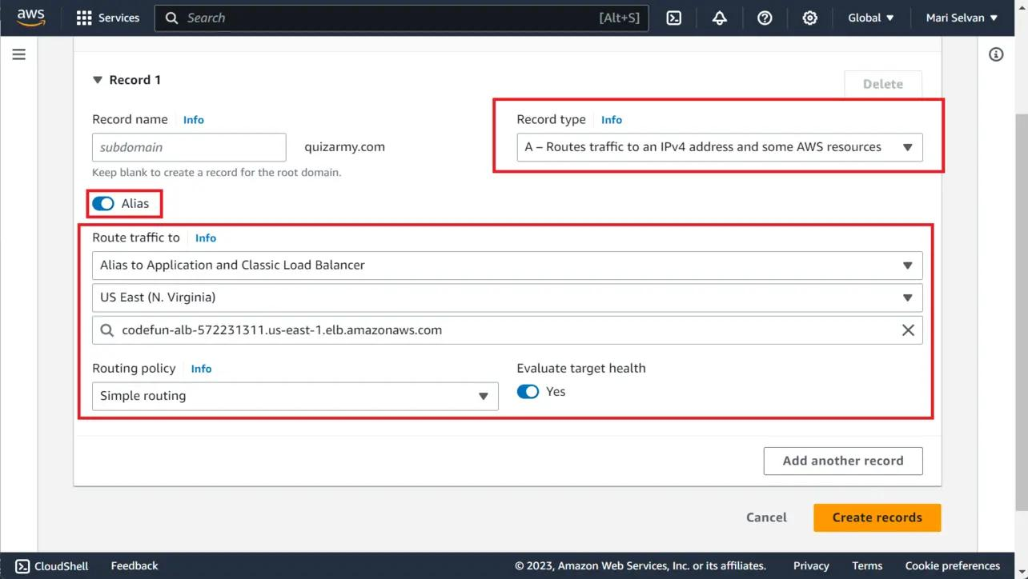
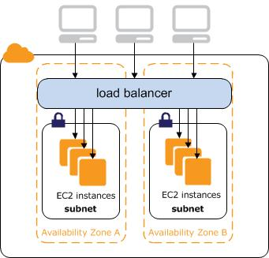
6

🔹 Config
Setting | Value
Type | Application LB
Scheme | Internet-facing
Subnets | 2 public subnets
SG | allow 80, 443

🔹 Listener
- HTTP (80) → Forward → Target Group

✅ Test
http://<ALB-DNS>

🔐 Step 4: Request SSL Certificate (ACM)
Using AWS Certificate Manager

📍 ACM → Request Certificate
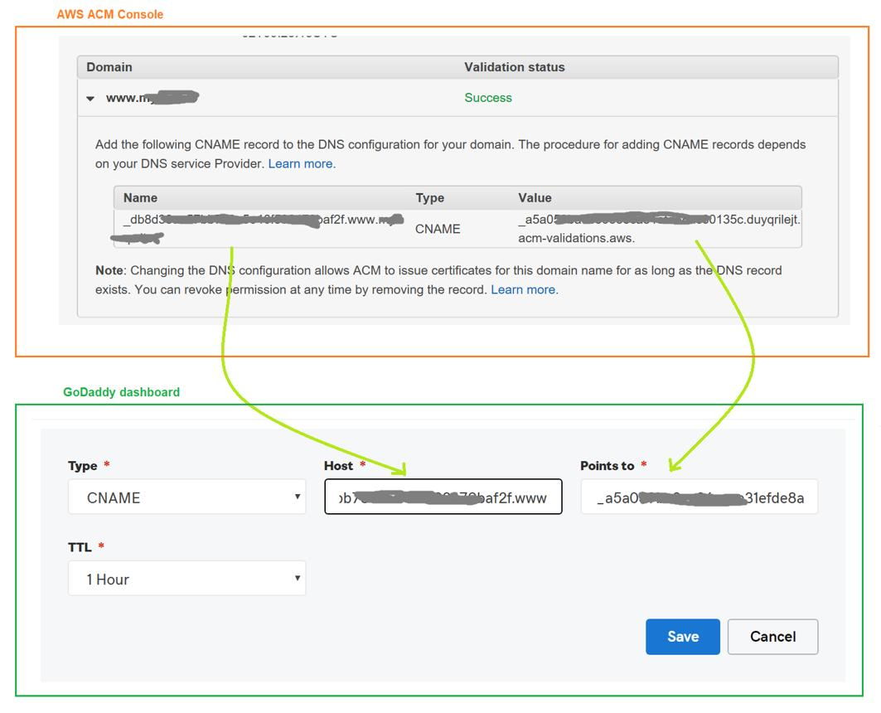
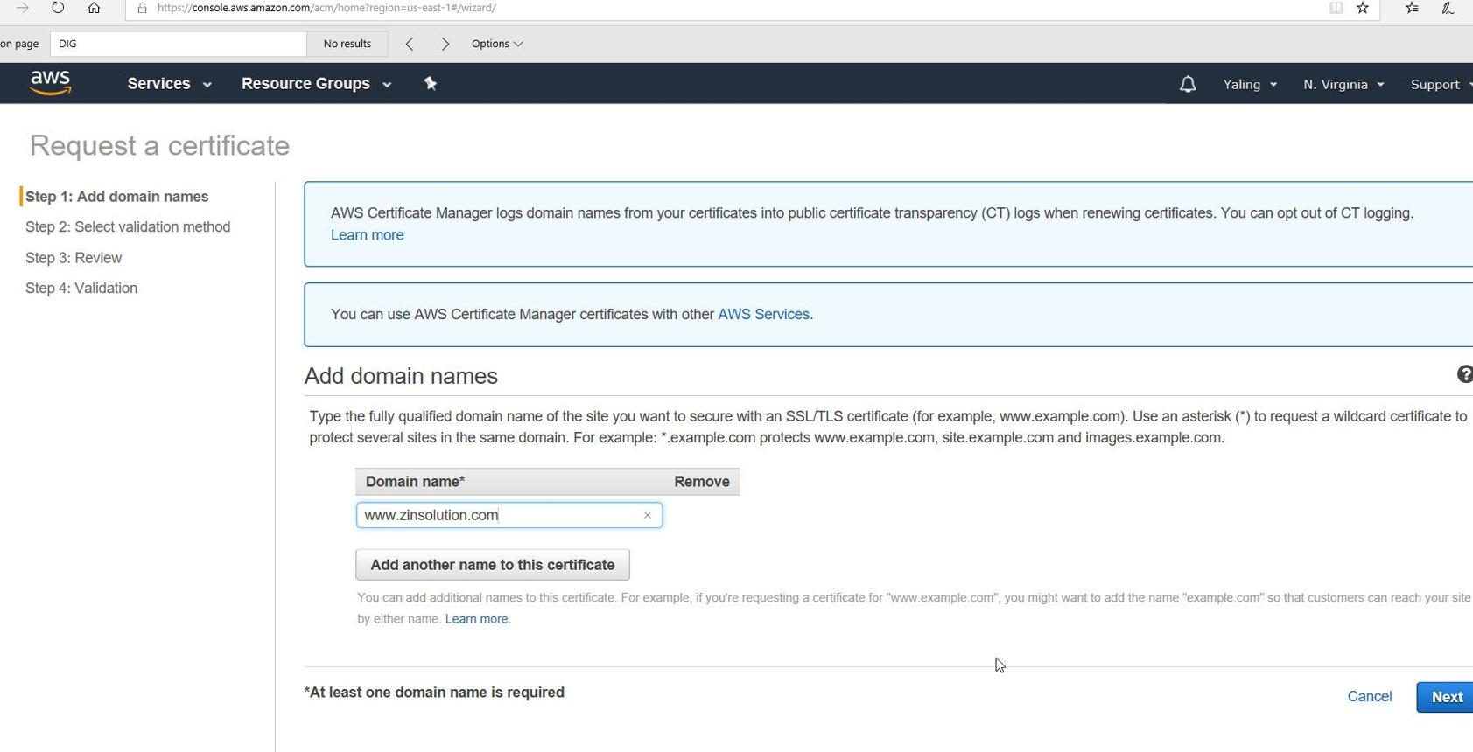
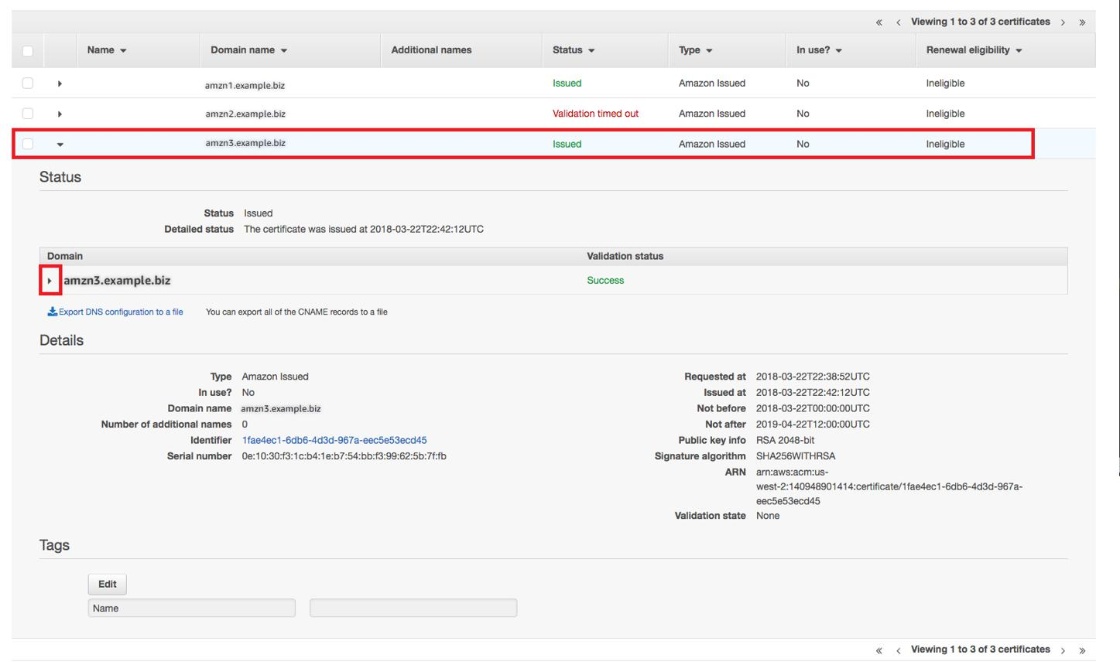
6

🔹 Add Domains
yourdomain.com
www.yourdomain.com

🔹 Validation → DNS

🔁 Add CNAME in GoDaddy
Example:
Name: _abc123
Value: _xyz.acm-validations.aws

⏳ Wait
Status → Issued

🔒 Step 5: Add HTTPS Listener to ALB
📍 ALB → Listeners → Add
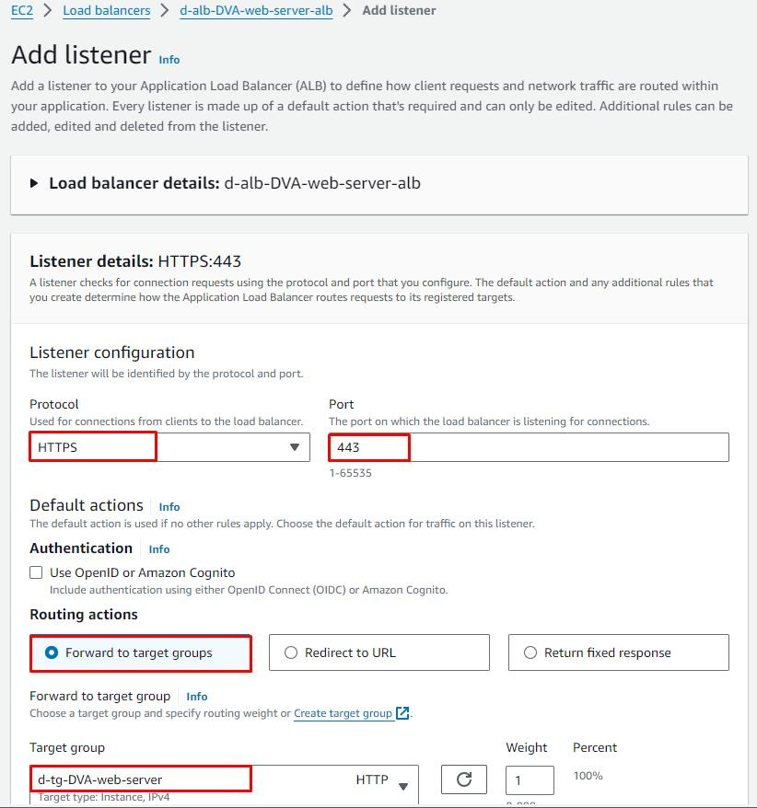
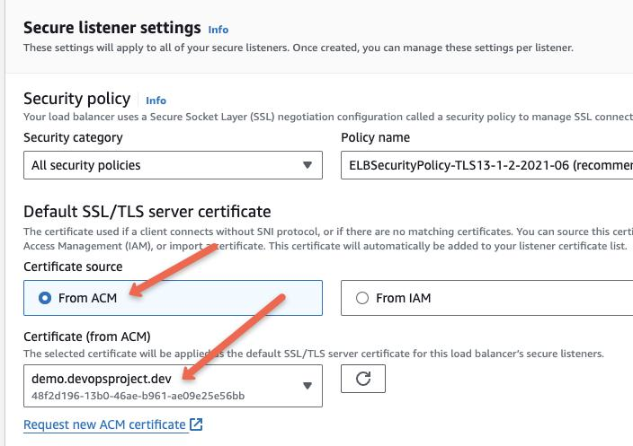
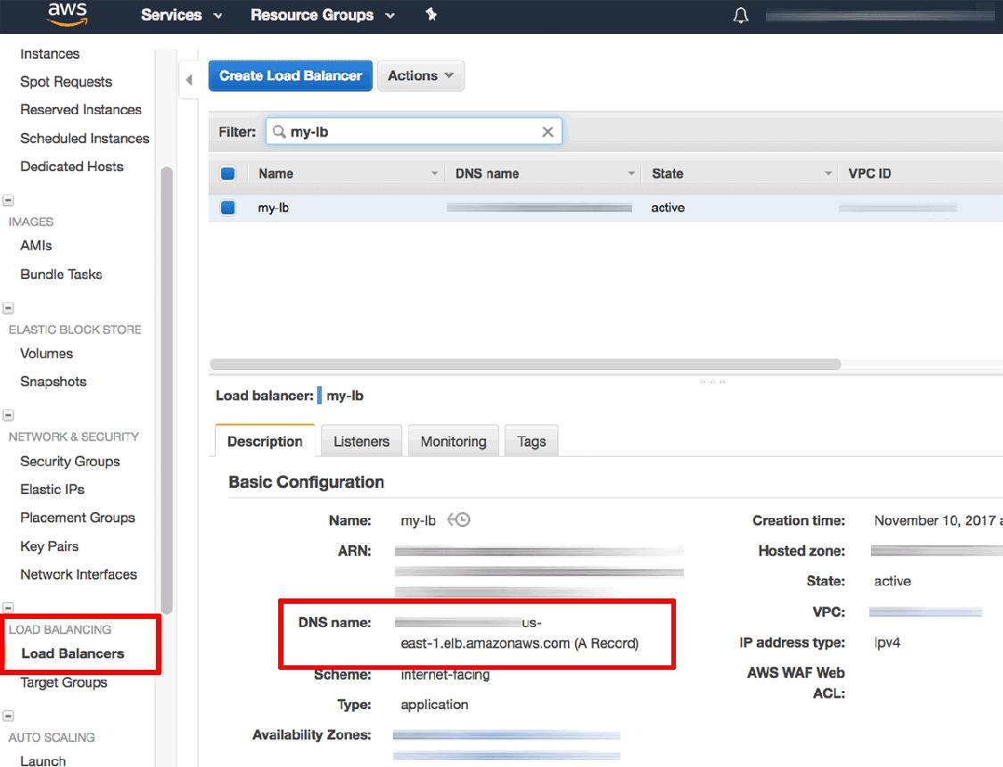
7

Config
Setting | Value
Protocol | HTTPS
Port | 443
Certificate | Select ACM cert

👉 Forward to Target Group

🔁 Step 6: Redirect HTTP → HTTPS
📍 Edit Listener (80)

Change to:
Redirect → HTTPS (443)

🌍 Step 7: Create Hosted Zone (Route53)
Using Amazon Route 53

📍 Create Hosted Zone
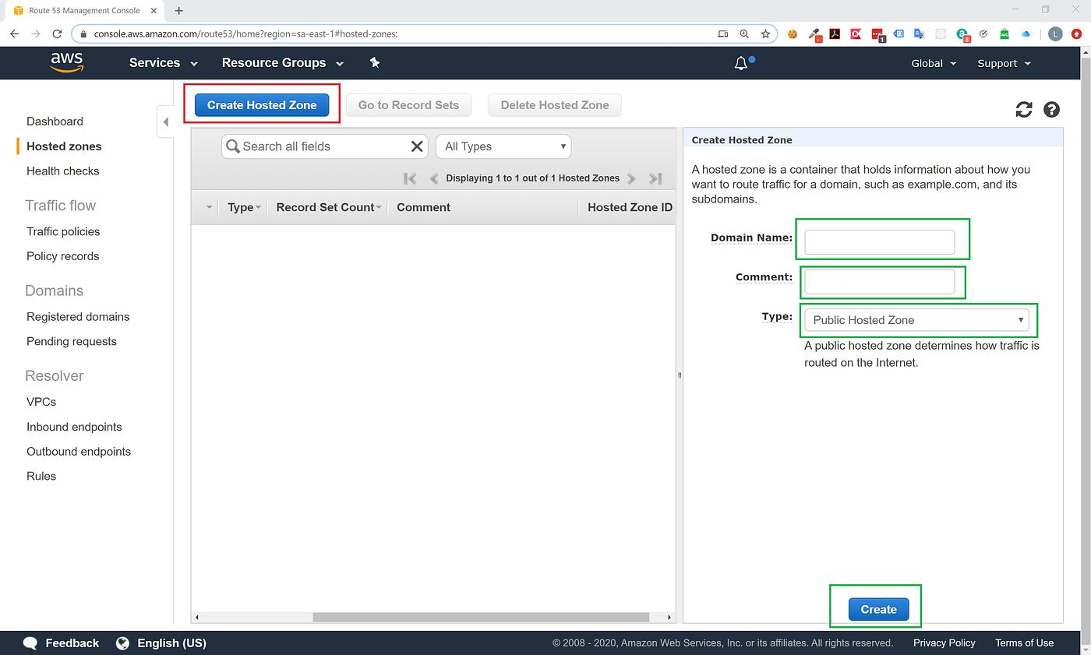
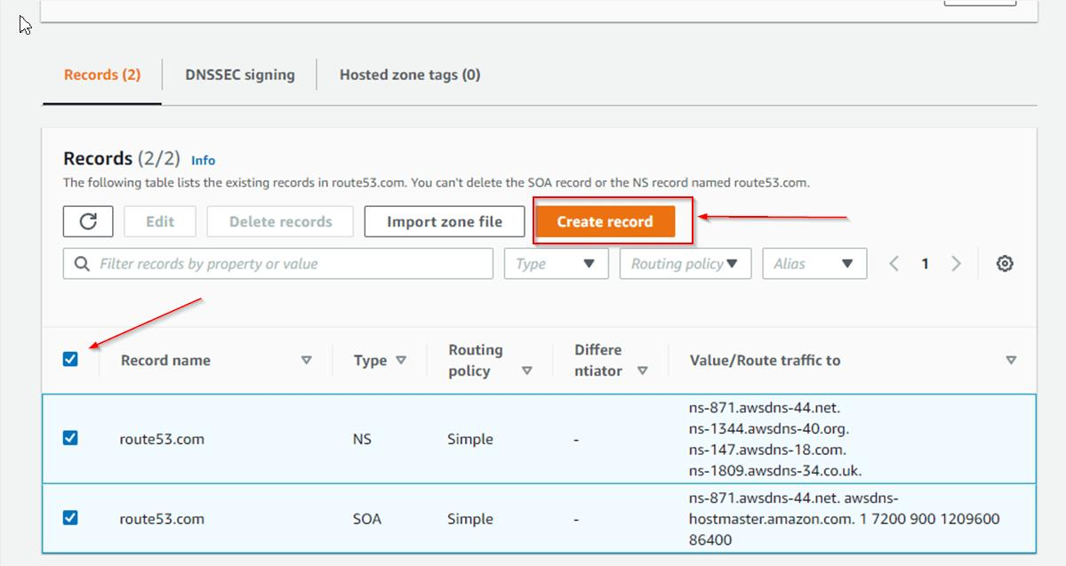
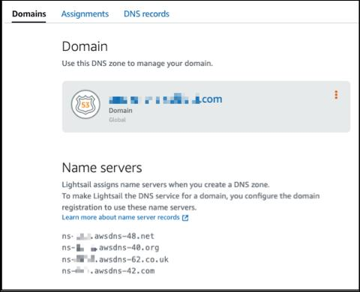
6

Copy NS records
ns-xxx.awsdns.com

🔁 Step 8: Update GoDaddy Nameservers
- GoDaddy → Domain settings
- Replace NS with Route53 NS

⏳ Wait (DNS propagation)

🚀 Step 9: Create Alias Record
📍 Route53 → Create Record
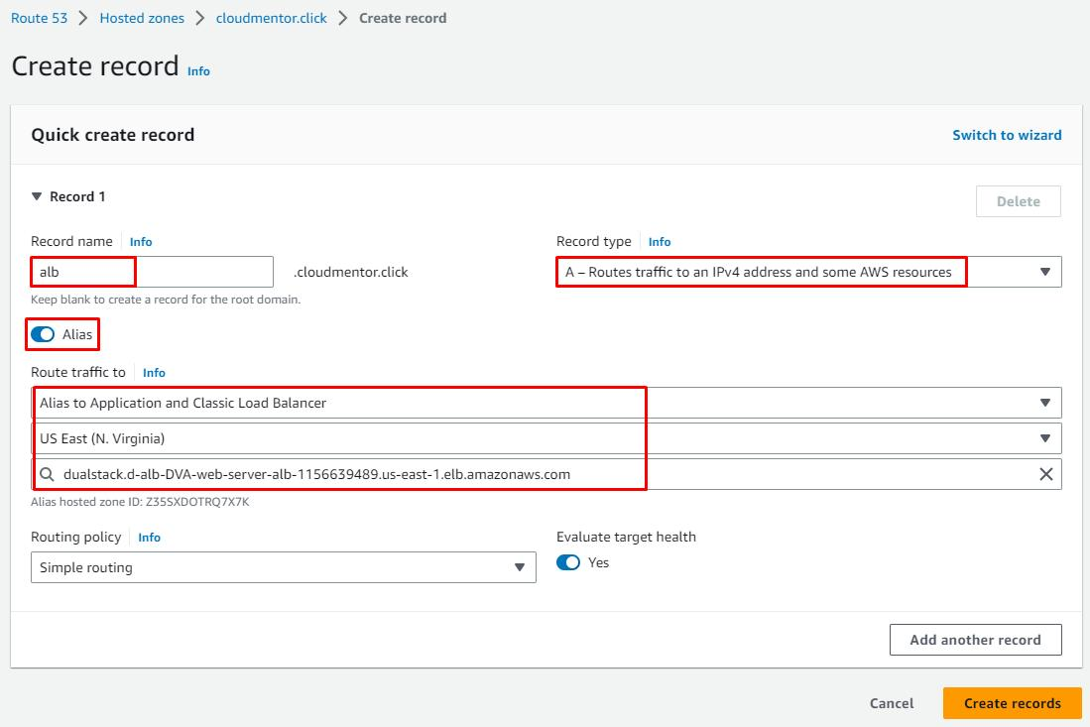
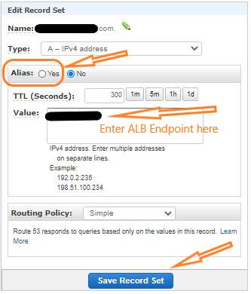

5

Config
Field | Value
Type | A
Name | (blank)
Alias | YES
Target | ALB

🧪 Step 10: Final Testing

🌐 Test URLs
http://yourdomain.com → redirects
https://yourdomain.com → loads app

✅ Expected
- SSL 🔒
- Valid cert
- App loads

🧠 Real-World Notes (Based on Your Work Experience)
You already mentioned:
✔ Region migration (us-east-1 → us-west-2)
✔ ALB swap
✔ ACM cert renewal
✔ Listener updates
👉 This SOP matches exactly what you did — but structured cleanly.

🔥 Production Checklist
✔ Domain → Route53
✔ Route53 → ALB
✔ ALB → HTTPS (ACM)
✔ HTTP → HTTPS redirect
✔ ALB → Target Group
✔ Target Group → EC2

📌 GitHub README Block
## Phase 4: Domain + HTTPS + ALB
- EC2 backend setup
- Target group creation
- ALB creation
- ACM SSL certificate
- Route53 hosted zone
- GoDaddy NS update
- Alias record to ALB
- HTTPS validation

