🚀 Serverless API Setup with Cloudflare + API Gateway + Lambda

📌 1. Overview
This project demonstrates how to build a fully serverless API using:
- AWS Lambda → Backend logic
- Amazon API Gateway → API layer
- Cloudflare → DNS + CDN
- Custom domain with HTTPS

🧠 2. Architecture
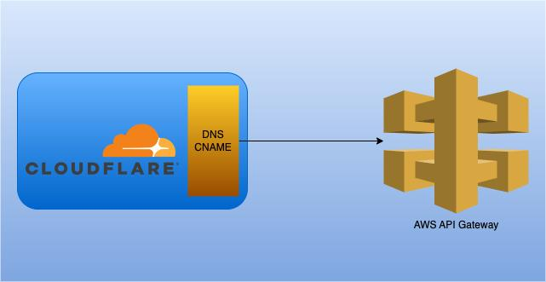
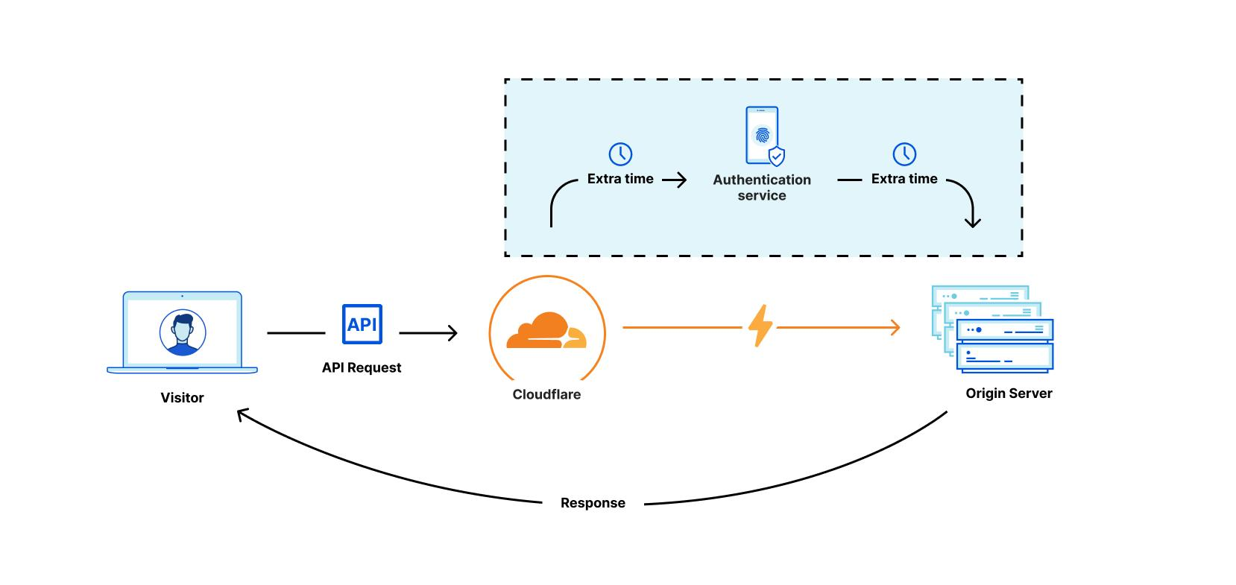
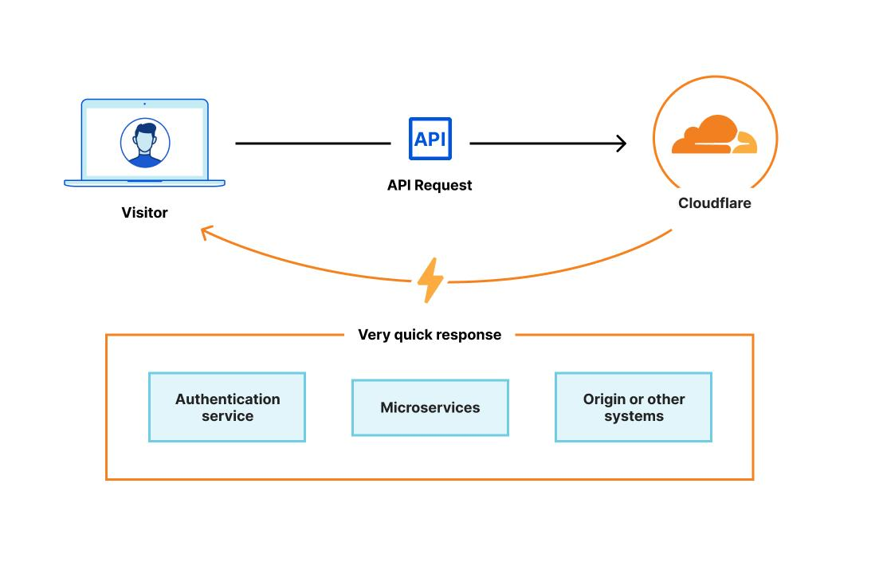
5
Client → Cloudflare DNS → API Gateway → Lambda → Response
✔️ Fully serverless
✔️ Globally accessible
✔️ No infrastructure management

🧾 3. Prerequisites
- AWS Account
- Domain (GoDaddy or any registrar)
- Cloudflare DNS configured
- Basic IAM permissions

🔧 4. Step 1: Create Lambda Function

🖼️ Reference
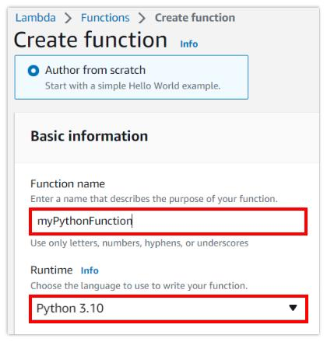
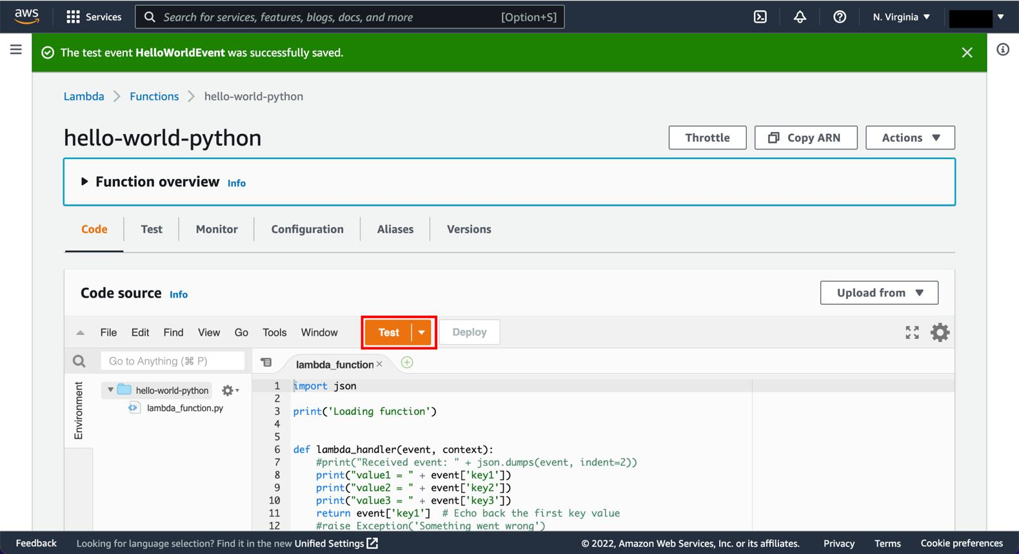
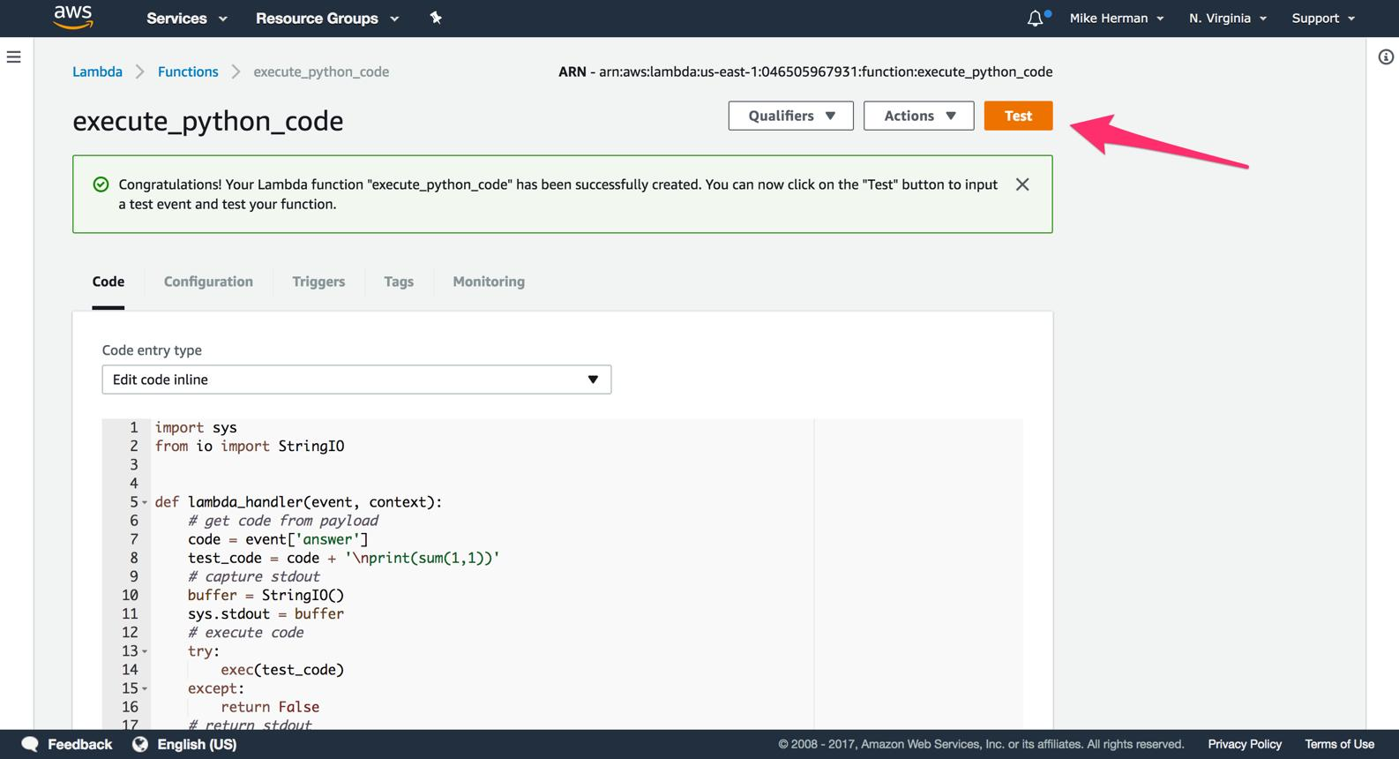
6

⚙️ Steps
- Go to AWS Console → AWS Lambda
- Click Create Function
- Choose Author from scratch
- Runtime: Python 3.x

💻 Sample Code
def lambda_handler(event, context):
return {
'statusCode': 200,
'body': 'Hello from Lambda 🚀'
}

- Click Deploy

🔧 5. Step 2: Create API Gateway

🖼️ Reference
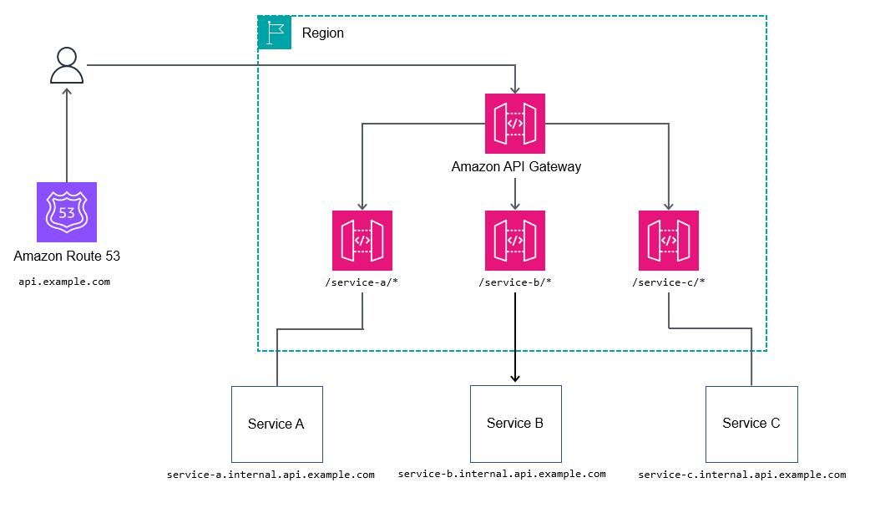
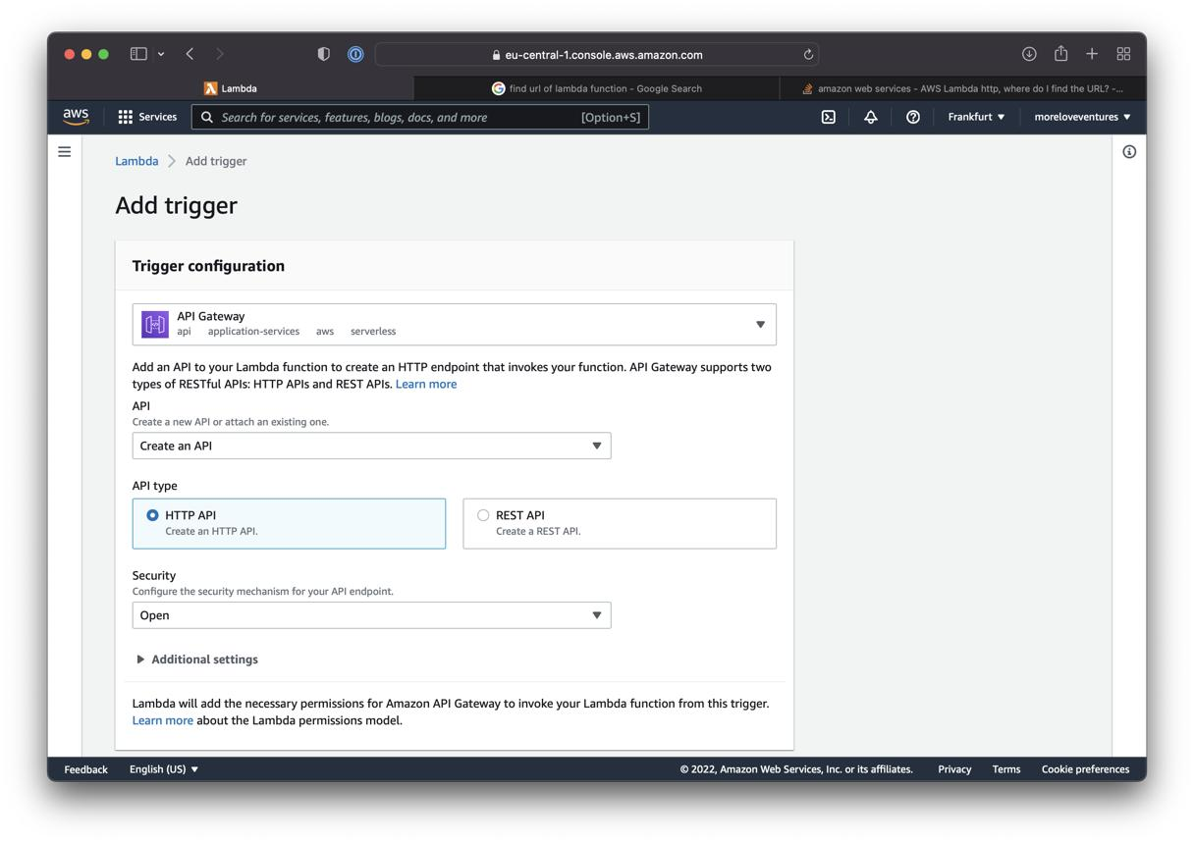
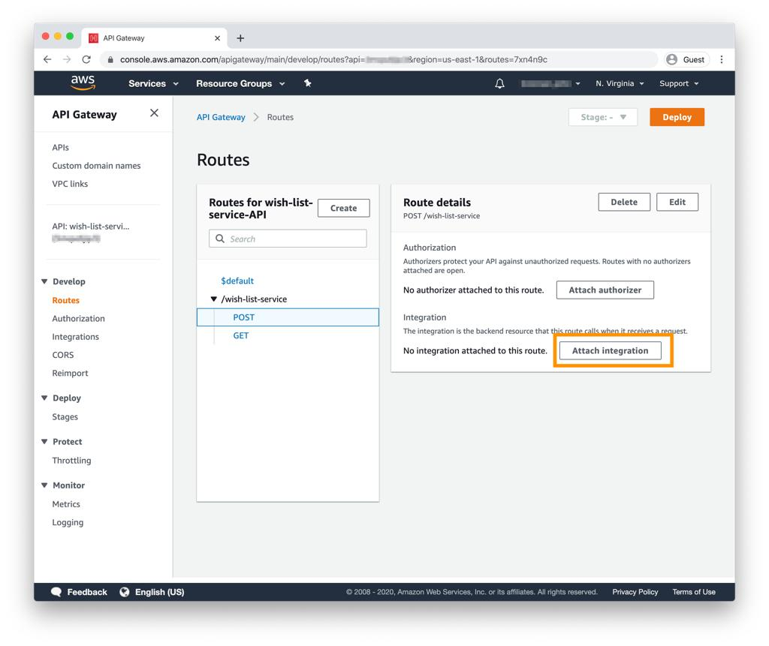
6

⚙️ Steps
- Go to Amazon API Gateway
- Click Create API
- Choose HTTP API

Configuration
- Integration: Lambda → select your function
- Route:
  - Method: GET
  - Path: /hello
- Stage: prod

- Deploy API

🧪 6. Step 3: Test API

🔗 Invoke URL
https://<api-id>.execute-api.<region>.amazonaws.com/hello
Open in browser → verify response:
Hello from Lambda 🚀

🔐 7. Step 4: Create SSL Certificate

🖼️ Reference
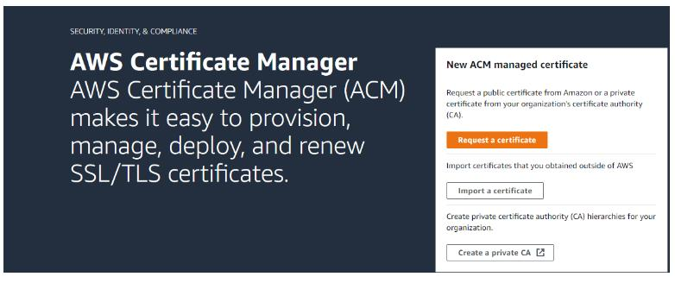
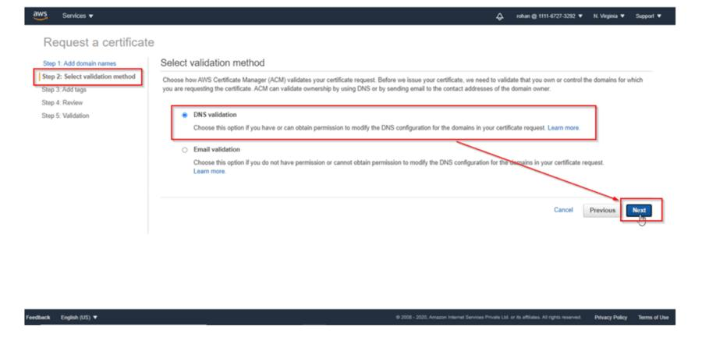
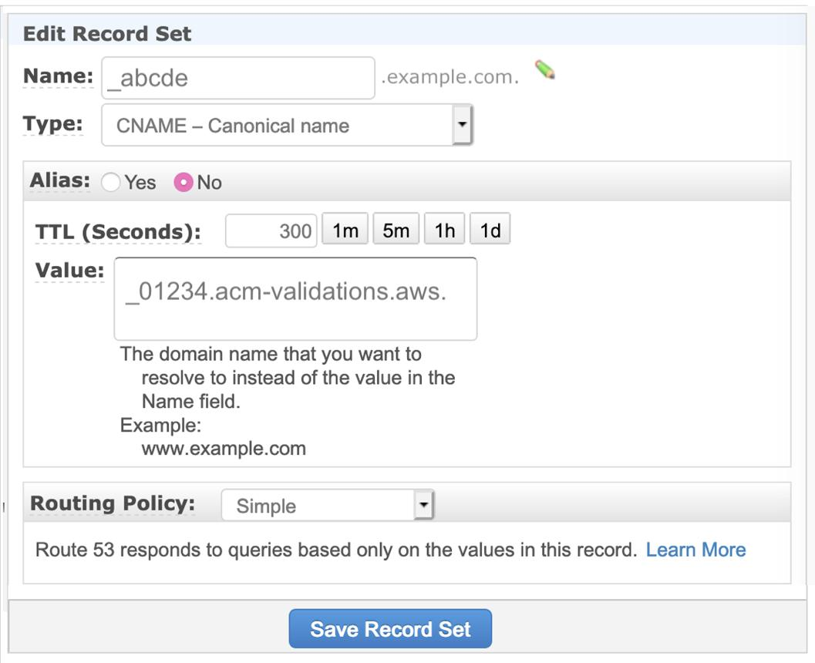
6

⚙️ Steps
- Go to AWS Certificate Manager
- Request certificate:
  - Domain: api.yourdomain.com
- Choose DNS validation

🌐 8. Step 5: Validate Domain via Cloudflare

🖼️ Reference
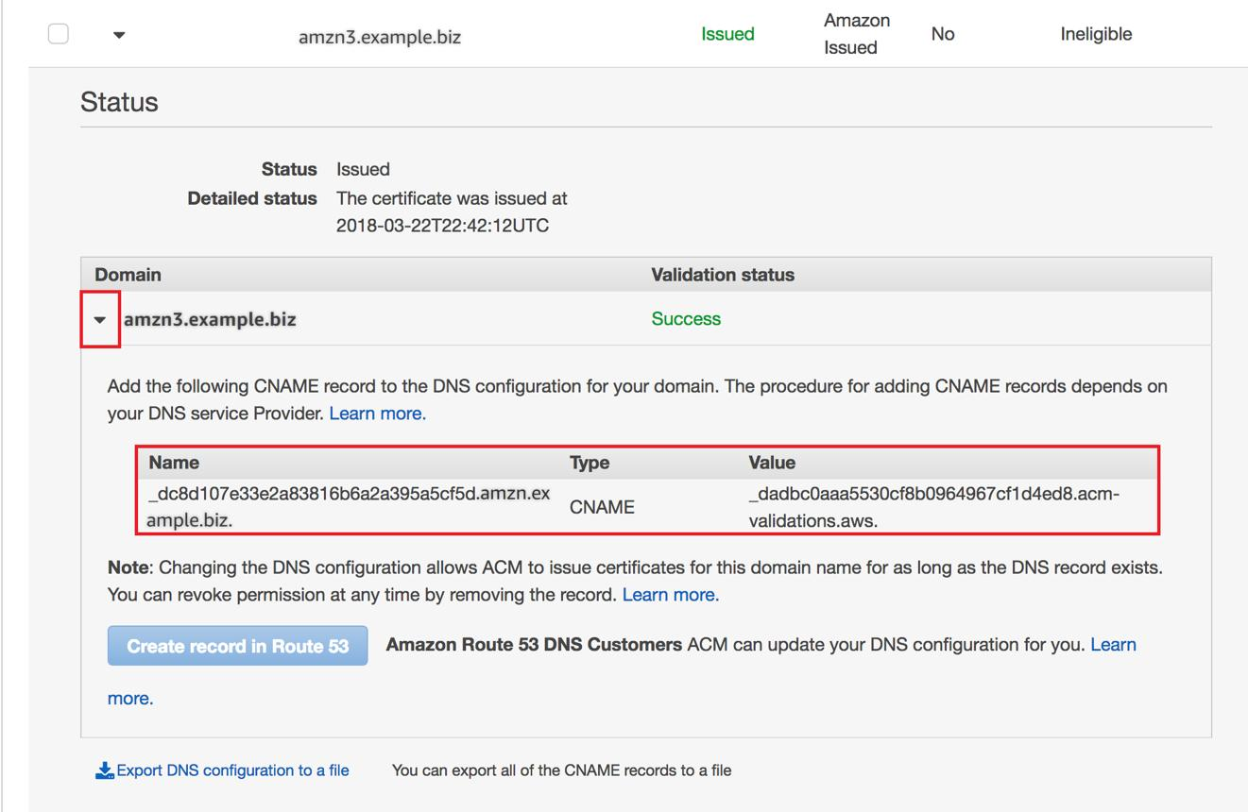
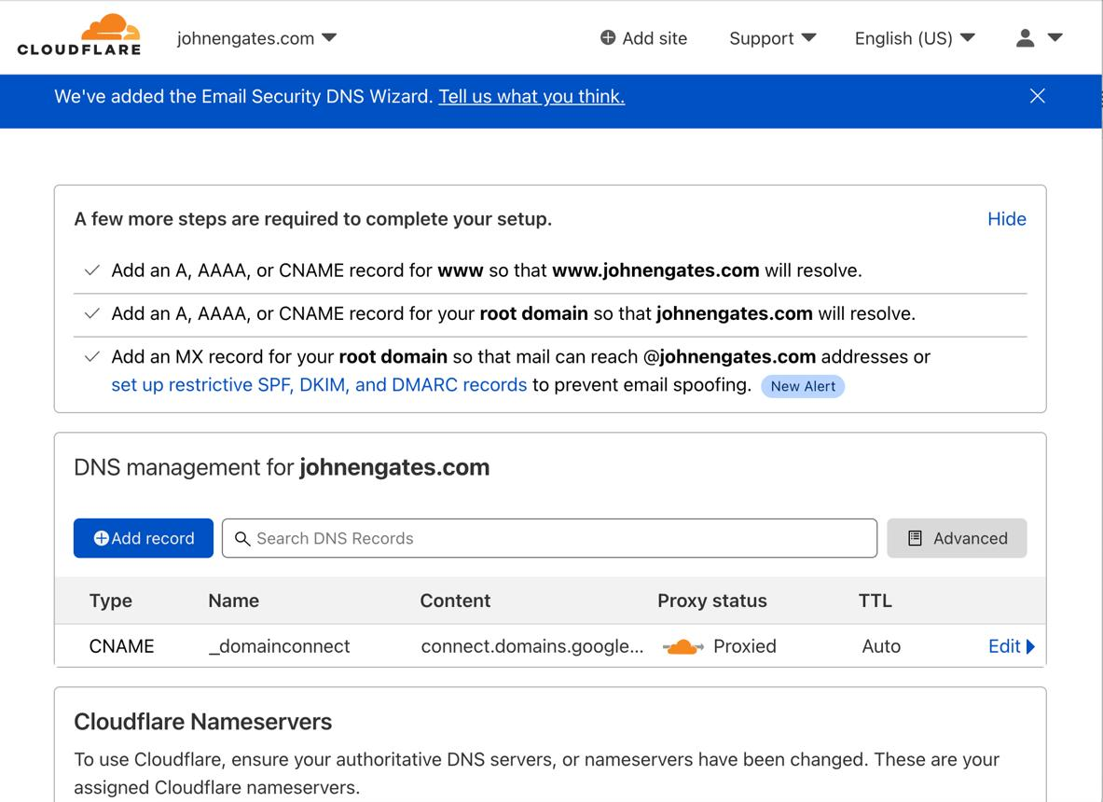
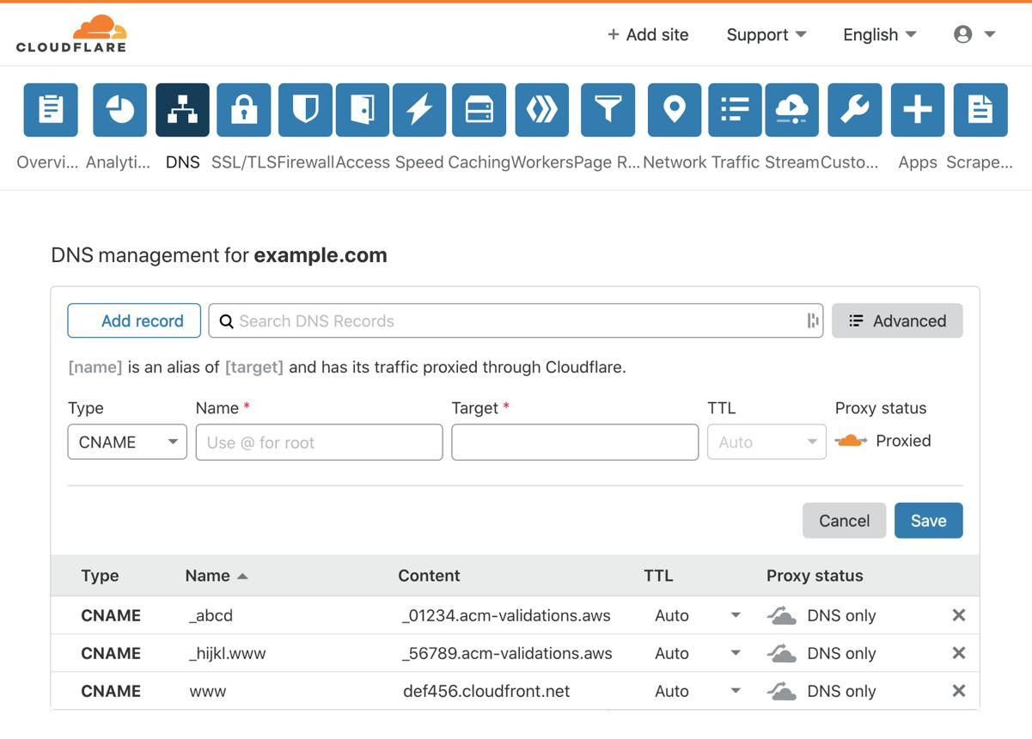
6

⚙️ Steps
- Go to Cloudflare DNS
- Add CNAME record provided by ACM
Type | Name | Value
CNAME | _acme-challenge.api | AWS validation value

- Wait until certificate status = ✅ Issued

🔗 9. Step 6: Configure Custom Domain in API Gateway

🖼️ Reference
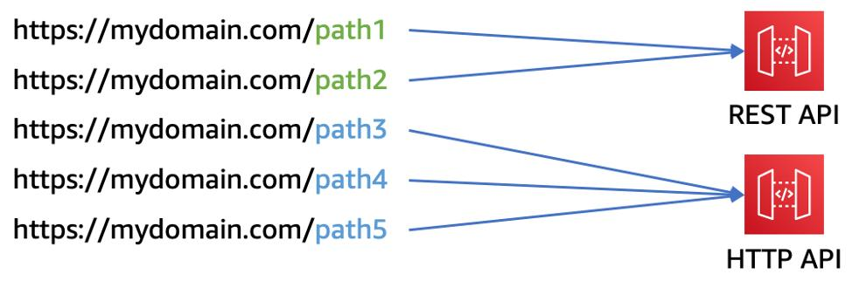
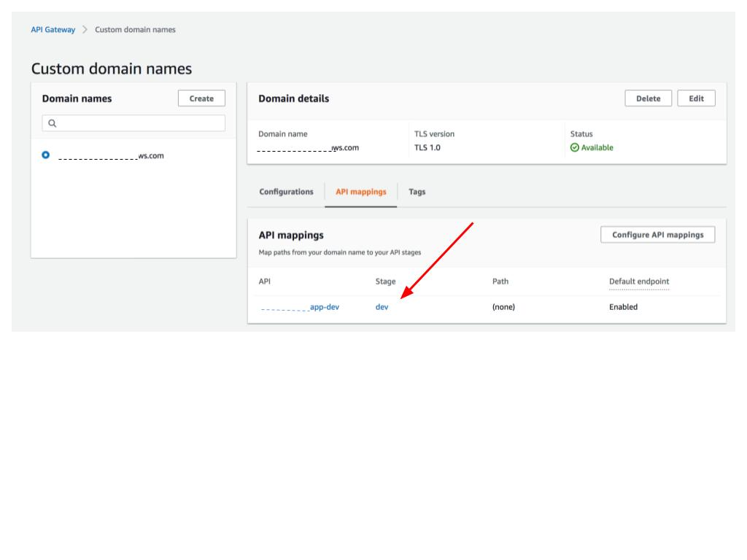
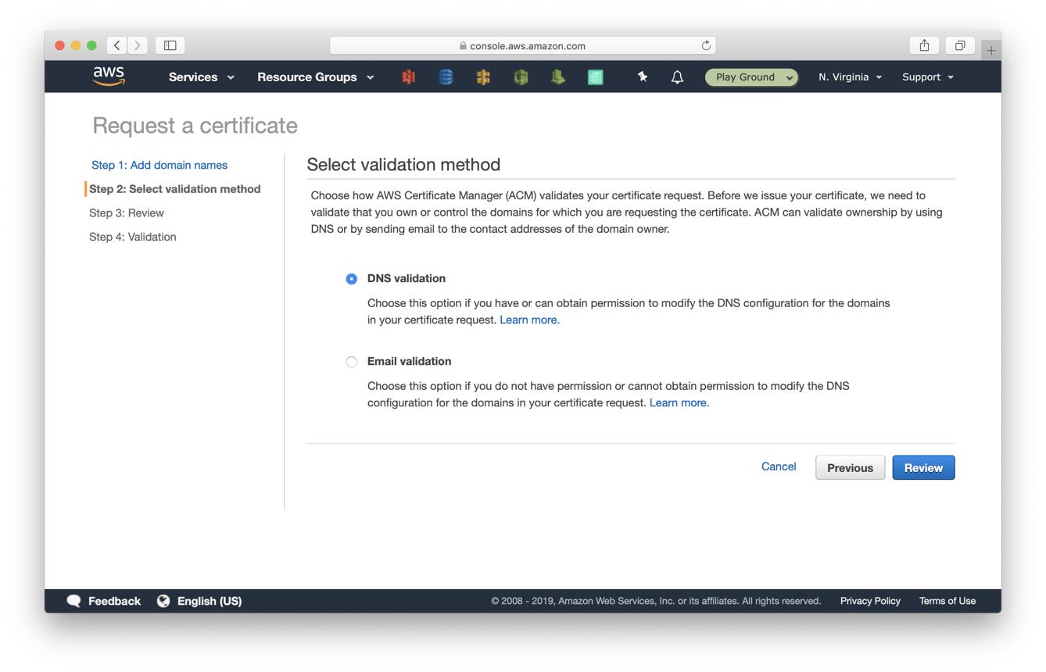
5

⚙️ Steps
- Go to API Gateway → Custom Domains
- Create domain:
  - api.yourdomain.com
- Attach ACM certificate
- Map API:
  - Stage: prod

🌍 10. Step 7: Configure Cloudflare DNS

🖼️ Reference

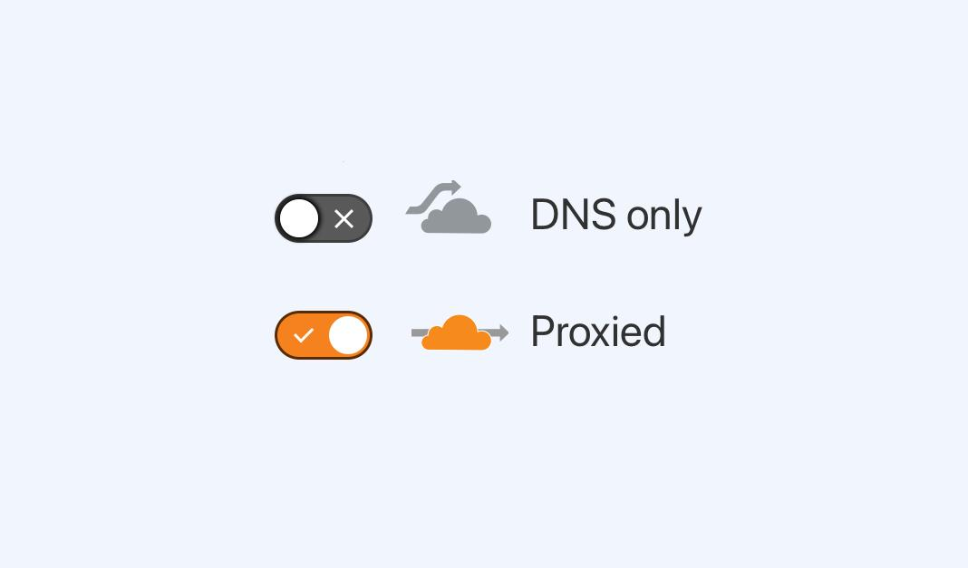
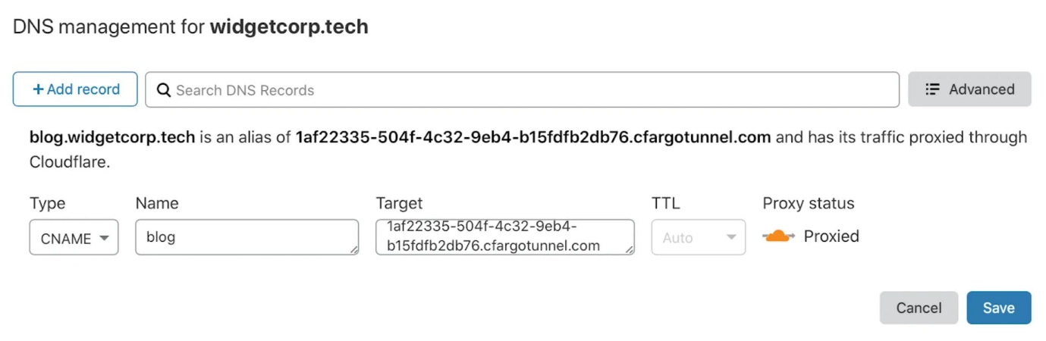
6

⚙️ Steps
Add record:
Type | Name | Target
CNAME | api | <api-id>.execute-api.<region>.amazonaws.com

⚠️ Proxy Settings
- OFF → DNS only (testing)
- ON → Production (CDN + security)

🧪 11. Step 8: Final Test

Open:
https://api.yourdomain.com/hello

✅ Expected Output
Hello from Lambda 🚀

🔒 12. Security Considerations
- Use HTTPS (ACM certificate)
- Enable Cloudflare proxy (recommended)
- Add WAF protection
- Use authentication:
  - JWT
  - IAM

📈 13. Improvements
- Add multiple API routes
- Integrate with database (DynamoDB)
- Add authentication layer
- Implement CI/CD pipeline

🎯 14. Conclusion
This setup provides:
- Scalable serverless backend
- Secure custom domain access
- Global DNS via Cloudflare
- Cost-efficient architecture

🏷️ Tags
AWS Lambda API Gateway Cloudflare Serverless DevOps

🧠 Explain the Architecture
Client → Cloudflare → API Gateway → Lambda → Response

🧩 Components
- AWS Lambda → Backend logic
- Amazon API Gateway → API exposure
- Cloudflare → DNS + CDN
- ACM → SSL

❓ Why this architecture?
- Fully serverless (no servers to manage)
- Auto-scaling
- Cost-efficient (pay per request)
- Global performance via Cloudflare

🧪 How did you implement it?
👉 Sample answer:
“I created a Lambda function and exposed it using API Gateway HTTP API.
Then I configured a custom domain using ACM and mapped it to API Gateway.
Finally, I used Cloudflare for DNS and optional CDN + security.”

🔐 Security Points
- HTTPS using ACM
- Cloudflare proxy for protection
- Optional JWT/IAM auth

🔥 Interview Tip
“API Gateway acts as the entry point, Lambda executes logic, and Cloudflare improves performance and security.”

