🔗 AWS Networking SOP: VPC Peering vs Transit Gateway (TGW)

📌 1. Overview
This document demonstrates how to connect multiple VPCs using:
- VPC Peering → Simple, direct connectivity
- AWS Transit Gateway (TGW) → Scalable hub-based connectivity

🧠 2. Concepts

🔹 VPC Peering
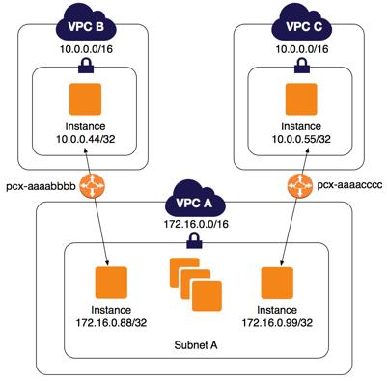
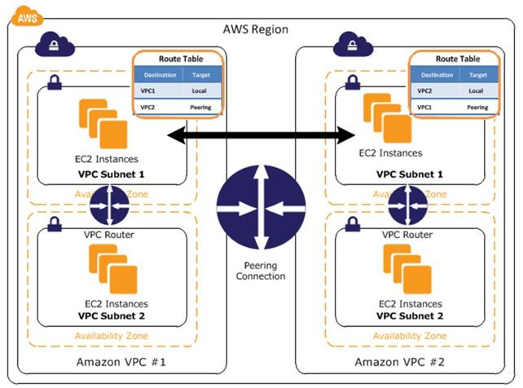
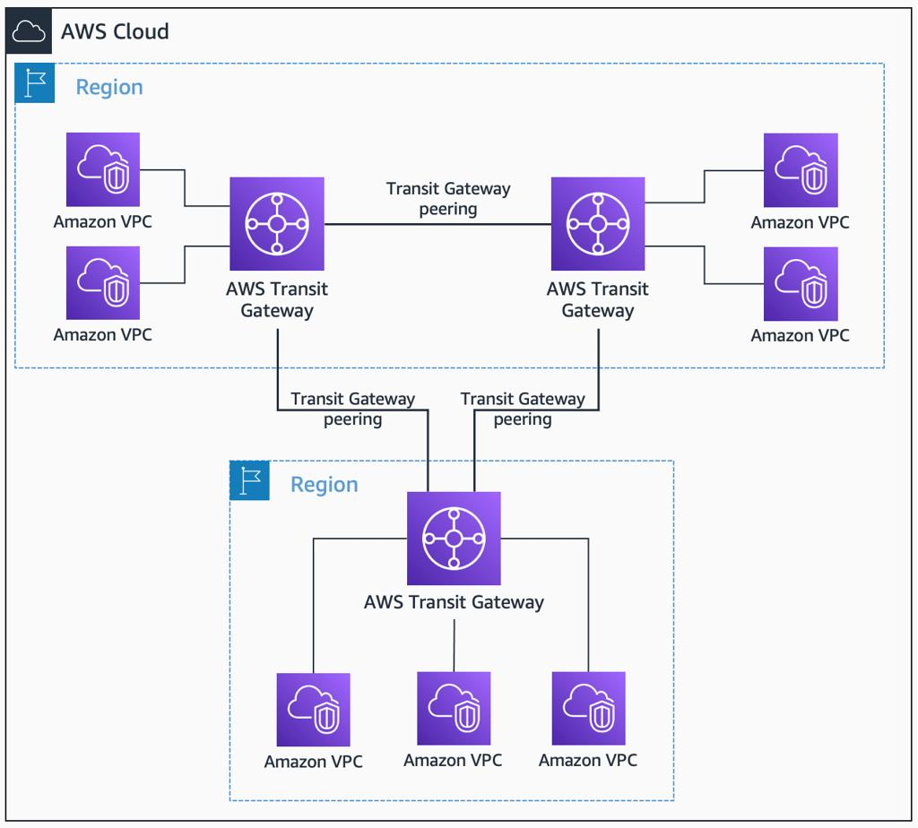
6
A direct private connection between two VPCs
VPC-A ↔ VPC-B
✅ Key Points
- Simple setup
- One-to-one connection
- No transitive routing ❌

🔹 Transit Gateway (TGW)
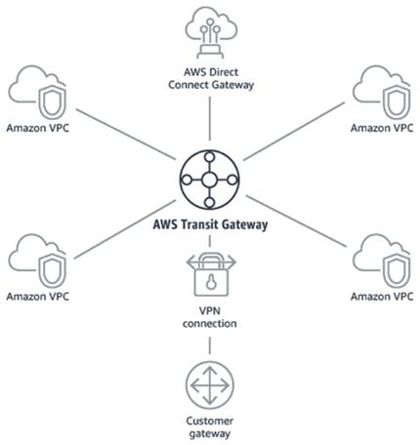
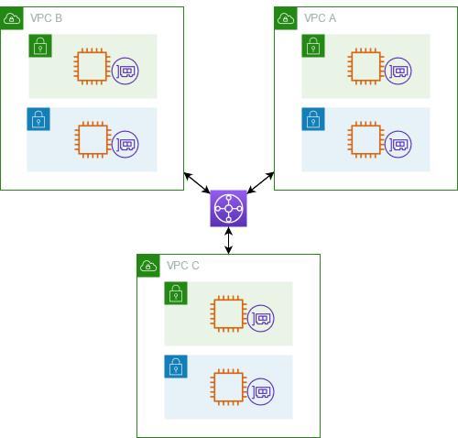
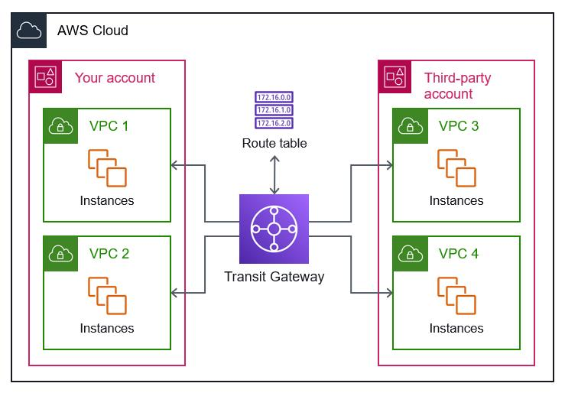
6
A central hub that connects multiple VPCs
TGW
/ | \
VPC1 VPC2 VPC3
✅ Key Points
- Highly scalable
- Supports transitive routing ✅
- Hub-and-spoke architecture

🎯 3. Lab Goal
- Connect 2 VPCs using VPC Peering
- Connect 3 VPCs using AWS Transit Gateway
- Verify connectivity between Amazon EC2 instances

🧱 4. Prerequisites
- AWS Account
- Basic EC2 knowledge
- SSH access configured

🧪 PART 1: VPC Peering

🖼️ Architecture

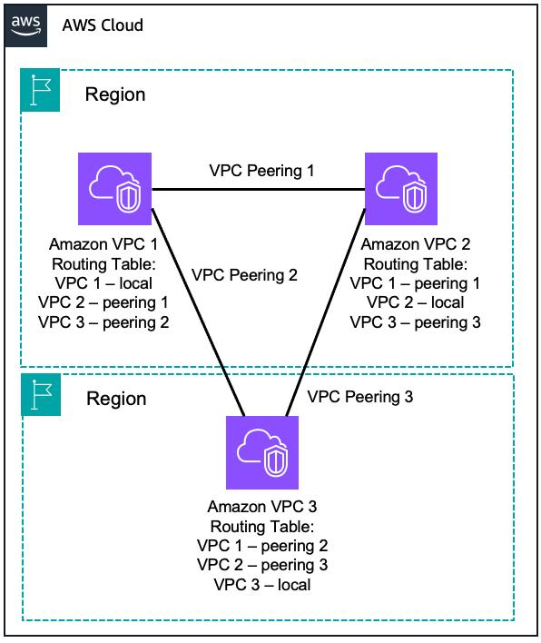
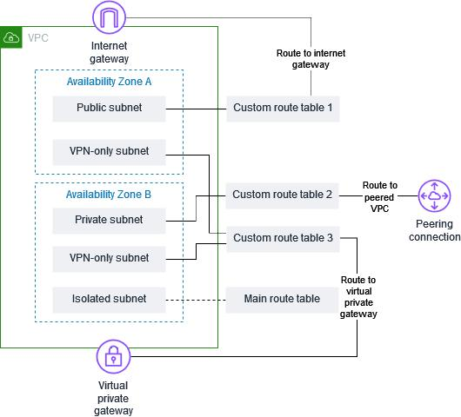
5

🔧 Step 1: Create VPCs
Create two VPCs:
VPC | CIDR
VPC-A | 10.0.0.0/16
VPC-B | 10.1.0.0/16

🔧 Step 2: Create Subnets
- VPC-A → 10.0.1.0/24
- VPC-B → 10.1.1.0/24

🔧 Step 3: Launch EC2
Use Amazon EC2:
- One EC2 in each VPC
- Enable SSH access

🔧 Step 4: Create VPC Peering Connection
- Go to VPC → Peering Connections
- Create connection:
  - Requester: VPC-A
  - Accepter: VPC-B
- Accept request

🔧 Step 5: Update Route Tables
In VPC-A:
10.1.0.0/16 → Peering Connection

In VPC-B:
10.0.0.0/16 → Peering Connection

🔧 Step 6: Security Groups
Allow:
- SSH (Port 22)
- ICMP (Ping)

🧪 Step 7: Test Connectivity
From EC2 in VPC-A:
ping <private-ip-of-vpc-b-ec2>

✅ Result
- Communication works between VPC-A and VPC-B

❗ Limitation (No Transitive Routing)
VPC-A ↔ VPC-B
VPC-B ↔ VPC-C
👉 VPC-A ❌ cannot reach VPC-C

🧪 PART 2: Transit Gateway (TGW) — COMPLETE SOP (BEGINNER FRIENDLY)

🧠 0. What You Are Building
You are creating this architecture:

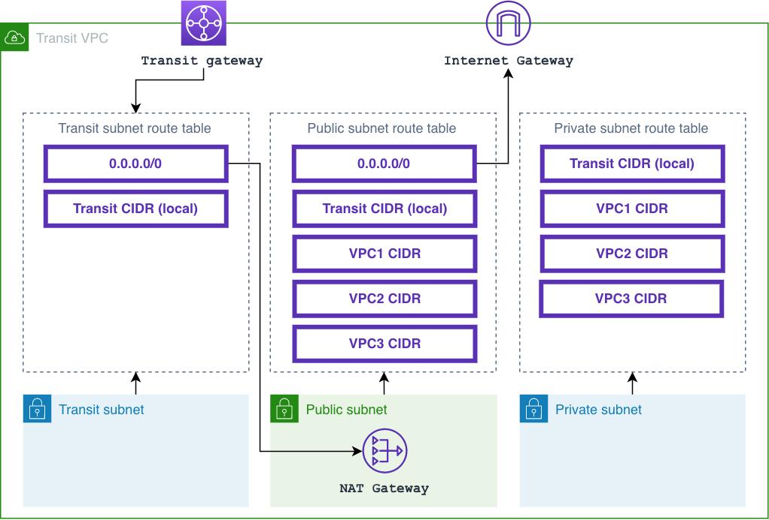
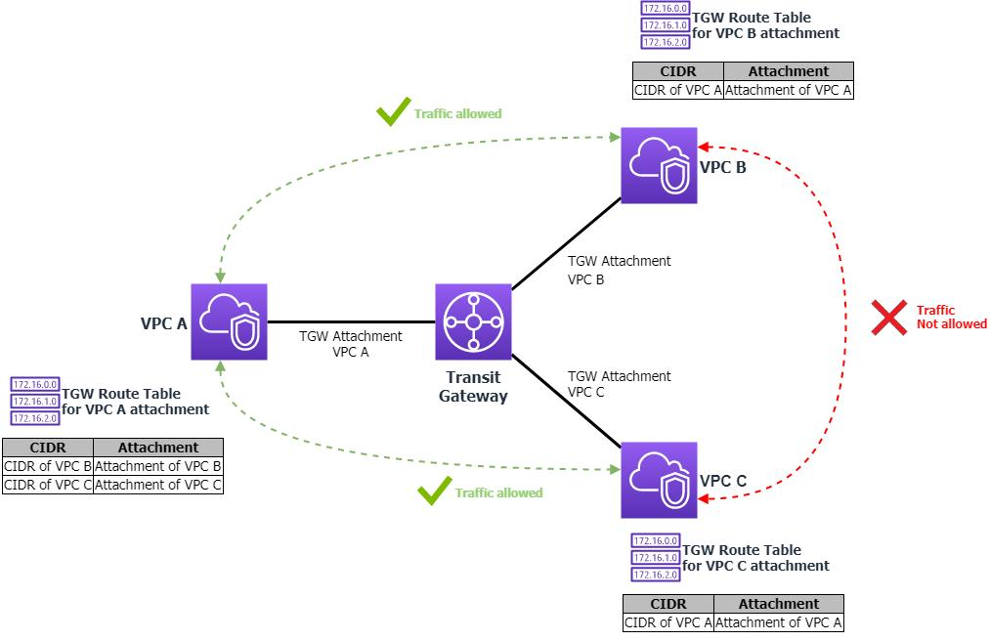
5
VPC-1 VPC-2 VPC-3
\ | /
Transit Gateway
👉 Goal: All VPCs should talk to each other

🔧 Step 1: Create 3 VPCs

🖼️ Console Reference
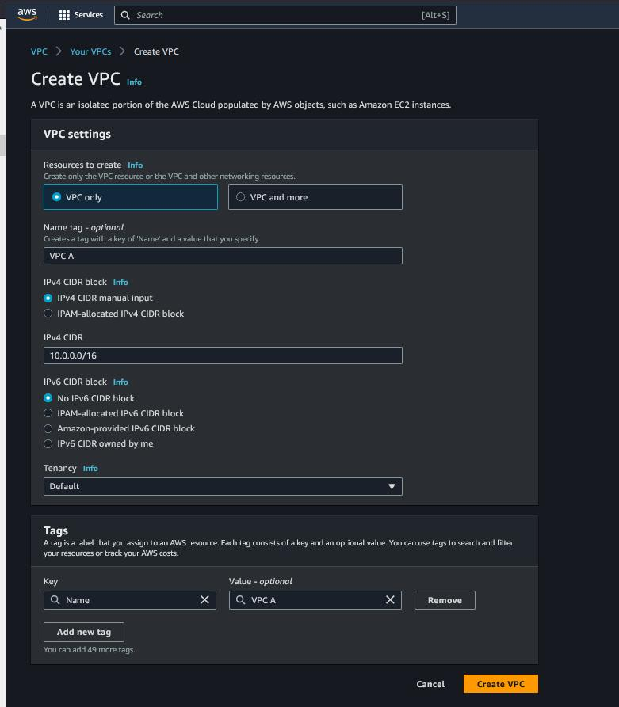
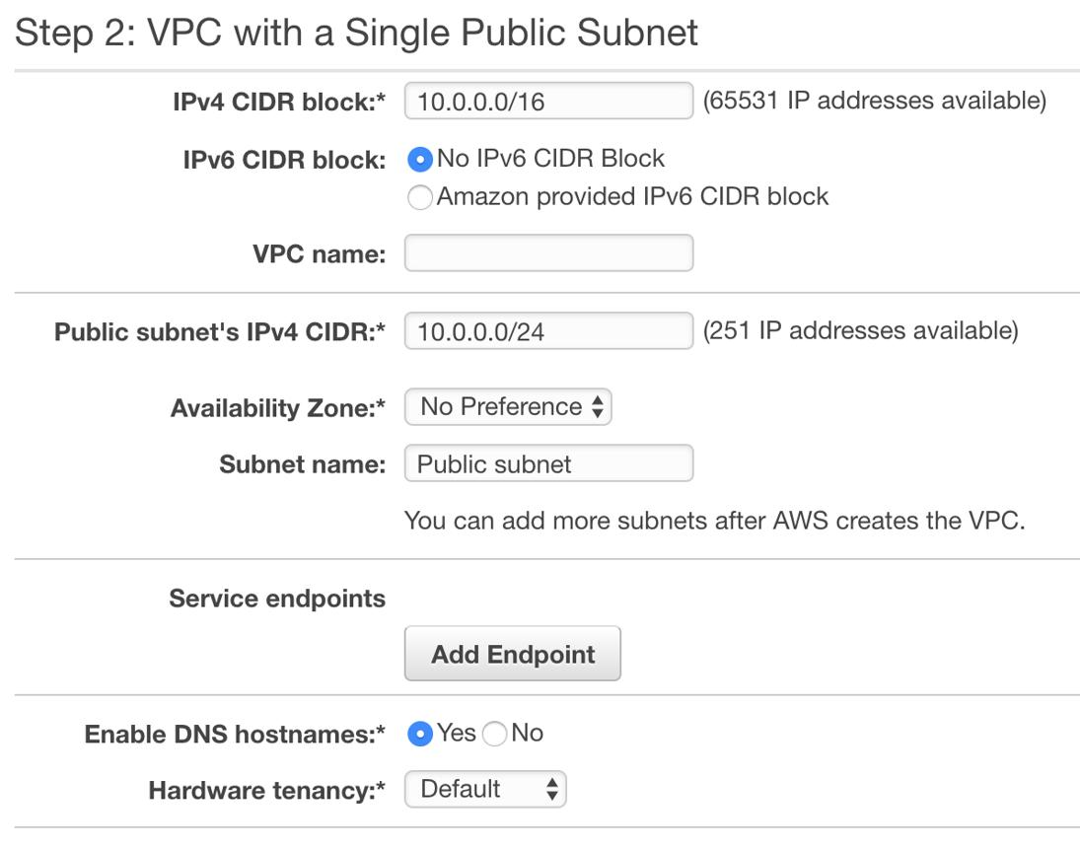
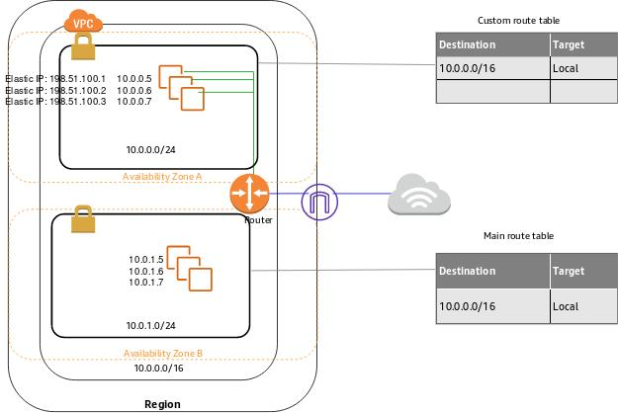
5

⚙️ Steps (Repeat 3 times)
Go to VPC → Your VPCs → Create VPC

Create VPC-1
- Name → VPC-1
- CIDR → 10.0.0.0/16
- Click Create

Create VPC-2
- Name → VPC-2
- CIDR → 10.1.0.0/16

Create VPC-3
- Name → VPC-3
- CIDR → 10.2.0.0/16

🔧 Step 2: Create Subnet + EC2 (IMPORTANT)

🖼️ Reference
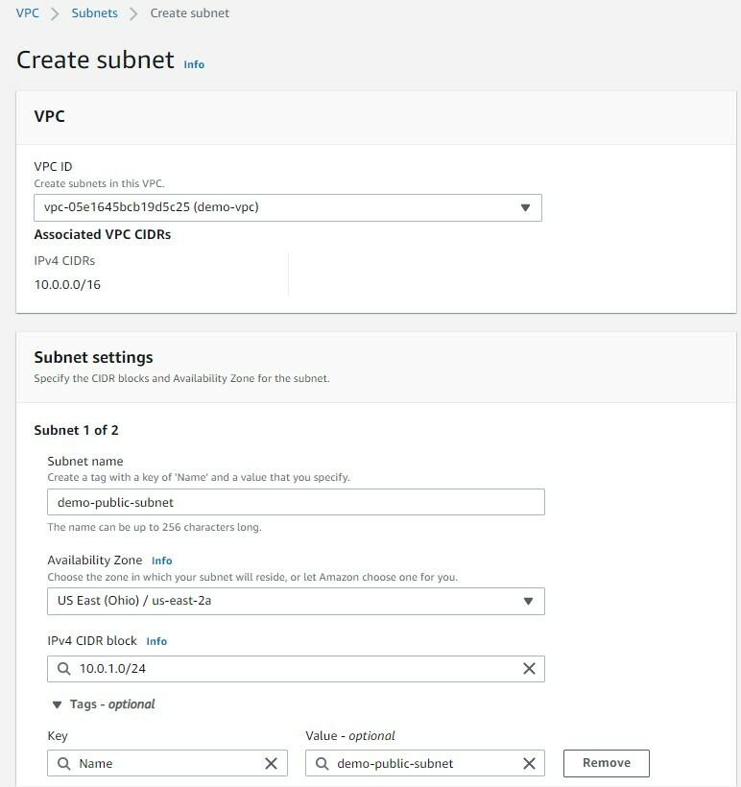
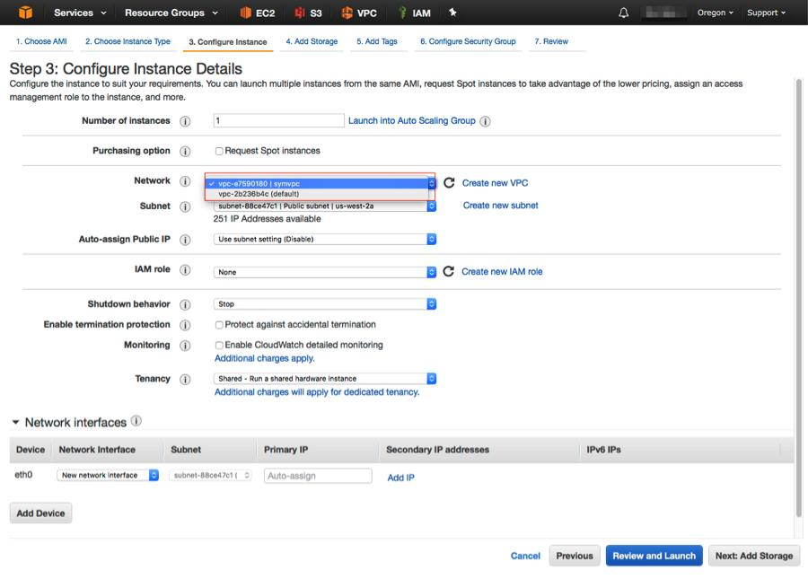
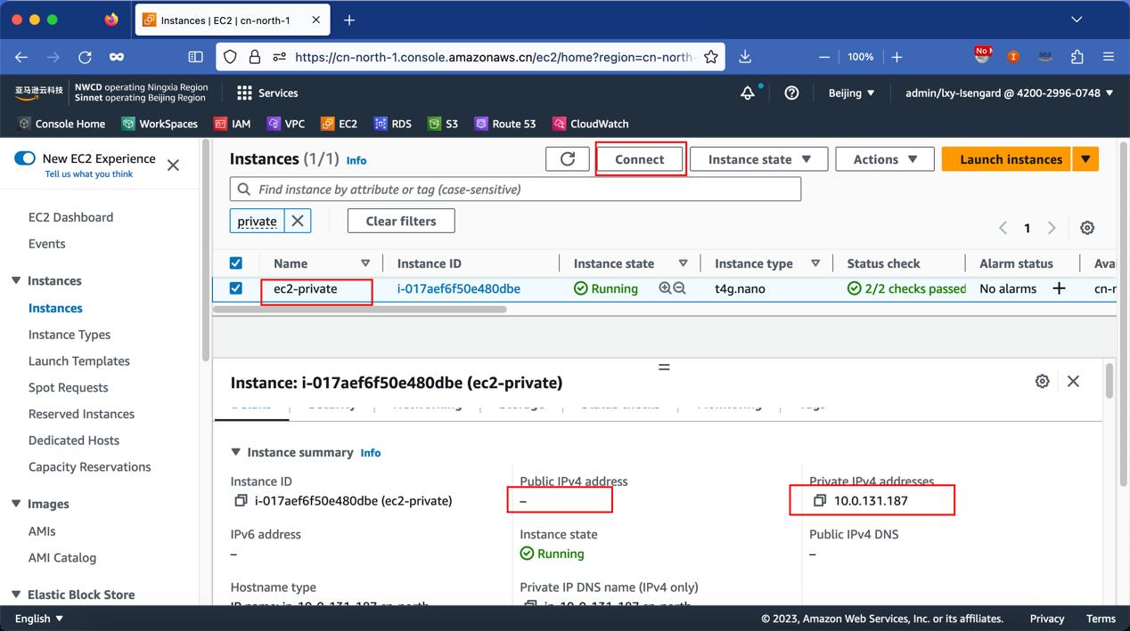
6

⚙️ Step A: Create Subnet (for each VPC)
Go to VPC → Subnets → Create subnet

Example: VPC-1
- VPC → VPC-1
- Subnet CIDR → 10.0.1.0/24

Repeat:
VPC | Subnet
VPC-1 | 10.0.1.0/24
VPC-2 | 10.1.1.0/24
VPC-3 | 10.2.1.0/24

⚙️ Step B: Launch EC2 in each VPC
Go to Amazon EC2 → Launch Instance

Settings (VERY IMPORTANT)
- Name → ec2-vpc1
- AMI → Amazon Linux
- Instance type → t2.micro
- Network → Select correct VPC
- Subnet → Select subnet you created
- Auto-assign Public IP → ENABLE (for testing)

Repeat for all 3 VPCs.

🧠 Save this (VERY IMPORTANT)
Copy private IPs of all EC2 instances.

🔧 Step 3: Create Transit Gateway

🖼️ Reference
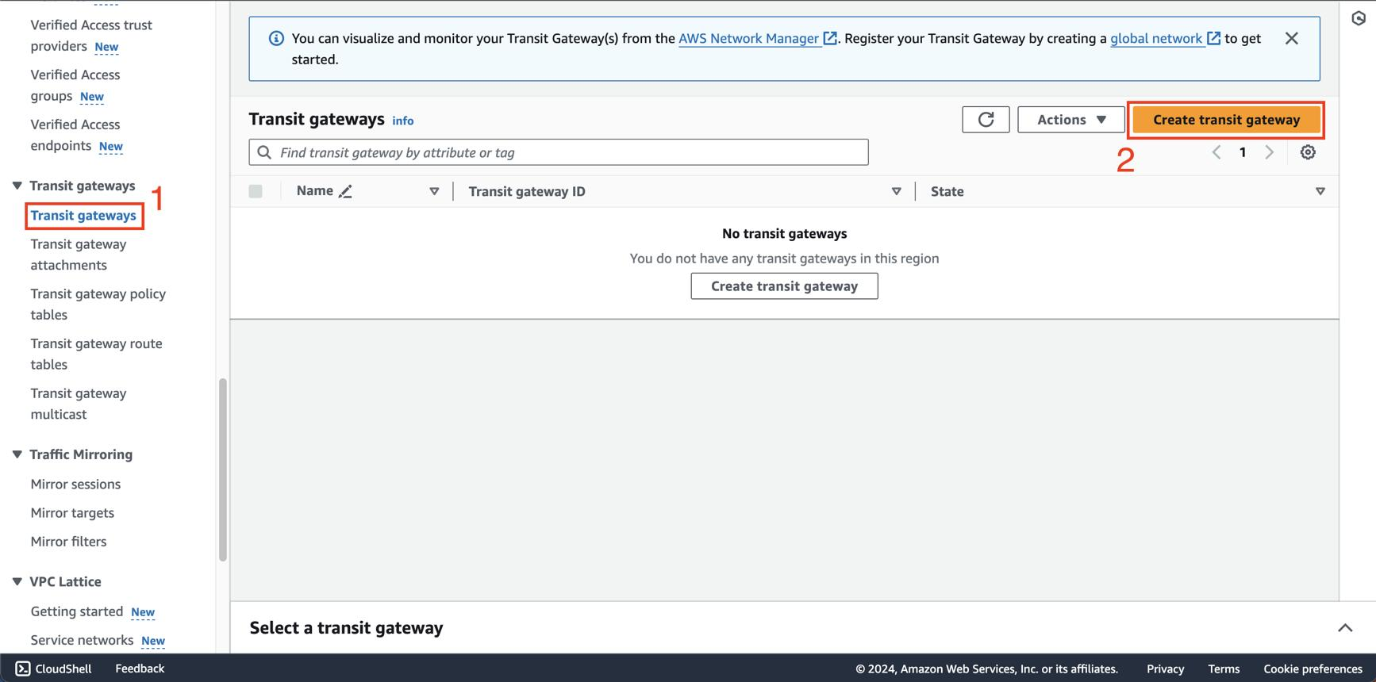
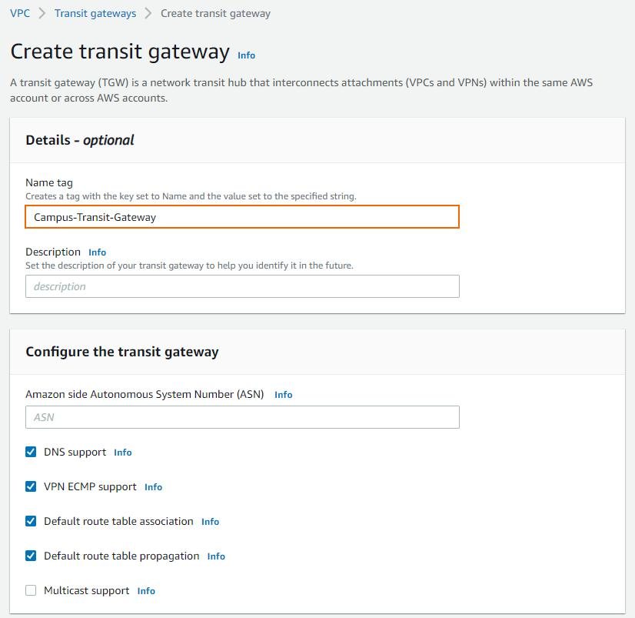
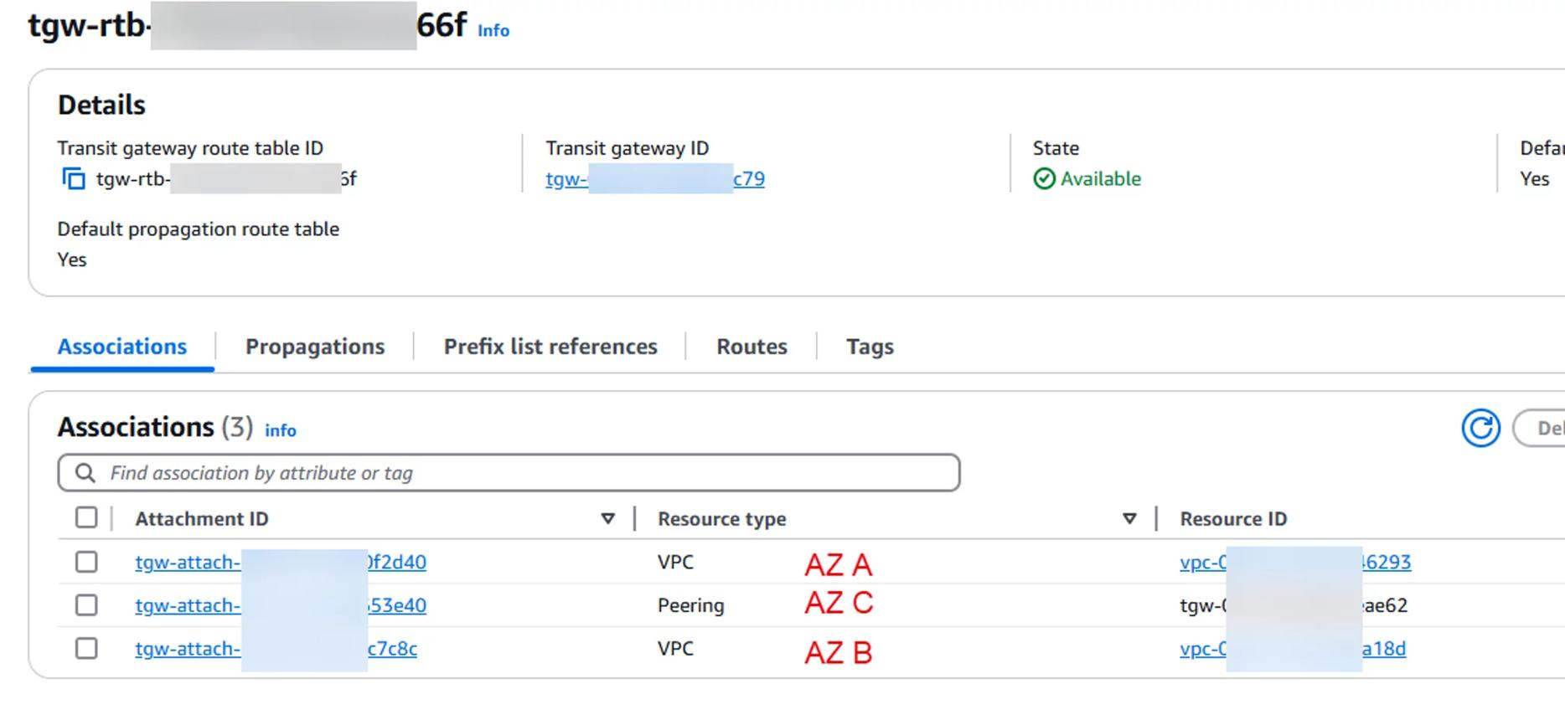
6

⚙️ Steps
Go to:
👉 VPC → Transit Gateways → Create

Fill details:
- Name → my-tgw
- Leave everything else default
Click Create Transit Gateway

⏳ Wait until:
State = Available

🔧 Step 4: Attach VPCs to TGW (CRITICAL)

🖼️ Reference
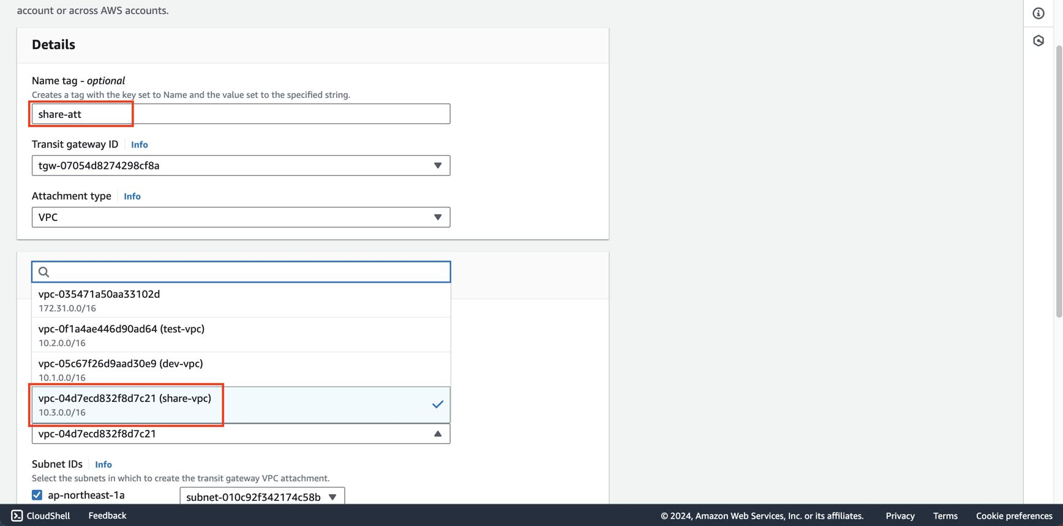
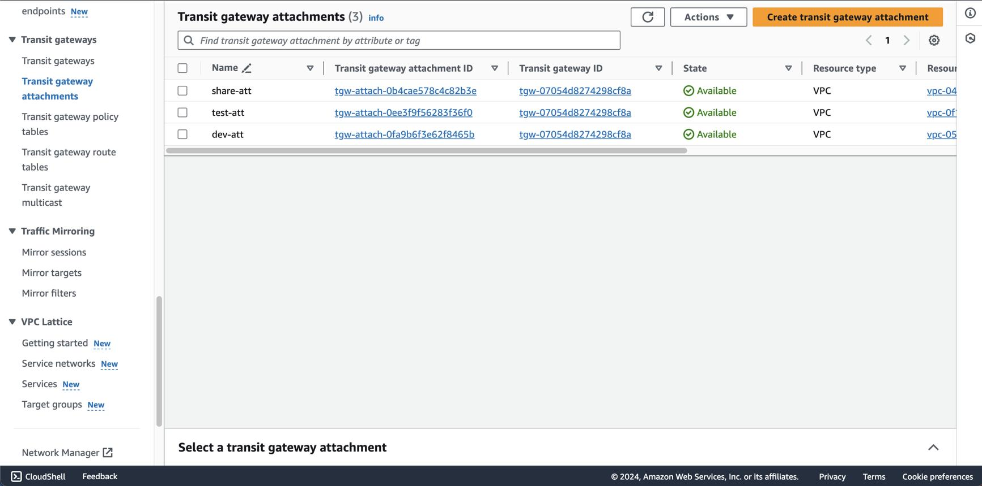

5

⚙️ Steps (DO 3 TIMES)
Go to:
👉 VPC → Transit Gateway Attachments → Create

Example: Attach VPC-1
- Name → attach-vpc1
- Transit Gateway → my-tgw
- Attachment Type → VPC
- VPC → VPC-1

⚠️ MOST IMPORTANT STEP
Subnet selection
👉 Select subnet: 10.0.1.0/24
💡 If you skip this → TGW won’t work

Click Create

🔁 Repeat for:
- VPC-2 → subnet 10.1.1.0/24
- VPC-3 → subnet 10.2.1.0/24

⏳ Wait
All attachments must show:
Available ✅

🔧 Step 5: Update Route Tables (THIS MAKES IT WORK)

🧠 What you are doing
You are telling each VPC:
👉 “Send traffic for other VPCs to TGW”

🖼️ Reference
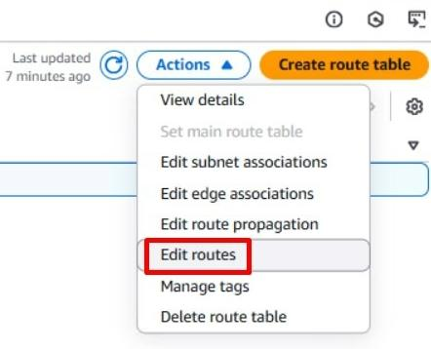
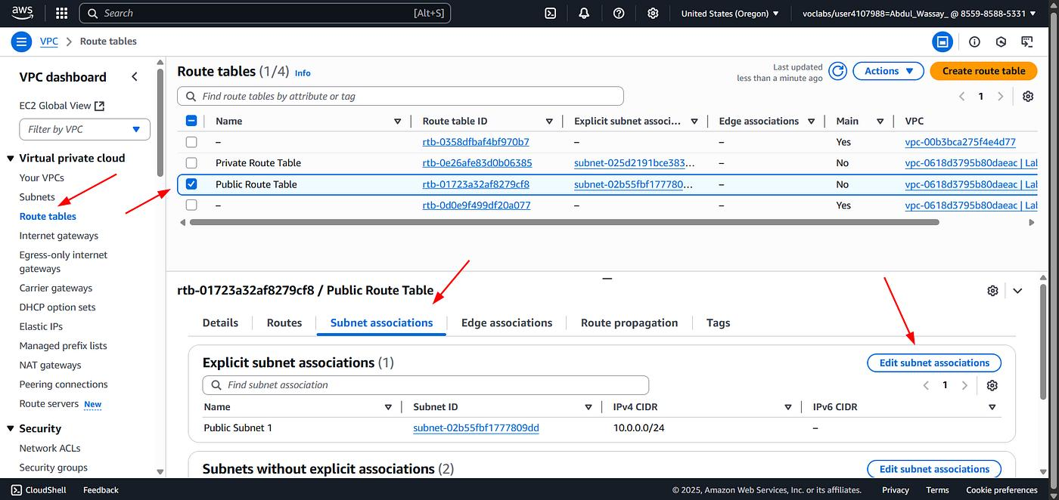
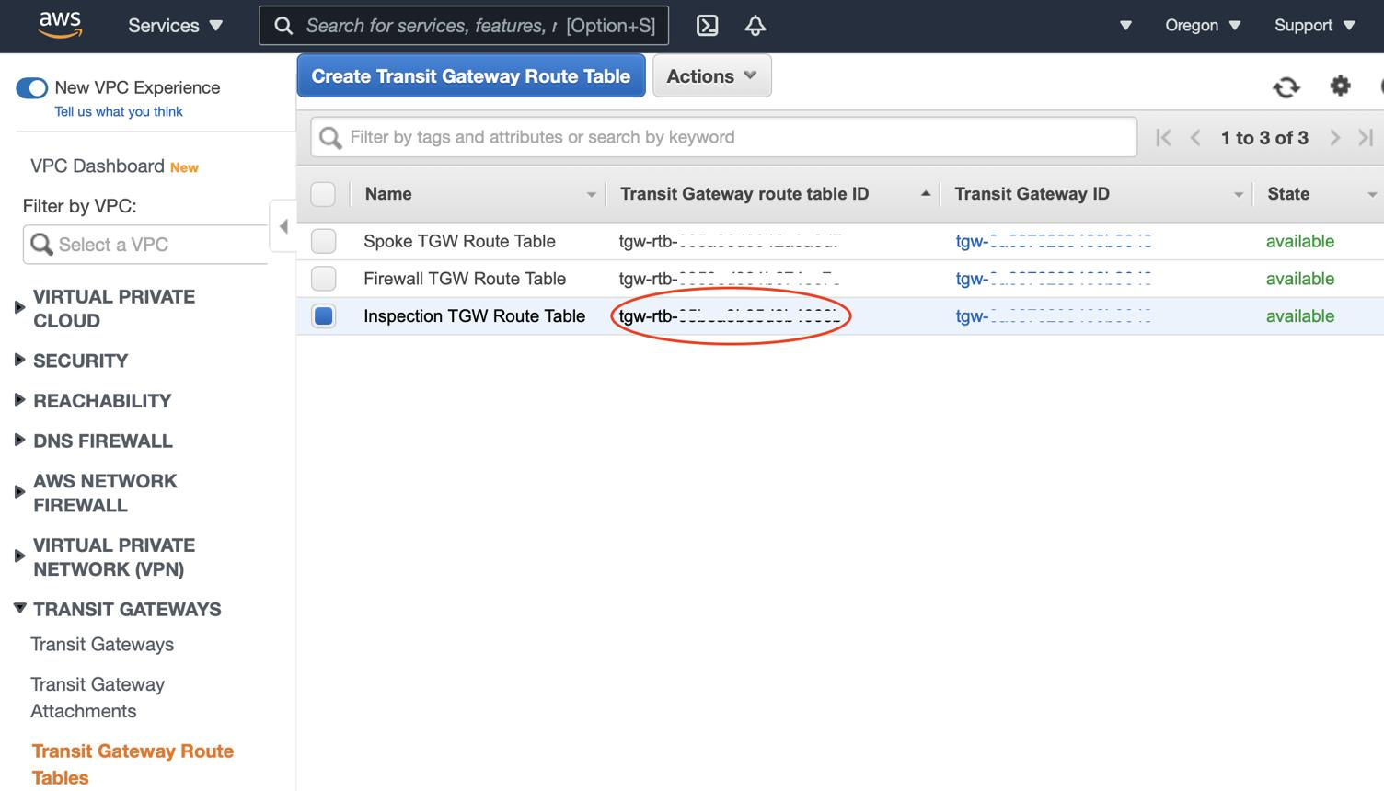
6

⚙️ Steps (DO FOR EACH VPC)

🔹 VPC-1 Route Table
Go to:
👉 VPC → Route Tables → select VPC-1 route table
Click Edit routes → Add route

Add:
Destination | Target
10.1.0.0/16 | TGW
10.2.0.0/16 | TGW

🔹 VPC-2 Route Table
Destination | Target
10.0.0.0/16 | TGW
10.2.0.0/16 | TGW

🔹 VPC-3 Route Table
Destination | Target
10.0.0.0/16 | TGW
10.1.0.0/16 | TGW

❌ DO NOT DO THIS
10.0.0.0/8 ❌
👉 Too broad → causes routing issues

🔧 Step 6: Security Groups (MOST COMMON ISSUE)

🖼️ Reference
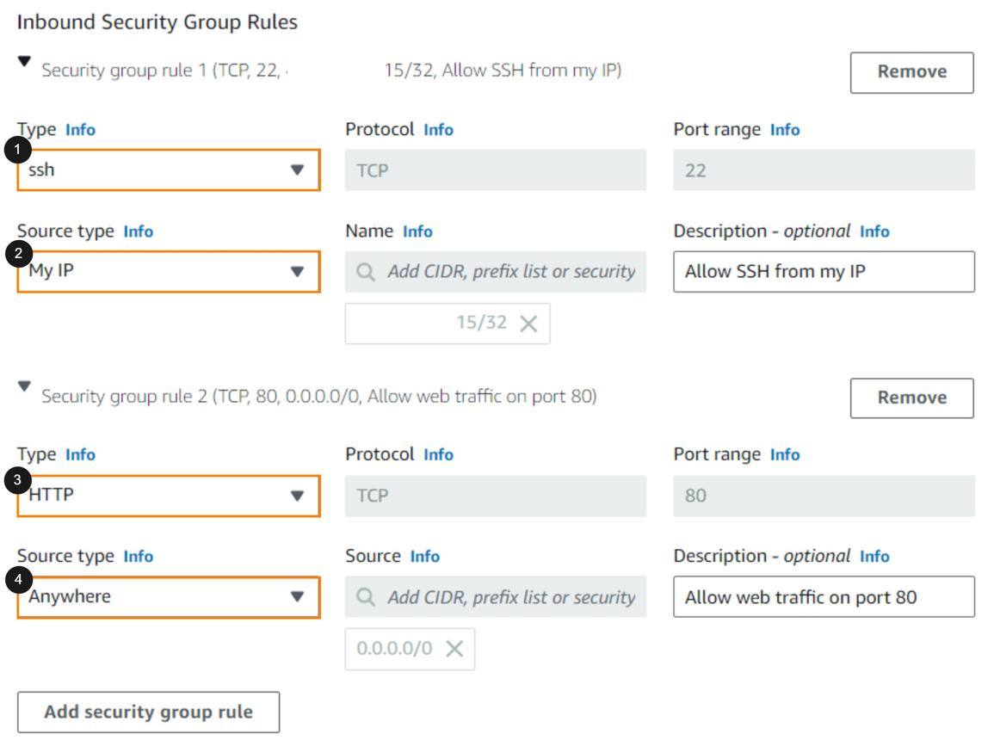
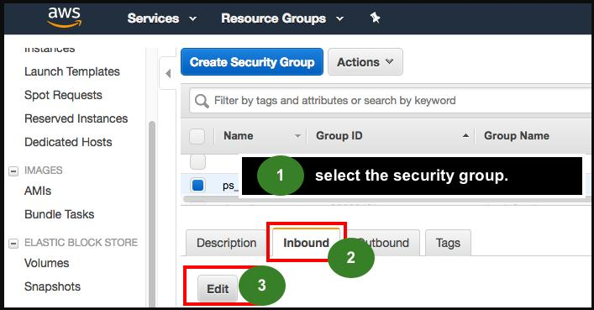
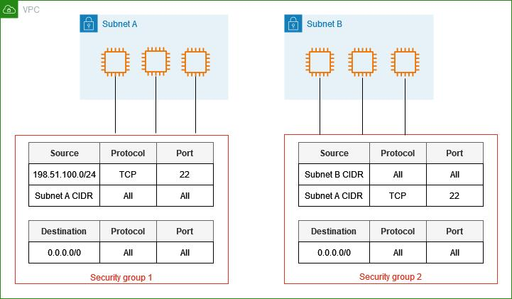
5

⚙️ Steps (FOR ALL EC2s)
Go to:
👉 EC2 → Instances → Select instance → Security → Security Group

Click Edit inbound rules

Add rules:

🔹 SSH
- Type → SSH
- Port → 22
- Source → your IP

🔹 ICMP (Ping)
- Type → All ICMP - IPv4
- Source → 0.0.0.0/0 (testing)

🧪 Step 7: Test Connectivity

Connect to EC2 (VPC-1)
ssh ec2-user@<public-ip>

Run:
ping <private-ip-of-vpc-3>

✅ Expected Result
✔️ VPC-1 → VPC-2 works
✔️ VPC-2 → VPC-3 works
✔️ VPC-1 → VPC-3 works

🚨 Real Debug Checklist (IMPORTANT)
If it fails, check:
- TGW → Available
- Attachments → Available
- Subnet selected in attachment
- Route tables updated correctly
- Security group allows ICMP
- Using private IP (not public)

🔥 Key Differences
Feature | VPC Peering | TGW
Scale | Small | Large
Routing | Non-transitive | Transitive
Architecture | Mesh | Hub & Spoke
Management | Complex | Centralized

🎯 Conclusion
- VPC Peering → Good for 2–3 VPCs
- AWS Transit Gateway → Best for real-world architectures.
🎯 3. VPC Peering vs Transit Gateway — Interview Explanation

🧠 VPC Peering
A direct connection between two VPCs
VPC-A ↔ VPC-B

✅ Characteristics
- Simple setup
- One-to-one
- No transitive routing

❗ Limitation
If:
A ↔ B
B ↔ C
👉 A cannot talk to C

🧠 Transit Gateway (TGW)
A central hub connecting multiple VPCs
TGW
/ | \
VPC1 VPC2 VPC3

✅ Characteristics
- Scalable
- Supports transitive routing
- Hub-and-spoke model

🧪 Real Implementation Explanation
“I created three VPCs and attached them to a Transit Gateway.
Then I updated route tables to route traffic via TGW.
After configuring security groups, I verified connectivity using private IPs.”

🔥 Key Difference (IMPORTANT)
Feature | VPC Peering | TGW
Routing | Non-transitive | Transitive
Scale | Small | Large
Design | Mesh | Hub

💡 When to use what?
👉 Say this confidently:
- “VPC Peering is good for small setups (2–3 VPCs)”
- “Transit Gateway is used in enterprise environments with many VPCs”.

