🔌 AWS VPC Endpoints – Complete Hands-On SOP

📌 1. Introduction
🧠 What is a VPC Endpoint?
A VPC Endpoint allows resources inside a VPC (like EC2) to connect to AWS services privately — without traversing the public internet.

🔑 Why do we need it?
❌ Traditional Approach
EC2 → NAT Gateway → Internet → S3
Problems:
- Uses public internet
- Adds NAT Gateway cost 💰
- Increased attack surface

✅ With VPC Endpoint
EC2 → VPC Endpoint → S3
Benefits:
- No internet exposure
- Lower cost
- Improved security

📚 2. Types of Endpoints

🔹 Gateway Endpoint (S3 / DynamoDB)
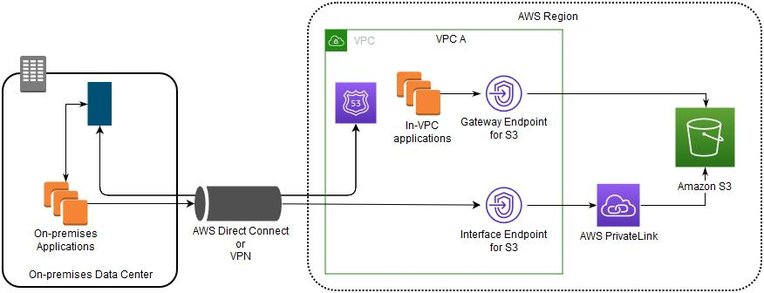
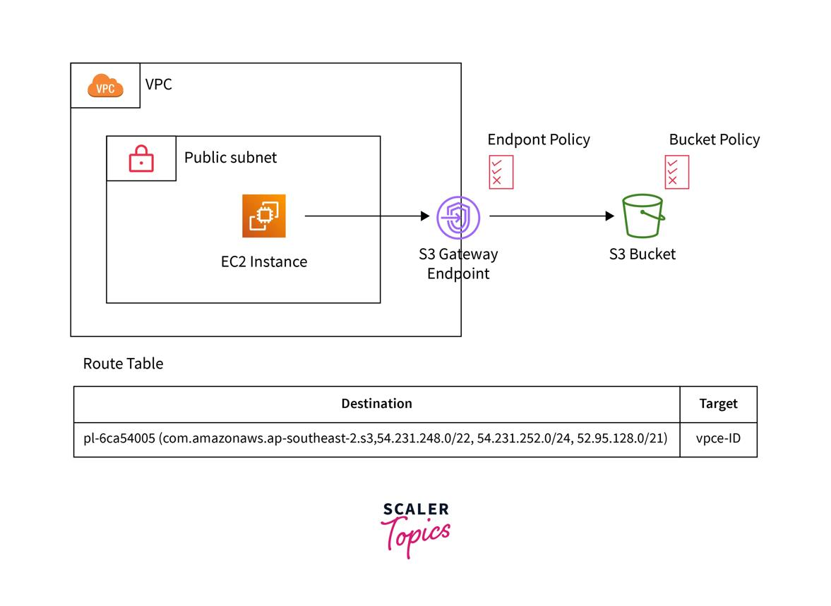
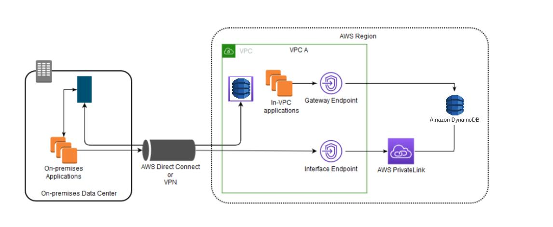
4
- Used for:
  - Amazon S3
  - DynamoDB
- Works via:
  - Route Tables
- No ENI required

🔹 Interface Endpoint (PrivateLink)
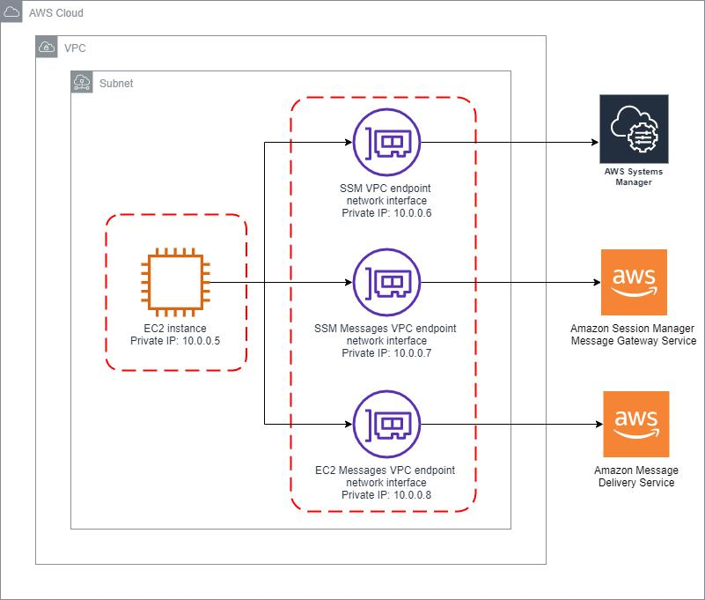
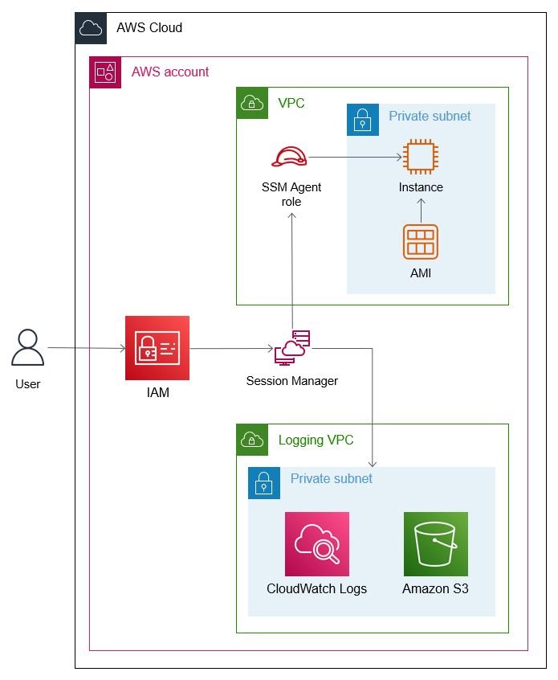
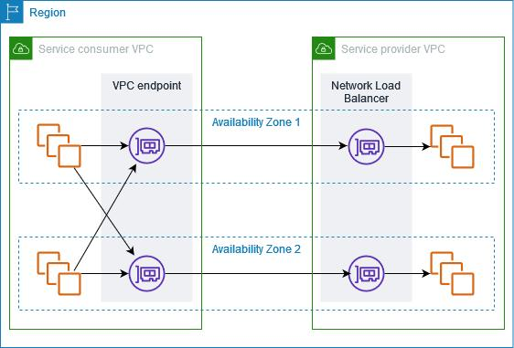
6
- Used for:
  - SSM, SNS, SQS, etc.
- Works via:
  - ENI (Elastic Network Interface)
  - Private IP
  - Security Groups

🎯 3. Lab Goal
We will build a fully private architecture:
Laptop → SSM → Private EC2 → S3 (via Endpoint)
✔️ No NAT
✔️ No Internet
✔️ Fully Private

🧭 4. Methods Covered
Method | Description
Method 1 | Bastion + Endpoint
Method 2 | SSM + NAT
Method 3 | SSM + Endpoints (Fully Private)

🧪 METHOD 1: Bastion Host + Endpoint

🖼️ Architecture

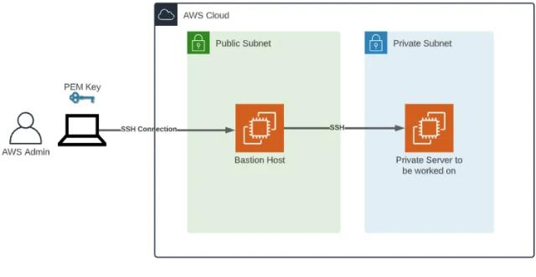
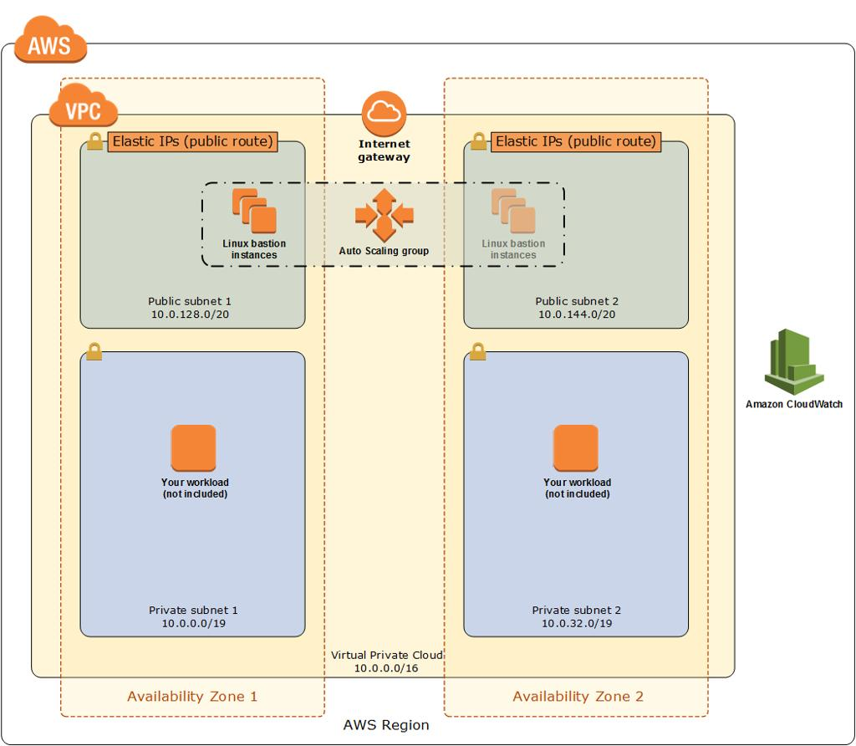
5

⚙️ Steps
1. Create VPC
- CIDR: 10.0.0.0/16

2. Create Subnets
- Public: 10.0.1.0/24
- Private: 10.0.2.0/24

3. Create Internet Gateway
- Attach to VPC

4. Configure Route Tables
- Public → IGW
- Private → No internet route

5. Launch EC2 Instances
Bastion Host (Public)
- Public IP enabled
- SSH access
Private EC2
- No public IP

6. Security Groups
- Bastion → Allow SSH from your IP
- Private EC2 → Allow SSH from Bastion

7. Create S3 Gateway Endpoint
- Attach to private route table

8. Test Connectivity
ssh bastion
ssh private-ec2
aws s3 ls

🧪 METHOD 2: SSM + NAT Gateway

🖼️ Architecture
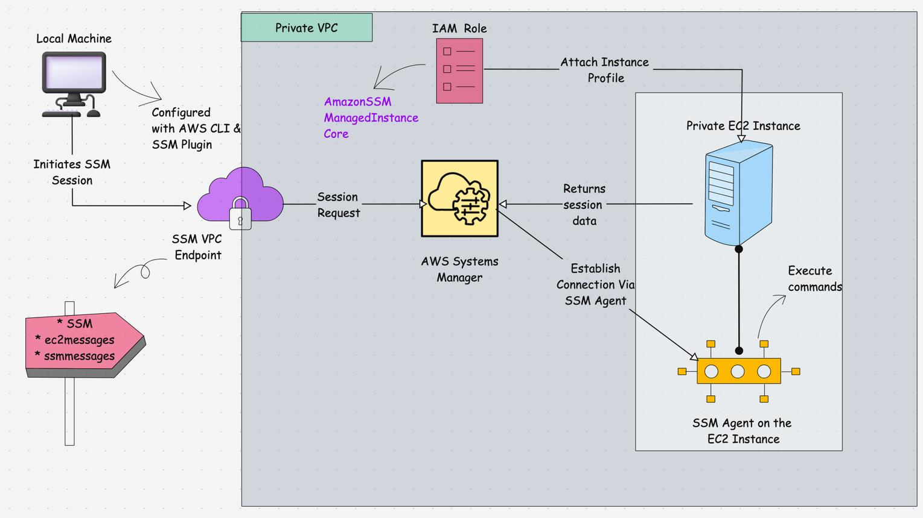
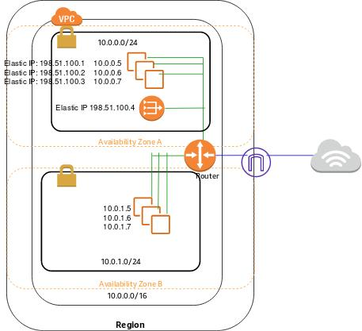
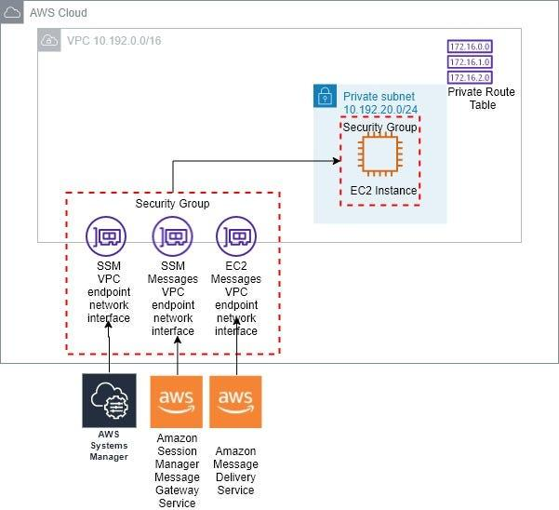
7

⚙️ Steps
1. Create NAT Gateway
- Deploy in public subnet
- Attach Elastic IP

2. Update Route Table
0.0.0.0/0 → NAT Gateway

3. Attach IAM Role to EC2
- AmazonSSMManagedInstanceCore
- S3 access policy

4. Connect via SSM
- Go to AWS Systems Manager → Session Manager

5. Test
aws s3 ls
✔️ Works
❌ Uses Internet

🧪 METHOD 3: SSM + Endpoints (Fully Private)

🖼️ Architecture

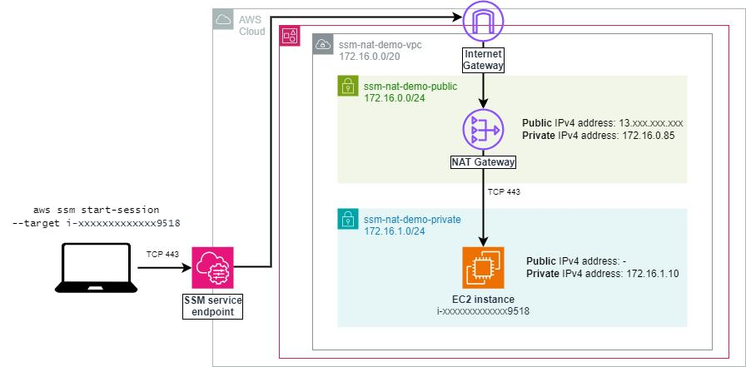

7

⚙️ Steps

1. Remove NAT Route
- Delete:
0.0.0.0/0 → NAT Gateway

2. Attach IAM Role
- AmazonSSMManagedInstanceCore
- AmazonS3ReadOnlyAccess

3. Create Interface Endpoints
Create 3 endpoints:
- ssm
- ssmmessages
- ec2messages

Endpoint Configuration
- VPC → Your VPC
- Subnet → Private subnet
- Private DNS → Enabled
Security Group:
- Allow HTTPS (443) from VPC CIDR

4. Create S3 Gateway Endpoint
- Attach to private route table

5. Reboot EC2

6. Connect via SSM
- Use AWS Systems Manager Session Manager

7. Test
aws s3 ls
✔️ Works
✔️ No Internet
✔️ Fully Private

🔍 5. Key Learnings

🔑 IAM vs Endpoint
Component | Purpose
IAM Role | Permissions
Endpoint | Network path

🔁 NAT vs Endpoint
Feature | NAT | Endpoint
Internet | Yes | No
Cost | Paid | Free (Gateway)
Security | Medium | High

🎯 6. Conclusion
This lab demonstrates:
- Private AWS connectivity patterns
- Secure architecture design
- Real-world DevOps networking setups

🏷️ Tags
AWS VPC Endpoints SSM Networking DevOps

🎯 1. VPC Endpoints — Interview Explanation

🧠 What is a VPC Endpoint?
A VPC Endpoint allows private connectivity between resources inside a VPC and AWS services without using the internet.
👉 Example: EC2 accessing S3 privately.

❓ Why do we use it?
Normally:
EC2 → NAT Gateway → Internet → S3
Problems:
- Costs money (NAT Gateway)
- Uses public internet
- Less secure

✅ With Endpoint:
EC2 → VPC Endpoint → S3
Benefits:
- No internet
- More secure
- Cost-efficient

🔑 Types of Endpoints
1. Gateway Endpoint
- Used for:
  - S3
  - DynamoDB
- Works using:
  - Route Tables

2. Interface Endpoint (PrivateLink)
Uses:
- ENI (private IP inside subnet)
- Security Groups
Used for:
- SSM
- SNS, SQS, etc.

🧪 Real-World Scenario
“I built a fully private architecture where:
- No NAT Gateway
- EC2 accessed S3 via Gateway Endpoint
- Connected to EC2 using AWS Systems Manager (SSM) via Interface Endpoints
So everything worked without internet access.”

🔥 Interview Tip
👉 Key line to say:
“IAM controls permissions, but VPC Endpoints control network path.”

