📌 PROJECT OBJECTIVE
Build an automated pipeline where:
Code push → GitHub Actions → Build Docker Image → Push to ECR → Deploy to EKS.
🧭 PHASE 0 — ENVIRONMENT SETUP
🎯 Objective
Prepare local + cloud environment

✅ Step 0.1 — Install Tools
Install:
- Visual Studio Code
- Docker
- Git
- AWS CLI

✅ Step 0.2 — Configure AWS CLI
aws configure
Enter:
AWS Access Key
AWS Secret Key
Region: ap-south-1
Output: json

📸 Reference
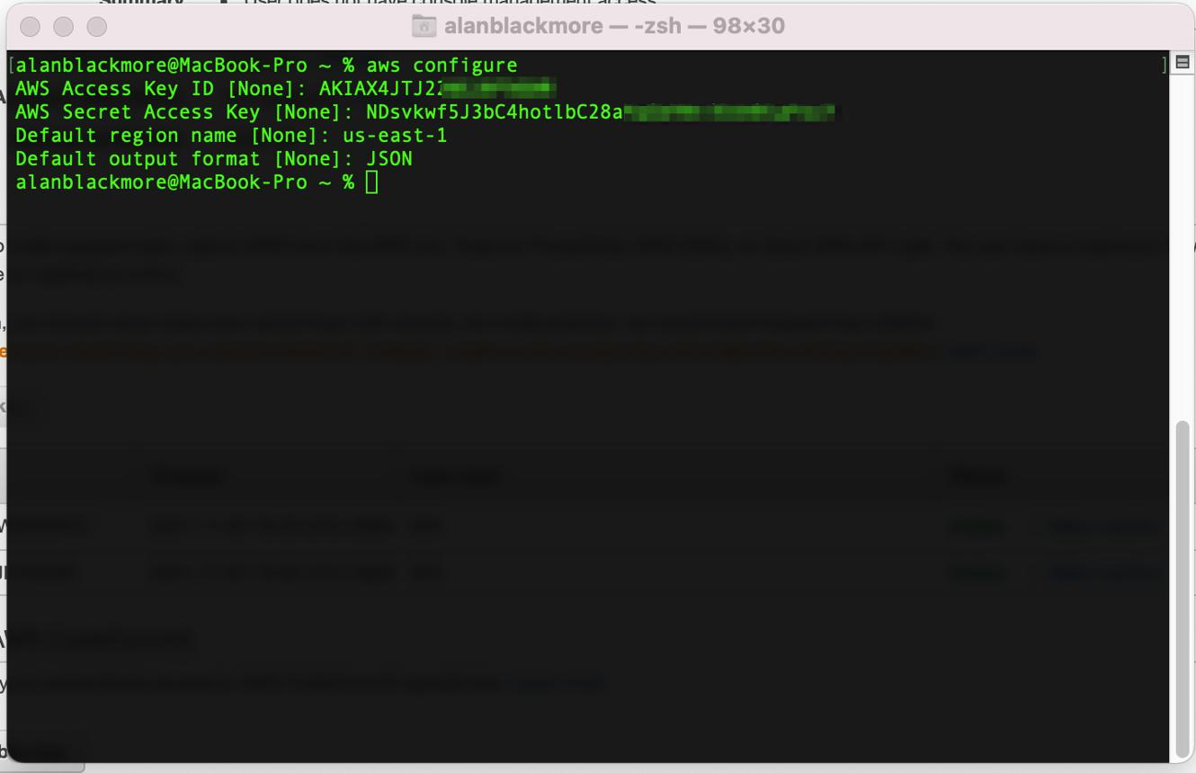
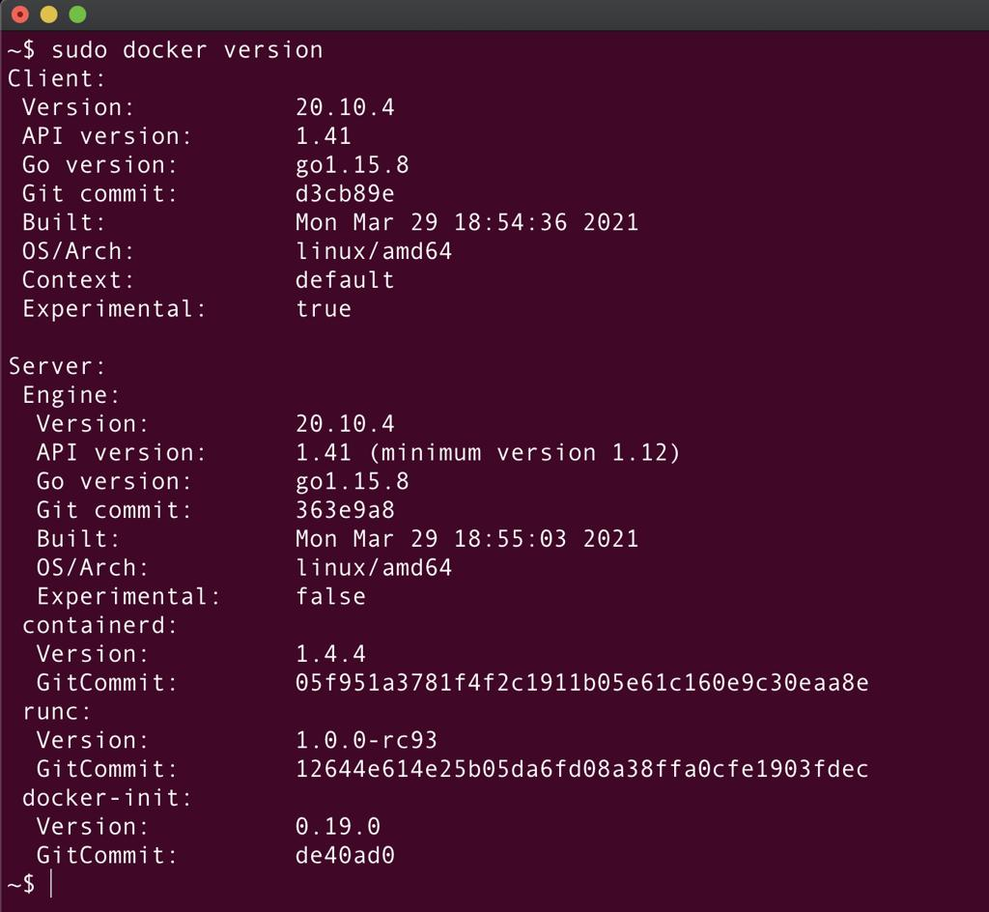
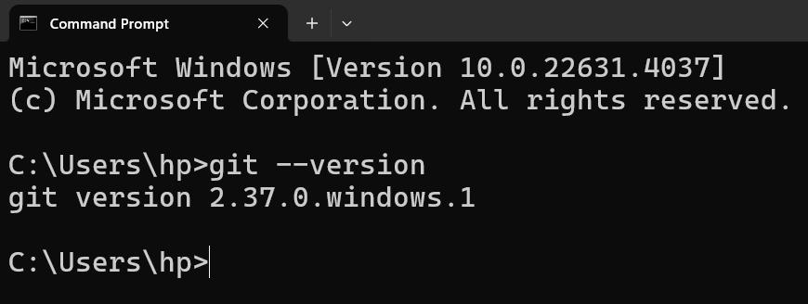

🧭 PHASE 1 — APPLICATION SETUP
🎯 Objective
Create simple app + containerize

📁 Step 1.1 — Create Project
mkdir mani-devops-project
cd mani-devops-project

📄 Step 1.2 — Create Files
app.py
from flask import Flask
app = Flask(__name__)
@app.route("/")
def hello():
return "Hello from Manikanta DevOps Project!"
if __name__ == "__main__":
app.run(host="0.0.0.0", port=5000)

requirements.txt
flask

Dockerfile
FROM python:3.9-slim
WORKDIR /app
COPY requirements.txt .
RUN pip install -r requirements.txt
COPY . .
CMD ["python", "app.py"]

🧪 Step 1.3 — Test Locally
docker build -t mani-app .
docker run -p 5000:5000 mani-app
Verify:
http://localhost:5000

📸 Reference
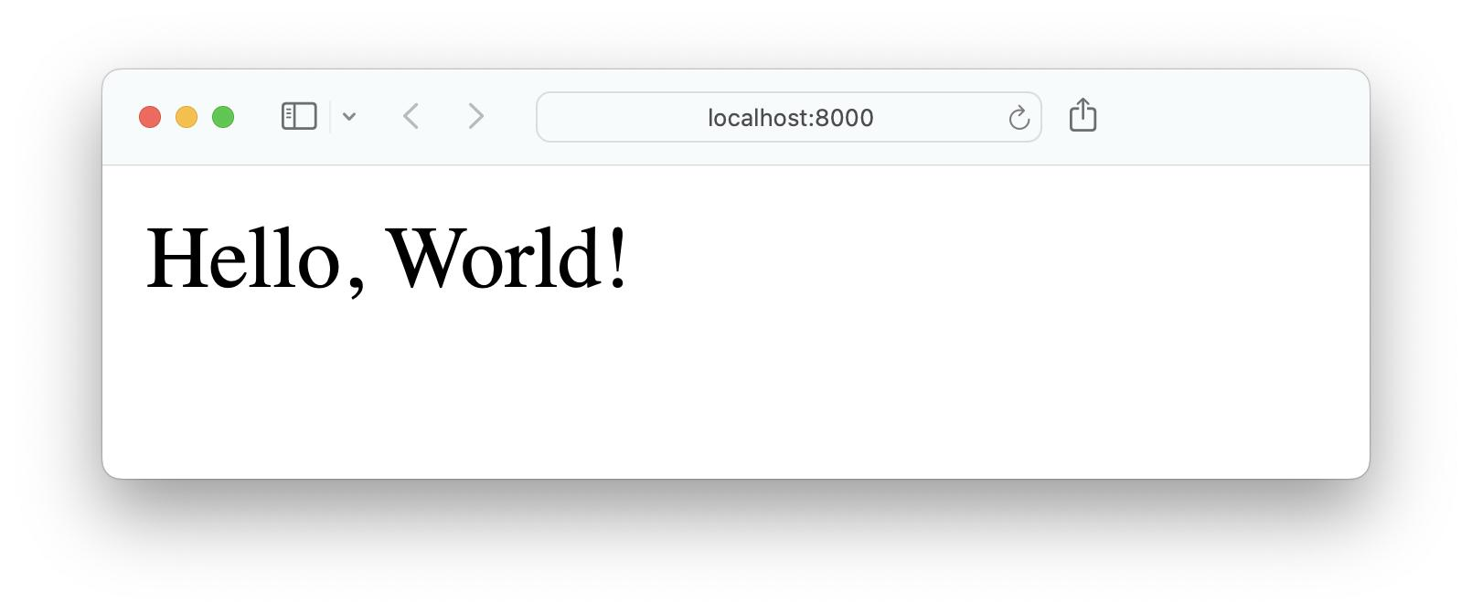
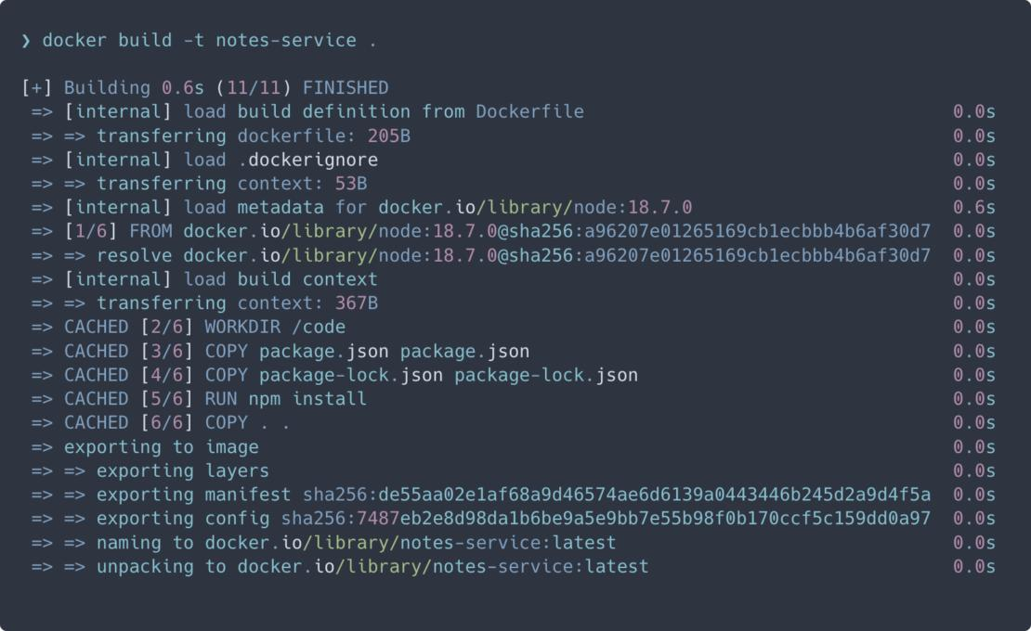
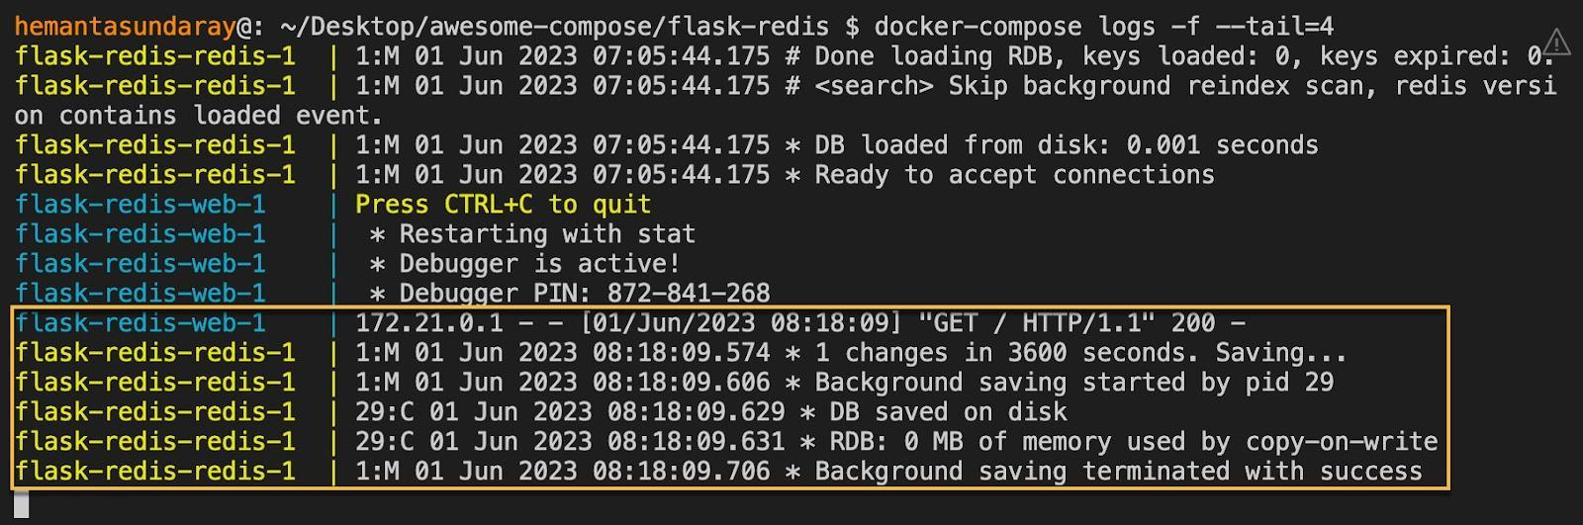
🧭 PHASE 2 — VERSION CONTROL
🎯 Objective
Push code to GitHub

Step 2.1 — Initialize Repo
git init
git add .
git commit -m "initial commit"

Step 2.2 — Create Repo on GitHub
- Name: mani-devops-project

Step 2.3 — Push Code
git remote add origin <repo-url>
git branch -M main
git push -u origin main

📸 Reference
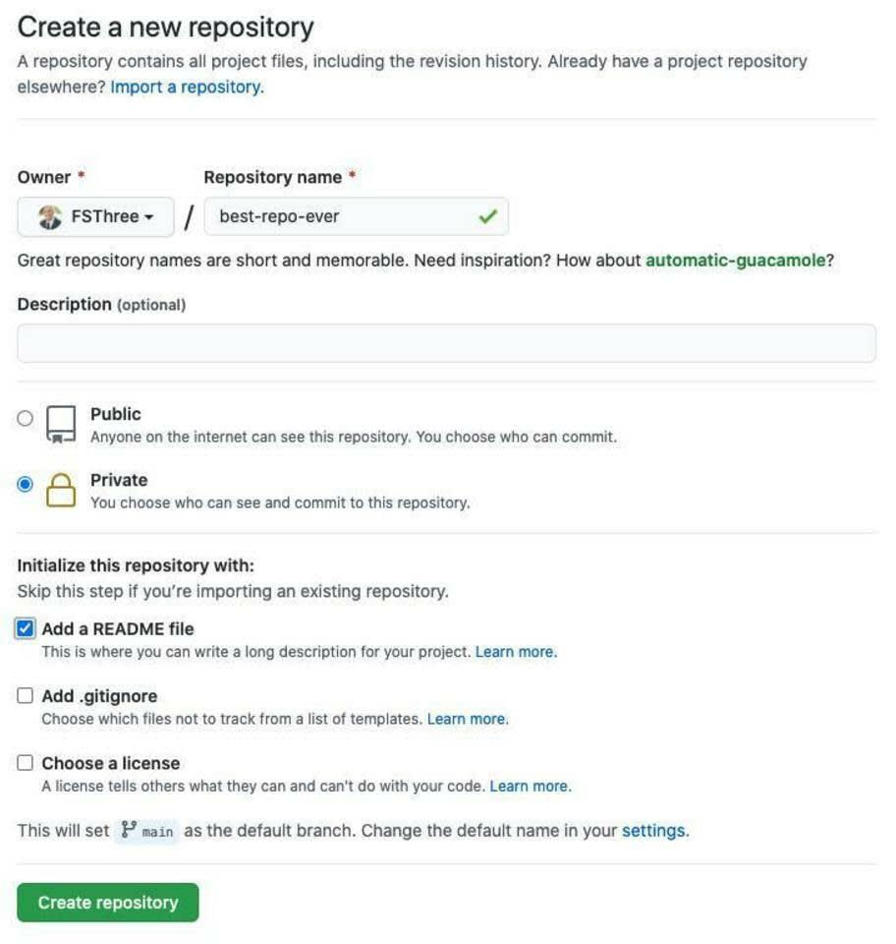
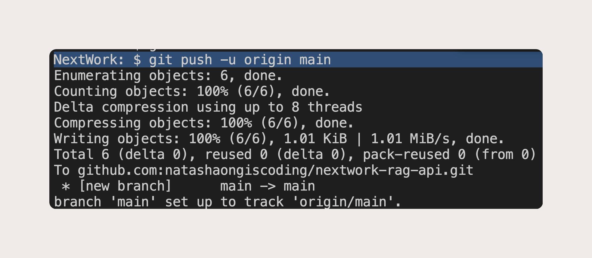
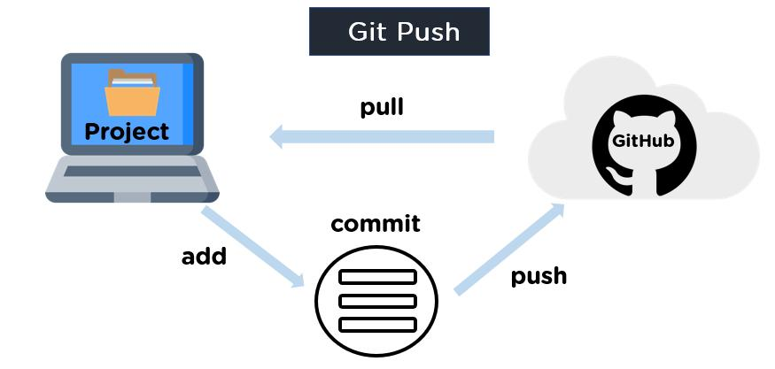
6

🧭 PHASE 3 — AWS ECR SETUP
🎯 Objective
Create Docker registry

Step 3.1 — Create ECR Repo
Go to AWS Console → ECR → Create
Repository Name: mani-devops-app
Region: ap-south-1

Step 3.2 — Copy URI
Example:
123456789.dkr.ecr.ap-south-1.amazonaws.com/mani-devops-app

📸 Reference
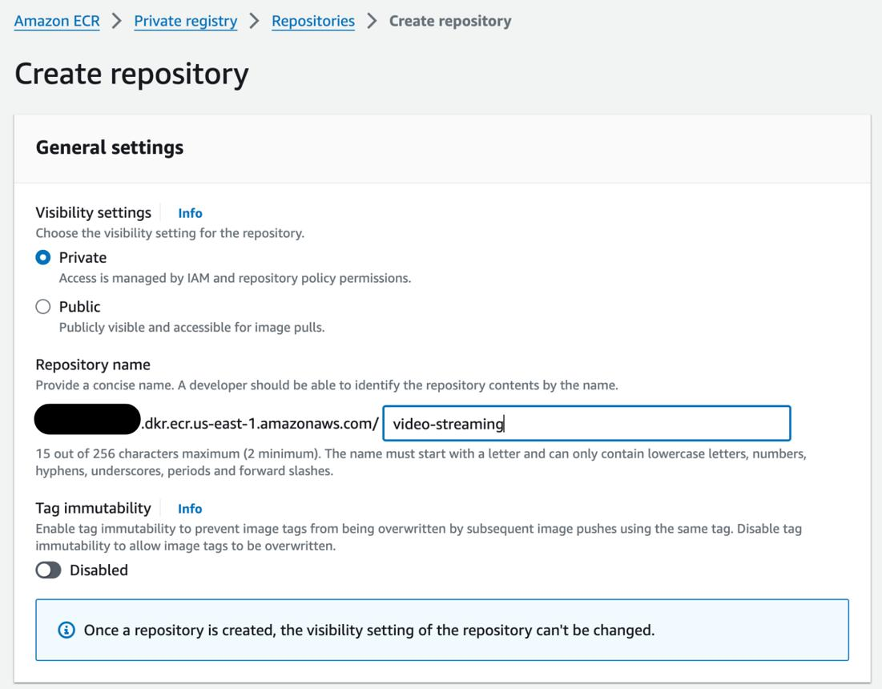
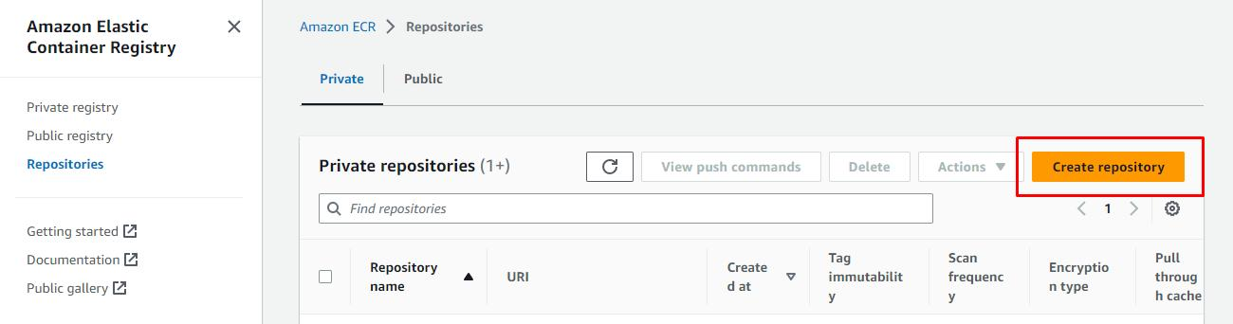
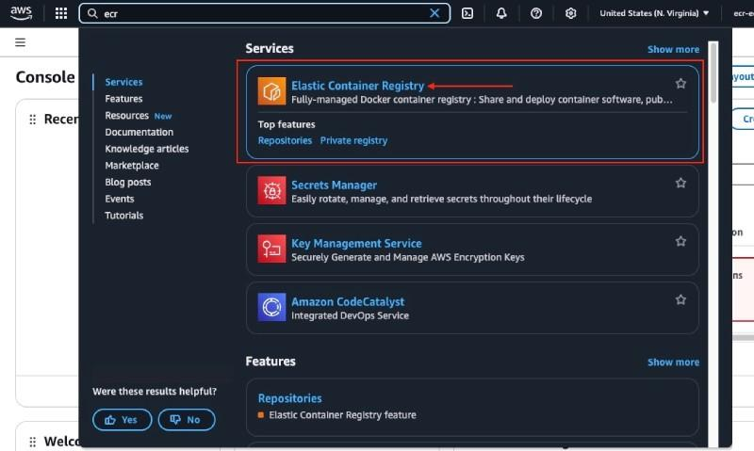
7

🧭 PHASE 4 — IAM USER FOR CI/CD
🎯 Objective
Allow GitHub to access AWS

Step 4.1 — Create IAM User
Go to AWS → IAM → Users → Create User
Username: github-actions-user
Access: Programmatic access

Step 4.2 — Attach Policy
Attach:
AmazonEC2ContainerRegistryFullAccess

Step 4.3 — Save Keys
Download:
AWS_ACCESS_KEY_ID
AWS_SECRET_ACCESS_KEY

🧭 PHASE 5 — GITHUB ACTIONS SETUP
🎯 Objective
Automate build + push

Step 5.1 — Create Workflow
mkdir -p .github/workflows
File:
deploy.yml

Step 5.2 — Add Pipeline
(Use this EXACT — replace placeholders)
name: Build and Push to ECR
on:
push:
branches:
- main
jobs:
build:
runs-on: ubuntu-latest
steps:
- name: Checkout
uses: actions/checkout@v3
- name: AWS Configure
uses: aws-actions/configure-aws-credentials@v2
with:
aws-access-key-id: ${{ secrets.AWS_ACCESS_KEY_ID }}
aws-secret-access-key: ${{ secrets.AWS_SECRET_ACCESS_KEY }}
aws-region: us-east-1
- name: ECR Login
run: |
aws ecr get-login-password --region us-east-1 | \
docker login --username AWS --password-stdin 447633182123.dkr.ecr.us-east-1.amazonaws.com
- name: Build Image
run: docker build -t mani-app .
- name: Tag Image
run: docker tag mani-app:latest447633182123.dkr.ecr.us-east-1.amazonaws.com/mani-devops-app:latest
- name: Push Image
run: docker push 447633182123.dkr.ecr.us-east-1.amazonaws.com/mani-devops-app:latest

Step 5.3 — Add Secrets in GitHub
Go to:
Settings → Secrets → Actions
Add:
AWS_ACCESS_KEY_ID
AWS_SECRET_ACCESS_KEY

Step 5.4 — Trigger Pipeline
git add .
git commit -m "added pipeline"
git push

📸 Reference
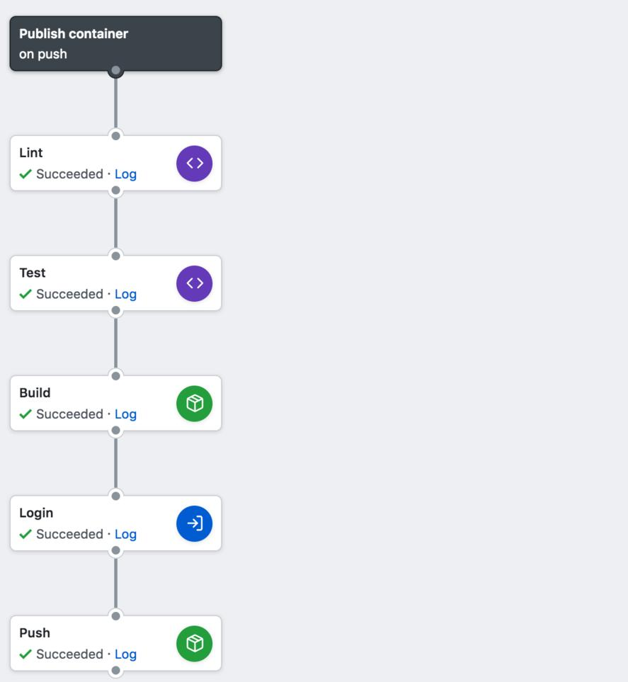
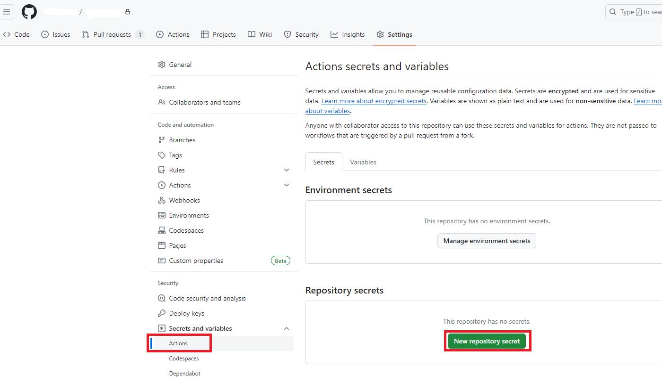
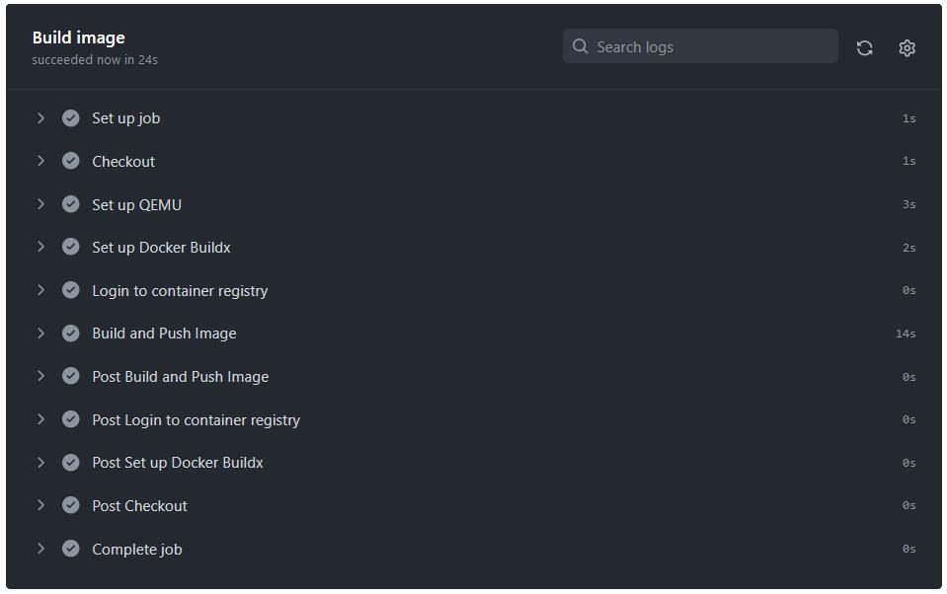
6

🧭 PHASE 6 — VALIDATION
🎯 Objective
Confirm image pushed

Step 6.1 — Verify in AWS ECR
Check:
- Image present
- Tag = latest

🧠 CURRENT STATE
You have built:
✔ CI pipeline
✔ Docker automation
✔ AWS integration
✔ Registry push

