SET09107: Advanced Database Systems
2022/23 Coursework

(Report Template)
Name: Mansour Sami
Matriculation Number: 40617066

Task 1: Draw an ER diagram corresponding to the relational database schema and the scenario. (5 marks)

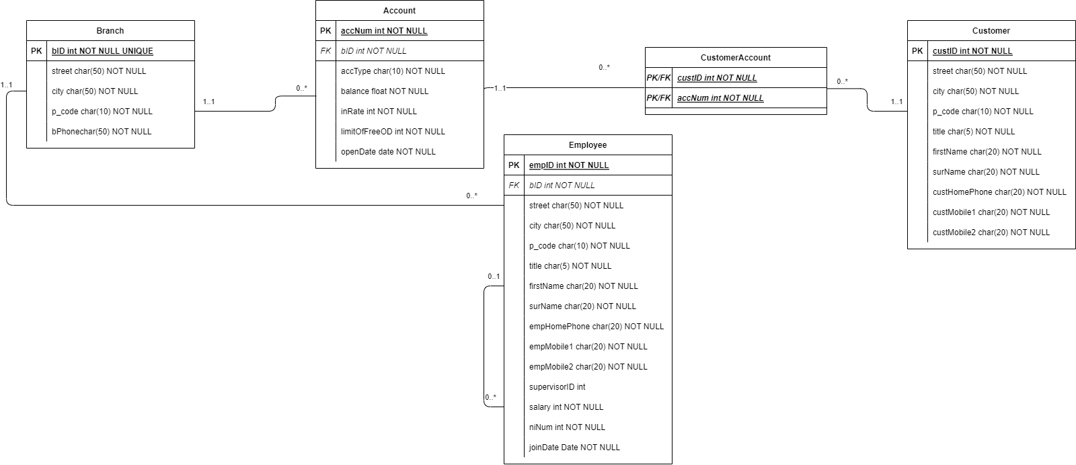

Task 2: Re-design the database to capture more of the semantics of the application making use of object-relational features as extensively as possible while still retaining the semantics of the application. Provide a critical discussion on the rationale for your object-relational design justifying the design you adopted with reasons. The discussion should include alternative possible object-relational representations you considered and why they were rejected (only include those if you think they demonstrate a deeper understanding of the problem involved). (40 marks)

In designing the database schema, the first step was to simplify the types as much as possible and reuse them where feasible. This led to the creation of the Person type, which comprises three other types: Address, Phone, and Name. However, an alternative was considered, which was to combine all the values into one class. While this approach would have made data access easier, it would have made the database schema disorganized and untidy. Moreover, in practice, the design is to create the Person class with three different classes, namely Name, Phone, and Address. The reason for not creating any more classes is that they cannot be used in at least two different subclasses.

The Job type includes the Position and Salary attributes, with the Position attribute being unique and used to reference the job from the employee table. An alternative approach would be to include both the Position and Salary attributes directly in the Employee class, but this would have increased the amount of data saved in the database. The Branch type includes the bID, Address type, and phone number as a varchar2. The Account type saves the account information in its table, with the bID used as a reference to the rows of the Branch table. The Customer type uses the Person type as the superclass, with CustID as the primary key, and niNum as a unique identifier to prevent duplicate values.

The Employee type is a subclass of Person, with supervisorID, E_Job, and bID as references to the Employee, Job, and Branch tables, respectively. The customer account serves to establish a many-to-many relationship between Accounts and Customers, achieved using custID as a reference to the Customer and accNum as a reference to the Account.

The rationale for using object-relational features in the design is to create a more structured and organized database schema. Alternative possible object-relational representations were considered, including using inheritance and subtypes, but these were rejected as they would have made the database schema more complex and harder to manage. The use of object types and nested tables provides a more straightforward and efficient way to manage the database schema while still capturing the semantics of the application.

Task 3: Implement the database according to your design at task 2 and populate the tables with test data, 15 rows at least for each table. The data you inserted should be sufficient to demonstrate your object-relational design decisions and unambiguously answer the queries below. All SQL statements for creating and populating the database should be included. (10 marks)

Job
Position | Salary_Max | Salary_Min
Head | 42000 | 87000
Manager | 28000 | 57000
Project Leader | 27000 | 97000
Accountant | 24000 | 60000
Cashier | 15000 | 33000

Branch
bID | Street | City | Postcode | B_Phone
901 | Market | Edinburgh | EH1 5AB | 01311235560
908 | Bridge | Glasgow | G18 1QQ | 01413214556
426 | Morningside Rd | Edinburgh | EH10 5QF | 03457213141
9 | Clifton Pl | Glasgow | G3 7JU | 03457242424
236 | Pollokshields | Glasgow | G41 2NL | 03457273141
158 | Fenwick Rd | Glasgow | G46 6XB | 03457242474
185 | Baker St | London | NW1 6XB | 03456021997
90 | Paul St | London | EC2A 4NE | 02039620108
1 | Pound Way | Oxford | OX4 3XS | 03456025997
5 | Queen St | Oxford | OX1 1EJ | 03450808500
130 | High St | Cheltenham | GL50 1EW | 03454021997
4 | Westgate St | Gloucester | GL1 2NW | 03457203040
3 | Wharfside Street | Birmingham | B1 1RD | 03330048048
762 | Brindley Pl | Birmingham | B1 2HP | 01214078000
84 | High St | Birmingham | B4 7TE | 03457345345
120 | Colmore Row | Birmingham | B3 3BA | 03457212212
109 | Roman Rd | Glasgow | G61 2SP | 03457213131

Account
AccNum | AccType | Balance | bID | InRate | LimitOfFreeOD | OpenDate
1001 | current | 800 | 901 | 0.005 | 800 | 01-MAY-16
1010 | savings | 3000 | 901 | 0.02 |  | 08-MAR-15
8002 | current | 200 | 908 | 0.005 | 100 | 05-MAY-12
9011 | current | 700000 | 901 | 1.3 | 122 | 02-AUG-10
9012 | current | 800000 | 901 | 0.85 | 171 | 05-DEC-16
9013 | current | 400000 | 901 | 0.0082 | 51 | 04-DEC-12
9081 | current | 50000 | 908 | 1.2 | 53 | 27-AUG-21
9082 | current | 300000 | 908 | 2 | 199 | 07-OCT-10
9083 | current | 700000 | 908 | 1.2 | 62 | 19-MAR-17
4261 | current | 600000 | 426 | 1.6 | 113 | 27-AUG-16
4262 | current | 500000 | 426 | 0.31 | 121 | 20-JUN-19
4263 | current | 800000 | 426 | 1.4 | 95 | 07-JUL-14
91 | current | 300000 | 9 | 0.94 | 182 | 15-MAY-12
92 | current | 800000 | 9 | 1.9 | 129 | 30-DEC-20
93 | current | 400000 | 9 | 0.13 | 143 | 08-DEC-10
2361 | current | 900000 | 236 | 1.7 | 78 | 07-JUL-15
2362 | current | 700000 | 236 | 1.6 | 134 | 15-FEB-18
2363 | current | 500000 | 236 | 1.8 | 89 | 09-MAY-14
1581 | current | 600000 | 158 | 0.56 | 136 | 15-MAY-13
1582 | current | 700000 | 158 | 0.62 | 62 | 01-JAN-13
1583 | current | 90000 | 158 | 1.8 | 186 | 25-AUG-14
1851 | current | 900000 | 185 | 1 | 144 | 06-APR-11
1852 | current | 600000 | 185 | 1.4 | 190 | 01-SEP-11
1853 | current | 700000 | 185 | 1.2 | 103 | 15-JAN-17
901 | current | 900000 | 90 | 0.065 | 152 | 07-JAN-13
902 | current | 600000 | 90 | 1.1 | 116 | 22-AUG-13
903 | current | 800000 | 90 | 0.91 | 62 | 30-JUL-21
11 | current | 300000 | 1 | 1.2 | 114 | 27-JUN-16
12 | current | 1000000 | 1 | 1 | 128 | 25-DEC-16
13 | current | 400000 | 1 | 1.6 | 163 | 26-FEB-21
51 | current | 500000 | 5 | 0.99 | 181 | 11-FEB-15
52 | current | 500000 | 5 | 1.2 | 124 | 07-OCT-11
53 | current | 300000 | 5 | 0.51 | 127 | 16-OCT-16
1301 | current | 900000 | 130 | 1 | 87 | 23-DEC-13
1302 | current | 400000 | 130 | 2 | 139 | 05-DEC-20
1303 | current | 100000 | 130 | 0.11 | 150 | 06-APR-12
41 | current | 200000 | 4 | 0.91 | 110 | 18-DEC-17
42 | current | 400000 | 4 | 0.21 | 144 | 07-MAR-10
43 | current | 500000 | 4 | 1.1 | 112 | 20-JUL-15
31 | current | 200000 | 3 | 1.9 | 112 | 10-MAY-11
32 | current | 700000 | 3 | 1.2 | 171 | 09-NOV-10
33 | current | 100000 | 3 | 1.4 | 107 | 13-AUG-11
7621 | current | 500000 | 762 | 0.23 | 55 | 09-FEB-14
7622 | current | 900000 | 762 | 0.84 | 51 | 15-APR-16
7623 | current | 1000000 | 762 | 0.55 | 72 | 10-FEB-19
841 | current | 700000 | 84 | 0.23 | 192 | 03-FEB-22
842 | current | 800000 | 84 | 1.9 | 112 | 04-DEC-20
843 | current | 500000 | 84 | 1.3 | 186 | 20-AUG-10
1201 | current | 600000 | 120 | 0.8 | 95 | 06-OCT-10
1202 | current | 700000 | 120 | 0.086 | 189 | 14-MAR-13
1203 | current | 600000 | 120 | 0.86 | 125 | 14-MAY-19
1091 | current | 500000 | 109 | 1.3 | 69 | 13-NOV-13
1092 | current | 800000 | 109 | 1.1 | 55 | 09-MAR-16
1093 | current | 50000 | 109 | 0.72 | 186 | 07-SEP-21
90115 | savings | 500000 | 901 | 0.43 |  | 16-JAN-12
90125 | savings | 600000 | 901 | 0.68 |  | 03-JAN-04
90135 | savings | 400000 | 901 | 0.15 |  | 03-AUG-06
90815 | savings | 300000 | 908 | 1.5 |  | 08-JAN-12
90825 | savings | 500000 | 908 | 1.9 |  | 21-JAN-14
90835 | savings | 500000 | 908 | 1.4 |  | 05-OCT-09
42615 | savings | 200000 | 426 | 0.49 |  | 30-DEC-14
42625 | savings | 80000 | 426 | 0.63 |  | 08-MAY-17
42635 | savings | 500000 | 426 | 0.89 |  | 23-DEC-14
915 | savings | 500000 | 9 | 0.047 |  | 19-DEC-21
925 | savings | 600000 | 9 | 0.17 |  | 04-NOV-18
935 | savings | 500000 | 9 | 1.6 |  | 15-APR-14
23615 | savings | 300000 | 236 | 0.61 |  | 09-SEP-01
23625 | savings | 90000 | 236 | 1.5 |  | 26-MAY-18
23635 | savings | 900000 | 236 | 2 |  | 08-APR-05
15815 | savings | 500000 | 158 | 0.0013 |  | 15-FEB-13
15825 | savings | 200000 | 158 | 0.52 |  | 19-JUL-12
15835 | savings | 800000 | 158 | 0.88 |  | 16-MAY-03
18515 | savings | 200000 | 185 | 0.014 |  | 27-FEB-05
18525 | savings | 100000 | 185 | 0.16 |  | 14-APR-15
18535 | savings | 100000 | 185 | 1.9 |  | 26-MAY-08
9015 | savings | 100000 | 90 | 1.6 |  | 31-AUG-03
9025 | savings | 700000 | 90 | 1.6 |  | 25-OCT-12
9035 | savings | 200000 | 90 | 1.2 |  | 07-JUL-05
115 | savings | 900000 | 1 | 0.26 |  | 19-NOV-10
125 | savings | 300000 | 1 | 1.3 |  | 31-MAY-05
135 | savings | 200000 | 1 | 1.4 |  | 07-MAY-07
515 | savings | 90000 | 5 | 0.6 |  | 14-MAY-16
525 | savings | 40000 | 5 | 1.5 |  | 22-SEP-10
535 | savings | 300000 | 5 | 1.2 |  | 17-FEB-02
13015 | savings | 400000 | 130 | 0.85 |  | 03-DEC-20
13025 | savings | 1000000 | 130 | 0.46 |  | 06-DEC-05
13035 | savings | 800000 | 130 | 1.2 |  | 23-JAN-13
415 | savings | 800000 | 4 | 1.5 |  | 27-DEC-17
425 | savings | 10000 | 4 | 0.17 |  | 04-MAY-14
435 | savings | 400000 | 4 | 0.23 |  | 11-FEB-09
315 | savings | 500000 | 3 | 0.71 |  | 02-JUL-01
325 | savings | 400000 | 3 | 0.43 |  | 01-JUL-16
335 | savings | 800000 | 3 | 0.26 |  | 28-OCT-08
76215 | savings | 300000 | 762 | 0.82 |  | 22-FEB-16
76225 | savings | 500000 | 762 | 0.23 |  | 10-FEB-09
76235 | savings | 500000 | 762 | 0.33 |  | 12-DEC-04
8415 | savings | 30000 | 84 | 1.3 |  | 12-AUG-19
8425 | savings | 10000 | 84 | 0.24 |  | 26-JUL-16
8435 | savings | 900000 | 84 | 0.4 |  | 07-JAN-09
12015 | savings | 100000 | 120 | 0.94 |  | 03-MAY-18
12025 | savings | 500000 | 120 | 1.1 |  | 07-AUG-09
12035 | savings | 800000 | 120 | 1.3 |  | 30-MAR-02
10915 | savings | 300000 | 109 | 0.52 |  | 31-AUG-18
10925 | savings | 1000000 | 109 | 0.4 |  | 27-NOV-12
10935 | savings | 1000000 | 109 | 0.47 |  | 20-OCT-14

Employee
Street | City | postcode | title | Firstname | surname | Home phone | Mobile | NiNum | EmpID | Supervisor | Position | bID | JoinDate | Salary
Colinton | Edinburgh | EH105TT | Mrs. | Alison | Smith | 01312125555 | ('07705623443', '07907812345') | NI001 | 101 |  | Head | 901 | 01-FEB-05 | 50000
New | Edinburgh | EH24AB | Mr. | John | William | 01312031990 | ('07902314551', '07701234567') | NI010 | 105 | 101 | Manager | 901 | 04-MAR-07 | 40000
Old | Edinburgh | EH94BB | Mr. | Mark | Slack | 01312102211 |  | NI120 | 108 | 105 | Accountant | 901 | 01-FEB-15 | 30000
Ardwell Road | Glasgow | G52 1PR | Mr. | John | Johnson | 01362031990 | ('07902323551', '07706454567') | NI010 | 115 | 101 | Manager | 901 | 14-MAR-07 | 50800
123 Main St | Anytown | 12345 | Mr. | John | Doe | 555-1234 | ('555-5678', '555-9012') | AB123456C | 001 |  | Head | 1 | 19-MAR-23 | 62200
456 Elm St | Otherville | 67890 | Ms. | Jane | Smith | 555-5678 | ('555-1234', '555-9012') | CD456789A | 002 | 001 | Manager | 1 | 19-MAR-23 | 53300
789 Oak St | Anycity | 13579 | Dr. | Bob | Johnson | 555-9012 | ('555-1234', '555-5678') | EF789012B | 003 | 001 | Project Leader | 1 | 19-MAR-23 | 91500
123 Main St | Los Angeles | 90001 | Mr. | John | Doe | 555-1234 | ('555-5678', '555-9012') | AB123456C | 004 | 002 | Accountant | 1 | 19-MAR-23 | 36900
456 Oak Ave | New York | 10001 | Ms. | Jane | Smith | 555-5678 | ('555-1234', '555-9012') | DE456789F | 005 | 003 | Cashier | 1 | 19-MAR-23 | 26000
456 Main St | Los Angeles | 90001 | Mr. | John | Doe | 555-5678 | ('555-9012') | AB123456C | EMP001 |  | Head | 3 | 01-JAN-22 | 74000
789 Main St | Los Angeles | 90001 | Ms. | Jane | Smith | 555-2345 | ('555-6789') | CD123456E | EMP002 | EMP001 | Manager | 3 | 02-JAN-22 | 53400
101 Main St | Los Angeles | 90001 | Mr. | Bob | Johnson | 555-3456 | ('555-7890') | EF123456G | EMP003 | EMP001 | Project Leader | 3 | 03-JAN-22 | 72000
111 Main St | Los Angeles | 90001 | Ms. | Emily | Davis | 555-4567 | ('555-8901') | GH123456H | EMP004 | EMP001 | Accountant | 3 | 04-JAN-22 | 44500
456 Oak St | New York | 10001 | Ms. | Jane | Smith | 555-5678 | ('555-9012', '555-3456') | CD456789E | emp005 |  | Head | 4 | 01-JAN-00 | 47000
789 Elm St | San Francisco | 94101 | Mr. | David | Lee | 555-9012 | ('555-3456', '555-7890') | EF789012G | emp006 | emp005 | Manager | 4 | 01-JAN-00 | 35400
321 Pine St | Chicago | 60601 | Ms. | Emily | Nguyen | 555-3456 | ('555-7890', '555-1234') | GH234567I | emp007 | emp005 | Manager | 4 | 01-JAN-00 | 49500
654 Cedar St | Boston | 02101 | Mr. | Daniel | Chen | 555-7890 | ('555-1234', '555-5678') | IJ345678K | emp008 | emp006 | Project Leader | 4 | 01-JAN-00 | 57600
987 Maple St | Seattle | 98101 | Ms. | Catherine | Chung | 555-1234 | ('555-5678', '555-9012') | KL456789M | emp009 | emp007 | Accountant | 4 | 01-JAN-00 | 53900
741 Birch St | Houston | 77001 | Mr. | William | Huang | 555-5678 | ('555-9012', '555-3456') | MN567890O | emp010 | emp007 | Accountant | 4 | 01-JAN-00 | 45200
852 Spruce St | Miami | 33101 | Ms. | Isabella | Kim | 555-9012 | ('555-3456', '555-7890') | OP678901Q | emp011 | emp007 | Accountant | 4 | 01-JAN-00 | 50600
963 Pine St | Dallas | 75201 | Mr. | Samuel | Choi | 555-3456 | ('555-7890', '555-1234') | QR789012S | emp012 | emp007 | Accountant | 4 | 01-JAN-00 | 34900
159 Cedar St | Washington D.C. | 20001 | Ms. | Olivia | Park | 555-7890 | ('555-1234', '555-5678') | ST234567U | emp013 | emp007 | Accountant | 4 | 01-JAN-00 | 40900
753 Oak St | Philadelphia | 19101 | Mr. | Ethan | Wong | 555-1234 | ('555-5678', '555-9012') | UV345678W | emp014 | emp007 | Accountant | 4 | 01-JAN-00 | 29000
456 Pine St | Los Angeles | 90001 | Ms. | Avery | Ng | 555-5678 | ('555-9012', '555-3456') | WX456789Y | emp015 | emp007 | Accountant | 4 | 01-JAN-00 | 44800
456 Elm St | New York | 10001 | Ms. | Alice | Smith | 555-5678 | ('555-1234', '555-9012') | CD234567D | emp016 | emp007 | Accountant | 4 | 01-JAN-00 | 29300
12 Main Street | Napier | 4110 | Mr. | John | Smith | 0271234567 | ('0212345678') | NI123456A | emp17 |  | Head | 5 | 01-JAN-00 | 62900
14 Main Street | Napier | 4110 | Ms. | Jane | Doe | 0272345678 | ('0213456789') | NI123457B | emp18 | emp17 | Manager | 5 | 01-JAN-00 | 52400
16 Main Street | Napier | 4110 | Mr. | Jack | Johnson | 0273456789 | ('0214567890') | NI123458C | emp19 | emp17 | Manager | 5 | 01-JAN-00 | 33100
18 Main Street | Napier | 4110 | Ms. | Sarah | Lee | 0274567890 | ('0215678901') | NI123459D | emp20 | emp18 | Project Leader | 5 | 01-JAN-00 | 60500
20 Main Street | Napier | 4110 | Mr. | William | Ng | 0275678901 | ('0216789012') | NI123460E | emp21 | emp18 | Accountant | 5 | 01-JAN-00 | 55500
22 Main Street | Napier | 4110 | Ms. | Emily | Wong | 0276789012 | ('0217890123') | NI123461F | emp22 | emp19 | Cashier | 5 | 01-JAN-00 | 24700
24 Main Street | Napier | 4110 | Mr. | David | Chen | 0277890123 | ('0218901234') | NI123462G | emp23 | emp19 | Cashier | 5 | 01-JAN-00 | 32400
12 Main Street | Napier | 4110 | Ms. | Samantha | Smith | 0271234567 | ('0212345678') | NI123456A | emp24 |  | Head | 9 | 01-JAN-00 | 61000
14 Main Street | Napier | 4110 | Mr. | John | Doe | 0272345678 | ('0213456789') | NI123457B | emp25 | emp24 | Manager | 9 | 01-JAN-00 | 44700
16 Main Street | Napier | 4110 | Mr. | Adam | Johnson | 0273456789 | ('0214567890') | NI123458C | emp26 | emp25 | Accountant | 9 | 01-JAN-00 | 42900
18 Main Street | Napier | 4110 | Ms. | Emily | Lee | 0274567890 | ('0215678901') | NI123459D | emp27 | emp25 | Cashier | 9 | 01-JAN-00 | 21700
24 Main Street | Napier | 4110 | Ms. | Rachel | Nguyen | 0278765432 | ('0219876543') | NI123460E | emp31 | emp25 | Project Leader | 5 | 01-JAN-00 | 86200
26 Main Street | Napier | 4110 | Ms. | Catherine | Wang | 0277654321 | ('0218765432') | NI123461F | emp32 | emp31 | Cashier | 5 | 01-JAN-00 | 28600
28 Main Street | Napier | 4110 | Mr. | Tom | Lee | 0276543217 | ('0217654321') | NI123462G | emp33 | emp31 | Cashier | 5 | 01-JAN-00 | 21200
30 Main Street | Napier | 4110 | Ms. | Emily | Tan | 0275432176 | ('0216543217') | NI123463H | emp34 | emp31 | Cashier | 5 | 01-JAN-00 | 27300
20 Main Street | Napier | 4110 | Ms. | Olivia | Brown | 0275678901 | ('0216789012') | NI123463H | emp35 | emp31 | Cashier | 5 | 01-JAN-00 | 15700
22 Main Street | Napier | 4110 | Mr. | Ethan | Johnson | 0276789012 | ('0217890123') | NI123464J | emp36 | emp31 | Cashier | 5 | 01-JAN-00 | 30300
24 Main Street | Napier | 4110 | Ms. | Isabella | Davis | 0277890123 | ('0218901234') | NI123465K | emp37 | emp31 | Cashier | 5 | 01-JAN-00 | 31600
28 Queen Street | Napier | 4110 | Mrs. | Maria | Garcia | 0277890123 | ('0218901234') | NI678912A | emp38 |  | Head | 84 | 01-JAN-12 | 50100
30 Queen Street | Napier | 4110 | Mr. | David | Lee | 0278901234 | ('0219012345') | NI678913B | emp39 | emp38 | Project Leader | 84 | 01-JAN-12 | 68400
32 Queen Street | Napier | 4110 | Ms. | Emily | Wang | 0279012345 | ('0210123456') | NI678914C | emp40 | emp38 | Project Leader | 84 | 01-JAN-12 | 40300
34 Queen Street | Napier | 4110 | Mr. | Daniel | Kim | 0270123456 | ('0211234567') | NI678915D | emp41 | emp38 | Project Leader | 84 | 01-JAN-12 | 57400
20 Main Street | Napier | 4110 | Ms. | Samantha | Jones | 0275678901 | ('0216789012') | NI123462G | emp42 | emp38 | Cashier | 84 | 01-JAN-12 | 25900
22 Main Street | Napier | 4110 | Mr. | Peter | Chen | 0276789012 | ('0217890123') | NI123463H | emp43 | emp38 | Cashier | 84 | 01-JAN-12 | 25200
24 Main Street | Napier | 4110 | Ms. | Julia | Wang | 0277890123 | ('0218901234') | NI123464I | emp44 | emp38 | Cashier | 84 | 01-JAN-12 | 32400
10 Marine Parade | Napier | 4110 | Mr. | Adam | Smith | 0271234567 | ('0212345678') | NI123456A | emp45 |  | Head | 90 | 01-JAN-18 | 59800
12 Marine Parade | Glasgow | 4110 | Ms. | Emma | Jones | 0272345678 | ('0213456789') | NI123457B | emp46 | emp45 | Manager | 90 | 01-JAN-18 | 29700
14 Marine Parade | Napier | 4110 | Mr. | William | Brown | 0273456789 | ('0214567890') | NI123458C | emp47 | emp45 | Manager | 90 | 01-JAN-18 | 41500
10 High Street | Glasgow | G1 1LE | Mr. | David | On | 01412345678 | ('07712345678') | GL123456D | emp48 | emp47 | Accountant | 90 | 01-JAN-18 | 58500
123 Main Street | Napier | 4110 | Mrs. | King | Brown | 0271111111 | ('0211111111') | NI123456A | emp49 |  | Head | 109 | 01-JAN-18 | 71500
125 Main Street | Napier | 4110 | Mr. | John | Smith | 0272222222 | ('0212222222') | NI123457B | emp50 | emp49 | Manager | 109 | 01-JAN-18 | 35500
10 Main Street | Napier | 4110 | Mr. | David | Brown | 0271234567 | ('0212345678') | NZ654321D | emp51 | emp50 | Project Leader | 109 | 01-JAN-18 | 55600
12 Main Street | Napier | 4110 | Ms. | Emily | Davis | 0272345678 | ('0213456789') | NZ654322E | emp52 | emp50 | Cashier | 109 | 01-JAN-18 | 26800
14 Main Street | Napier | 4110 | Mr. | Daniel | Taylor | 0273456789 | ('0214567890') | NZ654323F | emp53 | emp50 | Cashier | 109 | 01-JAN-18 | 32000
22 Main Street | Napier | 4110 | Mr. | David | Taylor | 0275678901 | ('0216789012') | NZ123456A | emp54 |  | Head | 120 | 01-JAN-18 | 48100
24 Main Street | Napier | 4110 | Mr. | John | Smith | 0276789012 | ('0217890123') | NZ123457B | emp55 | emp54 | Manager | 120 | 01-JAN-18 | 55500
Toronto | M5H 2N2 | Canada | Mr. | Daniel | Lee | 4165556789 | ('6475556789', '4375556789') | CA123 | emp56 | emp54 | Accountant | 120 | 01-JAN-18 | 44100
10 Marine Parade | Napier | 4110 | Ms. | Emily | Wilson | 0273456789 | ('0214567890') | NW234567A | emp57 |  | Head | 130 | 01-JAN-20 | 83000
12 Marine Parade | Napier | 4110 | Mr. | Jacob | Anderson | 0274567890 | ('0215678901') | NW234568B | emp58 | emp57 | Manager | 130 | 01-JAN-20 | 31500
Toronto | M5H 2N2 | Canada | Mr. | Daniel | Lee | 4165556789 | ('6475556789', '4375556789') | CA123 | emp59 | emp57 | Accountant | 130 | 01-JAN-20 | 59800
22 George Street | Sydney | 2000 | Ms | Isabella | Brown | 0298765432 | ('0410123456', '0420123456', '0430123456', '0440123456', '0450123456', '0460123456') | AU1234 | emp60 |  | Head | 158 | 01-JAN-22 | 54200
22 George Street | Sydney | 2000 | Ms | Emma | Garcia | 0498765432 | ('0410111111', '0420222222', '0430333333', '0440444444') | AU1235 | emp61 | emp60 | Manager | 158 | 01-JAN-22 | 42600
22 George Street | Sydney | 2000 | Mr. | David | Jones | 0398765432 | ('0410777777', '0420888888', '0430999999') | AU1236 | emp62 | emp60 | Accountant | 158 | 01-JAN-22 | 37600
1 Napier Street | Napier | 4110 | Mr. | John | Smith | 068759432 | ('0210987654', '0220987654', '0230987654') | NZ123 | emp63 |  | Head | 185 | 01-JAN-22 | 86600
Paris | 75008 | France | Mr | Jean | Dupont | 0147202020 | ('0620202020') | FR123 | emp64 | emp63 | Manager | 185 | 01-JAN-22 | 54600
3 Napier Street | Napier | 4110 | Ms. | Olivia | Wilson | 068234567 | ('0213456789', '0223456789', '0233456789') | NZ345 | emp65 | emp63 | Accountant | 185 | 01-JAN-22 | 35100
50 Emerson Street | Napier | 4110 | Mr. | John | Smith | 06-123-4567 | ('021-123-4567', '027-123-4567') | NZ5678 | emp66 |  | Head | 236 | 01-JAN-22 | 76600
10 Herschell Street | Napier | 4110 | Ms | Samantha | Williams | 06-234-5678 | ('021-234-5678', '027-234-5678') | NZ6789 | emp67 | emp66 | Manager | 236 | 01-JAN-22 | 46300
25 Tennyson Street | Napier | 4110 | Mr. | David | Johnson | 06-345-6789 | ('021-345-6789', '027-345-6789') | NZ7890 | emp68 | emp66 | Accountant | 236 | 01-JAN-22 | 34400
19 Shakespeare Road | Napier | 4110 | Mr. | William | Smith | 068743218 | ('027843219', '027643218', '027943217') | NZ1234 | emp69 |  | Head | 426 | 01-JAN-22 | 65000
31 Dalton Street | Napier | 4110 | Ms | Olivia | Johnson | 068556789 | ('027845678', '027645679', '027945678') | NZ2345 | emp70 | emp69 | Manager | 426 | 01-JAN-22 | 33100
6 Main Street | Cork | T23 XY12 | Mr | Patrick | O\Leary | 0217777777 | ('0861234567') | EI4567 | emp71 | emp70 | Accountant | 426 | 01-JAN-22 | 45200
56 Carlyle Street | Napier | 4110 | Mr. | Lucas | Brown | 068987654 | ('027843215', '027643214', '027943213') | NZ4567 | emp72 | emp69 | Cashier | 426 | 01-JAN-22 | 21600
42 Elm Street | Napier | 4110 | Ms | Olivia | Jones | 06-843-8572 | ('027-123-4567', '021-234-5678') | NZ1290 | emp73 |  | Head | 762 | 01-JAN-23 | 61300
55 High Street | Napier | 4110 | Mr | Ethan | Wang | 06-843-3456 | ('021-345-6789', '027-456-7890') | NZ1289 | emp74 | emp73 | Manager | 762 | 01-JAN-23 | 47300
33 Main Road | Napier | 4112 | Ms | Sophia | Lee | 06-842-1234 | ('021-987-6543', '027-876-5432') | NZ1288 | emp75 | emp73 | Accountant | 762 | 01-JAN-23 | 30100
21 Broadway | Napier | 4110 | Mr | William | Smith | 06-845-6789 | ('027-765-4321', '021-654-3210') | NZ1287 | emp76 | emp73 | Cashier | 762 | 01-JAN-23 | 23600
456 High St | Napier | 4110 | Ms | Samantha | Jones | 06-765-4321 | ('021-012-3456', '021-112-3456') | NZ1234 | 801 |  | Head | 908 | 01-JAN-23 | 64100
5 George Square | Toronto | M5H 2N2 | Mr | Jacob | Lee | 4165556789 | ('6475556789', '4375556789', '9055556789') | CA14 | emp78 | 801 | Manager | 908 | 01-JAN-23 | 38300
567 King St | Napier | 4110 | Ms | Emily | Wilson | 06-444-4444 | ('021-432-3456', '021-532-3456') | NZ9101 | emp79 | emp78 | Accountant | 908 | 01-JAN-23 | 30900
234 Elm St | Napier | 4110 | Mr | Thomas | Nguyen | 06-222-2222 | ('021-632-3456', '021-732-3456') | NZ1112 | emp80 | emp78 | Cashier | 908 | 01-JAN-23 | 17900
Adam | Edinburgh | EH16EA | Mr | Jack | Smith | 01311112223 | ('0781209890') | NI810 | 804 | 801 | Project Leader | 908 | 05-FEB-12 | 35000
Colinton | Edinburgh | EH105TT | Mrs. | Alison | Smith | 01312125555 | ('07705623443', '07907812345') | NI001 | 101 |  | Head | 901 | 01-FEB-05 | 50000

Customer
Street | City | Postcode | Title | First name | Surname | Home number | Mobile number
Adam | Edinburgh | EH1 6EA | Mr | Jack | Smith | 01311112223 | ('0781209890', '0771234567') | NI810 | 1002
Adam | Edinburgh | EH1 6EA | Ms | Anna | Smith | 01311112223 | ('0770111222') | NI010 | 1003
New | Edinburgh | EH2 8XN | Mr | Liam | Bain | 01314425567 |  | NI034 | 1098
10 Park Street | Belfast | BT7 2ED | Mr | John | Doe | 02890222222 | ('07912345678', '07787654321') | NI1234 | 1004
1 Main Street | Dublin | D01 AB2C | Ms | Mary | Murphy | 016789012 | ('0831234567', '0760123456') | EI9876 | 1005
22 George Street | Glasgow | G1 1QB | Mr | David | Brown | 01411234567 | ('07898765432', '07987654321') | SI6789 | 1006
123 Main Street | Cork | T12 XY1Z | Ms | Sarah | Jones | 0215555555 |  | EI1234 | 1007
456 Queen Street | Belfast | BT3 9DS | Mr | Michael | O\Neill | 02812345678 |  | NI9876 | 1008
23 Rose Street | Edinburgh | EH2 2PR | Ms | Elizabeth | Taylor | 01315555555 | ('07776543210', '0760765432') | NI4321 | 1009
4 High Street | Dublin | D02 XY34 | Mr | Daniel | Murphy | 015555555 | ('0851234567', '0867654321') | EI5678 | 1010
5 George Square | Glasgow | G2 1DY | Ms | Fiona | McDonald | 01412223344 |  | SI3456 | 1011
6 Main Street | Cork | T23 XY12 | Mr | Patrick | O\Leary | 0217777777 | ('0861234567', '0760888777') | EI4567 | 1012
London | SE1 2SW | UK | Ms | Sophie | Green | 02071234567 | ('07771234567', '07981234567', '0760987654') | GB123 | 2034
New York | 10001 | USA | Mrs | Elizabeth | Brown | 2125550123 | ('9175550123') | US123 | 4321
Paris | 75008 | France | Mr | Jean | Dupont | 0147202020 | ('0620202020', '0760111222') | FR123 | 5687
Berlin | 10117 | Germany | Ms | Maria | Schmidt | 03012345678 | ('01761234567', '01781234567', '0760123456') | DE123 | 9867
Dublin | D02 DY26 | Ireland | Mr | David | Murphy | 014567890 | ('0851234567') | IE123 | 2345
Sydney | 2000 | Australia | Ms | Emily | Chen | 0298765432 | ('0410123456', '0760567890') | AU123 | 8754
Toronto | M5H 2N2 | Canada | Mr | Daniel | Lee | 4165556789 | ('6475556789', '4375556789', '0760998877') | CA123 | 1289
Tokyo | 100-0005 | Japan | Ms | Yuka | Ito | 0367523412 | ('08012345678') | JP123 | 4567
Rio de Janeiro | 22250-040 | Brazil | Mr | Luiz | Santos | 2122334455 | ('21999887766', '0760456789') | BR123 | 3421
Cape Town | 8001 | South Africa | Ms | Nomonde | Mbele | 0211234567 |  | ZA123 | 6532
123 Main Street | New York | 10001 | Mr | William | Johnson | 2125555555 | ('9175555555', '6465555555', '7185555555', '2125554444', '2125553333', '0760223344') | US1234 | 2001
456 Queen Street | London | SE1 2SW | Ms | Olivia | Smith | 02071234567 | ('07771234567', '07981234567', '07761234567', '07871234567') | GB1234 | 2002
1 Main Street | Paris | 75008 | Mr | Thomas | Martin | 0147202020 | ('0620202020', '0620202021', '0620202022', '0760889900') | FR1234 | 2003
22 George Street | Sydney | 2000 | Ms | Isabella | Brown | 0298765432 | ('0410123456', '0420123456', '0430123456', '0440123456', '0450123456', '0460123456') | AU1234 | 2004
5 George Square | Toronto | M5H 2N2 | Mr | Jacob | Lee | 4165556789 | ('6475556789', '4375556789', '9055556789') | CA1234 | 2005

Customer Account

CustID | AccNum
1002 | 1001
1002 | 1010
1003 | 1010
1098 | 8002
1004 | 90115
1004 | 925
1004 | 23635
1004 | 76215
1004 | 8435
1005 | 10915
1006 | 42615
1006 | 42635
1006 | 915
1006 | 8425
1007 | 315
1008 | 18525
1008 | 13015
1010 | 15835
1010 | 13025
1010 | 12025
1011 | 335
1012 | 90125
1012 | 90135
1012 | 9025
1012 | 10925
1012 | 10935
2034 | 15825
5687 | 90825
5687 | 18515
5687 | 515
5687 | 13035
5687 | 435
5687 | 12015
9867 | 135
2345 | 12035
8754 | 23615
8754 | 415
4567 | 23625
3421 | 525
6532 | 42625
6532 | 9035
6532 | 425
6532 | 8415
2001 | 90835
2001 | 935
2001 | 15815
2001 | 76235
2003 | 90815
2004 | 9015
2004 | 115
2004 | 325
2005 | 18535
2005 | 125
2005 | 535
2005 | 76225
5687 | 51
2005 | 1301
1010 | 1301
5687 | 9081
1005 | 9081
2004 | 9081
1004 | 53
1005 | 9013
1005 | 9083
1005 | 1581
1005 | 1583
1005 | 51
1005 | 1301
1007 | 9081
1007 | 91
1007 | 903
1007 | 32

1008
1008 | 4261
1008 | 4262
1008 | 93
1008 | 842
1008 | 1203
1010 | 2363
1010 | 901
1010 | 12
1010 | 1302
1010 | 1303
1010 | 1202
1011 | 92
1011 | 41
1011 | 7623
2034 | 52
5687 | 1853
9867 | 843
9867 | 1093
2345 | 1851
2345 | 902
2345 | 42
2345 | 1092
4567 | 9012
4567 | 2361

3421
3421 | 11
3421 | 43
3421 | 33
3421 | 1091
6532 | 9011
6532 | 2362
6532 | 841
2001 | 13
2004 | 1852
2004 | 31
2004 | 7622
2004 | 1201

2005
2005 | 7621

Task 4: Provide SQL statements and answers (outputs) to the following queries on the database you re-designed and implemented. Comments are expected. Output should be formatted. Data/information displayed should be in values, not in types, e.g., John Smith, not NAME('John', 'Smith'). (35 marks)

Question a
SELECT e.P_Name.title || ' ' || e.P_Name.FirstName || ' ' || e.P_Name.SurName AS "Full Name"
FROM MS_Employee_Table e
WHERE
e.P_Name.SurName LIKE '%on%' AND
e.P_Address.City = 'Glasgow';
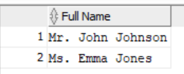

Question b
SELECT count(1) AS "Number of savings accounts",
deref(bID).b_address.street || ', ' || deref(bID).b_address.city || ', ' || deref(bID).b_address.PostCode AS "Address"
FROM MS_Account_Table
WHERE accType = 'savings'
GROUP BY bID;
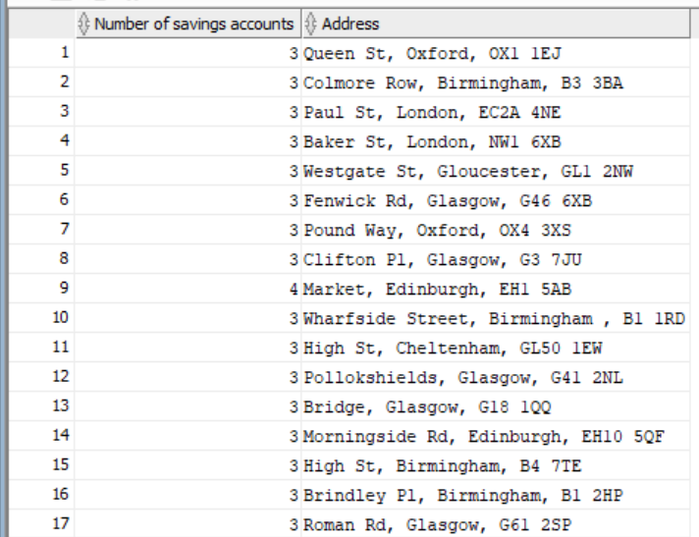

Question c
SELECT
DEREF(DEREF(ca.accNum).bID).bID AS "Branch ID",
DEREF(ca.custID).P_Name.title || ' ' || DEREF(ca.custID).P_Name.firstName || ' ' || DEREF(ca.custID).P_Name.surName AS "Full name",
DEREF(ca.accNum).balance AS "Balance"
FROM MS_CustomerAccount_Table ca
INNER JOIN
(
SELECT
DEREF(DEREF(ca.accNum).bID).bID AS "Branch ID",
MAX(DEREF(ca.accNum).balance) AS "Balance"
FROM MS_CustomerAccount_Table ca
GROUP BY DEREF(DEREF(ca.accNum).bID).bID
) CA2
ON
DEREF(DEREF(ca.accNum).bID).bID = CA2."Branch ID" AND
DEREF(ca.accNum).balance = CA2."Balance";
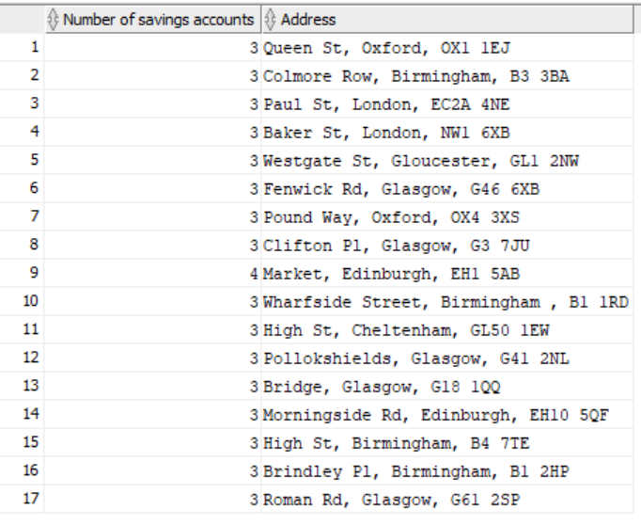

Question d
SELECT
DEREF(E.bID).bID AS "Branch that the employee works.",
DEREF(DEREF(CA.accNum).bID).bID AS "Branch that the Account was opend."

FROM MS_Customer_Table C
INNER JOIN MS_Employee_Table E
ON C.niNum = E.niNum
INNER JOIN MS_CustomerAccount_Table CA
ON C.CustID = DEREF(CA.custID).CustID;
WHERE DEREF(DEREF(E.supervisorID).E_Job)."Position" = 'Manager';
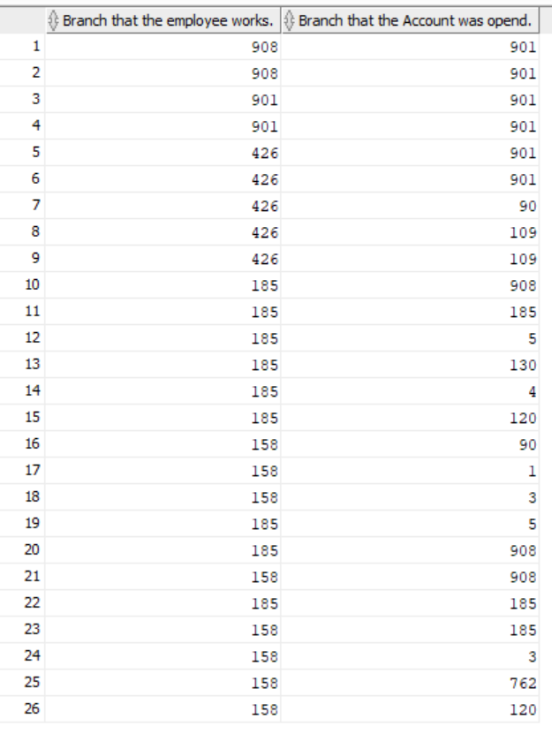

Question e
SELECT
DEREF(DEREF(ca.accNum).bID).bID AS "Branch ID",
DEREF(ca.custID).P_Name.title || ' ' || DEREF(ca.custID).P_Name.firstName || ' ' || DEREF(ca.custID).P_Name.surName AS "Full name",
DEREF(ca.accNum).limitOfFreeOD AS "Limit Of Free Overdraft"
FROM MS_CustomerAccount_Table ca
INNER JOIN
(
SELECT
DEREF(DEREF(ca.accNum).bID).bID AS "Branch ID",
MAX(DEREF(ca.accNum).limitOfFreeOD) AS "limitOfFreeOD",
COUNT(*) AS "Owners",
DEREF(ca.accNum).accType
FROM MS_CustomerAccount_Table ca
WHERE DEREF(ca.accNum).accType = 'current'
GROUP BY DEREF(DEREF(ca.accNum).bID).bID, DEREF(ca.accNum).accNum, DEREF(ca.accNum).accType
) CA2
ON
DEREF(DEREF(ca.accNum).bID).bID = CA2."Branch ID"
WHERE CA2."Owners" > 1 AND DEREF(ca.accNum).limitOfFreeOD > 0;
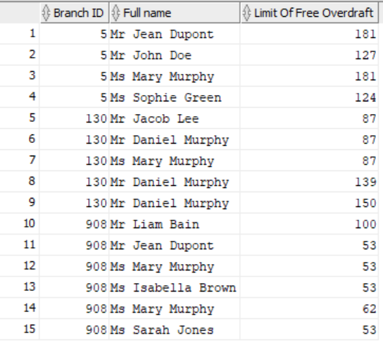

Question f
SELECT
C1."Full name", C2."Number of mobile phones"
FROM
(
SELECT
C.niNum,
C.P_Name.Title || '. '|| C.P_Name.FirstName || ' ' || C.P_Name.SurName AS "Full name"
FROM MS_Customer_Table c, Table(C.P_Phone.Mobile) t
WHERE COLUMN_VALUE LIKE '0760%'
) C1

INNER JOIN
(
SELECT
C.niNum,
COUNT(1) AS "Number of mobile phones"
FROM MS_Customer_Table c, Table(C.P_Phone.Mobile) t
WHERE t.COLUMN_VALUE NOT LIKE '362%'
GROUP BY C.niNum
HAVING COUNT(1) > 1
ORDER BY "Number of mobile phones"
) C2
ON C1.niNum = C2.niNum;
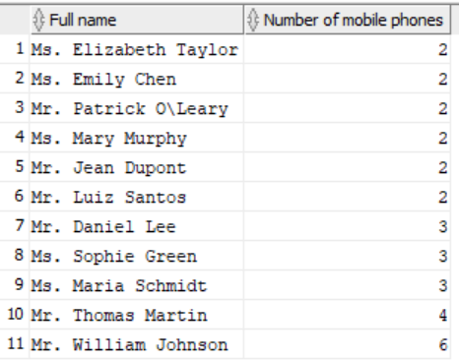

Question g
SELECT COUNT(1) AS "Number of employees"
FROM MS_Employee_Table E
WHERE
DEREF(E.SupervisorID).P_Name.Title = 'Mr.' AND
DEREF(E.SupervisorID).P_Name.FirstName = 'John' AND
DEREF(DEREF(E.SupervisorID).SupervisorID).P_Name.Title = 'Mrs.' AND
DEREF(DEREF(E.SupervisorID).SupervisorID).P_Name.FirstName = 'King';
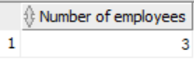

Question h
SELECT e.P_Name.firstName || ' ' || e.P_Name.SURName AS "Employee_Name",
e.employeeStatus() AS "Employee_Status"
FROM MS_Employee_Table e;

SELECT e.P_Name.firstName || ' ' || e.P_Name.SURName AS "Employee_Name",
NVL(e.employeeStatus(), '') AS "Employee_Status"
FROM MS_Employee_Table e
WHERE e.employeeStatus() IS NOT NULL
ORDER BY
CASE
WHEN e.employeeStatus() = 'gold' THEN 1
WHEN e.employeeStatus() = 'silver' THEN 2
WHEN e.employeeStatus() = 'bronze' THEN 3
END;
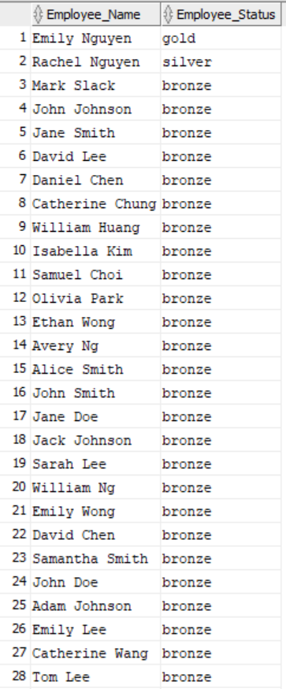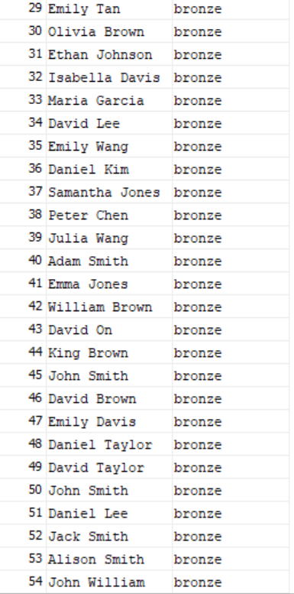

Task 5.: Critically discuss the advantages and disadvantages of the object-relational model against the relational model, based on the designs and implementations for the proposed bank database. (8 marks)

The advantages of our design approach are:
We can store multiple phone numbers for both customers and employees using nested tables, without any limitations on the number of phone numbers. In comparison, traditional relational modeling only allows a maximum of two phone numbers.
By using references, we can minimize the need for duplicate values in our tables. For example, we only need to save job information once in the Job table, and then reference it from the Employee table. This approach makes it easier to access information and eliminates the need for join statements to retrieve related data like when we want to show the data of a branch, job, or supervisor of an employee, or when we want to see the information in the CusomerAccount table.
Using structured types makes our tables look more organized and well-designed. We can look at Branch where we used the Address type
The use of inheritances and subtypes makes our tables consistent, which can reduce confusion and errors in our work. The usage is in the Employee and Customer when we used Person type as the superclass. Like having position unique in the job, making bID primary key and b_Phone unique to not have duplicate rows or miss values. Another sample would be making accNum and accType similar to the Branch table but in the Account table. In the Customer and Employee, the niNum is unique so a person is not inserted twice. In Customer CustID and in Employee the empID is primary key.
The use of constraints ensures that we maintain data integrity and prevents false data from being inserted into our tables.

However, there are also some disadvantages to our approach:
Accessing data through nested types can be more difficult compared to relational modeling. It may also be harder to remove or modify values.
Using structured types, subtypes, and inheritances can lead to more layers in our tables, which can make it harder to navigate and access specific values.
Although using references can minimize the need for joins, it can sometimes take longer to find a specific value through a reference.

