IQ - TEST

# BY-ANSHUL VERMA (2019CSB1075)

# -PIYUSH PRESANNAN (2019CSB1106)

# MOTIVATION

We always wanted to create a GUI(Graphical User Interface) since we began programming. The Idea of creating a Graphical User Interface was rooted in our minds after we learnt about module tkinter. So we thought that that we should take this idea to make our mini project for GEL-103. This was the best possible chance for us explore the module tkinter.

# IDEA

The idea of the project is to create an IQ Test in Graphical User Interface. We have taken ten different questions from different domains. We went to many people and conducted the IQ test and displayed the score. We also showed them their position on the leader board.

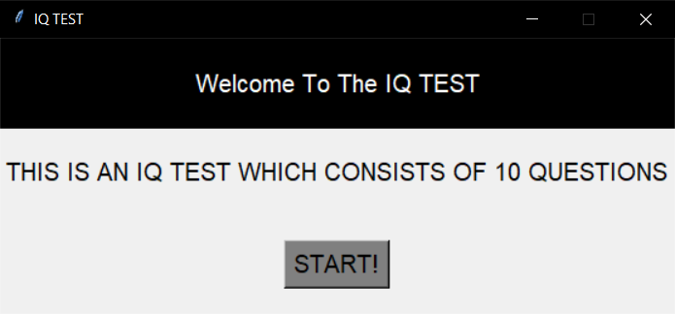

# THE GAME

The first task that we accomplished was the creation of the main page. It Consisted general information of our test. It stated that there are ten questions in this game and after the completion of the game it will tell you the category in which your IQ falls.

It consisted a start button which takes the person to the next page.

In the next page we asked details of the person like their name and entry number. After filling the details, the player moves to the next page.

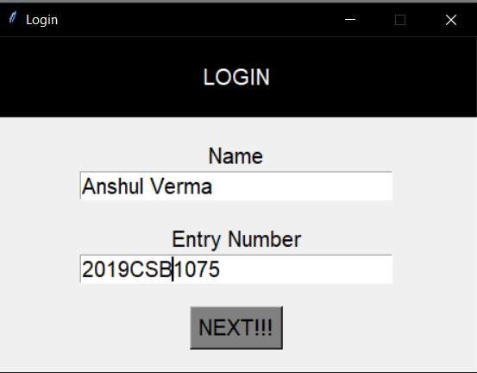

Then finally we wish the player all the best and the timer begins.

# RULES

The person has to definitely answer the question, once he moves to the next question, he does not have the choice to come back. This way the player completes all 10 questions. Different question, have different marks assigned to it as per the difficulty of the question. There are questions of 50,100,200,250 marks. Max score that a player can achieve is 1400. A timer of 10 minutes was fixed for every player to play. As the person completes his test or the time is up, he received, the marks he scored and his position in the leader board.

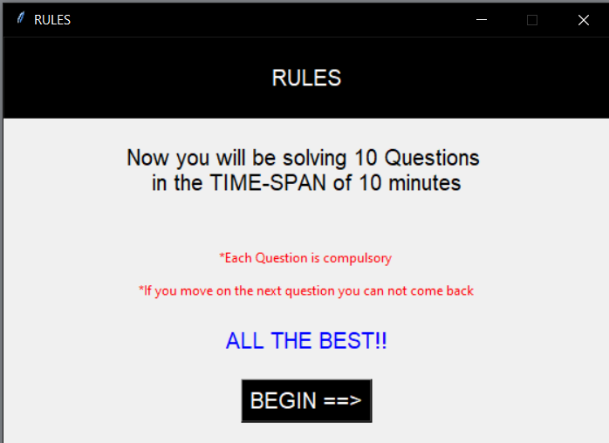

# CREATING THE INTERFACE

The primary task for us was the creation of main page. We used basic syntax of the module tkinter to do that. We created a screen, fixed its geometry and title.

mainscreen = Tk()

mainscreen.geometry="500x500"

mainscreen.title("IQ TEST")

Then we added text to it. Following is the syntax of adding a text

Label(mainscreen, text="").pack()

We could also adjust the font size of the text by –

Label(mainscreen, text=”GEL-103”,font=”5”).pack()

Then we created a next button which would take the player to the next screen

Button(mainscreen, text="START!", font="5", bg="grey", fg="black", command=login_page).pack()

The command which is present in the button takes it to the corresponding function

e.g. command=login_page, takes the code to function of login_page as the players clicks the button

We have looked up on the internet for the basic syntax of creating a screen, adding text, making a button.

Every time the next button is clicked, we destroy the previous screen and create the next screen.

# QUESTIONS

After the player enters all his details the player faces questions.

Every question contains four options out of which only one is correct. We have assigned values to the correct option according to the weightage of the question. As the person clicks any option the value assigned to that option is stored. According to the option that the player has selected he secures marks. Then the scores of every question is added and the final score is calculated.

stored. According to the option that the player has selected he secures marks. Then the scores of every question is added and the final score is calculated.

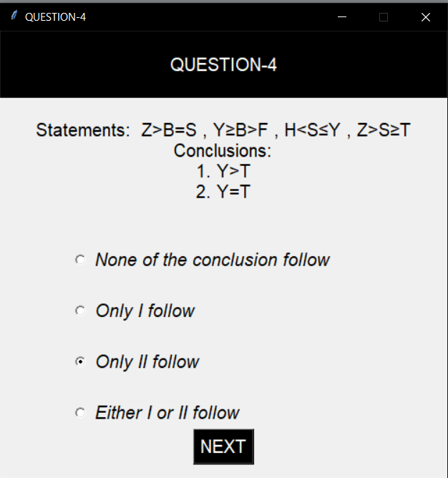

# RESULT

After the person completes the test, he clicked the submit button on the page of the last question. As results he gets to know the number question he got correct, number of questions he got wrong and the final score which he got.

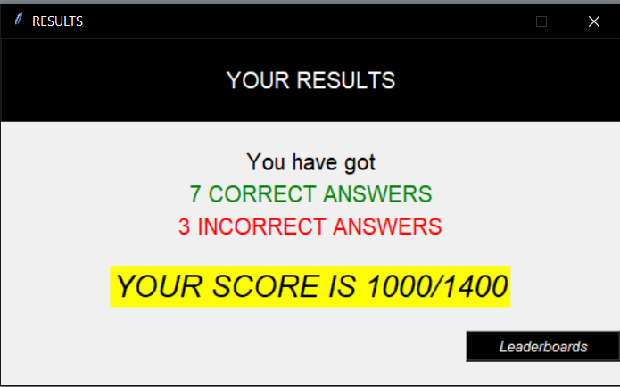

# LEADER BOARD

As the player completes the test, he gets his name registered into the leader board. According to the score that he got, his name is adjusted in the leader board

# 

# FUTURE PLANS

One thing which we wished but we could not do was to link a stopwatch with interface which would begin as the begins and end as the game finishes. Instead of this we used the timer of our mobile phones. We started the timer as the player began and as the time would finish, we would end their game.

(We also give you the result txt file in which our data of the leader board is stored)