AIQ題網頁端對3DBuilder所下的指令說明文件

* 完整的AIQ題的網頁端程式會利用1個獨立的NamedPipe程式(CSNamedPipe.exe)來將指令傳給3DBuilder以讓3DBuilder去做相對應的顯示.
* 說明中的名稱定義:

1. AITypeQuestion XML 題庫檔:

例如: IPC_Question_Origin/SceneFile_Knee_ex.xml

(存有所有膝蓋的器官. 為3DBuilder可讀取的格式. 3DBuilder讀取此檔後,可顯示所有其中設定為Visible的器官)

1. AITypeQuestion XML檔:

例如:IPC_Questions/1160-1450/tea1_Q_20181210231100.xml

(和AITypeQuestion XML 題庫檔一樣格式的存有老師編輯的AIQ題內容的XML.

為3DBuilder可讀取的格式. 3DBuilder讀取此檔後,可顯示所有其中設定為Visible的器官)

1. Organ XML檔:
2. AITypeQuestion XML 題庫檔與 ②AITypeQuestion XML檔的統稱.
3. NamedPipe_IPC_Connection.cs: App_Code/ NamedPipe_IPC_Connection.cs是含有所有對利用NamedPipe程式(CSNamedPipe.exe)來將指令傳給3DBuilder以讓3DBuilder去做相對應的顯示的functions 的C# Class.
4. NamedPipe程式(CSNamedPipe.exe):

App_Code/CSNamedPipe/bin/Debug/ CSNamedPipe.exe是用來將網頁端的指令傳往3DBuilder的NamePipe程式

* 詳細說明:

我們用App_Code/NamedPipe_IPC_Connection.cs C# Class裡的function來將指令從AIQ題的網頁端傳往3DBuilder.

NamedPipe_IPC_Connection.sendMsg23DBuilder(***msgFor3DBuilder***);

***msgFor3DBuilder 的指令有以下幾種:***

1. Initiate 3DBuilder: Set Mode to Practice Mode in 3DBuilder for initialization.

This command should be called at the very beginning when an user wants to display organs in 3DBuilder.

***msgFor3DBuilder*** ="1 2"

1. Send the specified Organ XML檔to 3DBuilder for displaying 3D organs in that file.

3DBuilder will read in this Organ XML 檔

(It can be either AITypeQuestion XML 題庫檔 or AITypeQuestion XML檔)

and display 3D organs accordingly.

***msgFor3DBuilder*** ="3 " + absoluteKneeXMLFolder + QuestionFileName + "_" + NameOrNumberAnsweringMode_Session + strRandomQuestionNo);

1. Update student answer to the 3D label in the 3DBuilder

***msgFor3DBuilder*** = "5 " + givenOrganName + " " + studentOrganNumberAnswer + " " + correctOrganName;

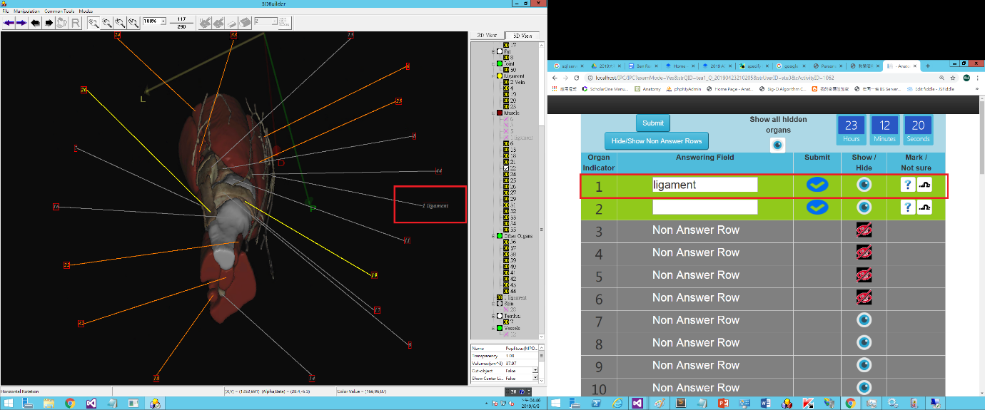

1. Hide or show a 3D organ in 3DBuilder

***msgFor3DBuilder*** = "6 " + HideOrShow + " " + correctOrganName.ToString();

(HideOrShow=”hide” or HideOrShow=”show”)

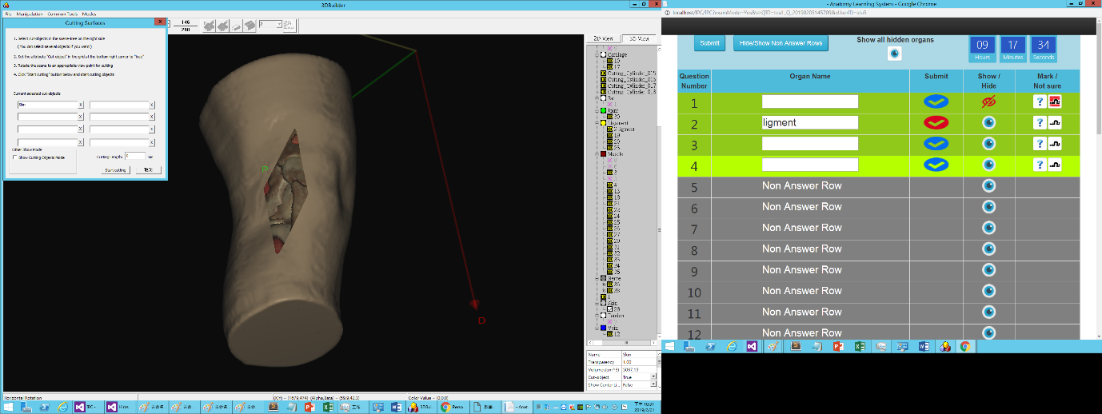

1. Show All 3D organs hidden by a student.

Notice: The 3D organs hidden by a teacher will remain hidden.

***msgFor3DBuilder*** = "7 " + ”showAll”



1. Show or Hide 3D Labels in 3DBuilder

If 3D Labels is hidden, they will be shown and vice versa.

***msgFor3DBuilder*** = "8 " + "Show_3D_Labels";

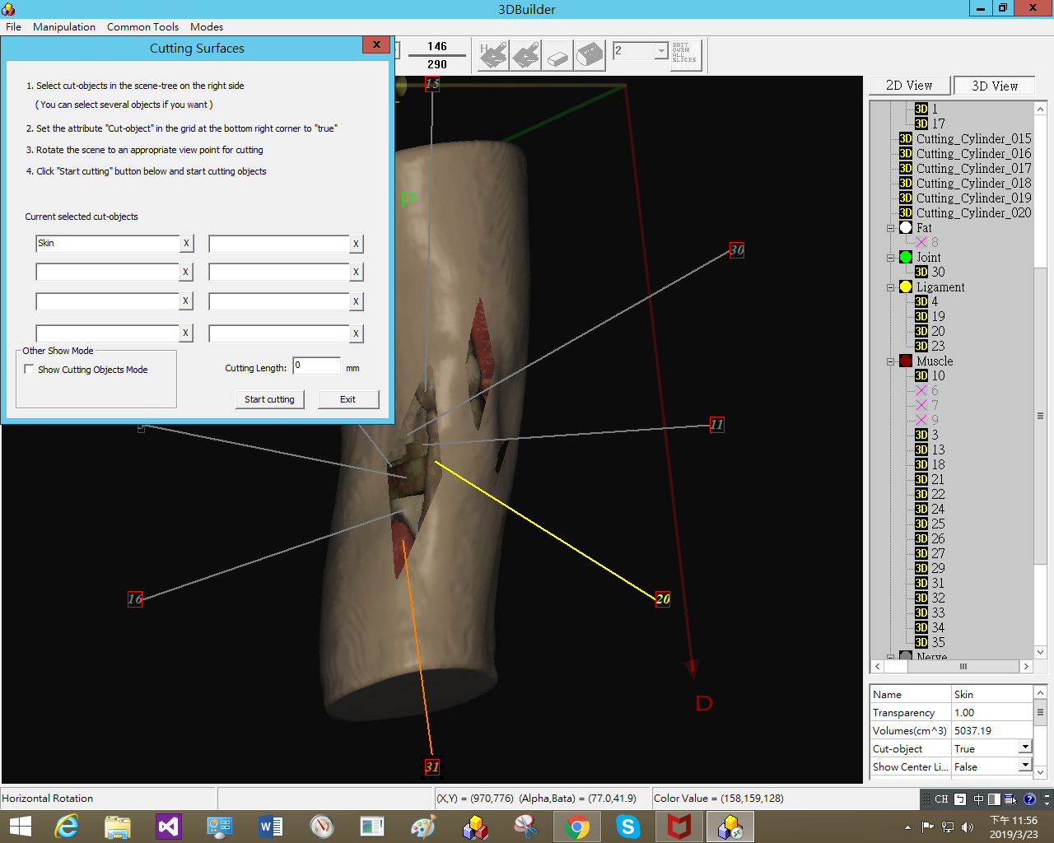

1. Activate the callback function of the “Save_Scene_As” button in 3DBuilder to save the 3D organs edited by a teacher with 3DBuilder.

We use this command to save 老師再3DBuilder中用虛擬手術刀所切開的皮膚切口

***msgFor3DBuilder*** = "9 " + "Activate_Save_Scene_As";

